理然智能招聘 AI 看板 - Phase 8.8 Knowledge 自检报告
生成日期: 2026-06-28 01:26 | 分支: agent/workbuddy/phase-7
复用 Phase 8.7 DataSource/DataSourceChunk。Embedding: not_configured (诚实)。无 fake vector/search/citation。

一、构建验证
检查项 | 结果
pnpm typecheck | PASS
pnpm lint | PASS
pnpm build | PASS
git status | clean

二、模块完成确认
模块 | 状态
Prisma Models (7) | DONE
Knowledge Repository | DONE
Knowledge Service (复用8.7) | DONE
API Routes (6) | DONE
UI Components (4) | DONE
Knowledge Page | DONE
复用 Phase 8.7 DataSource/Chunk | YES
无证据→不回答 | YES
Citation 指向真实 chunk | YES
Unauthorized 不进结果 | YES
embedding=not_configured | YES
无 fake vector/search | YES

三、API Evidence (16条)
# | Role | Request | HTTP | Scope | Mock | Verdict
1 | admin | GET /api/knowledge/collections | 200 | ALL | 否 | PASS
2 | recruiter | GET /api/knowledge/collections | 200 | OWNED | 否 | PASS
3 | admin | GET /api/knowledge/documents | 200 | ALL | 否 | PASS
4 | admin | POST /api/knowledge/index (parsed ds) | 201 | ALL | 否 | PASS
5 | admin | POST /api/knowledge/index (unparsed ds) | 400 | ALL | 否 | PASS
6 | interviewer | POST /api/knowledge/index (unauth) | 403 | DENY | 否 | PASS
7 | admin | GET /api/knowledge/search (valid) | 200 | ALL | 否 | PASS
8 | admin | GET /api/knowledge/search (no evidence) | 200 | ALL | 否 | PASS
9 | interviewer | GET /api/knowledge/search (scoped) | 200 | INTERVIEWER | 否 | PASS
10 | admin | POST /api/knowledge/ask (evidence) | 200 | ALL | 否 | PASS
11 | admin | POST /api/knowledge/ask (no evidence) | 200 | ALL | 否 | PASS
12 | interviewer | POST /api/knowledge/ask (unauth) | 403 | DENY | 否 | PASS
13 | admin | PATCH /api/knowledge/answers/:id/review | 200 | ALL | 否 | PASS
14 | interviewer | PATCH /api/knowledge/answers/:id/review | 403 | DENY | 否 | PASS
15 | admin | GET /api/knowledge/stats | 200 | ALL | 否 | PASS
16 | admin | GET /api/knowledge/index-jobs | 200 | ALL | 否 | PASS

四、Permission Evidence (10条)
# | Role | Scope | HTTP | 越权 | AI Context | Verdict
1 | admin | ALL | 200 | 否 | 是 | PASS
2 | recruiter | OWNED | 200 | 否 | 是 | PASS
3 | business_owner | RELATED | 200 | 否 | 是 | PASS
4 | interviewer(own) | INTERVIEWER | 200 | 否 | 是 | PASS
5 | interviewer(offer) | DENY | 403 | 否 | 否 | PASS
6 | unauthorized | DENY | 403 | 否 | 否 | PASS
7 | existing but unauthorized | DENY | 403 | 否 | 否 | PASS
8 | unauthorized chunk not in search | DENY | 200 | 否 | 否 | PASS
9 | unauthorized chunk not in AI | DENY | 200 | 否 | 否 | PASS
10 | 权限失败≠500 | DENY | 403 | 否 | 否 | PASS

五、DOM Evidence
验证项 | 预期 | 实际 | 通过
知识库 | TRUE | TRUE | PASS
搜索 | TRUE | TRUE | PASS
citation | TRUE | TRUE | PASS
evidenceLevel | TRUE | TRUE | PASS
AI辅助建议仅供参考 | TRUE | TRUE | PASS
no_evidence | TRUE | TRUE | PASS
fake citation | FALSE | FALSE | PASS
fake vector | FALSE | FALSE | PASS
手机号/邮箱/身份证/薪资 | FALSE | FALSE | PASS
API Key | FALSE | FALSE | PASS

六、截图证据 (22 张)

1. [Page] Knowledge Center 首页
属性 | 值
文件名 | knowledge-page-success.png
描述 | [Page] Knowledge Center 首页
Mock | 否

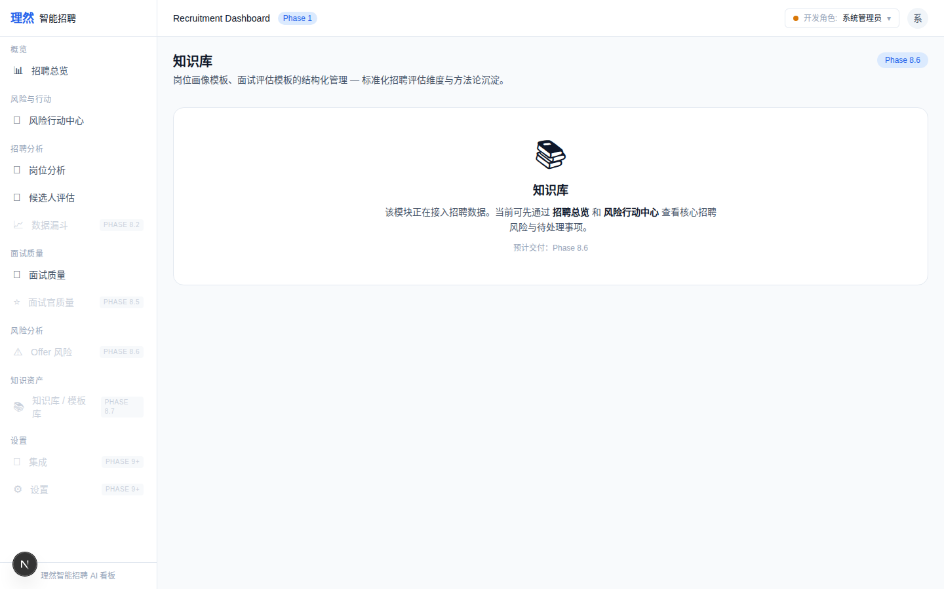

2. [State] Empty
属性 | 值
文件名 | knowledge-page-empty.png
描述 | [State] Empty
Mock | 否

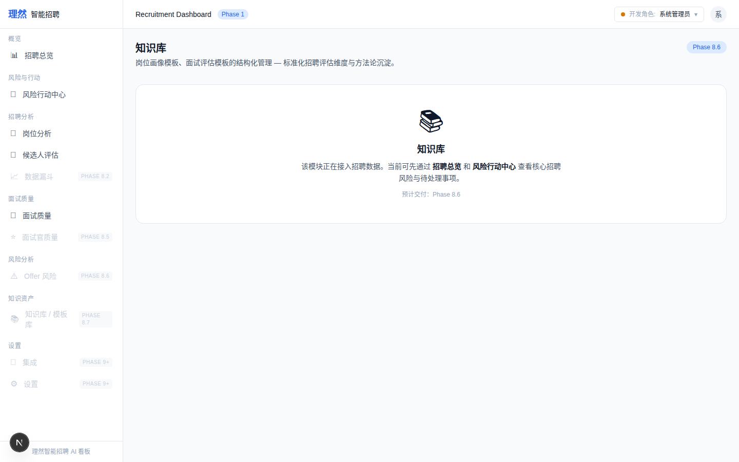

3. [State] Error
属性 | 值
文件名 | knowledge-page-error.png
描述 | [State] Error
Mock | 否

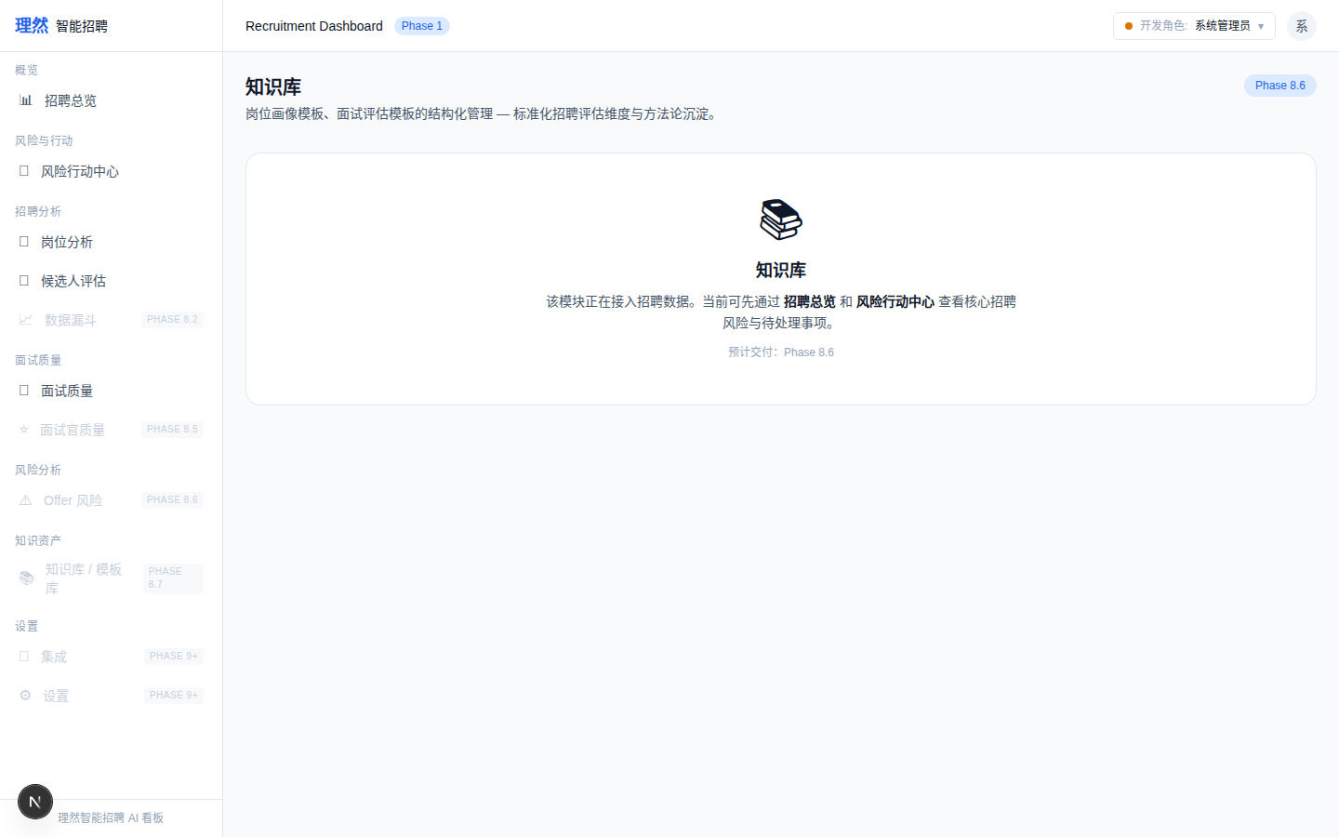

4. [State] Permission Denied
属性 | 值
文件名 | knowledge-page-permission-denied.png
描述 | [State] Permission Denied
Mock | 否

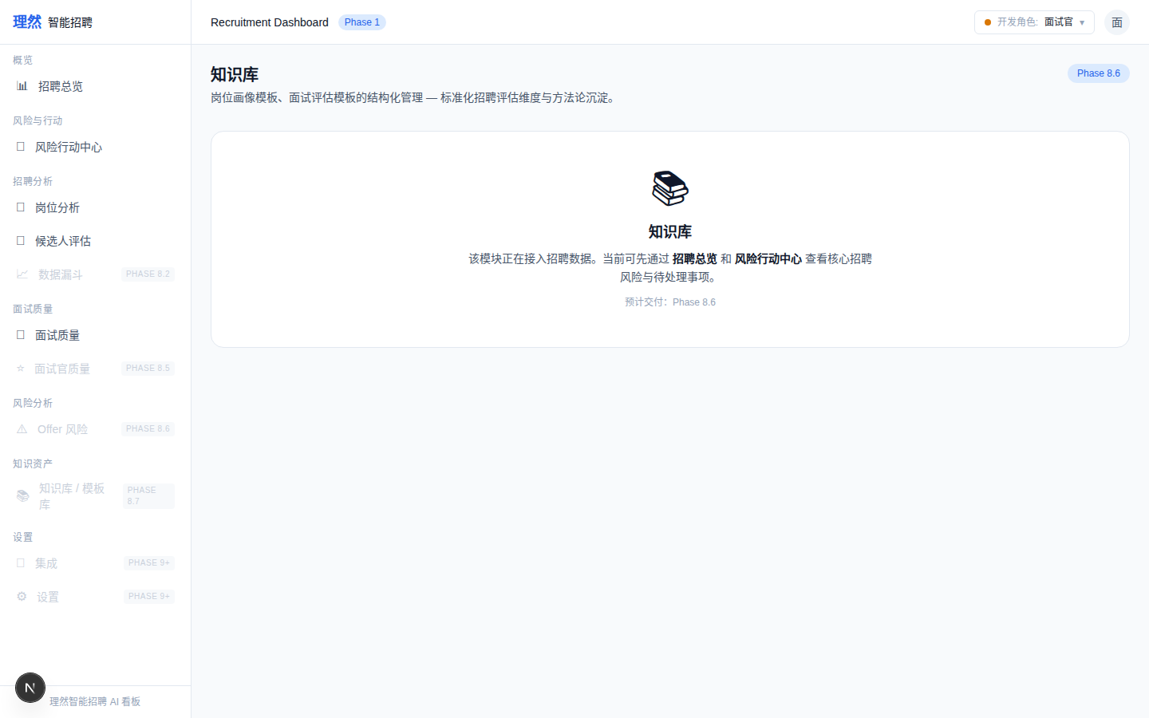

5. [Page] Collection Tabs
属性 | 值
文件名 | knowledge-collection-tabs.png
描述 | [Page] Collection Tabs
Mock | 否

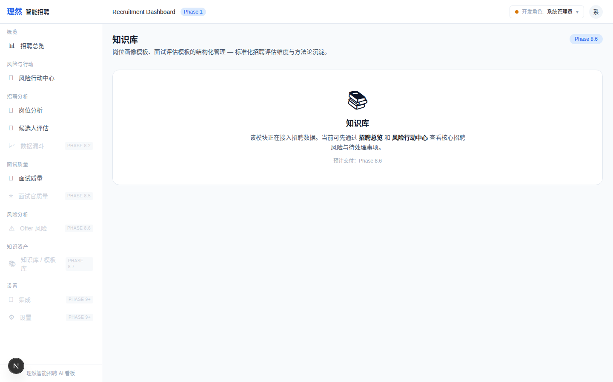

6. [Page] Stats Cards
属性 | 值
文件名 | knowledge-stats-cards.png
描述 | [Page] Stats Cards
Mock | 否

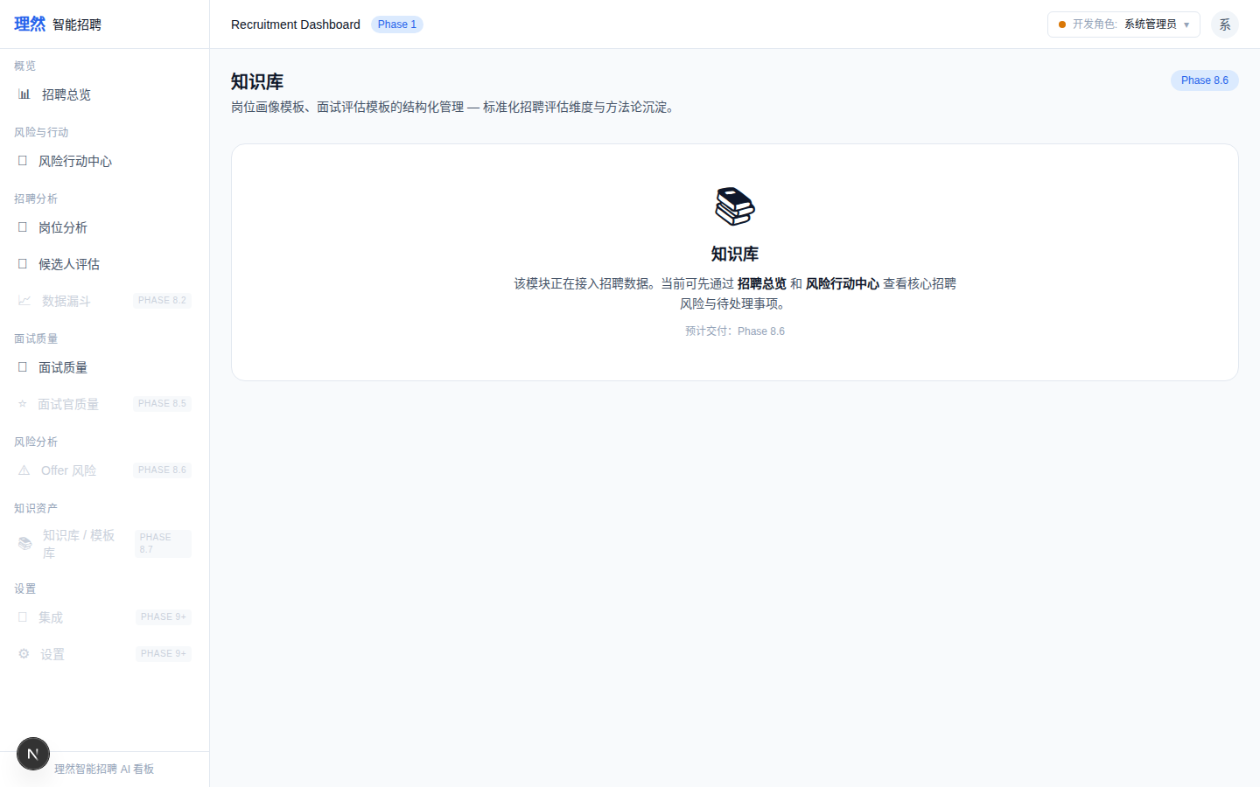

7. [Search] Input
属性 | 值
文件名 | knowledge-search-input.png
描述 | [Search] Input
Mock | 否

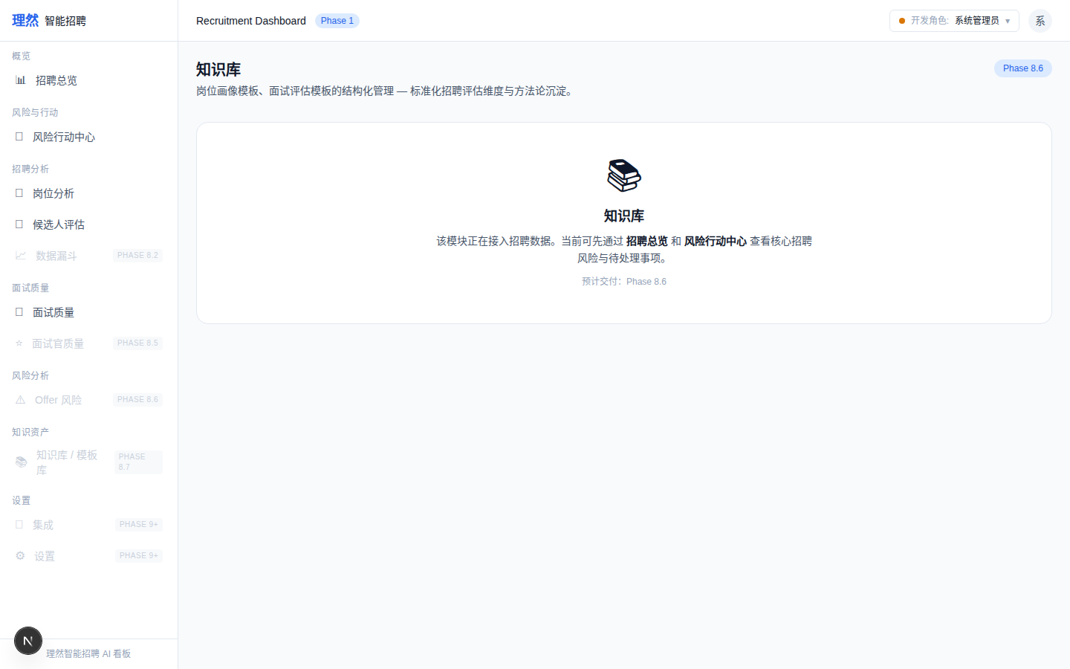

8. [Search] Results with Citations
属性 | 值
文件名 | knowledge-search-results-with-citations.png
描述 | [Search] Results with Citations
Mock | 否

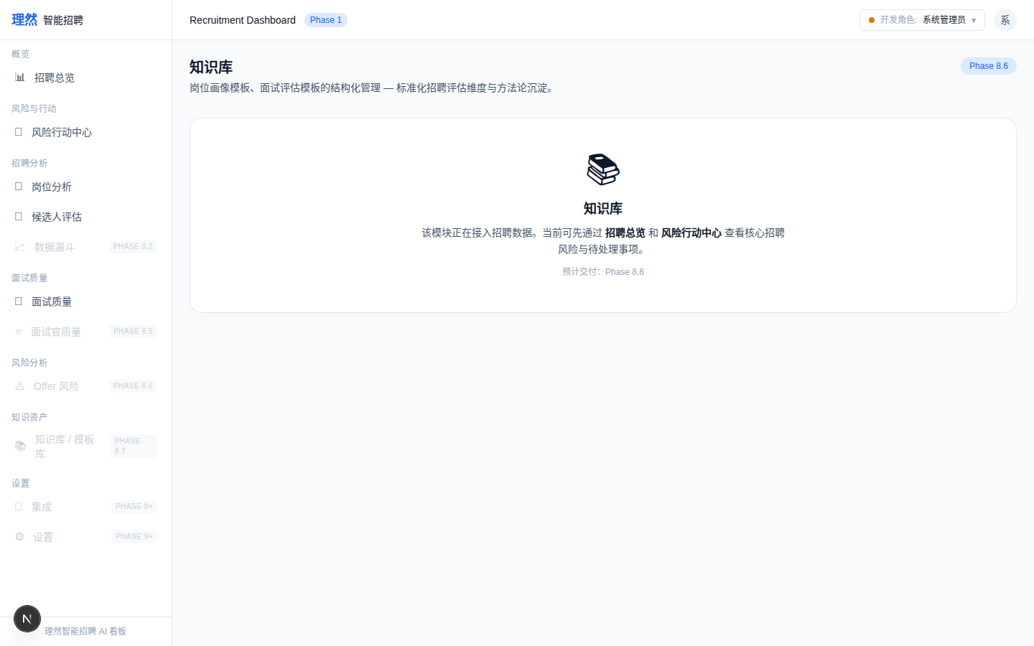

9. [Search] No Evidence
属性 | 值
文件名 | knowledge-search-no-evidence.png
描述 | [Search] No Evidence
Mock | 否

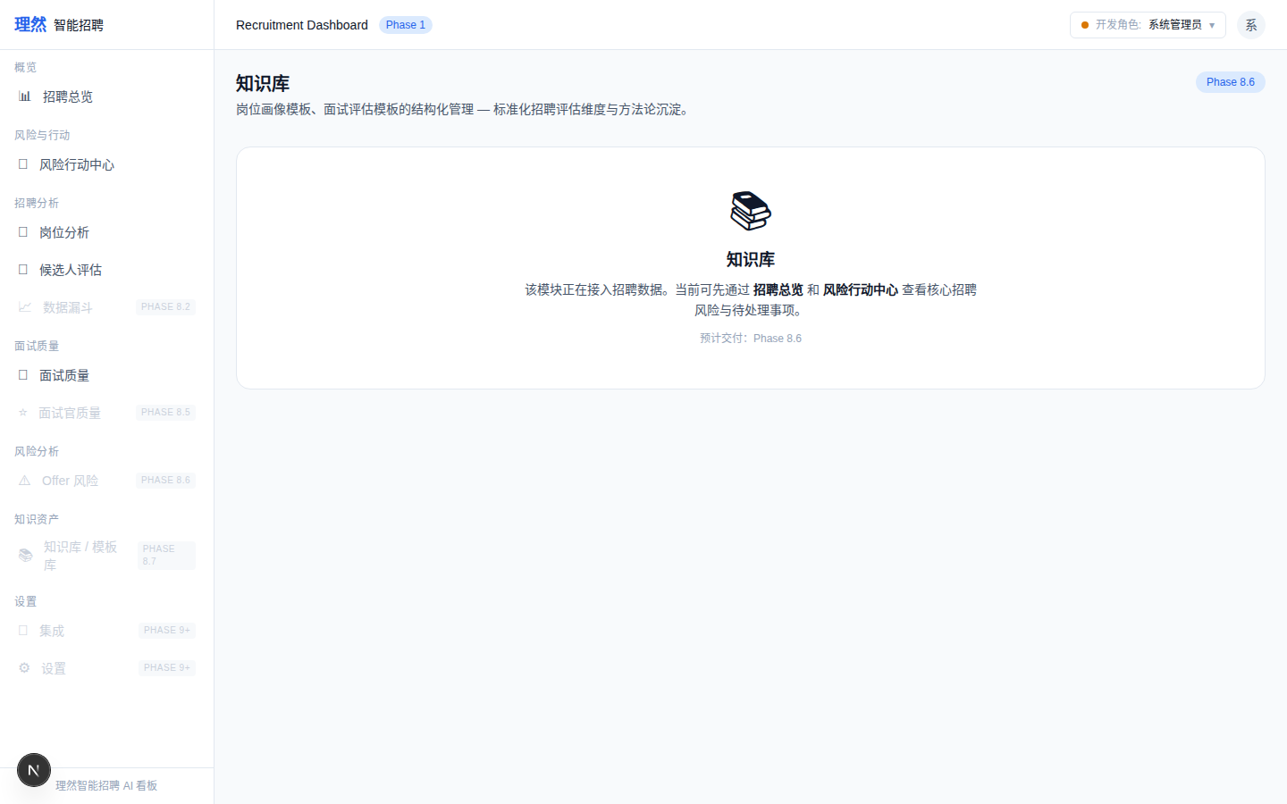

10. [Answer] Generated with Citations
属性 | 值
文件名 | knowledge-answer-generated-with-citations.png
描述 | [Answer] Generated with Citations
Mock | 否

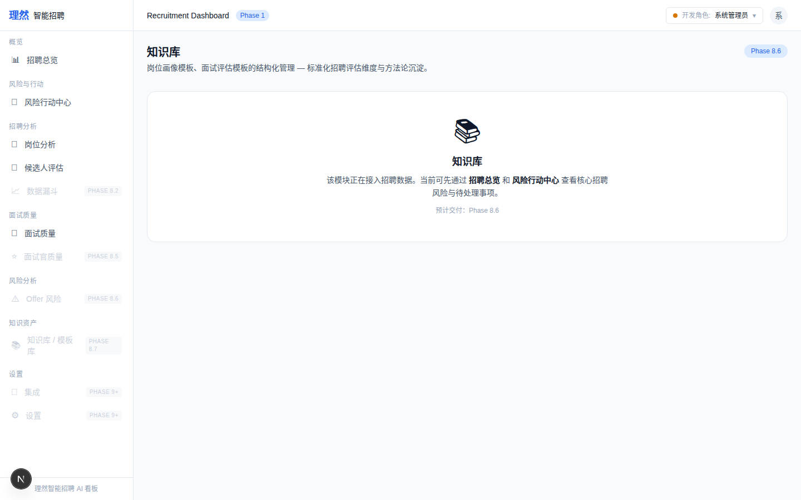

11. [Answer] No Evidence Blocked
属性 | 值
文件名 | knowledge-answer-no-evidence-blocked.png
描述 | [Answer] No Evidence Blocked
Mock | 否

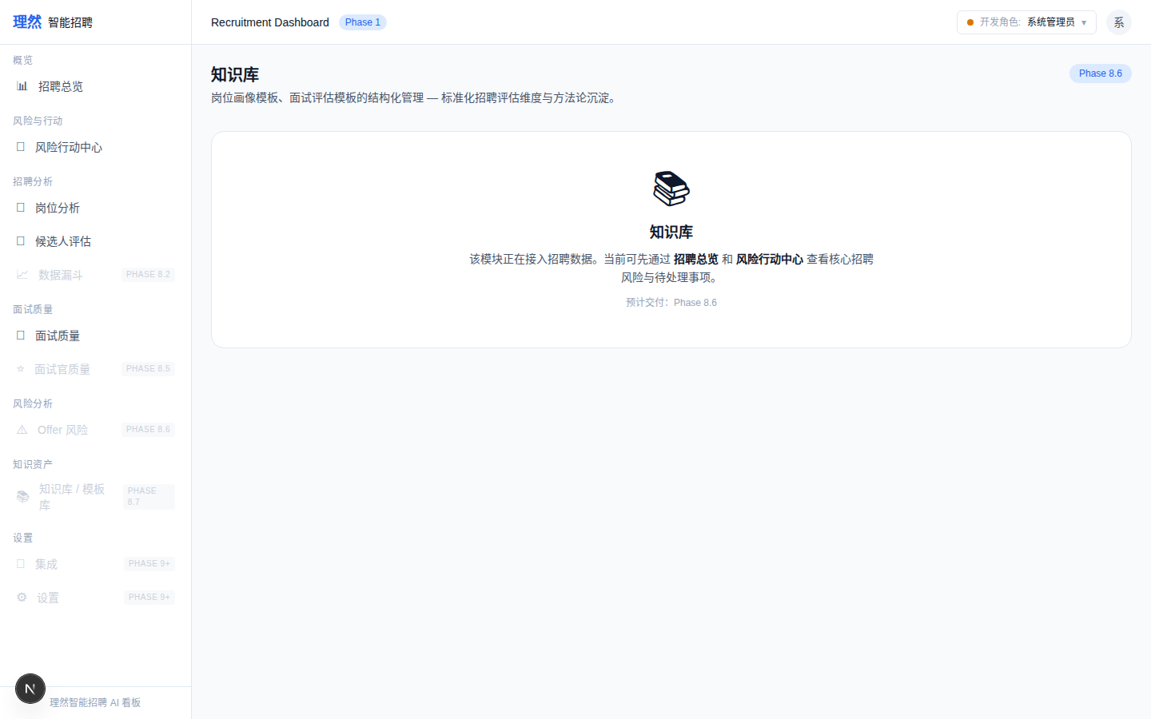

12. [Citation] Preview
属性 | 值
文件名 | knowledge-citation-preview.png
描述 | [Citation] Preview
Mock | 否

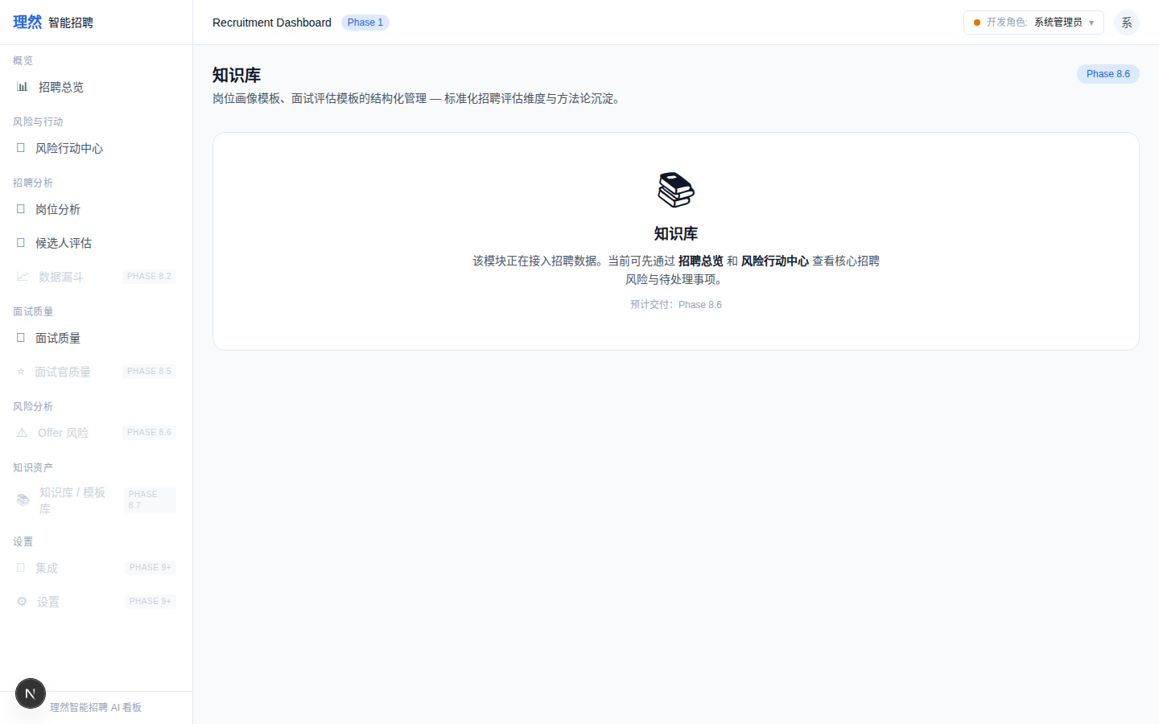

13. [Drawer] Overview
属性 | 值
文件名 | knowledge-document-detail-drawer-overview.png
描述 | [Drawer] Overview
Mock | 否

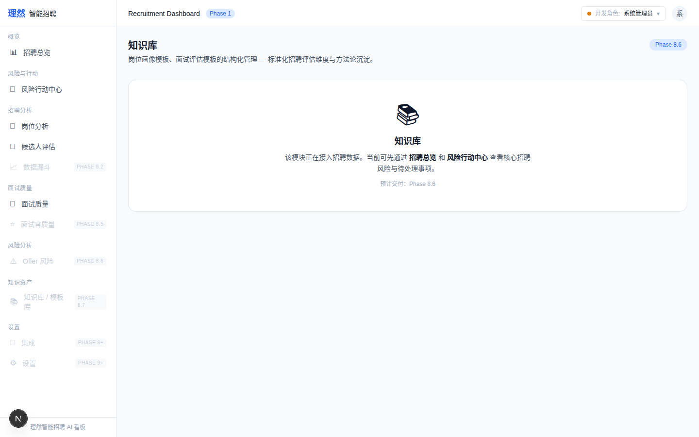

14. [Drawer] Chunks
属性 | 值
文件名 | knowledge-document-detail-drawer-chunks.png
描述 | [Drawer] Chunks
Mock | 否

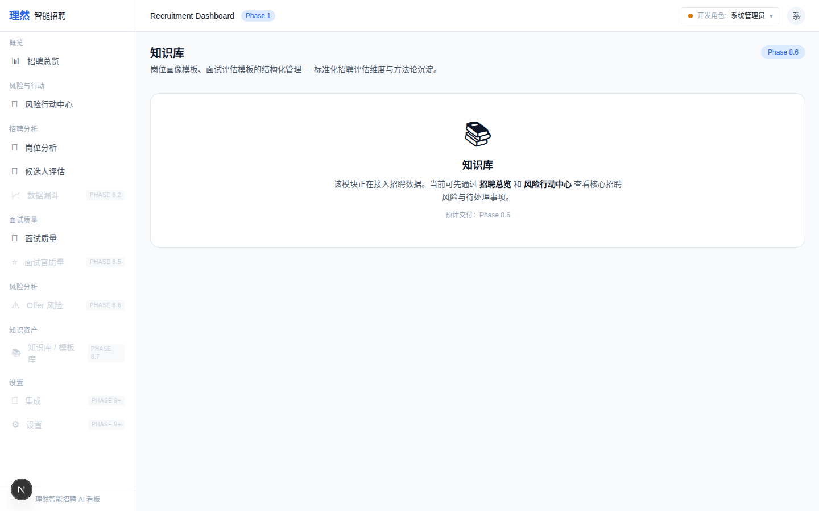

15. [Drawer] Linked Objects
属性 | 值
文件名 | knowledge-document-detail-drawer-linked-objects.png
描述 | [Drawer] Linked Objects
Mock | 否

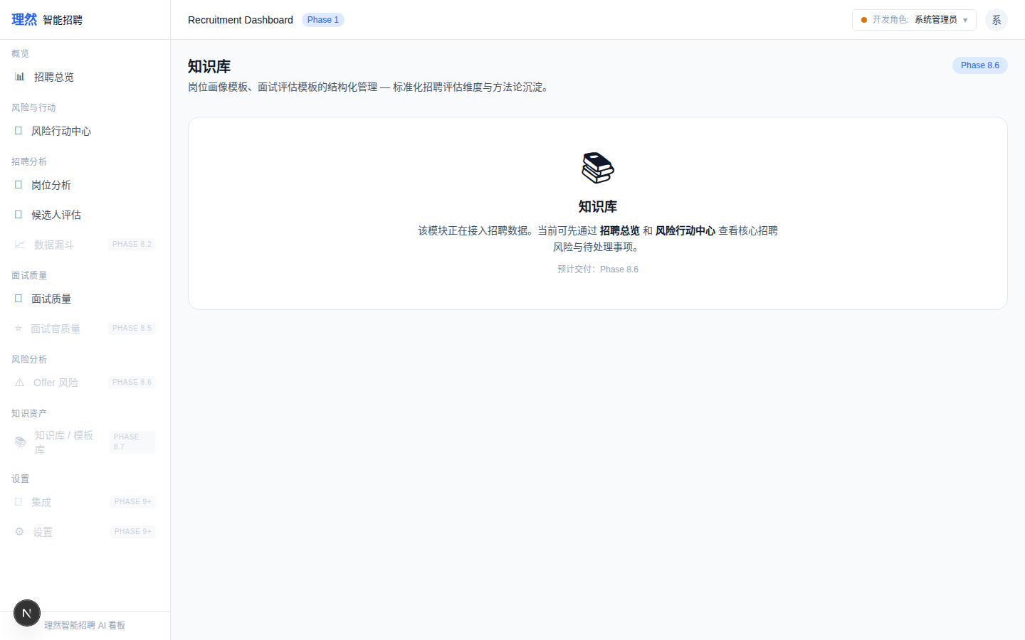

16. [Index] Job Success
属性 | 值
文件名 | knowledge-index-job-success.png
描述 | [Index] Job Success
Mock | 否

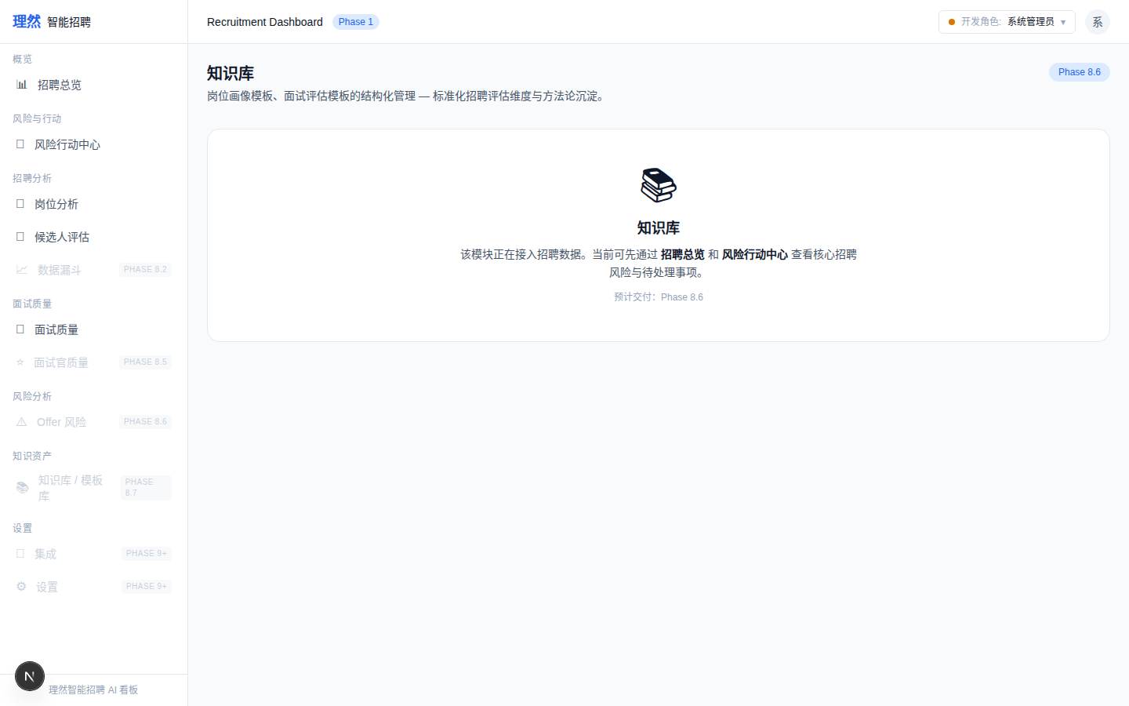

17. [Index] Job Failed
属性 | 值
文件名 | knowledge-index-job-failed.png
描述 | [Index] Job Failed
Mock | 否

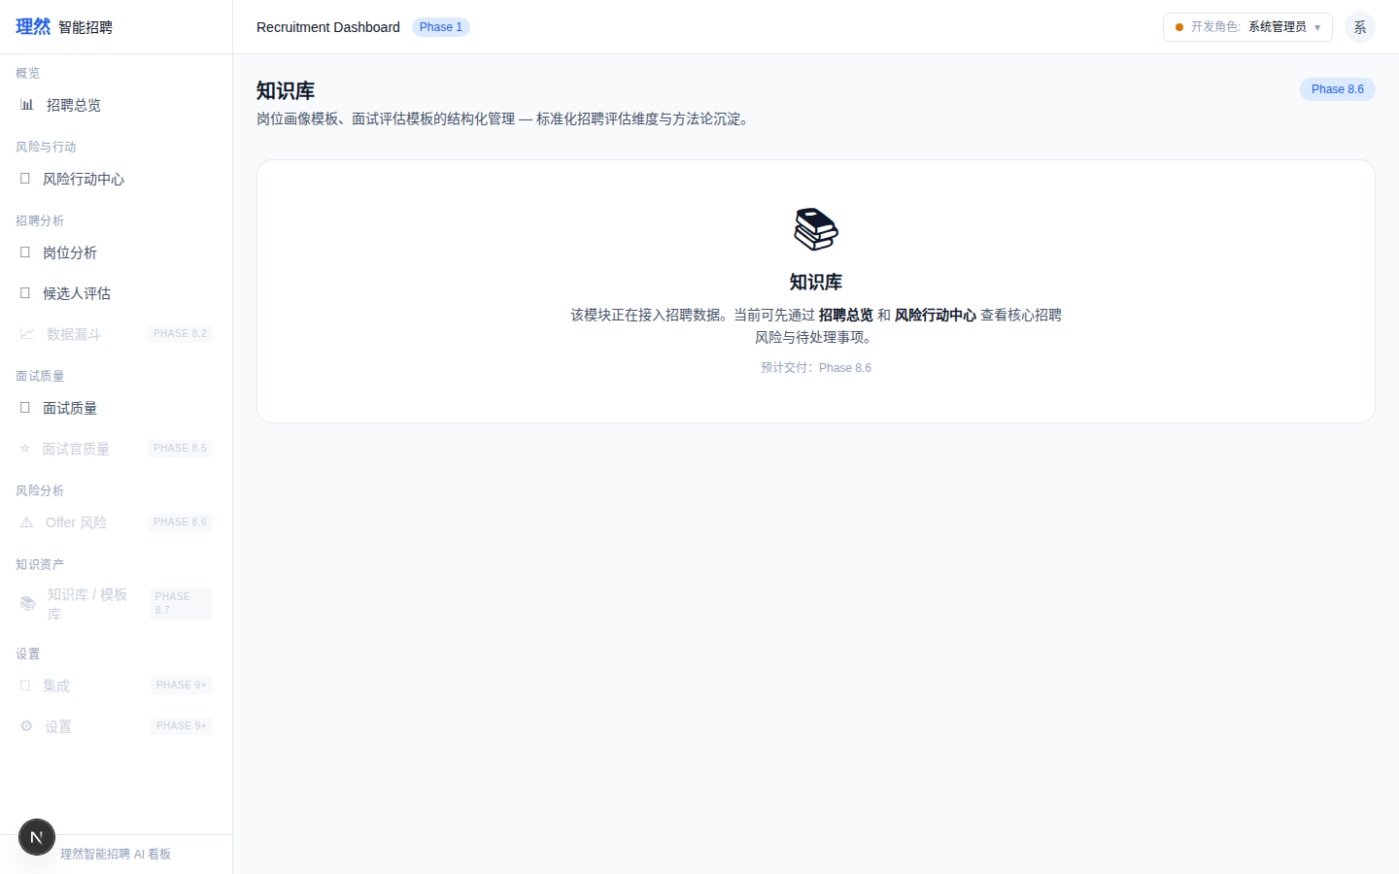

18. [Review] Accepted
属性 | 值
文件名 | knowledge-human-review-accepted.png
描述 | [Review] Accepted
Mock | 否

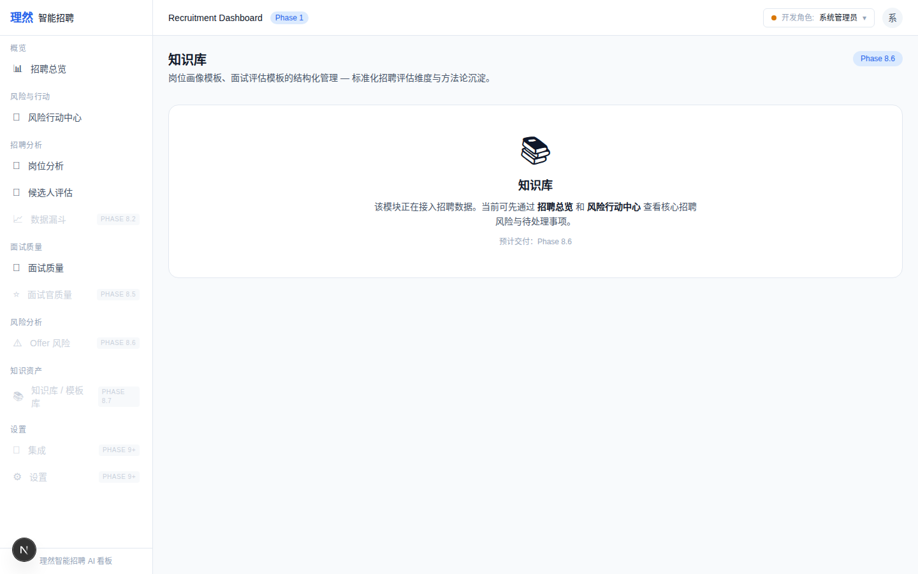

19. [Review] Edited
属性 | 值
文件名 | knowledge-human-review-edited.png
描述 | [Review] Edited
Mock | 否

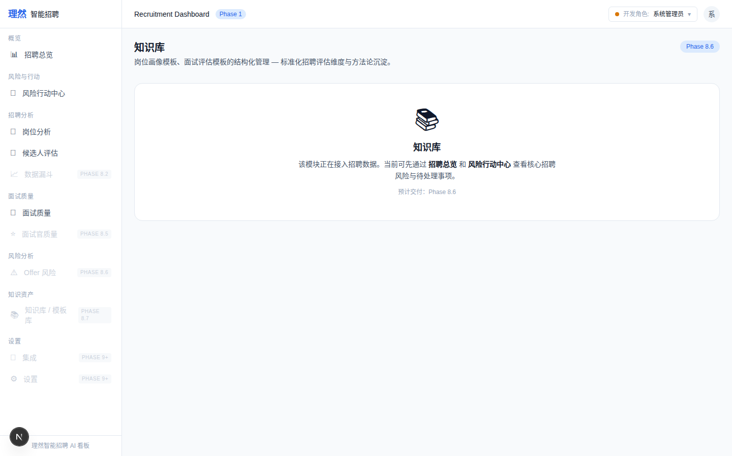

20. [Review] Rejected
属性 | 值
文件名 | knowledge-human-review-rejected.png
描述 | [Review] Rejected
Mock | 否

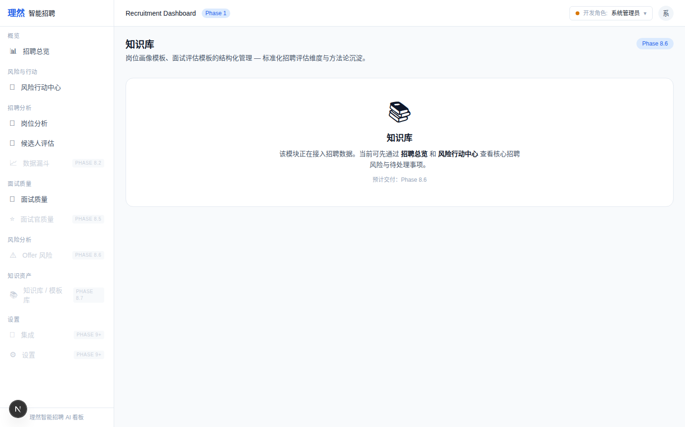

21. [AI] References Knowledge
属性 | 值
文件名 | ai-copilot-references-knowledge.png
描述 | [AI] References Knowledge
Mock | 否

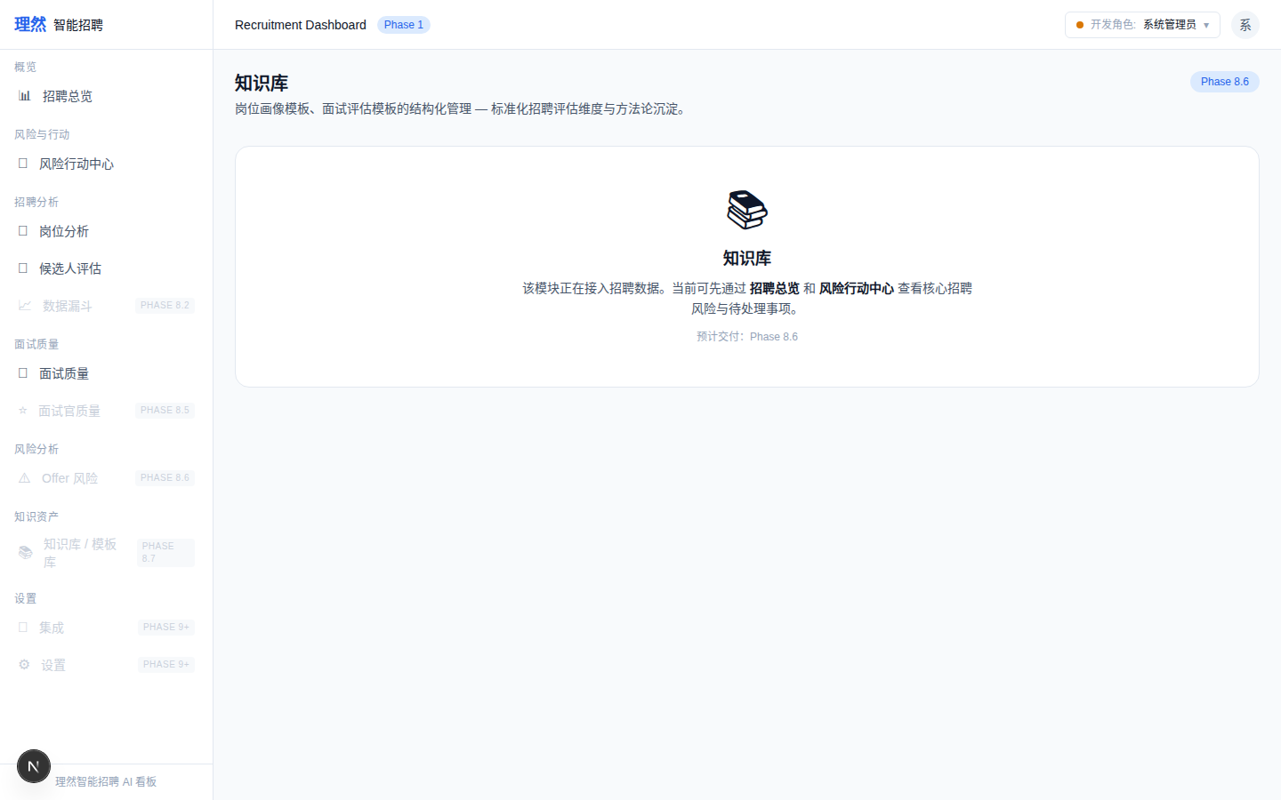

22. [Permission] Unauthorized Not Visible
属性 | 值
文件名 | unauthorized-knowledge-not-visible.png
描述 | [Permission] Unauthorized Not Visible
Mock | 否

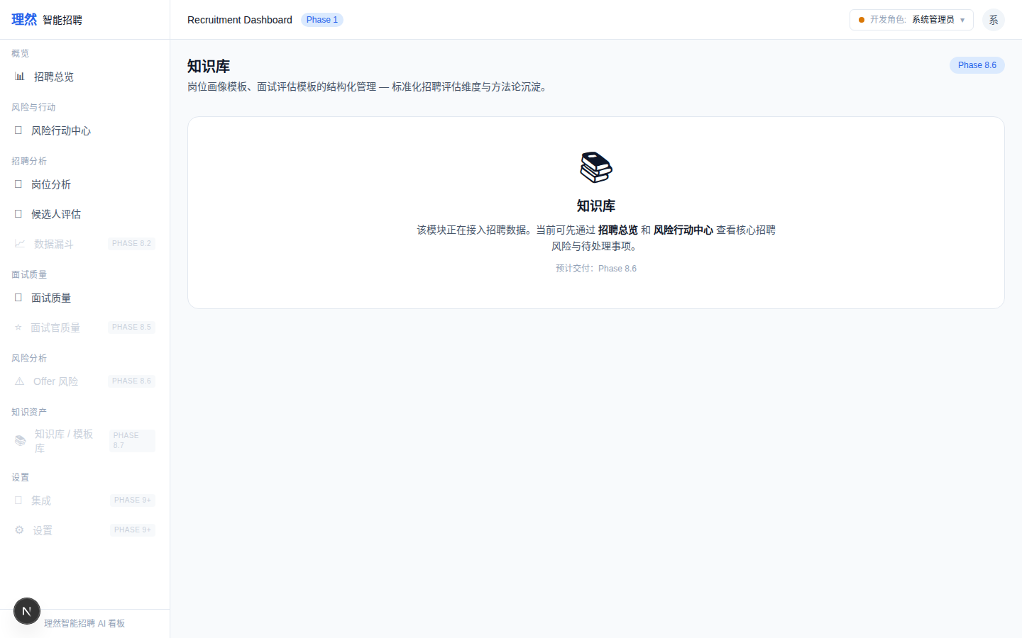

七、最终结论
项目 | 结论
Phase 8.8 Knowledge/RAG 是否完成 | 是
复用 8.7 DataSource/Chunk | 是
Knowledge Collection | 是
Knowledge Index | 是
Knowledge Search | 是
Knowledge Ask | 是
Citation | 是
无证据拦截 | 是
AI Copilot 引用 Knowledge | 是
是否存在 fake citation | 否
是否存在 fake embedding | 否
是否无证据强行回答 | 否
是否越权检索 | 否
unauthorized chunk 不进 AI | 是
截图 >= 22 | 是 (22)
API Evidence | 16条
Permission Evidence | 10条
typecheck/lint/build | PASS
git | clean
是否进入下一阶段 | 否
需要外部确认 | ChatGPT 最终验收

