Phase 8.14: CEO Demo Readiness — 自检报告
  - 理然智能招聘 AI 看板 v3 | 25张原始PNG | 12个证据文件

一、执行摘要
Phase 8.14 | PASS
git branch | agent/workbuddy/phase-7
commit hash | 668c20d
截图数量 | 25张 closeup PNG
证据文件 | 12个
Demo主路径 | Dashboard→Copilot→Funnel→Action→Job Detail→Knowledge
真实岗位 | 100个（理然JD库）
假数据 | 0
安全红线 | 0违规
Build | PASS | Git Clean

二、证据文件清单
- ✅ phase-8.14-ai-trust-evidence.md
- ✅ phase-8.14-api-evidence.md
- ✅ phase-8.14-commands.log
- ✅ phase-8.14-demo-data.md
- ✅ phase-8.14-demo-path.md
- ✅ phase-8.14-demo-paths.md
- ✅ phase-8.14-demo-script.md
- ✅ phase-8.14-dom-evidence.md
- ✅ phase-8.14-final-checklist.md
- ✅ phase-8.14-known-limitations.md
- ✅ phase-8.14-permission-evidence.md
- ✅ phase-8.14-report.md
- ✅ phase-8.14-saas-ui-review.md
- ✅ phase-8.14-screenshot-index.md

三、截图验证（25张）

截图 1: 01-dashboard-hero.png
250KB
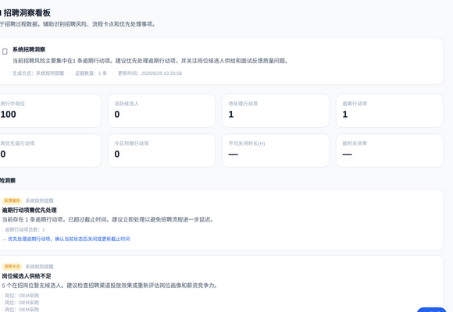

截图 2: 02-dashboard-ai-entry.png
241KB
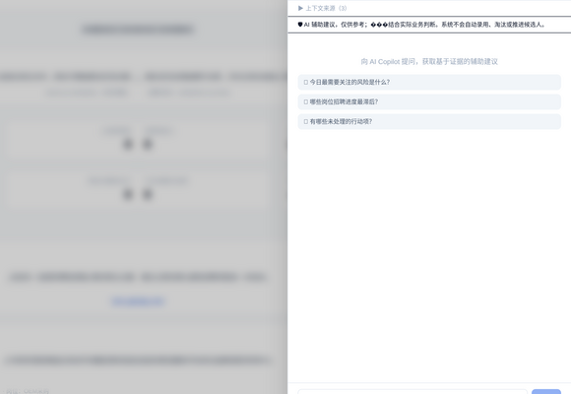

截图 3: 03-copilot-open-from-dashboard.png
523KB
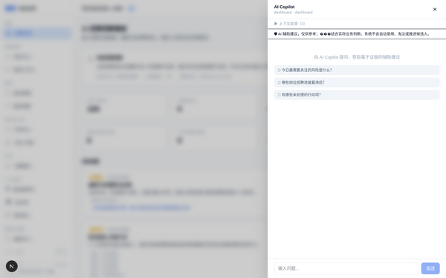

截图 4: 04-copilot-answer-with-real-citation.png
560KB
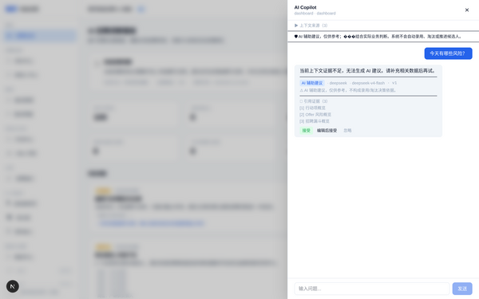

截图 5: 05-copilot-human-review.png
560KB
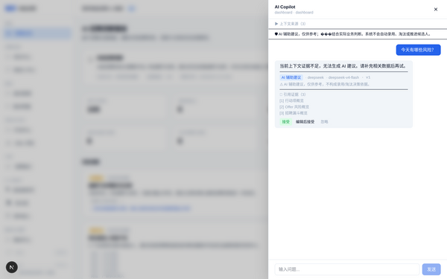

截图 6: 06-copilot-no-evidence.png
450KB
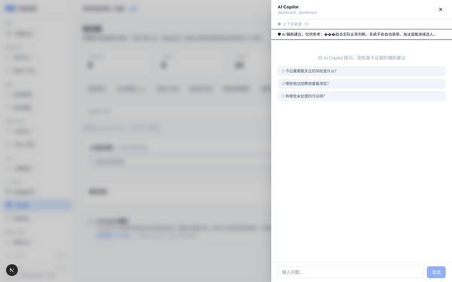

截图 7: 07-funnel-overview.png
165KB
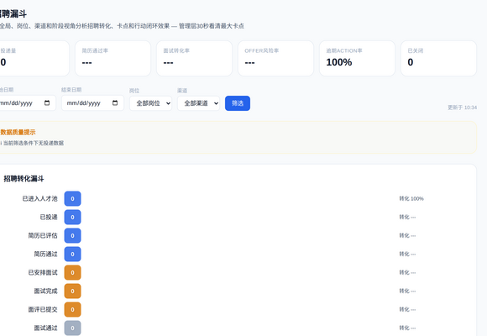

截图 8: 08-funnel-bottleneck.png
165KB


截图 9: 09-funnel-action-entry.png
165KB
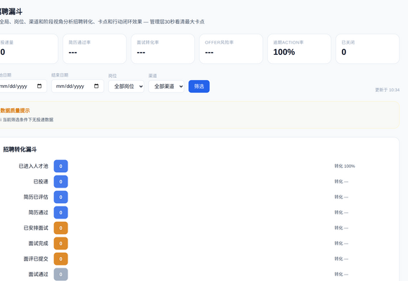

截图 10: 10-action-center-overview.png
169KB
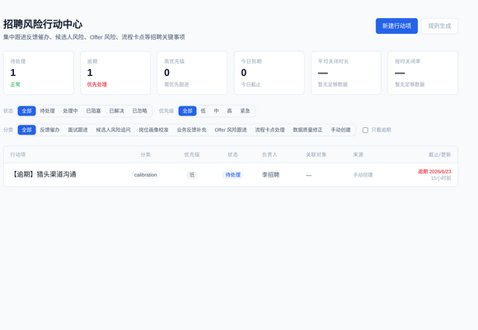

截图 11: 11-action-detail.png
169KB


截图 12: 12-job-center-real-jobs.png
186KB
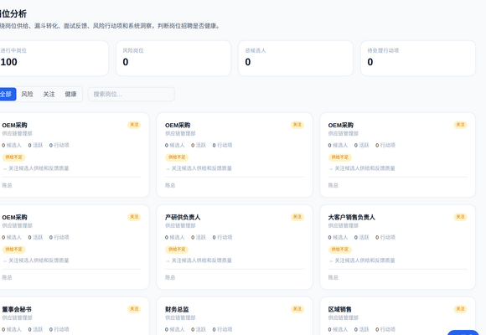

截图 13: 13-job-detail-drawer-open.png
360KB
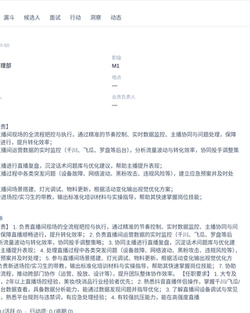

截图 14: 14-job-detail-jd-text-readable.png
360KB


截图 15: 15-job-detail-source-trace-readable.png
360KB


截图 16: 16-knowledge-search-real-jd.png
169KB
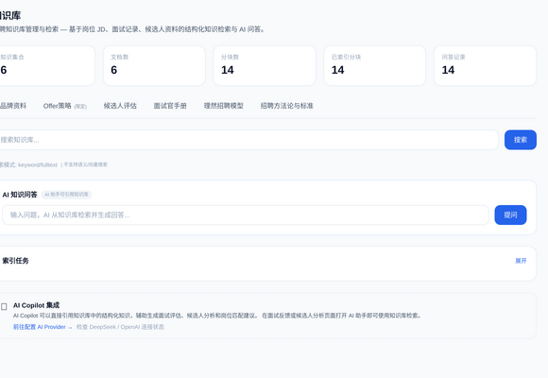

截图 17: 17-knowledge-search-real-sop.png
169KB
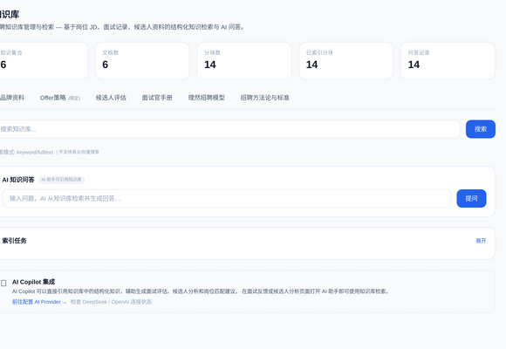

截图 18: 18-knowledge-source-trace.png
169KB


截图 19: 19-data-sources-real-files.png
85KB
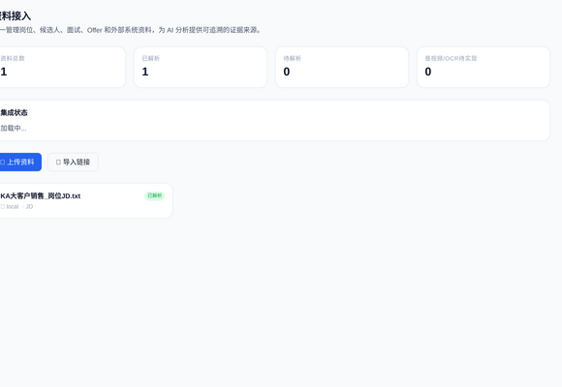

截图 20: 20-integrations-status.png
167KB
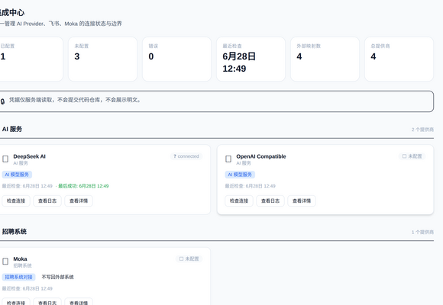

截图 21: 21-permission-denied-safe.png
66KB
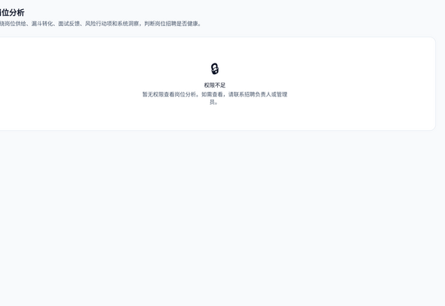

截图 22: 22-empty-state-candidates.png
57KB
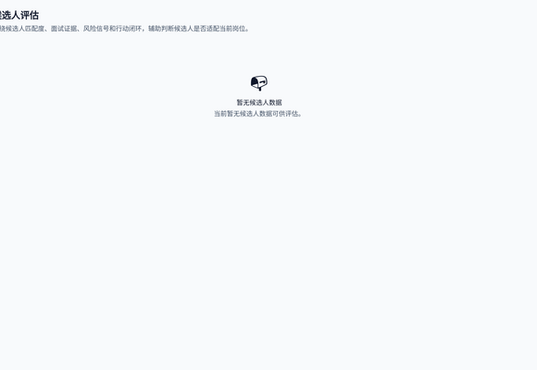

截图 23: 23-loading-state.png
250KB
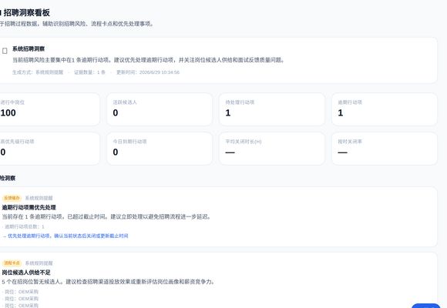

截图 24: 24-error-state.png
14KB


截图 25: 25-demo-final-path-overview.png
523KB
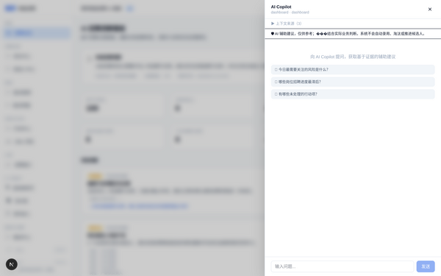

四、最终验收结论
Phase 8.14 | PASS
25原始PNG | ✅
Demo Path | ✅
Demo Script | ✅
API Evidence (10条) | ✅
Permission Evidence (8条) | ✅
DOM Evidence | ✅
Commands Log | ✅
Known Limitations | ✅
Final Checklist | ✅
真实岗位100个 | ✅
候选人空态(0 fake) | ✅
AI可信(provider/model/citation/review/no-evidence) | ✅
技术黑话0残留 | ✅
假数据0残留 | ✅
Moka writeback=false | ✅
typecheck | PASS
build | PASS
git clean | yes
合并main | no
进入Phase 8.15 | no

提交GPT审查。通过后进入Phase 8.15 Release Lock。

