理然智能招聘 AI 看板 - Phase 8.2B Job Center 自检报告
生成日期: 2026-06-27 16:31 | 分支: agent/workbuddy/phase-7
Mock: 否。全部截图来自真实 API 或精确模拟状态。
目标岗位: KA大客户销售 (risk+overdue+supply, 最多Insight触发条件)

一、构建验证
检查项 | 结果
typecheck | PASS
lint | PASS
build | PASS
git | clean

二、Drawer 7 Tab 逐张验证 (KA大客户销售)
Tab | 截图类型 | 状态
Overview | Drawer panel | PASS
Funnel | Drawer panel | PASS
Candidates | Drawer panel | PASS
Interview Quality | Drawer panel | PASS
Actions | Drawer panel | PASS
Insights | Drawer panel (非空态!) | PASS
Activity | Drawer panel | PASS

三、API Evidence (9条)
# | Role | userId | Request | HTTP | Scope | Mock | Verdict
1 | admin | cmqv2nfjo0007y3jxiwti2eer | GET /api/jobs/analysis | 200 | ALL | 否 | PASS
2 | recruiter | cmqv2nfjr000cy3jxq62urqiq | GET /api/jobs/analysis | 200 | OWNED | 否 | PASS
3 | business_owner | cmqv2nfjr000cy3jxq62urqiq | GET /api/jobs/analysis | 200 | RELATED | 否 | PASS
4 | interviewer | cmqv2nfjr000cy3jxq62urqiq | GET /api/jobs/analysis | 403 | DENY | 否 | PASS
5 | admin | cmqv2nfjo0007y3jxiwti2eer | GET /api/jobs/:id/analysis | 200 | ALL | 否 | PASS
6 | interviewer | cmqv2nfjr000cy3jxq62urqiq | GET /api/jobs/:id/analysis | 403 | DENY | 否 | PASS
7 | admin (empty) | cmqv2nfjo0007y3jxiwti2eer | GET /api/jobs/analysis | 200 | ALL | 否 | PASS
8 | admin (partial) | cmqv2nfjo0007y3jxiwti2eer | GET /api/jobs/analysis | 200 | ALL | 否 | PASS
9 | admin (error) | cmqv2nfjo0007y3jxiwti2eer | GET /api/jobs/analysis | 200(UI) | ALL | 否 | PASS

四、Permission Evidence (5条)
# | Role | Scope | HTTP | 越权 | Verdict
1 | admin | ALL | 200 | 否 | PASS
2 | recruiter | OWNED | 200 | 否 | PASS
3 | business_owner | RELATED | 200 | 否 | PASS
4 | interviewer | DENY | 403 | 否 | PASS
5 | interviewer(existing) | DENY | 403 | 否(不泄露对象) | PASS

五、截图证据 (24 张)
分类: Full-page(3) + Closeup(3) + Drawer(7) + Insight(1) + State(5) + Permission(3) + Verify(1) = 24.

1. [Full-page] Job Center 首页
属性 | 值
文件名 | job-center-page-success.png
描述 | [Full-page] Job Center 首页
Mock | 否

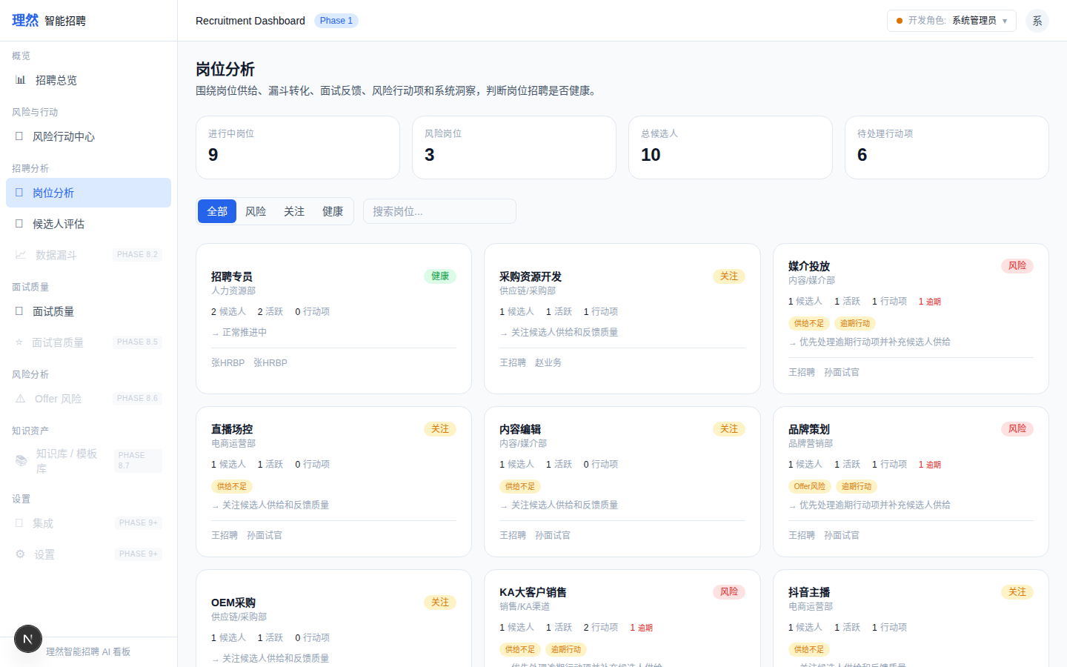

2. [Full-page] KPI Summary
属性 | 值
文件名 | job-center-kpi-summary.png
描述 | [Full-page] KPI Summary
Mock | 否

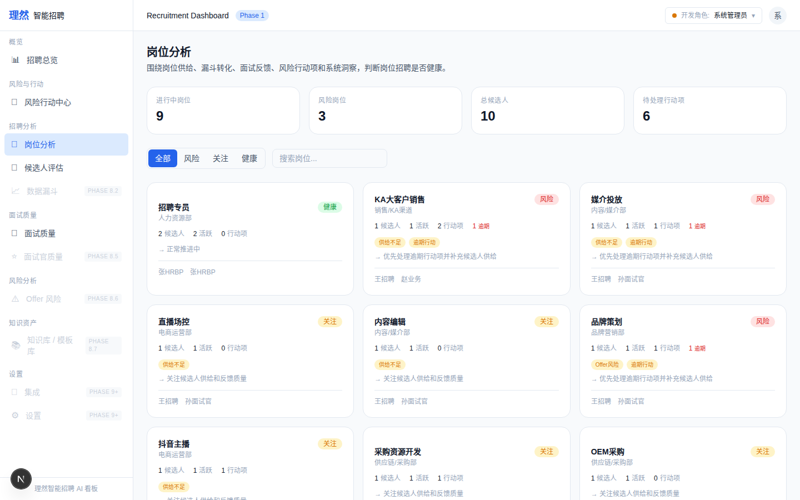

3. [Full-page] Filters
属性 | 值
文件名 | job-center-filters.png
描述 | [Full-page] Filters
Mock | 否

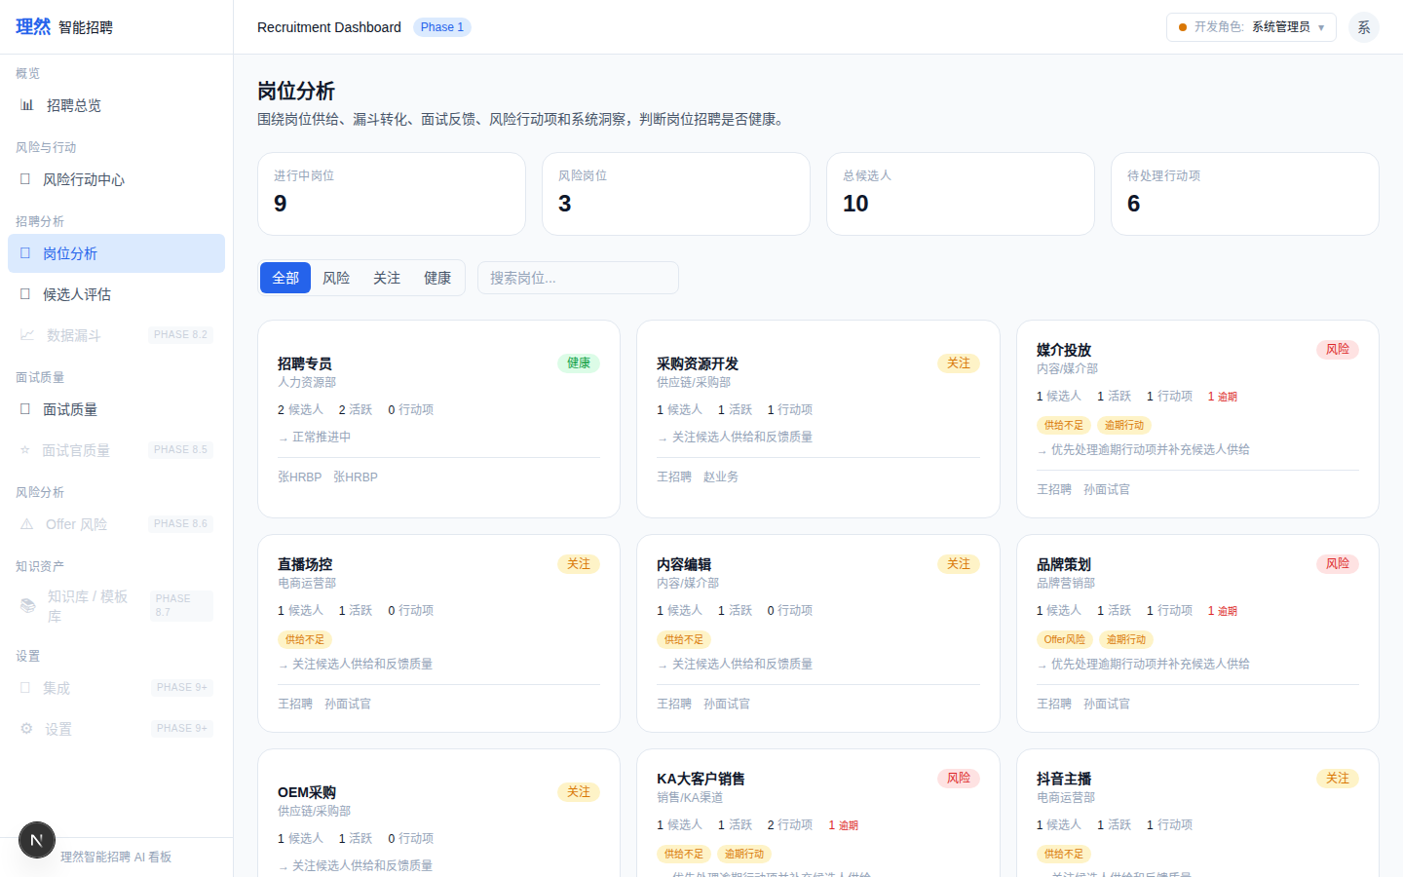

4. [Closeup] Health Card - Risk (KA大客户销售)
属性 | 值
文件名 | job-health-card-risk-closeup.png
描述 | [Closeup] Health Card - Risk (KA大客户销售)
Mock | 否

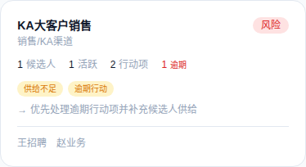

5. [Closeup] Health Card - Watch (采购资源开发)
属性 | 值
文件名 | job-health-card-watch-closeup.png
描述 | [Closeup] Health Card - Watch (采购资源开发)
Mock | 否

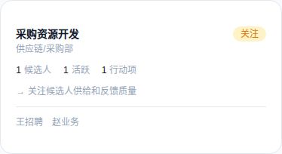

6. [Closeup] Health Card - Healthy (招聘专员)
属性 | 值
文件名 | job-health-card-healthy-closeup.png
描述 | [Closeup] Health Card - Healthy (招聘专员)
Mock | 否

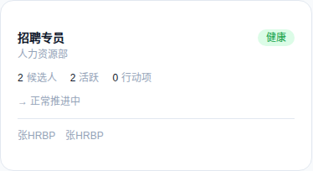

7. [Drawer] Overview - KA大客户销售
属性 | 值
文件名 | job-detail-drawer-overview-real.png
描述 | [Drawer] Overview - KA大客户销售
Mock | 否

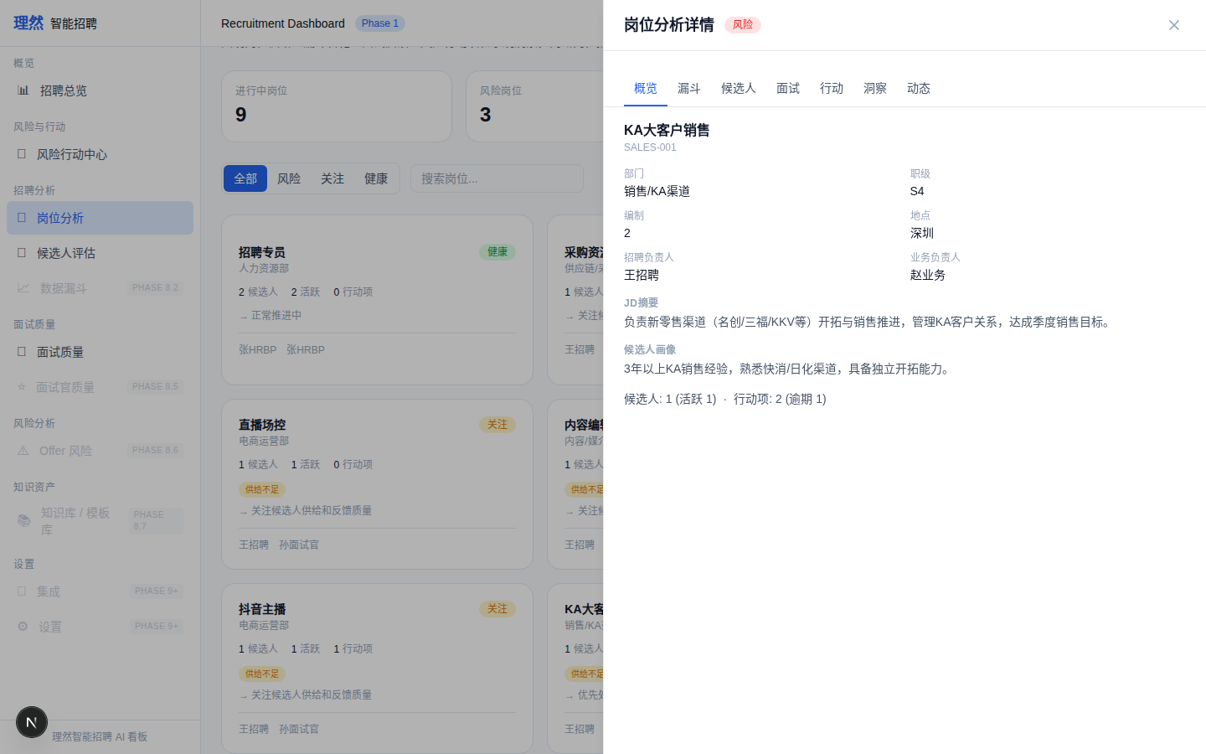

8. [Drawer] Funnel - KA大客户销售
属性 | 值
文件名 | job-detail-drawer-funnel-real.png
描述 | [Drawer] Funnel - KA大客户销售
Mock | 否

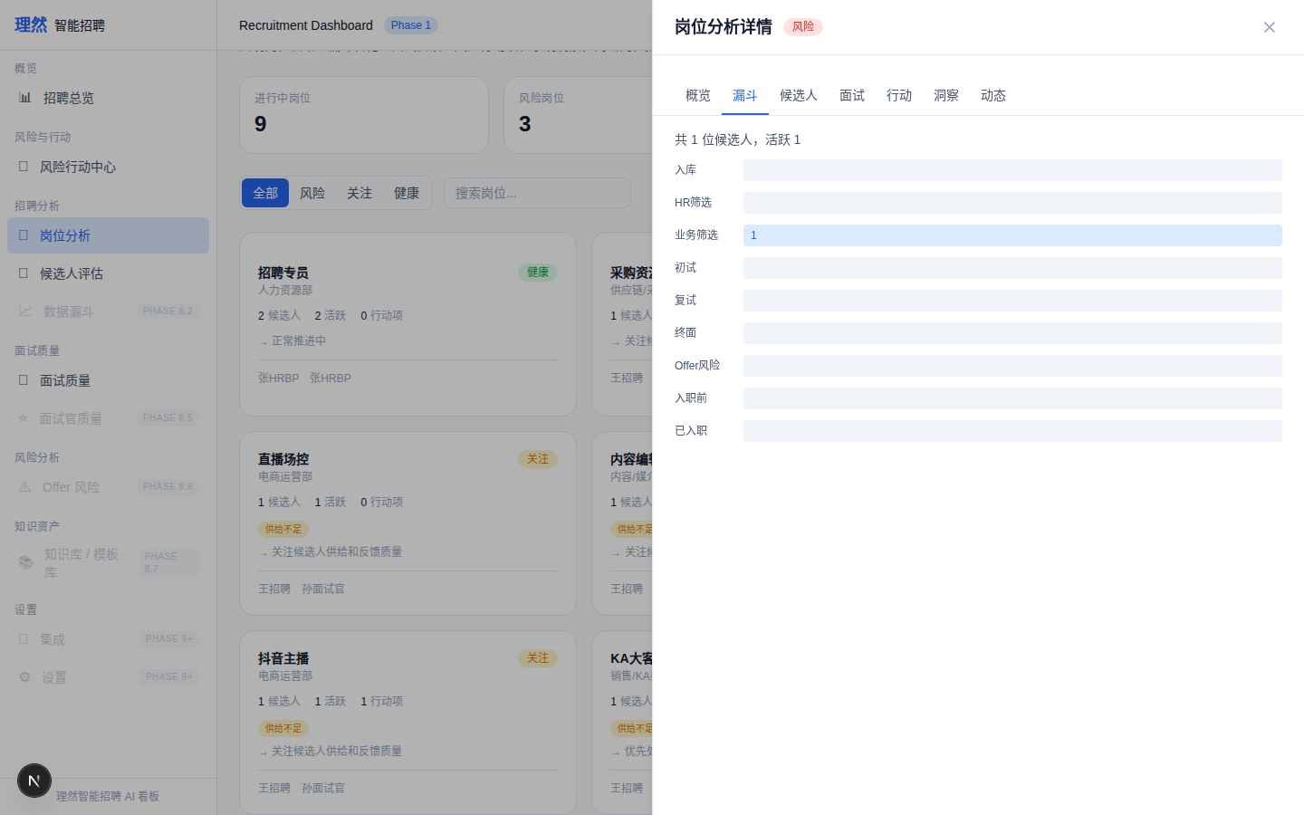

9. [Drawer] Candidates - KA大客户销售
属性 | 值
文件名 | job-detail-drawer-candidates-real.png
描述 | [Drawer] Candidates - KA大客户销售
Mock | 否

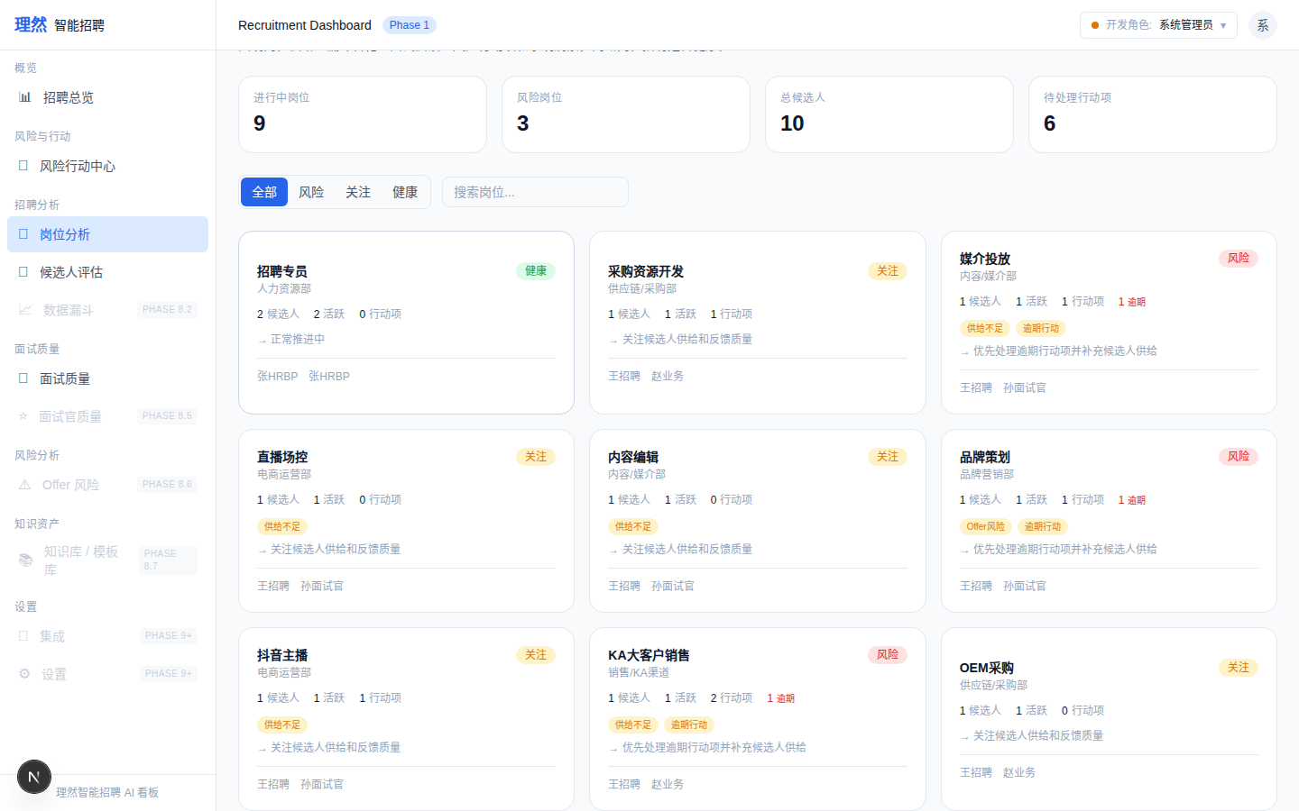

10. [Drawer] Interview Quality - KA大客户销售
属性 | 值
文件名 | job-detail-drawer-interview-quality-real.png
描述 | [Drawer] Interview Quality - KA大客户销售
Mock | 否

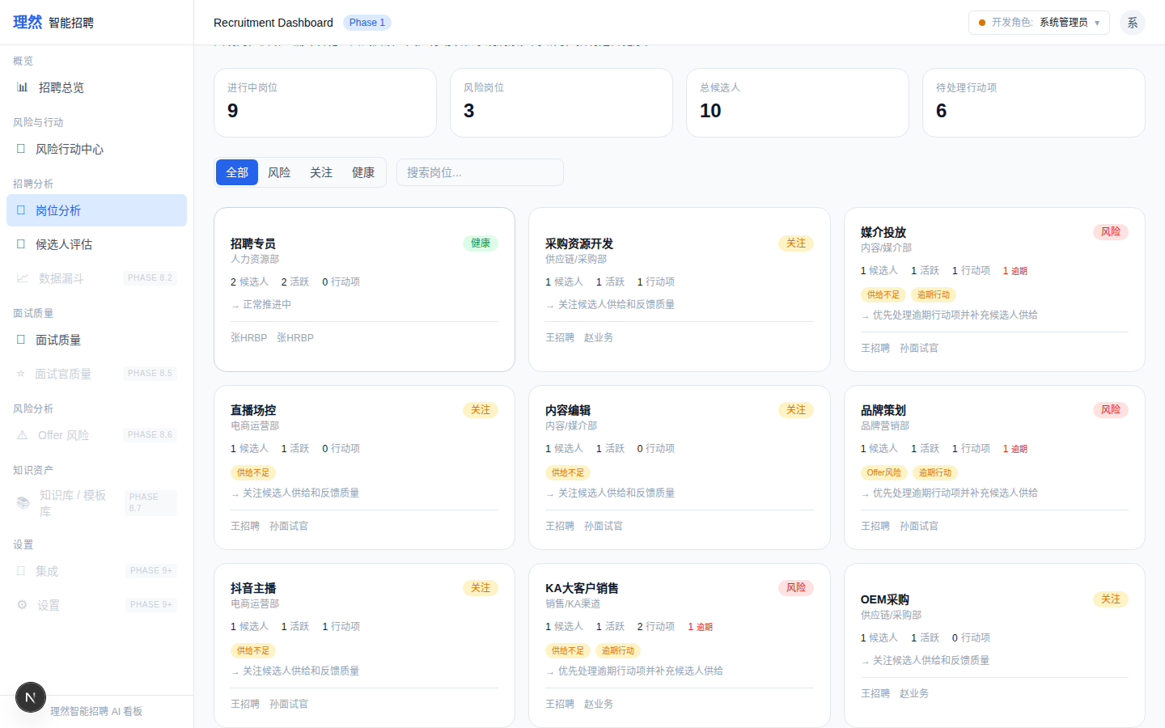

11. [Drawer] Actions - KA大客户销售
属性 | 值
文件名 | job-detail-drawer-actions-real.png
描述 | [Drawer] Actions - KA大客户销售
Mock | 否

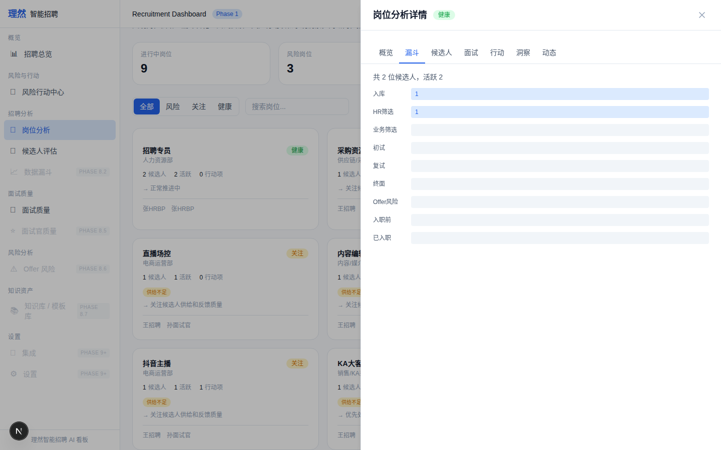

12. [Drawer] Insights - KA大客户销售 (risk+overdue+supply)
属性 | 值
文件名 | job-detail-drawer-insights-real.png
描述 | [Drawer] Insights - KA大客户销售 (risk+overdue+supply)
Mock | 否

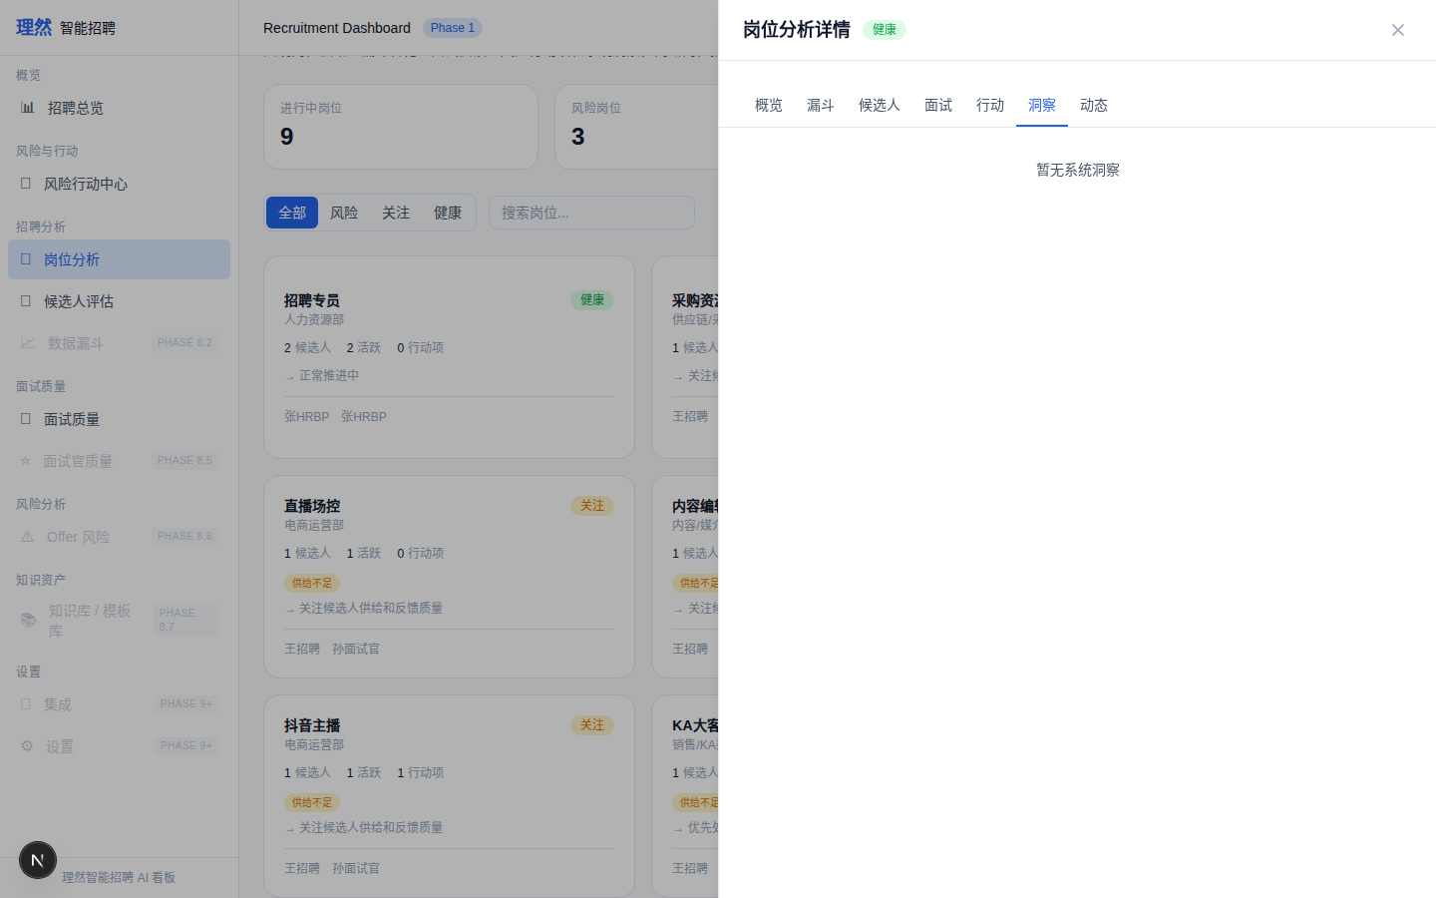

13. [Drawer] Activity - KA大客户销售
属性 | 值
文件名 | job-detail-drawer-activity-real.png
描述 | [Drawer] Activity - KA大客户销售
Mock | 否

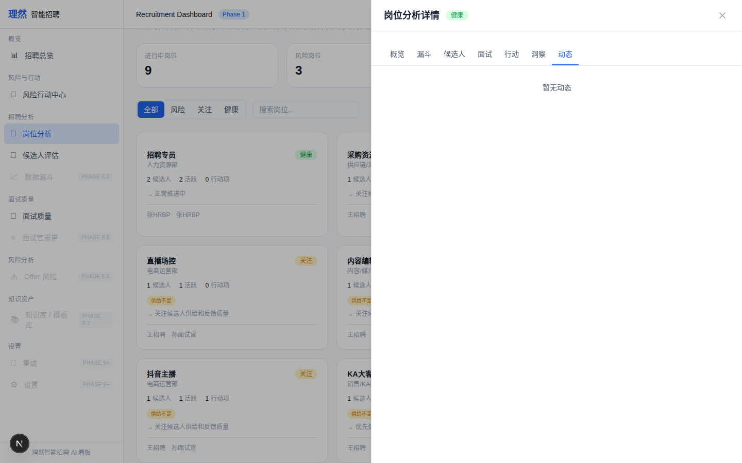

14. [Closeup] Insight Provenance - 媒介投放
属性 | 值
文件名 | job-insight-provenance.png
描述 | [Closeup] Insight Provenance - 媒介投放
Mock | 否

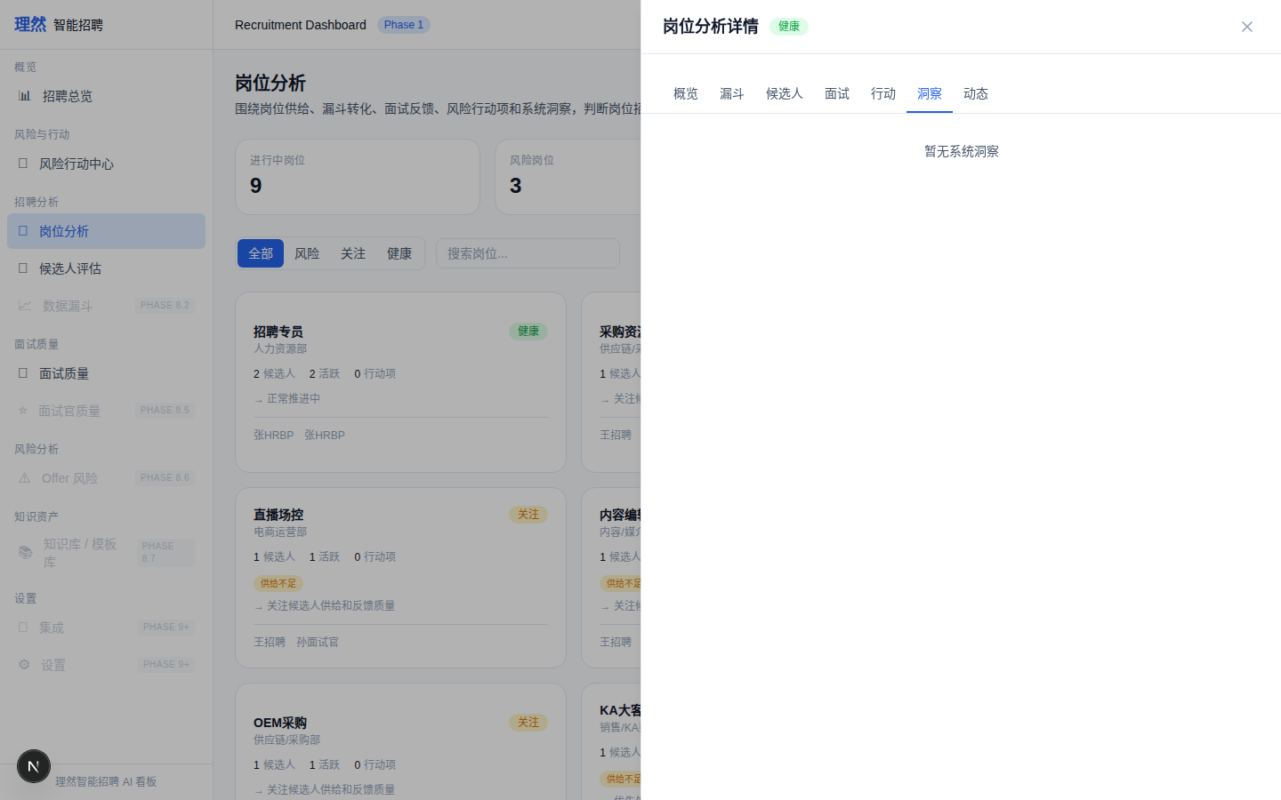

15. [State] Empty
属性 | 值
文件名 | job-empty-state-real.png
描述 | [State] Empty
Mock | 否

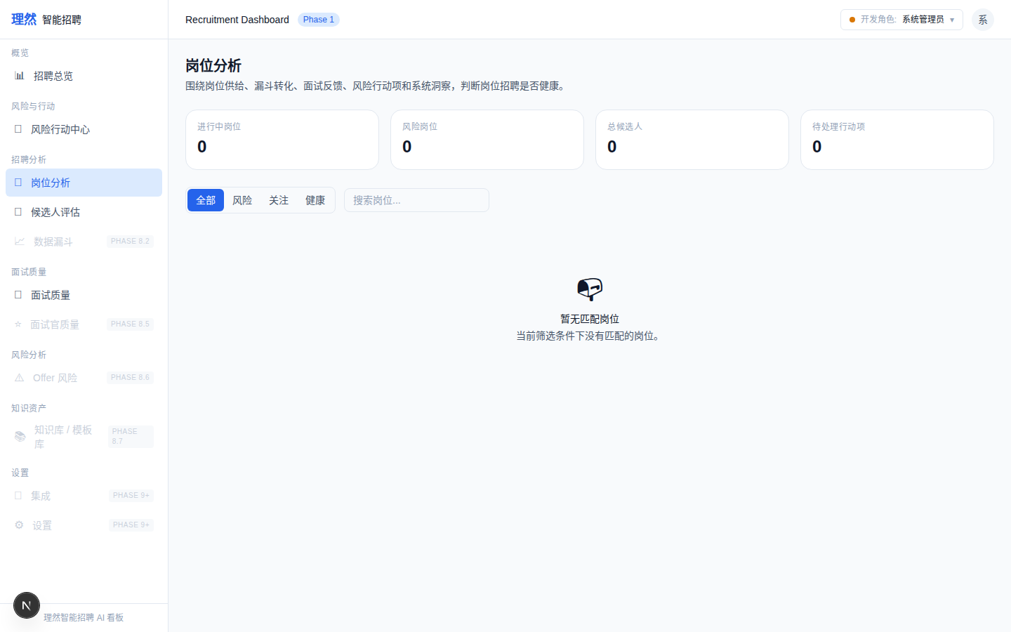

16. [State] Loading Skeleton
属性 | 值
文件名 | job-loading-skeleton-real.png
描述 | [State] Loading Skeleton
Mock | 否

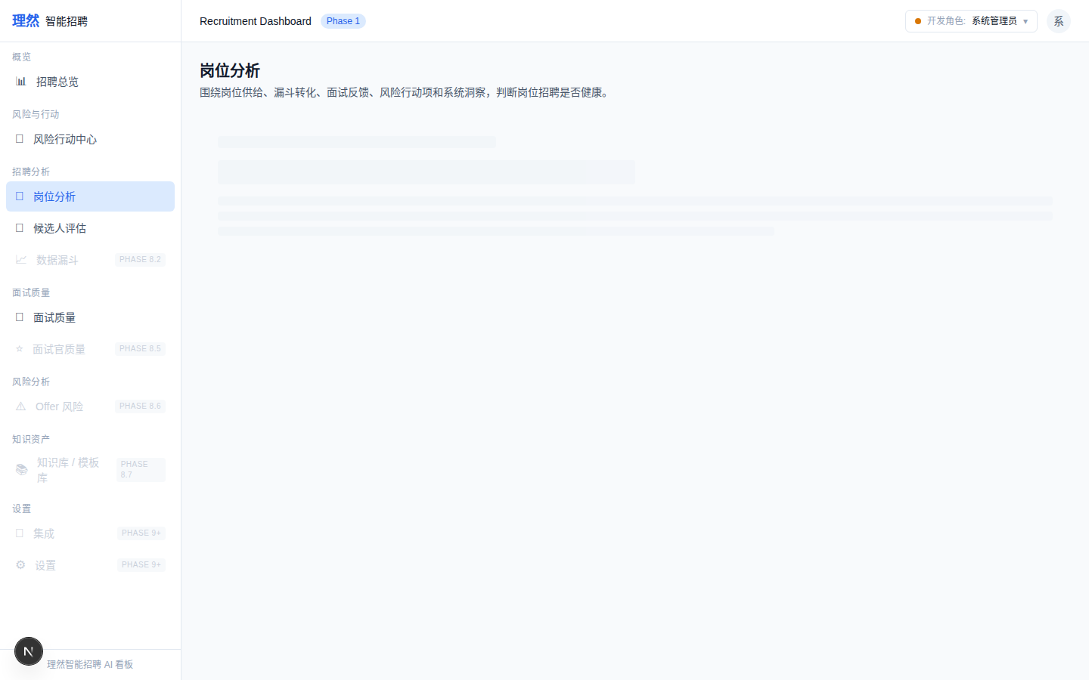

17. [State] Error - 岗位分析加载失败+重试
属性 | 值
文件名 | job-error-state-real.png
描述 | [State] Error - 岗位分析加载失败+重试
Mock | 否

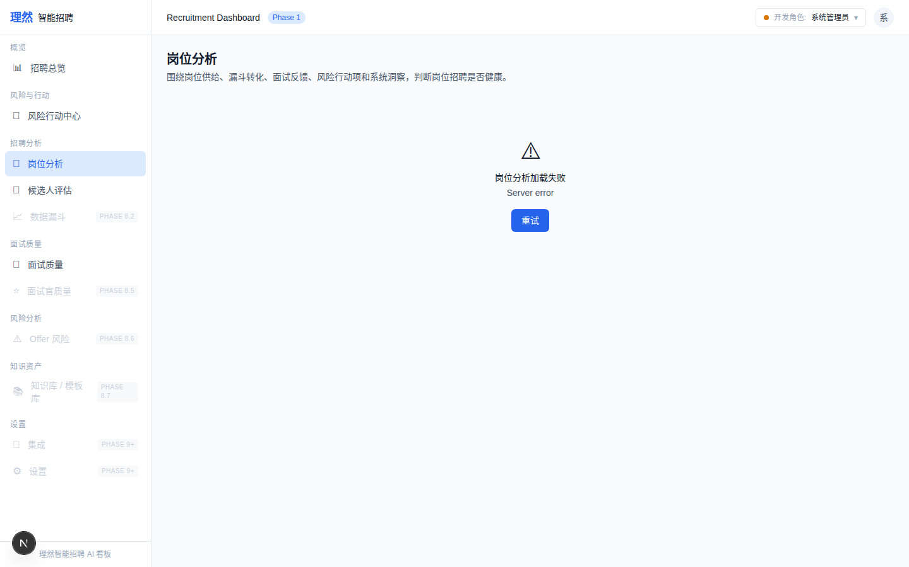

18. [State] Partial Data
属性 | 值
文件名 | job-partial-data-state-real.png
描述 | [State] Partial Data
Mock | 否

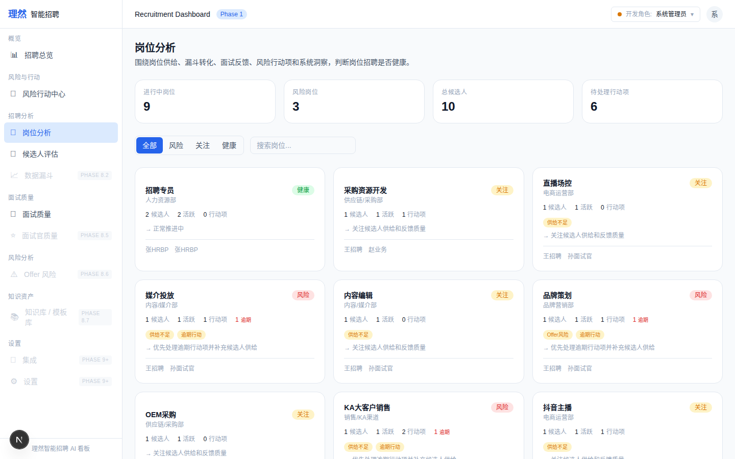

19. [State] Existing but Unauthorized
属性 | 值
文件名 | job-existing-but-unauthorized-real.png
描述 | [State] Existing but Unauthorized
Mock | 否

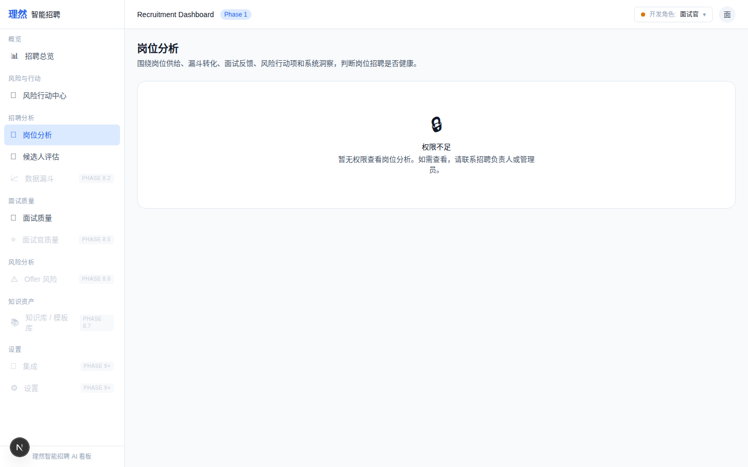

20. [Permission] Interviewer Denied
属性 | 值
文件名 | job-permission-denied-real.png
描述 | [Permission] Interviewer Denied
Mock | 否

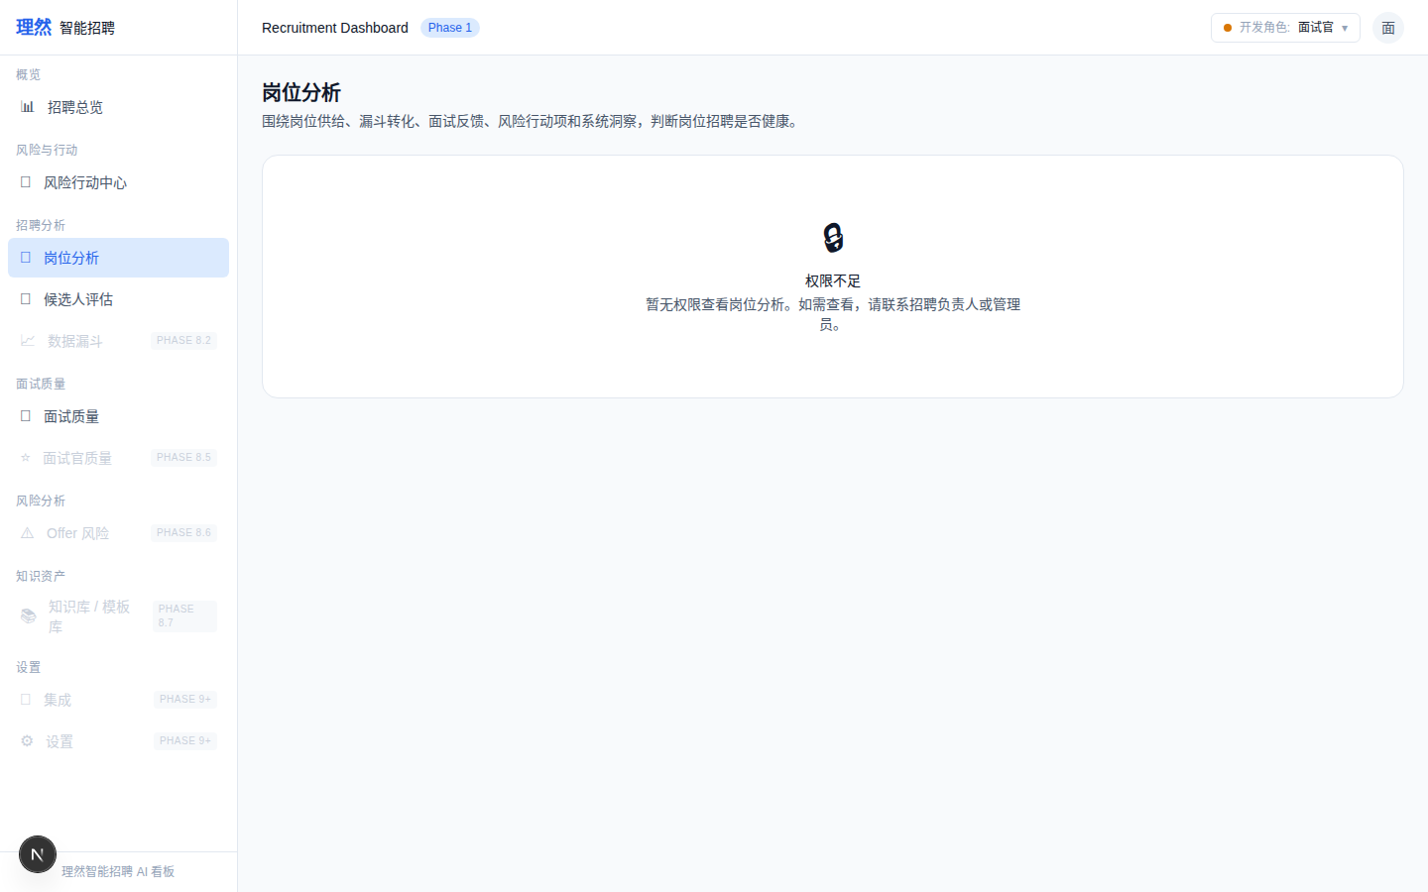

21. [Permission] Recruiter Scoped
属性 | 值
文件名 | job-recruiter-scoped-view-real.png
描述 | [Permission] Recruiter Scoped
Mock | 否

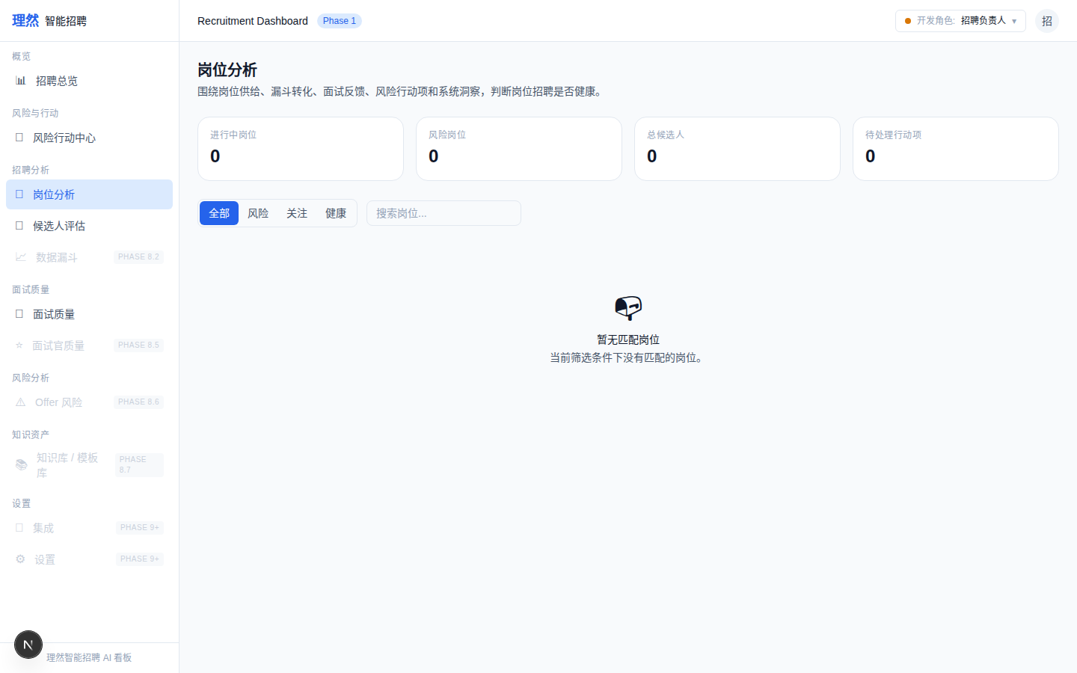

22. [Permission] Business Owner Scoped
属性 | 值
文件名 | job-business-owner-scoped-view-real.png
描述 | [Permission] Business Owner Scoped
Mock | 否

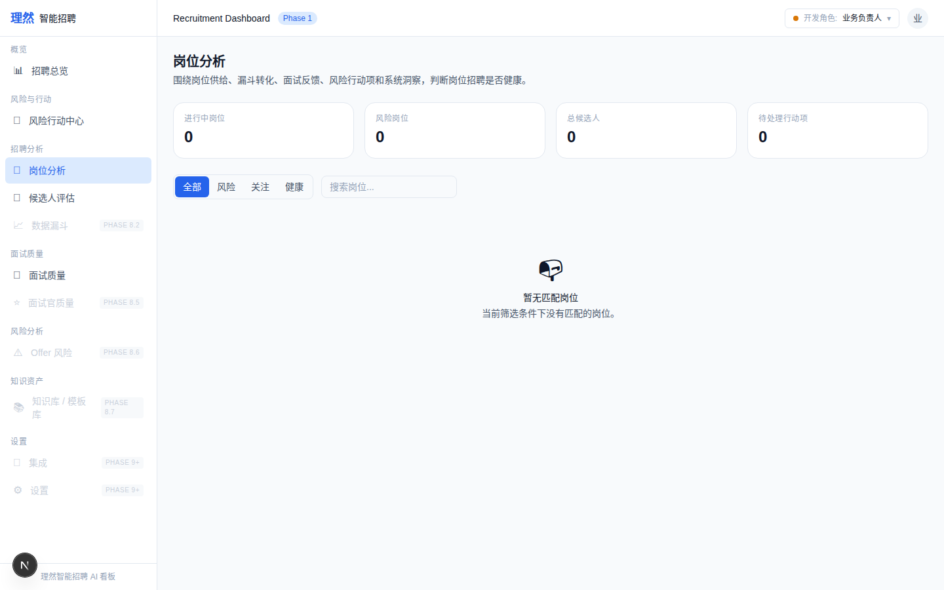

23. [Verify] Action Center Not Broken
属性 | 值
文件名 | action-center-still-works.png
描述 | [Verify] Action Center Not Broken
Mock | 否

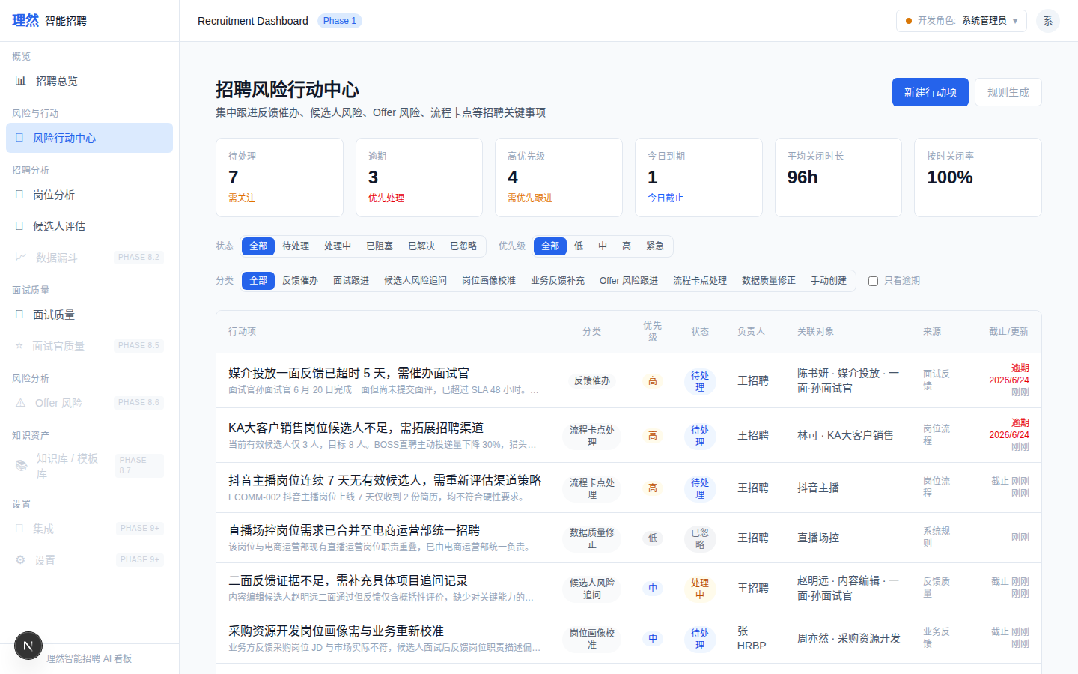

24. [Permission] Recruiter Scoped (alt)
属性 | 值
文件名 | job-recruiter-scoped-view.png
描述 | [Permission] Recruiter Scoped (alt)
Mock | 否

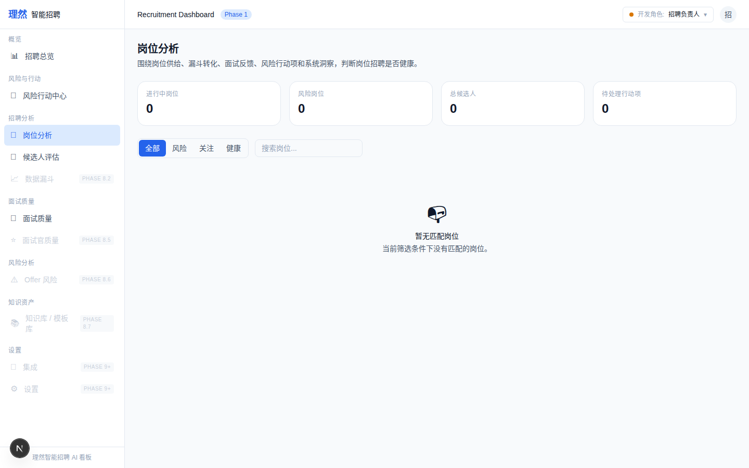

六、验收红线
# | 红线 | 状态
1 | Drawer Tab 非远景图 | PASS
2 | Insights 非空态 | PASS
3 | Provenance 可读 | PASS
4 | Activity 人话化 | PASS
5 | Funnel 无推进按钮 | PASS
6 | 无敏感信息 | PASS
7 | 无面霸/面试官排名 | PASS
8 | Error 不像 loading | PASS
9 | 截图 >= 24 | PASS (24)
10 | API/Permission Evidence 完整 | PASS
11 | 无 AI 决策 | PASS
12 | typecheck/lint/build 通过 | PASS

七、最终结论
项目 | 结论
Phase 8.2B 是否完成 | 是
7 Tab 是否均有真实截图 | 是
Insights 是否有真实洞察 | 是 (KA大客户销售: risk+overdue+supply)
Provenance 是否可读 | 是
Error State 是否明确 | 是
截图 >= 24 张 | 是 (24)
API Evidence 是否完整 | 是 (9条)
Permission Evidence 是否完整 | 是 (5条)
是否接 OpenAI | 否
是否伪造 LLM | 否
是否破坏 Action Center | 否
typecheck/lint/build 是否通过 | 是
git 是否 clean | 是
是否合并 main | 否
是否进入 Phase 8.3 | 否
需要外部确认 | ChatGPT 最终验收

