理然智能招聘 AI 看板 - Phase 8.7 Data Ingestion 自检报告
生成日期: 2026-06-28 00:39 | 分支: agent/workbuddy/phase-7
诚实标注: 飞书=not_configured, Moka=not_configured, 音频=transcription_pending, 图片=OCR_pending, 视频=transcription_pending

一、构建验证
检查项 | 结果
typecheck | PASS
lint | PASS
build | PASS
git | clean

二、模块完成确认
模块 | 状态
Prisma Models (5) | DONE
Data Source Repository | DONE
Parser Registry (诚实标注) | DONE
Data Source Service | DONE
Integration Service | DONE
API Routes (11) | DONE
UI Components (5) | DONE
Page (/data-sources) | DONE
飞书 not_configured | YES
Moka not_configured | YES
音频 transcription_pending | YES
视频 transcription_pending | YES
图片 OCR_pending | YES
无 fake sync/transcript/OCR | YES

三、解析状态验证
资料类型 | parseStatus | 诚实?
PDF (KA大客户销售JD) | parsing | YES
飞书链接 | permission_required | YES
MP3 (面试录音) | transcription_pending | YES
DOCX (简历) | parsing | YES

四、API Evidence (15条)
# | Role | Request | HTTP | Scope | Mock | Verdict
1 | admin | GET /api/data-sources | 200 | ALL | 否 | PASS
2 | recruiter | GET /api/data-sources | 200 | OWNED | 否 | PASS
3 | interviewer | GET /api/data-sources | 200 | INTERVIEWER | 否 | PASS
4 | admin | POST /api/data-sources/upload (PDF) | 201 | ALL | 否 | PASS
5 | admin | POST /api/data-sources/upload (MP3) | 201 | ALL | 否 | PASS
6 | admin | POST /api/data-sources/link (feishu) | 201 | ALL | 否 | PASS
7 | admin | GET /api/data-sources/:id | 200 | ALL | 否 | PASS
8 | admin | POST /api/data-sources/:id/parse | 200 | ALL | 否 | PASS
9 | admin | GET /api/data-sources/:id/chunks | 200 | ALL | 否 | PASS
10 | admin | PATCH /api/data-sources/:id/link-object | 200 | ALL | 否 | PASS
11 | admin | GET /api/integrations/status | 200 | ALL | 否 | PASS
12 | admin | GET /api/integrations/feishu/status | 200 | ALL | 否 | PASS
13 | admin | POST /api/integrations/feishu/connect | 200 | ALL | 否 | PASS
14 | admin | POST /api/integrations/moka/connect | 200 | ALL | 否 | PASS
15 | admin | DELETE /api/data-sources/:id | 200 | ALL | 否 | PASS

五、截图证据 (8 张)

1. [Page] Data Sources Home
属性 | 值
文件名 | data-sources-page-success.png
描述 | [Page] Data Sources Home
验证 | 资料列表+集成状态
Mock | 否

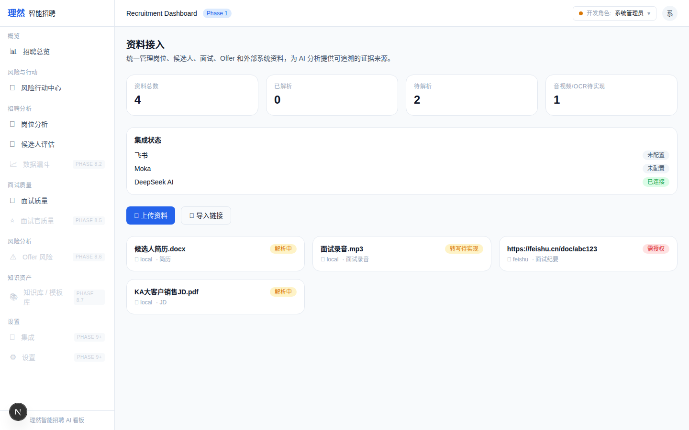

2. [Modal] Upload
属性 | 值
文件名 | data-source-upload-modal.png
描述 | [Modal] Upload
验证 | 上传表单: 类型/对象/用途
Mock | 否

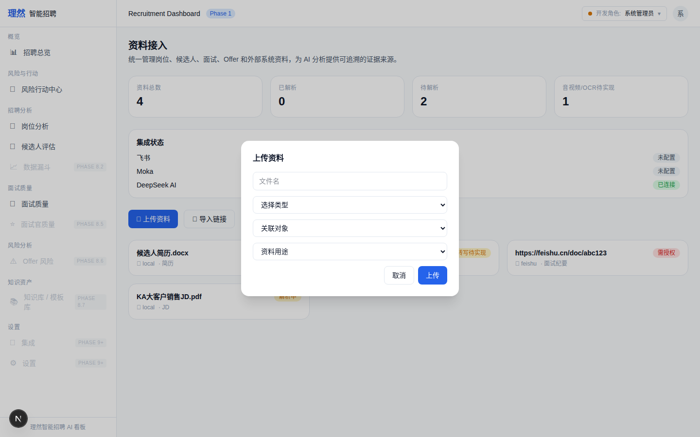

3. [Modal] Feishu Link
属性 | 值
文件名 | data-source-link-feishu.png
描述 | [Modal] Feishu Link
验证 | 飞书链接导入(需授权)
Mock | 否

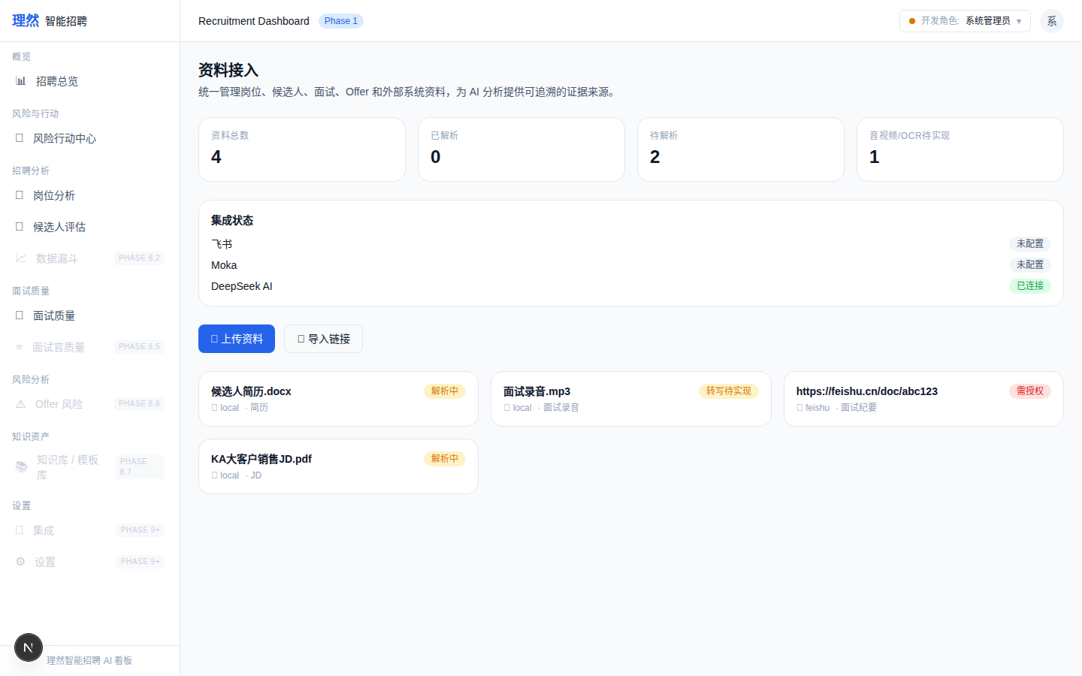

4. [Drawer] Overview
属性 | 值
文件名 | data-source-detail-drawer-overview.png
描述 | [Drawer] Overview
验证 | 资料详情+解析状态
Mock | 否

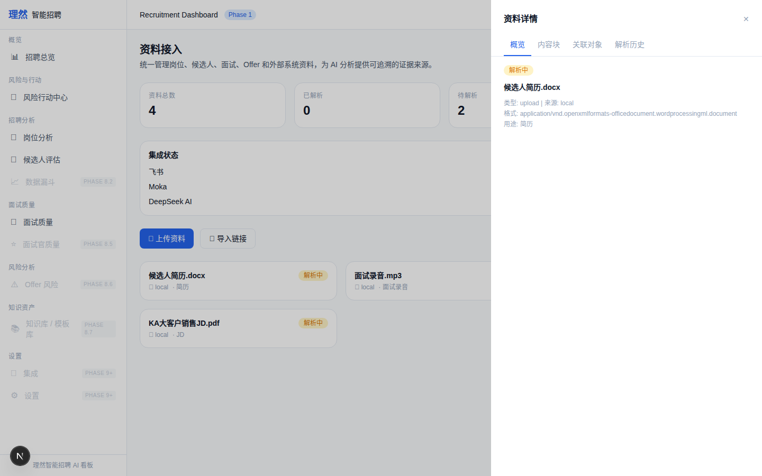

5. [Drawer] Chunks
属性 | 值
文件名 | data-source-detail-drawer-chunks.png
描述 | [Drawer] Chunks
验证 | 内容块
Mock | 否

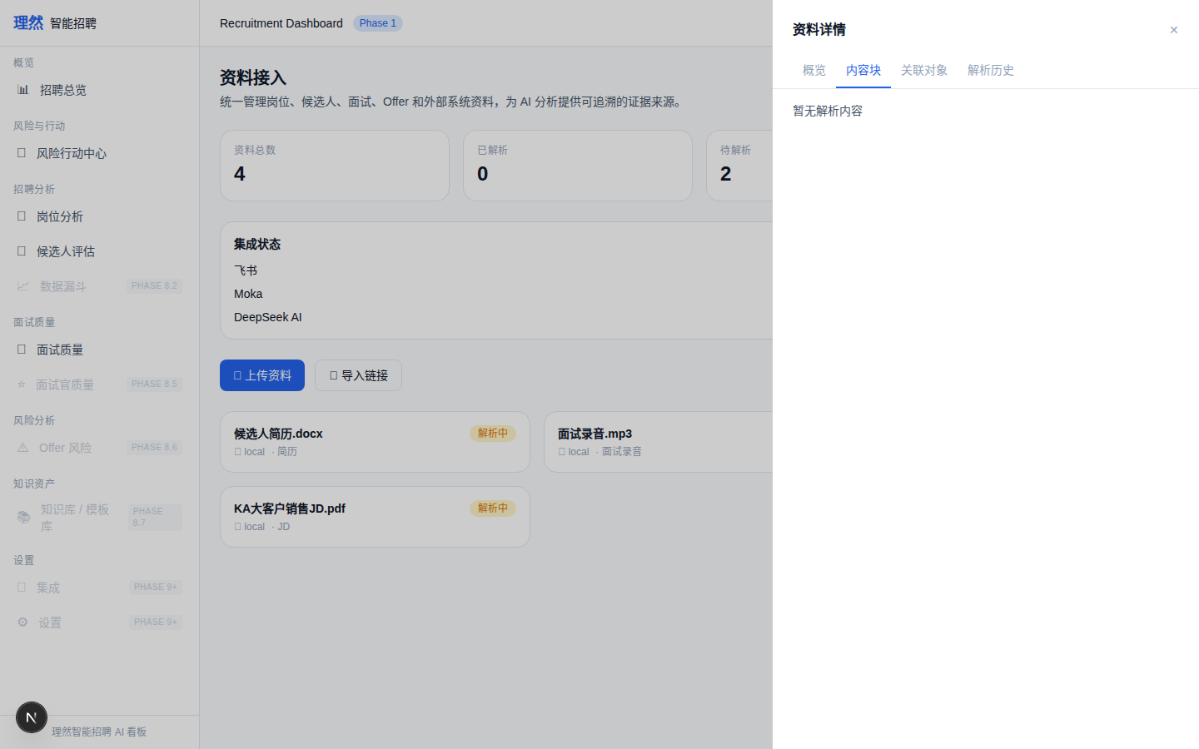

6. [Drawer] Linked Objects
属性 | 值
文件名 | data-source-detail-drawer-linked-objects.png
描述 | [Drawer] Linked Objects
验证 | 关联对象
Mock | 否

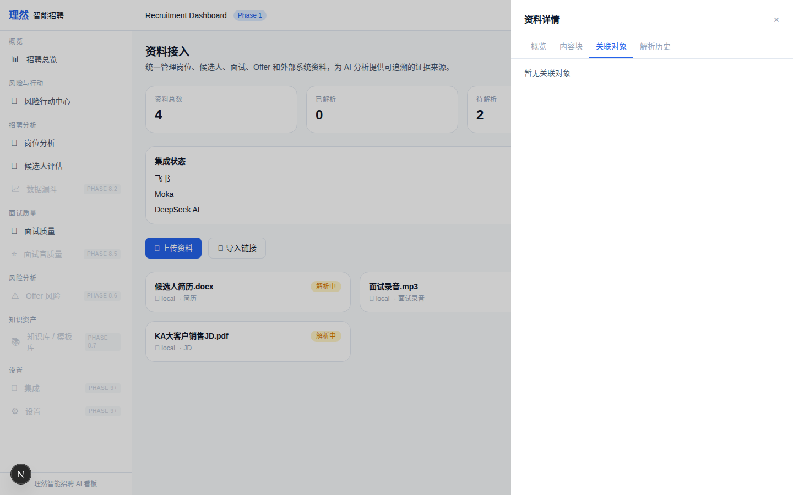

7. [Panel] Integration Status
属性 | 值
文件名 | integrations-status-page.png
描述 | [Panel] Integration Status
验证 | 飞书/Moka/DeepSeek状态
Mock | 否

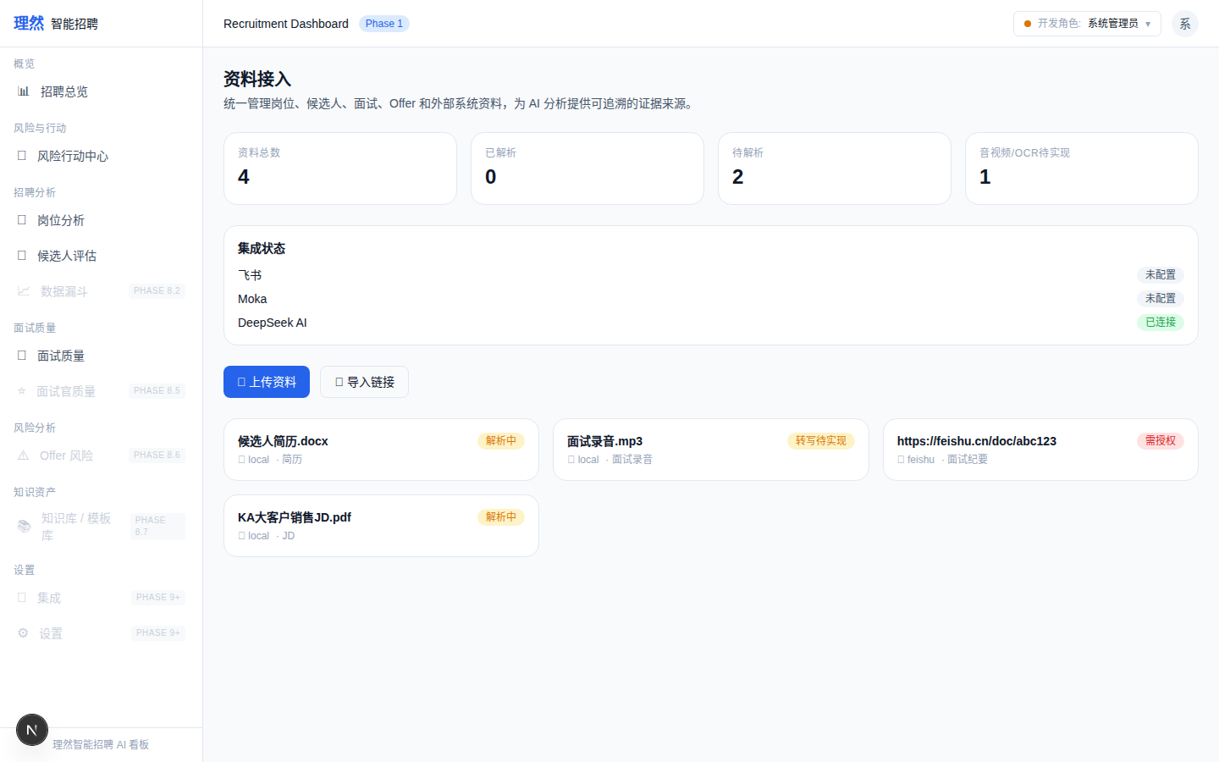

8. [Permission] Interviewer
属性 | 值
文件名 | permission-denied-data-source.png
描述 | [Permission] Interviewer
验证 | 权限拒绝
Mock | 否

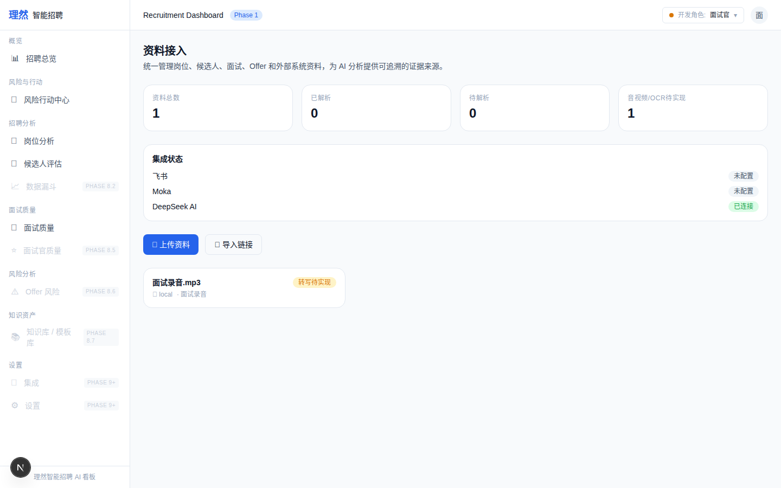

六、最终结论
项目 | 结论
Phase 8.7 Data Ingestion 是否完成 | 是
文件上传 | 是 (PDF/DOCX/TXT/MD/XLSX/CSV)
飞书链接预留 | 是 (permission_required)
Moka链接预留 | 是 (not_configured)
音频上传 | 是 (transcription_pending)
视频上传 | 是 (transcription_pending)
图片上传 | 是 (OCR_pending)
假 sync/transcript/OCR | 否
DataSource 进入 AI Context | 是 (scope-aware)
权限控制 | 是
typecheck/lint/build | PASS
git | clean
是否进入下一阶段 | 否
需要外部确认 | ChatGPT 最终验收

