Cognition_and_Neuroscience_Mod_2
Monday, May 25, 2026
10:29 AM

Lecture 1

Core Objectives
The concept of "representation" serves as the foundational bridge between biological neuroscience and artificial intelligence. At its core, the study of representation seeks to explain how raw sensory inputs—whether a stream of photons hitting a retina or a matrix of pixel values in a tensor—are transformed into internal states that support meaningful behavior. This lecture explores the provocative thesis that despite divergent evolutionary and environmental pressures (biological survival vs. optimized task performance), both brains and deep convolutional neural networks (DCNNs) arrive at surprisingly similar hierarchical solutions to the problem of perception.

Performance vs. Survival
Despite the image processing task is the same for both AI and the Brain there are several different between them
Dimension | Artificial Intelligence (AI) | Biological Brain
Optimization Goal | Maximizing performance on a discrete, predefined task. | Ensuring multi-modal survival (individual and social).
Objective Function | Mathematically fixed at the onset of the training phase. | Continuously respecified by internal physiological states.
Physical Constraints | Operates without a body, metabolic overhead, or survival risk. | Embedded in a physical substrate with constant metabolic and survival pressures.

What is a Representation
The Transformation Model Formally, a representation is a transformation of data that makes a downstream task computationally easier. We move from the content of the data to the utility of its format. Consider the following mappings:

Fundamental properties of a Representation
- Relative to a System: Usefulness is not an inherent property of data; it depends entirely on the downstream task. A representation optimized for "car recognition" is distinct from one optimized for "navigating a parking lot."
- Evaluable: Representations are not merely descriptions; they can be objectively measured as "better" or "worse" based on their utility for the system’s objective function.
- The "Lossy" Mandate: A representation is not a photograph or a "faithful recording of the input". To be useful, a system must discard irrelevant information (background noise, lighting fluctuations, pixel shifts). In this framework, being "lossy" is not a failure; it is a requirement for efficient recognition and generalization.

Marr’s Three Levels of Explanation
There are three levels of Brain-AI analysis
Level | Core Question | Vision Example
Computational | What is the problem the system is trying to solve, and why? | Recognizing an object reliably despite changes in position, size, and lighting.
Algorithmic | What representations and operations are used to solve it? | Utilizing filters and zero-crossings (mathematical sign changes in derivatives) for edge detection.
Implementational | What is the physical substrate carrying it out? | Biological neurons/V1 in the brain vs. Matrix multiplications on a GPU.

Local vs Distributed
These are two different ways a system (like the brain or a neural network) can format its internal information.
Local Representation (The "Grandmother Cell" Idea)
- Definition: In a local representation, one single unit encodes one specific concept.
- The Grandmother Cell Hypothesis: The instructor mentions a classic (but incorrect) theory that there might be a specific neuron in your brain that only fires when you see your grandmother.
- Pros: It is highly interpretable because you can easily point to exactly what a unit represents.
- Cons:
  - Fragile: If you lose that one specific neuron, you lose the entire concept (e.g., you would no longer recognize your grandmother).
  - Inefficient: You would need a unique neuron for every single object or person you encounter in your life.
Distributed Representation (The Modern View)
- Definition: Meaning emerges from patterns of activity across many units. No single unit carries the full meaning on its own.
- Pros:
  - Robust: This is the system's "insurance policy." Because the information is spread out, losing a single neuron won't cause you to forget a category; the recognition might just become slightly "weaker" or noisier, which is what often happens with age.
  - High Capacity & Efficient: Many different concepts can be represented by different patterns using the same set of neurons.
Brain vs. AI
- The Brain: Uses sparse distributed representations. This means that out of a large population of neurons, only a small, specific subset is active for any given object.
- Deep Networks: Generally use dense distributed representations, where most units in a layer are active to some degree to represent a concept.

The Ventral Stream: Manifold "Untangling"
Biological vision escapes the "pixel space" trap through a topological transformation within the ventral stream.

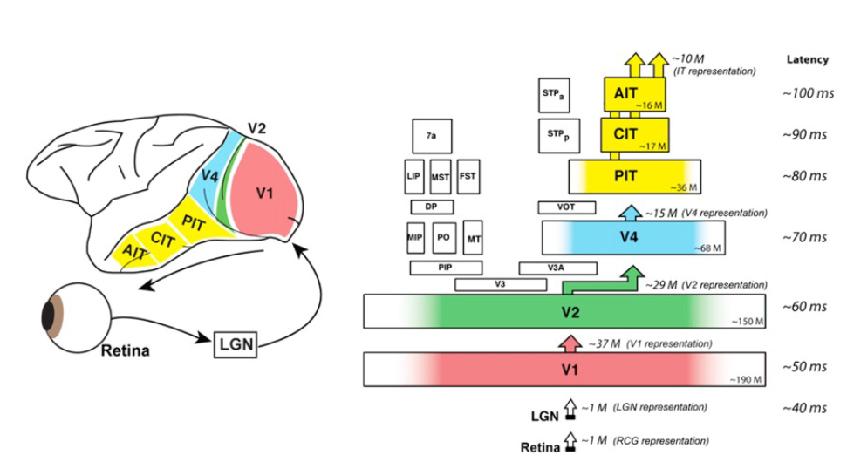
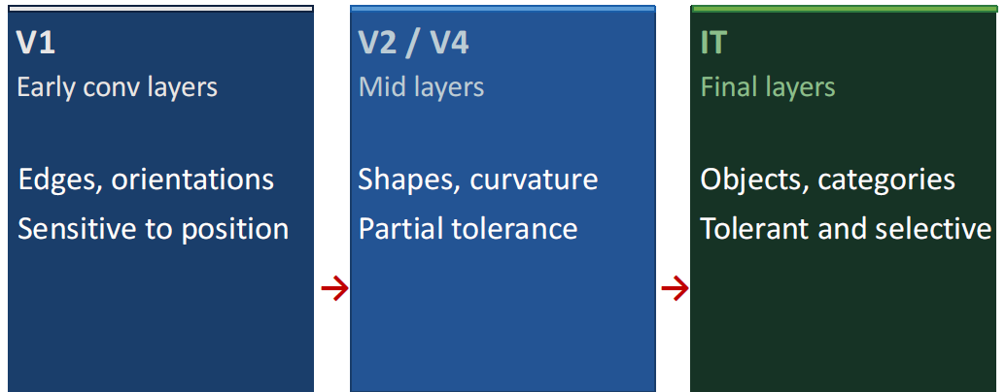

Temporal and Hierarchical Map of the Ventral Stream The flow of information is characterized by specific temporal latencies:
- Retina/LGN (~40ms): Initial sensory transduction.
- V1 (~50ms): Early processing; sensitivity to edges, orientations, and precise spatial positions.
- V2/V4 (~60–70ms): Mid-level processing; integration of edges into shapes and curvature with partial tolerance.
- IT Cortex (~100ms): Final stage; selective for object categories with high tolerance for transformations.

The Untangling Problem
In your eye (the retina), information is just a grid of light and dark pixels. Because of this, even if you see the same person from a slightly different angle, the pixel pattern changes completely.
- In this "Pixel Space," the identities of Joe and Sam are "tangled" or crumpled together.
- If you tried to separate them with a single straight knife-cut (a linear readout), you couldn't do it because the points are all mixed up in the crumpled ball.

For example this two set of dots is not separable with a single line (linearly separable). But it is possible to apply a transformation that add a further dimension in which these dots are easily separable

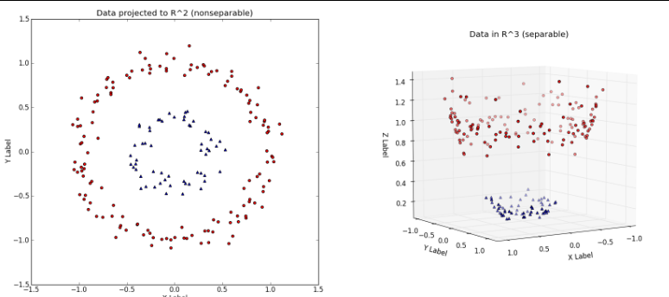

As visual information moves through the brain (from area V1 to V2, V4, and finally the IT cortex), the brain performs a series of transformations that helps to divide the two concepts.

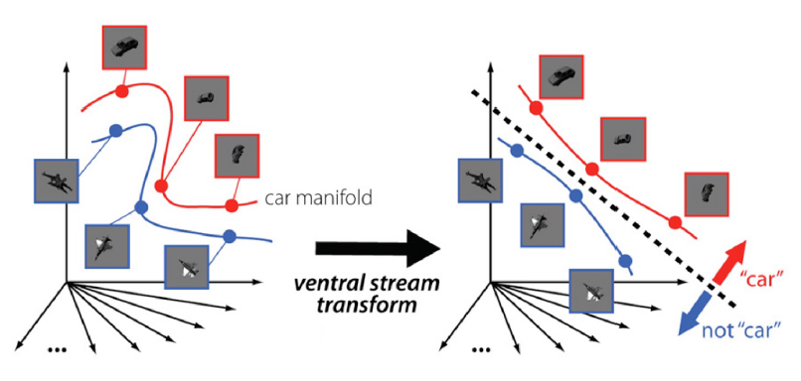

Linear Separability
A representation is considered "good" when it is linearly separable. This means the data is organized so simply that a single "downstream" neuron can act like a straight line, easily separating one category from another.

Similarity Analysis

The RDM
In modern neuroscience, we don't look for a single "Grandmother cell" that recognizes your grandma. Instead, we look at the entire population of neurons.
- If you treat the activity of many neurons as a "map," the distances between the points on that map tell you what the brain thinks.
- If the "map" for a car is very different from the "map" for a face, the brain can tell them apart. This map of distances is called the Representational Dissimilarity Matrix (RDM).

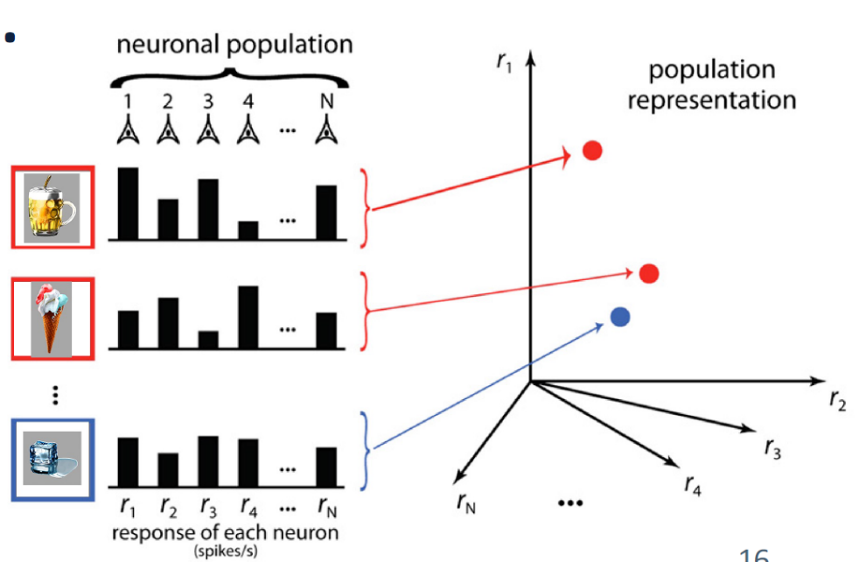

RSA: Comparing Maps
Representational Similarity Analysis (RSA) is just a way to compare these "maps" across different systems.
- Scientists have found that if you show the same pictures to a monkey and to an AI (a DCNN), the "maps" created in the monkey’s brain and the AI’s layers are strikingly similar.
- This proves that both the brain and the AI are "untangling" the information in roughly the same way to solve the same problem.

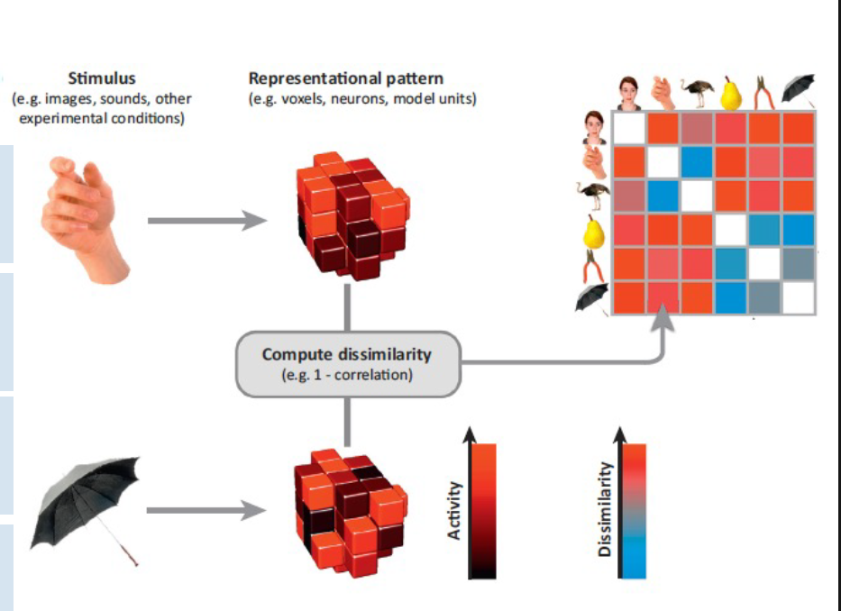

Glossary of Technical Terminology
- Objective Function: The mathematical goal a system is optimized to satisfy during learning or evolution.
- DCNN (Deep Convolutional Neural Network): Hierarchical architectures that serve as the current best models for the ventral visual stream.
- RSA/RDM: Representational Similarity Analysis and the resulting N \times N matrix used to compare the "shape of meaning" across systems.
- Invariance: Stability in representation across transformations that do not alter the target identity.
- Linear Readout: A downstream mechanism (neuron or classifier) that performs a weighted sum of inputs to find a separating hyperplane.
- IT Cortex (Inferotemporal): The apex of the ventral stream, responsible for high-level, invariant object selectivity.
- Zero-crossings: Algorithmic edge-detection operations typical of Marr’s Level 2 in early vision.
- Manifold: A high-dimensional surface representing all possible variations of a stimulus; the ventral stream's goal is to ensure manifolds for different categories do not overlap (untangling).
- Sparse vs. Dense Coding: The brain utilizes sparse distributed coding (few active units, high efficiency), whereas AI typically utilizes dense distributed coding (most units active).

Lecture 2

The Invariance Problem
The Invariance Problem is fundamentally a Generalization Problem. For the brain to function, it must recognize that a coffee cup remains a "cup" whether it is viewed in a dimly lit room, seen from a profile view, or partially hidden behind a saucer.
The Theoretical Debate: Marr vs. Tarr
Historically, psychologists have tackled this via two major hypotheses:
- View-Invariant Recognition (Marr, Biederman): Proposes that we store "structural descriptions"—building blocks like "geons" (Lego-like parts). Recognition is viewpoint-independent because it relies on identifying these canonical parts and their spatial relationships.
- View-Dependent Recognition (Tarr, Bülthoff): Suggests we store an "album of photos" or templates of familiar views. Generalization occurs by interpolating or rotating a new input to fit these stored views.
- Synthesis: Modern neural evidence suggests a convergence: the brain initially utilizes view-dependent representations that are transformed into view-independent "canonical" representations at the highest stages of the hierarchy.

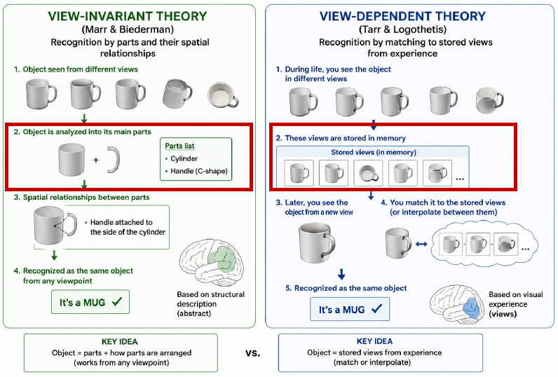

The Computational Conflict and the "Multi-dimensional Curse"
The instructor highlights a fundamental tension between Invariance (lumping together different instances by discarding irrelevant data like pose) and Separability (maintaining boundaries between different categories, such as distinguishing Joe’s face from Sam’s). Relying on a simple "lookup table" for every possible version of an object is mathematically impossible due to the Combinatorial Explosion or Multi-dimensional Curse—the sheer volume of possible retinal patterns for a single object is infinite.

Dimensions of Variability
The following table outlines how physical transformations impact the raw data received by the retina:
Dimension of Variability | Impact on Pixel Space | Retinal Result
Position | Object appears anywhere in the field. | Shifts the entire pixel vector.
Size | Objects may be near or far. | Changes the scale/number of active sensors.
Lighting | Brightness and shadows alter values. | Radically changes pixel intensity without changing shape.
Viewpoint | Rotations (profile vs. frontal). | Creates inputs with almost zero pixel-level similarity.
Occlusion | Partial hiding by other objects. | Missing data; requires "filling in" by the brain.
Clutter | Surrounding objects create "noise." | Competition for recognition within the same vector.
The "So What?" Layer
At the pixel level, representation is "almost maximally unhelpful." Two images of the same cup from different angles are farther apart in pixel space than images of two different objects in similar lighting. To succeed, the brain must escape pixel space and transform data into a global, tolerant representation. Having understood this strategic requirement, we now examine the physical cortical hierarchy that organizes this "escape."

The Structural Hierarchy of the Ventral Stream (AGAIN)
The brain’s solution to the invariance problem is the Ventral Stream, a hierarchical pathway that transforms raw data into abstract meaning through successive cortical stages.
Anatomical Progression
- V1 (Primary Visual Cortex): The entry point of the cortex. It utilizes Simple Cells acting as a Gabor filter bank. These neurons are extremely "picky," requiring the stimulus to be in the very center of the receptive field and at a specific orientation. They possess zero tolerance for spatial shifts.
- V2 / V4 (Intermediate Layers): These layers form "Proto-objects" by grouping features, filling in surfaces, and beginning the process of separating the object from the background. This stage marks the emergence of Partial Tolerance.
- IT (Inferior Temporal Cortex): The end-stage where objects and categories are represented. IT neurons have large receptive fields and exhibit Global Tolerance, maintaining selectivity for identity regardless of the object's physical transformation.

To validate these models, we must utilize analytical tools that measure the information transformed at each stage.

How do we analyze the activity of the Ventral Stream
These slides (13-17) detail the methodologies used in neuroscience to study visual representations, moving from the level of a single cell to larger brain regions, and the critical logic behind proving how the brain actually works.

Single-Unit Recording — Listening to One Neuron
This slide introduces the single-unit recording method, which is the most "local" way to study the brain.
- What it does: It involves placing a microelectrode (a tiny needle) near an individual cell to record its action potentials or "firing rate". Researchers can amplify this signal and even "listen" to the cell firing through loudspeakers.
- What it reveals: It is used to define a neuron’s tuning—what specific stimuli (like a vertical bar) make it fire and what it ignores. It also reveals selectivity (how picky the neuron is) and tolerance (how much a stimulus can change before the neuron stops responding).
- The Limitation: The sources describe this as the "tree vs. forest" problem. While you see the fine detail of one neuron, you miss the population activity. Because visual meaning is distributed across many neurons, it is largely invisible to single-unit analysis.

fMRI: From Neurons to Voxels
As we move to human studies, the focus shifts from individual neurons to voxels.
- What is a Voxel?: A voxel (volumetric pixel) is a small 3D unit, often 1mm x 1mm x 1mm of neurons.
- Indirect Measure: Unlike electrodes, fMRI does not measure electrical spikes directly. Instead, it uses the BOLD signal (Blood Oxygenation Level Dependent), which measures how much oxygen/blood the brain is consuming in a specific area.
- Aggregate Activity: Because one single voxel contains hundreds of thousands of neurons, fMRI provides an average of activity rather than the high-resolution "tuning" of a single cell.

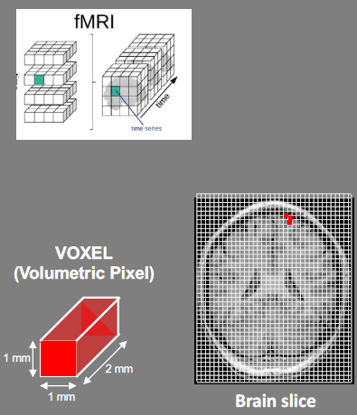

There are two different ways to analyze fMRI data: Univariate and Multivariate.

Univariate Analysis
- Methodology: This approach treats each voxel as an independent data point. Researchers look at one voxel (or a group of them) at a time to see if the intensity of its activation changes based on the stimulus.
- Goal: It is designed to find specialized brain "modules." For example, it identifies regions that show significantly higher blood-oxygen consumption when a subject looks at faces compared to when they look at tools.
- Limitation: While excellent for mapping where a function is located in the brain, it is "blind" to the internal structure of the information. Knowing that an area "lights up" for faces doesn't explain how the brain distinguishes between two different faces.

Multivariate Pattern Analysis / MVPA
- Methodology: MVPA shifts the focus from the amount of activity to the spatial pattern of activity across many voxels. It treats the activity levels of a group of voxels as a population vector.
- The Role of Machine Learning: Researchers use machine learning classifiers (like Support Vector Machines) to "read" these patterns. The computer is trained to recognize that "Pattern A" across the voxels means the subject is seeing a car, while "Pattern B" means they are seeing a plane.
- "The Pattern is the Representation": This is a key conceptual shift. In MVPA, we assume that the specific way neurons are firing across a region—the "geometry" of the activity—is what actually carries the meaning.

Analytical Frameworks
fMRI is one of the primary methods used to study the visual cortex and create Representational Dissimilarity Matrices (RDMs), particularly in human subjects.
Here is how fMRI data is used to build these matrices and why it is a critical tool for neuroscientists:

From Voxels to Population Vectors
Because fMRI divides the brain into voxels (3D units representing the average activity of thousands of neurons), researchers look at the spatial pattern of activity across these voxels. For each object a subject views, the brain produces a specific pattern of voxel activation, which researchers treat as a population vector.

Computing Dissimilarity
To create the RDM, researchers compare these voxel patterns for every pair of objects tested:
- Dissimilarity Measure: Each cell in the matrix represents how different two objects are in the brain's "representation space". This is typically calculated using 1 minus the correlation between the two voxel patterns.
- The Result: A matrix where blue usually represents high similarity (low dissimilarity) and red represents high dissimilarity.

The "Common Currency"
The sources emphasize that the RDM is a "gift" to neuroscience because it acts as a common currency. Because the RDM focuses on the structure and geometry of the representation rather than the raw data itself, it allows researchers to directly compare:
- Human IT (fMRI voxels) vs. Monkey IT (single-unit electrode recordings).
- Human Brain Activity vs. Artificial Intelligence Layers (like a DCNN).

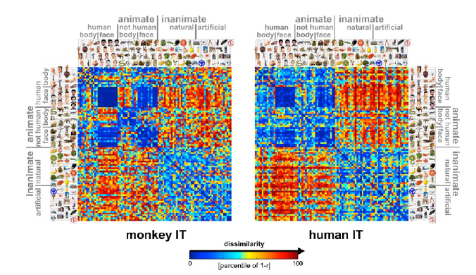

Correlative vs. Causal -> Casual Methods
This slide highlights a vital scientific caution: knowing where something happens is not the same as knowing how or if it is necessary.
- Correlative (fMRI, RSA, Recording): These methods show that certain data is activated when a stimulus is presented. However, correlation is not an explanation; it doesn't prove that the brain region is necessary for the behavior.
- Causal (Lesions, TMS, Optogenetics): To prove necessity, you must perturb the system and observe what breaks.
  - TMS: Uses magnetic fields to temporarily interfere with brain activity to see if a subject then fails a specific task.
  - Optogenetics: A highly precise method using viral infection to make specific neurons light-sensitive, allowing researchers to silence or activate them using light.
- The Takeaway: To truly understand object recognition (in the brain?), you need both: correlative methods to see the "what and where" and causal methods to prove that those representations are actually being used by the brain to perform the task.

Other stuff in this lecture
The 150ms Constraint: Core recognition occurs within 150ms, which is the time required for a single forward sweep of information from retina to IT. This speed effectively excludes feedback loops for simple objects, explaining why feed-forward CNNs are such robust models for core vision. If a task takes longer (e.g., recognizing occluded objects), recurrence is implied.

The Economy of the Brain: The brain organizes neurons into columns with similar preferences to save energy. This distributed representation is robust; losing a few neurons merely weakens the signal rather than causing the selective loss of a specific object (the "Grandmother Cell" fallacy).

This image represent what the ventral stream does:
achieve linear separability of object manifolds.

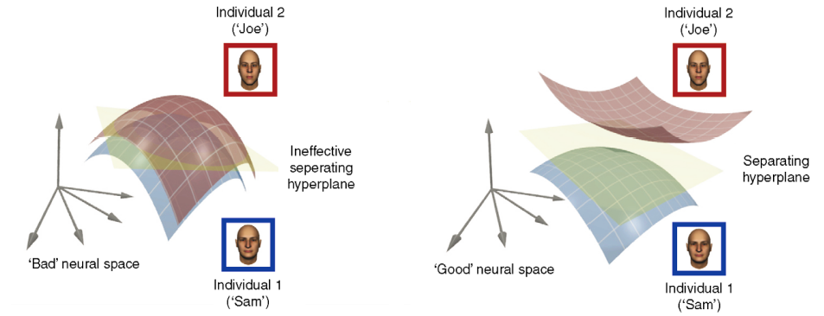

Lecture 3

The fundamental thesis of this lecture is that the visual system achieves the Untangling through a repeating computational motif: the systematic alternation of selectivity and pooling.

Hubel, Wiesel - V1 Study
Basically Hubel and Wiesel have recorded a single neurons in cat primary visual cortex — V1.
And they discover that:
- V1 neurons are not general light detectors.
- Each neuron responds selectively to a specific orientation of an edge at a specific location.

That mean that given an edge if we rotate it or if we translate it on the scene, the neuron will stop firing

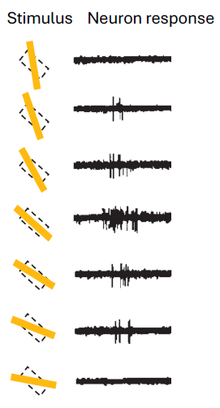
<---- Here we can see that the light stimulus match the neuron
activation region. and the neuron activate pretty strongly

<--- Further we rotate the light stick, less the neuron will activate

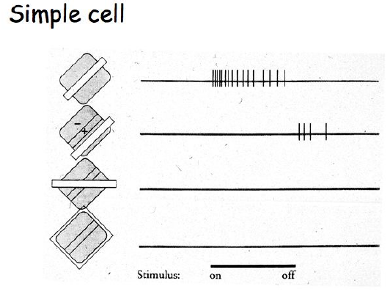
<--- The neuron cell has actually a small response if the bright
region is translated slightly. But not if it is rotated

LGN Cells
A simple cell that recognize and edge is actually supported by a series of LGN cells that recognize a single light "pixel" in the retina
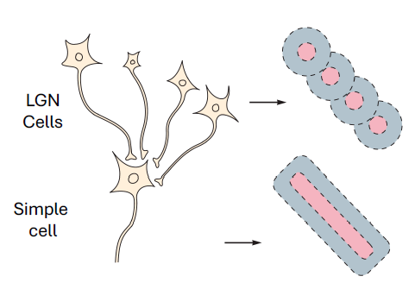

The Complex Cell
A complex cell is a neuron that is able to recognize the same edge in different positions.
To do that a complex cell pool over ("sum" the inputs of) simple cells with the same orientation but different positions.
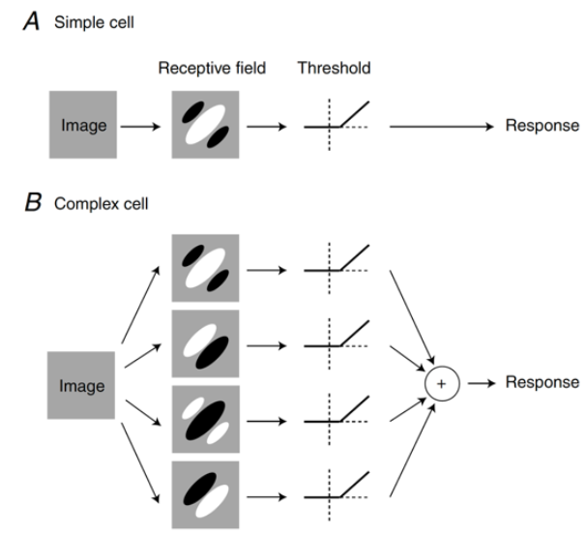

The Cost of Invariance While pooling is essential for recognition, it comes with a significant informational price:
- Loss of Spatial Precision: To identify "what" an object is, the ventral stream must systematically discard information about "where" it is (position, scale, and exact angle).
- Functional Specialization: This "cost" is precisely why the brain maintains two streams. The Dorsal Stream (the "where/how" pathway) preserves the spatial and pose information that the ventral stream discards, as this data is critical for navigation and grasping.
- Irreversibility: Once the responses of multiple simple cells are pooled into one complex cell, the system can no longer determine which specific simple cell triggered the response.

The Repeating Motif is the application of this simple-complex logic across multiple stages (V1 → V2 → V4 → IT). At each stage, the complexity of features increases (from edges to corners, then eyes, then faces), and the spatial extent of invariance grows.

The HMAX Model
the HMAX model, is a computational model about this selectivity and pool mechanism in the demonstrated that the alternating logic of selectivity and pooling could indeed perform object recognition.

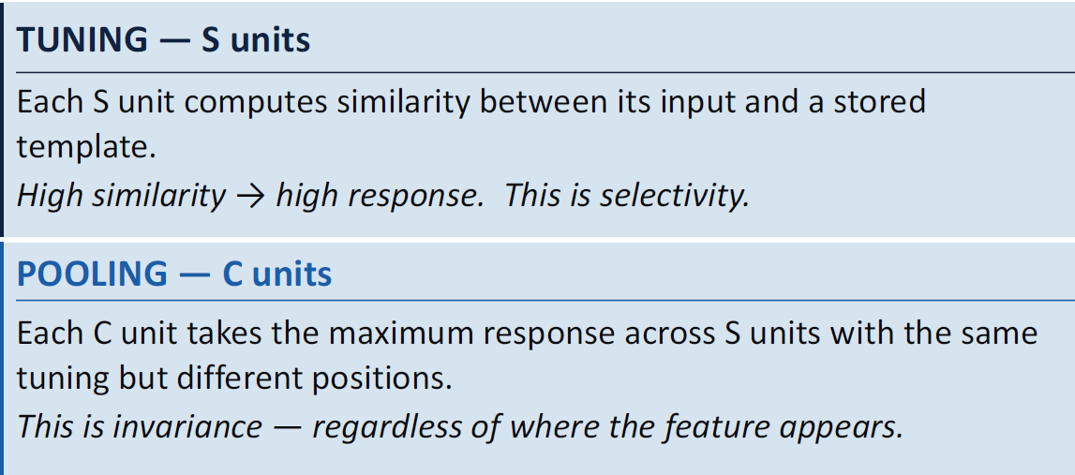

The HMAX architecture maps directly to biological areas:
- S1 (Simple): Gabor filters detecting oriented edges (V1 Simple cells).
- C1 (Complex): Max pooling over S1 to create position tolerance (V1 Complex cells).
- S2 (Simple): Template matching on C1 to detect edge combinations (V4 neurons).
- C2 (Complex): Max pooling over S2 to achieve global invariance (IT neurons).

The "So What?" Layer: Max vs. Sum Pooling A critical insight from HMAX is the superiority of MAX pooling over SUM pooling.
- SUM pooling adds all inputs. It cannot distinguish between one strong match (a true feature) and many weak matches (clutter). It builds invariance but destroys specificity.
- MAX pooling preserves only the single best response. It asks, "Is there a good match anywhere?" This allows the system to build invariance while maintaining high feature specificity, effectively ignoring clutter and preserving the identity of the feature.
HMAX: Achievements vs. Limitations
- What HMAX Achieves: Successfully demonstrates position and scale invariance; provides a "proof of concept" for the hierarchical motif.
- What HMAX Cannot Do: HMAX uses hand-designed Gabor filters and cannot learn from data. It fails to scale to complex, natural image recognition and only modestly predicts real-world IT neural responses.

CNNs
Note: study CNNs from the IPCV slide it's better

Convolutional Neural Networks (CNNs) did not replace the biological principles of HMAX; they scaled them using data-driven learning. While HMAX used hand-designed filters, models like AlexNet (2012) learn their filters from millions of natural images.
The "Engineering Realization" consists of three components:
- Convolutional Layers (Learned Selectivity): Using the principle of Weight Sharing, the same learned filter is applied across the entire input. This represents many neurons with the same tuning but different receptive fields.
- Pooling Layers (Invariance): These implement the "Complex Cell operation," a mechanistic parallel to biology that buys invariance at the cost of spatial data.
- Depth (Abstraction): Depth allows for compositionality. Layers build on the vocabulary of the previous ones (edges → corners → wheels → cars).
Furthermore, the system aims for "Tolerant Invariance." Neither the brain nor CNNs achieve perfect mathematical invariance. Instead, they seek just enough invariance to make object manifolds linearly separable in the high-dimensional response space, while still keeping enough informational "life" (sub-categorical pose or size data) alive to maintain a robust representation.

Important to remember :
- The Motif: The simple-complex cell logic (detect then pool) is the fundamental operation of vision across biology and AI.
- Depth as Abstraction: Hierarchical depth is the necessary mechanism to compose local operations into global, invariant representations.
- Optimal Format: The visual system's format is genuinely optimal for the natural world, converging on the same solution whether the goal is recognition or statistical efficiency.

Lecture 4

From Edges to Shapes (V1 & V4) (AGAIN)
Seeing isn't an instant flash; it’s a construction project that happens in precise temporal stages. We can actually track the "latency" (the time it takes for a signal to reach a region) as the image moves through the hierarchy.
The Building Blocks (V1) [Latency: ~50ms] The Primary Visual Cortex (V1) is the brain’s "Lego" set.
- Simple Cells: These are your basic bricks. They act as oriented edge detectors, firing only for a specific line at a precise location.
- Complex Cells: These pool information from simple cells, offering "movement freedom." They still care about orientation but respond even if the edge shifts slightly.
Evaluating the Gabor Filter V1 is the "best-behaved" part of the brain. The way simple cells respond matches mathematical Gabor filters almost perfectly. For AI practitioners, this is the most direct parallel: V1 simple cells are the biological version of a convolutional filter, and complex cells are the biological version of a max-pooling layer.
The Middle Ground (V4) [Latency: ~70ms] By the time the signal hits V4, the "receptive fields" (the area of the world a neuron "sees") have grown. V4 moves beyond simple lines to process colors, curves, and specific shapes. It acts as a bridge, grouping elementary features into "proto-objects" and separating them from the background.

The Inferotemporal (IT) Cortex
The IT Cortex is the "Grand Finale" of object recognition, reached approximately 100ms after an image hits the retina.
The "Hand" Discovery, discovered the "messy" reality of IT. While recording from neurons, he found they completely ignored the "clean" bars and edges that V1 loves. Instead, the neurons only fired vigorously when he showed the monkey a silhouette of a monkey hand. This proved that IT is tuned to complex, naturalistic objects.

(this is the IT layer analysis)
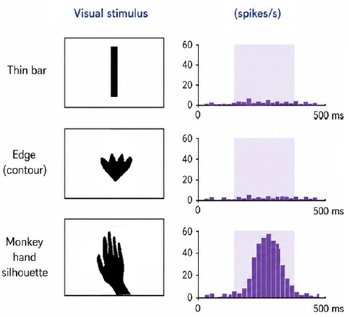

The Face Patches
The brain’s dedication to faces is mind-blowing. Using fMRI-guided recordings, Doris Tsao discovered at least 9 distinct face patches (with 6 major ones) in the IT cortex. That means area of the visual cortex that activates basically only for faces.
- Posterior Patches: These are "view-dependent," meaning they care about the angle of the face.
- Anterior Patches (FFA): These are for "identity and expression." They are invariant, meaning they recognize the person regardless of the viewpoint.

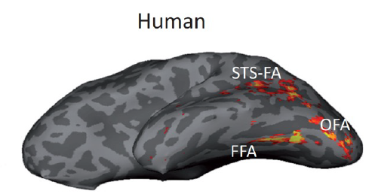

The Magic of Invariance (Tolerance) IT neurons ensure you recognize an object regardless of how it is presented. However, the brain finds some changes easier to handle than others:
- Size (Scale) & Position (Translation): The brain handles these with relative ease; invariance here is robust.
- Rotation (Viewpoint): This is actually difficult for the brain. As shown in the Logothetis "wire-frame" studies, the brain is not naturally invariant to rotation. It must learn to recognize an object from a new angle through months of experience.

Tanaka’s Hypothesis and Columnar Organization
using a method called "Progressive Reduction" to find the "critical features" of IT cells. He would start with a complex object (like an elephant) and strip away parts (the trunk, the ears) until he found the simplest "building block" that still made the neuron fire.

This image show how the IT layer stop firing
We the image became less and less associated with a class
He discovered also that IT is organized in columns perpendicular to the surface, where neurons in the same column share similar feature preferences.
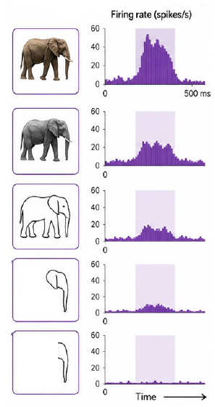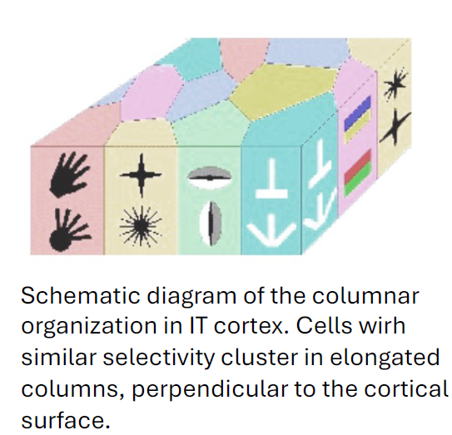

The Great Debate: Grandmother Cells vs. The Crowd
How does the brain store this information? Is it a single "expert" neuron or a "distributed team"?
The "Grandmother Cell" Myth The old idea was that you have one single neuron for your grandmother. If that cell died, you’d forget her. Research shows this "localistic" view is a myth.
The Distributed Crowd (Population Coding) study used a Machine Learning classifier (SVM over fMRI) to "read the mind" of a monkey. By looking at the activity of just 300 neurons—an incredibly small sample—the classifier could identify objects and categories with nearly 100% accuracy. This proves that meaning is not in one cell, but in the population pattern (or population vector).

The test also show that bigger is the fMRI region of the brain used for the classification, better are the classification results.

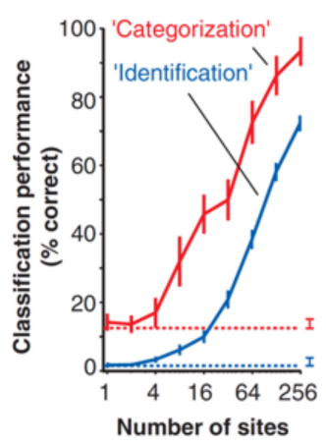

Decoding the Brain Most impressively, this "mind-reading" happens in a window of just 25 to 100 milliseconds. The brain decodes the "crowd" so efficiently that it understands the category of an object before the signal has even fully settled in the cortex.

Why We Are Smarter Than Machines: Experience & Context
AI is "static"; the brain is "dynamic." A CNN treats an image the same way every time. The brain, however, changes based on its goals.

Mixed Selectivity: the same neuron responds to apparently unrelated stimuli — red circles, vertical stripes, a specific face. Mixed selectivity exponentially increases the number of linear classifications
a downstream readout neuron can perform.

Basically A single neuron in the brain can code for both color and context simultaneously. This "multi-tasking" allows the brain to be incredibly flexible, switching strategies in a way that fixed-weight CNNs cannot.

Mixed selectivity increases dimensionality, and that turns hard problems like XOR into easy, linearly
separable ones.
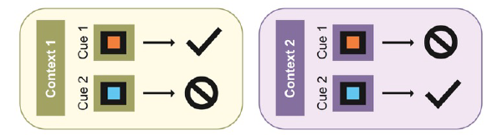

The Power of Experience Unlike V1, which is largely "hardwired" at birth, the IT cortex is highly plastic. The Logothetis wire-frame study showed that monkeys aren't born knowing every object; they learn them. This experience builds the "tolerance" we see in IT, proving that biological vision is a result of constant learning.

The monkey had been trained to recognize these two set of different faces. At first the Monkeys fails to recognize them but after some time, some neuron became specialized in this task and start firing only on the feature that categorize the two categories

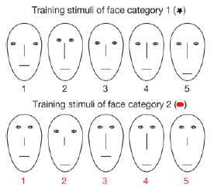

Key Takeaways: The "Must-Know" Points
- The Hierarchy is Real & Timed: Processing moves from V1 (~50ms) to V4 (~70ms) to IT (~100ms), increasing in complexity and abstraction at every step.
- Crowds, Not Individuals: Object identity is found in the population pattern of neurons. Even a small group of 300 neurons can provide a robust, decodable "mind-reading" signal.
- Learning is Mandatory: While V1 is a mathematical fit for Gabor filters, the IT cortex is shaped by experience. Rotation invariance, in particular, is a learned skill.
- Dynamic Processing & Mixed Selectivity: The brain uses context and attention to solve complex problems (like the stoplight reversal), utilizing neurons that code for multiple features at once.

Lecture 5

The study revealed that being exceptionally good at a visual task makes a model brain-like by necessity. There appears to be a universal "logic of vision" that forces any system—biological or silicon—to adopt similar representational structures to solve the problem of invariance. This suggests that the brain’s architecture is not an evolutionary accident, but a mathematical requirement for high-performance vision.

HCNNs vs. The Brain
Hierarchical Convolutional Neural Networks (HCNNs) are our primary tool for this comparison because they serve as a direct structural analogy to the layered nature of the visual cortex. These are not loose metaphors; they are quantitative parallels of the biological "hardware" of sight.
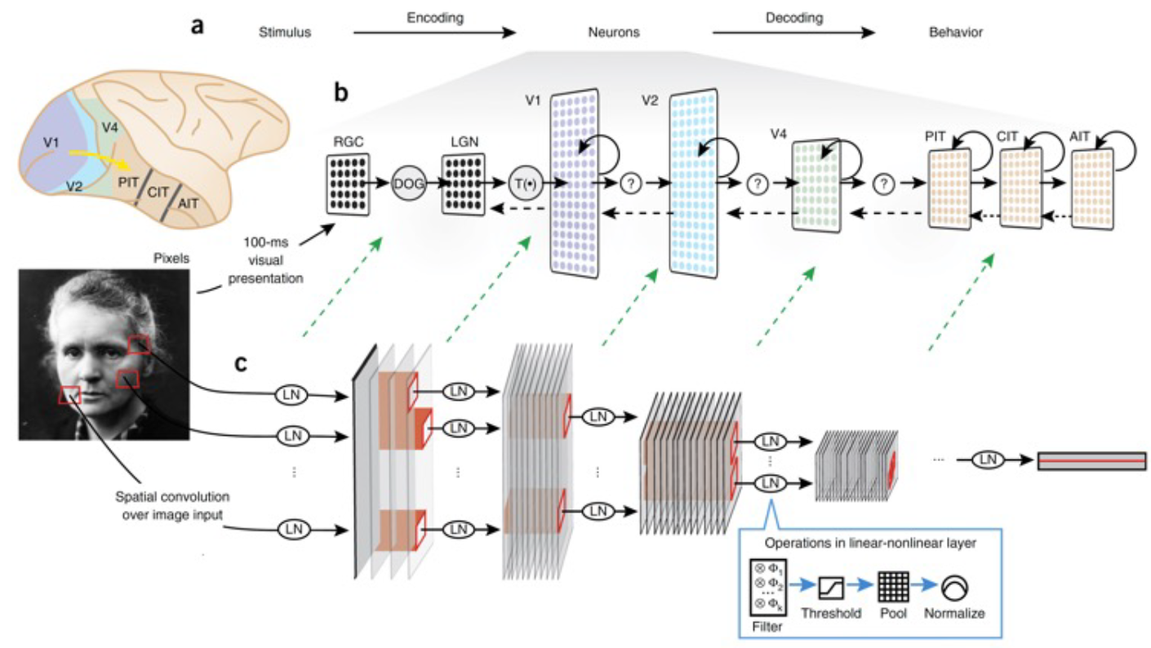

The alignment of operations is remarkably precise:
- Convolution: Small kernels act like V1 simple cell receptive fields. The kernel size in an HCNN essentially approximates the receptive field size of these early neurons.
- Filter Banks: Multiple filters per layer mimic the way V1 contains neurons tuned to different orientations, scales, and colors simultaneously.
- Depth: The progression from simple edges in early layers to complex objects in late layers maps directly onto the biological hierarchy of V1 → V4 → IT. As we go deeper, receptive fields grow and feature complexity increases.
- Pooling: This operation discards precise positional data to build "invariance," mirroring the behavior of complex cells that care more about the presence of a feature than its exact pixel coordinates.
- Activation & Normalization: Models use nonlinear functions like ReLU to process signals, while divisive normalization keeps these signals within a standard range, preventing the "explosive" activity that would be biologically catastrophic.

A successful model of the ventral stream must meet Four Requirements:
- Image-computable: The model must be runnable on raw data.
  - Simplified translation: You can feed it a standard JPG, and it produces a concrete answer.
- Task-equivalent: The model must match human-level performance.
  - Simplified translation: It should reach over 90% accuracy in identifying objects in complex scenes.
- Structurally aligned: The architecture should mirror the physical layout of the cortex.
  - Simplified translation: The model’s layers must correspond to the V1-V2-V4-IT hierarchy.
- Neural-predictive: The model’s internal activity must accurately predict real neural firing patterns.
  - Simplified translation: When shown the same photo, "synthetic neurons" in the AI should fire just like real neurons in a monkey's brain.
So What? Meeting these criteria ensures the model isn't just "behaving" like a human, but is using the same underlying mechanism to solve the problem

The Yamins Experiment: Find the best architecture
2014 Yamins and DiCarlo study utilized a "Discovery" approach. They explored a massive "model space" of over 1,000 architectures to find the best object recognizer, rather than the best "brain mimic."
The HMO (Hierarchical Modular Optimization) Framework The researchers used the HMO framework to build networks through two types of composition:
The Training Process Models were trained on ImageNet. By varying the number of layers, units per layer, and nonlinearities, they searched for the specific architecture that achieved peak accuracy. They didn't optimize for neural data; they optimized for performance.

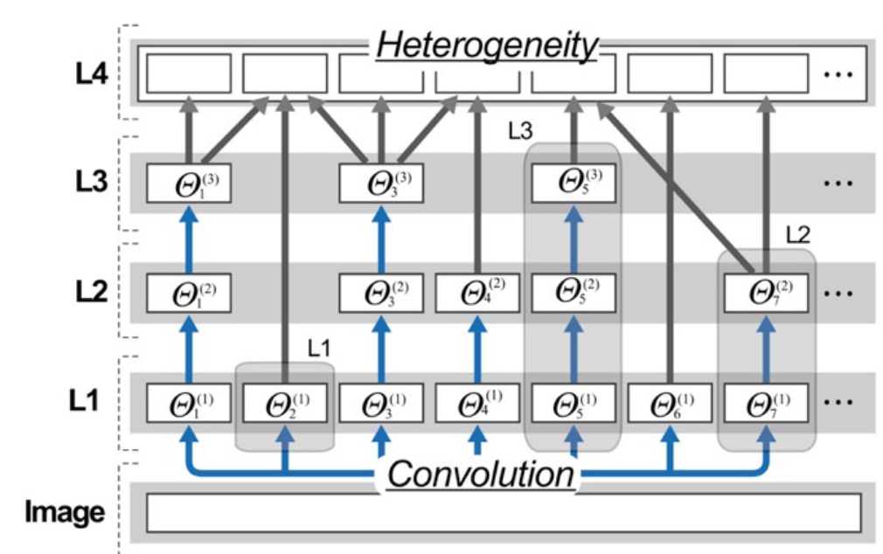

So What? Yamins proved that "Start from Task" is a viable strategy for neuroscience. By simply trying to solve the computational problem of vision, the AI was forced to develop representations that look remarkably like those found in biology.

Measuring the Match: PLS Regression & RSA
Comparing a computer program with millions of digital units to a monkey's brain with only a few hundred recorded neurons is like comparing two different languages. We need a "translation" metric.
1. Partial Least Square (PLS) Regression
Standard linear regression fails here because the model has thousands of units while the neural recordings have only a few hundred. PLS Regression is used to handle this dimensionality mismatch.
- Training: Half the images are shown to both the AI and the monkey. PLS finds the mathematical weights that map AI activity to the monkey's neural responses.
- Testing: New images are shown. We use the frozen weights to see if the AI can predict how the monkey's neurons will fire.
2. RSA (Representational Similarity Analysis)
RSA is the "gold standard" because it is independent of the number of neurons. It uses a Representational Dissimilarity Matrix (RDM) to analyze the system's "internal logic."
- The Concept: Think of an RDM as a "fingerprint." Just as a fingerprint identifies a person without needing to see their face, an RDM identifies a system’s logic by looking at how it groups objects (e.g., are "chairs" closer to "tables" than to "faces"?). If the AI's "fingerprint" matches the brain's, they share the same representational geometry.

The Result: Accuracy = Brain-Likeness
The central discovery was profound: The models that were best at recognizing objects were also the ones that best predicted the brain. Brain-likeness was an emergent property of high performance.
Key Findings:
- Hierarchical Alignment: Early and intermediate AI layers best predicted V4, while the late hidden layers (the top of the hierarchy) best predicted IT.
- Emergent Predictivity: This match was not programmed; it appeared naturally as models moved from 50% to 90% accuracy.
The "Mappability" was also strikingly hierarchical:
- Early and intermediate model layers naturally predicted the activity of area V4.
- Late, deep layers of the model provided the best predictions for the IT cortex.

So What? This points to a "Convergence Solution." It implies that given the geometry of the natural world (the statistical properties of ImageNet) and a hierarchical architecture, there may be only one mathematically optimal way to solve vision. The brain and the AI converged on the same solution because it is the only one that works

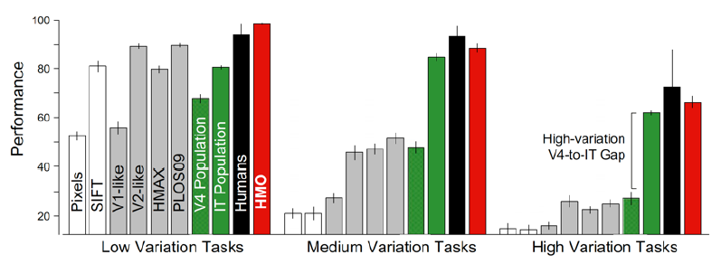
This image show that HMO have better performance than humans in low variation tasks.
while it is slightly worse for medium and high variation tasks.
Notice how the V4 level of the brain stem is way worse than the It level on High variation tasks

Specialized Modules: Faces, Objects, and Food
The brain contains specialized "patches" for faces. Does task-optimization also create these in AI?
The Dual Network Experiment Researchers trained a "dual network" on both faces and objects and then performed "functional segregation" via a lesioning study (setting specific filters to zero).
- The Result: "Lesioning" face-sensitive filters destroyed face recognition but left object recognition intact. The AI had spontaneously segregated these categories.
- The Innate vs. Expert Debate: This supports the "Expertise" view (Isabel Gauthier) over the "Innate" view (Nancy Kanwisher). It suggests face patches aren't necessarily "hard-coded" by genetics but emerge because faces are computationally unique stimuli that require specialized processing.
The "Food Area" Divergence Crucially, the AI also developed a specialized module for food. Since the human brain does not have a dedicated "food area," this represents a key point of divergence. It shows that AI will modularize anything that is statistically distinct in its training data, even if biology does not.

Limitations and Philosophical Crossroads
Despite these triumphs, we must maintain our scholarly skepticism. Current HCNNs are not yet perfect replicas:
- Gaussian Noise: If you make an image "fuzzy" with noise, AI performance collapses, while humans remain steady. This reveals that AI is currently over-reliant on texture, whereas the human brain prioritizes shape.
- Adversarial Attacks: Tiny, invisible pixel changes can trick an AI into misidentifying a cat as a car—a mistake no biological system would make.
- The Black Box Problem: We have, in many ways, replaced one black box (the brain) with another (the neural network). We see the correlation, but we still struggle to define the exact parameters that grant a model its "brain-score."
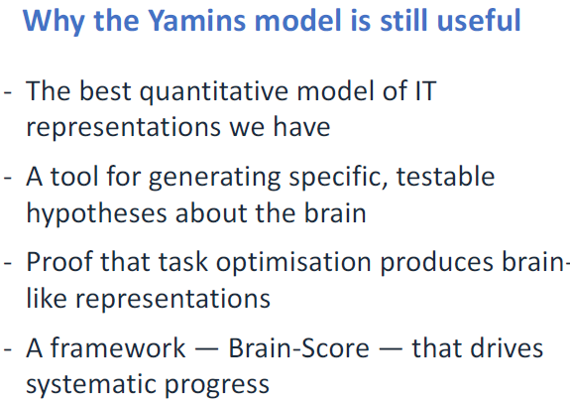

Brain-Score (Schrimpf et al.) has emerged as the modern benchmark, aggregating multiple datasets to rank how "brain-like" a model is.

Lecture 6

The Core Philosophy: Objective Shapes Representation
In cognitive neuroscience and artificial intelligence, an internal "map" or representation is never a neutral copy of the world; it is a functional artifact of the objective it was designed to achieve.

the realization that the structure of information—how a system sees, categorizes, and encodes data—is dictated by the goals of the agent. As we examine the alignment between specific objectives and their resulting representations, we find a consistent pattern: change the objective, and you fundamentally change the representation.
The manifestation of this principle is evident across three distinct systems:

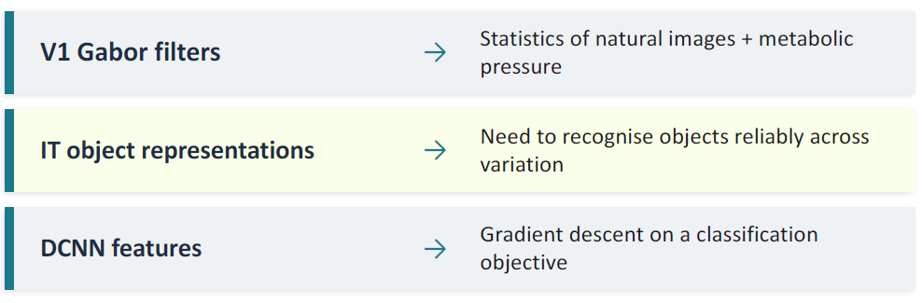

the brain does not aim for a "perfect" copy of reality; it constructs a representation that facilitates survival-relevant actions. While AI and the brain both learn representations, the "How" and "Why" differ significantly, leading to a structural gap in their functional capabilities.

The AI Answer: Supervised vs. Unsupervised Learning
Unlike the curated, category-labeled environments of DCNNs, biological organisms operate in a continuous, unlabeled, and often noisy sensory stream.

Supervised Learning Supervised learning involves training networks on millions of human-labeled images, such as the ImageNet dataset. Here, the objective is explicit, external, and fixed. The network's internal structure is shaped entirely by minimizing a loss function defined by human annotators. However, research using the SAYCam dataset—head-mounted video from infants—reveals that human visual input is continuous, egocentric, and lacks the clean, static structure of ImageNet. Infants and primates do not receive millions of labels during development, suggesting that supervision cannot be the primary driver of biological learning.

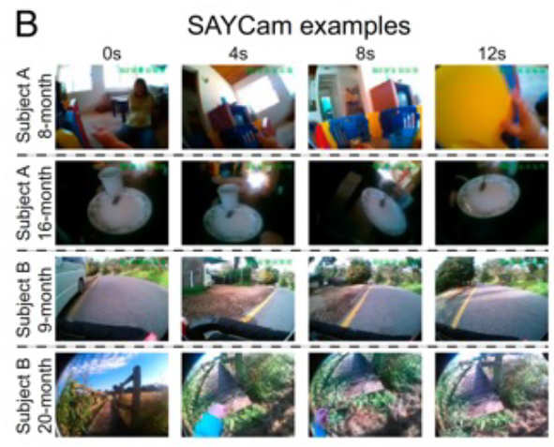

Unsupervised Learning In unsupervised learning, the objective is derived from the inherent structure of the data. Key methods include:
- Masked Autoencoders: Learning to reconstruct missing portions of an image.
- Contrastive Learning: Learning to recognize that different "augmented" views of a single image should share a similar representation.
- Local Aggregation (LA): An optimization method that pushes an embedding closer to its "close neighbors" in a mathematical space while separating it from "background neighbors."

Example of local aggregation
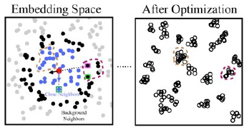

A critical finding by Zhuang et al. demonstrates that unsupervised models trained purely on the statistics of natural images predict ventral stream responses in the brain as effectively as supervised models. This suggests that the statistics of the world, rather than human labels, are the primary signal for visual learning. However, a nuanced "Gap" remains. While unsupervised methods (like SimCLR and Local Aggregation) equal or even outperform supervised models in tasks such as object position and size estimation, they still lag significantly in categorization.

Furthermore, a major takeaway from Huber et al. highlights a representational mismatch: children rely heavily on shape cues for recognition, whereas DCNNs remain overly dependent on texture cues. This shape-centric inductive bias allows children to be far more robust to image distortions than artificial systems.

To bridge the gap between static images and the temporally correlated inputs of a child, Zhuang et al. introduced Video Instance Embedding (VIE)—an extension of Local Aggregation to video that allows contrastive learning to handle real developmental sensory streams.

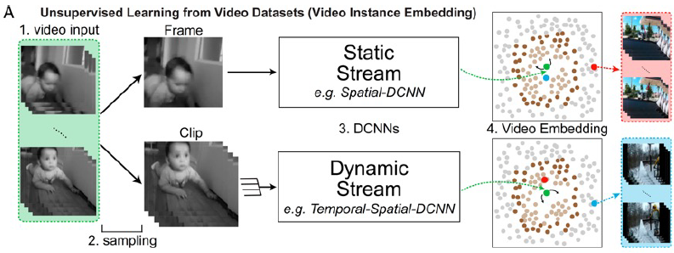

The Biological Answer: Efficient Coding and Sparse Coding
In 1961, Horace Barlow proposed a visionary framework: the brain’s primary job is to strip away statistical redundancy. Because natural images are highly predictable (adjacent pixels are usually similar), representing every pixel would be metabolically catastrophic.
Barlow’s Goal: Efficient Coding The sensory system’s objective is to construct a representation where each neuron carries as much independent, surprising information as possible. By discarding the predictable, the brain maximizes the information gained per unit of energy expended.

The Olshausen & Field (1996) Experiment This landmark study provided empirical support for Barlow’s theory. By training a system to represent natural images using sparsity—the constraint that as few units as possible should be active at any given time—they found that the system automatically developed Gabor-like filters. This occurred without any recognition labels or supervised objectives. Evolution and gradient descent arrive at the same solution because it is the mathematically optimal response to natural image statistics.

The Dual Pressures Biological representations are forged by two inseparable forces:
- Statistical Pressure: The requirement to reflect the oriented edges and spatial correlations inherent in the physical world.
- Metabolic Pressure: Neural activity is expensive. Sparse codes minimize the energy cost per input.
Standard DCNNs find solutions to visual problems, but they lack the survival-driven metabolic pressure found in biology. In a living organism, "less firing = less energy" is not an engineering preference; it is a requirement for staying alive. Without this constraint, AI may find solutions that are functionally effective in narrow tasks but structurally divergent from the brain’s robust and efficient architecture.

Experience and the Dynamic Value Landscape
Unlike AI, which typically operates with a fixed objective function and a curated "offline" dataset, the brain’s representations are dynamic and "online." They are continuously reshaped by experience and shifting internal states.

Representational Plasticity
- Developmental Plasticity: Hubel’s work on ocular dominance proved that visual deprivation during critical periods physically degrades representational columns.
- Adult Plasticity: Representation change is continuous. Maguire et al. (2000) showed that London Taxi Drivers possess larger posterior hippocampal volumes, reflecting how navigation goals physically restructure the brain’s "map."

The "Hungry Animal" Problem In biological systems, the objective function is never static. As explored by Keramati & Gutkin, a physiological state such as hunger or thirst restructures the entire "value landscape."
- A hungry animal and a satiated animal are not running the same computation; they are solving entirely different survival problems.
- Internal homeostasis redefines what is "valuable" in real-time. For a thirsty agent, water-seeking is assigned higher value because the internal state has respecified the objective.
- Crucially, this internal shift allows for instant replanning. An agent can use its existing world model to change its behavioral strategy immediately without needing new environmental data or further training epochs.

The agent can replan instantly using the existing model
without any environmental interaction
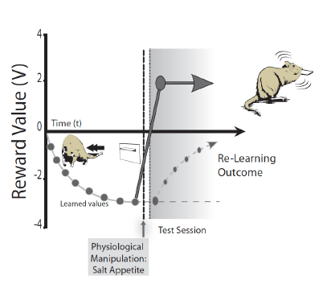

As Haueis & Colaço argue, metabolic considerations are not just external limitations; they determine what is valuable and urgent. A feedforward AI system, receiving the same input, will always produce the same output. A biological organism, however, can change its representation of that same stimulus based on its current needs, ensuring survival in an open-ended world.

Summary: The Mismatch Theory
The "Gap" between biological and artificial intelligence is not merely a quantitative issue of data volume; it is a structural divergence defined by Mismatch Theory. The brain and AI are solving fundamentally different problems because they do not share the same objectives.
Feature | AI Systems (DCNNs) | Biological Brain
Objective | Fixed, External, Invariant | Dynamic, Internal, Survival-based
Learning | Offline, Static, Curated | Online, Continuous, Streamed
Constraints | No metabolic cost, No body | High metabolic cost, Embodied
Representational Cue | Texture-biased | Shape-biased
Data Signal | Human labels / Data structure | Survival, Social context, Homeostasis
The Mismatch Theory states that an Unshared Objective → The Gap. The Overlap we see (such as Gabor filters in both systems) tells us what the physics of object recognition requires. The Gap, however, reveals what biological vision is actually for: survival in a body with limited resources. While AI excels at categorization in static datasets, it lacks the "hunger" that drives generalisation and robust, real-time replanning.

Lecture 7
Current AI has achieved remarkable feats, understanding why it still diverges from human vision is the key to breaking through current performance plateaus.
To reach the next level of neural predictivity, we must shift our focus from static, one-way streets of data to the critical dimensions of time and recurrence.

The 150ms Sprint: What the Feedforward Sweep Achieves
When an image first hits the retina, the brain initiates a "first impression" known as the Feedforward Sweep. This is a rapid surge of neural activity that travels up the visual hierarchy without the benefit of feedback or iteration.
Core Object Recognition and the 150ms Boundary
In neuroscience, Core Object Recognition refers to the ability to categorize an object within a fraction of a second. This process is largely completed within the 150ms boundary following image onset.
During this initial pass:
- Signals reaching the IT (Inferotemporal) Cortex: Information travels from V1 through V2 and V4 to reach the IT cortex, the final stage of the ventral stream.
- Basic Categorization: The brain can successfully decode basic categories (e.g., car vs. face) from neural activity in this window.
- Success Under "Clear Conditions": This sweep is remarkably effective for unoccluded, centered, and unambiguous objects.

The "So What?" of the Yamins Result The landmark Yamins result demonstrated that a single forward pass in a deep network could reach human-level performance on standard benchmarks. This was a triumph because it proved that DCNNs capture a "real and powerful" aspect of the brain's initial sweep. However, it also hinted at a major limitation: if a single pass is enough for simple, sterile benchmarks, it fails to explain the dense recurrent connectivity found throughout the primate brain.
While the 150ms sprint is powerful, it is mathematically insufficient for the visual challenges of the real world.

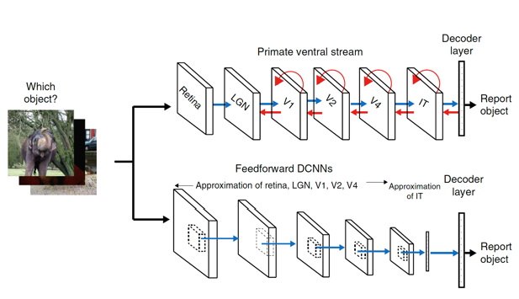

Hitting the Wall: Where Simple Models Fail
In the sterile environment of a laboratory, images are often clear and centered. However, the "messy" real world presents visual hurdles that simple feedforward architectures cannot clear.
The Four Failure Points of Feedforward Models
- Occlusion: When parts of an object are hidden, a single pass lacks the mechanism for context-based completion. The brain must use surrounding information to "fill in" the gaps.
- Figure-Ground Segregation: Separating an object from its background requires integrating information across both space and time, a task where one-way data flow struggles.
- Cluttered Scenes: In a scene with multiple objects, feedforward models lack a "selection mechanism." They process everything at once, whereas the brain uses attention to prioritize specific targets.
- Ambiguous Images: When an image has multiple interpretations, the brain shifts its view based on expectation. Feedforward models typically provide a fixed output, lacking this interpretative flexibility.
Synthesis: The Insufficiency of the Single Pass For these "hard" images, a single pass of information is mathematically insufficient to achieve biological-level accuracy. This suggests that the brain’s architectural solution—recurrence—is not just an ornament of biology but a computational necessity.

Recurrence: Keeping the Past Alive
Recurrence is metaphorically a "reverberation loop." It is the brain’s way of keeping information from being discarded, allowing the past to interpret the present and shape future learning.
Comparison: Primate Ventral Stream vs. DCNNs
Feature | Primate Ventral Stream (Mental Model) | DCNN (Machine Model)
Direction | Multi-directional (Feedforward, Feedback, Horizontal) | Almost entirely Feedforward
Connectivity | Densely connected with subcortical loops | One-way street of data
Example | Ventral Stream: Heavily recurrent | Cerebellum: Mostly feedforward exception
While the ventral stream is the rule of recurrence, the Cerebellum serves as a biological exception—it is a primarily feedforward structure involved in the online control of motor skills, where speed and immediate execution dominate over temporal refinement.

Functions of Recurrent Circuits (Felleman & Van Essen)
- Processing: Enables sustained activity for working memory and contextual integration for figure-background segregation.
- Learning: Facilitates error-driven learning and Hebbian "fire together, wire together" rules, reinforcing synaptic weights through repeated reverberation.
The "So What?" of Time Scales The feedforward sweep is fast and automatic, but recurrent refinement operates on a "slower" time scale. This suggests the brain doesn't just deliver a static calculation; it evolves its response over time to solve complex visual puzzles.

The Evidence: Monkeys, Machines, and "Hard" Images
To prove recurrence is vital, we look to Kar et al. (2019), who moved the story from correlation to causal proof.
Experimental Methodology
- The Stimuli: 1,320 images divided into "Easy/Control" (Blue) and "Hard/Challenge" (Red) images (blurred, cluttered, or unusual views).
- The Measure: Researchers used D-Prime (discrimination accuracy) and OST (Object Solution Time)—the moment neural responses reach behavioral accuracy levels.
Key Results
- The Time Lag: Challenge images took 30ms longer to "solve" in the brain than easy images. This delay represents the time required for recurrent loops to refine the representation.
- The Prediction Drop: While AlexNet predicted early brain activity well, its Neural Predictivity crashed (dropping below 20%) after 100ms for hard images. It could not capture how the brain's response evolved.
- The Causal Proof: Pharmacological inactivation of the PFC (Prefrontal Cortex)—a major source of feedback—specifically impaired the recognition of "hard" images while leaving "easy" ones untouched.
Distilling the "So What?" This proves the brain's response is not fixed; it evolves. For difficult tasks, feedback from higher areas like the PFC is a causal requirement for recognition.

The first chart show that the brain takes more time to elaborates complex
Images, because it use recursion.
The second chart show that the cnn is not able to predict the neuron activity
For the complex images (the explained variance drop)
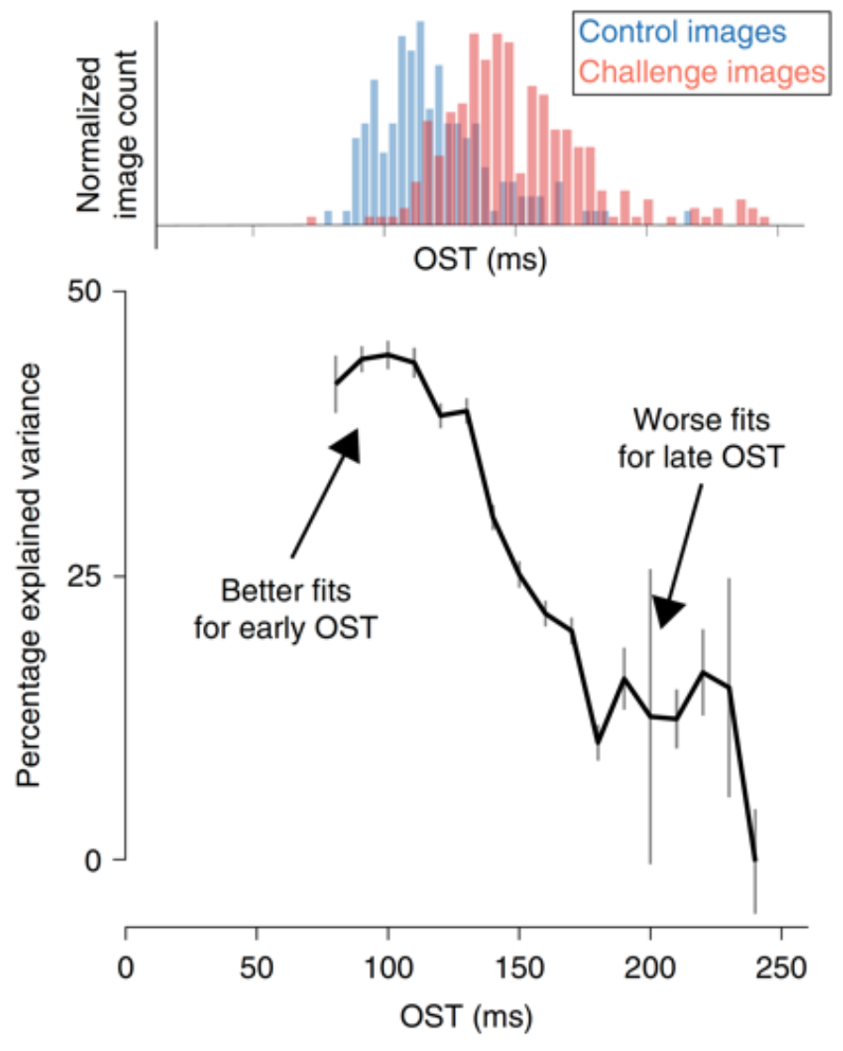

Building a Better Brain Model: From ResNet to CORnet
The quest to fix the "AlexNet failure" led to two distinct architectural strategies.
Two Strategies for Emulating Recurrence
- Going Deeper (e.g., ResNet): Some argue that extremely deep models "unroll" recurrence. By having hundreds of layers, a feedforward model approximates iterative processing through sheer depth.
- CORnet: This model maps specifically to the four stages of the ventral stream (V1, V2, V4, IT). It uses a multi-pass mechanism (5 passes per layer) to mirror biological feedback.
The Success of CORnet CORnet’s temporal accuracy is its greatest strength. While its first pass handles "easy" images, its later passes (3–5) are significantly better at explaining "hard" images and late-stage IT cortex activity. This demonstrates that iterative loops are a more biologically plausible and efficient way to achieve visual refinement than simply stacking infinite layers.

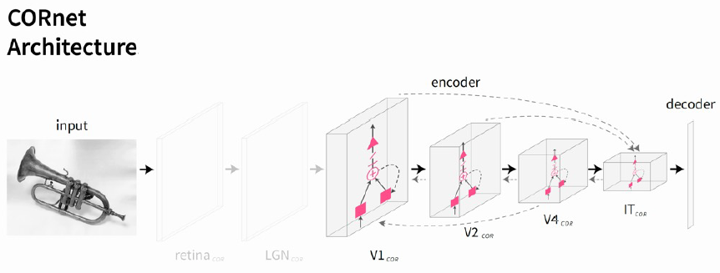

The New Frontier: Transformers and Predictive Coding
Modern AI has introduced Vision Transformers (ViTs), while neuroscience has embraced the Predictive Brain theory.
Attention: Neuroscience vs. Transformers
- Neuroscience (Moran & Desimone): Attention is "selective sculpting." Paying attention to a "red bar" causes a neuron to ignore a "green bar" in the same receptive field, completely altering the neural response.
- Transformers: Use Self-Attention and tokenization. They find global, relational groupings across an image. However, ViTs are less effective at predicting early-layer brain activity; the classic Gabor filters (edge detectors) found in V1 are much more accurately represented in CNNs than in ViTs.

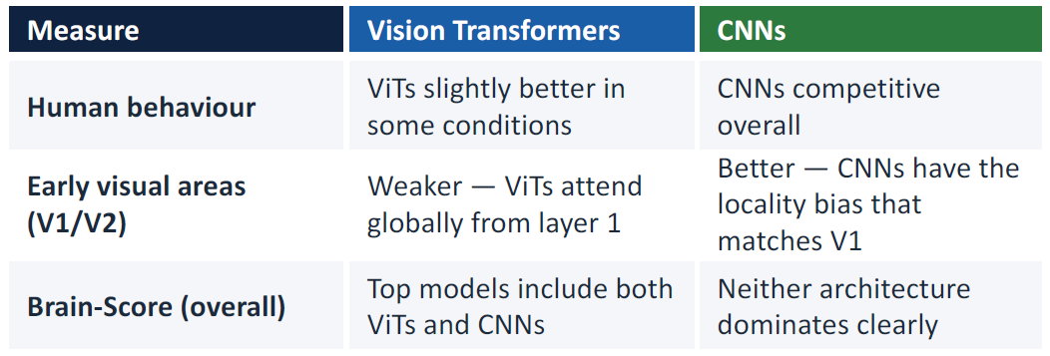

Predictive Coding Theory
The brain is continuously generates predictions about incoming sensory input:
- Feedforward: Conveys the "Prediction Error" (the surprise).
- Feedback: Conveys the "Internal Model" (the guess).
Precision Weighting and the "Foggy Day" Metaphor We weight prediction errors based on Precision. On a perfect, clear day, your internal model is reliable; you give low weight to minor errors. In a foggy environment, the input is confused, so you must increase the "precision weight" on prediction errors to adapt your model.
- Autism: May involve giving too much weight to detail (over-weighting prediction errors).
- Hallucinations: Giving too much weight to the internal model, seeing what you expect even when it isn't there.

Summary: Biological Flexibility vs. Machine Rigidity
- Pattern Completion: Recurrence is mathematically required for messy, real-world data.
- Economy vs. Flexibility: Recurrence is a matter of Hardware Space (Economics)—sharing parameters to save room in the skull—but also Qualitative Computation (Flexibility). The brain can stop processing once a solution is found, whereas a feedforward model must complete every layer.
- The Dynamic Gap: AI still lacks the Dynamic Objective Function of the brain. Our vision is shaped by survival pressure and internal states, while AI remains a rigid, fixed-goal calculator.
The gap remains: AI has mastered the 150ms sprint, but the biological brain still wins the marathon of complexity, ambiguity, and survival.

Lecture 8

This lesson is a big recap of the course

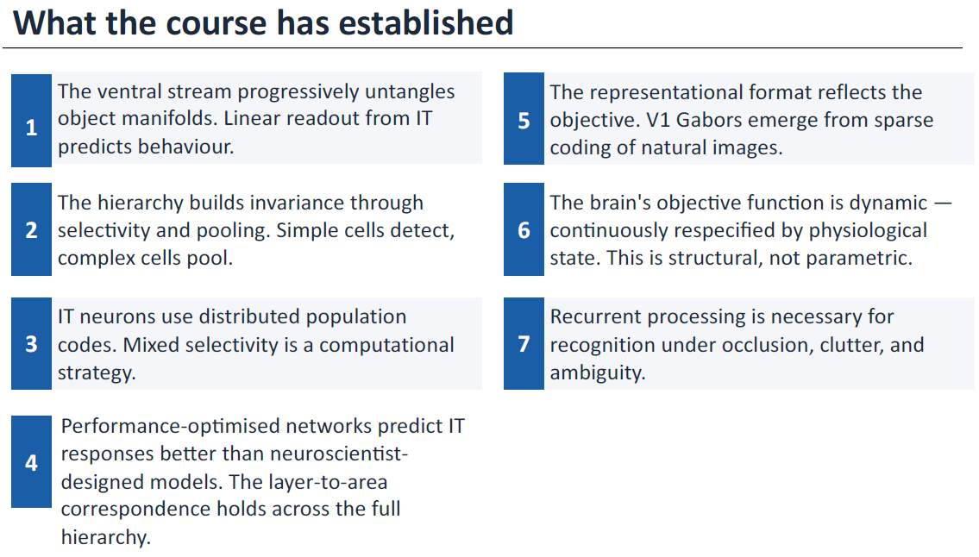

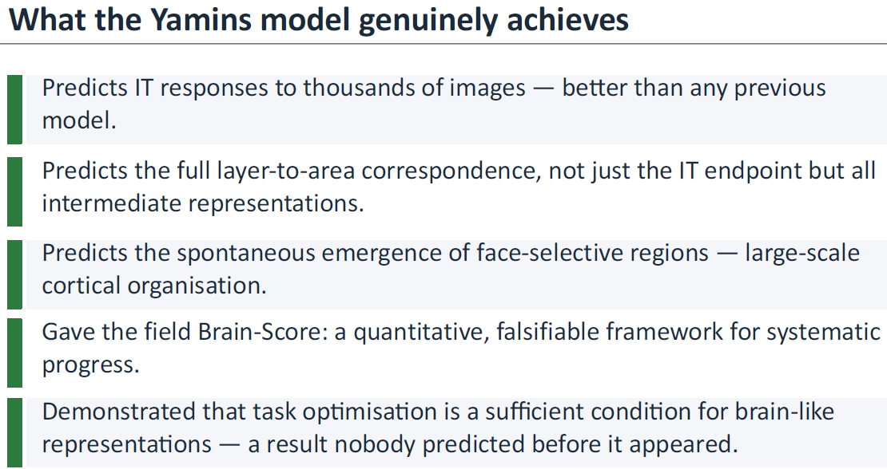

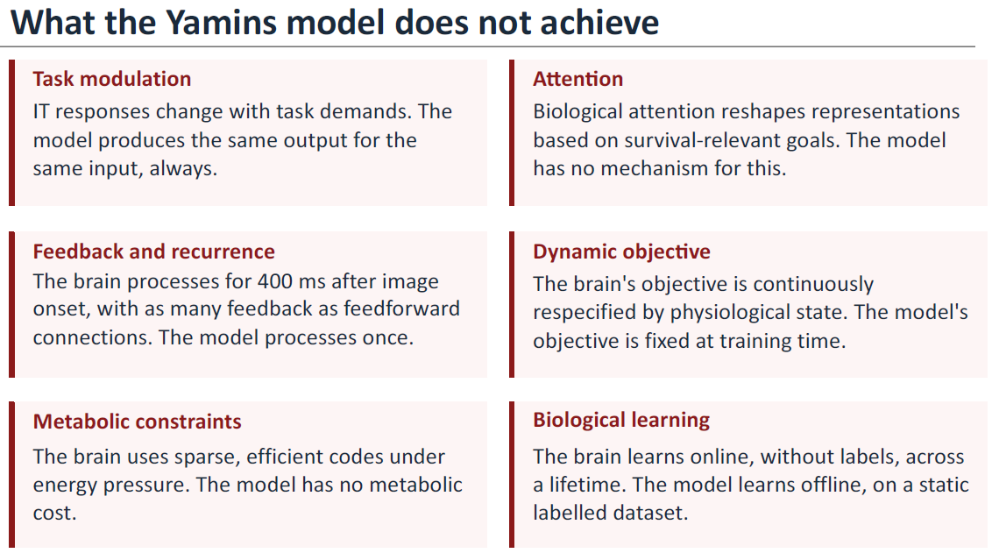

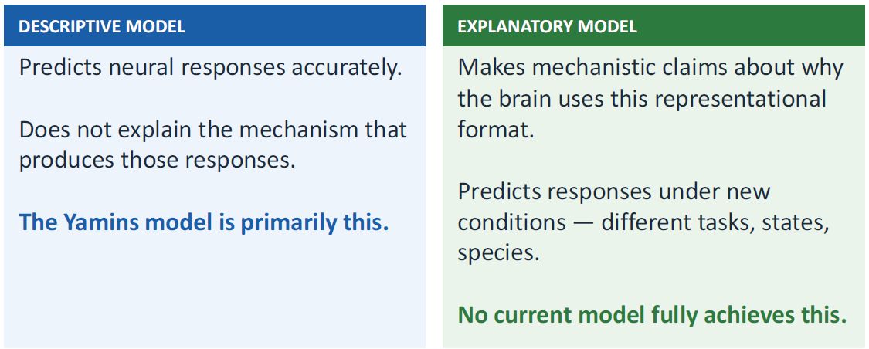

The Gap: Where AI Fails to Be Human (The "Unshared" Part)
The areas where AI and the brain diverge tell us what biological vision is really for: Survival.
- The 400ms Reality: AI is a "Single Pass" (feedforward) system—one shot from pixels to label. The brain, however, continues processing for up to 400 ms after seeing an image, using Recurrence and Feedback to solve difficult, cluttered, or occluded scenes.
- Structural Divergence (The Food Area): In one notable failure, the Yamins model developed a specialized "Food Area." While the human brain has specialized areas for faces, body parts, and environmental layouts (the parahippocampal place area), it has no known dedicated food area.
- Dynamic Objectives: The brain’s goals are structural, not parametric. This means our "objective function" is continuously respecified by our Physiological State. If you are starving, a burger is processed with much higher priority than if you are full.
- Metabolic Constraints: The brain operates on a strict "Energy Budget," forcing it to use sparse, efficient coding. AI has no such metabolic cost.
- Online Learning: Humans learn "on the fly" from a lifetime of unlabeled experience, not from 1.2 million labeled ImageNet photos.
When comparing CNNs vs. Transformers, CNNs excel at local edges, while Transformers are better at "Global Context." However, neither captures the brain's full progression from local early processing to global late processing, combined with massive feedback loops.

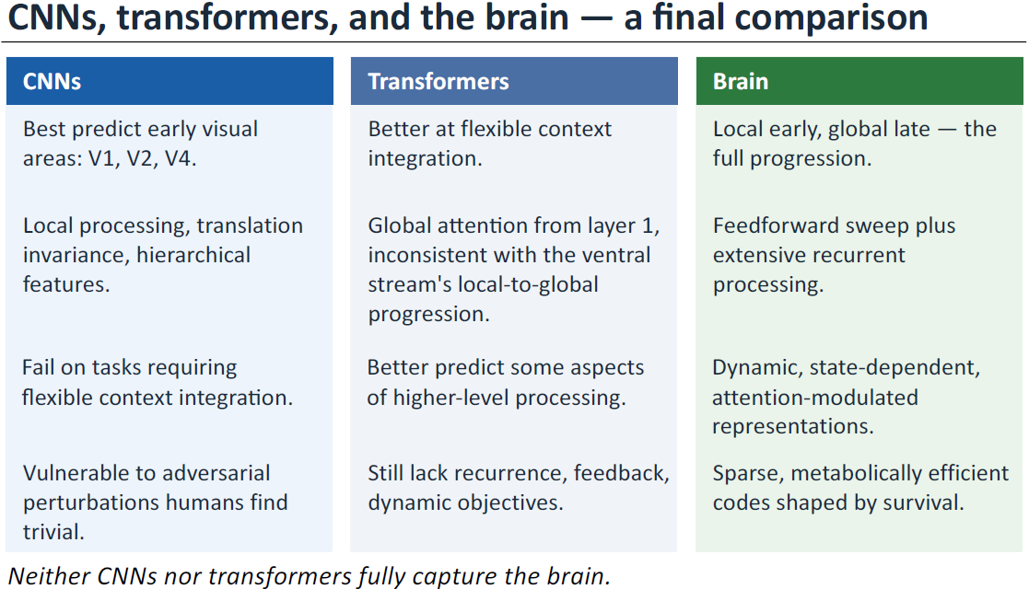

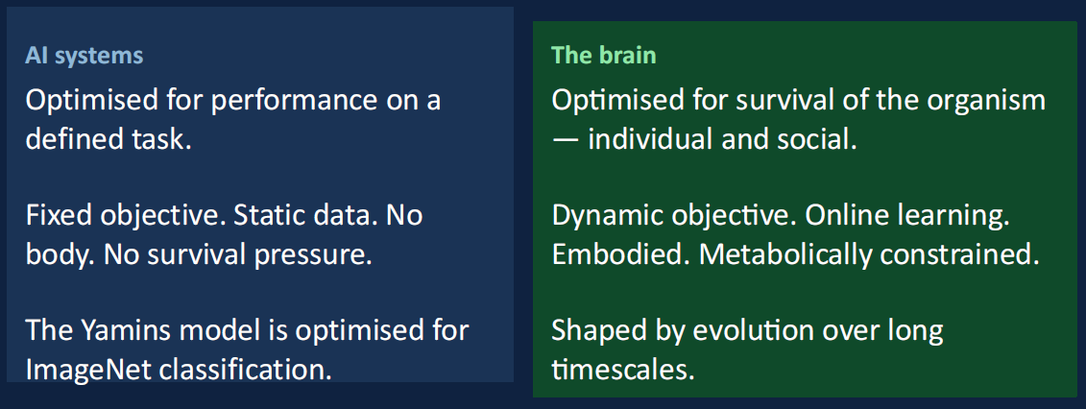

Closing the Loop: The Future of NeuroAI
The "Grand Integration" reached a peak with the creation of "Super-Stimuli." Researchers used the Yamins model to mathematically synthesize bizarre images designed to activate specific monkey neurons. When shown to the animals, these synthetic images triggered higher neural firing rates than any real-world object ever could. This "closed the loop," proving the model could not only describe the brain but control it.
This has established a New Standard for Neuroscience. We no longer settle for vague verbal theories; we demand quantitative Brain-Scores.
The ultimate lesson of this research is simple: The similarity between AI and the Brain tells us what recognition requires; the difference tells us what living requires. AI can identify a chair, but the brain must navigate toward it, economize energy, and decide if it's worth sitting in based on how tired it feels. The future of the field lies in building models that don't just see, but survive.

Exam Example Questions
