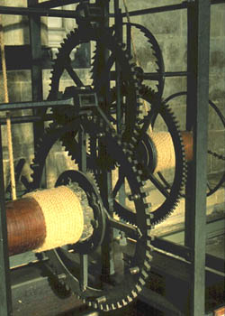
The Salisbury Cathedral Clock (1386)
The Science Museum, London

