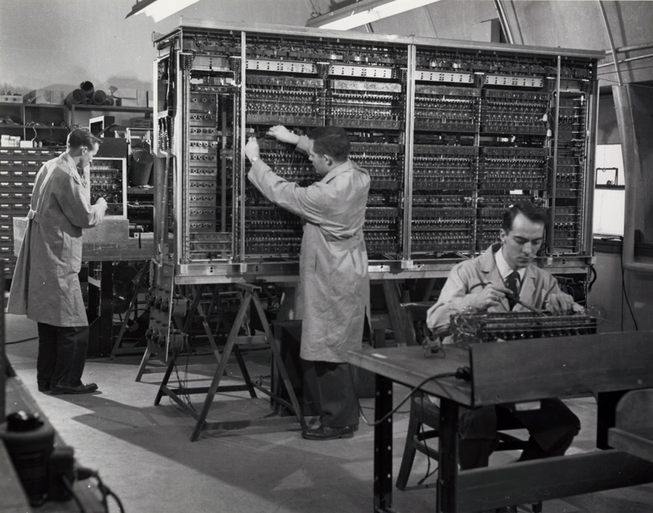

An inspiring summer school on computing at the University of Pennsylvania´s Moore School of Electrical Engineering stimulated construction of stored-program computers at universities and research institutions. Grazie alla IAS di von Neumann

This free, public set of lectures inspired the EDSAC, BINAC, and, later, IAS machine clones like the AVIDAC. Here, Warren Kelleher completes the wiring of the arithmetic unit components of the AVIDAC at Argonne National Laboratory. Robert Dennis installs the inter-unit wiring as James Woody Jr. adjusts the deflection control circuits of the memory unit.

Lo store diventa memory
Il computer diventa il cervello elettronico
Le applicazioni impegnative diventeranno intelligenza artificiale!

