WLSP Field Service Engineering (FSER) Tool

Test Script

##### Prepared: November 2016

**WLSP FSER Tool Testing -Workflow**

**Wo**.**t**,**ldl**, -',**�w**-. **�J**. **�**\ **(!**·,·. **a**. **to**>**r• ·..**

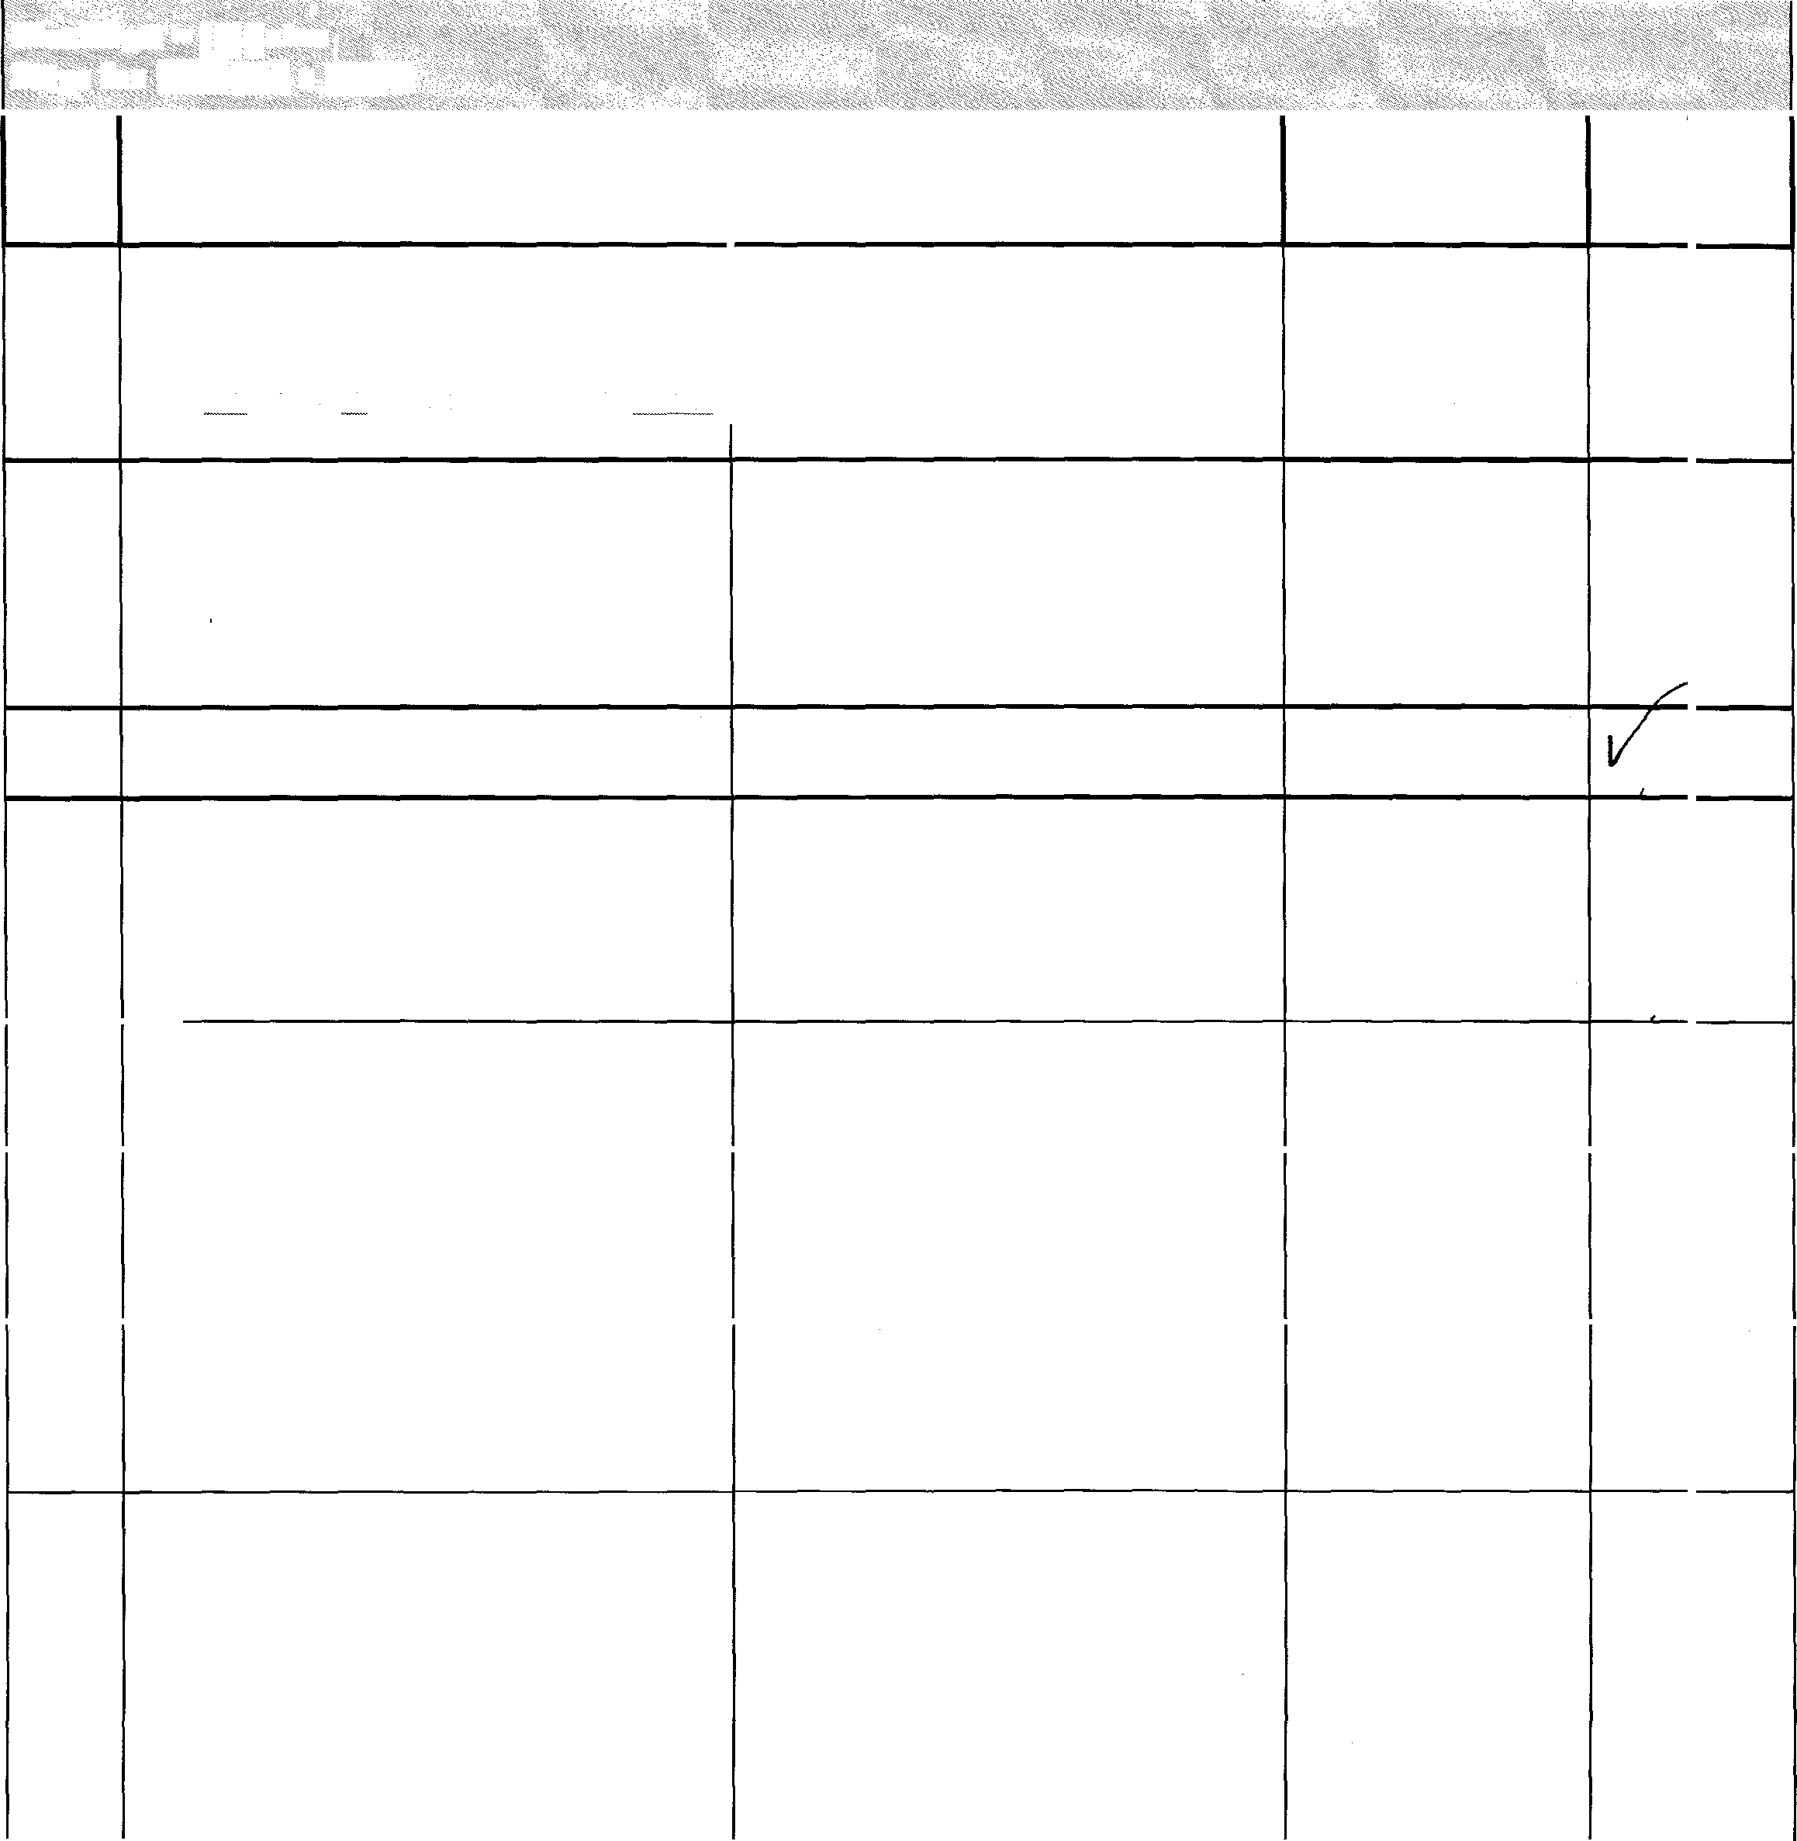

**Step**<o**s**. -**for �tinga.F$ER**

, . , . · -·· .

......

.•_

1.

.· · .. ·. ..

|  |  |  |  |
| --- | --- | --- | --- |
| **STEP ACTION**  **NO.**  Connect to the WLSP FSER Tool portal from the NGGN network via a web browser. bttp://w I�pfser. is.northropgrumman.com/ | **EVENT**  *The welcome page for the WLSP FSER tool displays in the browser* | **COMMENTS PASS** | **FAIL** |
| 1. Enter a Username and Password in the   *Log In* menu.  **Note:** The user must have permissions to create draft.   1. Click on the Log In button. 2. Hover over the *FSER Woriflow*   navigation bar.  **Note:** Optional. Click on the *Create New Draft FSER* link on the **Home** page.   1. Hover over *Initiator* in the navigation. | *Login credentials are entered.*  *WLSP FSER home page displays*  *FSER Woriflow navigation bar highlights in blue.*  *Navigation bar highlights in blue on selection* |  |
| 6. Click on *Create a Draft FSER.* | *Navigation bar highlights in blue on selection. Message box displays with Create New Draft FSER statement.* |  |  |
| 1. Click **OK** on the message box 2. Select a name from *Originator* drop­ down menu.   **Note:** *The originator is part of the testing process. This ensures that the FSER is monitored in the workflowfrom creation to completion.* | *Create a Draft FSER page displays with FSER number and originator name populated*  *Name highlights in blue and populatesfield.* |  |  |

... /..i .. ... . . . .. .

**Worktlow...;�f,iatc>i- ......**

**Steps f9r Cre?ting aJ?S�R**

.,. .. .

> . • •• . . · . . ... · ,

i . .

.. .

. .· .

·, ' • •

**STEP NO.**

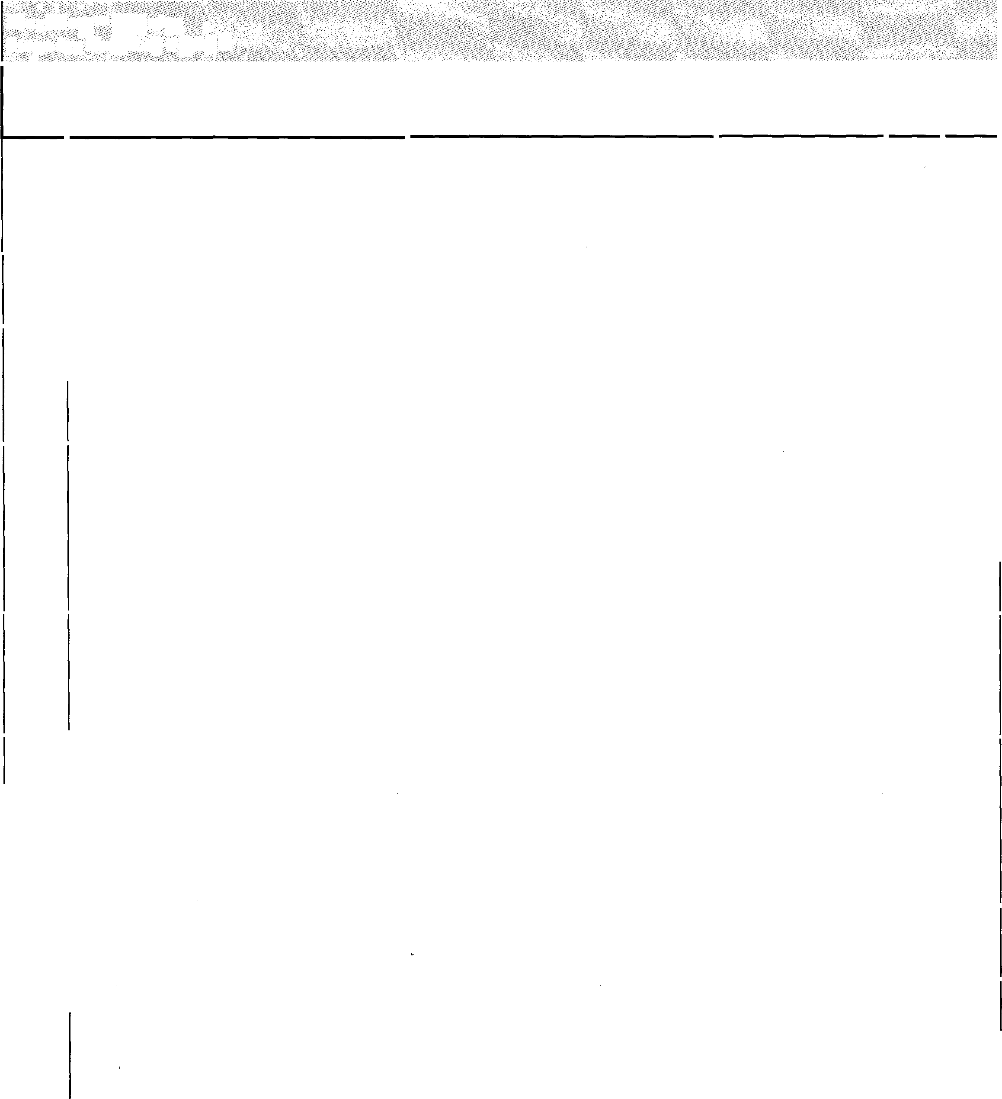

### 9.

10.

11.

12.

13.

14.

15.

16.

. ·

**ACTION**

Select group affected from the Group Affected drop-down menu.

### Select a priority from the *Priority* drop- down menu.

Click on the calendar and choose a date in the Requested Delivery Date field.

Select a query subtype from the Query SubType drop-down menu.

**Note:** Selecting Already Authorized by A/PT check box selection moves the FSER from Initiator to Level 2 (that is, it skips AIPT Level 1).

Select export license from the Export License drop-down menu.

### **Note:** Export License not required (TAA) is optional populates field if selected.

Enter an export authorization number in the Export Authorization Number drop- down menu.

### **Note:** DSEA not required check box when selected populates the field with message of not required per initiator.

Enter the problem title in the Problem Title field.

### Select related FSER affected from the

Related FSERS selection menu.

### **Note:** Hold down the CTRL key to make multiple selections.

..· ..

**EVENT COMMENTS PASS FAIL**

#### Group is highlights in blue and populatesfield.

Priority is highlights in blue and populatesfield.

Date selected highlights in blue. Current date highlights in gray. Selected date populatesfield in MMIDDIYYYYformat.

Query subtype highlights in blue and populatesfield.

Export license highlights in blue and populatesfield.

Export authorization number populates thefield

Entered problem title displays in the field.

Selected related FSERs affected highlights in blue.

|  |  |  |  |  |  |
| --- | --- | --- | --- | --- | --- |
| ·.. .. < .· . •. • : .. .  . ...  **Worktlow·�l)Jitiator**  .. ··. ·· ': . .. . . ... . ,. :· . ·. .. .. ,. . ':. . .·  **Steps fot �reating a FSEl** | | | | | |
| **STEP NO.**  17. | **ACTION**  Enter a description in the *Description* text entry box. | **EVENT**  *Entered description displays in the lfield.* | **COMMENTS** | **PASS** | **FAIL** |
| 18. | Enter the justification in the *Justification*  text entry box. | *Entered justification displays in the field.* |  |  |  |
| 19. | Select an Asset(s) Impacted  **Note:** Multiple assets can be selected by using the CTRL button. | *Selected Asset highlights in blue.* |  |  |  |
| 20. | Click on the **Attachment Management**  link in the **Attachments** field. | *The Attachment Management message displays.* |  |  |  |
| 21. | Click on a number of attachments from the drop-down menu and then click the **OK** button. | *The Upload Attachments page displays.* |  |  |  |
| 22. | Click on the **Browse** button to locate a file to attach and click on the **Submit** button. | *File to Upload displays. Selected filename displays on the Upload Attachments page.* |  |  |  |
| 23. | Click on the **Submit** button and then on the **OK** button in the attachment management display message. | *Attachment Management message displays with document uploaded successfully. Current attachments for FSER displays on the Upload Attachments page.* |  |  |  |
| 24. | Click on the **View FSER** button to return to the Create a Draft FSER page.  **Note:** To add additional attachments, click on the **Add More** button. To delete the attachment click on the **Delete** button.  A message appears when FSER has been deleted successfully, click OK. to return to the draft FSER, click on the **Home** navigation button and then click on the selected draft FSER Number **link.** | *Attachment displays in the attachmentfield.* |  |  |  |
|  | |

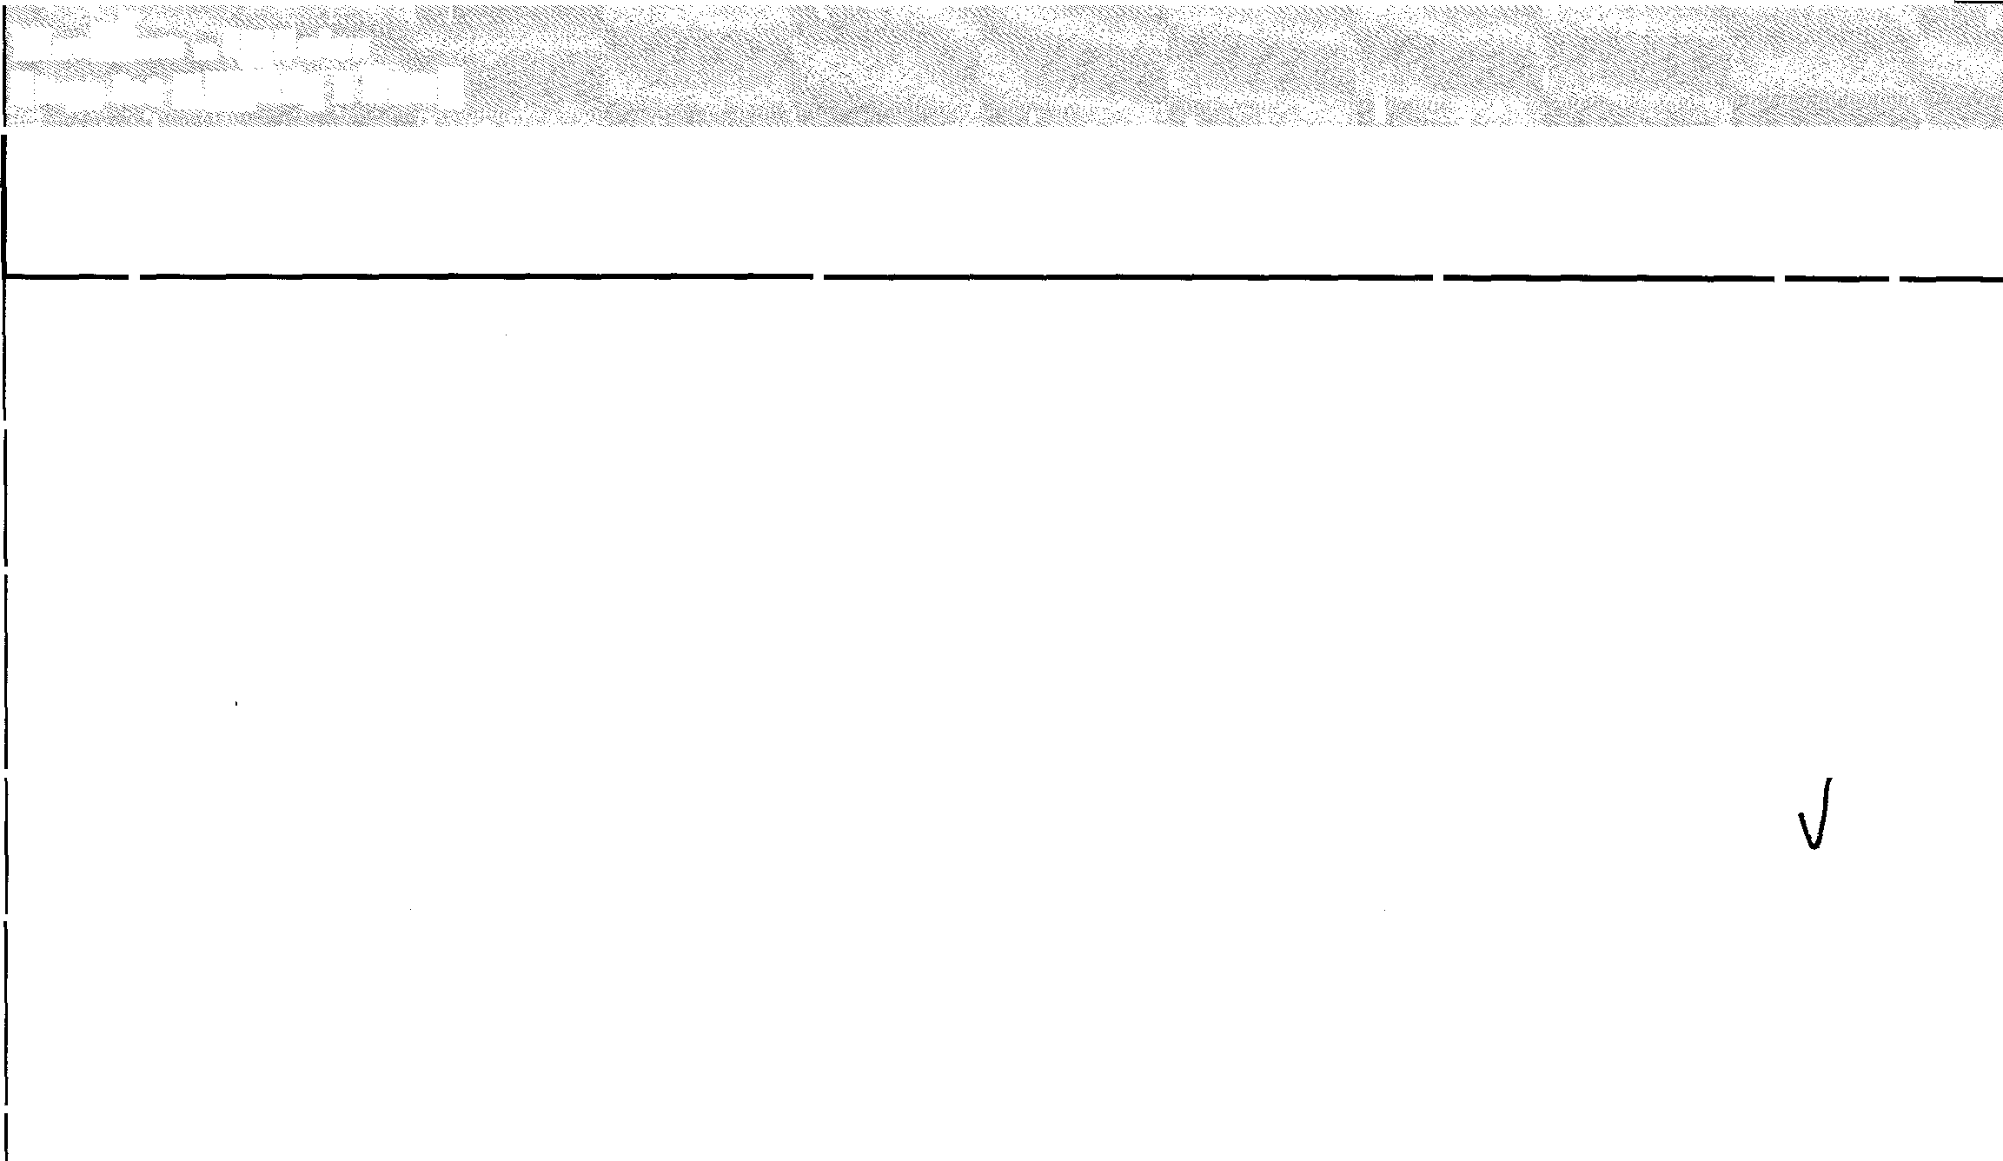



|  |  |  |  |  |
| --- | --- | --- | --- | --- |
| **Worldl<>w** '""·**Initiator . . ...**  **Steps, for C,�ati,nga FSER** •· | | | | |
| **STEP ACTION EVENT NO.**  25. Click on the **Save** button at the bottom of *Green check marks display next to* | | **COMMENTS** | **PASS** | **FAIL** |
|  | the page and then click on the **OK** *each entry field indicating a saved*  button. *FSER draft.*  **Note:** Clicking on the **Delete** button deletes the drafted FSER. A WLSP FSER Message displays. Click **OK** to return to the WLSP FSER home page. |
| 26. | Click on the **Submit** button and then the *WLSP FSER Messaging box displays*  **OK** button in the message box. *message that FSER has been* |  |  |  |
| *submitted to Level 1 (A/PT Release Authority)*  *User is returned to the WLSP FSER Home page.*  *Home page displays the FSER number, expected delivery date, problem title, and current status check mark on LI* | | |
| 27. | Notate the FSER number used for testing. | | |  |
| 28. | Click on the **Log Out** navigation button *The Welcome to WLSP FSER page*  *displays.*  *A/PT Release Authority assignees are notified via email that a FSER has been submitted.* | | |  |
| ***'[�e FSE�moves toh�velfAfP'{Rel1a��fo�****af****ptova{ Contin�efollowing the. ��tPflisted kelow:· iti· the*** *.,.,.,,,.vu* | | | | |

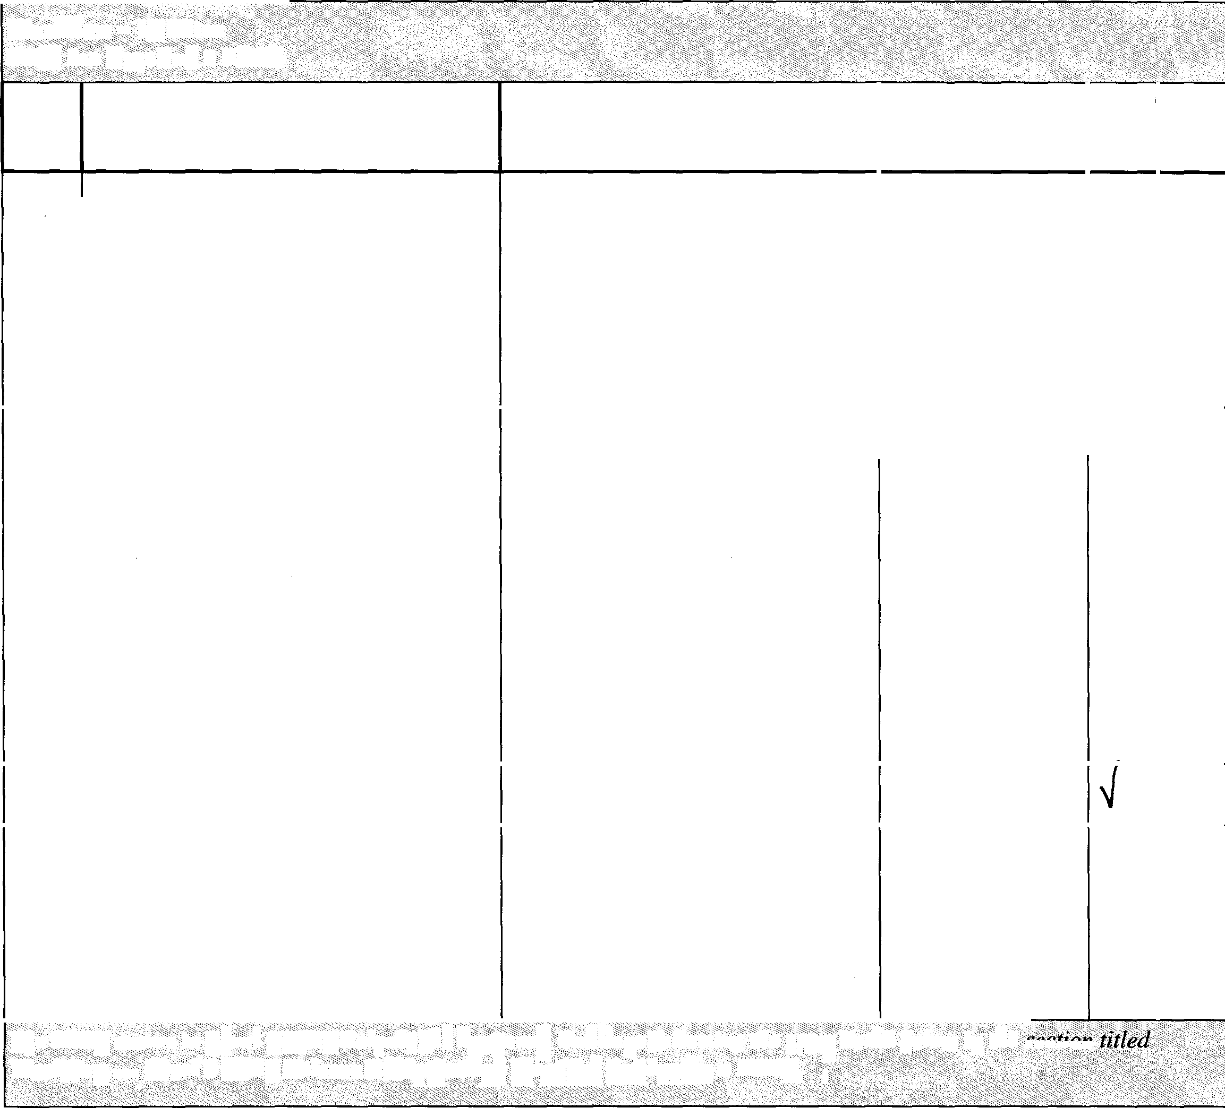

**# �ell�['!{�l'P"'!!!#� a FSEll:� . :**

**Wqrkjlo,r:-Leyel14-IPlR:elf«$t?A.u!liJ1,jzr.itif:**

**·**

|  |  |  |  |  |  |
| --- | --- | --- | --- | --- | --- |
| **Workflow - Level 1 AIPT Release Authorization Steps for Approving a FSER** | | | | | |
| **STEP**  **NO.** | **ACTIONS** | **EVENT** | **COMMENTS** | **PASS** | **FAIL** |
| 1. | Connect to the WLSP FSER Tool portal from the NGGN network via a web browser. http:/jwlspfser.is.northropgrumman.com/ | *The welcome page for the WLSP FSER tool displays in the browser* |  |  |  |
| 2. | Enter a usemame and password with Level 1 permissions (UK person) in the *Log In* field.  **Note:** Level 1 permissions users only have access this step in the workflow. | *Login credentials are entered* |  |  |  |
| 3. | Click on the **Log In** button. | *WLSP FSER home page displays* |  |  |  |
| 4. | Read the ITAR disclaimer and then click on the **Continue** button. | *FSER /TAR Disclaimer displays* |  |  |  |
| 5. | Hover over the *FSER Workjlow*  navigation bar  **Note:** The FSER ready for AIPT Release can also be accessed on the *WLSP Home* page by clicking on the FSER link in the *All Drafts* & *Open FSERs* table. If this method is used, the user is automatically taken to the *Level 1: A/PT Release Authority* page. | *FSER Workjlow navigation bar highlights in blue* |  |  |  |
| 6. | Click on the **Level lAIPT Release**  **Authority.** | *Navigation bar highlights in blue on selection. The AIPT Release Authority FSER Review link displays with a green check mark* |  |  |  |
| 7. | On the *Level 1: AIPT Release Authority*  page, click on the FSER link | *The Level 1: A/PT Release Authority page displays with the details of the FSER Request.* |  |  |  |

|  |  |  |  |  |  |
| --- | --- | --- | --- | --- | --- |
| **Workffow** - **Level 1 AIPT Release Authorization Steps for Approving a FS£R** | | | | | |
| **STEP NO.** | **ACTIONS** | **EVENT** | **COMMENTS** | **PASS** | **FAIL** |
| 8. | Review the details of the FSER Request. Select the within scope **Yes** radio button, select Yes in the Priority drop-down menu, and then click on the **Approve** button. | *WLSP FSER Messaging displays a message stating the FSER has been accepted by the A/PT Release Authority. An OK button displays.* |  |  |  |
| 9. | Click on the **OK** button. | *Originator receives an email message stating acceptance of FSER. The originator will continue to be notified of FSER status as it moves through the worliflow.*  *User is returned to the WLSP FSER Homepage.* |  |  |  |
| 10. | Click on the **Log Out** button. | *The welcome page for the WLSP FSER tool displays in the browser* |  |  |  |
| *The FSER moves to Level 2 NGTSfor approval. Continue following the steps listed below in the section titled* ***Workflow*** -  ***Level*** *2* ***NGTS Approval Steps for NGTS Approval***  . .. | | | | | |

|  |  |  |  |  |  |
| --- | --- | --- | --- | --- | --- |
| **Work.flow•,, Level 2 NGTS Approval Steps for NGTS Approval** | | | | | |
| **STEP**  **NO.** | **ACTION** | **EVENT** | **COMMENTS** | **PASS** | **FAIL** |
| 1. | Connect to the WLSP FSER Tool portal from the NGGN network via a web browser. httg://wlsufser.is.northroggrumman.com/ | *The welcome page for the WLSP FSER tool displays in the browser* |  |  |  |
| 2. | Enter the usemame and password for a  *Level 2* user in the *Log In* field. | *Login credentials are entered* |  |  |  |
| 3. | Click on the **Log In** button. | *WLSP FSER home page displays* |  |  |  |
| 4. | Hover over the *FSER Workflow*  navigation bar. | *FSER Workflow navigation bar highlights in blue* |  |  |  |
| 5. | Select *Level 2 NGTS Approval* | *Navigation bar highlights in blue on selection. The Level 2 NGTS Approval page displays with the NGTS Approval FSER Review table. The FSER to work has a green check mark.* |  |  |  |
| 6. | Click on the FSER link in the *NGTS Approval FSER Review* table. | *The Level 2: NGTS Approval page displays.* |  |  |  |
| 7. | Review the details of the FSER Request |  |  |  |  |
| 8. | Select a *TAA* and choose *NGAS* as the  *Lead Assignment* in NGTS section | *Selection highlights in blue. Approve and Reject button display on the page.* |  |  |  |

|  |  |  |  |  |  |
| --- | --- | --- | --- | --- | --- |
| **Workflow** - **Level 2 NGTS Approval Steps for NGTS Approval** | | | | | |
| **STEP**  **NO.** | **ACTION** | **EVENT** | **COMMENTS** | **PASS** | **FAIL** |
| 9. | Click on the **Approve** button. | *WLSP FSER Messaging displays that the FSER has been accepted at NGTS Approval.*  *The FSER originator receives an email message stating acceptance of FSER. The originator will continue to be notified of FSER status as it moves through the workflow.* |  |  |  |
| 10. | Click the **OK** button. | *The Home page displays.* |  |  |  |
| 11. | Click on the **Log Out** button. | *The WLSP FSER Welcome page displays.* |  |  |  |
| *The FSER moves to Level 3 NGTS for acceptance. Continue following the steps listed in section* ***Workflow*** - ***Level 3 Acceptance Steps for Level 5 Approval Type*** | | | | | |

|  |  |  |  |  |  |
| --- | --- | --- | --- | --- | --- |
| .. . ·. ·.·  .; •. .. . . .;..... .• . •. . ....•. :· ....>. .....  **Wei- qw 1,,ev,1_3 f p nr**··•.·.  **St ps f()r 1,,ev J pPt()val 1:!f ••·** ....... . ...... . . | | | | | |
| **STEP NO.** | **ACTIONS** | **EVENT** | **COMMENTS** | **PASS** | **FAIL** |
| 1. | Connect to the WLSP FSER Tool portal from the NGGN network via a web browser. http://lxlspfscr.is.northrop2:rumman.com/ | *The welcome page for the WLSP FSER tool displays in the browser* |  |  |  |
| 2. | Enter the usemame and password for a  *Level 3* user in the Log In field. | *Login credentials are entered* |  |  |  |
| 3. | Click on the **Log In** button. | *WLSP FSER home page displays* |  |  |  |
| 4. | Hover over the *FSER Workflow*  navigation bar. | *FSER Workflow navigation bar highlights in blue* |  |  |  |
| 5. | Select **Level 3 Acceptance.** | *Navigation bar highlights in blue on selection* |  |  |  |
| 6. | On the **Level 3: NGAS Acceptance**  page, click on the FSER link  Review the details of the FSER Request | *NGAS Acceptance link displays with a green check mark* |  |  |  |
| 7. |
|  | |
| 8. | Click on the **<100 Hours** button in the *Message appears. Keep at NGAS*  Hours Breakdown section. *under JOO hours must be approved before proceeding. Group and*  **Note:** If great than 100 hours is chosen, *Assignee must be selected.*  the FSER will move back to Level lAIPT Release for authorization.  Click on the **Specify Group and** *Level 3 NGAS Approval home page*  **Assignee** button. *displays* | |  |  |  |
| 9. |
| 10. | Select a *Group Assignment* from the *Selection is highlights in blue*  drop-down menu. | |  |  |  |
| 11. | Select the actionee. *Selection is highlights in blue*  **Note:** For testing purposes, select your own name as the actionee. | |  |  |  |

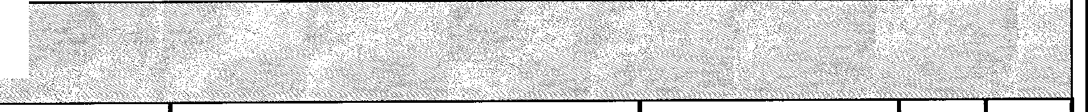

|  |  |  |  |  |  |  |  |
| --- | --- | --- | --- | --- | --- | --- | --- |
| ,°' <' ' ' " ',' - ,,,  'iorliiow q! l,l.t\ c pt i .,r  s(;f() :k,ve1SA,.e,pr(},v,1wiJ> ··· | | |  | | | | |
| **STEP NO.** | **ACTIONS** |  |  | **EVENT** | **COMMENTS** | **PASS** | **FAIL** |
| 12. | Select ***Level 5*** as the FSER Approval Type.  **Note:** There are three options at this step Level 5, Peer Review, and TRB. The remainder of the steps below is for Level 5 only.  Follow the steps in the sections titled:  \****Steps for Peer Review Approval Type*** and ***\*Steps for TRB Approval Type*** for Peer Review and TRB selections. | | | *Selection is highlights in blue* |  |  |  |
| 13. | Select a funding source in the *Funding Source* section | | | *Selection is highlights in blue* |  |  |  |
| 14. | Click on the calendar and select an  *Expected Delivery Date.* | | | *Date is populated in the entry field. An Accept and Reject button displays.* |  |  |  |
| 15. | Click on the **Accept** button. | | | *WLSP FSER Message appears. NGAS has been accepted and group and actionee have been assigned.*  *The FSER* is *now considered InWork.*  *Originator receives an email message stating acceptance of FSER.*  *Originator will continue to be notified of FSER status as it moves through the wodiflow.*  *Actionees continue to update the status in the Level 4 step Periodic Status* |  |  |  |
| 16. | Click on the **OK** button. | | | *The WLSP Home page displays.* |  |  |  |
| 17. | Click on the **Log Out** button. | | | *The WLSP Welcome page displays.* |  |  |  |
| *The FSER has been accepted and group and actionees have been assigned. The FSER is now considered InWork. Continue ollowing the steps listed in section* ***Workjlow Step*** - ***Level 4 Periodic Status Steps*** *for Entering Periodic & Final Status.* | | | | | | | |

|  |  |  |  |  |  |
| --- | --- | --- | --- | --- | --- |
| ., .. : ..  **WorldJ'>'t•::: *tel..* 4 ift i e** :  **\***o**S**<,,o>**p**', ,**s**" **,**' **(**, **9x**'-' ,**-**, **l**s**>**' ' **e**' , **f**'- **;**<C**i**,**,«**,o,,' **r**,,<**f**,,**i**a' **w**', '**.**, **J**, **\**,'<**.p**> **p**> **1**,'<**:**',< , **f**•' **yp**< ,**e**_,,, ...··••··•• *'i* | | .·· ':. ... *,,r·* ''.<<  .:} ../. . .·· | > ':'>.  : .· .. . .. | .... ·...· | ·.:c• ••.  ·,  .... |
| **STEP NO.** | **ACTIONS** | **EVENT** | **COMMENTS** | **PASS** | **AIL** |
| *The following steps below are for Level 3 Acceptance with Peer Review Approval* | | | | | |
| **1.** | Connect to the WLSP FSER Tool portal from the NGGN network via a web browser.  httg://wls12fscr.i-.,.nonhro122:rumman.com/ | *The welcome page for the WLSP FSER tool displays in the browser* |  |  |  |
| 2. | Enter the username and password for a  *Level 3* user in the Log In field. | *Login credentials are entered* |  |  |  |
| 3. | Click on the **Log In** button. | *WLSP FSER home page displays* |  |  |  |
| 4. | Hover over the *FSER Workflow*  navigation bar. | *FSER Workflow navigation bar highlights in blue* |  |  |  |
| 5. | Select **Level 3 Acceptance.** | *Navigation bar highlights in blue on selection* |  |  |  |
| 6. | On the **Level 3: NGAS Acceptance**  page, click on the FSER link | *NGAS Acceptance link displays with a green check mark* |  |  |  |
| 7. | Review the details of the FSER Request |  |  |  |  |
| 8. | Click on the **<100 Hours** button in the Hours Breakdown section. | *Message appears. Keep at NGAS under JOO hours must be approved before proceeding. Group and Assignee must be selected.* |  |  |  |
| 9. | Click on the **Specify Group and Assignee** button. | *Level 3 NGAS Approval home page displays* |  |  |  |
| 10. | Select a Group Assignment. | *Selection highlights in blue* |  |  |  |
| 11. | Select an as the actionee. | *Selection highlights in blue* |  |  |  |

\y() w. 4te13 cceptllnce···

! t (t<e t f P,r,0f !

## STEP ACTIONS NO.

**EVENT COMMENTS PASS FAIL**

1. Select ***Peer Review*** as the FSER Approval Type.

##### **Note:** There are three options at this step Level 5, Peer Review, and TRB. The remainder of the steps is for Peer Review Only.

*See steps titled Accepting FSER as **Level 5** and **Accepting FSER as TRB Approval Type** for further instructions.

Selection highlights in blue

1. Select a funding source **in** the *Funding Source* section

Selection highlights in blue

##### Click on the calendar and select an

Expected Delivery Date.

Date is populated in the entry field. An Accept and Reject button displays.

1. Click on the **Accept** button. *WLSP FSER Message appears.*

NGAS has been accepted and group and actionee have been assigned.

The FSER is now considered InWork.

Originator receives an email message stating acceptance of **FSER.**

Originator will continue to be notified of **FSER** status as it moves through the workflow.

1. Click on the **OK** button. *The WLSP Home page displays.*
2. Click on the **Log Out** button. *The WLSP Welcome page displays.*

The FSER moves to Level 4 for the assignee to update Periodic & Final Status. Continue following the steps below.

##### Connect to the WLSP FSER Tool portal from the NGGN network via a web browser.

http://\vlspfser.i. .northropgrumman.corn,/

The welcome page for the WLSP FSER tool displays in the browser.



WLSP FSER Tool Test Script 12

|  |  |  |  |  |  |  |  |  |  |  |  |  |  |  |  |  |  |  |  |  |  |  |  |  |  |  |
| --- | --- | --- | --- | --- | --- | --- | --- | --- | --- | --- | --- | --- | --- | --- | --- | --- | --- | --- | --- | --- | --- | --- | --- | --- | --- | --- |
| ;; *:* ; '":, ,<: . ;.'.;•;. ;·.. .: *')*  **Wof "' ', v l3.4.cc pt'nc ,,** .·••·· ,. | | |  |  |  |  | .. |  |  |  |  | ... | •· | . |  | ·' |  | * .. |  |  |  |  |  |  | *./* |  |
| **\*Step$fo,rPeer,**  *<':'>,-:-,,,-_-,,'_>',* ,,:_:. -, ,',;,,,\,,-, | | **e ew..!pproval 'fype·**  *,,,<'->:* ,,, '-<=---> "",,,,',,'''-, °'-- "' \ ,' | .. | .>. | :· | ...., | . | | . | •; | ,,······.·.·. | .· | | | | •; | ;· .. :. , | .. | | . | .. |  | ··. | .• | .. |  |
| **STEP**  **NO.** | **ACTIONS** | | | | **EVENT** | | | | | | | **COMMENTS** | | | | | | | | **PASS** | | **FAIL** | | | | |
| 19. | Enter the *Assignee* usemame and password. | | | | *Login credentials are entered* | | | | | | |  | | | | | | | |  | |  | | | | |
| 20. | Click on the Log In button. | | | | *WLSP FSER home page displays.* | | | | | | |  | | | | | | | |  | |  | | | | |
| 21. | Hover over the *FSER Workflow*  navigation bar. | | | | *FSER Workflow navigation bar highlights in blue* | | | | | | |  | | | | | | | |  | |  | | | | |
| 22. | Select **Level 4 Periodic Status** | | | | *The Level 4: NGAS Periodic Status & Final Response page displays with the Final Review & Closure table* | | | | | | |  | | | | | | | |  | |  | | | | |
| 23. | Click on the FSER ID link in the *Final Review & Closure* table. | | | | *The Level 4: NGAS Periodic Status*  *& Final Response page displays* | | | | | | |  | | | | | | | |  | |  | | | | |
| 24. | Select the **Periodic** radio button in the status type section. | | | |  | | | | | | |  | | | | | | | |  | |  | | | | |
| 25. | Slide the estimated completion to 50%. | | | | *50% displays* | | | | | | |  | | | | | | | |  | |  | | | | |
| 26. | Enter text in the *Periodic Update* entry box. | | | | *Text populates entry box. Update FSER and Cancel button display.* | | | | | | |  | | | | | | | |  | |  | | | | |
| 27. | Click on the **Update FSER** button. | | | | *FSER progress chart displays showing 50% status.* | | | | | | |  | | | | | | | |  | |  | | | | |
| 28. | Select the **Final** radio button in the status type section | | | | *Estimated* % *completion default of 100% displays.* | | | | | | |  | | | | | | | |  | |  | | | | |
| 29. | Enter text in the *Final Update* entry box. | | | | *Text populates entry box. Update FSER and Cancel button display* | | | | | | |  | | | | | | | |  | |  | | | | |
| 30. | Click on the **Update FSER** button. | | | | *WLSP FSER Messaging displays with message that the FSER has been submitted to Level 5.* | | | | | | |  | | | | | | | |  | |  | | | | |
| 31. | Click on the **OK** button. | | | | *WLSP FSER home page displays in the browser.* | | | | | | |  | | | | | | | |  | |  | | | | |

|  |  |  |  |  |  |  |  |  |
| --- | --- | --- | --- | --- | --- | --- | --- | --- |
| . . .·. ;.  Wo"rldlo! . r e\3  *Steps for, er It viewA pPJa_v;·•";  r -l f,i-o al T ;;;_;, ... ;-.  c , C <':,/ ' ",,, ,," ;'' ,' c,,,, / o' ',-,,C '',',,,,, *t;'*,,,,,, */'* ,, ' ,, ,,,,, ,-, | | ""' . .  './  ...• ';:;!' .,. ... "· *:* j'.;·..· ,·_.<}, | | .·. */* .  < ;,_ >: '· .. > | ;; | ·.··  ;;,·.·._;.· | | . |
| **STEP**  **NO.** | **ACTIONS** | | **EVENT** | **COMMENTS** | **PAS** |  | **FAIL** | |
| 32. | Click on the **Log Out** button. | | *The Welcome page for the WLSP FSER tool displays in the browser* |  |  |  | | |
| *The FSER moves to Level 5 for Peer Review. Continue following the steps below to replicate each Peer Review user.* | | | | | | | | |
| 33. | Connect to the WLSP FSER Tool portal from the NGGN network via a web browser. httg://vvhpt\er.is.northropgrumman.com/ | | *The welcome page for the WLSP FSER tool displays in the browser* |  |  |  | | |
| 34. | Enter the usemame and password for a *Continuing Airworthiness* user in the Log In field. | | *Login credentials are entered. The Home page displays with the All Draft* & *Open FSERs table* |  |  |  | | |
| 35. | Click on the FSER link in the *All Draft* &  *Open FSERs* table. | | *The Level 5: Peer Review page displays with the FSER link and a message indicating how my records are available.*  *The Peer Review FSER table for the FSER displays with an Approve button.* |  |  |  | | |
| 36. | Click on the **Approve** button in the  *Continuing Airworthiness* column | | *Level 5: Peer Review page displays* |  |  |  | | |
| 37. | Click on the **Log out** button | | *Welcome to WLSP FSER welcome page displays* |  |  |  | | |
| 38. | Connect to the WLSP FSER Tool portal from the NGGN network via a web  browser.  httQ://,vlspfscr.is.nurthropgruinman.eorn/ | | *The welcome page for the WLSP*  ***FSER*** *tool displays in the browser* |  |  |  | | |
| 39. | Enter the usemame and password for a *Systems Engineering Integration* user in the Log In field. | | *Login credentials are entered. The Home page displays with the All Draft* & *Open FSERs table* |  |  |  | | |

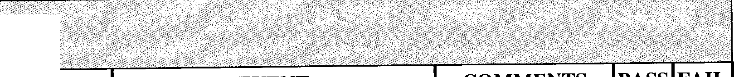

|  |  |  |  |  |  |  |
| --- | --- | --- | --- | --- | --- | --- |
| **\V()rkflow·· .•·, vel c!p n e,**  **\* ieetf0 rPeei:!t l, i&ft>JJ!0 ",tr,n,**· | |  | | | | |
| **STEP**  **NO.** | **ACTIONS** |  | **EVENT** | **COMMENTS** | **PASS** | **FAIL** |
| 40. | Click on the link with the correct FSER in the *All Draft & Open FSERs* table | | *The Level 5: Peer Review page displays with the FSER link and a message indicating how my records are available.*  *The Peer Review* ***FSER*** *table for the* ***FSER*** *displays with an Approve button.* |  |  |  |
| 41. | Click on the **Approve** button in the  *Systems Engineering Integration* column | | *Level 5: Peer Review page displays* |  |  |  |
| 42. | Click on the **Log out** button | | *Welcome to WLSP FSER welcome page displays* |  |  |  |
| 43. | Connect to the WLSP FSER Tool portal from the NGGN network via a web browser. | | *The welcome page for the WLSP FSER tool displays in the browser* |  |  |  |
| 44. | Enter the usemame and password for a  *Quality* user in the Log In field. | | *Login credentials are entered. The Home page displays with the All Draft & Open FSERs table* |  |  |  |
| 45. | Click on the link with the correct FSER  **in** the *All Draft & Open FSERs* table | | *The Level 5: Peer Review page displays with the FSER link and a message indicating how my records are available.*  *The Peer Review* ***FSER*** *table for the FSER displays with an Approve button.* |  |  |  |
| 46. | Click on the **Approve** button in the  *Quality* column | | *Level 5: Peer Review page displays*  *WLSP FSER Message appears stating that the FSER has been accepted at Peer Review and is now at Level 6 (Export Approval)* |  |  |  |



il< t piJ,tf ! ew[4pproyalJyp·e

**ACTIONS**

\\'9r 'tv "'4fet , ceptll!fe. :.·••·•· •..•·

**EVENT**

**COMMENTS PASS FAIL**

The FSER is submitted to Level 6 Export Approval. Follow the steps listed in section **Workflow** - **Level 6 Export Approval Steps for Submitting FSERs for Export**

Welcome to WLSP FSER welcome page displays

Click on the **Log out** button

48.

WLSP home page displays

Click on the **OK** button.

47.

**STEP NO.**

|  |  |  |  |  |  |
| --- | --- | --- | --- | --- | --- |
| .·• •·.  **Workflow _;Level 3 Accepta11ce** •·  **\*Stepito**.**r**.**TRIJ Approval Type**  ,.· " | | | | | |
| **STEP**  **NO.** | **ACTIONS** | **EVENT** | **COMMENTS** | **PASS** | **FAIL** |
| *The following steps below are for Level 3 Acceptance with TRB Approval* | | | | | |
| 1. | Connect to the WLSP FSER Tool portal from the NGGN network via a web browser.  httD://,\ lsofser 1s.no11hroo2rumman .com/ | *The welcome page for the WLSP FSER tool displays in the browser* |  |  |  |
|  |
| 2. | Enter the usemame and password for a  *Level 3* user in the *Log In* field. | *Login credentials are entered* |  |  |  |
| 3. | Click on the **Log In** button. | *WLSP FSER home page displays* |  |  |  |
| 4. | Hover over the *FSER Worliflow*  navigation bar. | *FSER Workflow navigation bar highlights in blue* |  |  |  |
| 5. | Select **Level 3 Acceptance.** | *Navigation bar highlights in blue on selection* |  |  |  |
| 6. | On the **Level 3: NGAS Acceptance**  page, click on the FSER link | *NGAS Acceptance link displays with a green check mark* |  |  |  |
| 7. | Review the details of the FSER Request. |  |  |  |  |

|  |  |  |  |  |  |
| --- | --- | --- | --- | --- | --- |
| ... . ... .· .: •:.: ... > ...••. ..: .·· ... :·•··  *i•Sftreot•·•, . ev Ja A e jtanc•·. *·ff}* .  ... : t.o..r..T..R..B:.4..•..1.1.p.r..9..yf.i.l·f•·y..pe. .·.. :; . : ... .•. .: . >; *?: .* :> . . <... /< .. . ··. .;• . | | | | | |
| **STEP**  **NO.** | **ACTIONS** | **EVENT** | **COMMENTS** | **PASS** | **FAIL** |
| 8. | Click on the **<100 Hours** button in the Hours Breakdown section. | *Message appears. Keep at NGAS under100 hours must be approved before proceeding. Group and Assignee must be selected.* |  |  |  |
| 9. | Click on the **Specify Group and Assignee** button. | *Level 3 NGAS Approval home page displays* |  |  |  |
| 10. | Select a Group Assignment. | *Selection highlights in blue* |  |  |  |
| 11. | Select an as the actionee. | *Selection highlights in blue* |  |  |  |
| 12. | Select ***TRB*** as the *FSER Approval Type.*  **Note:** There are three options at this step Level 5, Peer Review, and TRB. The remainder of the steps is for TRB Only.  *See steps titled ***Accepting FSER as Level* 5** and ***Accepting_ FSER as Peer*** | *Selection highlights in blue. An Accept and Reject button display.* |  |  |  |
| ***Review Al!J!.roval*** for further instructions. |
| 13. | Select a funding source **in** the *Funding Source* section | *Selection highlights in blue* |  |  |  |
| 14. | Click on the calendar and select an  *Expected Delivery Date.* | *Date is populated in the entry field. An Accept and Reject button displays.* |  |  |  |
| 15. | Click on the **Accept** button. | *WLSP FSER Message appears. NGAS has been accepted and group and actionee have been assigned.*  *The FSER is now considered InWork.*  *Originator receives an email message stating acceptance of FSER.*  *Originator will continue to be notified of FSER status as it moves through the workflow.* |  |  |  |

|  |  |  |  |  |  |  |  |
| --- | --- | --- | --- | --- | --- | --- | --- |
| l | V l'lcfl ?J'iefelJ .·' . *./* ·.···· .·. ..  J<Steps·torTRB c.t P! ll ·· ........ | | | < • ....  ... | |  | .. |
|  | | | | | | | |
| **STEP NO.** | | **ACTIONS** | **EVENT** | **COMMENTS** | **PASS** | **FAIL** | |
| 16. | | Click on the **OK** button. | *The WLSP Home page displays.* |  |  |  | |
| 17. | | Click on the **Log Out** button. | *The WLSP Welcome page displays.* |  |  |  | |
| *The FSER moves to Level 4 for the assignee to update Periodic & Final Status. Continue following the steps below.* | | | | | | | |
| 18. | | Connect to the WLSP FSER Tool portal from the NGGN network via a web browser. httg://\vlsgfser,is.northrog12:rumman.com/ | *The welcome page for the WLSP FSER tool displays in the browser.* |  |  |  | |
| 19. | | Enter the *Assignee* usemame and password. | *Login credentials are entered* |  |  |  | |
| 20. | | Click on the **Log In** button. | *WLSP FSER home page displays.* |  |  |  | |
| 21. | | Hover over the *FSER Work.flow*  navigation bar. | *FSER Worleflow navigation bar highlights in blue* |  |  |  | |
| 22. | | Select **Level 4 Periodic Status.** | *The Level 4: NGAS Periodic Status & Final Response page displays with the Final Review & Closure table* |  |  |  | |
| 23. | | Click on the FSER ID link in the *Final Review & Closure* table. | *The Level 4: NGAS Periodic Status*  *& Final Response page displays* |  |  |  | |
| 24. | | Select the **Periodic** radio button in the  *Status Type* section. |  |  |  |  | |
| 25. | | Slide the estimated completion to 50%. | *50% displays* |  |  |  | |
| 26. | | Enter text in the *Periodic Update* entry box. | *Text populates entry box. Update FSER and Cancel button display.* |  |  |  | |
| 27. | | Click on the **Update FSER** button. | *FSER progress chart displays showing 50% status.* |  |  |  | |
| 28. | | Select the **Final** radio button in the status type section | *Estimated* % *completion default of 100% displays.* |  |  |  | |

**

|  |  |  |  |  |  |
| --- | --- | --- | --- | --- | --- |
| **STEP**  **NO.** | **ACTIONS** | **EVENT** | **COMMENTS** | **PASS** | **FAIL** |
| 29. | Enter text in the *Final Update* entry box. *Text populates entry box. Update*  *FSER and Cancel button display* | |  |  |  |
| 30. | Click on the **Update FSER** button. | *WLSP FSER Messaging displays with message that the FSER has been submitted to Level* 5. |  |  |  |
| 31. | Type in a TRB Number and then click on *WLSP FSER Messaging box displays*  the **Add TRB Number** button. *a message that the FSER has been*  *assigned a TRB number and has been submitted at Level 6. An OK button displays* | |  |  |  |
| 32. | Click on the **OK** button. | *WLSP FSER home page displays in the browser.* |  |  |  |
| 33. | Click on the **Log Out** button. | *The Welcome page for the WLSP FSER tool displays in the browser* |  |  |  |
| *Th FSER is submitted to Level 6 Export Approval. Continue following the steps listed in section* ***Workflow*** '- ***Level 6 E port Approval Steps for Submitting FSERs for Export.*** | | | | | |

|  |  |  |  |  |
| --- | --- | --- | --- | --- |
| **Workflow - Level 4 Periodic Status Steps for Entering Periodic & Final Status** | | | | |
| **STEP ACTIONS EVENT COMMENTS**  **NO.** | | | | **PASS FAIL** |
| *1.* Connect to the WLSP FSER Tool portal from the NGGN network via a web browser. *hug://wlsr.1fser.is.northro[12:mmman.com/* | | *The welcome pagefor the WLSP FSER tool displays in the browser.* |  |
| 2. Enter the *Assignee* usemame and password. | | *Login credentials are entered* |  |  |
| Click on the Log In button. | | *WLSP FSER home page displays.* |  |  |
| 4. Hover over the *FSER Workflow*  navigation bar. | | *FSER Worliflow navigation bar highlights in blue* |  |  |
| 5. Select **Level 4 Periodic Status** | | *The Level 4: NGAS Periodic Status & Final Response page displays with the Final Review & Closure table* |  |  |
| *6.* Click on the FSER ID link in the *Final Review & Closure* table. | | *The Level 4: NGAS Periodic Status & Final Response page displays* |  |  |
| 7. Select the **Periodic** radio button in the status type section. | |  |  |  |
| 8. Slide the estimated completion to 50%. | | *50% displays* |  |  |
| 9. Enter text in the *Periodic Update* entry box. | | *Text populates entry box. Update FSER and Cancel button display.* |  |  |
| 10. Click on the **Update FSER** button. | | *FSER progress chart displays showing 50% status.* |  |  |
|  |  |
| 11. Select the **Final** radio button in the status type section | | *Estimated* % *completion default of 100% displays.* |  |  |
| 12. Enter text in the *Final Update* entry box. | | *Text populates entry box. Update FSER and Cancel button display* |  |  |
| 13. Click on the **Update FSER** button. | | *WLSP FSER Messaging displays with message that the FSER has been submitted to Level 5.* |  |  |

**

3.

WLSP FSER Tool Test Script 20

|  |  |  |  |  |  |
| --- | --- | --- | --- | --- | --- |
| **Workflow- Level 4 Periodic Status Steps for Entering Periodic** & **Final Status** | | | | | |
| **STEP NO.** | **ACTIONS** | **EVENT** | **COMMENTS** | **PASS** | **FAIL** |
| 14. | Click on the **OK** button. | *WLSP FSER home page displays in the browser.* |  |  |  |
| 15. | Click on the **Log Out** button. | *The Welcome page for the WLSP FSER tool displays in the browser* |  |  |  |
| *The Periodic and Final status comments have been saved and submitted to level* 5. *Continue following the steps listed in section* ***Workflow Step*** - ***Level 5 Release Steps for Reviewing FSER*** & ***Release.*** | | | | | |



**STEP**

**ACTIONS**

**EVENT**

**COMMENTS PASS FAIL**

**NO.**

Enter the username and password for a Login credentials are entered Level 5 user in the Log In field.

Click on the **Log In** button.

WLSP FSER home page displays.

Hover over the FSER Worliflow

navigation bar.

FSER Worliflow navigation bar highlights in blue

Select **Level 5 Release.**

Selection highlights in blue. The Level 5: Release page displays with the Release table.

Click on the FSER ID link in the Final The Level 5: Release page displays. Review & Closure table.

Review the detailed FSER information FSER Request Detail Information

and the Status Updates. and Status Updates display. An Approve and Reject button displays.

7.

6.

S.

4.

3.

2.

The welcome page for the WLSP FSER tool displays in the browser

Connect to the WLSP FSER Tool portal from the NGGN network via a web browser.

1.



|  |  |  |  |  |  |
| --- | --- | --- | --- | --- | --- |
| **STEP NO.** | **ACTIONS** | **EVENT** | **COMMENTS** | **PASS** | **FAIL** |
| 8. | Click on the **Approve** button. | *Screen displays that the FSER has been accepted at Release.* |  |  |  |
| 9. | Click on the **Log Out** button. | *The Welcome page for the WLSP FSER tool displays in the browser* |  |  |  |
| *The FSER is accepted at level 5 release. Continue following the steps listed in section* ***Workflow Step*** - ***Level 6 Export Approval Steps for Submitting FSERs for Export.*** | | | | | |

|  |  |  |  |  |  |
| --- | --- | --- | --- | --- | --- |
| ' :, . ... . . . ·.· ·· ..  **Wotktlow....., evel 6 Exi,ort 4pproval**  **Steps for Submit@g fS ltsfor xpQrt** . ·.  ' ·.• •·... • • •• ' ··c . •• ..,..,, <. <f' •. <., ·. | | | | | |
| **STEP**  **NO.** | **ACTIONS** | **EVENT** | **COMMENTS** | **PASS** | **FAIL** |
| 1. | Connect to the WLSP FSER Tool portal from the NGGN network via a web browser.  httn://w lsnfser.i,.northromrnimman corn/ | *The welcome page for the WLSP FSER tool displays in the browser* |  |  |  |
| 2. | Enter the usemame and password for a  *Level 6* user in the *Log In* field. | *Login credentials are entered* |  |  |  |
| 3. | Click on the **Log In** button. | *WLSP FSER home page displays.* |  |  |  |
| 4. | Hover over the *FSER Workflow*  navigation bar. | *FSER Workflow navigation bar highlights in blue* |  |  |  |
| 5. | Select **Level 6 Export Approval** | *Selection highlights in blue. The Level 6: Export Control page displays* |  |  |  |
| 6. | Click on the *Submit FSERs and Contact Logs for /TAR Approval* link. | *The Non-Export Controlled FSERs table displays with a send button* |  |  |  |

|  |  |  |  |  |  |
| --- | --- | --- | --- | --- | --- |
| .. .. .. . , ....•... ·. ··....·•. . : . ·:.• .· ... . ·. . .·•··:· . • *,·,i/t/ 'J*  **W fld191" .teyeJf *. '1.*!\pprq!ai1** .>' Z>  **t psfor J!b,mi gFSEl&fof E.xpor**.**t**··  ,·. ·, ', . " ,·,· '< «:.. " ....'..\·.\ ., .... '·. . ,,,•• •. ',· ... .··....···..  . .. i\ . ..:::. :..*.)* : | | | | | |
| **STEP NO.** | **ACTIONS** | **EVENT** | **COMMENTS** | **PASS** | **FAIL** |
| 7. | Click on the **Send** button. | *A message displays on the Level 6: Export Control page that the /TAR Spreadsheet has been prepared and sent as an email for further distribution.* |  |  |  |
| 8. | Click on the **Log Out** button. |  |  |  |  |
| *Follow the guidelines for submitting the* ***ITAR*** *spreadsheet and receiving the authorization number.* | | | | | |
| 9. | Reconnect to the WLSP FSER Tool portal from the NGGN network via a web browser.  [http://wlspfser.is.northropgrumm 1n.com/](http://wlspfser.is.northropgrumm1n.com/) | *The welcome page for the WLSP FSER tool displays in the browser* |  |  |  |
| 10. | Enter the username and password for a  *Level 6* user in the *Log In* field. | *Login credentials are entered* |  |  |  |
| 11. | Click on the **Log In** button. | *WLSP FSER home page displays.* |  |  |  |
| 12. | Hover over the *FSER Workflow*  navigation bar. | *FSER Workflow navigation bar highlights in blue* |  |  |  |
| 13. | Select **Level 6 Export Approval** | *Selection highlights in blue. The Level 6: Export Control page displays.* |  |  |  |
| 14. | Click on the *Process Submitted FSERS and Contact Logs.* | *The Level 6: Export Control page displays with an entry field for input of the authorization number. An Update Export Control Status and Cancel button displays.* |  |  |  |
| 15. | Enter the authorization number for the FSER and click on the **Update Export Control Status** button. | *The Export Control page displays with a message that the FSER has been updated with a DSEA number and closed.* |  |  |  |
| 16. | Click on the **Log Out** button. | *The Welcome page for the WLSP FSER tool displays in the browser* |  |  |  |

**

**

|  |  |  |  |  |  |  |
| --- | --- | --- | --- | --- | --- | --- |
| W'orldl •• rel6 J!:jJ,()tf 1pfJi'()tal  **S! psf r,S11\ipit ,i E :!01; xll':)rt** | |  | | | | |
| **STEP NO.** | **ACTIONS** |  | **EVENT** | **COMMENTS** | **PASS** | **FAIL** |
| *The FSER is updated with a DSEA number. Continue following the steps listed in* ***Workjlow-Acknowledge Receipt Steps or Acknowledging Receipt of FSER.*** | | | | | | |

|  |  |  |  |  |  |
| --- | --- | --- | --- | --- | --- |
| **STEP NO.** | **ACTIONS** | **EVENT** | **COMMENTS** | **PASS** | **FAIL** |
| 1. | Connect to the WLSP FSER Tool portal from the **NGGN** network via a web browser. http://wlspfscr.is.northropgrnmman.comt' | *The welcome page for the* ***WLSP FSER*** *tool displays in the browser* |  |  |  |
| 2. | Enter the *Originators* usemame and password the in the *Log In* field. |  |  |  |  |
| 3. | Click on the **Log In** button. | *WLSP FSER home page displays* |  |  |  |
| 4. | Click on the **FSER Workflow** button in the navigation bar. | *The FSER Workflow Home page displays.* |  |  |  |
| 5. | Click on the **Acknowledge Receipt**  button on the workflow. | *The Acknowledge Receipt of FSER page displays with the Unacknowledged FSER Request table.* |  |  |  |
| 6. | Click on the FSER in the *FSER ID*  column. |  |  |  |  |
| 7. | Using the drop-down fields, select a **1,** 2, 3, or 4 **in** the accuracy, completeness, coordination, timeliness, overall satisfaction. |  |  |  |  |
| 8. | Enter comments in the  *Comments/Recommendations* entry field |  |  |  |  |

**

**

|  |  |  |  |  |  |
| --- | --- | --- | --- | --- | --- |
| **STEP NO.** | **ACTIONS** | **EVENT** | **COMMENTS** | **PASS** | **FAIL** |
| 9. | Select the **Yes/No** radio button in the *Would you like someone to contact you* field. |  |  |  |  |
| 10. | Click on the I **Acknowledge Receipt**  button. | *The Acknowledge Receipt of FSER page displays with the Previously Acknowledged FSER Requests table.* |  |  |  |
| 11. | Click on the **Log Out** button on the navigation bar. |  |  |  |  |
| *The FSER has been acknowledged in the worliflow. Continue following the steps listed in* ***Workflow -Acknowledge Receipt Steps for Submitting FSER Recommendation Survey*** | | | | | |

|  |  |  |  |  |  |
| --- | --- | --- | --- | --- | --- |
| **STEP NO.** | **ACTIONS** | **EVENT** | **COMMENTS** | **PASS** | **FAIL** |
| 1. | Connect to the WLSP FSER Tool portal from the NGGN network via a web browser. | *The welcome page for the WLSP FSER tool displays in the browser* |  |  |  |
| 2. | Enter a **Username** and **Password** in the  *Log In* field.  **Note:** The user must be the Originator. | *Login credentials are entered* |  |  |  |
| 3. | Click on the Log In button. | *WLSP FSER home page displays.* |  |  |  |
| 4. | Hover over the **FSER Workflow** button. | *Navigation bar highlights in blue on selection* |  |  |  |
| 5. | Click on *FSER Recommendations Survey.* | *The FSER Recommendation Survey page displays with FSER that have surveys completed.* |  |  |  |

WLSP FSER Tool Test Script 25



|  |  |  |  |  |  |
| --- | --- | --- | --- | --- | --- |
| **STEP**  **NO.** | **ACTIONS** | **EVENT** | **COMMENTS** | **PASS** | **FAIL** |
| 6. | Click on a FSER in the FSER ID column. | *The Recommendations Usage and Comments page displays.* |  |  |  |
| 7. | Select and *Recommendation Usage* from the drop-down menu.  **Note:** If *Recommendations Accepted as Written, but with Changes* or *Not Accepted* is selected, then comments  must be entered in the *Comments* field. | *Selection highlights in blue.* |  |  |  |
|  | |
| 8. | Enter comments in the *Comments* entry field. | *Entered comments displays* |  |  |  |
| 9. | Click on the **Submit** button. | *The FSER Recommendation Survey page displays.* |  |  |  |
| 10. | Click on the *Log Out* button. | *The WLSP FSER Welcome page displays.* |  |  |  |

# WLSP FSER Tool Testing -Workflow FSER Rejection

**Note:** The following steps are for Reiecting a FSER at various points in the FSER Worliflow.

|  |  |  |  |  |  |
| --- | --- | --- | --- | --- | --- |
| **Workflow Step** - **Level 1 AIPT Release Authorization Steps for Rejecting a FSER at Level 1** | | | | | |
| **STEP NO.** | **ACTION** | **EVENT** | **COMMENTS** | **PASS** | **FAIL** |

1. Connect to the WLSP FSER Tool portal *The welcome page for the WLSP* from the NGGN network via a web *FSER tool displays in the browser* browser.



http://\vlspber.is.northro1grumman.com/

1. Enter a username and password with *Login credentials are entered*

Level 1 permissions (UK person) in the

Log In field.

**Note:** Level 1 permissions users only have access this step in the workflow.

1. Click on the **Log In** button. *WLSP FSER home page displays*
2. Read the ITAR disclaimer. Click on the *FSER /TAR Disclaimer displays*

**Continue** button.

1. Hover over the *FSER Worliflow FSER Worliflow navigation bar*

navigation bar highlights in blue

**Note:** The FSER ready for AIPT Release can also be accessed on the WLSP Home page by clicking on the FSER link in the All Drafts & Open FSERs table. If this method is used, the user is automatically taken to the Level 1: A/PT Release Authority page.

1. Click on *Level IA/PT Release Authority Navigation bar highlights in blue on*

selection

1. On the *Level 1: AJPT Release Authority A/PT Release Authority FSER*

page, click on the FSER link Review link displays with a green

check mark

|  |  |  |  |  |  |
| --- | --- | --- | --- | --- | --- |
| **Workflow Step - Level 1 AIPT Release Authorization Steps for Rejecting a FSER at Level 1** | | | | | |
| **STEP NO.** | **ACTION** | **EVENT** | **COMMENTS** | **PASS** | **FAIL** |
| 8. | Review the details of the FSER Request, select **No** radio button, select a priority from the Priority drop-down menu, and then click on the **Reject** button. | *A text entry box for reason for the rejection displays.* |  |  |  |
| 9. | Type in a reason for the rejection of the FSER and then click on the **Reject** button. | *The Level 1: A/PT Release Authority page displays with the message that the rejection information has been successfully updated.*  *The FSER originator is notified via email the FSER was rejected.*  *The FSER moves back to Initiator Create Draft.* |  |  |  |
| 10. | Click on the **Log Out** button. | *The welcome page for the WLSP FSER tool displays in the browser* |  |  |  |
| *The FSER is rejected and the FSER Originator is notified via email. The FSER moves back to the Initiator step in the WLSP FSER Workflow.* | | | | | |

|  |  |  |  |  |  |
| --- | --- | --- | --- | --- | --- |
| **Worktlow Step -Level 2NGTS Approval Steps for Rejecting a FSER at Level 2** | | | | | |
| **STEP NO.** | **ACTION** | **EVENT** | **COMMENTS** | **PASS** | **FAIL** |

**

|  |  |  |  |  |  |
| --- | --- | --- | --- | --- | --- |
| 1. | Connect to the WLSP FSER Tool portal from the NGGN network via a web browser. http://\vlspfser.is.n011hropgrumman.com/ | *The welcome page for the WLSP FSER tool displays in the browser* |  |  |  |
| 2. | Enter the usemame and password for a  *Level 2* user in the Log In field. | *Login credentials are entered* |  |  |  |
| 3. | Click on the **Log In** button. | *WLSP FSER home page displays* |  |  |  |
| 4. | Hover over the *FSER Worliflow*  navigation bar | *FSER Workflow navigation bar highlights in blue* |  |  |  |
| 5. | Select *NGTS Approval.* | *Navigation bar highlights in blue on selection* |  |  |  |
| 6. | On the *Level 2: NGTS Approval* page, click on the FSER link  Review the details of the FSER Request | *NGTS Approval FSER Review link displays with a green check mark* |  |  |  |
| 7. |
| 8. | Select a *TM* and choose *NGAS* as the Lead Assignment in NGTS section | *Selection highlights in blue* |  |  |  |
| 9. | Click on the **Reject** button. | *A text entry box for reason for the rejection displays.* |  |  |  |
| 10. | Type in a reason for the rejection of the FSER and then click on the **Reject** button. | *The Level 2: NGTS Approval page displays with the message that the rejection information has been successfully updated.*  *The FSER originator is notified via email the FSER was rejected.*  *The FSER moves back to Level I A/PT Release Authorization.* |  |  |  |

|  |  |  |  |  |  |
| --- | --- | --- | --- | --- | --- |
| **Workflow Step -Level 2 NGTS Approval Steps for Rejecting a FSER at Level 2** | | | | | |
| **STEP**  **NO.** | **ACTION** | **EVENT** | **COMMENTS** | **PASS** | **FAIL** |
| 11. | Click on the **Log Out** button. | *The welcome page for the WLSP FSER tool displays in the browser* |  |  |  |
| *The FSER is rejected and the FSER Originator is notified via email. The FSER moves back to the Level 1 Release Authority step in the WLSP FSER Workjlow.* | | | | | |

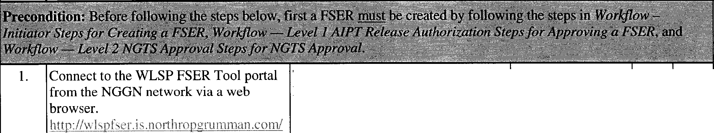

|  |  |  |  |  |  |
| --- | --- | --- | --- | --- | --- |
| **Workflow Step** - **Level 3 Acceptance Steps for Rejecting a FSER at Level 3** | | | | | |
| **STEP NO.** | **ACTION** | **EVENT** | **COMMENTS** | **PASS** | **FAIL** |

|  |  |  |  |  |  |
| --- | --- | --- | --- | --- | --- |
| The welcome page for the WLSP FSER tool displays in the browser | | |  |  |  |
|  |  |  |
| 2. | Enter the username and password for a  *Level 3* user in the Log In field. | *Login credentials are entered* |  |  |  |
| 3. | Click on the **Log In** button. | *WLSP FSER home page displays* |  |  |  |
| 4. | Hover over the *FSER Workflow*  navigation bar. | *FSER Workflow navigation bar highlights in blue* |  |  |  |
| 5. | Select **Level 3 Acceptance.** | *Navigation bar highlights in blue on selection* |  |  |  |
| 6. | On the **Level 3: NGAS Acceptance**  page, click on the FSER link | *NGAS Acceptance link displays with a green check mark* |  |  |  |
| 7. | Review the details of the FSER Request | *The NGAS FSER Request table displays.* |  |  |  |

|  |  |  |  |  |  |
| --- | --- | --- | --- | --- | --- |
| **Workflow Step- Level 3 Acceptance Steps for Rejecting a FSER at Level 3** | | | | | |
| **STEP**  **NO.** | **ACTION** | **EVENT** | **COMMENTS** | **PASS** | **FAIL** |
| 8. | In the NGAS Acceptance, click on the  **Reject** button. | *A text entry box displays* |  |  |  |
| 9. | Type in rejection comments and click on the **Reject** button. | *The Level 3: NGAS Acceptance page displays with the message that the rejection information has been successfully updated.* |  |  |  |
| 10. | Click on the **Log Out** button. | *The Welcome page for the WLSP FSER tool displays in the browser* |  |  |  |
| *The FSER is rejected and moves back to Level 2 for approval/rejection. If the FSER was tagged as an already authorized by A/PT during create draft submission, the then FSER moves back to Level I instead of Level 2.* | | | | | |

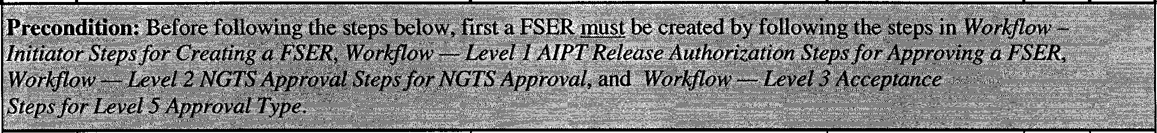

|  |  |  |  |  |  |
| --- | --- | --- | --- | --- | --- |
| **Workflow Step - Level 5 Release Steps for Rejecting a FSER at Level 5** | | | | | |
| **STEP**  **NO.** | **ACTION** | **EVENT** | **COMMENTS** | **PASS** | **FAIL** |

|  |  |  |  |  |  |
| --- | --- | --- | --- | --- | --- |
| 1. | Connect to the WLSP FSER Tool portal *The welcome page for the WLSP* from the NGGN network via a web *FSER tool displays in the browser* browser.  bttp:Hw Ispfst>r.i s. no rth rop0 rumman.corn/ | |  |  |  |
| 2. | Enter the username and password for a  *Level 5* user **in** the *Log In* field. | *Login credentials are entered* |  |  |  |
| 3. | Click on the **Log In** button. | *WLSP FSER home page displays.* |  |  |  |
| 4. | Hover over the *FSER Workflow*  navigation bar. | *FSER Workflow navigation bar highlights in blue* |  |  |  |
| 5. | Select **Level 5 Release.** | *Selection highlights in blue* |  |  |  |

|  |  |  |  |  |  |
| --- | --- | --- | --- | --- | --- |
| **Workflow Step - Level 5 Release Steps for Rejecting a FSER at Level 5** | | | | | |
| **STEP**  **NO.** | **ACTION** | **EVENT** | **COMMENTS** | **PASS** | **FAIL** |
| 6. | Click on the FSER ID **link** in the *Final Release* table. | *NGAS Release table displays* |  |  |  |
| 7. | Review the detailed FSER information and the Status Updates. | *FSER Request Detail Information and Status Updates display.* |  |  |  |
| 8. | Click on the **Reject** button. | *Level 5: Release page displays with an Reason for Rejection entry box* |  |  |  |
| 9. | Enter reason for rejection in the entry text entry box and then click on the **Reject** button. | *Level 5: Release page displays with the message that the FSER has been rejected. The FSER moves back to Level 3 for Review.* |  |  |  |
| 10. | Click on the **Log Out** button. | *The Welcome page for the WLSP FSER tool displays in the browser* |  |  |  |
| *The FSER is rejected and moves back to Level 3 for approval/rejection.* | | | | | |

WLSP FSER Tool Testing - Gaining Access to WLSP FSER



**WLSPFSER Tool**

**St psfor Loggi11g'l11 {k Joggitjg()ut**

**ACTION**

**EVENT**

**COMMENTS PASS FAIL**

Connect to the WLSP FSER Tool portal The welcome page for the WLSP from the NGGN network via a web FSER tool displays in the browser browser.

[htt p://wlspfser .is .northropgru mman .com/](http://wlspfser.is.northropgrumman.com/)

Enter a usemame and password for in the Login credentials are entered Log In field.

Click on the Log In button.

WLSP FSER home page displays

Click on the **Log Out** button on the navigation bar.

Welcome to WLSP FSER page displays.

**Note:** In ord. i;r tq fogi? .o th e WLSPfSER tool, arz accountinust be req1.1.ested, Follow the steps in **WLSP FSER '1'6o1Steps or Requesting an Account**

4.

3.

2.

1.

**STEP NO.**

|  |  |  |  |  |  |  |  |
| --- | --- | --- | --- | --- | --- | --- | --- |
| .·..· ...  **WLSP FSER Tool**  **Stepsfor ForgotJ:>ass ord**  .. ·•.· .... *ii* ·.·· | | | | | | | |
| **STEP NO.** | **ACTION** | **EVENT** | **COMMENTS** | **PASS** | | | **FAIL** |
| *Follow the steps below to request your password ifyoitalready have access to the* ***WLSP FSER*** *tool.*  ·.....·· ·•····... · .. ·. .·•.··••. | | | | _,,_- | .· | _::-.-.,_ | |
| 1. | Connect to the WLSP FSER Tool portal from the NGGN network via a web | *The welcome page for the WLSP FSER tool displays in the browser* |  |  | | |  |
|  | browser.  [http://w lspfser.is.northropgru mman.com/](http://wlspfser.is.northropgrumman.com/) |  |
| 2. | Click on the **Forgot Password**  navigation button. | *The Reset Your Password page displays.* |  |  | | |  |
| 3. | Enter a user id **in** the User ID entry field. |  |  |  | | |  |

|  |  |  |  |  |  |
| --- | --- | --- | --- | --- | --- |
| **WLSP FSER Tool**  **Steps for Forgot Password** | | | | | |
| **STEP NO.** | **ACTION** | **EVENT** | **COMMENTS** | **PASS** | **FAIL** |
| 4. | Click on the Submit button. | *The enter your security response entry box displays.* |  |  |  |
| 5. | Enter the answer in the security box and then click on the Submit button. | *The page displays a message that the password has been reset. An email is sent with a new password.* |  |  |  |
| 6. | Click on the red X in the window to close the WLSP tool. | *Open email to access new password* |  |  |  |

|  |  |  |  |  |  |
| --- | --- | --- | --- | --- | --- |
| **WLSP FSER Tool**  **Steps for Requesting Account** | | | | | |
| **STEP**  **NO.** | **ACTION** | **EVENT** | **COMMENTS** | **PASS** | **FAIL** |
| *Follow the steps below to request a WLSP FSER account if you do not have access to the WLSP FSER tool.* | | | | | |
| 1. | Connect to the WLSP FSER Tool portal from the NGGN network via a web browser.  httn ://w1'.infser is;.nonhrno2:ru mman.com/ | *The welcome page for the WLSP FSER tool displays in the browser* |  |  |  |
| 2. | Click on the **Request Account**  navigation button. | *The Request a FSER Account page displays.* |  |  |  |
| 3. | Enter user information and create a security question and answer. |  |  |  |  |
| 4. | Click on the **Submit** button. | *The Request a FSER Account page displays with a message that the user request has been sent. FSER administrator is notified of request via email.* |  |  |  |
| 5. | Click on the red **X** in the window. | *WLSP FSER tool is closed.* |  |  |  |

|  |  |  |  |  |  |
| --- | --- | --- | --- | --- | --- |
| **WLSP FSER Tool**  **Steps for Contacting the Administrator** | | | | | |
| **STEP NO.** | **ACTION** | **EVENT** | **COMMENTS** | **PASS** | **FAIL** |
| *Follow the steps below to Request help from the WLSP FSER administrator. Login to the FSER tool is not required.* | | | | | |
| 1. | Connect to the WLSP FSER Tool portal from the NGGN network via a web browser.  httn-//wlsnfs,·r.1s n .n "1"'11unrnan ,nm/ | *The welcome page for the WLSP FSER tool displays in the browser* |  |  |  |
| 2. | Click on the **Contact Admin** navigation button. | *The Request Help entry box displays.* |  |  |  |
| 3. | Type in an email address, subject, and question and then click on the **Request Help** button. | *Message* is *sent to the administrator. A copy of the email is sent to the message sender.* |  |  |  |
| 4. | Click on the red **X** in the window. | *WLSP FSER tool is closed.* |  |  |  |

# WLSP FSER Tool Testing- Initiator Functions

|  |  |  |  |  |  |
| --- | --- | --- | --- | --- | --- |
| **Restoring a Saved Draft FSER** | | | | | |
| **STEP NO.** | **ACTION** | **EVENT** | **COMMENTS** | **PASS** | **FAIL** |
| *The steps below are used to replicate a user returning to a previous drafted FSER that was not complete. First, follow steps 1-12 to create a draft and save and then continue with steps 13-18 to return to the saved draft for completion.* | | | | | |
| 1. | Connect to the WLSP FSER Tool portal from the NGGN network via a web browser.  httD://wlsofscr 1s.northromrrumman.com/ | *The welcome page for the WLSP FSER tool displays in the browser* |  |  |  |
| 2. | Enter a **Username** and **Password** in the  *Log In* field.  **Note:** The user must be the Originator of the FSER to modify the FSER fields. | *Login credentials are entered* |  |  |  |
| 3. | Click on the **Log In** button. | *WLSP FSER home page displays.* |  |  |  |
| 4. | Click on the **FSER Workflow** navigation button. | *Navigation bar highlights in blue on selection* |  |  |  |
| 5. | Hover over *Initiator* in the navigation. | *Navigation bar highlights in blue on selection* |  |  |  |
| 6. | Click on **Create a Draft FSER.** | *Navigation bar highlights in blue on selection. Message box displays with Create New Draft FSER statement* |  |  |  |
| 7. | Click **OK** on the message box | *Create a Draft FSER page displays with FSER number and originator name populated.* |  |  |  |
| 8. | Note the FSER number. |  |  |  |  |
| 9. | Select a name from **Originator** drop- down menu. | *Name is highlighted in blue and populates field.* |  |  |  |
| 10. | Select a group in the Group Affected. | *Group is highlighted in blue and populates field.* |  |  |  |

|  |  |  |  |  |  |
| --- | --- | --- | --- | --- | --- |
| **Restoring a Saved Draft FSER** | | | | | |
| **STEP**  **NO.** | **ACTION** | **EVENT** | **COMMENTS** | **PASS** | **FAIL** |
| 11. | Click the **Save** button at the bottom of the page.  **Note:** A FSER saves automatically when created. Although, it will not save any inputted entry fields unless the user clicks on the **Save** button. | *Message displays that the FSER XX- XXXX has been saved* |  |  |  |
| 12. | Click the **Log Out** button on the navigation bar. | *The welcome page for the WLSP FSER tool displays in the browser* |  |  |  |
| 13. | Reconnect to the WLSP FSER Tool portal from the NGGN network via a web browser. http://v,;lspfst'r.is.nonhropgrnmman. 9m/ | *The welcome page for the WLSP FSER tool displays in the browser* |  |  |  |
| 14. | Enter the **Username** and **Password** in the  *Log In* field. | *Login credentials are entered* |  |  |  |
| 15. | Click on the **Log In** button. | *WLSP FSER Home page displays.* |  |  |  |
| 16. | Hover over *Initiator* in the navigation. | *Navigation bar highlights in blue on selection* |  |  |  |
| 17. | Select the *FSER Workflow* > *Restore A Save Draft.*  **Note:** A saved draft can also be accessed on the *WLSP Home* page by clicking on the FSER link in the *All Drafts & Open FSERs* table. If this short cut is used, the *Continue a Draft* page displays the **link** to the previously created draft. Click on the link and the Create a Draft FSER page displays. | *Navigation bar highlights in blue on selection. The Create a Draft FSER page displays.* |  |  |  |
| 18. | Click on the FSER link on the *Continue a Draft FSER page.* | *FSER Request page displays with saved FSER information from previous entry* |  |  |  |
| *Continue inputting information in the create a draft entry fields by following the steps in the section titled* ***Workflow*** -  ***Initiator Steps for Creating a FSER*** | | | | | |

|  |  |  |  |  |  |
| --- | --- | --- | --- | --- | --- |
| **Adding and Removing Attachments to/from FSERs - Current/Historic** | | | | | |
| **STEP**  **NO.** | **ACTION** | **EVENT** | **COMMENTS** | **PASS** | **FAIL** |
| *Use the steps below to add or remove attachments from a FSER already created.* | | | | | |
| 1. | Connect to the WLSP FSER Tool portal from the NGGN network via a web browser.  httJ;r//,'-' ls11fser. is.northrom;ru mman .com/ | *The welcome page for the WLSP FSER tool displays in the browser* |  |  |  |
| 2. | Enter a **Username** and **Password** in the  *Log In* field.  **Note:** The user must be the Originator of the FSER to modify the FSER fields. | *Login credentials are entered* |  |  |  |
| 3. | Hover over the **FSER Workflow** button. | *Navigation bar highlights in blue on selection* |  |  |  |
| 4. | Hover over *Initiator* > *Add Current Attachments*  **Note:** Changes to Historic attachments follows the same steps listed below. | *Selection highlights in blue. The Add Current FSER Attachments page displays.* |  |  |  |
| 5. | Click on the FSER in the *FSER ID*  column | *A Please Select Attachment for FSER displays* |  |  |  |
| 6. | Enter a description in the *Description*  entry field. | *The field populates* |  |  |  |
| 7. | Click on the Browse button and navigate to the attachment on the computer. |  |  |  |  |
| 8. | Click on the **Upload File** button. | *WLSP FSER Messaging appears with a message that the attachment added successfully.* |  |  |  |
| 9. | Click on the **OK** button. | *The Add Current FSER Attachments page displays.* |  |  |  |
| 10. | Click on the **Log Out** button. | *The WLSP FSER Welcome page displays.* |  |  |  |

|  |  |  |  |  |  |
| --- | --- | --- | --- | --- | --- |
| **Adding and Removing Attachments to/from FSERs - Current/Historic** | | | | | |
| **STEP**  **NO.** | **ACTION** | **EVENT** | **COMMENTS** | **PASS** | **FAIL** |
| **11.** | Reconnect to the WLSP FSER Tool portal from the NGGN network via a web browser.  httQ:/ /wls Qfse r.is.northroQQ:rumman.com/ | *The welcome page for the WLSP FSER tool displays in the browser* |  |  |  |
| 12. | Enter a **Username** and **Password** in the  *Log In* field.  **Note:** The user must be the Originator of the FSER to modify the FSER fields. | *Login credentials are entered* |  |  |  |
| 13. | Hover over the **FSER Workflow** button. | *Navigation bar highlights in blue on selection* |  |  |  |
| 14. | Hover over *Initiator* > *Remove Current Attachments*  **Note:** Changes to Historic attachments follows the same steps below. | *Selection highlights in blue. The Delete FSER Attachments page displays.* |  |  |  |
| 15. | Click on the FSER in the *FSER ID*  column  **Note:** Click on a FSER that already has a FSER attachment. | *A Delete FSER Attachments table displays.* |  |  |  |
| 16. | Click on the **Delete** button. | *WLSP FSER Messaging appears with a message that the attachment has been deleted. An Ok button displays.* |  |  |  |
| 17. | Click on the **OK** button. | *The Remove Current FSER*  *Attachments page displays.* |  |  |  |
| 18. | Click on the **Log Out** button. | *The WLSP FSER Welcome page displays.* |  |  |  |

|  |  |  |  |  |  |
| --- | --- | --- | --- | --- | --- |
| **Modifying FSER Fields** | | | | | |
| **STEP NO.** | **ACTION** | **EVENT** | **COMMENTS** | **PASS** | **FAIL** |
| . •' ...· */* ...· ..  . . .. . · .· ... . .. .... . ·.. .·. .., . i *• • .i* . *i* ,. ·<  *Follow th,e siepf brlowlo M:Qdifya F$ERalreddy created*  ·. ·.···• ·. \ */,..··* | | | | | |
| **1.** | Connect to the WLSP FSER Tool portal from the NGGN network via a web browser.  httg ://wlspfser.is.no rth roggrumman.com / | *The welcome page for the WLSP FSER tool displays in the browser* |  |  |  |
| 2. | Enter a **Username** and **Password** in the  *Log In* field.  **Note:** The user must be the Originator of the FSER to modify the FSER fields. | *Login credentials are entered* |  |  |  |
| 3. | Click on the **Log In** button. | *WLSP FSER home page displays.* |  |  |  |
| 4. | Hover over the **FSER Workflow** button. | *Navigation bar highlights in blue on selection* |  |  |  |
| 5. | Hover over *Initiator* | *Selection highlights in blue.* |  |  |  |
| 6. | Click on *Modify FSER Fields.* | *The Originator Modify FSER Fields page displays with the Available FSERs table.* |  |  |  |
| 7. | Click on a FSER link. | *The page displays with editable lfields .* |  |  |  |
| 8. | Make changes to each of the original values by selecting from the drop-down menus. | *New selections highlight in blue.* |  |  |  |
| 9. | Enter change notes in the *Change Notes*  entry field. | , |  |  |  |
| 10. | Click on the **Update FSER** button. | *WLSP FSER Messaging displays with a message that the FSER has been successfully updated.* |  |  |  |
| 11. | Click on the **OK** button. | *Originator Modify FSER Fields page displays .* |  |  |  |

|  |  |  |  |  |  |
| --- | --- | --- | --- | --- | --- |
| **Modifying FSEll Fields** | | | | | |
| **STEP**  **NO.** | **ACTION** | **EVENT** | **COMMENTS** | **PASS** | **FAIL** |
| 12. | Click on the **Log Out** button. | *The WLSP FSER Welcome page displays.* |  |  |  |

|  |  |  |  |  |  |
| --- | --- | --- | --- | --- | --- |
| **Replacing and Deleting Attachments** | | | | | |
| **STEP NO.** | **ACTION** | **EVENT** | **COMMENTS** | **PASS** | **FAIL** |
| ··.·.· ···.·... ·. ... . ........ .. ...> . ·····. .. ·... .. ..··. *t* . •···.·.·..·.·  *Follow the steps below to Replace or Delete Auachments inFSER already created.*  .•···· ·.· • . · • <.• .··.•·•··. · •·.·• .· ..··.. . ·.••··•·. .·.•···· •• ··•····· | | | | | |
| 1. | Connect to the WLSP FSER Tool portal from the NGGN network via a web browser.  htt p://wls pfser .is .no rth rop2:rtm1man.com/ | *The welcome page for the WLSP FSER tool displays in the browser* |  |  |  |
| 2. | Enter a **Username** and **Password** in the  *Log In* field.  **Note:** The user must be the Originator. | *Login credentials are entered* |  |  |  |
| 3. | Click on the **Log In** button. | *WLSP FSER home page displays.* |  |  |  |
| 4. | Click on Replace Attachments | *The Replace Historic Attachments page displays.* |  |  |  |
| 5. | Click on the link *Replace Attachments for New FSER Requests.*  **Note:** The same steps below apply for replacing attachments for Historic FSER requests. | *The Replace New Attachments page displays with a table with Open and Closed FSERs* |  |  |  |
| 6. | Click on a FSER link with the status as open. | *FSER Attachments display* |  |  |  |
| 7. | Click on the FSER attachment in the *File Description* column. | *A Select Replacement for the Attachment entry field displays.* |  |  |  |

|  |  |  |  |  |  |
| --- | --- | --- | --- | --- | --- |
| **Replacing and Deleting Attachments** | | | | | |
| **STEP**  **NO.** | **ACTION** | **EVENT** | **COMMENTS** | **PASS** | **FAIL** |
| 8. | Enter a change reason in the *Change Reason* entry field. |  |  |  |  |
| 9. | Enter a description in the *Description*  field. |  |  |  |  |
| 10. | Click on the **Browse** button and navigate to a new attachment on the computer.  **Note:** To delete the attachment, simply click on the **Delete this Attachment** button. A message of deletion displays on the Replace New Attachments page. | *Choose file to upload displays and populates the file name entry field* |  |  |  |
| 11. | Click on the **Update** button. | *The Replace New Attachments page displays.* |  |  |  |
| 12. | Click on the **Log Out** button. | *The WLSP FSER Welcome page displays.* |  |  |  |

|  |  |  |  |  |  |
| --- | --- | --- | --- | --- | --- |
| **Adding a FSER Summary** | | | | | |
| **STEP**  **NO.** | **ACTION** | **EVENT** | **COMMENTS** | **PASS** | **FAIL** |
| *The FSER Summary is not a requirement, but can be used to add summary notes to a FSER.* | | | | | |
| 1. | Connect to the WLSP FSER Tool portal from the NGGN network via a web | *The welcome page for the WLSP FSER tool displays in the browser* |  |  |  |
|  | browser. |  |
|  | htt12://\vls12fser.i:;.northropgrumman.com/ |  |
| 2. | Enter a **Username** and **Password** in the  *Log In* field.  **Note:** The user must be the Originator. | *Login credentials are entered* |  |  |  |
| 3. | Click on the **Log In** button. | *WLSP FSER home page displays.* |  |  |  |

|  |  |  |  |  |  |
| --- | --- | --- | --- | --- | --- |
| **Adding a FSER Summary** | | | | | |
| **STEP**  **NO.** | **ACTION** | **EVENT** | **COMMENTS** | **PASS** | **FAIL** |
| 4. | Hover over the **FSER Workflow** button. | *Navigation bar highlights in blue on selection* |  |  |  |
| 5. | Click on *Add a FSER Summary* > *Add Current Summary* | *Add a FSER Summary page displays with a table* |  |  |  |
| 6. | Click on the FSER link in the FSER ID column. | *An entry text box displays.* |  |  |  |
| 7. | Enter a summary in the entry box and then click on the **Submit** button. | *The workflow home page displays. A message displays that the summary has been added.* |  |  |  |
| 8. | Click on the **Log Out** button. | *The WLSP FSER Welcome page displays.* |  |  |  |

**WLSP FSER Tool Testing- Contact Logs**

|  |  |  |  |
| --- | --- | --- | --- |
|  | | | |
| **STEP**  **NO.** | **ACTION** | **EVENT** | **COMMENTS** |
| *Please note that Contact Logs can only be viewed at this time. The functionality is currently being tested and evaluated for tture release. The steps below should be followed to ensure the View Contact Logs page is accessible and viewable.* | | | |
| 1. | Connect to the WLSP FSER Tool portal from the NGGN network via a web browser. http://wlspfser.is.northrop2Jumman.i.::om/ | *The welcome page for the WLSP FSER tool displays in the browser* |  |
| 2. | Enter a **Username** and **Password** in the  *Log In* field. | *Login credentials are entered* |  |
| 3. | Click on the Log In button. *WLSP FSER home page displays.* | |  |
| 4. | Click on the **View Contact Logs** *Selection highlights in blue. View*  navigation button. *Contact Logs page displays.* | |  |
| 5. | Review the information on the *Contacts Log* page. | |  |
| 6. | Hove the mouse over the Task and *Pop-up text displays with Task and*  Response column and view the details of *Response information.*  the task and response | |  |
| 7. | Click on another page number, the **First** *Page responds with corresponding* | |  |
|  | navigation page number, and the **Last** *page selections.* | |
|  | page number. | |
| 8. | Click on the **Log Out** button on the *The welcome page for the WLSP* | |
|  | navigation bar. *FSER tool displays in the browser* | |

**WLSP FSER Tool Testing - Administration Functions**

|  |  |  |  |  |  |
| --- | --- | --- | --- | --- | --- |
| **Changing Your Password** | | | | | |
| **STEP**  **NO.** | **ACTION** | **EVENT** | **COMMENTS** | **PASS** | **FAIL** |
| *Follow the steps below to change your password when you already have a FSER account.* | | | | | |
| 1. | Connect to the WLSP FSER Tool portal from the NGGN network via a web browser.  htto://wlsot\er.is.northronqrumman.com/ | *The welcome page for the WLSP FSER tool displays in the browser* |  |  |  |
|  |
| 2. | Enter a Username and Password in the  *Log In* menu. | *Login credentials are entered.* |  |  |  |
| 3. | Click on the **Log In** button. | *WLSP FSER home page displays* |  |  |  |
| 4. | Click on the **Administration** button on the workflow. | *Administration Home page displays* |  |  |  |
| 5. | Click on the *Change Your Password* link. | *The Change Your FSER Password page displays.* |  |  |  |
| 6. | Type in the *old password* and *new password.* Retype the new password in the entry fields. |  |  |  |  |
| 7. | Click on the **Submit** button.  **Note:** To clear the fields, click on the **Clear** button. To cancel the request, click on the **Cancel** button. | *The page displays the message: you have successfully updated your password.* |  |  |  |
| 8. | Click on the **Log Out** navigation button. | *The Welcome to WLSP FSER page displays.* |  |  |  |

|  |  |  |  |  |  |
| --- | --- | --- | --- | --- | --- |
| **Changing Your Security Question/Answer** | | | | | |
| **STEP**  **NO.** | **ACTION** | **EVENT** | **COMMENTS** | **PASS** | **FAIL** |
| *Follow the steps below to change your security question/answer when you already have a FSER account.* | | | | | |
| 1. | Connect to the WLSP FSER Tool portal from the NGGN network via a web browser. httg://v,lsgfser.is.northrnpgrumman.com/ | *The welcome page for the WLSP FSER tool displays in the browser* |  |  |  |
| 2. | Enter a Usemame and Password in the  *Log In* menu. | *Login credentials are entered.* |  |  |  |
| 3. | Click on the **Log In** button. | *WLSP FSER home page displays* |  |  |  |
| 4. | Click on the **Administration** navigation button. | *The Administration home page displays* |  |  |  |
| 5. | Click on the *Change Your Security Question/Answer* **link.** | *The Change Your Security Question/Answer page displays.* |  |  |  |
| 6. | Enter a security question and answer. |  |  |  |  |
| 7. | Click on the **Submit** button. | *Message displays that the security question and answer have been successfully updated.* |  |  |  |
| 8. | Click on the **Log Out** navigation button. | *The Welcome to WLSP FSER page displays.* |  |  |  |

|  |  |  |  |  |  |
| --- | --- | --- | --- | --- | --- |
| **Contacting the Administrator** | | | | | |
| **STEP NO.** | **ACTION** | **EVENT** | **COMMENTS** | **PASS** | **FAIL** |
| *Follow the steps below to contact the administrator when you already have a FSER account.* | | | | | |
| 1. | Connect to the WLSP FSER Tool portal from the NGGN network via a web browser. httn://wbpfser.is.nonhroggrumman.com/ | *The welcome page for the WLSP FSER tool displays in the browser* |  |  |  |
| 2. | Enter a Usemame and Password in the  *Log In* menu. | *Login credentials are entered.* |  |  |  |
| 3. | Click on the **Log In** button. | *WLSP FSER home page displays* |  |  |  |
| 4. | Click on the **Administration** navigation button. | *The Administration home page displays.* |  |  |  |
| 5. | Click on the *Contact the Administrator*  link. | *The page displays with a comments entry box.* |  |  |  |
| 6. | Enter a subject and the comment or question in the entry fields. |  |  |  |  |
| 7. | Click on the **Submit** button. | *The page displays with a message that the comment/question has been sent to the administrator. The administrator receives an email with the question.* |  |  |  |
| 8. | Click on the **Log Out** navigation button. | *The Welcome to WLSP FSER page displays.* |  |  |  |

**NO.**

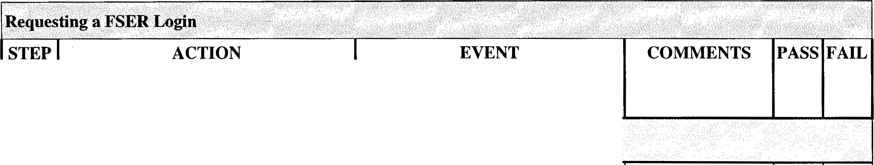

Follow the steps below to request a FSER login when you already have a FSER account.

,. "",

1.

Connect to the WLSP FSER Tool portal from the NGGN network via a web browser.

[http ://w lspfser.is.north ropgrumman.com/](http://wlspfser.is.northropgrumman.com/)

The welcome page for the **WLSP**

**FSER** tool displays in the browser

2.

Enter a Username and Password in the

Log In menu.

Login credentials are entered.

3.

Click on the **Log In** button.

WLSP FSER home page displa ys

4.

Click on the **Administration** navigation button.

The Administration home page displays.

5.

Click on the Request a FSER Login link.

The Request a FSER Account page displays.

6.

Enter User Information and Create a Security Question and Answer in the entry fields.

7.

Click on the **Submit** button.

The page displays with the message the user request has been sent

8.

Click on the **Log Out** navigation button.

The Welcome to WLSP FSER page displays.

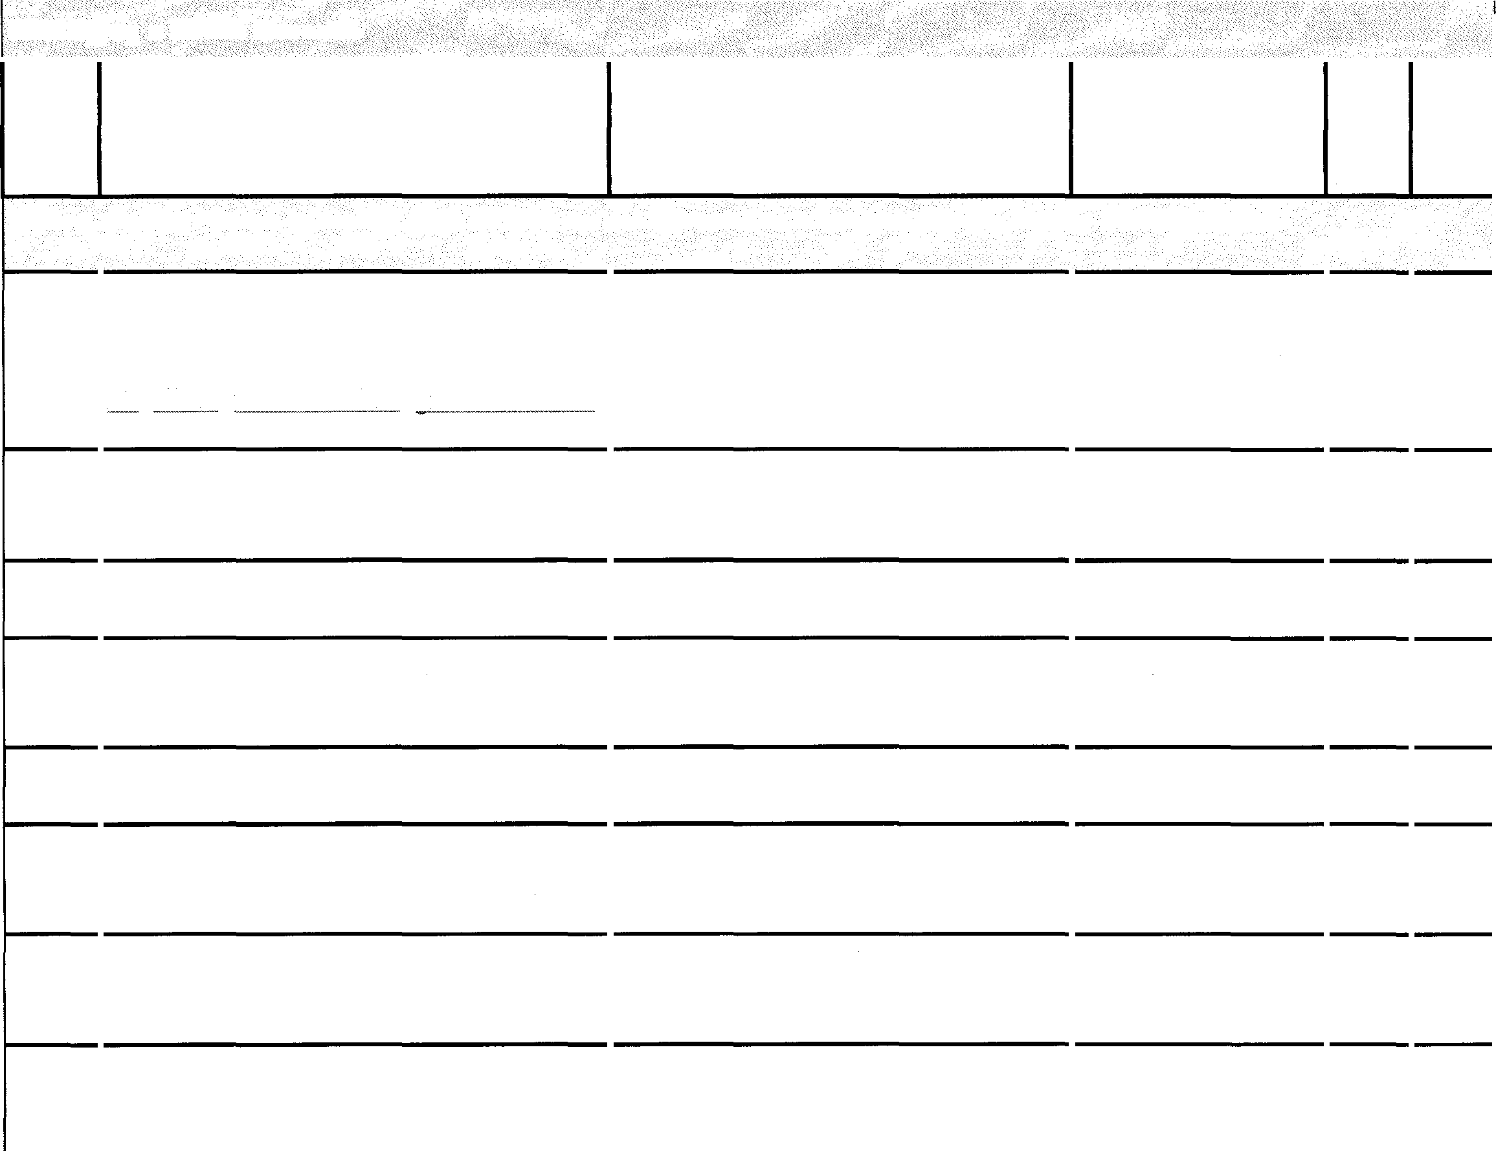

|  |  |  |  |  |  |
| --- | --- | --- | --- | --- | --- |
| **Modifying a FSER Account** | | | | | |
| **STEP ACTION EVENT COMMENTS PASS FAIL NO.**  *Follow the steps below to modify your FSER account information when you already have a FSER account.* | | | | | |
| 1.  2.  3.  4.  5.  6.  7.  8. | Connect to the WLSP FSER Tool portal from the NGGN network via a web browser. httg://wlsQfser.is.northrop2:rumman.corn/  Enter a Usemame and Password in the  *Log In* menu.  Click on the **Log In** button.  Click on the **Administration** navigation button.  Click on the *Modify Account* link.  Add or remove information in the User Information entry fields.  Click on the **Submit** button.  Click on the **Log Out** navigation button. | *The welcome page for the WLSP FSER tool displays in the browser*  *Login credentials are entered. The Home page displays.*  *WLSP FSER home page displays*  *The Administration home page displays.*  *A User In formation table displays.*  *A message displays that the account info has been updated.*  *The WLS FSER welcome page displays.* |  |  |  |

#### WLSP FSER Tool Test Script 49