**ABSTRACT**

EZMarket is a global marketplace solution. We serve for trading digital assets: code script, plugin, tutorial guides, themes, templates, photos, ... Everything that you can buy and sell over internet. We focus on payment feature, make it become easiest based on blockchain technology. In this article we will introduce the project EZMarket, features and objectives of the project. Information on ICO and its benefits to future investors

1. **INTRODUTION**

If you are a software developer or an internet content maker, you probably have at least once wanted to buy some code scripts, or a tutorial, or some beautiful website templates that you cannot afford or do not have time to do yourself. Even if you are not a software developer, sometimes you need to buy something for your work such as a photo, an icon or a video clip... So the market for buying and selling digital content is obviously huge.

But until now, all service providers are still providing to users with a complex and painstaking process to engage in the buying or selling, mostly due to payment method.

We are software developers for many years. We having been involved in some of marketplaces, we understand the difficulties to that users face when they want to join the system. Therefore, our goal is creating a convenient and fast shopping process for our users. With the development and popularity of the cryptocurrency, it is entirely possible.

1. **VALUATION**

Our goal is creating a conveniently and easily marketplace for user. With EZMarket, you not need to provide too much personal information, no credit card, no bank account or Paypal account... The only thing you need is a cryptocurrency address (Bitcoin, Eth, ...).

With the new method of payment, we will reduce the cost of the payment system. Therefore, the authors fees will be greatly reduced compared to the current services. This will benefit both the author and the buyer. Help increase the number of users, increase profits for investors.

* Decentralized

EZMarket is a decentralized application built on the Ethereum blockchain.  
It has no centralized authority. It don’t require a middleman to function or to manage a user’s information.  
No central point of failure, it's can't be shut down, our items are available at all times.

* Easy

With EZMarket, you can buy items with a few clicks. Smart contracts are the bridge on blockchain to connect buyers and sellers.  
Transactions are completed in a trustless manner and automatically.

* Fast

We are using decentralized database on blockchain, and caching technology to speed up application.  
All operations are fast, secured and immediately synchronized.

* Low fees

Smart contracts save you money since we knock out the presence of an intermediary.  
You don't have to pay a notary to witness your transaction.

* Privacy

The payment is executed by smart contract, so it's absolutely anonymous. User don't have to provide any personal information.  
It makes you stay away from any kind of leak or attack.

1. **USER FLOW**
2. **Author**

Author

Upload and Description

Verify

Valid

Admin

Publish

No

Yes

1. **Buyer**

Buyer

Choose item

Send money

Success

Download

Assets

Yes

No

1. **FEES**

We have two types of fee apply for user who want to sell their products on our system.

- For current authors (no account registration): fixed fee is 35% of total revenue of each product.

- For regular authors (registered account): the starting fee is 25% of total revenue of each product.

This fee will be decrease base on some criteria such as the total sales achieved, the score from the purchase and not less than 10%. In addition, we also have discount policy for the referral.

Compare to other marketplaces, they have 55% fee for Non-Exclusive Author and for Exclusive Author is 37.5% decrease to 12.5%. We are confident we are the cheapest supplier. Beside, we have another worth functions as Immediately withdraw, Secure payment and privacy

1. **BENEFIT**

EZMarket will charge a fee for each product sold. This fee will be equally distributed to the entire investors corresponding to the number of shares they hold.

The company also holds a percentage of the shares so we will also be distributed profit.

This amount will be used for product maintenance and development.

EZMarket token also can trade on some exchanges

1. **ICO**

Buying our EZMarket token will be open to everyone in the form of a crowdsale by pledging Ethereum into the smart contract.

**Token name : EZMarket  
Token symbol : EZM  
Total supply : 150,000,000 EZM  
ICO supply : 114,000,000 EZM  
Pre-sale time : October 01, 2017 10:00:00 AM (GMT)   
Start time : October 14, 2017 10:00:00 AM (GMT)  
End time : November 25, 2017 10:00:00 AM (GMT)  
Accept currency : ETH  
Rate : 1 ETH = 1,000 EZM**

**Bonuses:**

**Week1 : 30%  
Week2 : 25%  
Week3 : 20%  
Week4 : 15%  
Week5 : 10%  
After week 5 : 0%**

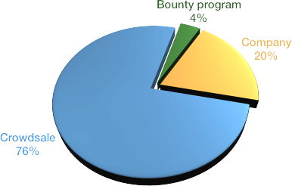**Allocation of tokens**

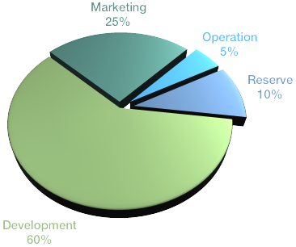**Distribution of funds**

1. **ROADMAP**

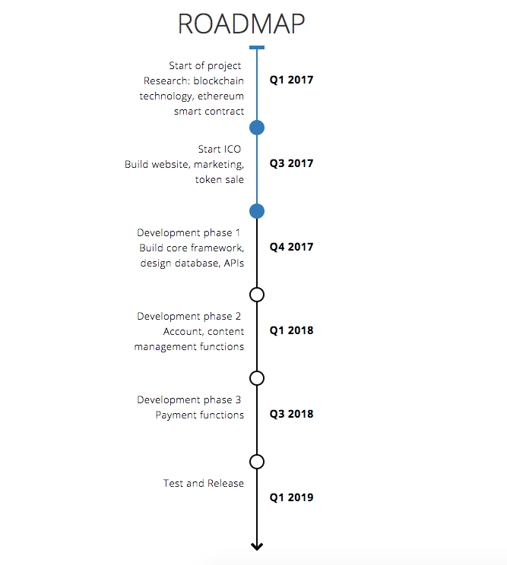

1. **CONTACT AND REFERENCE**

Email: contact@ezmarket.io

Slack: https://ezmarketteam.slack.com/

Twitter: https://twitter.com/ezmarketsupport

Facebook: https://www.facebook.com/EZMarket-112233276141456/