## Calculate Subnets

192.168.1.0/24 -> 4 subnets

11111111.11111111.11111111.11111111.00000000 255.255.255.0

Network | Host 192.168.1 | .0

Subnets -> 2^n 2^2 = 4 subnets

192.168.1.00 00 0000

192.168.1.0/26

1. 192.168.1.00 192.168.1.0/26
2. 192.168.1.01 192.168.1.64/26
3. 192.168.1.10 192.168.1.128/26
4. 192.168.1.11 192.168.1.192/26

## Subnet 1

Network = 192.168.1.00 00 0000 = 192.168.1.0/26 1st = 192.168.1.00 00 0001 = 192.168.1.1/26 3rdlast = 192.168.1.00 11 1100 = 192.168.1.60/26 2ndlast = 192.168.1.00 11 1101 = 192.168.1.61/26 Last = 192.168.1.00 11 1110 = 192.168.1.62/26 Broadcast = 192.168.1.00 11 1111 = 192.168.1.63/26

## Subnet 2

Network = 192.168.1.01 00 0000 = 192.168.1.64/26 1st = 192.168.1.01 00 0001 = 192.168.1.65/26 3rdlast = 192.168.1.01 11 1100 = 192.168.1.124/26 2ndlast = 192.168.1.01 11 1101 = 192.168.1.125/26 Last = 192.168.1.01 11 1110 = 192.168.1.126/26 Broadcast = 192.168.1.01 11 1111 = 192.168.1.127/26

## Subnet 3

Network = 192.168.1.10 00 0000 = 192.168.1.128/26 1st = 192.168.1.10 00 0001 = 192.168.1.129/26 3rdlast = 192.168.1.10 11 1100 = 192.168.1.188/26 2ndlast = 192.168.1.10 11 1101 = 192.168.1.189/26 Last = 192.168.1.10 11 1110 = 192.168.1.190/26 Broadcast = 192.168.1.10 11 1111 = 192.168.1.191/26

## Subnet 4

Network = 192.168.1.11 00 0000 = 192.168.1.192/26 1st = 192.168.1.11 00 0001 = 192.168.1.193/26 3rdlast = 192.168.1.11 11 1100 = 192.168.1.252/26 2ndlast = 192.168.1.11 11 1101 = 192.168.1.253/26 Last = 192.168.1.11 11 1110 = 192.168.1.254/26 Broadcast = 192.168.1.11 11 1111 = 192.168.1.255/26

## Configure Router 1

R1>en  
R1#sh ip int brief  
Interface IP-Address OK? Method Status Protocol   
GigabitEthernet0/0/0 unassigned YES unset administratively down down   
GigabitEthernet0/0/1 unassigned YES unset administratively down down   
Serial0/1/0 unassigned YES unset administratively down down   
Serial0/1/1 unassigned YES unset administratively down down   
Loopback0 1.1.1.1 YES manual up up   
Vlan1 unassigned YES unset administratively down down  
R1#conf t  
Enter configuration commands, one per line. End with CNTL/Z.  
R1(config)#int g0/0/0  
R1(config-if)#no shut  
  
R1(config-if)#  
%LINK-5-CHANGED: Interface GigabitEthernet0/0/0, changed state to up  
  
%LINEPROTO-5-UPDOWN: Line protocol on Interface GigabitEthernet0/0/0, changed state to up  
ip add  
% Incomplete command.  
R1(config-if)#ip add  
R1(config-if)#ip address 192.168.1.62 255.255.255.192  
R1(config-if)#end  
R1#  
%SYS-5-CONFIG_I: Configured from console by console  
show  
R1#show ip int  
R1#show ip interface brief  
Interface IP-Address OK? Method Status Protocol   
GigabitEthernet0/0/0 192.168.1.62 YES manual up up   
GigabitEthernet0/0/1 unassigned YES unset administratively down down   
Serial0/1/0 unassigned YES unset administratively down down   
Serial0/1/1 unassigned YES unset administratively down down   
Loopback0 1.1.1.1 YES manual up up   
Vlan1 unassigned YES unset administratively down down  
R1#ping 192.168.1.62  
  
Type escape sequence to abort.  
Sending 5, 100-byte ICMP Echos to 192.168.1.62, timeout is 2 seconds:  
!!!!!  
Success rate is 100 percent (5/5), round-trip min/avg/max = 0/3/6 ms  
  
R1#

## Configure Switch 1

Switch>en  
Switch#conf  
Switch#configure t  
Switch#configure terminal   
Enter configuration commands, one per line. End with CNTL/Z.  
Switch(config)#host S1  
S1(config)#int vlan1  
S1(config-if)#no shut  
  
S1(config-if)#  
%LINK-5-CHANGED: Interface Vlan1, changed state to up  
  
%LINEPROTO-5-UPDOWN: Line protocol on Interface Vlan1, changed state to up  
ip addre  
S1(config-if)#ip address 192.168.1.61 255.255.255.192  
S1(config-if)#end  
S1>show ip interface brief  
Interface IP-Address OK? Method Status Protocol   
GigabitEthernet1/0/1 unassigned YES unset up up   
[...]  
Vlan1 192.168.1.61 YES manual up up  
S1>  
S1>ping 192.168.1.62  
  
Type escape sequence to abort.  
Sending 5, 100-byte ICMP Echos to 192.168.1.62, timeout is 2 seconds:  
.!!!!  
Success rate is 80 percent (4/5), round-trip min/avg/max = 0/0/0 ms  
  
S1>ping 192.168.1.62  
  
Type escape sequence to abort.  
Sending 5, 100-byte ICMP Echos to 192.168.1.62, timeout is 2 seconds:  
!!!!!  
Success rate is 100 percent (5/5), round-trip min/avg/max = 0/0/0 ms  
  
S1>  
S1>en  
S1#conf t  
Enter configuration commands, one per line. End with CNTL/Z.  
S1(config)#ip def  
S1(config)#ip default-gateway 192.168.1.62  
S1(config)#end  
S1#  
%SYS-5-CONFIG_I: Configured from console by console  
  
S1#ping 192.168.1.62  
  
Type escape sequence to abort.  
Sending 5, 100-byte ICMP Echos to 192.168.1.62, timeout is 2 seconds:  
!!!!!  
Success rate is 100 percent (5/5), round-trip min/avg/max = 0/0/0 ms  
  
S1#

## Configure DHCP 1

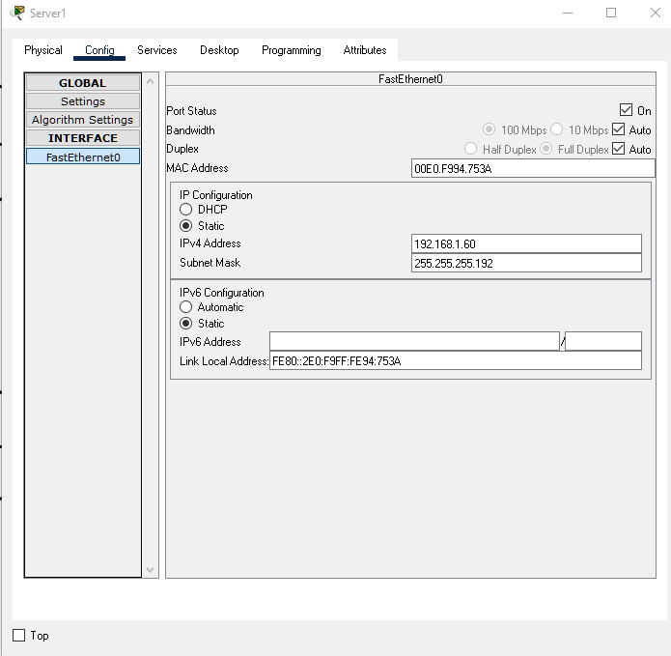

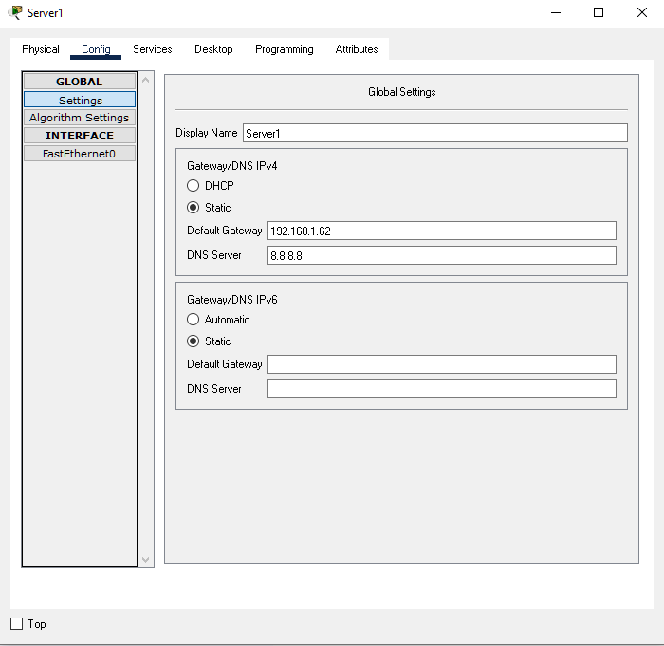

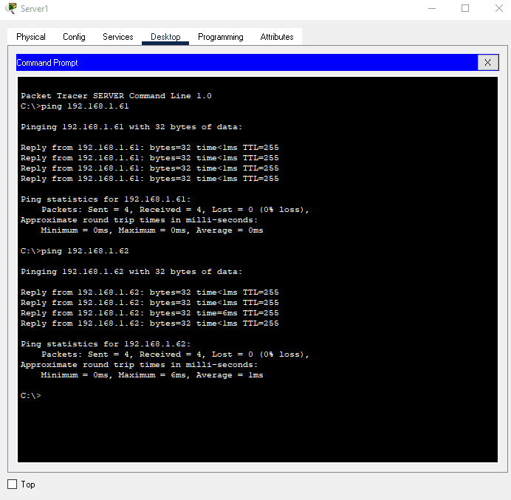

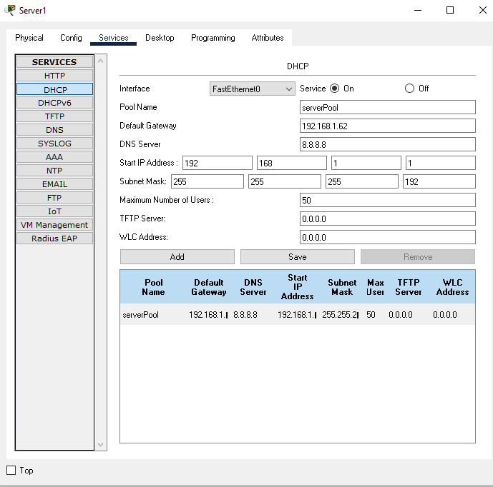

Second PC 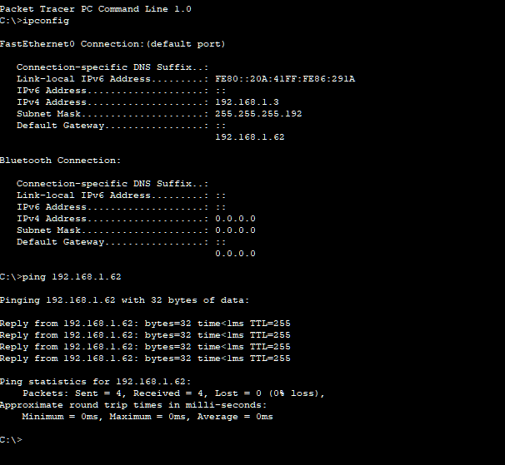

Second PC 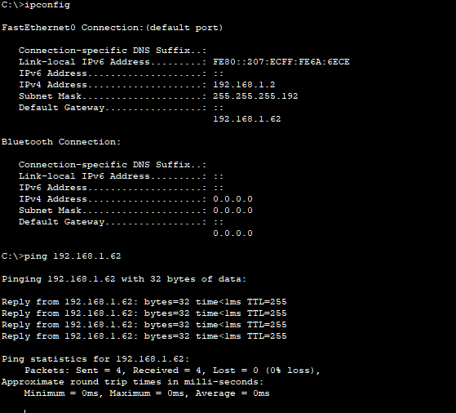

## Router 1 Config

R1>sh ip int brief  
Interface IP-Address OK? Method Status Protocol   
GigabitEthernet0/0/0 192.168.1.62 YES manual up up   
GigabitEthernet0/0/1 unassigned YES unset administratively down down   
Serial0/1/0 unassigned YES unset administratively down down   
Serial0/1/1 unassigned YES unset administratively down down   
Loopback0 1.1.1.1 YES manual up up   
Vlan1 unassigned YES unset administratively down down  
R1(config-if)#ip address 192.168.1.65 255.255.255.192  
R1(config-if)#end  
R1#  
%SYS-5-CONFIG_I: Configured from console by console  
show ip inter  
R1#show ip interface brief  
Interface IP-Address OK? Method Status Protocol   
GigabitEthernet0/0/0 192.168.1.62 YES manual up up   
GigabitEthernet0/0/1 unassigned YES unset administratively down down   
Serial0/1/0 192.168.1.65 YES manual up up   
Serial0/1/1 unassigned YES unset administratively down down   
Loopback0 1.1.1.1 YES manual up up   
Vlan1 unassigned YES unset administratively down down  
R1#  
IntRouter#conf t  
Enter configuration commands, one per line. End with CNTL/Z.  
IntRouter(config)#int s0/1/0  
IntRouter(config-if)#no shut  
IntRouter(config-if)#ip address 192.168.1.126 255.255.255.192  
IntRouter(config-if)#  
00:58:54: %OSPF-5-ADJCHG: Process 1, Nbr 1.1.1.1 on Serial0/1/0 from LOADING to FULL, Loading Done  
  
IntRouter(config-if)#end  
IntRouter#  
%SYS-5-CONFIG_I: Configured from console by console  
  
IntRouter#ping 192.168.1.65  
  
Type escape sequence to abort.  
Sending 5, 100-byte ICMP Echos to 192.168.1.65, timeout is 2 seconds:  
!!!!!  
Success rate is 100 percent (5/5), round-trip min/avg/max = 8/11/13 ms  
  
IntRouter#

## Proof Router can ping DNS

R1#ping 8.8.8.8  
  
Type escape sequence to abort.  
Sending 5, 100-byte ICMP Echos to 8.8.8.8, timeout is 2 seconds:  
.!!!!  
Success rate is 80 percent (4/5), round-trip min/avg/max = 13/14/20 ms

ping from PC1 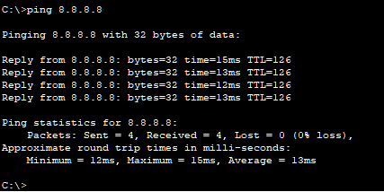 Tracert from PC1 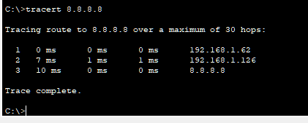

PC 1 external web tests

Cisco 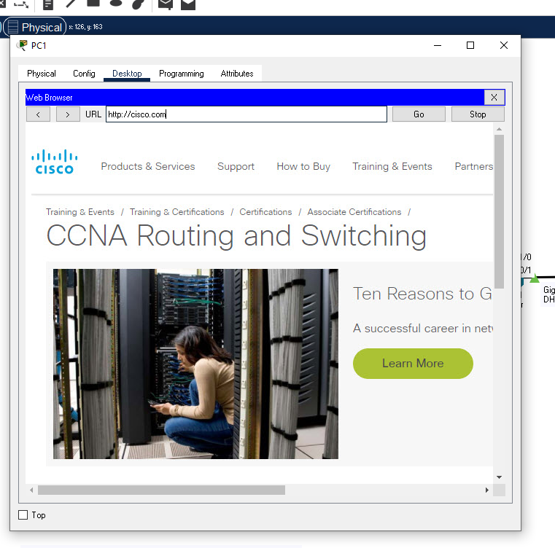 Facebook 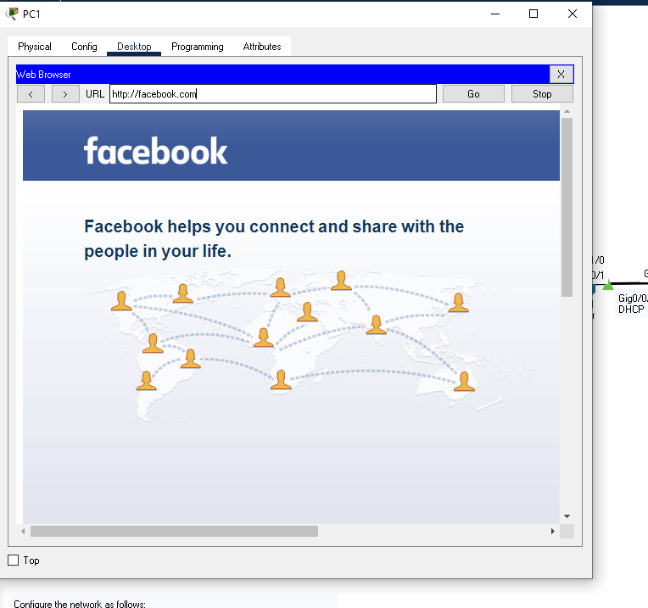

# Configure Router 2

R2>en  
R2#sh ip int brief  
Interface IP-Address OK? Method Status Protocol   
GigabitEthernet0/0/0 unassigned YES unset administratively down down   
GigabitEthernet0/0/1 unassigned YES unset administratively down down   
Serial0/1/0 unassigned YES unset administratively down down   
Serial0/1/1 unassigned YES unset administratively down down   
Loopback0 2.2.2.2 YES manual up up   
Vlan1 unassigned YES unset administratively down down  
R2#conf t  
Enter configuration commands, one per line. End with CNTL/Z.  
R2(config)#int g0/0/0  
R2(config-if)#no shut  
  
R2(config-if)#  
%LINK-5-CHANGED: Interface GigabitEthernet0/0/0, changed state to up  
  
%LINEPROTO-5-UPDOWN: Line protocol on Interface GigabitEthernet0/0/0, changed state to up  
  
R2(config-if)#ip address 192.168.1.190 255.255.255.192  
R2(config-if)#end  
R2#  
%SYS-5-CONFIG_I: Configured from console by console  
sh ip int brief  
Interface IP-Address OK? Method Status Protocol   
GigabitEthernet0/0/0 192.168.1.190 YES manual up up   
GigabitEthernet0/0/1 unassigned YES unset administratively down down   
Serial0/1/0 unassigned YES unset administratively down down   
Serial0/1/1 unassigned YES unset administratively down down   
Loopback0 2.2.2.2 YES manual up up   
Vlan1 unassigned YES unset administratively down down  
R2#ping 192.168.1.190  
  
Type escape sequence to abort.  
Sending 5, 100-byte ICMP Echos to 192.168.1.190, timeout is 2 seconds:  
!!!!!  
Success rate is 100 percent (5/5), round-trip min/avg/max = 2/2/3 ms  
  
R2#

## Configure Switch 2

Switch>en  
Switch#conf t  
Enter configuration commands, one per line. End with CNTL/Z.  
Switch(config)#host s2  
s2(config)#int vlan1  
s2(config-if)#no shut  
  
s2(config-if)#  
%LINK-5-CHANGED: Interface Vlan1, changed state to up  
  
%LINEPROTO-5-UPDOWN: Line protocol on Interface Vlan1, changed state to up  
  
s2(config-if)#ip address 192.168.1.189 255.255.255.192  
s2(config-if)#end  
s2#  
%SYS-5-CONFIG_I: Configured from console by console  
  
s2#show ip interface brief  
Interface IP-Address OK? Method Status Protocol   
[...]  
Vlan1 192.168.1.189 YES manual up up

pinging router

s2#  
s2#ping 192.168.1.190  
  
Type escape sequence to abort.  
Sending 5, 100-byte ICMP Echos to 192.168.1.190, timeout is 2 seconds:  
.!!!!  
Success rate is 80 percent (4/5), round-trip min/avg/max = 0/0/0 ms  
  
s2#

## Configure DHCP 2

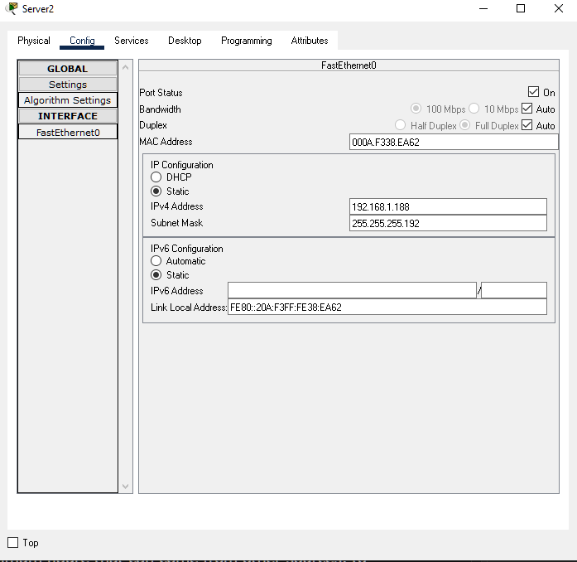

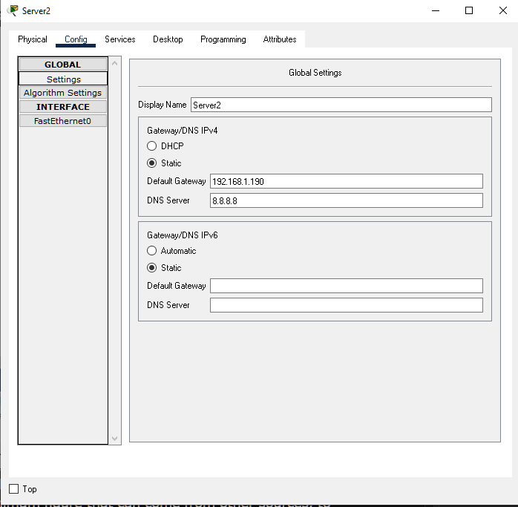

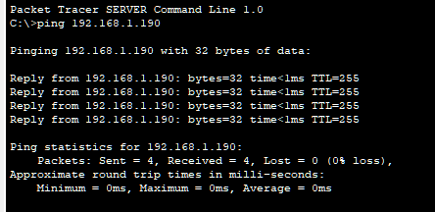

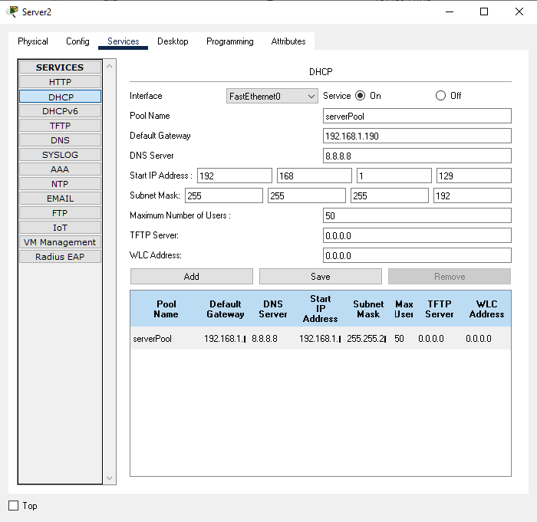

Testing PC 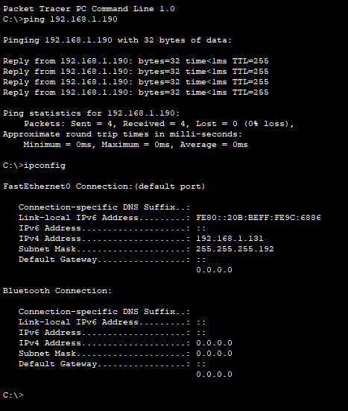

## Configure second serial connection on Internet router

IntRouter>show ip interface brief  
Interface IP-Address OK? Method Status Protocol   
GigabitEthernet0/0/0 unassigned YES unset administratively down down   
GigabitEthernet0/0/1 8.8.8.100 YES DHCP up up   
Serial0/1/0 192.168.1.126 YES manual up up   
Serial0/1/1 unassigned YES unset down down   
Loopback0 3.3.3.3 YES manual up up   
Vlan1 unassigned YES unset administratively down down  
IntRouter>enable  
IntRouter#configure terminal  
Enter configuration commands, one per line. End with CNTL/Z.  
IntRouter(config)#int s0/1/1  
IntRouter(config-if)#no shut  
IntRouter(config-if)#ip address 192.168.1.254 255.255.255.192  
IntRouter(config-if)#no shut  
IntRouter(config-if)#end  
IntRouter#  
%SYS-5-CONFIG_I: Configured from console by console  
  
IntRouter#show ip int brief  
Interface IP-Address OK? Method Status Protocol   
GigabitEthernet0/0/0 unassigned YES unset administratively down down   
GigabitEthernet0/0/1 8.8.8.100 YES DHCP up up   
Serial0/1/0 192.168.1.126 YES manual up up   
Serial0/1/1 192.168.1.254 YES manual down down   
Loopback0 3.3.3.3 YES manual up up   
Vlan1 unassigned YES unset administratively down down  
IntRouter#

## Testing Subnet 2

Router 2

show ip int brief  
Interface IP-Address OK? Method Status Protocol   
GigabitEthernet0/0/0 192.168.1.190 YES manual up up   
GigabitEthernet0/0/1 unassigned YES unset administratively down down   
Serial0/1/0 192.168.1.193 YES manual up up   
Serial0/1/1 unassigned YES unset down down   
Loopback0 2.2.2.2 YES manual up up   
Vlan1 unassigned YES unset administratively down down  
R2#ping 192.168.1.193  
  
Type escape sequence to abort.  
Sending 5, 100-byte ICMP Echos to 192.168.1.193, timeout is 2 seconds:  
!!!!!  
Success rate is 100 percent (5/5), round-trip min/avg/max = 4/15/23 ms

PC 3

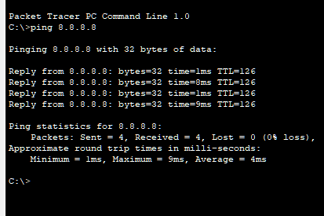



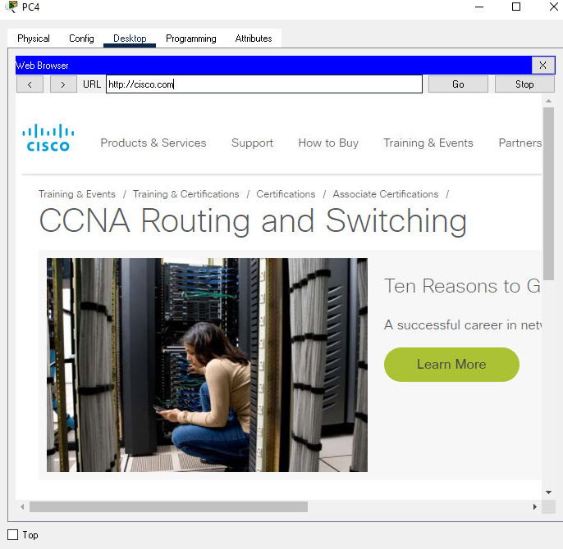

PC 3 pinging PC 0

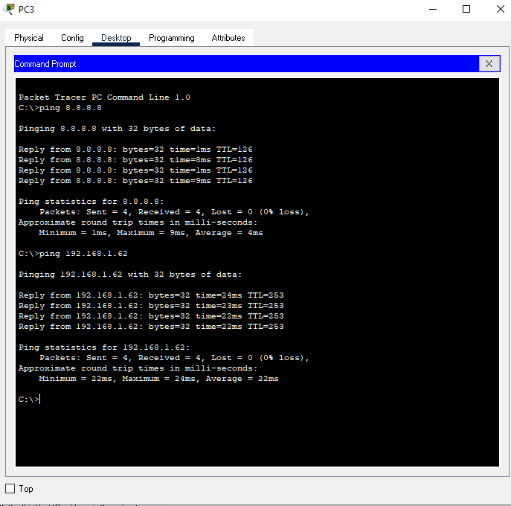

PC 3 tracert to PC1

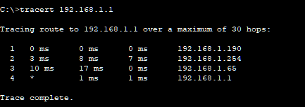

## Final Network

