# Task

{{p task}}

##### Section 1: Knowledge Comprehension, and Application

This section of the rubric consists of the required elements of the assignment. Students should take special care to include ALL these elements as they are often extended in the following sections

##### Section 2: Analysis, Synthesis, and Evaluation.

This section will evaluate your ability to include critical thinking and justification elements into your work. Often the requirements for extension are not explicitly given, so it will be up to the you to decide how best to demonstrate what you have learned beyond the required unit goals and curriculum. Items such as 3D models, pictures, drawings, diagrammatic responses, notes, evidence of problem solving, advanced programming concepts, elegant responses, media, etc., are all available options.

##### Section 3: Submission Guidelines

For this section, students will be expected to provide a submission which fulfills all of the formatting and citation requirements listed in this assessment sheet but also that the submission is of a professional quality. Be aware, points in this section could be 2- or 4-point items. Treat them accordingly.

## Submission

All submission items should be stored in an appropriate format. For example, code must be stored in a programmatical format so it can be evaluated (**images of code, or code simply copied and pasted into a document, will not be marked**)

Evidence of working material must be recorded where appropriate. For example, if you are showing how your game meets some requirement, you must submit a recording. Similarly, if you are showing how your robot meets a requirement, you must record it.

If you are unsure if an element needs to be recorded, **ask the teacher.**

All materials must be submitted to google classrooms.

Students are responsible for keeping backups/master-copies.

## **Scoring Notes**

Formatting for all typed/written assessments should be as follows:

|  |  |  |  |  |  |  |
| --- | --- | --- | --- | --- | --- | --- |
| **All** | Title Page/Slide/Source should include:   * Name * Date * Class * Assessment title | | | | |  |
| **Google Doc** | 11-12 Pt | 1.15-1.5 Line Spacing | 1 Space between paragraphs | Spelling and Grammar  “Soft Limits” | In-Text Citations with footnotes |  |
| **Slides** | 10-12 pt. font text  14-24 pt. font titles | 1.0 1.15 Line Spacing | Bullet Points Preferred | Word Count per slide >100-110 “Soft Limit” | Approved Templates and Themes |
| **Python** | We apply the **PEP 8** style guide to Python files. However, in general most programs follow this broad layout.    [PEP 8: The Style Guide for Python Code](https://pep8.org/) | | | | | |
| **Arduino**  **C/C++** | We apply the **Arduino style** guide to Arduino C/C++ files. However, in general most programs follow this broad layout.    I accept both K&R and K&R alternative bracing format. As long as it is consistent in your file.  [Arduino Style Guide for Creating Libraries | Arduino Documentation | Arduino Documentation](https://docs.arduino.cc/learn/contributions/arduino-library-style-guide) | | | | | |
| **Mark down** | We apply the **google style** guide for markdown documents. However, in general, most documents follow some variation of the following layout:    <https://github.com/google/styleguide/blob/gh-pages/docguide/style.md> | | | | | |

“Soft Limits” are not rigidly defined limits and will be assessed on a case-by-case basis. Ask for clarification for specific tasks

## Possible Scoring Groups are out of 2, 3, or 4 Points.

**2-Point Criteria - Knowledge and Application**

Criteria assessed as 2-Points are classified as Knowledge and Application criteria. These will examine and evaluate a student’s ability to state facts and define terms and concepts effectively. Analysis and synthesis of the information will not be assessed through these criteria.

|  |  |  |  |
| --- | --- | --- | --- |
|  | 0 Points | 1 Point | 2 Points |
| 2 Point Criteria | **Not present** or **not able to be assessed** as the required criteria | Item is presented but **does not meet expectations** for quality, rigour, or detail. | Item is presented and **does meet expectations** for quality, rigour, or detail |

**3-Point Criteria – Knowledge, Application, and Understanding**

Criteria assessed as 3-Points are classified similarly to 2-Point Criteria. Unlike 2-Point Criteria, students may show their ability to move beyond core ability and show their growing understanding of the topic through mastery or reflection.

|  |  |  |  |  |
| --- | --- | --- | --- | --- |
|  | 0 Points | 1 Point | 2 Points | 3 Points |
| 3 Point Criteria | **Not present** or **not able to be assessed** as the required criteria | Item is presented but **does not meet expectations** for quality, rigour, or detail. | Item is presented and **does meet expectations** for quality, rigour, or detail | Item is presented and **goes beyond expectations** for quality, rigour, or detail  **-or-**  Item was **presented for drafts** and **showed evidence of reflection/learning** |

**4-Point Criteria – Analysis, Evaluation, and Synthesis**

To show true mastery of your developing skills, students must show that they can go beyond simple repetition of the given tasks or an explanation of processes. Students will show their ability to show higher order thinking through analysis, evaluation, or the linking of multiple fields of learning to solve problems in novel ways.

**Analysis, Evaluation, and Synthesis**

Analysis, Evaluation, and Synthesis components evaluate a student’s ability to effectively review data and understandings and develop these into a coherent and relevant statement. Analysis refers to the generating of thoughts from interpreting the data, while synthesis refers to combining analysis of the data with other relevant information to develop an original and effective idea.

|  |  |  |  |  |  |
| --- | --- | --- | --- | --- | --- |
|  | 0 Points | 1 Point | 2 Points | 3 Points | 4 Points |
| 4 Point Criteria | **Not present** or **not able to be assessed** as the required criteria | Item is presented and explained. However, it **does not show appropriate evidence of higher order thinking** such as analysis, evaluation, or synthesis. | Item is presented and **shows appropriate evidence of higher order thinking** such as analysis, evaluation, or synthesis. | Item is presented and **exceeds expectations for evidence of higher order thinking** such as analysis, evaluation, or synthesis.  **-or-**  Item is presented and shows appropriate evidence of higher order thinking such as analysis, evaluation, or synthesis and **exceeds expectations for quality or rigour**, of understanding of the selected mastery. | Item is presented and **exceeds expectations for evidence of higher order thinking** such as analysis, evaluation, or synthesis. **Additionally, this item exceeds expectations for quality or rigour**, of understanding of the selected mastery. |

**Expert Review**

Expert Reviews evaluate a student’s ability to build solutions using the skills that have been taught during the semester. Criteria assessed as 4-Points are classified as Analysis and Synthesis criteria. These will examine and evaluate a student’s ability to effectively review data and understandings and develop these into a coherent and relevant statement. Analysis refers to the generating of thoughts from interpreting the data, while synthesis refers to combining analysis of the data with other relevant information to develop an original and effective idea.

|  |  |  |  |  |  |
| --- | --- | --- | --- | --- | --- |
|  | 0 Points | 1 Point | 2 Points | 3 Points | 4 Points |
| 4 Point Criteria | **Not present** or **not able to be assessed** as the required criteria | Item is presented and broadly solves the problem. However, upon review, it **does not show enough evidence of appropriate mastery**. | Item is presented and broadly solves the problem. On review, it **does show appropriate evidence** of mastery. | Item is presented and solves the specific problem. On review, the evidence **shows understanding beyond expected mastery**.  **-or-**  Item is presented and broadly solves the problem. On review, it does show appropriate evidence of mastery and is **done so in a well-constructed or design method** that clearly shows higher levels of understanding**.** | Item is presented and solves the specific problem. On review, **the evidence shows understanding well beyond expected mastery** and is **done so in a well-constructed or design method** that clearly shows higher levels of understanding. |

**Multiplier**

Criteria will be combined with a **Multiplier**. While each criterion will be scored on the 0-1-2-4 scale, the multiplier will attach relevant worth to each criterion. Be aware of these multipliers and dedicate appropriate time to ensure you achieve your best result.

**Achievement Standards:**

{{achievement_standard}}

##### Evidence of higher order learning:

What is it that I mean by “higher order thinking”?

It means I want you to go beyond just replicating what we do in class. I want you to dig into your brain and understand why you did something, what about it was great, what could be improved.

Why is this important? Reflective thinkers can go beyond what they are taught and can customise their learning to ben

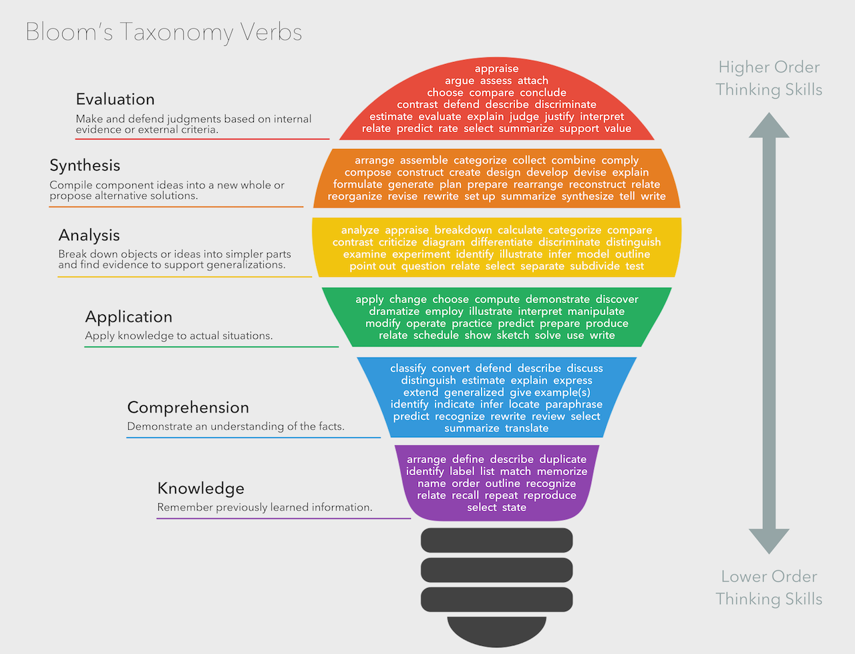

{{p rubric}}

## VET Competencies

{{p vet_competencies}}