**Introduction**

Suicide is the second leading cause of death among adolescents and rates are climbing.1 Promising interventions such as dialectical behavior therapy (DBT) are available to treat suicidal youth, and new approaches may improve their engagement, adherence, and effectiveness.2,3 In particular, personal smartphones are ubiquitous among adolescents4 and could enhance existing, evidence-based interventions by providing new opportunities for assessment and intervention between sessions.

Routine outcome monitoring (i.e., tracking outcomes during treatment) is critical for measurement-based care and improves clinical outcomes,5 but is not often utilized due to concerns about burdensomeness and the validity of retrospective self-report measures.6 Smartphones directly address these barriers by using a less burdensome, objective, and continuous approach. Suicide risk factors, mood, and behavior can be measured with minimal user input through both passive (e.g., built-in smartphone sensors) and active (e.g., ecological momentary assessment) data collection.3,7 For example, sleep duration can be estimated using accelerometer and device use data, potentially supporting the early detection of sleep disturbances8 (a known suicide risk factor9). Additionally, sentiment in naturalistic messages can be extracted from keyboard input data, and may be a surrogate for one’s daily mood.10 Thus, smartphones can detect fluctuations that may signal changes in risk for suicidal thoughts and behaviors (STB).3

Importantly, personal smartphones also provide opportunities to deliver micro-interventions. Practicing therapeutic skills between sessions is associated with better treatment outcomes11; however, completion among youth is often variable.12 Reminders to implement therapeutic strategies can be delivered via smartphone push notifications, which may increase skill utilization between sessions and improve clinical outcomes.13 For example, a notification offering tailored content (e.g., sleep hygiene reminders) at a tailored time (e.g., shortly before one’s usual bedtime) may increase the likelihood that a patient experiencing sleep disturbances implements sleep hygiene strategies. Several suicide risk reduction interventions delivered digitally (e.g., using smartphones) have been developed, and preliminary studies suggest that they are feasible, acceptable, and may be efficacious for reducing STB.14–17 Although these findings are highly promising, these interventions have generally been designed for adults and evaluated in relatively small pilot studies. Thus, novel interventions designed for youth at risk for suicide are urgently needed, and preliminary data collected from adults suggest a digital intervention for youth may be feasible, acceptable, and efficacious.

To leverage technological capabilities and enhance existing interventions, Ksana Health has developed the Vira digital behavior change platform, which consists of a patient-facing smartphone app and a linked, HIPAA-compliant web portal for clinicians. The smartphone app monitors a range of proximal suicide risk factors (e.g., sleep disturbance, low mood) using mobile sensing and brief self-report surveys, provides patients access to these data 24/7, and offers insights into passively sensed behavioral patterns associated with their mood. Clinicians can use the web portal to view these data and gain insight into patients’ behavior and mood between sessions. The clinician portal also enables clinicians to schedule personalized notifications based on therapy plans, which are then delivered to a patient’s smartphone. Vira thereby enables enhanced support between sessions, which is important for reducing suicide risk in adolescents.18

The Vira platform was developed based on principles of behavioral activation and DBT. It has been optimized through user-centered design activities including qualitative interviews with various stakeholders (i.e., youth with lived experience, clinicians, clinic administrators) and unmoderated user testing. The data collected during this iterative development process informed the Vira platform’s design (e.g., interface, content) and implementation strategy. In addition to user-centered design activities, the Vira platform integrates numerous evidence-based strategies to increase engagement, including human support, tailored push notifications, and data visualization.19 This is important because digital mental health interventions have suffered from relatively low engagement, limiting their effectiveness.16 The Vira platform demonstrated feasibility, acceptability, and preliminary effectiveness for reducing depressive symptoms and other mental health problems in young adults with elevated depressive symptoms.20 Additionally, similar approaches were feasible, acceptable, and efficacious in prior studies of adult primary care patients.21,22 These studies provide preliminary evidence that implementing a digital behavior change platform in outpatient care may be feasible, acceptable, and improve clinical outcomes.

To build on advancements in digital mental healthcare and address rising rates of adolescent STB, the present study will test the Vira platform’s feasibility, acceptability, and effectiveness in an intensive outpatient DBT program for adolescents at high risk for suicide. Adolescents beginning treatment will be randomly assigned to receive DBT with either the Vira platform or an app that will acquire mobile sensor data and deliver self-report surveys (i.e., a measurement-only comparison condition). We hypothesize that the Vira platform will have high usability, acceptability, and adoption by adolescents and their clinicians. Our primary clinical hypothesis is that, compared to adolescents in the comparison group, adolescents receiving DBT with Vira will demonstrate greater reductions in STB at 3- and 6-month follow-up assessments. As secondary aims, we will test whether adolescents receiving DBT with Vira experience greater reductions in other psychiatric symptoms or suicide risk factors compared to those in the comparison group. Lastly, exploratory analyses will test whether adolescents receiving DBT with Vira demonstrate greater engagement in DBT treatment (e.g., higher session attendance) and/or are more likely to utilize crisis care.

**Method**

**Study Setting**

This two-armed, pragmatic randomized controlled trial (RCT; ClinicalTrials.gov identifier: NCT05920252) will be conducted in the Intensive Adolescent and Family DBT Program at Columbia University Irving Medical Center, a program that offers intensive outpatient DBT services for adolescents (ages 13-18) with current acute suicidal thoughts or behaviors. This program operates after the school day (4:30-6:30pm), includes both in-person and telehealth sessions, and provides foundational clinical skills through individual psychotherapy, DBT skills groups, and phone coaching. Adolescents transition into the program by either ‘stepping up’ from less intensive outpatient care or ‘stepping down’ from inpatient or residential care. Adolescents begin the program with a 2-month intensive phase consisting of weekly individual psychotherapy sessions and psychotherapy groups three days per week. Parents/guardians attend treatment groups two days per week during this period. Depending on clinical responsiveness, adolescents’ duration in the intensive phase may be extended. After the intensive phase, adolescents continue weekly individual psychotherapy, and they and their parents/guardians continue a weekly multi-family DBT skills group. The total duration of treatment ranges from 2-6 months.

**Participants**

Adolescents (*N*=200) will be recruited upon admission to the Intensive Adolescent and Family DBT Program. Clinic staff will explain the study to the adolescent and their legal guardian (if the adolescent is a minor). If they are interested in participating, the clinic staff member will obtain verbal consent and/or assent to share information with research study staff regarding inclusion/exclusion criteria, contact information, and stratification variables (gender, suicide attempt history). Study staff will then contact potentially eligible participants or their legal guardian to provide more information about the study. At that point, written informed assent will be obtained from adolescents ages 13-17 and parental permission from their legal guardians, and 18-year-old adolescent participants will provide written informed consent. To be eligible, adolescents must be 13-18-years-old, initiating treatment at the Intensive Adolescent and Family DBT Program, own a personal smartphone, and be fluent in English. Adolescents will be compensated $100 for completing the baseline assessment, $50 for completing each of the 3- and 6-month follow-up assessments, $100 for the collection of passive mobile sensing data, and $100 for completing daily and weekly surveys in the Vira or EARS app. This study will also include ~20 clinicians who provide intensive outpatient DBT services in the Intensive Adolescent and Family DBT Program. Clinicians will be recruited via email and must be fluent in English and at least 22 years old to be eligible. Clinicians will include social workers and psychologists. Written informed consent will be obtained from all participating clinicians. Participating clinicians will not receive direct compensation. Instead, the clinic will receive a portion of the grant funding, which will support clinicians’ participation. In prior studies with similar recruitment approaches at this site, we have found that samples reflect the community racially and ethnically. Based on these studies, we anticipate that approximately 60% of the sample will identify as white and not Latinx/Hispanic, 20% will identify as Latinx; and 38% will be racial minorities or mixed race. No data will be collected from parents/caregivers or from patient medical records. Study procedures have been approved by the Columbia University Institutional Review Board and a data safety monitoring board will review progress biannually. The project is registered at ClinicalTrials.gov (identifier: NCT05920252), which tracks all protocol modifications.

**Interventions**

After completing baseline assessments, adolescents will be randomly assigned to either DBT utilizing the Vira platform (*n*=100) or a measurement-only comparison condition (*n*=100) involving DBT as usual plus a smartphone app called Effortless Assessment Research System (EARS)23,24 that collects mobile sensing and self-report data. Randomization will be performed within-clinician with a 1:1 allocation ratio. Study staff will oversee randomization procedures, which will stratify by adolescents’ gender and suicide attempt history (yes/no), as these are established risk factors for suicide.25 Due to the nature of the intervention, clinicians and adolescents will be aware of the group assignment. Staff involved in randomization and communicating group assignments to clinicians also will be aware of the group allocation. However, study staff assessing outcomes at follow-up will not know the allocation, and research study staff will not be involved in any clinical care or decision-making within the intensive outpatient program. All adolescents will receive information about how to use the smartphone app to which they were assigned (Vira or EARS) and privacy/security safeguards. All adolescents will be instructed to uninstall the Vira or EARS app from their smartphone when they discontinue treatment at the Intensive Adolescent and Family DBT Program.

**DBT and Vira Condition**

Adolescents assigned to DBT utilizing the Vira platform will install the Vira app (**Figure 1**) on their personal smartphone. The app passively collects data from smartphone sensors (i.e., measures of physical activity, sleep patterns, mobility, and language patterns reflecting mood states and cognition) that are indicative of risk-relevant behaviors or psychological states. It also prompts users to answer a daily check-in question asking, “*How much did you enjoy yesterday?*” on a 5-point Likert scale. Each night, data are encrypted and uploaded to a secure cloud server. Mobile sensing data are automatically processed to generate daily and weekly aggregates for each feature. Daily enjoyment ratings over the past week and weekly aggregates of mobile sensing features are visualized in the app and available 24/7. After 10 days of use, the Vira app offers patients personalized insights based on associations between daily enjoyment ratings and passively-sensed behavioral patterns. For example, the app might indicate that a patient feels more joy on days they wake up earlier or spend less time at home.

The Vira app also prompts users to complete a weekly 3-item survey assessing past-week STB. Specifically, this survey will assess the frequency of suicidal ideation on a scale from 1 (*never*) to 5 (*all the time*) and whether the adolescent made a suicide plan (yes/no) or attempt (yes/no). Surveys indicating clinically significant ideation (*all the time*) or a suicide plan or attempt in the past week will trigger an automated email alert sent to study staff and the adolescent’s clinician (if they are still in DBT treatment). If a past-week suicide attempt is endorsed, a clinically licensed member of the research team will speak to the adolescent as soon as is feasible, conduct a safety assessment, bridge to emergency clinical care if necessary, and convey the assessment summary to the adolescent’s clinician (if they are still in DBT treatment) and their guardian (if they are a minor).

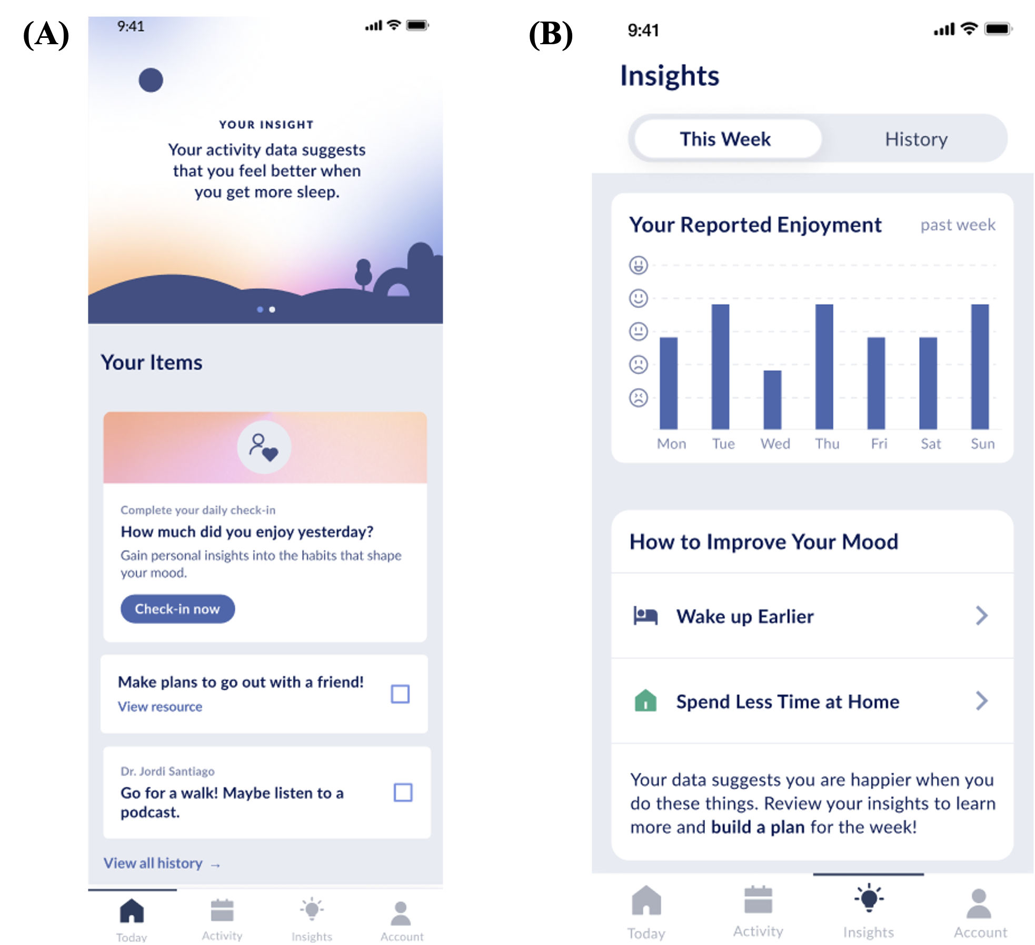

***Figure 1*.** Example screenshots of the Vira app’s home page (panel A) and insights tab (panel B).

Clinicians can use the linked web portal (**Figure 2**) to view patients’ daily enjoyment and daily and weekly aggregates of mobile sensing features. The clinician portal also allows clinicians to schedule notifications to be delivered to a patient’s smartphone in everyday life. The notification content can be customized by the clinician or quickly selected from a predefined list of evidence-based therapeutic techniques and strategies. Thus, clinicians can easily schedule notifications based on therapy plans or to remind or encourage the patient to practice techniques discussed in session. Patients will be instructed to mark notifications as “complete” when they complete an activity, thereby allowing clinicians to remotely monitor out-of-session adherence and completion. At the beginning of the study, clinicians will receive training led by the study team about how to view patients’ data in the clinician portal, how to use the data to inform and monitor treatment, and how to schedule notifications. Clinicians who join the Intensive Adolescent and Family DBT Program after the study begins and enroll in the study will receive the same training.

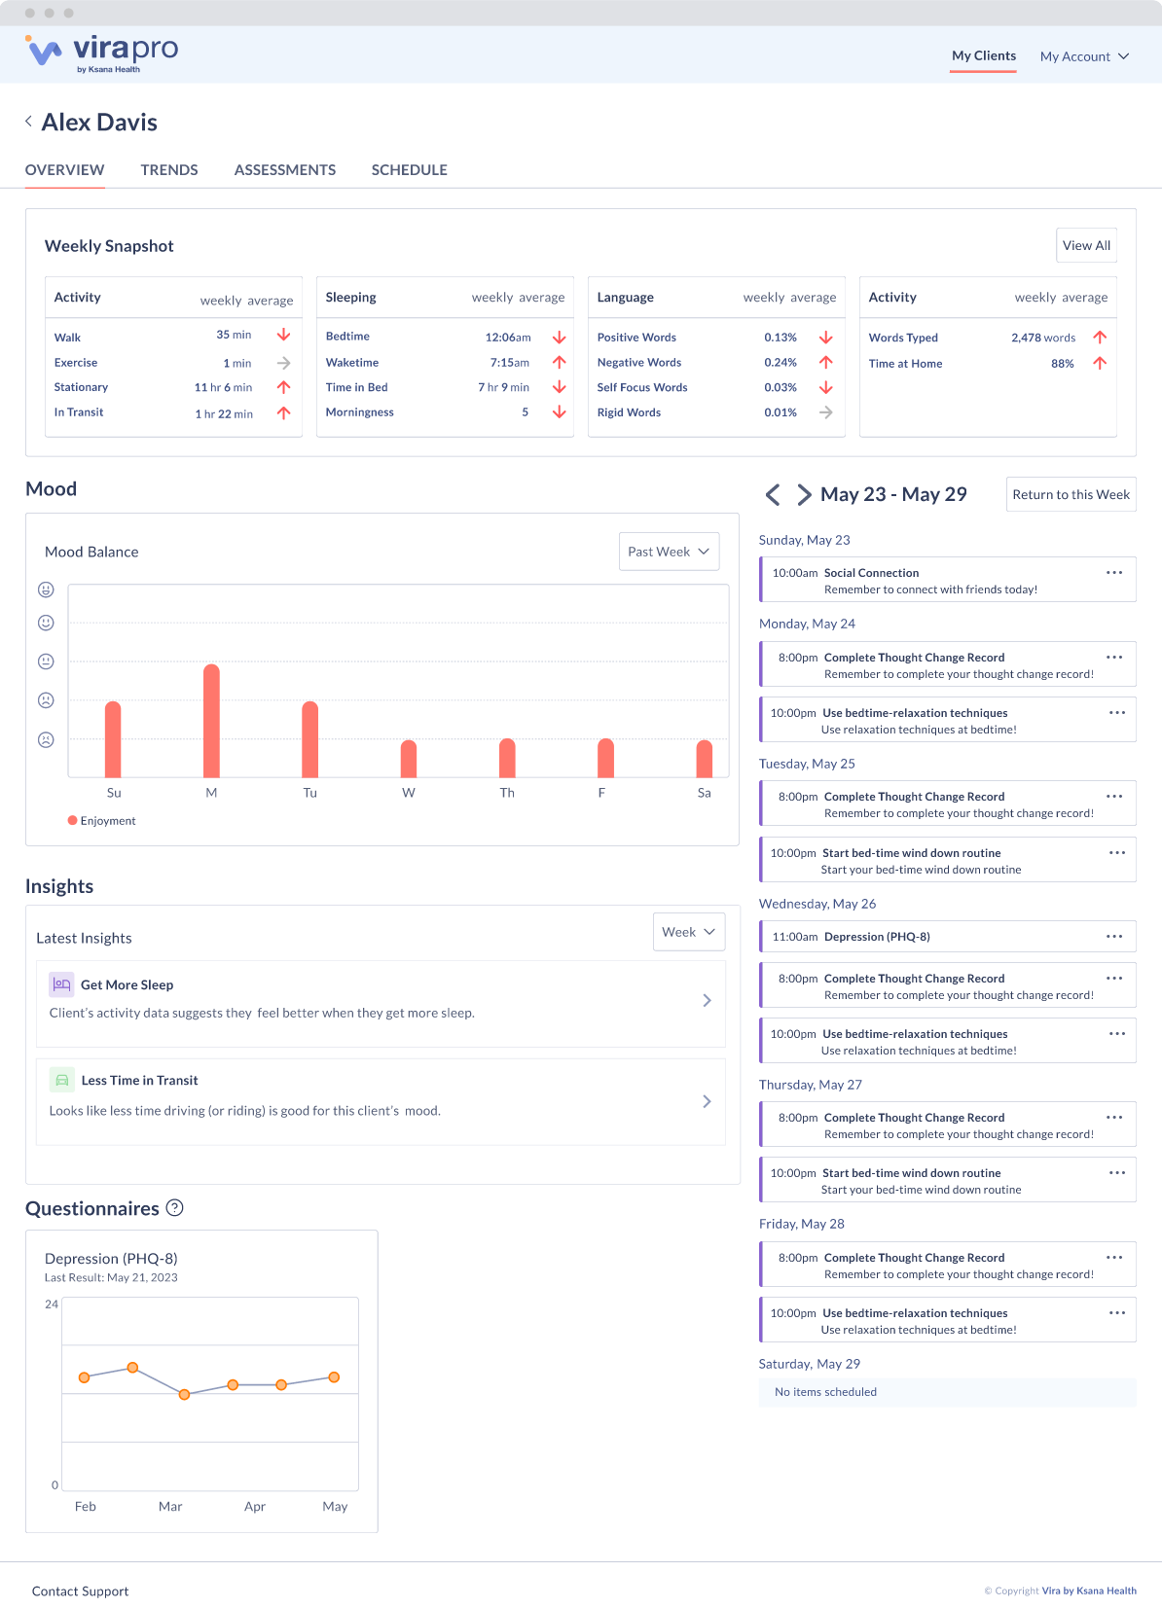

***Figure 2*.** The overview tab of the Vira clinician web portal.

**DBT and EARS Condition (Comparison Condition)**

Adolescents assigned to the measurement-only comparison condition will receive DBT as usual and use the EARS app. The EARS app will collect the same mobile sensing data and self-report data collected by the Vira app. However, the EARS app does not allow patients to access these data and does not offer personalized insights into behavioral patterns associated with self-reported daily enjoyment. There also is no clinician portal associated with the EARS app. Thus, if an adolescent is assigned to the comparison condition, their clinician cannot access any of their mobile sensing or self-report data or schedule smartphone notifications.

**Measures**

Adolescents will complete assessments at baseline, 3 months, and 6 months (**Figure 3; Table 1**). Assessments will be administered by the research team and conducted over Zoom. Each assessment will include measures of STB, psychiatric symptoms, and suicide risk factors. Clinicians will receive a summary of their patient’s baseline assessment data. Implementation outcomes and other exploratory outcomes will also be assessed at the follow-up timepoints.

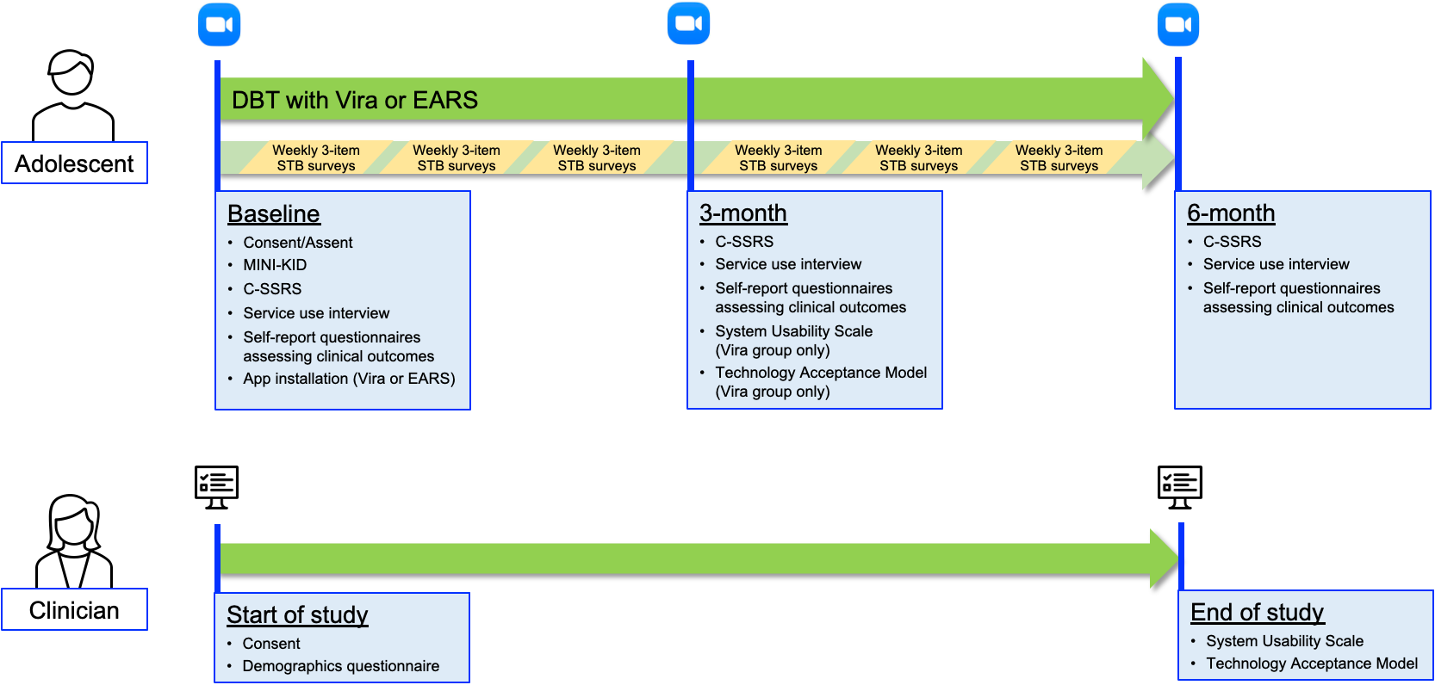

***Figure 3*.** Overview of the study protocol and assessment schedule. The duration of DBT treatment is determined by the treatment team and typically is between 2 and 6 months. The Vira or EARS apps are uninstalled following treatment termination.

***Implementation Measures***

Feasibility and utilization of the Vira platform will be measured by metrics derived from objective and self-reported usage data. The platform will automatically log adolescents’ objective usage of the Vira app, including how frequently they view personalized insights, navigate through insight details, and view resources. Additional objective adolescent usage metrics will include daily active usage (i.e., the percentage of users still in DBT treatment who used the Vira app each day) and retention (i.e., the furthest day from installation on which active usage was recorded for each participant). Retention will likely be confounded with treatment length, so an additional metric will adjust for treatment length by dividing retention by the number of days between app installation and treatment termination. Clinicians’ objective use of the clinician portal (e.g., the frequencies with which they access the clinician portal and schedule notifications) will also be automatically logged.

Adolescents will complete measures of the Vira app’s usability and acceptability at the 3-month follow-up. Usability will be assessed using the 10-item System Usability Scale (SUS),26 and acceptability will be assessed using items from the Technology Acceptance Model (TAM).27 The TAM focuses on two specific dimensions of acceptability: perceived ease of use and perceived usefulness. Each dimension will be assessed using ten items from the corresponding TAM subscale.27 Clinicians will complete the same measures (SUS and TAM) at the end of the study regarding the clinician portal.

***Suicidal Thoughts and Behaviors***

STB are the primary clinical outcomes and will be assessed using the Columbia Suicide Severity Rating Scale (C-SSRS)28 and the Scale for Suicidal Ideation (SSI).29 Suicidal ideation and suicidal behaviors will be assessed separately. At the 3- and 6-month follow-ups, the C-SSRS ideation subscale will assess ideation since the previous assessment. The C-SSRS behavior subscale will assess the occurrence of suicidal behaviors since the previous assessment. If an adolescent reports imminent suicide risk during the C-SSRS at any timepoint, a clinically licensed study team member will conduct a risk assessment and bridge to emergency care if necessary. At all timepoints, the SSI total score will assess past-week suicidal ideation. As noted previously, weekly 3-item surveys assessing past-week STB will be administered until adolescents discontinue DBT treatment, providing an opportunity to test group differences in the temporal patterns and frequencies of suicidal ideation, plans, and attempts during treatment. Interviewers will be trained to administer the C-SSRS; training will include didactics, mock interviews, and direct observation. Interviewers will achieve at least 80% agreement with the trainer before administering the C-SSRS with participants. We will examine the inter-rater reliability of C-SSRS subscales in a randomly selected subset of interviews.

***Psychiatric Symptoms and Suicide Risk Factors***

To characterize the sample, the Mini International Neuropsychiatric Interview for Children and Adolescents (MINI-KID)30 will be administered at baseline to assess adolescents’ lifetime and current psychiatric diagnoses. Interviewers administering the MINI-KID will undergo training similar to the C-SSRS interview training procedures. Additionally, interviewers will meet weekly with the clinical supervisor to confirm diagnoses. A subset of interviews will be randomly selected to examine the inter-rater reliability of MINI-KID diagnoses. Secondary clinical outcomes will be assessed at baseline and at the 3- and 6-month follow-ups. We will also assess several theoretical suicide risk factors that are potential mechanisms of change in STB. Symptoms of depression, anxiety, and anhedonia will be assessed by the Short Mood and Feelings Questionnaire (SMFQ),31 the Screen for Anxiety Related Emotional Disorders (SCARED),32 and the Anticipatory and Consummatory Interpersonal Pleasure Scale (ACIPS),33 respectively. Overall sleep quality will be measured using the total score of the Pittsburgh Sleep Quality Index (PSQI).34Risky behaviors (e.g., aggression, rule-breaking) will be assessed using the Risky Behavior Questionnaire for Adolescents (RBQ-A),35 and substance use will be assessed using the National Institute of Drug Abuse (NIDA) Quick Screen V1.0.36 We will also assess several theoretical suicide risk factors that are potential mechanisms of change. Perceived burdensomeness and thwarted belongingness will be measured using the corresponding subscales of the Interpersonal Needs Questionnaire (INQ).37 Fearlessness about death will be measured using the Acquired Capability for Suicide Scale-Fearlessness about Death (ACSS-FAD).38 Psychometric information for study measures is presented in **Table S1** in the supplementary materials.

***Engagement and Mental Healthcare Utilization***

Other exploratory outcomes include patient engagement in DBT treatment (e.g., the proportion of scheduled sessions that were attended) and utilization of crisis care (e.g., STB-related emergency room visits). Crisis care utilization will be assessed at each timepoint using a brief service use interview and will be dichotomized (utilized/not utilized), as we anticipate that it will be relatively infrequent during the follow-up period.

|  |  |  |  |  |  |  |
| --- | --- | --- | --- | --- | --- | --- |
|  | **STUDY PERIOD** | | | | | |
| **TIMEPOINT** | **Enrollment** | **Baseline** | **3 months** | **6 months** | **Weekly during DBT** | **End of study** |
| **ENROLLMENT:** |  |  |  |  |  |  |
| Eligibility screen | X |  |  |  |  |  |
| Informed consent/assent | X |  |  |  |  |  |
| Allocation |  | X |  |  |  |  |
| App installation (Vira or EARS) |  | X |  |  |  |  |
| **ASSESSMENTS:** |  |  |  |  |  |  |
| Mini International Neuropsychiatric Interview |  | A |  |  |  |  |
| Hollingshead SES Index |  | A |  |  |  |  |
| Service Use Interview |  | A | A | A |  |  |
| Columbia Suicide Severity Rating Scale |  | A | A | A |  |  |
| Scale for Suicidal Ideation |  | A | A | A |  |  |
| Short Mood and Feelings Questionnaire |  | A | A | A |  |  |
| Screen for Anxiety Related Emotional Disorders |  | A | A | A |  |  |
| Anticipatory and Consummatory Interpersonal Pleasure Scale |  | A | A | A |  |  |
| Pittsburgh Sleep Quality Index |  | A | A | A |  |  |
| Risky Behavior Questionnaire for Adolescents |  | A | A | A |  |  |
| NIDA Quick Screen |  | A | A | A |  |  |
| Interpersonal Needs Questionnaire |  | A | A | A |  |  |
| Acquired Capability for Suicide Scale-Fearlessness about Death |  | A | A | A |  |  |
| 3-item survey on past-week suicidal thoughts/behaviors |  |  |  |  | A |  |
| System Usability Scale |  |  | A (Vira group only) |  |  | C |
| Technology Acceptance Model |  |  | A (Vira group only) |  |  | C |

***Table 1*.** Schedule of enrollment, interventions, and assessments. *Note:* ‘A’ indicates that the assessment will be completed by adolescents at that time point. ‘C’ indicates that the assessment will be completed by clinicians at that time point.

**Data Analytic Plan**

Implementation outcomes (e.g., acceptability, usability, and utilization of the Vira platform) will be tested by calculating descriptive statistics (e.g., mean, standard deviation). These analyses will only include adolescents and clinicians who used the Vira platform.

Clinical outcomes will be evaluated using multilevel modeling following an ‘intent-to-treat’ approach. Analyses of primary and secondary clinical outcomes will focus on differential group changes from baseline to the 3- and 6-month follow-ups. Significant group by time interactions will be followed up by testing within-group changes over time. All multilevel models will include random intercepts for clinician and adolescent, and will include adolescents’ stratification variables (gender, baseline suicide attempt history) and age at baseline as fixed-effect covariates.39 We also will test whether other adolescent sociodemographic characteristics (e.g., race, ethnicity) relate to STB outcomes. Any characteristic that significantly relates to a STB outcome will be included as a covariate when predicting that outcome. Regarding exploratory outcomes, we will test for group differences in DBT session attendance over time using the same multilevel modeling approach described above. Group differences in crisis care utilization during the study period will be tested using a Chi-square test (or Fisher’s exact test, if >20% of cells have expected frequencies <540).

All tests will use two-sided *p*-values. Multilevel modeling will be performed using the lme4 and lmerTest R packages,41,42 with *p*-values estimated using Satterwaithe’s method. False discovery rate (FDR) adjustments43 will be made separately for each category of clinical outcomes (e.g., primary, other). Given the relatively large number of secondary clinical outcomes, they will be grouped into subcategories reflecting psychiatric symptoms (SMFQ, SCARED, ACIPS), psychiatric behaviors (RBQ-A, PSQI, NIDA Quick Screen), and interpersonal risk factors (INQ, ACSS-FAD) when implementing FDR adjustments. Results will be considered significant if FDR-adjusted *p*<0.05. Missing outcome data at the 3- and 6-month follow-ups will be imputed using multiple imputation. We will test for differential attrition effects by comparing baseline characteristics between dropouts and completers.

**Justification for Target Sample Size**

A power analysis indicates that 200 adolescents will provide adequate power (power=.80) to detect small to medium effects (Cohen’s *d*>0.34) for clinical outcomes, which is in the range of effect sizes observed in previous studies of interventions for at-risk youth.2 This power analysis accounted for non-independence of observations and made the following assumptions: α=.05, *r*=.65 between pre- and post-test measures, a conservative ICC of .055, and an adolescent attrition rate of 10%.

**Timeline for Study Completion**

Recruitment is projected to begin in March 2024 and will extend until the target sample size is achieved. Data processing and analysis are expected to be complete by July 2026.

References

1. Glenn CR, Kleiman EM, Kellerman J, et al. Annual Research Review: A meta‐analytic review of worldwide suicide rates in adolescents. *J Child Psychol Psychiatr*. 2020;61(3):294-308. doi:10.1111/jcpp.13106

2. Arango A, Gipson PY, Votta JG, King CA. Saving Lives: Recognizing and Intervening with Youth at Risk for Suicide. *Annual Review of Clinical Psychology*. 2021;17(1):259-284. doi:10.1146/annurev-clinpsy-081219-103740

3. Kleiman EM, Glenn CR, Liu RT. The use of advanced technology and statistical methods to predict and prevent suicide. *Nat Rev Psychol*. 2023;2:347-359. doi:10.1038/s44159-023-00175-y

4. Pew Research Center. *Teens, Social Media and Technology*. Pew Research Center; 2022. Accessed December 7, 2022. https://www.pewresearch.org/internet/2022/08/10/teens-social-media-and-technology-2022/

5. Lambert MJ, Whipple JL, Kleinstäuber M. Collecting and delivering progress feedback: A meta-analysis of routine outcome monitoring. *Psychotherapy*. 2018;55:520-537. doi:10.1037/pst0000167

6. Lewis CC, Boyd M, Puspitasari A, et al. Implementing Measurement-Based Care in Behavioral Health: A Review. *JAMA Psychiatry*. 2019;76(3):324-335. doi:10.1001/jamapsychiatry.2018.3329

7. Allen NB, Nelson BW, Brent D, Auerbach RP. Short-term prediction of suicidal thoughts and behaviors in adolescents: Can recent developments in technology and computational science provide a breakthrough? *Journal of Affective Disorders*. 2019;250:163-169. doi:10.1016/j.jad.2019.03.044

8. Alamoudi D, Breeze E, Crawley E, Nabney I. The Feasibility of Using Smartphone Sensors to Track Insomnia, Depression, and Anxiety in Adults and Young Adults: Narrative Review. *JMIR mHealth and uHealth*. 2023;11(1):e44123. doi:10.2196/44123

9. Sedano-Capdevila A, Porras-Segovia A, Bello HJ, Baca-García E, Barrigon ML. Use of Ecological Momentary Assessment to Study Suicidal Thoughts and Behavior: a Systematic Review. *Curr Psychiatry Rep*. 2021;23(7):41. doi:10.1007/s11920-021-01255-7

10. Li LY, Trivedi E, Helgren F, et al. Capturing Mood Dynamics through Adolescent Smartphone Social Communication. *Journal of Psychopathology and Clinical Science*. Published online 2023. doi:10.1037/abn0000855

11. Kazantzis N, Whittington C, Zelencich L, Kyrios M, Norton PJ, Hofmann SG. Quantity and Quality of Homework Compliance: A Meta-Analysis of Relations With Outcome in Cognitive Behavior Therapy. *Behav Ther*. 2016;47(5):755-772. doi:10.1016/j.beth.2016.05.002

12. Bunnell BE, Nemeth LS, Lenert LA, et al. Barriers Associated with the Implementation of Homework in Youth Mental Health Treatment and Potential Mobile Health Solutions. *Cogn Ther Res*. 2021;45(2):272-286. doi:10.1007/s10608-020-10090-8

13. Tang W, Kreindler D. Supporting Homework Compliance in Cognitive Behavioural Therapy: Essential Features of Mobile Apps. *JMIR Mental Health*. 2017;4(2):e5283. doi:10.2196/mental.5283

14. Depp CA, Parrish EM, Chalker SA, et al. Pilot feasibility trial of a brief mobile-augmented suicide prevention intervention for serious mental illness. *Psychiatr Rehabil J*. 2023;46(1):74-82. doi:10.1037/prj0000547

15. Rodante DE, Kaplan MI, Olivera Fedi R, et al. CALMA, a Mobile Health Application, as an Accessory to Therapy for Reduction of Suicidal and Non-Suicidal Self-Injured Behaviors: A Pilot Cluster Randomized Controlled Trial. *Archives of Suicide Research*. 2022;26(2):801-818. doi:10.1080/13811118.2020.1834476

16. Torok M, Han J, Baker S, et al. Suicide prevention using self-guided digital interventions: a systematic review and meta-analysis of randomised controlled trials. *Lancet Digit Health*. 2020;2(1):e25-e36. doi:10.1016/S2589-7500(19)30199-2

17. Franz PJ, Mou D, Kessler DT, et al. Digital bibliotherapy as a scalable intervention for suicidal thoughts: A randomized controlled trial. *Journal of Consulting and Clinical Psychology*. 2022;90(8):626-637. doi:10.1037/ccp0000752

18. Linehan MM. *Cognitive-Behavioral Treatment of Borderline Personality Disorder*. Guilford Press; 1993:xvii, 558.

19. Lipschitz JM, Pike CK, Hogan TP, Murphy SA, Burdick KE. The Engagement Problem: A Review of Engagement with Digital Mental Health Interventions and Recommendations for a Path Forward. *Curr Treat Options Psych*. 2023;10(3):119-135. doi:10.1007/s40501-023-00297-3

20. Weiner LS, Crowley RN, Scheeber LB, et al. Engagement, acceptability, and effectiveness of the Vira digital behavior change platform: A randomized trial comparing self-care and coach-supported versions in young adults at risk for depression and obesity. Published online 2023. doi:10.2196/preprints.51366

21. Place S, Blanch-Hartigan D, Smith V, Erb J, Marci CD, Ahern DK. Effect of a Mobile Monitoring System vs Usual Care on Depression Symptoms and Psychological Health: A Randomized Clinical Trial. *JAMA Netw Open*. 2020;3(1):e1919403-e1919403. doi:10.1001/jamanetworkopen.2019.19403

22. Bauer AM, Iles-Shih M, Ghomi RH, et al. Acceptability of mHealth augmentation of Collaborative Care: A mixed methods pilot study. *General Hospital Psychiatry*. 2018;51:22-29. doi:10.1016/j.genhosppsych.2017.11.010

23. Lind MN, Kahn LE, Crowley R, Reed W, Wicks G, Allen NB. Reintroducing the Effortless Assessment Research System (EARS). *JMIR Ment Health*. 2023;10:e38920. doi:10.2196/38920

24. Lind MN, Byrne ML, Wicks G, Smidt AM, Allen NB. The Effortless Assessment of Risk States (EARS) Tool: An Interpersonal Approach to Mobile Sensing. *JMIR Ment Health*. 2018;5(3):e10334. doi:10.2196/10334

25. Franklin JC, Ribeiro JD, Fox KR, et al. Risk factors for suicidal thoughts and behaviors: A meta-analysis of 50 years of research. *Psychological Bulletin*. 2017;143(2):187-232. doi:10.1037/bul0000084

26. Brooke J. SUS: A “Quick and Dirty” Usability Scale. In: *Usability Evaluation in Industry*. CRC Press; 1996.

27. Davis FD. Perceived Usefulness, Perceived Ease of Use, and User Acceptance of Information Technology. *MIS Quarterly*. 1989;13(3):319-340. doi:10.2307/249008

28. Posner K, Brown GK, Stanley B, et al. The Columbia–Suicide Severity Rating Scale: Initial Validity and Internal Consistency Findings From Three Multisite Studies With Adolescents and Adults. *AJP*. 2011;168(12):1266-1277. doi:10.1176/appi.ajp.2011.10111704

29. Beck AT, Kovacs M, Weissman A. Assessment of suicidal intention: The Scale for Suicide Ideation. *Journal of Consulting and Clinical Psychology*. 1979;47(2):343-352. doi:10.1037/0022-006X.47.2.343

30. Sheehan DV, Sheehan KH, Shytle RD, et al. Reliability and Validity of the Mini International Neuropsychiatric Interview for Children and Adolescents (MINI-KID). *J Clin Psychiatry*. 2010;71(3):17393. doi:10.4088/JCP.09m05305whi

31. Angold A, Costello EJ, Messer SC, Pickles A. Development of a short questionnaire for use in epidemiological studies of depression in children and adolescents. *International Journal of Methods in Psychiatric Research*. 1995;5(4):237-249.

32. Birmaher B, Khetarpal S, Brent D, et al. The Screen for Child Anxiety Related Emotional Disorders (SCARED): scale construction and psychometric characteristics. *J Am Acad Child Adolesc Psychiatry*. 1997;36(4):545-553. doi:10.1097/00004583-199704000-00018

33. Gooding DC, Pflum MJ. The assessment of interpersonal pleasure: Introduction of the Anticipatory and Consummatory Interpersonal Pleasure Scale (ACIPS) and preliminary findings. *Psychiatry Research*. 2014;215(1):237-243. doi:10.1016/j.psychres.2013.10.012

34. Buysse DJ, Reynolds CF, Monk TH, Berman SR, Kupfer DJ. The Pittsburgh Sleep Quality Index: a new instrument for psychiatric practice and research. *Psychiatry Res*. 1989;28(2):193-213. doi:10.1016/0165-1781(89)90047-4

35. Auerbach RP, Gardiner CK. Moving beyond the trait conceptualization of self-esteem: The prospective effect of impulsiveness, coping, and risky behavior engagement. *Behaviour Research and Therapy*. 2012;50(10):596-603. doi:10.1016/j.brat.2012.06.002

36. National Institute on Drug Abuse. *Resource Guide: Screening for Drug Use in General Medical Settings*. National Institute on Drug Abuse; 2012.

37. Van Orden KA, Cukrowicz KC, Witte TK, Joiner TE. Thwarted belongingness and perceived burdensomeness: construct validity and psychometric properties of the Interpersonal Needs Questionnaire. *Psychol Assess*. 2012;24(1):197-215. doi:10.1037/a0025358

38. Ribeiro JD, Witte TK, Van Orden KA, et al. Fearlessness about death: The psychometric properties and construct validity of the revision to the Acquired Capability for Suicide Scale. *Psychological Assessment*. 2014;26(1):115-126. doi:10.1037/a0034858

39. Kahan BC, Morris TP. Improper analysis of trials randomised using stratified blocks or minimisation. *Statistics in Medicine*. 2012;31(4):328-340. doi:10.1002/sim.4431

40. Kim HY. Statistical notes for clinical researchers: Chi-squared test and Fisher’s exact test. *Restor Dent Endod*. 2017;42(2):152-155. doi:10.5395/rde.2017.42.2.152

41. Bates D, Mächler M, Bolker BM, Walker SC. Fitting linear mixed-effects models using lme4. *J Stat Softw*. 2015;67(1):1-48. doi:10.18637/jss.v067.i01

42. Kuznetsova A, Brockhoff PB, Christensen RHB. lmerTest Package: Tests in Linear Mixed Effects Models. *J Stat Softw*. 2017;82(13). doi:10.18637/jss.v082.i13

43. Benjamini Y, Yekutieli D. The control of the false discovery rate in multiple testing under dependency. *The Annals of Statistics*. 2001;29(4):1165-1188. doi:10.1214/aos/1013699998