Carter Genrick

Assignment 6

Computer Graphics

1. Describe the difference between the Gouraud shading and Phong shading models. Include screen shots from your application to help strengthen your discussion.

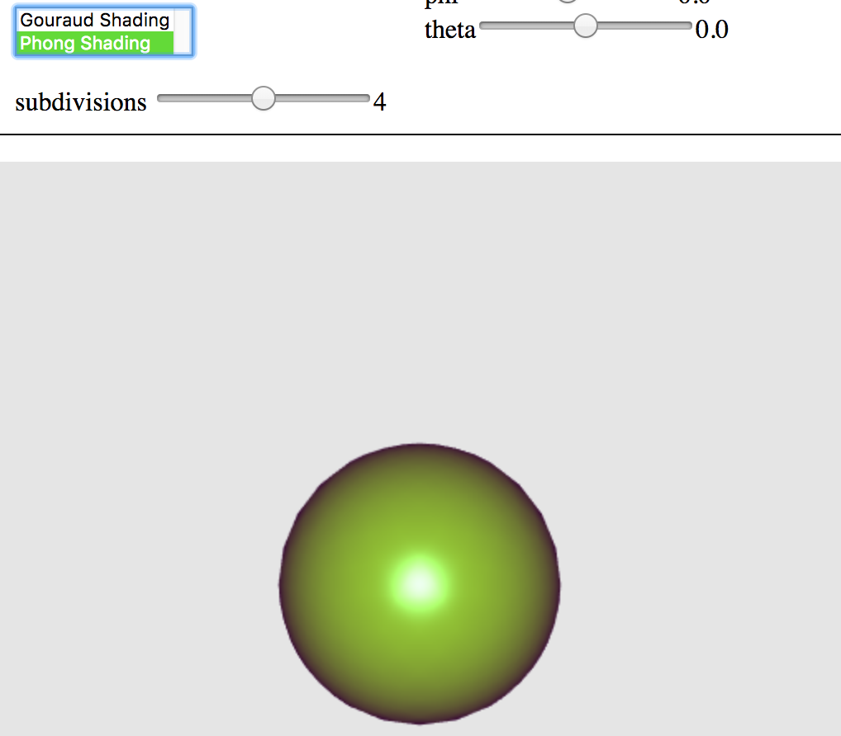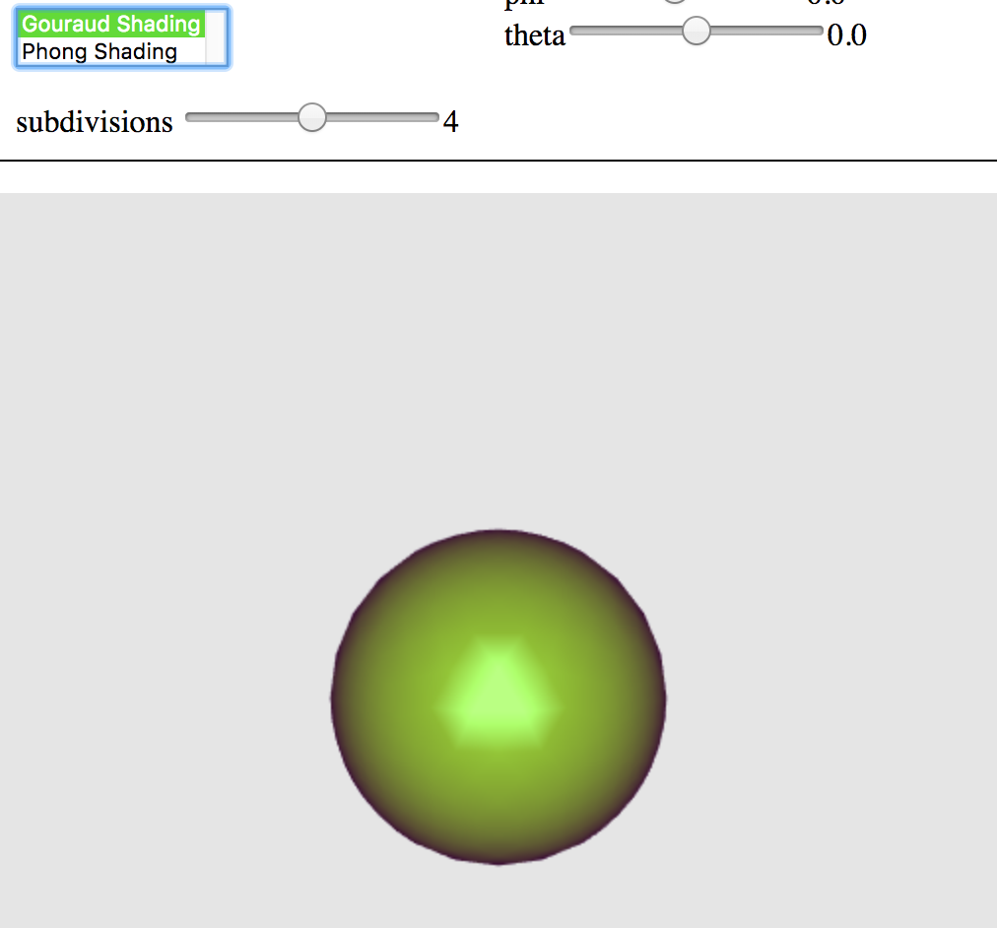

Gouraud shading is the less labor intensive of the two types of shading. Gouraud interpolates the colors along the polygon for each pixel. It calculates the intensity of each vertex using an illumination equation. You can see between the two pictures above that the Phong Shading looks more defined, has a cleaner circle. Inceasing the polygons for Gouraud will make the picture similar to the Phong Shader. This allows the shader to use linear interpolation for each edge pixel.

As I said before, Phong shader is more labor intensive and requires more out of a machine when running the code. Phong Shader is more realistic since it will calculate the normals at EVERY pixel and will interpolate the normal vectors at each point in the polygon. This means that the program will calculate the lighting equation at each pixel.

2. The Phong reflection model includes several non-physical (non-realistic) components in the model. List and describe these components that are not realistic and describe why they are made.