CSCI 441 - Lab 10

Friday, November 6, 2020

LAB IS DUE BY **FRIDAY NOVEMBER 13 11:59 PM**!!

Today, we’ll look at how to properly use geometry shaders and apply texturing. We will begin with a pass-through geometry shader and then expand a point into a textured quad.

Please answer the questions as you go inside your README.txt file.

**Step 0 – Get the Libraries copied**

If you don’t already have the TextureUtils.hpp file, copy it into your existing Z:/CSCI441/include/CSCI441 folder.

**Step 1 – Set up OpenGL Code**

For this lab, we’re not able to compile and run just yet. We need to do some initial setup.

There will be three files you need to modify for this lab:

* main.cpp
* shaders/billboardQuadShader.g.glsl
* shaders/billboardQuadShader.f.glsl

Let’s look at some things going on. Go to LOOKHERE #1 in setupShaders() of main.cpp. Note how our uniforms correspond to the ModelView matrix and the Projection matrix separately and not as the MVP like prior. This will be important very soon.

Scroll down to LOOKHERE #2 in setupBuffers(). We are generating NUM_SPRITES (which is set to 75) points set to random locations in the range [-10, 10] in all dimensions. These points are then put into a VBO and wrapped in a VAO. We also have an IBO that for now is just drawing our vertices in order 0 to 74.

And now in LOOKHERE #3 we use our program, set our uniforms, bind our VAO, and render the points. Let’s get everything hooked up so we can see stuff. Open up shaders/billboardQuad.g.glsl. This file corresponds to our Geometry Shader.

We’ll begin with TODO #A where we need to set the primitive input type. This takes the form of

layout( *primitiveType* ) in;

Since in main.cpp we called the function glDrawElements() with the argument GL_POINTS, that means our geometry shader must be ready to accept points as input. Therefore *primitiveType* should simply be points.

The next step, at TODO #B, is to set the primitive output type and number of vertices the geometry shader could output. This takes the form of

layout( *primitiveType*, max_vertices = *n* ) out;

Since we are creating a pass-through shader, the primitiveType should again be points and the max_vertices will be 1.

Now we see the projMatrix uniform. Where is the ModelView matrix? That’s in the vertex shader. Our vertex shader is performing the transformation into eye space and our geometry shader will be responsible for completing the transformation into clip space.

Let’s now make the geometry shader do something! The geometry shader needs to set the value of gl_Position for every vertex it emits. And this needs to be in clip space. The input to the geometry shader comes in the form of an array named gl_in. This is actually an array of structs so we will want the gl_Position member of gl_in. This variable is equal to the output of our vertex shader, so the vertex in eye space. We’ll need to transform this into clip space. The line we’ll need to add at TODO #C is

gl_Position = projMatrix * gl_in[0].gl_Position;

Don’t simply just copy and paste this line. Retype it yourself and understand what each part of the expression is contributing.

Now we’re ready to send this vertex on its way. At TODO #D, tell the geometry shader to ship the vertex down the pipe with the command EmitVertex(). Finally, at TODO #E tell the geometry shader to wrap up this primitive with the command EndPrimitive().

At this point, we can rerun our program and we should now see some random dots floating around.

Hooray! Our first working geometry shader! It simply passes the points through. Let’s start to manipulate our geometry.

Begin by changing TODO #B to output a max of 4 vertices. We’re going to use our geometry shader to create geometry. Next begin by copying the line after TODO #C where you set gl_Position to sections TODO #F, G, H to set gl_Position a total of four times. Be sure to also call EmitVertex() after every setting of gl_Position. Let’s rerun the program now. You should see the same thing you did before.

All four points are being drawn at the same location. We want to move them all slightly. Prior to the multiplication by the projection matrix, we need to translate each point slightly. We are working in eye space currently and this will give us instant billboarding (when we get to it). We want to shift each of our points in X and Y. We’ll move the point by adding a vector (yay vector math) and then multiply by the matrix. The general form will look like

gl_Position = projMatrix * (gl_in[0].gl_Position + *vector*);

We’ll need to replace the vector with the appropriate translation. We ultimately want to make a quad, so we’ll want to have a quad centered at our current location. Therefore, prior to emitting each vertex we’ll move it to a corner of our quad. The four corners will correspond to

(-1, -1)

(-1, 1)

(1, -1)

(1, 1)

and we need to replicate that with each vector. Recall that gl_Position is a vec4 so we need to add a vec4. X and Y will be set to above. We don’t want to modify Z, so what should it’s value be? This is also representing a vector, so what should W be?

When all four vertices are moved, rerun the program and now we should see 4X as many points as we did before!

And now for the Geometry Shader magik!! All we need to do is to change our output primitive from points to a triangle_strip and we’ll begin making quads! If you emit your vertices in the correct order then you will see some beautiful looking quads, as below:

If you are seeing bowties or just triangles, then reorder the points you are emitting to follow proper CCW winding order for a triangle strip.

As our scene rotates or we rotate our camera up/down, the quads rotate to always face us.

**Q1: Why are they billboarding?**

Let’s make them look a little prettier. Switch back to main.cpp briefly. At LOOKHERE #4, we are loading a texture.

To render the texture we need to keep working in our shaders. The first step will be in the Geometry Shader. We are emitting vertex positions but no other attributes. We need to have texture coordinates specified somewhere so we know which texel to load.

Let’s get the texture coordinate variable set up first. It will be created and output from the geometry shader, then read and used in the fragment shader. A varying! At TODO #I, add the output varying variable to the geometry shader. A texture coordinate is simply a two dimensional vector. Give it an appropriate name.

Now in the fragment shader at TODO #J, add the input varying variable ensuring the name and type match the output.

We’re ready to go. Now in the geometry shader, prior to emitting each vertex we need to set a texture coordinate that corresponds to the vertex. The texture coordinates should range over

(0,0)

(1,0)

(0,1)

(1,1)

Make sure you are emitting the texture coordinate with the corresponding vertex so they span the correct order.

Now in the fragment shader we need to look up the texel. The first step, at TODO #K, is to get access to the bound texture. Shaders have a special type for 2D textures and that is sampler2D. Create a uniform of this type and name it image to match the expected call from main.cpp.

Finally at TODO #L, we need to load the texel. GLSL has a special function called texture() that takes two arguments. The first is the sampler2D variable and the second is the texture coordinate. Set fragColorOut equal to the result of this function call.

And barring no typos, when we run our program we’ll see the following!!

Hip hip hooray! Rotate around and enjoy the winter wonderland. Wait, something’s not right? The snowflakes are occluding each other!

**Q2: Why do we see the black of the quad blocking snowflakes that are behind the current one?**

Until now, everything for this lab was dealing exclusively with shader programming and we didn’t need to touch anything with OpenGL.

**Q3: Why?**

In order to properly render our transparent objects, we need to draw them back to front.

**Q4: Why?**

This means we need to reorder the vertex data before we send it to the GPU to draw. We will do this in two steps. First we will compute the distance to the camera for each point. Then we will sort the points by this distance.

In the image below, the circled points are the distances we need to sort by.

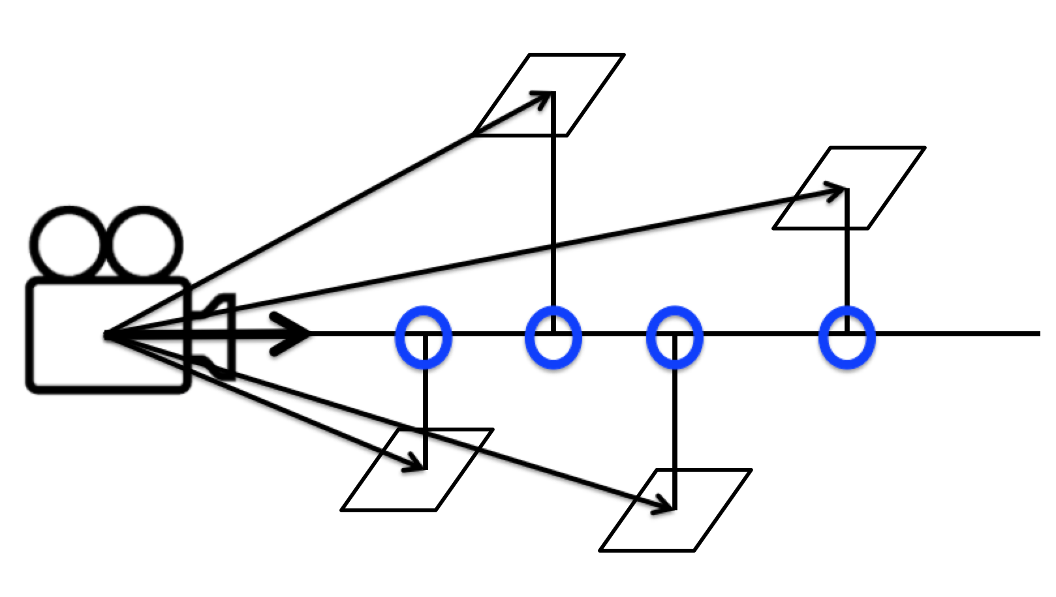

For an individual triangle, we have the following information:

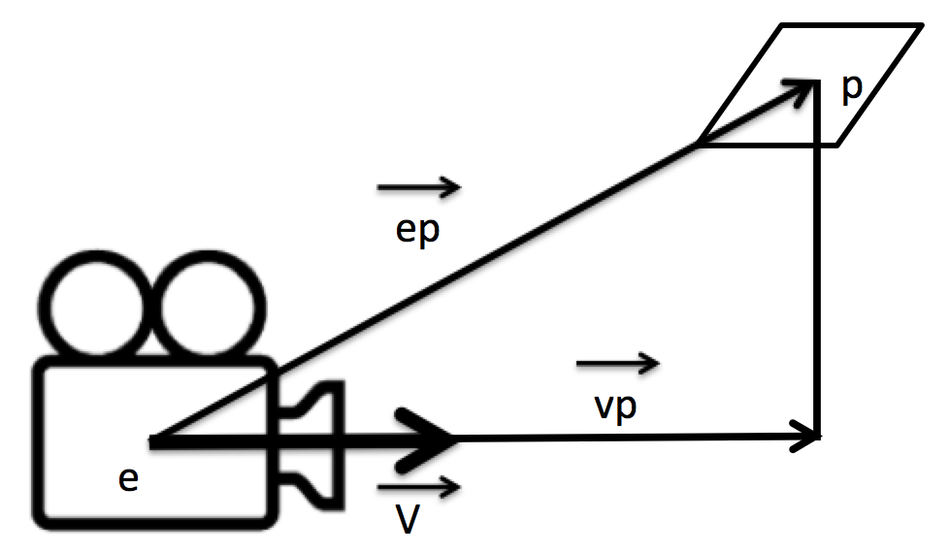

v is our normalized view vector. At TODO #1 in main.cpp, we will begin. Compute the normalized view vector from arcballCamera.lookAtPoint and arcballCamera.eyePos. We want the view vector pointing at the lookAt point.

There already exists a few arrays we’re going to need, all of size NUM_SPRITES. They are:

* spriteLocations – the (x,y,z) location of each sprite. These correspond to the point p in the image above.
* spriteIndices – this matches our IBO for the order to draw the spriteLocations in. We’ll be modifying this array in a moment.
* distances – this will hold the distance of each sprite to the camera. We’ll also modify this array in a moment.

Now we are going to loop through each of our points stored in the spriteLocations array with a bit of indirection. We need to mimic the IBO the GPU is using, so we will access the positions in our spriteLocations array based on the spriteIndices value.

glm::vec3 currentSprite = spriteLocations[ spriteIndices[i] ];

For each sprite, we first need to convert the point into world space. This means we will create a vec4 out of the currentSprite and multiply it by the model matrix. This will get us point p in world space. Our camera point, arcballCamera.eyePos, is already in world space. From these two points we can create the vector ep. As discussed in class, the length of vector vp gives us the distance to the point projected onto the view direction. This distance corresponds to the dot product between v and ep. Compute this distance aka dot product. (Hint: glm has a function called dot). We will now put into the ith position of the distances array the value of the dot product.

Next we need to sort the distances and move the ordered indices as well. This will go at TODO #2. For simplicity, I’d recommend doing a bubble sort. Compare the ith and jth distances. If the ith distance is less than the jth distance, then swap the indices and distances for position i and j in each array.

You may want to verify that these two arrays are sorted in the proper order.

Perfect. Now at TODO #3, we need to bind our ibo to the GL_ELEMENT_ARRAY_BUFFER. We can accomplish this via

glBindBuffer( GL_ELEMENT_ARRAY_BUFFER, ibos[VAOS.PARTICLE_SYSTEM] );

And now we send over the ordered index data to the GPU. We will use the glBufferSubData() command for this. Recall the four arguments:

1. Target (GL_ELEMENT_ARRAY_BUFFER)
2. Offset (0 – we want to start at the beginning)
3. Size ( sizeof(GLushort) * NUM_SPRITES )
4. The actual data (spriteIndicies)

Compile. Run. Watch them spin. Move the camera around. Voila! Magical transparent snowflakes.

**Q5: Was this lab fun? 1-10 (1 least fun, 10 most fun)**

**Q6: How was the write-up for the lab? Too much hand holding? Too thorough? Too vague? Just right?**

**Q7: How long did this lab take you?**

**Q8: Any other comments?**

To submit this lab, zip together your source code and README.txt with questions. Name the zip file <HeroName>_L10.zip. Upload this on to Canvas under the L10 section.

LAB IS DUE BY **FRIDAY NOVEMBER 13 11:59 PM**!!