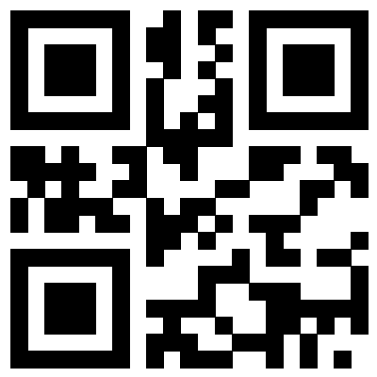
Carter Keel
contact@keel.me
Pensacola, FL
linkedin: Carter Keel
website: keel.me

EXPERIENCE

YouTube Channel:
- Published over 200+ videos and counting about IT, cybersecurity, and technology, educating over 1.5 million people per month across multiple platforms on best practices, new apps, and staying safe online.

Cybersecurity Completions:
- Regularly compete in cybersecurity competitions with the UWF Cyber Club, placing in the top 72% in NCL 2025 and CyberSeed 2025.

  - Open Source Intelligence
  - Cryptography
  - Password Cracking
  - Log Analysis
  - Network Traffic Analysis
  - Forensics
  - Scanning & Reconnaissance
  - Web Application Exploitation
  - Enumeration & Exploitation
  - Survey

Local Data Center:
- Administered my data center running Proxmox with virtual machines and containers, self-hosting services with active users such as Jellyfin, Immich, and n8n. Configured VPNs using WireGuard.

  - Proxmox
  - Wireguard
  - CLI
  - Network Admin
  - Firewall Rules
  - Hardware configuration
  - Group Policy
  - Docker

EDUCATION

- Bachelor of Science, Cybersecurity
University of West Florida – Expected Dec 2026

- Associate of Arts
Pensacola State College – 2023

EMPLOYMENT

Video Editor:

Kaiser Media Group – Pensacola, FL
Oct 2025 – Current
Be a Light Productions – Pensacola, FL
Oct 2022 – October 2025
Storypoint Church – Gulf Breeze, FL
Sept 2021 – Dec 2023

