Carter Keel
contact@keel.me
Pensacola, FL
linkedin: Carter Keel
website: keel.me
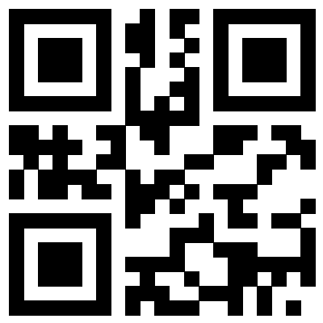
EDUCATION

- Bachelor of Science, Cybersecurity
University of West Florida – Pensacola, FL Expected Dec 2026

- Associate of Arts
Pensacola State College – Pensacola FL

PROJECTS

YouTube Channel:
- I built and have maintained a YouTube channel @RandomButCool for over five years, posting high-production videos daily on topics such as internet safety, server configuration, and account security. To produce these videos, I use industry-standard tools including vMix, Premiere Pro, After Effects, and DaVinci Resolve.

Proxmox Server:
- I created and maintain my personal home server, which is used by my entire family for media storage and consumption. I also host automation tools, such as n8n. I am very familiar with the terminal and use industry-standard software and hardware, including Ubiquiti networking and Proxmox hypervisor, to manage and create virtual machines and containers.

Web Apps Development:
- I developed a web application to help calculate the odds for the starting bet in Texas Hold’em. I created this app because I struggled with gaining chips in the game and wanted a tool that would remove emotion from preflop betting decisions. To develop the app, I used professional tools including VS Code, GitHub with branching, GitHub Copilot, and Cloudflare for hosting. Try the app at https://poker.keel.me.

EMPLOYMENT

- Video Editor
Storypoint church – Gulf Breeze, FL
Sept 2021 – Dec 2023
- Video Editor
Be A Light Productions – Pensacola, FL
Oct 2022 – Current

