**ScreenShot of quickdatabasediagrams.com output (note: full screenshot at end of this document)**

**Postgress Database: Quotes_to_Scrape_DB**

**ERD Portion**

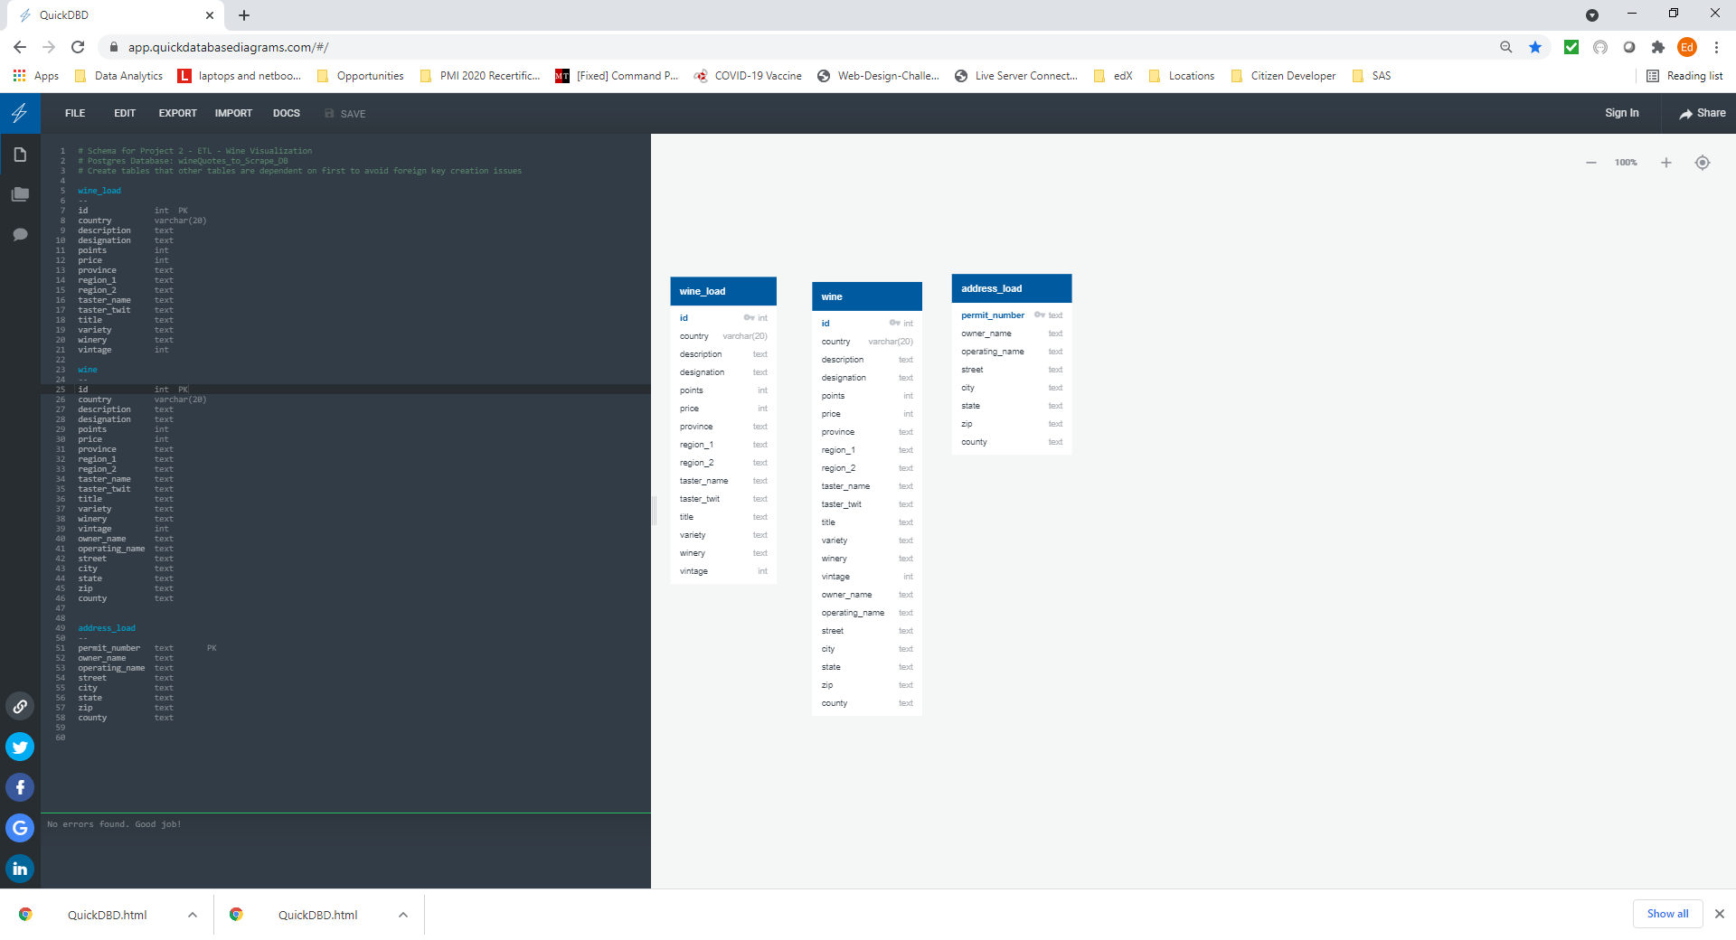

(Next pages – code screen and copy paste of code)

**Code Portion**



**CODE to Generate the Diagram above**

# Schema for Project 2 - ETL - Wine Visualization

# Postgres Database: wineQuotes_to_Scrape_DB

# Create tables that other tables are dependent on first to avoid foreign key creation issues

wine_load

--

id int PK

country varchar(20)

description text

designation text

points int

price int

province text

region_1 text

region_2 text

taster_name text

taster_twit text

title text

variety text

winery text

vintage int

wine

--

id int PK

country varchar(20)

description text

designation text

points int

price int

province text

region_1 text

region_2 text

taster_name text

taster_twit text

title text

variety text

winery text

vintage int

owner_name text

operating_name text

street text

city text

state text

zip text

county text

address_load

--

permit_number text PK

owner_name text

operating_name text

street text

city text

state text

zip text

county text

**Schema generated from quickdatabaseDiagrams.com**

**NOTE: The Schema generated has around all the tables and variables – THESE MUST BE REMOVED!**

-- Exported from QuickDBD: https://www.quickdatabasediagrams.com/

-- NOTE! If you have used non-SQL datatypes in your design, you will have to change these here.

-- Schema for Project 2 - ETL - Wine Visualization

-- Postgres Database: wineQuotes_to_Scrape_DB

-- Create tables that other tables are dependent on first to avoid foreign key creation issues

CREATE TABLE wine_load (

id int NOT NULL,

country varchar(20) NOT NULL,

description text NOT NULL,

designation text NOT NULL,

points int NOT NULL,

price int NOT NULL,

province text NOT NULL,

region_1 text NOT NULL,

region_2 text NOT NULL,

taster_name text NOT NULL,

taster_twit text NOT NULL,

title text NOT NULL,

variety text NOT NULL,

winery text NOT NULL,

vintage int NOT NULL,

CONSTRAINT pk_wine_load PRIMARY KEY (

id

)

);

CREATE TABLE wine (

id int NOT NULL,

country varchar(20) NOT NULL,

description text NOT NULL,

designation text NOT NULL,

points int NOT NULL,

price int NOT NULL,

province text NOT NULL,

region_1 text NOT NULL,

region_2 text NOT NULL,

taster_name text NOT NULL,

taster_twit text NOT NULL,

title text NOT NULL,

variety text NOT NULL,

winery text NOT NULL,

vintage int NOT NULL,

owner_name text NOT NULL,

operating_name text NOT NULL,

street text NOT NULL,

city text NOT NULL,

state text NOT NULL,

zip text NOT NULL,

county text NOT NULL,

CONSTRAINT pk_wine PRIMARY KEY (

id

)

);

CREATE TABLE address_load (

permit_number text NOT NULL,

owner_name text NOT NULL,

operating_name text NOT NULL,

street text NOT NULL,

city text NOT NULL,

state text NOT NULL,

zip text NOT NULL,

county text NOT NULL,

CONSTRAINT pk_address_load PRIMARY KEY (

permit_number

)

);