## horizontal line



<https://github.com/carterkioski/Utterly_Uncreative>

* **Overview:**
  + Dashboard showing information about wines based on their variety. The data
* **Data:**
  + <https://www.kaggle.com/zynicide/wine-reviews?select=winemag-data-130k-v2.json> (Wine Reviews)
  + <https://www.ttb.gov/foia/list-of-permittees> (List of Permittees)
* **Dashboard:**

Initial idea for dashboard

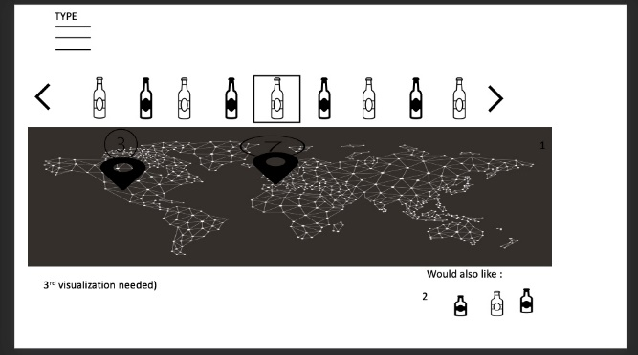

* Map listing wineries based on wine variety
* Drill down into region/state showing individual wineries rating for that variety as well as address and price.
* Visualization of other wine types based on similar reviews
* Sentiment analysis on reviews for more insights on wine varieties