**Presentation Notes**

Background:

* Study: <https://www.kaggle.com/c/aptos2019-blindness-detection/overview>
* Fundus photography: <https://en.wikipedia.org/wiki/Fundus_photography>

Fundus Camera

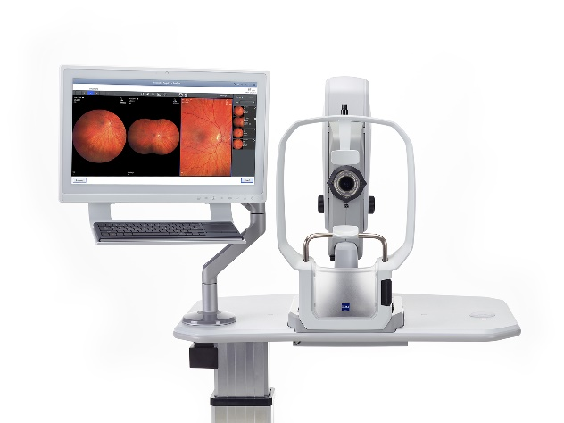

Normal Left and Right Eyes

* 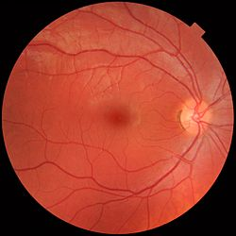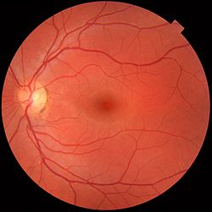

The Study

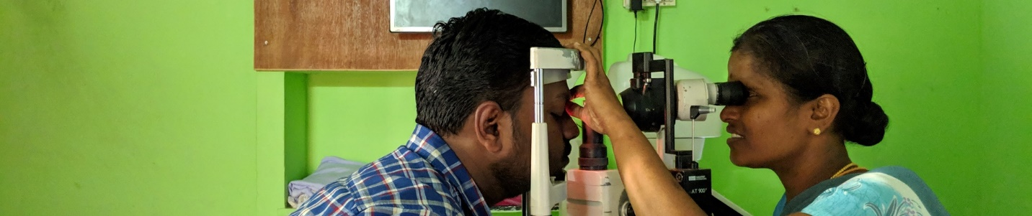

Type of model: CNN – Convoluted

Why

Design

Parameters

* Batch Normalization

Graph

* Accuracy
* loss

Improvement

Reference:

<https://keras.io/api/layers/convolution_layers/convolution2d/>

<https://www.geeksforgeeks.org/keras-conv2d-class/>

<https://machinelearningmastery.com/how-to-accelerate-learning-of-deep-neural-networks-with-batch-normalization/>

<https://intellipaat.com/community/368/how-to-interpret-loss-and-accuracy-for-a-machine-learning-model>

starting Point:

<https://www.kaggle.com/siddheshshelke/drd-cnn-transfer-learning-5-class/notebook>

<https://www.tensorflow.org/tutorials/images/cnn>

**Images**

Proliferate

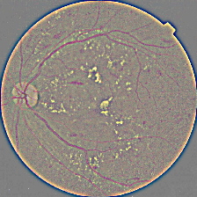

Severe

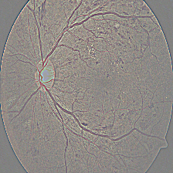

Moderate

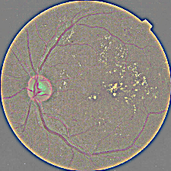

Mild

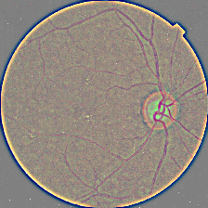

No Diabetic Retinopathy

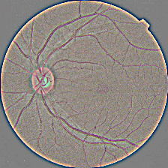

**Model**

