**Diabetes Notes**

Reference on the process for getting images: <https://en.wikipedia.org/wiki/Fundus_photography>

Reference on CNN for image analysis: <https://www.tensorflow.org/tutorials/images/cnn>

Reference of model that started with:

<https://www.kaggle.com/siddheshshelke/drd-cnn-transfer-learning-5-class/notebook>

Diabetes Document link:

<https://www.cdc.gov/diabetes/pdfs/data/statistics/national-diabetes-statistics-report.pdf>

Diabetes Map Reference and Data (note: need to click on the “Social Determinants” in top of left box and “Map Slider” at bottom of left side box)

* <https://gis.cdc.gov/grasp/diabetes/diabetesatlas.html#>

Slider Reference

* <http://zevross.com/blog/2014/08/12/add-a-before-after-map-slider-to-a-leaflet-map/>

Results Comparison – Original reference versus Ed’s

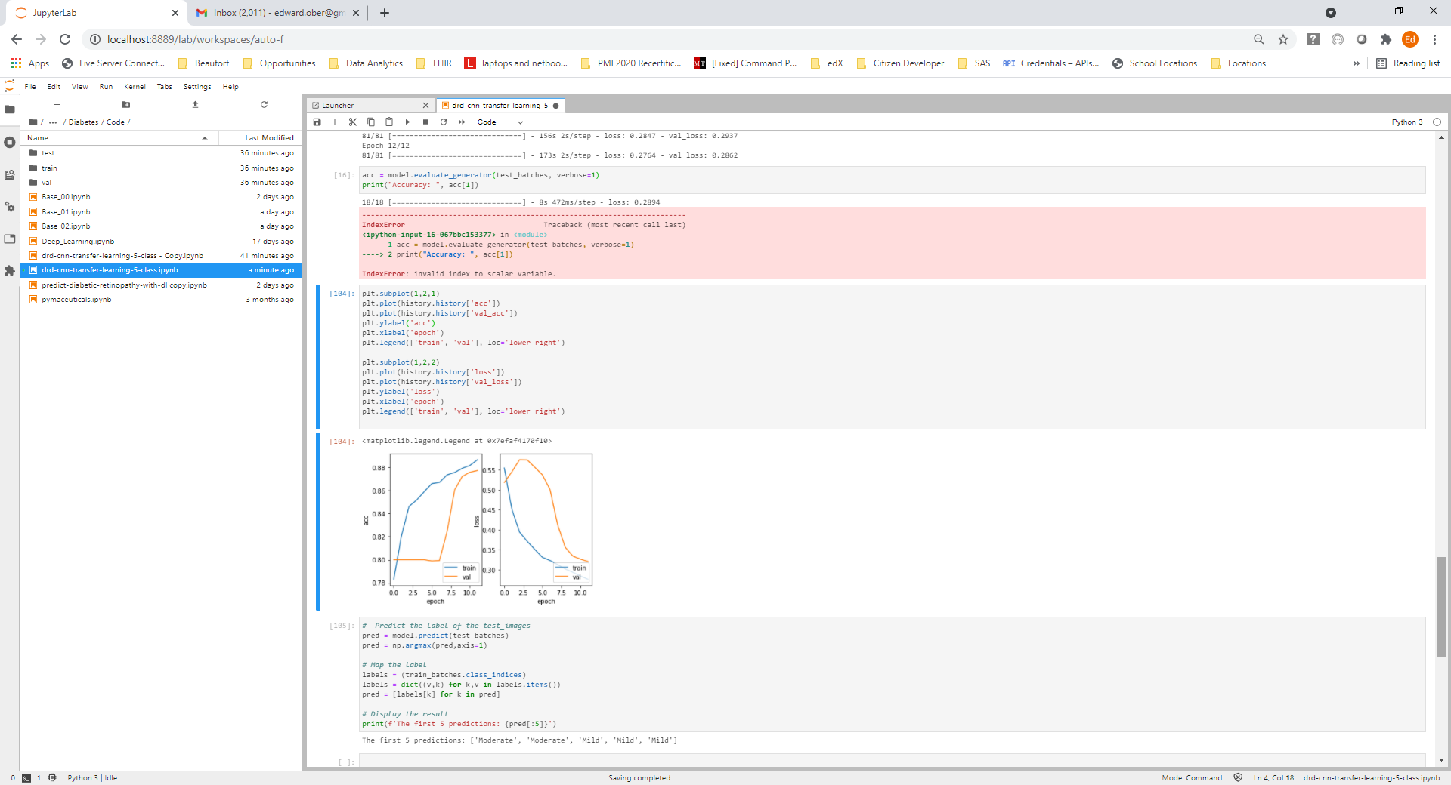



Ed’s – 0-20 Epochs

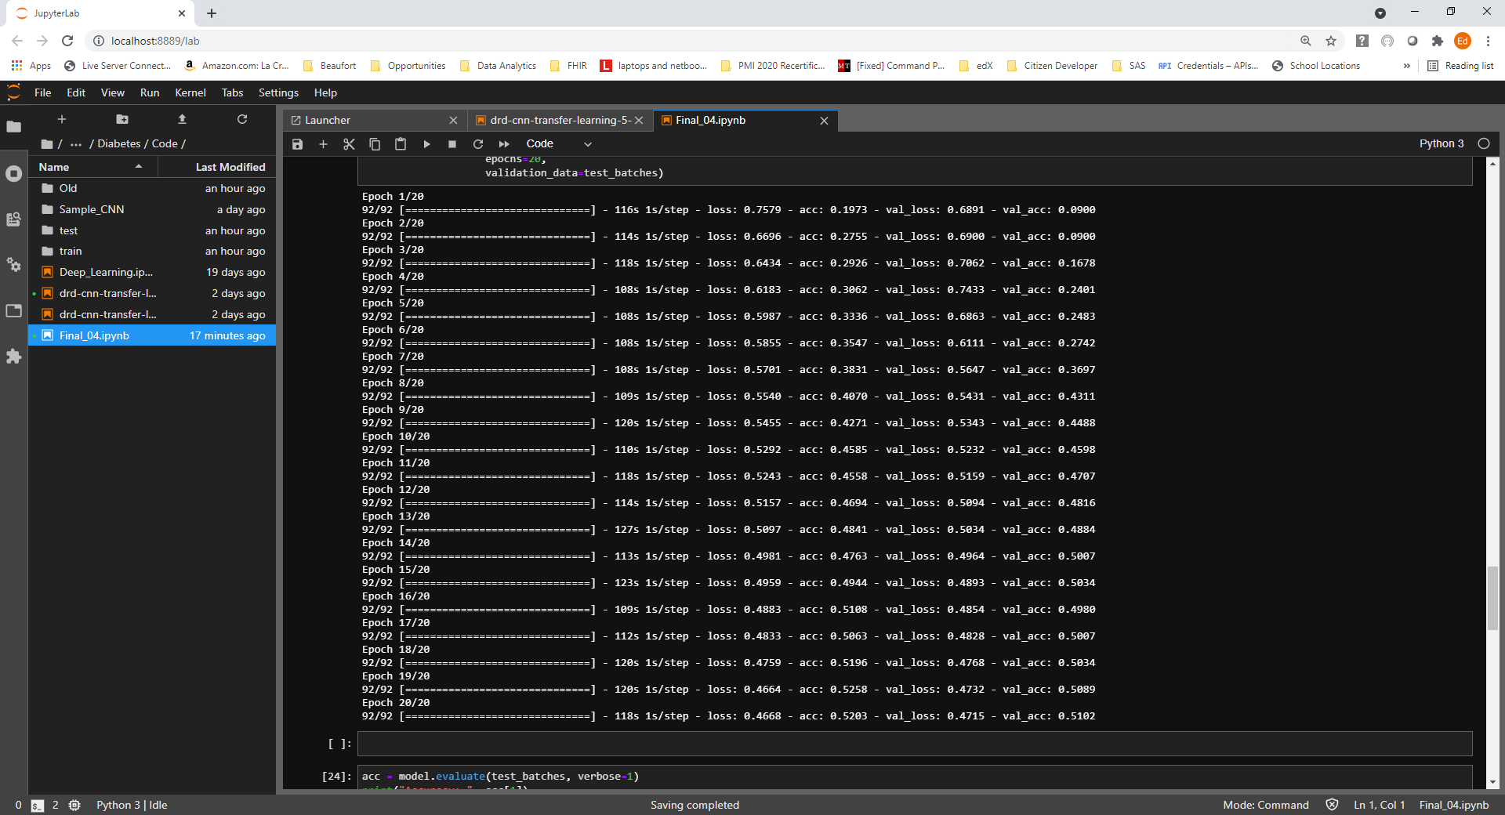

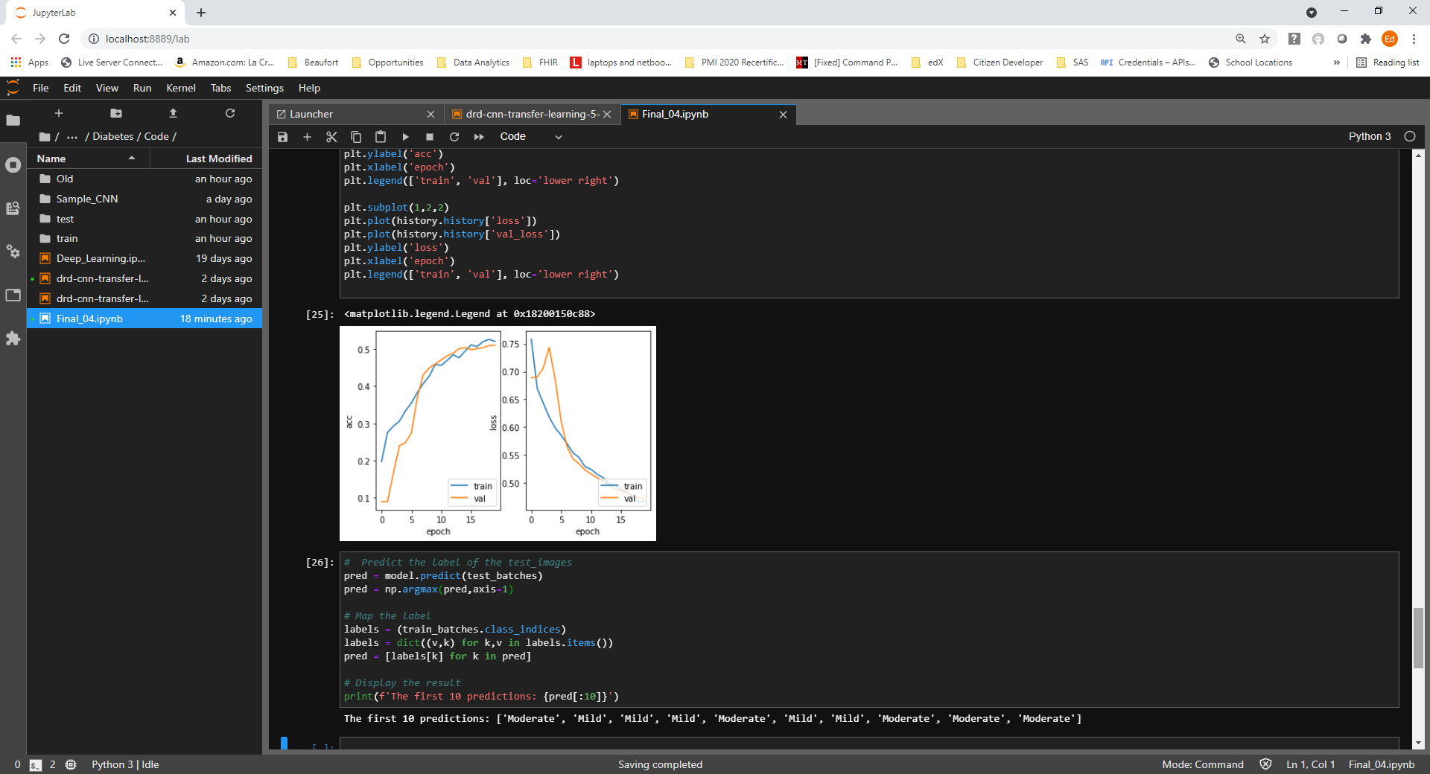

Ed’s 21-60 Epochs

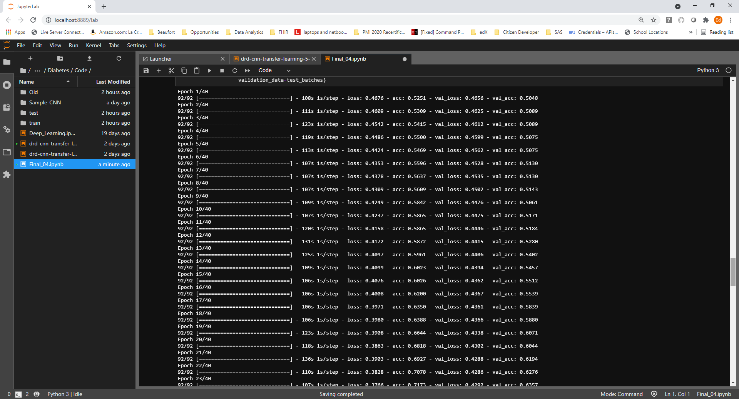

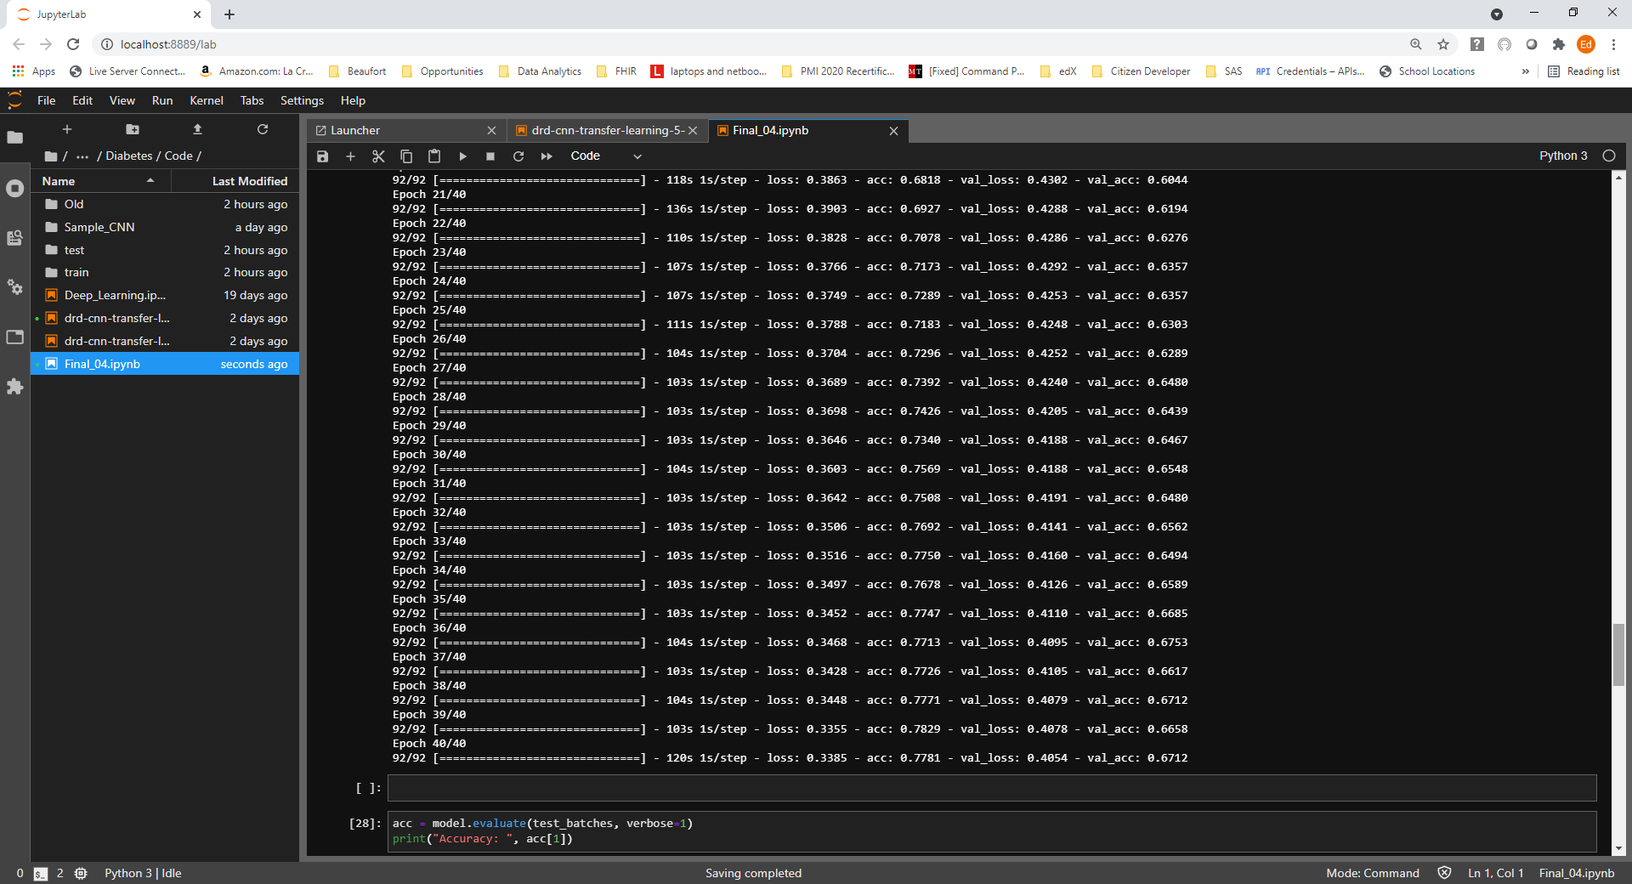

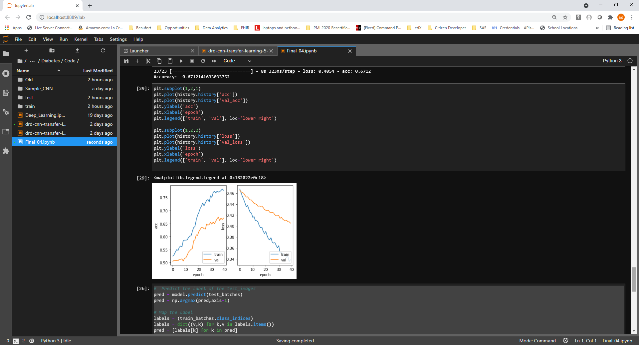

Ed’s Epochs 61-100

