**Changes: Corrected spelling on description, made quote_id serial and added the lines from quickdb**

**ScreenShot of quickdatabasediagrams.com output (note: full screenshot at end of this document)**

**Postgress Database: Quotes_to_Scrape_DB**

**ERD Portion**

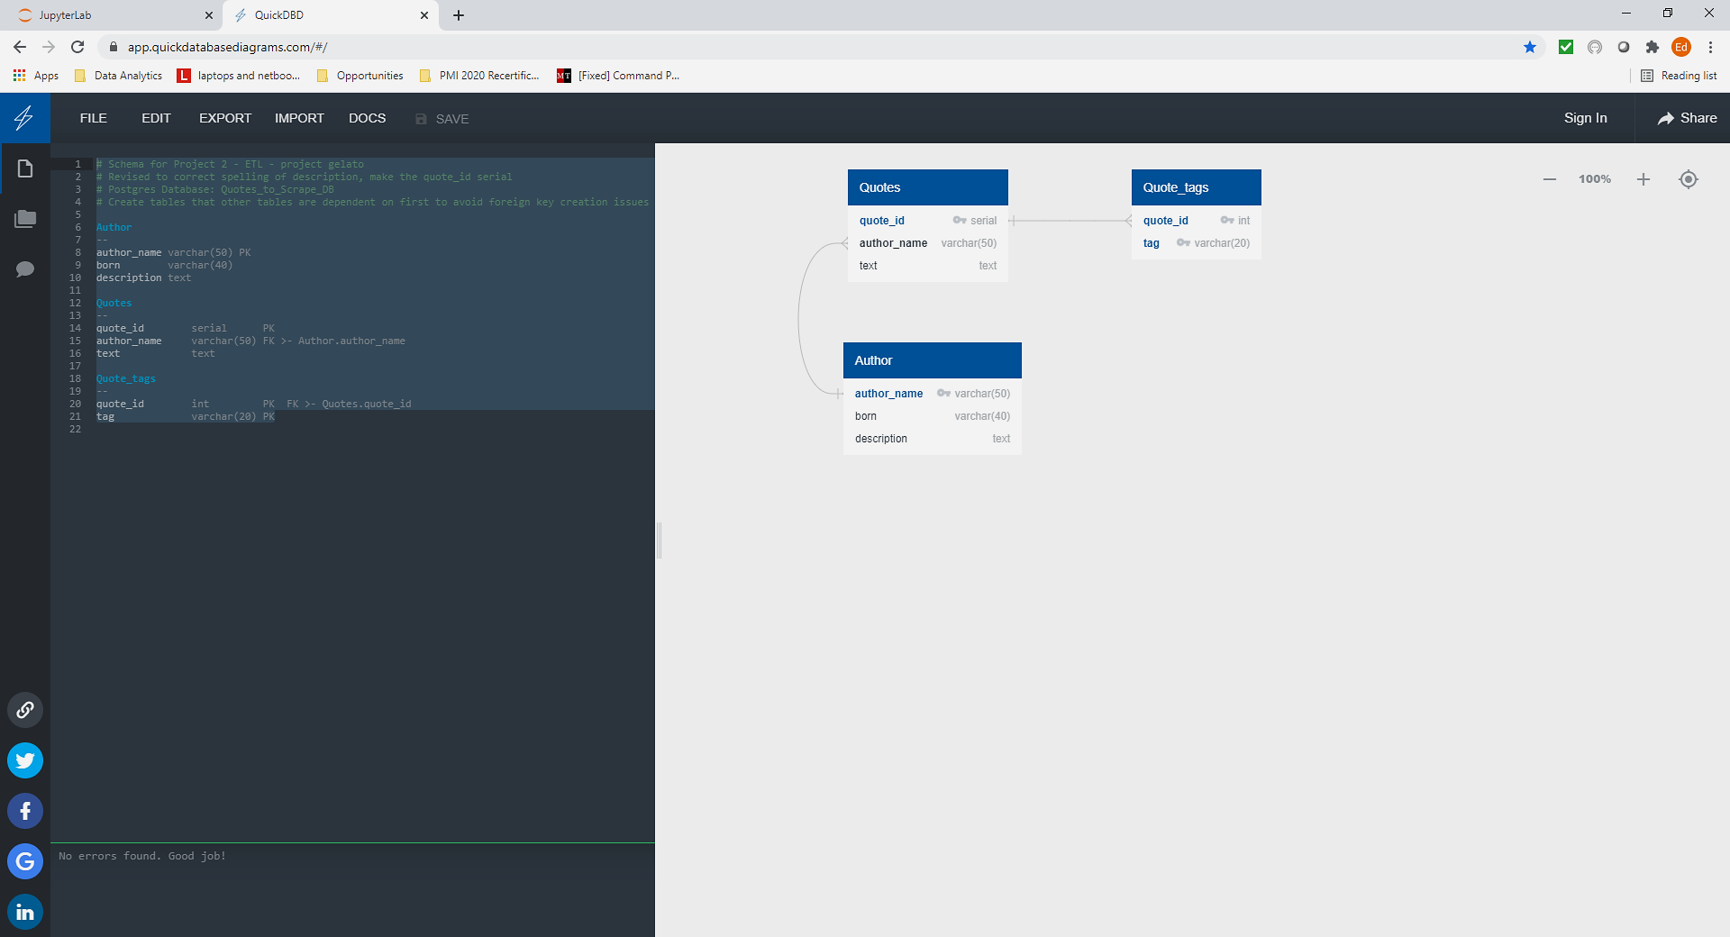

(Next pages – code screen and copy paste of code)

**Code Portion**

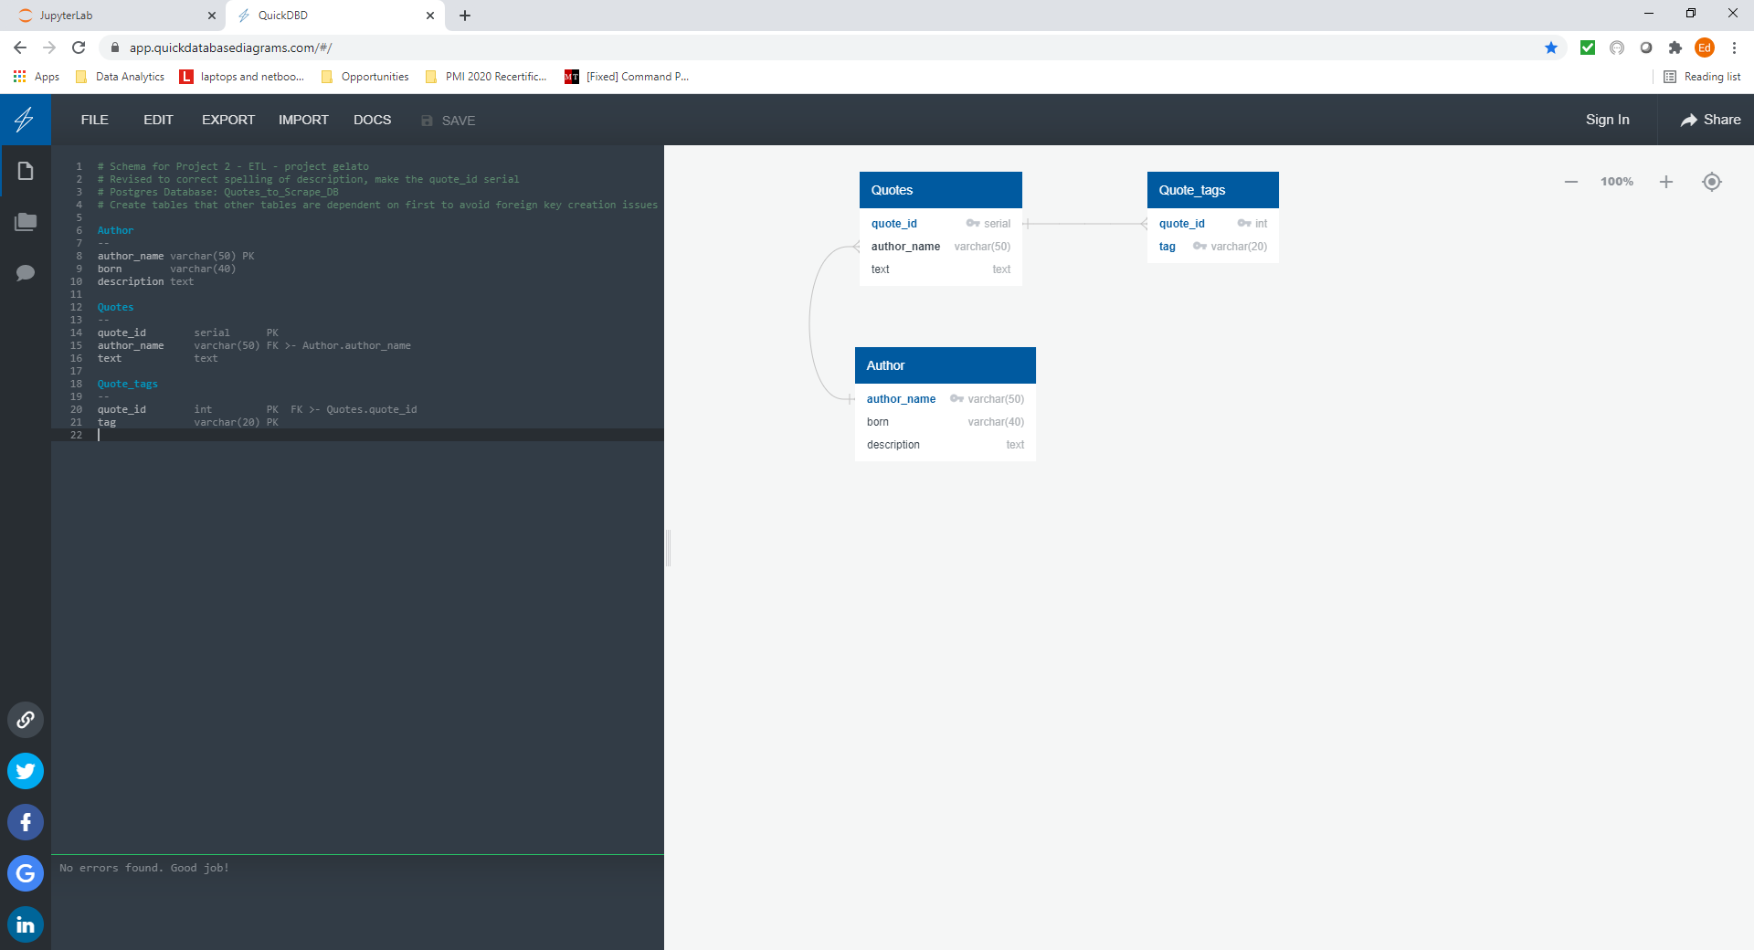

**CODE to Generate the Diagram above**

# Schema for Project 2 - ETL - project gelato

# Revised to correct spelling of description, make the quote_id serial

# Postgres Database: Quotes_to_Scrape_DB

# Create tables that other tables are dependent on first to avoid foreign key creation issues

Author

--

author_name varchar(50) PK

born varchar(40)

description text

Quotes

--

quote_id serial PK

author_name varchar(50) FK >- Author.author_name

text text

Quote_tags

--

quote_id int PK FK >- Quotes.quote_id

tag varchar(20) PK

**Schema generated from quickdatabaseDiagrams.com**

-- Exported from QuickDBD: https://www.quickdatabasediagrams.com/

-- NOTE! If you have used non-SQL datatypes in your design, you will have to change these here.

-- Schema for Project 2 - ETL - project gelato

-- Revised to correct spelling of description, make the quote_id serial

-- Postgres Database: Quotes_to_Scrape_DB

-- Create tables that other tables are dependent on first to avoid foreign key creation issues

CREATE TABLE Author (

author_name varchar(50) NOT NULL,

born varchar(40) NOT NULL,

description text NOT NULL,

CONSTRAINT pk_Author PRIMARY KEY (

author_name

)

);

CREATE TABLE Quotes (

quote_id serial NOT NULL,

author_name varchar(50) NOT NULL,

text text NOT NULL,

CONSTRAINT pk_Quotes PRIMARY KEY (

quote_id

)

);

CREATE TABLE Quote_tags (

quote_id int NOT NULL,

tag varchar(20) NOT NULL,

CONSTRAINT pk_Quote_tags PRIMARY KEY (

quote_id,tag

)

);

ALTER TABLE Quotes ADD CONSTRAINT fk_Quotes_author_name FOREIGN KEY(author_name)

REFERENCES Author (author_name);

ALTER TABLE Quote_tags ADD CONSTRAINT fk_Quote_tags_quote_id FOREIGN KEY(quote_id)

REFERENCES Quotes (quote_id);