L. Carter Price

Computer Vision

PS3 - 10/18/2019

**Programming: Image Mosaics**

**4.**

**Crop Images**

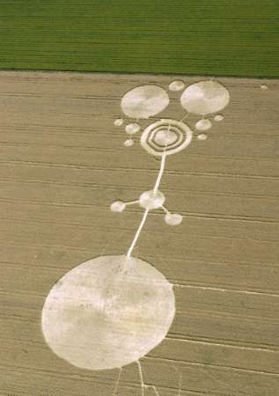

Figure : Original crop images. Image 1 (left) and image 2 (right)

Figure : Crops images with manually marked keypoints.

Figure : Results of the homography on crop images. After manually matching key features between crop image 1 and crop image 2. Crop image 1 was then transformed to fit in the frame of crop image 2 (top). Then the original crop image 2 was merged with the full output of the transformed image 1 (bottom).

**Washington DC Images**

Figure : Original WDC images. wdc 1 with keypoints in blue(left) and wdc 2 with keypoints(right)

Figure : Results of the homography on wdc images. After manually matching key features between wdc 1 and wdc 2. wdc 1 was then transformed to match perspective of wdc 2 (left). Then the original wdc 2 was merged with the full output of the transformed wdc 1 (right).

**5. Additional Example**

Figure : Original images of a Kendal in the living room. Kendal 1 (left) Kendal 2 (right)

Figure : Kendal pictures with keypoints

Figure : Image to verify the homography is correct. Red dots are results from homography matrix h. while blue points with blue circle are original keypoints

Figure : The output of Kendal 1 transformed into the perspective of Kendal 2 (left). The image on the right contains the original Kendal 2 overlaid with the output of the transformation from Kendal 1. Kendal’s face is blurry because she moved in between the photographs. This is not uncommon when taking multiple pictures of humans and should be addressed appropriately in the future to make the images still seem natural.

**6. Warp of Frame region**

Figure : Original images used for this exercise. (left) a bike and the beach. (right) Living room with a sunset painting on the wall.

Figure : the bike and beach picture is warped and replaces the sunset painting in the living room.

**Extra Credit**

1. **Use automatic Feature point detection**

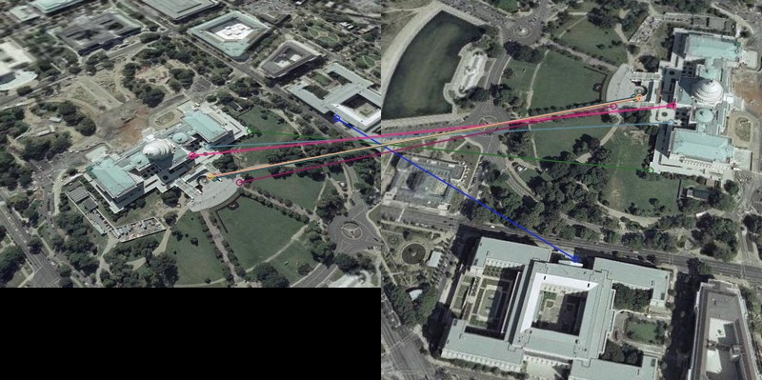

Figure :Keypoint matches using the ORB feature detector.

**

*Figure 13: Top 2 pictures show the original transformation using the manual keypoints. The bottom two pictures show the transformation using the ORB feature matching for keypoints. As can be seen the ORB technique resulted in more distortion due to imperfect matches.*

**3. Rectify planar surface**

Figure : Original image of patterned picture taken from a side view with a large angle between the perpendicular of the pattern of interest.

Figure : Output after manually selecting the corners of the pattern from the original image and then transforming it into a 400x400 pixel square pattern image. As can be seen there is still some distortion due to the sharp angle but hopefully a better understanding of the pattern.