PS5

Carter Price

11/27/2019

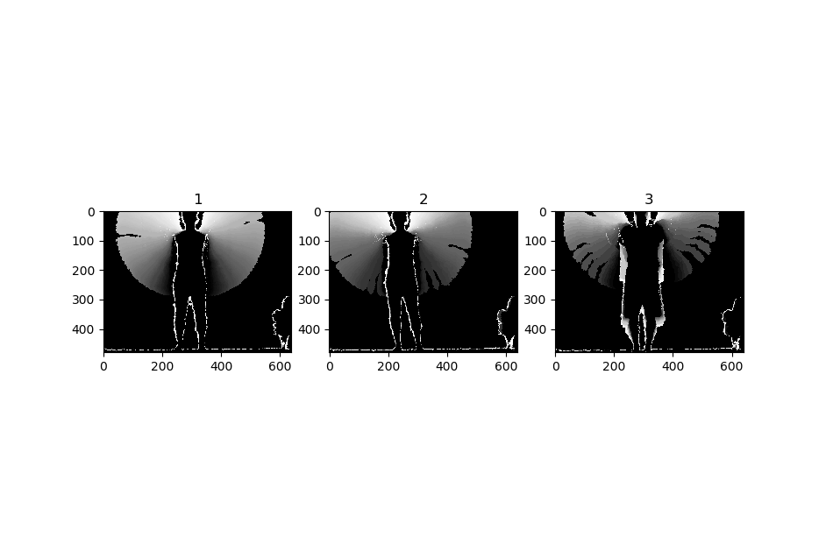

Figure : Sample MHIs from different action categories. Top row: Both arms up . Middle: right leg Kick. Bottom: Left arm up.

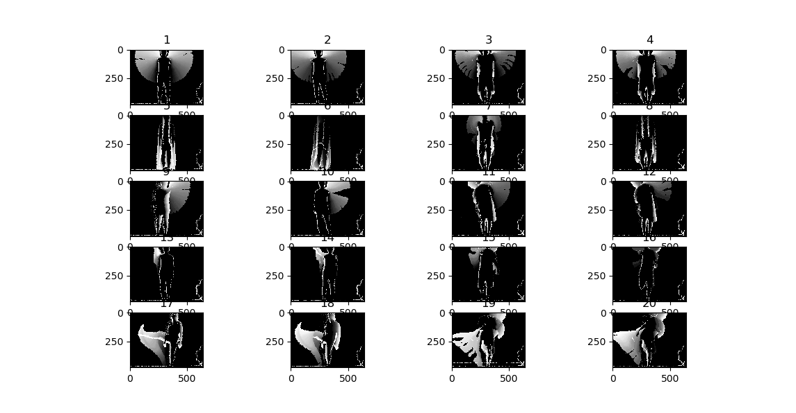

Figure : All 20 MHIs.

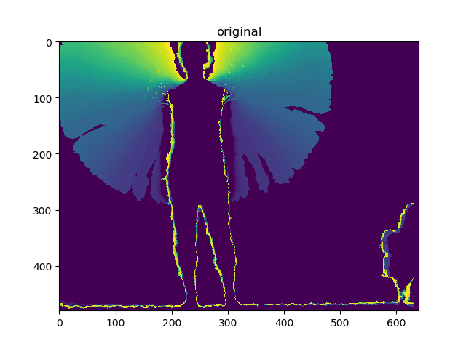

Figure : Top: original input MHI Both arms up being tested.

Figure Top: original input MHI being tested. Bottom: 4 most similar for original right kick image.

5.

**Confusion Matrix**

|  |  |  |  |  |  |  |
| --- | --- | --- | --- | --- | --- | --- |
|  |  | Actual | | | | |
|  |  | BothArms | Crouch | Leftarmup | Punch | Rightkick |
| Predicted | BothArms | 3 | 0 | 0 | 0 | 0 |
| Crouch | 0 | 2 | 1 | 1 | 0 |
| Leftarmup | 0 | 1 | 2 | 0 | 0 |
| Punch | 0 | 1 | 1 | 3 | 0 |
| Rightkick | 1 | 0 | 0 | 0 | 4 |

**Overall Recognition Rate:** 14/20 = 70%

**Mean Recognition Rate per class:**

|  |  |
| --- | --- |
|  | recognition rate |
| BothArms | 0.75 |
| Crouch | 0.5 |
| Leftarmup | 0.5 |
| Punch | 0.75 |
| Rightkick | 1 |

As seen above in the confusion matrix and the recognition rate statistics, the classifier did not perform particularly well. The right kick was classified correctly each time, but the other three classes all had errors. The crouch and left arm up seemed to struggle the most. They were able to correctly classify 2 of the 4 images. In both cases. There was no clear pattern in the error other than the fact that crouch, left-arm-up and punch seemed to have the most mixing of mis classification with the exception of the one image from the Both arms up category that was incorrectly classified as a kick. Overall, these results are not great, it would be preferred to have a much larger data set.

**Extra Credit:**

As a test, I implemented the KNN classifier on the raw MHI and actually saw for this sample set that there was improved performance the overall recognition rate was 75% as opposed to 70% using the Hu Moments. This method tended to over classify towards the punch category as you can see that each incorrect classification predicted the punch action. Though it did perform well on this small data set it is unlikely that it would out perform the HuMoment method were this to be scaled up.

|  |  |  |  |  |  |  |
| --- | --- | --- | --- | --- | --- | --- |
|  |  | Actual | | | | |
|  |  | BothArms | Crouch | Leftarmup | Punch | Rightkick |
| Predicted | BothArms | 3 | 0 | 0 | 0 | 0 |
| Crouch | 0 | 1 | 0 | 0 | 0 |
| Leftarmup | 0 | 0 | 3 | 0 | 0 |
| Punch | 1 | 3 | 1 | 4 | 0 |
| Rightkick | 0 | 0 | 0 | 0 | 4 |

**Overall Recognition Rate:** 15/20 = 75%