CSSE373: Project Milestone 1, RDT 1.0

Sean Carter and Austin Willis (“The Awesome Team”)

# Property 1 Screenshots

Key: sendBuffer is the sender’s buffer, recvBuffer is the receiver’s buffer

## State0 (init)

All data is in sendBuffer



## State1

Data1 is taken from the sendBuffer and put into a packet

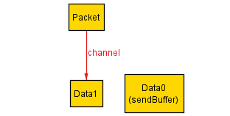

## State2

Data1 is unpackaged and placed in recvBuffer



## State3

Data0 is taken from sendBuffer and placed in a packet

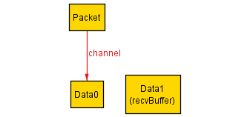

## State4

Data0 is unpackaged and placed in recvBuffer. All data is now in recvBuffer, and nothing is in sendBuffer or “on the wire” in a packet.



# Property 2

Our assertion found a counterexample, which we corrected. It now finds no counterexamples.