Cat vs. Dog Image Classification Using Deep Learning in Python
1. Student Registration Information
- Full Name: Carter Susi
- Student ID: cts24d
- Course Name: CAP4613
- Instructor Name: Dr Ahsan Abdullah
- Date of Submission (mm-dd-yyy): 12-02-25
1. Assignment Overview
- Using the 256x256px model for this assignment.
- The 256x256px model took 55min to train on a mid-tier machine with 6c CPU, 32GB RAM, 12GB VRAM.
- The objective of this assignment was to develop a CNN and train it to classify images as either a Cat or Dog.

2. Code Implementation
- Python code is at project root.
- Colab code is in the [project root]/colab directory.
- Instructions in [project root]/README.md.

3. Results Screenshot(s)
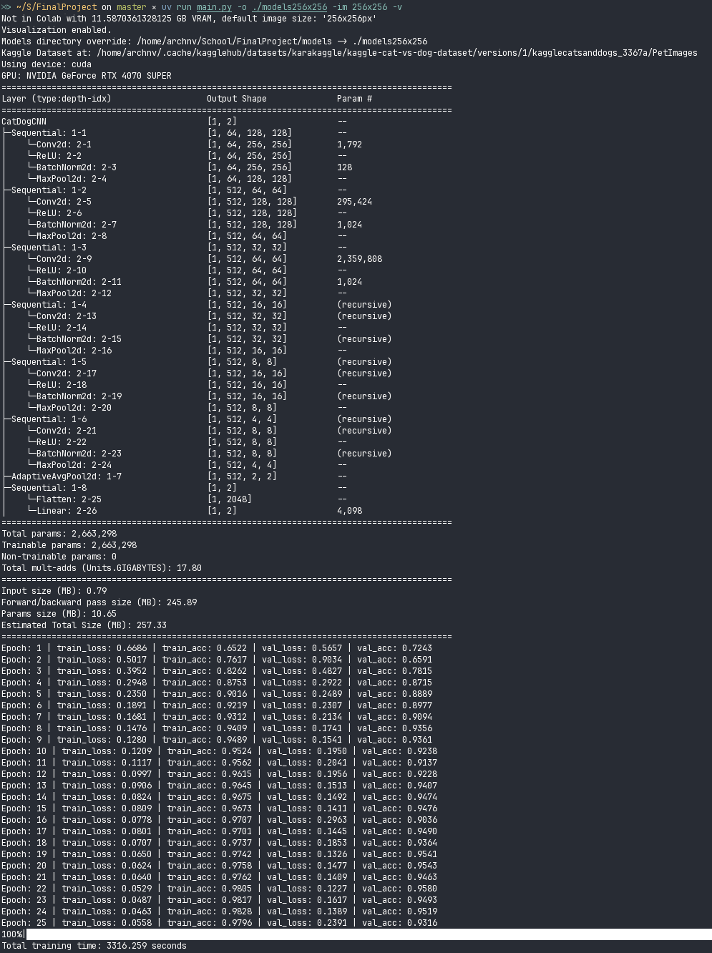

4. Data or Output Results
- Best Epoch: Epoch 22
{
"train_loss": [0.053],
"train_acc": [0.981],
"val_loss": [0.124],
"val_acc": [0.958]
}

5. Analysis of Results
- Training Curve:
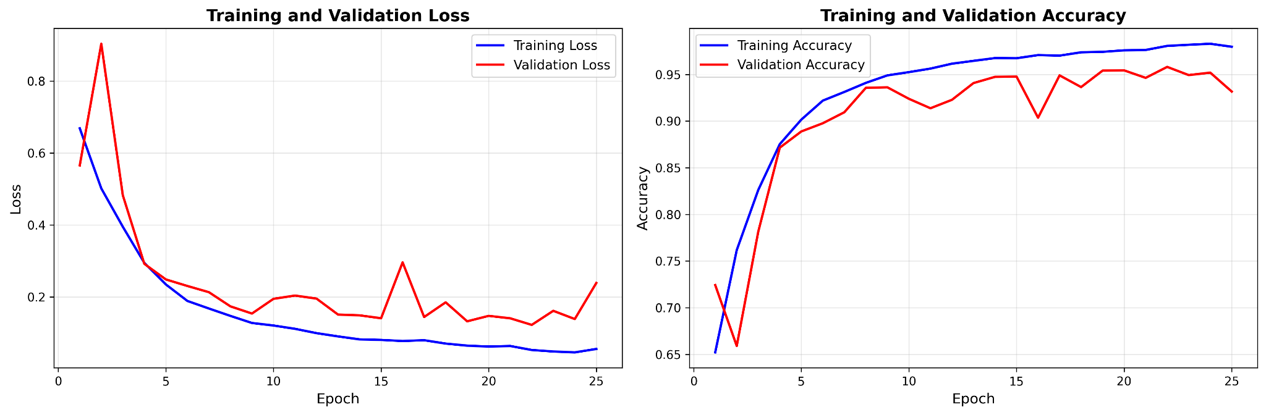
- Feature Maps:
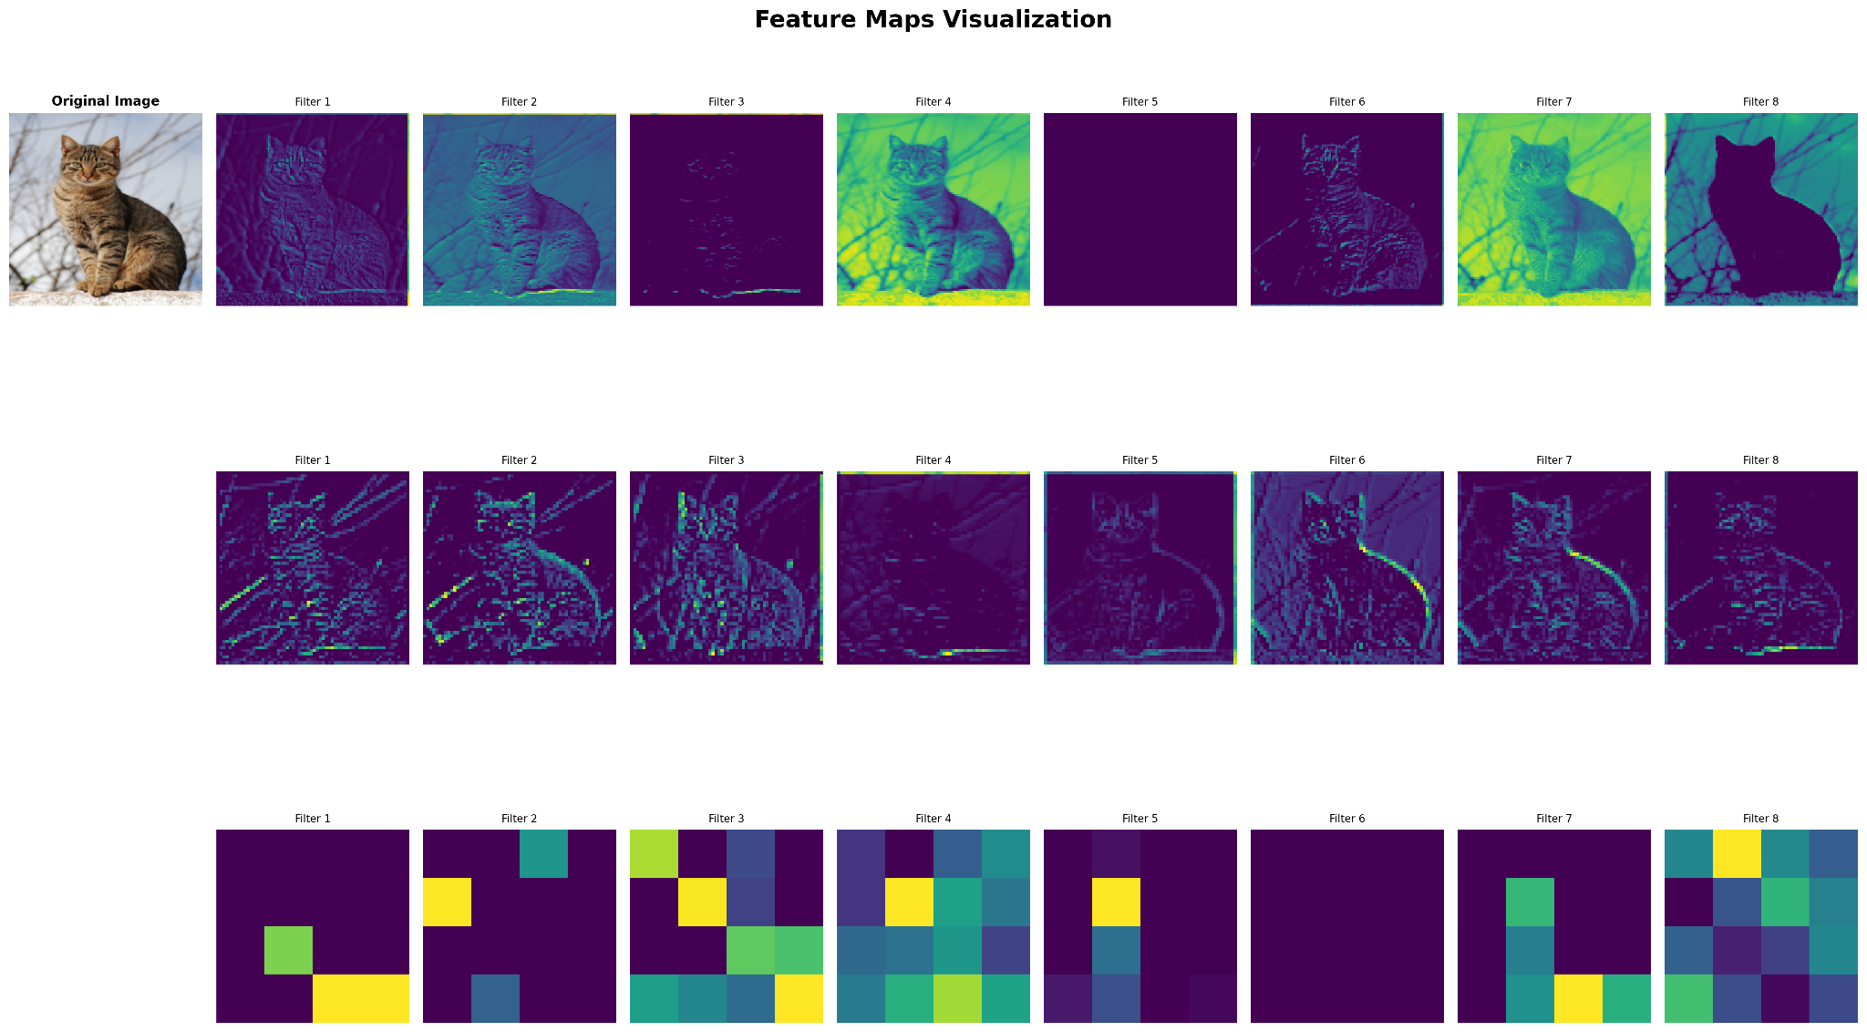
- Confusion Matrix:
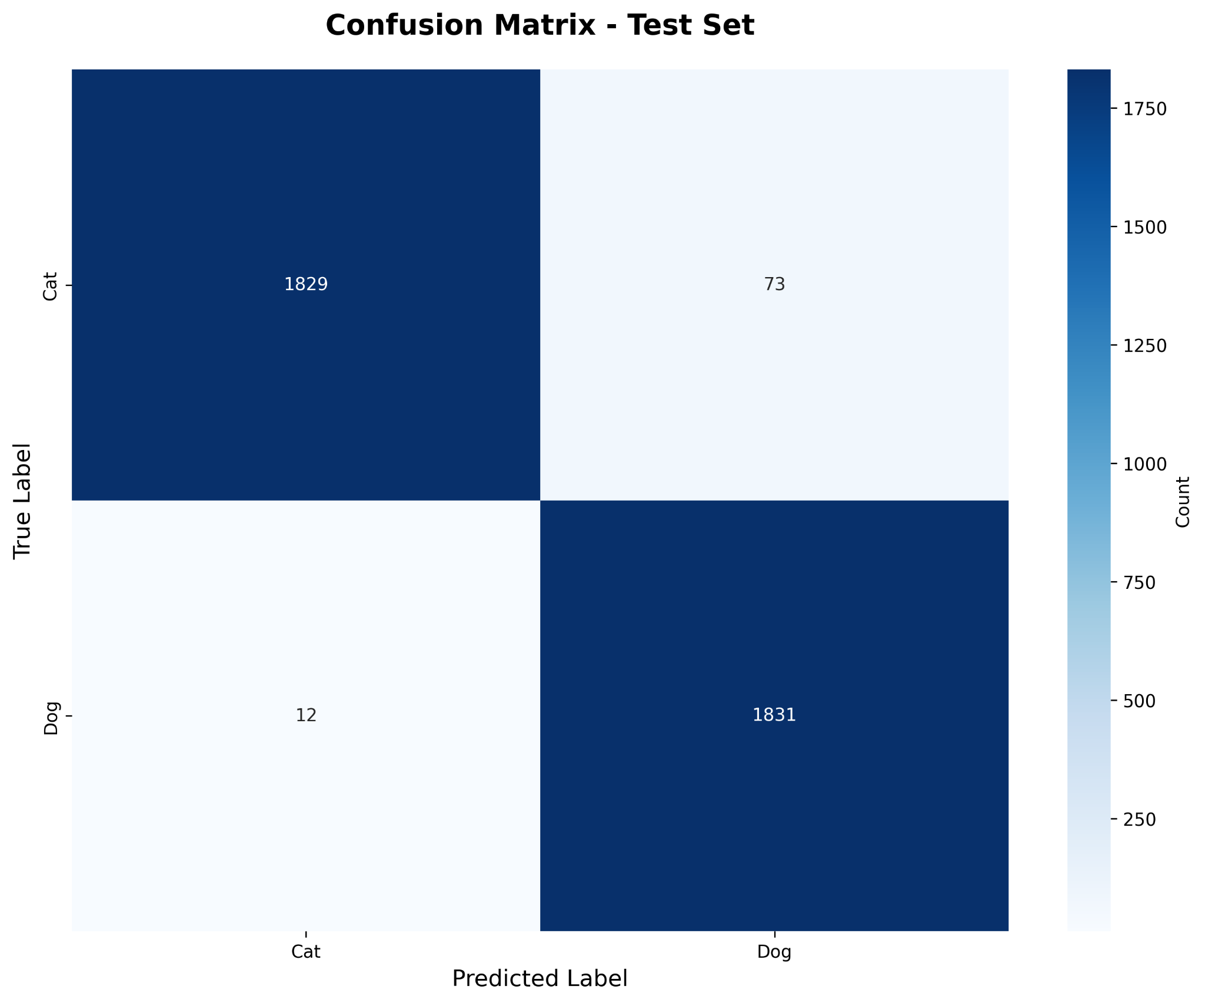
- More analysis in [project root]/models256x256.

6. Conclusion
- The model used for inference was able to achieve ~96% validation accuracy while still being a lightweight 11MB by increasing the image resolution, adding noise to the data augmenter, and increasing total epochs to 25.
- Improvements (relative to Assignments 1-3:
  - Dynamic resizing(64x64px, 128x128px, 256x256px) to adjust for GPU capability.
  - Adding random noise of strength 0.01 - 0.20 at a 50% probability to train images.
  - Increase epochs from 12 to 25.
  - Refactor code into data, train, visuals, and inference modules.

7. Key Reflective Questions
1. Explain a specific part of your code that was most challenging to implement. Why was it difficult, and how did you resolve it?
Since most of the model code extends from the previous 3 assignments and bonus project, the most difficult feature in this assignment was the dynamic nature of handling parameters and image resizing.

2. If you had to modify your code to handle an additional feature (e.g., session expiration message or logging login attempts), where would you make the changes and why?
Given more time, I would like to be able to configure a UI into the model’s inference mode using a library like gradio to get more data than the standard API already implemented.

3. Describe a mistake you made during development and what you learned from it.
Since the program would take ~130 seconds per epoch, debug time was slow when testing different layer sizes to adjust for different image sizes. I ended up finding a helpful method on the torch.nn module called AdaptiveAvgPool2d, that solved these issues.

8. Additional Comments – Bonus
I enjoyed how the final project was a work in progress all semester stemming off of Assignments 1-3 and the bonus project. This made me able to incrementally improve my code over the course of a semester with new knowledge each time.

