Uhoo Traveler
mobile log monitoring the development of Uhoo

9 January 2007:

Beginning of the serious attempt to render the Uhoo structure and simulate the form in its entirety. Uhoo begun at UTIA and am following the process to Smichov to continue work while I have free time.

Building the simultaneous Scilab libraries. Added plotlib to address the pesky and lackadaisical plot library contained in Scilab. Added XML-lab 1.53. Contained in the Scilab home directory. Setting auto path for the libraries. No auto, run the library from scipad until I get a better handle of the operation of the software. Command window says that plotlib version 0.196 is loaded and has confirmed it built the macros.

Not fond of this keyboard. Should do something about it shortly. Night.

11 January 2007:

Scilab 4.1 being used now and noticed graphic difference in uhoo-1 between resident and plotlib libraries. Unloaded plotlib for next experiments in starting the Uhoo shape.

Have built the first displayed version of Uhoo, here is a current picture:

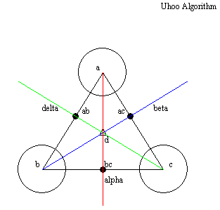 Figure 1: Uhoo Now

This does suffice for me to get a beginning understanding of how the shape should be drawn. It is not perfect, but a place to begin. In considering the form, I think the parabola represented in the bcd sector should be investigated next. I am interested in isolating the parabola centered in that “trinary” (word-choice) location to test my notion of spring, tension and line of force in the geometric system represented by the parabola and its symmetric fold across the ray α.

The laws (definitions) are:

There is an geometric centroid of the polygon vertices of a triangle denoted ABC. inscribed at its (point of the meeting of the sides) by circles with their center of mass (points) at the (meeting point) denoted a, b, and c. At the center of the ABC, is a triangle centroid …(working on rebuilding using point sets for lines instead of reverse from the eye alignment and that construction method.

The mechanical function is the action of the parabola contained within the points α, β, χ, with δ at its center as seen in Archimedes scheme:

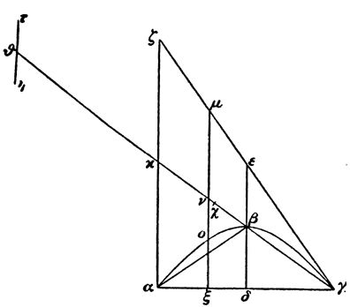Fig 2: Archimedes Conjecture

1813: Reviewing the text and filling in theory. Problems with the render of the drawing, mathematically speaking. Have stated over:

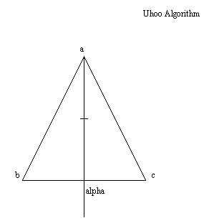Figure 3: Raw Uhoo Form

Consider the triangle ABC whose points are derived from their distance to a relative manifold center. Point a is 5 units from the center in the y₊ direction (0,5); point b is 5 units from the center in the y₋ direction and 5 units in the x₋ direction (5,-5); point c is 5 units from the center in the y₋ direction and 5 units in the x₊ direction (-5,-5) relative to the center axis passing through 0,0 along the y-axis. The length of the lines of the right triangles are ad = 10, bd = 5, cd = 5. By the Pythagorean Theorem, the length of side ab and ac are,

ab = 11.180339887498948482045868343656, or 11.18034 rounding to five decimal places. 10⁻⁴ precision in this instance. One more thing, to label the values on one side of the triangle and I’m on my way home.

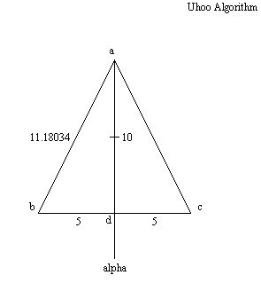Figure 4: Uhoo with dimensions

1948: On my way home after printing this document for review and annotation.

12 January 2007:

Not much today, installing Scilab 4.1 and transferring plotlib and XMLlab libraries on Smichov computer. Did calculate the angles and will be programming them into the graphics tomorrow. At least this is my plan right now. Want to put in the angles and continue building the shape.

13 January 2007:

Started this morning at 1139. Uhoo loaded and running on Smíchov. Have reviewed Archimedes Conjecture I and see that the walk from the center in the lower quadrant is too high and I should shift the axis to coincide with the rays tracing from and .

On having drawn the shape:

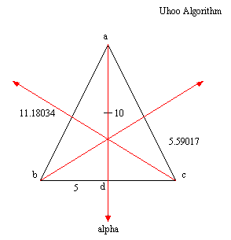Figure 5: Uhoo with rays

I immediately see the 3 dimensional leaking through. But I think the 3rd dimension can be inferred by the algorithm instead of fully manifesting it. If third axis is spun at the onset, then the extra dimension is obvious; however, I believe that the intersection through the indicates the slant of the triangle in the third dimension. It seems at the moment that the third dimension is arriving for free. But the goal is to run the constructor algorithm to manufacture the shape, yes? Not now. Perhaps in a further iteration but not at this time. Now is to build the walker and sim constructor and imply the data-tape storage embedded later with its manifestation as a VB-SQL program. That will be the real daddy!

Writing the walker code now. There is a small hole in how the agents know ½ the distance of their opposite sides to shoot at it. But letting it go in this version.

Here is the equation of how the values of θ were derived by the sine method:

Equation (1)

Then by the method of the angles of a triangle equal 180 degrees:

θ_{a} = 26.56505, θ_{d} = 90: θ_{b,c} =63.43495 Result (1)

Something is wrong, there is a snag here. Here is the debate for degrees and radians and if even it is so necessary to know the angle. I get the feeling it is irrelevant information by looking at the Archimedes form. The points matter and so does the intersection of the rays in 2 dimensions, and the length of the hypotenuse of both right triangle pair…no the angle doesn’t matter to the larger form. Screw it then.

Back to the walker code. How do I compute ac and ab so the algorithm can build it?

Consider the process, the database would have the information based on the calculation of the length of ab by the Pythagorean Theorem. Solved by adding lines to code that use opposing walkers one at a time to mark the point since the information is stored in the database (tape). Accuracy has popped up as a question again but I think it is enough for this model to demonstrate the concept. But to accomplish the programming in the manner described, program would need a floating grid with the tolerances listed in the dimensions. This is where the 0.01 precision may come necessary.

Going to adjust the trajectory of the rays 1 unit toward a. Ok, problems in how the system knows where the coordinates are without grid-defined Cartesian system. It may be necessary to draw the composite form to understand the intersections and how they are known to the agents before inscribing the parabola. Perhaps the knowledge is unnecessary?

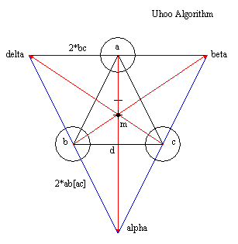Figure 6: Uhoo Now

This guarantees the balance of the rays so if we desire, can back-propagate to find the intersection point of to ac and its symmetrical opposite to ab. But knowledge of it does not seem necessary as we have located the center of mass by assigning a value to point m. Have assigned values to the intersections of the rays to the first layer triangle.

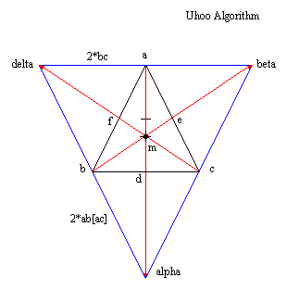Figure 7: Uhoo Labeled

This is the summation of the knowledge the system would have to have in order to draw the frame of the system wherein the parabola would be contained according to Proposition I. See the walker constructor code for ANSI example.

14 January 2007:

Went on a walk last night with Uhoo to a part of Prague with intense energy and felt as if I touched a livewire of the future. Just for a second but the feeling is with me now.

For modeling and publishing concern mid-February (6 pages): Include existing paragraphs of Archimedes Conjecture to complete paper in cooperation with K Warwick and author second paper strictly on the walker code. Third paper on explicit walker code in MS VB2005 and SQL2005 to illustrate the general case of the universal constructor ambitions.

Out for a walk myself on such a lovely and warm day.

Before that, paper publication list for 2007, pursuant to book adaptation in Cybernetics in Theory and Practice (2004):

- Archimedes Conjecture Analysis (Modeling Conference – 6 pages),
- Geometric Algorithm for AL (Unknown Journal Publication – 10 pages),
- The Functional Geometric Algorithm [VB-SQL coding of walker] (Undecided – 10 pages),
- Functional Libraries in Scilab (Undecided – 10 pages),
- Universality in the Geometric Algorithm [XML] (Undecided – 10 pages).

Need to have all of these papers submitted by August 2007 at latest. A total of 46 pages. What is not reasonable in divergent publication can be applied to the dissertation.

15 January 2007:

For the purposes of exhaustively pursuing the model, here is a tabulation of the data contained in the shape:

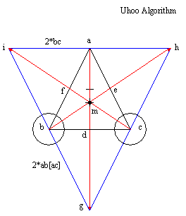Figure 8: Uhoo Labeling 2 show dimensions 4 walker

Lengths of sides by walker progression:

ad = 10
db, dc = 5; bc = 10;
ab, ac = 11.18034
θ_{a/2} = 26.56505˚ [0.46365 rad]; θ_{a} = 53.1301˚ [0.92730 rad]
θ_{d} = 90˚ [1.57080 rad]
θ_{b/2,c/2} = 31.717475˚ [0.553575 rad]
θ_{b,c} = 63.43495˚ [1.10715 rad]
ih = 20
ig, hg = 22.36068 Result (2)

Focusing the analysis for the first paper goals, let’s place the parabola as in the Archimedes Conjecture. A little scattered today and having trouble concentrating—got this stupid job obsession on my mind—so be patient.

16 January 2007:

Found an article, IEEE Spectrum Jan 2007, regarding a strength in constructor algorithms. Wonder if Uhoo is the wave of the future?

I think the next manual task that needs to be performed is a grid of the Uhoo Algorithm. It maybe computationally saving to use a different calculation method to generate ab and ac. I seem to remember something about the subtraction of coordinates for distance but I think that is purely walking on the grid. Working the walker code accordingly.

Thinking of running to the store for a coke and a banana, would make me feel better, for sure. Especially in this bowl season. Taking a quick one.

17 January 2007:

Found an interesting article in IEEE Spectrum January 2007 regarding some simulated chickens and mention by a scientist named Tredennick which has led me to the systolic array which creates a virtual machine by understanding the data and its pattern. This is the first half of what they call the anti-machine; the second half being the data sequencer methodology. The geometric form could represent the array, but what is the sequencer and what does the form create by its data flow? But this is only referential to the model and does not have to be discussed in this paper.

Have started the paper for the modeling conference and I think I’ve got a strong start. Still think it best to manually describe the shape to graph paper to get a sense of the coordinates and the manifest projection. Now focusing on the data structure and possible creation in VB and SQL. Might not be time or relevant as this approach has failed numerous times. But it could work out eventually, now that looking at an anti-machine paradigm for the model. Still, though with all this, what of the parabola?

Downloading some shows for tonight. A little creatively exhausted so gonna take it easy for a few hours and see what happens.

Read somewhere today about jobs where you get to think. I guess this job is it. Understanding lots about ideas and their creation and other things that make me go a big blank…but now going to install VB service pack in preparation for the move to a programming language to test to see if it is a systolic form. Archimedes to analysis of criteria proper for artificial life. But still on what would be the next step for the 6 page paper.

I like the work on the bph_03 database that takes from the O₂ design. But I hate either modifying the tables so they are rewritten or make another design and leave this for the dust. Just noticed this Dell has a dual 3GHz processors. This makes the Uhoo interesting now. Anyway, out for home for some entertainment. Night.

18 January 2007:

A new resolution. Drawn by a straight-edge and a compass, that is the limit of the ability of the constructor agents. Drafting 3 dimensional model of Uhoo is the next step. The paper will be disclosed in the current draft with talk of the data structure hypothesis, Greek inspiration by limit of technology (mimic), constructor (anti-machine). Six pages, more or less. So, pursuant is to render shape in ray-tracer since we are not necessarily worried about the RAM machine for pure computational structure, just the manipulation of information (energy). Notes now in 2006 engineering notebook where the gritty details should be. Need some caffeine and a smoke to get started. Can work two hours when I have to address the business—1330 the latest.

Ray tracing is valid since I am interested in the physical appearance of the object as a real data processing object—from the viewpoint of the eye, not as an object with its own luminescence. I think it would be a sink I’m looking for, not a source.

A figure of how the process is going:

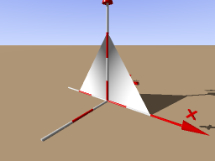Figure 9: Uhoo now in ray tracer

There is a lot of work to be done with the shape and I’m not wholly convinced rendering it in three dimensions this way is relevant. I am looking at a book on LaTeX graphics and noticed a three dimensional diagram of the flow of data through an object. This may suffice at the present time to end the orient paper for the deadline. Data flow pattern should be the last figure of the set. Seems not a good idea to try for two dimensions as the shape will ultimately be three dimensional or should I leave it? Questions, oh yes, questions. And another reference to a higher order convex hull, don’t forget.

In order for the three dimensional component to work, I am finding it necessary to define the form in terms of a function. Looking at CGAL in C++ since I am on the right track to something here. Still have left to load the Qt libraries. Is nearing 1700 so I will start fresh in the morning. Going to watch some movies tonight and relax my mind. See you tomorrow. NOTE: Working in .Net2003, try with alpha_shapes_2 vcproj.

19 January 2007:

Sitting in Smichov and contemplating the morning. Sun is here this morning after the winds last night. Have decided in the night that I will stick with understanding the data distribution and anti-machine in two dimensions of Uhoo. And it seems the shit has started as of today. It is definitely a new day. Bathed in sunlight—keyboard still sucks, unlike office keyboard and position. Found a data distribution diagram in a Latex book, it would be a good idea to draw Uhoo in such a fashion and assign the datapoints. Still addressing the full limit of the paper to see how far diagrams have to go in addition to the ones that populate this record. This project is getting more difficult as it continues. This is a good thing, I would surmise; I hope it can converge into the form of a decent paper due to Warwick by the end of the month (my schedule). I think time is to write and I may have enough data already accumulated; still feeling out the experimental process—submitted my first work code in Matlab to Ivan and Jitka with much fanfare so I hope I did it right or can defend myself if any shit comes down. Ooh, pretty excited.

Just start with the paper A Geometric Algorithm for an Artificial Life Form when you get to office and see how long you can make it with the data you have and see how it fills out. Having some nice thoughts lately and I dreamed of eating pieces of the Uhoo structure. Obviously.

Printing this today to inspire some manual work in the near future. Later.

One more thing…after you get the paper off to Kevin, have fun with Uhoo. I command it.

Just noticed, bph_choice here on Maggie could be a super Uhoo constructor. The three Uhoos, something can be learned from it. Later.

20 January 2007:

Was thinking about Uhoo this morning and disappointed in that I did not pursue the original task of modeling the Archimedes Conjecture. But new paper may be better for the first publication; I really haven’t decided yet. Now with simulation done, just the matter of writing the paper. Have an idea to satisfy me all the way around.

First publish the AL paper for the modeling conference, as K wants; then publish the treatment of Archimedes next. For the parabola, the drawing can stop in complexity to Figure 5.

Had some interesting thoughts over lunch and will work next to generate a carpet by the walker and illustrate the different facets of Uhoo because it is asymmetrical across the different rays.

21 January 2007:

Started to put an entry here but moved it to the big log. Uhoo is being stubborn of late and has not allowed me to make any progress. It is still cooking as exhibited by my brain last night in dreams. Will subvert myself to distractions in programming until it comes around.

22 January 2007:

Have begun the paper by putting in an outline that occurred to me in the night. Still feeling nervous about the paper but will let it go. Not in the office today as working from home. Had many dreams last night about flying and large doors and building something. Uhoo is still cooking but is getting close. Working on the website redesign so I can publish Uhoo and the PhD adventures on the internet. Will help me understand where everything should go as the degree continues; by feedback with each separate task, I hope to get this thing in publication so I can start from this point and move forward.

I am doing the website redesign today (Paradox2.0) to help focus my thoughts on the project as a whole and uhoo. Using Crimson editor to do the busy work. Quite proud at the moment but require 60 – 90 minutes exercise. Later.

23 January 2007:

Awake early this morning preparing for the interview that, hopefully, should get everything underway. Thinking of Uhoo and what I can do with money, a place to work, and something to do with my hands. After the interview, will continue on to UTIA and make progress on Paradox2.0 which, so far, has been a good vehicle for organizing my thoughts. Wish me luck as I need a fucking break! Okay, on my way…

Well, got fucked by that one, at least that what I think. The guy did say there was nothing for me; my problem is I step too big, like with Monster. We’ll see, they will contact me by Friday but it doesn’t look good neither do I want the job anyway, 45.000kc a month ain’t all that great. Fuck.

24 January 2007:

Had a super day working on the plan. Had epiphany about life and everything; working on the business plan and the autonomous assistant. Might as well write about it here since this record won’t survive un-encoded anyway. Cool. Back to MSRS in the Robotics Studio to accomplish several things at once: A place to go toward, a means to satisfy my technological learning needs, a means to retire myself early…as long as I complete my destiny and reproduce in respect to the time displacement whereby easing my personal level of responsibility to maintain existence and philosophy then, yes, it is so worth it.

The Plan involves the fulfillment of two goals: 1) Preserving a future event, and 2) reproduction. Filtered by: I must be happy and content in a technological sense such as MSRS and C#, SQL (dbase), Uhoo, architecture, success, “winging-it” management style, and trying to perpetuate my idea of species. All these are MinE.

Getting burned out from the day. Ready to relax and start fresh in the morning. Is now almost 1800.

26 January 2007:

Not much here today. Starting fresh tomorrow for the weekend devoted to writing the paper and working on furthering the research now that the job may be resolved. Nice. Tomorrow, then.

29 January 2007:

I make the argument that an artificial life being should possess a core or governing algorithm, similar in function but not form, of DNA in organic systems. Something analogous must be present, a driving impetus, that spawns a procedural construction of the machine. (by using an anti-machine algorithm) The key to understanding this algorithmic problem is to think of it in terms of a graph. Having argued a template algorithmic structure in place already, I will now directly apply the Hellenistic Methods to my problem and reveal the graph.

Have been writing the paper here and copying large segments to the paper. Left the first paragraph as a reminder.

Paper filling out nicely but need quiet time to write the normal parts of the paper. All analysis has been performed for the snapshot, all that is required for one more sitting is to read through the algorithm book chapter 4, and write the lesser parts of the paper.

Some good chatter about the mechanism: http://uplink.space.com/showflat.php?Cat=&Board=sciastro&Number=626457&page=5&view=collapsed&sb=5&o=0&fpart=all

Am very happy about it. Perfect coding and writing. Now, must get on to something else. Daniel called and is in Prague—meeting tonight to discuss the proposal I sent. I haven’t reviewed anything since sending it and haven’t read his replies. Guess now is the time. A time divided makes idle use of the devil’s hands, or something like that.

30 January 2007:

Here in the office today to give a sober rendition to the paper. Have filled it out as requested, however, seems exacting details of the algorithm are absent. Not unlike previous iterations but if I include the walker code, I think that will finish the document for draft and an offing to Warwick. Will slate delivery for tomorrow else this evening if I leave the office early enough to do it. Mate is still here and no sense me staying although snuck a puff in. I don’t know, waiting to see how the day fills out. One thing though, completely tired of looking at the paper and want it gone. I said by the end of the month, tomorrow is the last day in January so it will be gone by then, guaranteed.

Whew! Paper is finished and off to Kevin—1630. Damn, I’m done with a task I had set out for myself in June 2006. I feel good about it and as soon as the mate is gone, will congratulate myself fully. Good work!

I have made a series of frame animations for the agent constructor routine to glean insight into the process. I can see where to take the form next but will leave it for a future date. Comments will not appear here unless the work is undertaken anew.

31 January 2007:

What features should an artificial life form possess?

It should be brought to bear that it is a replica of human cognitive processes, divided into two cognitive categories: 1) syntactic modules, and 2) historically obtained knowledge. The latter could be gleaned either by practical storage of information or by experiential storage of information.

Supporting for my argument of diagram representing an algorithm, some logical proof if you want to use it as such. [The Shaping of Deduction, p.18].

Been reading this morning The Shaping of Deduction in Greek Mathematics, A Study in Cognitive History and found it is quite informative. But getting hungry and need to fatten up before it is too late. Stopped on page 45.

1 February 2007:

Continuing with the reading. I have disagreement with the following statement:

“First, the option that the diagram points towards an ideal mathematical object can be disposed of. Greek mathematics cannot be about squares-as-such, that is, objects which have no other property except squareness, simply because many of the properties of squares are not properties of squares-as-such; e.g. the square on the diagonal
of the square-as-such is the square-as-such, not its double. It is not that speaking about objects-as-such is fundamentally wrong. It is simply not the same as speaking about objects. The case is clearer in algebra. One can speak about the even-as-such and the odd-as-such: this is a version of Boolean algebra. Modern mathematics (that is, roughly, that of the last century or so) is characterized by an interest in the theories of objects-as-such; Greek mathematics was not.”

------------------

Netz, Reviel. The Shaping of Deduction in Greek Mathematics, p.51:

In that the object called the Antikythera Mechanism. The mathematics to technologically and methodologically and instruct about the process involved in such a construction has to support the notion that in some cases, maybe even known to the author, they were building “idealized” mathematical objects, the optimum of ideal being their manifesting in physicality in varied and populous forms. The usage of the word “imagine” perhaps is the point where the fleshing out begins.

The argument is continued on p.54:

“An ancient continuum theorist could well believe in the physical constructability of geometrical objects, and Lear (1982) thinks Aristotle did. This, however, does not alter the fact that the actual diagrams in front of the mathematician are not instantiations of the
mathematical situation.”

I believe the argument cannot be solved one way or the other as there in simply not enough information (54):

“We seem to have reached a certain impasse. On the one hand, the Greeks speak as if the object of the proposition is the diagram. Verbs signifying spatial action must be taken literally. On the other hand, Greeks act in a way which precludes this possibility (quite regardless of what their ontology may have been!), and the verbs signifying spatial
action must, therefore, be counted as metaphors.”

However, I am willing to accept the possibility that the diagrams are make-believe objects meant to inspire the imagination of the engineer. But I find this interesting (56):

“Let me explain briefly why the indexical nature of letters is significant. This is because indices signify references, not senses. Suppose you watch a production of Hamlet, with the cast wearing soccer shirts. John, let’s say, is the name of the actor who plays Hamlet, and he is wearing shirt number 5. Then asking ‘what’s your opinion of John?’ would refer, probably, to his acting; asking ‘what’s your opinion of Hamlet?’ would refer, probably, to his indecision; but asking ‘what’s your opinion of no. 5?’ would refer ambiguously to both. Greek letters are like numbers on soccer shirts, points in diagrams are like actors and mathematical objects are like Hamlet.”

And onto how the aesthetic object that is Uhoo represented (59):

This is true, however, only in a limited sense. Greek elite education included literacy, numeracy, music and gymnastics, but not drawing or indeed any other specialized art.
The educated Greek was experienced in looking, not in drawing. Furthermore, the profusion of the visual was limited to the visual as an aesthetic object, not as an in-
formative medium. There is an important difference between the two. The visual as an aesthetic object sets a barrier between craftsman and client: the passive and active processes may be different in kind. But in the visual as a medium of information, the coding and decoding principles are reciprocal and related. To the extent that I can do anything at all with maps I must understand some of the principles underlying
them. On the other hand, while the ëreadersí of art who know nothing about its production may be deemed philistines, they are possible. The visual as information demands some exchange between craftsmen and clients, which art does not.

What about striking a balance between the two? (60)

preserving shapes, but not distances. The main point of Aristophanes’ passage is clear: though diagrammatic representations were understood by at least some members of the audience, they were a technical, specialized form. It may be significant that the passage follows immediately upon astronomy and geometry.

And the conclusion (60):

What is made clear by this brief survey is that Greek geometry did
not evolve as a reflection upon, say, architecture. The mathematical
diagram did not evolve as a modification of other practical diagrams,
becoming more and more theoretical until finally the abstract geo-
metrical diagram was drawn. Mathematical diagrams may well have
been the first diagrams. The diagram is not a representation of some-
thing else; it is the thing itself. It is not like a representation of a
building, it is like a building, acted upon and constructed. Greek
geometry is the study of spatial action, not of visual representation.

For the builders of AM, research the class of banausos in time of Rhodes and the ‘great mechaniscian Strato of Lampsacus 340 to 268BC, the third head of the Lyceum. In spirit of creation, you might have to pull from the Pythagorean propostions of the 6th c BC. AM mentioned p65 footnote 156.

Stop p87 to eat and clean the flat…my baby’s coming home at 2000 tonight! Is not 1234, thinking about smoking a fatty, getting some grub, and start the cleaning. Nice having spent time with you and all that. Will be back after cleaning but how much will be carried on is anybody’s guess but I’ll tell you something, I have a very profound sense of wisdom about history, thought, mathematics, and technology I never had before. This AL problem, it is a sticky one.

Music’s over, time is nigh and I wanna get high. Missing this time already and will practically tear soon, especially considering how much I’m learning about myself through all this. The ennui is slowly breaking and I’m breaking through for the first time ever. Feel fucking better everyday and gonna continue to. I can picture the bustling of the past in the Greek times when I read the book. It’s a nice thing that I can do, wonder how I can use it to help me control my life and make it financially satisfying. Need to make some money, no matter how I cut it, but how to cut it is another matter. Still planning nothing save one day at a time, but now need to get started on the flat, is 1248 and I haven’t eaten. Oh boy, it’ll be a rush and I’d better get to it. Later.

A detail: how is an engineer in ancient Greece different from a banausos in terms of military equipment? Such as Pericles with the battering ram in the battle of Samos in 440BC by his engineer Artemon, hailed from Clazomenae or Archiemedes at the fortification of Syracuse, from this time forward? Keyword ‘siege engine’.

----------------------

23 February 2007:

Back here after writing the paper and sending it out for conference. Reason I am back here is to continue with Uhoo.

Considering two different plans: 1) the design methods used in FSX (all versions), and 2) how I exposed flaws in the design with BPHv1.1.8.1. Also extending what I was trying to understand with bph_choice_1 from 19 January 2007 in VB. Getting ready to start by replacing the SQL with XMS to mirror the Uhoo Constructor. No more VB as the XMS I have from Xpriori is C#. Setting up the interface.

Ok done. Now gathering the last version bphv1.1.8.1 with the diagrams represented in jpeg and the last xml, xsd sheets.

Gathered everything in one place for the XMS work. Have all the designs in SQL from the bph project to fsx. Stopping for now and will resume shortly.

1 March 2007:

Had an idea that seems very relevant. Upon passing through interviews and refreshing a tactile knowledge of recursion, have found a physical deployment for the Sydrandria symbolic language.

Sydrandria

There she is.

Purpose: Groups of symbols represent blocks in the data spaces. There are fifty symbolic characters that can represent the space address, resolution, and occupancy. Merging the contents of “Symbolic Language” 2002 here.

K:\BPH\BPHv1.1.7\Boagaphish_Toolbox_v.0.1.1\The Gasket\The Code\50_symbolic\Symbolic Language.xls

Professedly, it is a good idea to present the progress of coding of the shape. I have authored a set of T-Sql tables, using the addressing schema of the hand-written Uhoo diagram. Have tried XMS but might be a future proposition right now as sql reflecting the tables and some sample data. Now to port the new robot, (Haden?), will arrive shortly—a Lego NXT—for a mobile computer, a bank of simple sensors, modular in design, easy to add or subtract to the body, and running through the Microsoft Robotics Studio and C#.NET. This pursuit will consume the next phase of this development and should be presented as a speech.

2 March 2007:

Looking at the Lego Robot Invention system today and getting a beginning understanding of the geometry of the parts and their orientation. Am also collecting software to start designing the setup. The ultimate goal of this project is not only to prepare myself for larger robotics works but to begin to understand the scope and application of Uhoo.

Two approaches: 1) use the graphical IDE with blocks to simply do things and 2) write in assembly code routines basing them on the addressing function in the remote database through the DSS host. Since infrared communication is possible here, a feedback can happen between the brick and the computer. No mention of it being lego, just describe the parts, the code, and their relationship.

There are two distinct component families here: 1) instinct, and 2) intuition. The first category is the RCX brick, the collection of sensors, and the locomotives comprised and deployed by an assembly language modeled in a flavor of C; the second category is the high level abstractions above it. As we have a finite maximum space in the processor, how do the agents superimpose the carpet onto the hardware?

7 March 2007:

The first place to begin is with the Introduction to Programming Lego Mindstorms from Microsoft Visual Express website. Not for now, must run to Tesco for twelve alkaline batteries. Will fetch and start coding.

8 March 2007:

Retrieved the batteries last night and assembled the driving base. Installed the NXT software interface. I like the interface, it is simple and carries with it a lot of options that can be programmed into the NXT brick. I will be building the tribot accessory with the suite of sensory tools to construct an interactive machine. I must, however, find a method to quick-store the necessary construction blocks and a proper place to store those that are not used but remainder in the bags. Just ran a hand-coded demo on the brick and it is nice! Moving slowly on this thing and taking my extreme time to digest the details of the potential that lies before me.

Stuck, however, on progress because of the lack of a Bluetooth device on dolores. Here is the new plan: can work within the Lego Interface for now until such time as I have the predilection to buy a Bluetooth dongle.

Work with NXT# from Bram Fokke (here), is simpler than MSRS and better documented. Taking a break now and return with investigation using only the Mindstorms software.

1833: Resuming with the construction of the fully outfitted sensor robot project. Seems according to consensus of opinion that robotics will be the next technological wave, I wouldn’t doubt it and glad to have a second chance at programming and realizing clever designs and implementations for fun and profit.

Got a notion of how to get away with using LEGOs to demonstrate and get experience with robotics while at the same time satisfying my paper requirements. Have installed LabView 7.1 and the NXT toolkit extension. Is just the same as the Mindstorms environment, but more scientific-looking, hence, more serious. This will, at least, give me the façade I have been looking for.

9 March 2007:

Here at the office to experiment with LabView and the sensor nexus of NXT. Here is the strategy so far:

I want to become familiar with the nature of how to interface the ARM-7 Microcontroller with routines that I write in C#.NET. I have just written test_routine_01 to have the sound sensor’s data, piped through USB, into a waveform display. One note is that the sound sensor must be plugged into port 2. The interface for the virtual instrumentation is being handled by the LabView compiler and referenced by a getting started pdf.

It might be of interest to write a Haden Programmer’s Guide to being the focus on Paper Two for Warwick.

Finished the first test routine and have found an introduction how to handle the coding environment of LabView and the blocks I can create for the NXT. Now that I have the interface constructed, how to get the information into SQL tables is next.

10 March 2007:

Paused to take a minute to reflect on the progress of this work. Received an interesting article in email this morning about god and the progression of technology, it’s acceleration and direction. It offered reasons on the former and none on the latter. Regardless, however, I found it eerily familiar in the collection of thoughts I’ve been having the past months, namely since October last year and especially so since beginning this body of work represented here.

In the light of the acceleration of my work and having digested the information overnight, I have discovered a wholesale solution to my desire to assemble the Uhoo data structure with a proper input/output system driven by a microcontroller. Uhoo is useless unless I can find the means to demonstrate the power of the design.

Using the newly coined title of the upcoming paper: “Mapping I/O Response Patterns in a Recursive-Agent Model Database”, I will be pulling from the ten-year dusty Recursive Modeling Method and Recursive Model Structure for agent-based systems where decisions need to be made. The first step would be to get a suitable robotic device with typical input parameters such as sensors and output parameters such as motors and lamps that can take instructions from a bridge between the hardware, controllers, and generalized circuitry piping the flow of information back and forth to the Uhoo structure.

In light of this, Figure 10 represents the first step on this path:

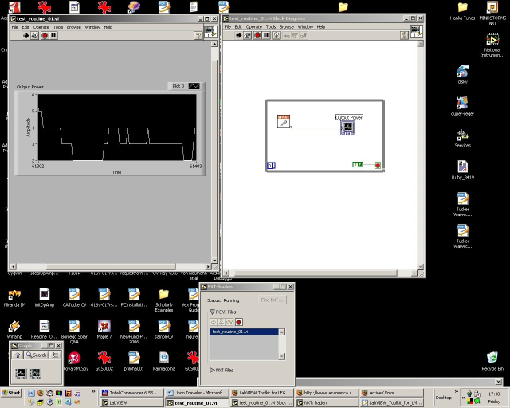
Figure 10: Uhoo Extended into Programmable Hardware

Here I wanted to answer the question whether or not I could control a sensor attached to the 32-bit ARM7 RISC microprocessor with an 8-bit AVR (Advanced Virtual RISC) microcontroller at 4MHz, send the data to a remote computer—either by wire or wireless—where the data would go through processing into a separate system consisting of C#.NET technology and passed to the Uhoo structure to understand how the vision fits together in totality. I have only begun this process by accomplishing the tasks illustrated in Figures 10 and 11. An interesting feature I discovered by performing the programming task was that LabView deploys OOP by allowing objects to be created and destroyed. While this may not be interesting in itself, what is interesting is the sharing of objects between the host and mobile computer. By distributing the design accordingly, I can foresee a plethora of specialized tasks performed at different levels and where I can fully define the agents and their roles. For example, look at the following procedure illustrated in Figure 11:

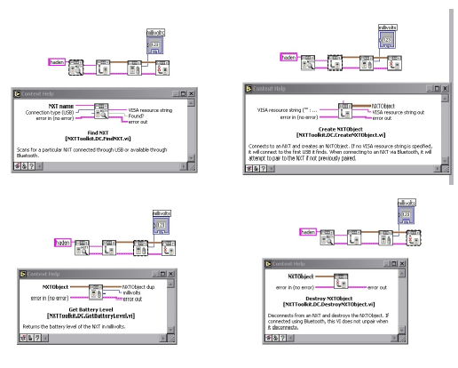
Figure 11: The Process of Creating Temporary Objects to Perform Operational Tasks

Here one can see the process of an object being created and destroyed deployed in a low memory environment such as the one I have {There are two caches of flash memory, 256KiB (256KB) for the microprocessor and 4KiB (4KB) for the microcontroller}. There is some confusion as to the exact amount of memory in the device but this can be explored when it becomes necessary. Additionally, there is a IEC 61158 Fieldbus Type 4 located at one of the input ports for “future use”, but data regarding its more hurried deployment can be found here.

Returning specifically to the task, it would seem that I can recommend the source contained here. I am just beginning to understand this ideal so I most likely will be adding to the theorem as time progresses. However, it would appear that recursive modeling would be recommended as a conceptual and programmatic framework for the rest of the project’s duration. A note of organization: the solution file UhooDataConstructor contains formStream the database that current maps the Uhoo data structure. It is my task today to return to the office for more research and programming experience.

At the office now and have understood two premises:

- Have: Sensor to LabView,
- Need: LabView to Visual Studio

I am preparing to work on the second task now.

Presently, I have written a new file test_routine_02_vc for these purposes. Currently, the program runs on the host computer and there is no file weight to the mobile computer, save the object execution in memory at this time is unknown but small enough to function in the system. This means that one executes the program in the LabView console (referred to as console) and not in the NXT runtime window. I have gotten the reading of the sound sensor to a waveform chart displayed in the console.

Seems problems are running like crazy around here. Cannot bridge between LabView and Visual Studio with a USB connection. There are two options: USB to serial so I can get a COM address port, or use Bluetooth. Either way this will cost by the direct method. Now I may have to return to LabView for a way to pass the data in a clever fashion out of the API to my VS IDE.

Have a partial solution: Use LabSQL as a custom palate in LabView to connect to the SQL database. Have created a correspondingly named database to the project and is backed up for transport. Hold on, must restart. Have rolled back the data additions and the file works as written. Will resume work to move data via LabView through to SQL tables building the appropriate palates. Have prepared a diagram describing the new setup to connect the sensor to data constructor. Will be perhaps short on time next few days with preparation for Amsterdam conversation Tuesday, so may not be able to return until then.

Pick up by reviewing the diagram and the prior paragraph.

12 March 2007:

After a lengthy look at where the project is and what can be inferred by working with it, I have a plan for the work today. I have given myself two hours (give or take) to get the audio sensor to present its streaming data into a SQL database. I will most likely use the existing test_routine_02_vc.mdf file to store the values as they approach. In order to accomplish this, I have downloaded a toolbox constructor called LabSQL that will allow me to make custom palates and use controls to facilitate the task. I will begin the task shortly after coffee and smoke break.

1332: Begin task. Going well but after loading two ADO toolkits, I am coming to the realization that it is an ADO knowledge manipulation gig and nothing to do with the icons or vi in LabView.

1549: Got the front part of the job finished but now trying to understand how to display the data so I can confirm that the program functions. Ready to eat and head out, the two hours are up and the ADO programming thing is a sticking point at current, as I expected. Will return to this at the next sitting.

13 March 2007:

In trying to ascertain the particular point of what I’m doing, I have shaped a possible hypothesis:

Personality/Behavior is the result of the flavor of information management; i.e., how the data is input and shaped upon reflection to the outputs.

In looking at comparable approaches, I have found some very similar works—however not as wide in scope as mine—in agent-oriented programming. At present reading, such an environment would consist of the following features:
- Agents
- Capabilities
- Events
- Plans
- Agent Knowledge Bases (Databases)
- Resource and Concurrency Management
Contrasted with Uhoo, it would seem to mirror the attempt and especially so as I am currently addressing number five. I am close, very close.
Now it is of interest to consider test_routine_02 as collected with a computational laboratory—a framework for the study of a complex system behaviors—in order to facilitate controlled and replicable data.
Could be interesting to say that this work could be Engineering the Imagination Circuit.
18 March 2007:
A thought raced into my head this weekend concerning the state of the project and my responsibilities under my graduate student agreement. In playing with Haden the past few days, taking a few pictures and filming a video or two, it occurred to me that I was ostensibly fidgeting for a way to understand how a robot functions and the programming knowledge associated with such a task. It was not as bad as I imagined and I quickly lost the point of the task, relegating the poor machine to collect dust on the shelf. This by no means suggests the end of the Haden Project, on the contrary, it has inspired exactly the opposite.
A series of original research papers must be authored at the quickest speed imaginable.
And it begins here----↓↓↓↓↓↓
The point is this: it occurs to me that I’ve invented something pretty cool, this Uhoo thing. It is also pretty cool that Uhoo doesn’t even exist save for the action of the little agent-constructors who build the shape. So, what remains after all the bullshit is swept away is that there are three little autonomous guys who do the exhaustive job of constructing the shape, mapping the data-spaces, and remembering how the spaces are organized so they can be manipulated by an application layer.
For the purposes of a reasonable definition, an Uhoo agent is a(n) (software) entity that conveys a sense that it has intent or agency of its own. It possesses these qualities by default because they are the entry point for the entire façade, algorithmic, and functional fundamental of the entire system. Additionally, with the cooperation of others (the social attribute) it (they) serve as the foundation constructors. It can be argued they are the creators of Uhoo and as such, by default and the nature of their behavior, they must possess intent. The concept of intent may be inherited by a human entity such as myself but I merely provide the rules of the game, the artificial environment, the idea of supervenience, providing a loosely-coupled hierarchy and methodology of how task ideally should be carried out. The brilliant thing about the conditions set forth is that although rigorously defined in at least two-dimensions, there is still room for emergence in the system and that the form of this emergence will remain unknown until the system is finished—coded by myself in a computing environment and run with a set of input data as a source of information (motivation of problem solving and partitioning into the data-spaces)—where it can be tested whether it is a strong or weak phenomenon in this case. The point, though, is it gets “the ball rolling” on classifying types of artificial life forms and if they can be made comparative to organic systems in how they perpetuate by solving real-world problems, adapting to changing conditions, and capable of self-regulation.
Quote: An emergent property can appear when a finite number of simple entities or agents operate in an artificial environment manifesting an observed set of complex behaviors as a collective. If emergence occurs over disparate size scales or resolutions, a causal relation is said to be happening. In this state, a form of top-down feedback is functioning to drive the observed emergent properties. By this demarcation, emergence is comprised of a complex causal orchestration across disparate resolutions accompanied by feedback.
For example, the manifest actions of a collective of agents may not be necessarily predicted as a resultant causal effect of their work. One can have relative reassurances of how a recipe will generally be regarded, however, there will be minute differences such as additions and subtractions to the whole form that will alter the flavor of the result. It is the purpose of this work to constrain the limit of the flavor within a reasonable bound so that the result will, at the very least, still be palatable.
Will return to this after reading the materials I gathered for this purpose.
22 March 2007:
Have started on the “freeze-frame” paper for the newest Uhoo research. The current loose abstract is:
Models of artificial life database constructors can vary in design but should possess discernable qualities. They should be agent-based, autonomous, and be privy to emergent domains within a limited range or flavor. Additionally, for clarity and to allow for a widespread use of these types of programs, a common interface development environment (IDE) should be deployed. In embracing these restrictions, this paper will discuss a model of an artificial life algorithm, demonstrate its architecture and behavior, and offer a development platform.
After speaking with KW, it would seem this is better served for the JAIR submission and the existing paper for the conference. The paper deals with the work on the project UhooDataConstructor with the formStream database coupled with the NXT module in LabView. As I have not finished the connections, it may be of interest to simply write what you have so far, make your arguments, and set it for submission. KW is coming the middle of April, and that gives me ample time to get something hammered out.
It would appear that the next step—or perhaps a previous step—would be to actually construct the three agents and let them construct the database. It is one thing to make the full connections of the NXT to SQL, but it doesn’t inform the reader about the nature of the clever agents. In keying a search for “agent based programming in .NET”, it doesn’t turn up anything so it may be worthwhile to investigate how to go about programming an agent and the definitions of how its task is performed (plus two cooperative others). The agents in Uhoo are extremely simple in that they only construct a database (dataspace) layout and this is the strength of the research at this point in time. This could suffice for the paper: “Intelligent Autonomous Agents for a Universal Constructor in C#.NET” instead of keeping so deep in theory and relying on your hopeful clarity to expound on your chosen subject.
24 March 2007:
I have come to the understanding that I have established a three-phase plan:
- The Antikythera Mechanism,
- Building Intelligent Agents in .NET,
- The Uhoo Data Constructor coupled to a NXT Module.
The first paper is in for a conference at CVUT, Karlovo Namesti, July 2007. The third has been orchestrated programmatically and outlined here in this diary. The second exists as an abstract, briefly noted in the previous entry. From the healthy amount of research I have conducted so far, I have found two sources: an article in the MSDN library dated February 2006 and a book Building Intelligent .NET Applications: Agents, Data Mining, Rule-Based Systems, and Speech Processing, dated March 2005, that details real-world applications in .NET incorporating AI.
In considering the second paper draft due to KW near to the middle of next month, I need to get something underway demonstrating how the Uhoo concept would fit into everyday IDEs. And it should be insightful grabbing many of the concerns by Pattee 1995 regarding the epistemic cut wherein the limits or flavor on the results of the work of the collection of agents.
Will return to this as my time becomes available.
27 March 2007:
After getting work done at the office rather quickly yesterday, I have some time today to return to this project. Okay, there is a draft due by 16/17 April and I would like to advance Uhoo to at least an understanding of the agent level and begin to discern the brain construction of this entity. I have looked at Honda Research Europe and found the following useful diagram:
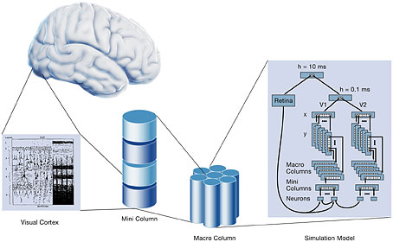
Figure 12: The Brain Represented as a Function of the Logic of the Computer
which provides insight into the newest advances in neuroscience regarding how the brain is structured and performs its tasks. The Institute thinks that the following process describes complex systems, which I tend to agree with:
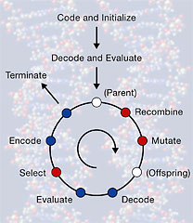Figure 13: The Living Adaptation Process
It would be of great interest once I get phase two Uhoo understood and implemented that I could perhaps continue my unique studies at the Institute. In the meantime, it seems to me that the agent methodology in coding—the first pathway, Code and Initialize—is exactly where I am currently. Now, how to exemplify my thoughts into a reasonable and approachable model in code and implementation…okay… macro column database, Uhoo, constructed by agents…data represented by storage of encoded vector states (data-spaces)…
The problem of artificial life can be reduced to one of similitude; an artificial brain should be constructed exactly the same as its biological counterpart. What are the criteria specifications and how should they be deployed? That an artificial brain should have the ability to self-organize incoming data into a hierarchy that raises its abstraction into higher degrees of granularity from columns to macro-groups representative of compiled data for elegant retrieval. How this can be accomplished programmatically is by the explicit use of agents using a shared computational template in a common language frame.
In looking at a starter project where the author has designed traveling, task, and interaction agents in the .NET 2.0 framework, pre-WCF. In the next few sentences, I will be decoding the lingo into the nomenclature of the project:
There is an abstract class called Agent.cs that is the template from which the other system agents are constructed from. It allows construction by definition of the agent qualities, gets the construction assemblies (factory), provides the rule-set for the behavior of the collective, embedded as the methods Run and Move, and generates the runtime for the action of transferring the agents from one location to another. Considering the methods, Run is a dependent property of the location or host, i.e., it is instanced by the environment, and Move is an autonomous property invoked by the agent. This is the Constructor template for this particular method of implementation.
28 March 2007:
In considering the move toward parallelism in hardware, let me quickly address how this will be mirrored in software:
The major parallel algorithms are organized into three main sub-groups:
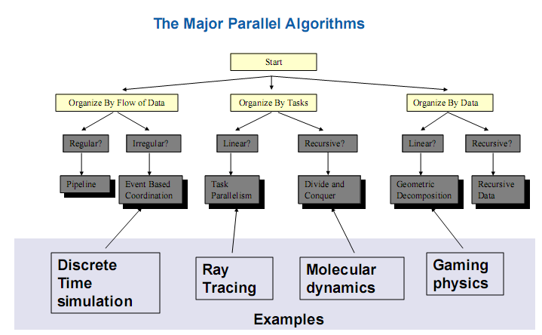Figure 14: The Major Parallel Algorithms
My job is to choose which bucket my tasks fit into; this is a non-trivial task. Some of the key issues in the process of working in parallel are the following tools:
- architectural analysis, visualization of the applications and their roles in the system,
- introduction of parallelism, highly optimized compilers delivering scalable solutions,
- confidence / correctness, detect latent programming to address unique challenges,
- optimize / tune, tune for performance and scalability.
The goal is to understand the role of parallelism and provide a robust implementation using the three “biggies”;
- Scalability,
- Correctness,
- Maintainability.
So, in looking at the challenges ahead for Uhoo and subsequent generations, there are distinctly two choices: 1. develop the system for up to a limited number of cores since it is a mobile technology, or 2. resort to a scalable language from C# to C++. I know it sucks, but we have to come to a decision about it, else mention the knowledge of the problem and that it will be addressed in future iterations.
Although interesting and necessary, I believe I will have to leave the OpenMP integration into the project for later. Now is the time to simulate Uhoo as a function of the work of the agents as in the original paper. I guess the crux of the point is be careful when using explicit threads; the concurrency revolution is speeding along and developers are finding the solutions they can use today to abstract away from explicit thread management will contain non-determinism sufficiently to be the solution of choice. Returning then…
Here is a suitable definition from IBM regarding what an intelligent agent is:
Intelligent agents are software entities that carry out some set of operations on behalf of a user or another program with some degree of independence or autonomy, and in so doing, employ some knowledge or representation of the user's goals or desires. A more general definition would state that agents are software that represents users in the same way the users would represent themselves. Just as a sports agent acts in the best interest of an athlete, a software agent should act in the best interest of its client—the user. It should be able to identify a specific need that the user has and act on that need.
In order to get an understanding of how to go about constructing the constructor, it is becoming apparent that I have again stepped too far ahead with insisting on actual construction of Uhoo without first understanding the system as a simulation. The result of these long days of constant thinking and research have yielded an open source program called Processing, a Java-based system wherein I will build the walker constructor as a dynamic presentation of exhibited agent behavior since it is practically impossible to create a visual model simply by performing a construction iteration. For now, the .NET work will be paused and full time effort will be spent on the simulation.
NOTE: In inspecting the uhoo-2.sce and uhoo-3.sce files, the only differences are that I changed the numbering order beginning with zero, and named vertices “points”. This implies that uhoo-3.sce is the latest file and I should use it to build the simulation.
29 March 2007:
I watched a show last night on German satellite with English about artificial life that taught me a very important thing that I learned the hard way yesterday—that interfacing the human compunction to visualize-to-understand is of primary import. The duration of my thesis from October 2006 to today is a treatise of the attempt to visualize the question “what is artificial life?”, one that has been wrought with just about everything imaginable and is due a chronicle. From the manifestation of vestiges of my thesis to Archimedes to Uhoo to the Constructor and my attempt to start the agents in their work without any visual queues to check if they are performing their work according to my vision have brought me around full circle, back to the whims of the master. So, the show. It constructed artificial life, based on the principle of the creation of an artificial intelligence “virus”. What is interesting about this is that all life is a bacteria and it are the viruses, or the mutations of bacteria that are the forces of evolution. I can easily extend this notion to artificial life forms. (Have sent an email to the man who gave me the information to glean a better understanding and source materials.)
So, the point is this: a new paradigm of the creation of Uhoo. Realizing the limitations of Scilab for advanced creation as late as January 2007, there has been a void in the work while looking into agents, and controls via the NXT. Thinking the limitation might be the lack of using the proper IDE, I sought the foundation in C#.NET. No go. Now there is a revised phase plan:
Premise: Consider a collective consisting of three autonomous agents in an arbitrary environment with a set of pre-determined artificial physical laws…
- The Antikythera Mechanism, the inspiration for the model,
- Simulation of the Uhoo Walker Constructor in “Processing”, a Java based applet builder in the spirit of MACOS9 found by keying in “Visual Programming Language into Google,
- The programmatic extension to real-time hardware—the NXT.
In the subsequent times, it is devoted to construction and expansion of the applet into a control interface including a sweet visual paradigm.
Exploring the user library for how to work the first part of the animation…the explosion of a globe into a sheet representing the big-bang to space-time continuum.
The first particulate: Create a point-filled shell globe that is rotating and upon some event explodes into the space-time sheet.
Problem: no dice is writing a complex applet such as the one I want to. MS J# is a waste and not good for anything of the kind. Have downloaded SUN java and also NetBeans to facilitate building *.java files. Am going to try a dummy project to see if I can build a class. Not really and getting damn frustrated with the next step in this process. Well, made some progress but back at the beginning of this task listed at the first particulate. Will take time for sure.
30 March 2007:
Switching for the next little while to the water project as it is time to get the preparations ready for it. Will return when time avails itself.
Well, maybe it’s not over yet. Got a push for a job catching electronic thieves for a German exchange bank. My AI skills and, god-dammit, Java work may come in handy. Guess she wants to live after all. A dinner break and we’ll come back to this.
Working writing applets, is fun and good to forward to the banking job for larger money. Could be interesting. Night.
1 April 2007:
Quick next paper outline:
A Model for a Self-Constructing System Capable of Evolution and Independence
Abstract: Database Constructor a solid realization of Universal Computer/Universal Constructor.
Introduction: Models of substantive autonomous machines, for the purposes of this paper, should obey a foundational argument for their perpetuation. In this example, I suggest that the Universal Computer/Universal Constructor (U[Com|Cst]) is such a model for substantive perpetuation while maintaining enough independence away from human interference.
My model will address the following:
- Self-constructing database based on a stored template,
- Fully addressed locals within the manifest software known to the system,
- Dataspace resolution to allow for growth, mutation, and evolution,
- A high-level language derived from the assembly logic,
- Gestalt by design.
Some questions that might want to be addressed. Prelude by “In terms of this paper…”:
- What is the role of emotion to the development of this type of organism?
- Can it be shown that an attribute such as emotion can serve as a connection to a specific object?
- Can it be assumed that, like it is speculated in humans, that the system contains the information of the entire universe?
- It is relevant to try to answer if feedback influences emotions and vice-versa?
- Probably, the most important and relevant question, can the individual (gestalt) emerge from the machine and can the machine contain such a feature? As in Maschinegestalt?
A quick synopsis of the intentions set forth above:
Self-Replicating Program Paradigm
Communication to Gain Knowledge
Laboring under my immediately preceding work, agents, I found it impossible or at least computationally unforgiving to track the agents as per the theory of their function via different projects on the internet. Their work manifest as threads and I went through several hours digesting the range from academic theory, proofs, parallelism, and commercial products regarding this topic. It led me to run a sample agent program, unrealized in MS, however, ran well in #develop including the reporting of the active threads. I went further and ran a source program that monitored all active thread and cached those that had ceased. Despite the detail of this information, I found it rather meaningless and difficult to draw tangible evidence of agent work and response by such a non-informative interface. So, I abandoned the line of thought and research. After thinking next to animate the Uhoo constructor agents and running through a very nice beta Java drawing program, I again abandoned the work. Now I have come to the interesting part.
Realizing that the beta program worked well, it was limited in animating a length of code. But what was very interesting was that it could be tied to a MySQL database, so small snippets of a routine could be fleshed out but I required a larger programming environment. Hence, the introduction of Java to this research.
The next steps are to work out the details of the animation as a function of a Java applet in order to get a handle on the graphics capabilities as it is such a reporting interface that I am looking for based on a sci-fi show on German satellite in English. It reminded me that for such complex tasks establishing such a delicate thesis framework, it was imperative to visually understand what I was looking at to model the dynamics of the artificial system in exactitude with the one swimming in my brain. A copy of a model of a copy evolved over millions of years. The transposition of this version of the self into another frame. This method is highly confident and can translate easily from one party to another for verification and testing. Additionally, it more importantly establishes a method whereby future works of this type will be judged.
From a dream this weekend and recorded in the notebook “Physics 3920”:
Program moves from place to place based on its constructor template, reports its location through an interface (window), and displays the modifications it has made. I was watching a program unfold from a Java-like window; it reported its location in the system, noted its active operation, and the node (file) it was operating on.
The point: To make a machine of a qualitatively different type.
2 April 2007:
Seem to keep hitting walls here. The details not listed here are in the Diary2006 file. Working in ray-tracing and hand-coding the renders and is going well, making nice static pictures. Will keep going.
5 April 2007:
Updated the website today with more explanations about Uhoo and my chronicle of the search for true artificial life. It is a little rough and I need to somehow find my voice. With all the damn writing I’ve done these long years (since 1988) you would think that I would have it by now, but no. Maybe I’m taking all this too seriously but I don’t know. All I can say is I don’t feel right about the writing and getting feedbacks like “you must’ve been high when you wrote that because it didn’t make any sense”. Giving them points for honesty, it doesn’t get me anywhere. Well, best look at something for this meeting and see how it goes.
How about a feasibility study?
Differential projects, by type and by budget, exploration issues by estimation issues including time. I believe that I can construct the item, with the materials necessary at a given cost, and they can be built in the following amount of time.
17 April 2007:
Now is the summer of my recompense. Back to full-Uhoo without anymore commercial interruption! Jesus Christ, I can’t believe I’m actually here working on what once was the Boagaphish Compiler. It’s a weird feeling and a little hard to comprehend, but it is here nevertheless.
I think the first thing to do is consider the compiler, as this will most likely take the greatest amount of time and is the most important entity in Boagaphish.
Caught in work and programming for money. Will come to this tomorrow.
22 April 2007:
Didn’t get much of a chance to come back to Boagaphish as the Friday meeting set me on a separate path that continues through today and will probably do so for a significant period of time. I’m speaking of the Model ‘G’ HHS that outsiders have pushed me to create at the present time regardless of the works I have to accomplish here with Uhoo and its successful migration into a computing complex. No worry, though, will continue to work and think about it in the spaces of time when my brain can do so. Have been training my brain to do this feat and is going well. It won’t be as bad as I paint it.
There is one significant possibility that I’ve been pondering is the construction of the clockwork Uhoo [get a scan of the original drawing for here] while fussing with the other machines. That would be pretty fun and I think I could squeeze it in to try to understand the nature of the spring parabola in context of the shape. That would be a “damn good” paper in itself, especially the experimental part. Perhaps not so much in the theory but I’m sure I can find a language to speak of it in.
Working on an interesting supposition to separate classifications of machine types although they are used together to serve a common purpose. One is “core”, the other “process”. More about this shortly.
24 April 2007:
I think it is wise at this point to begin working simulations for the Uhoo behavior motifs to understand how the compiler should function by working the symbolic language. I believe the first step is to model the project in an artificial world and source with references to Pattee in epistemic cuts.
Now to work the eventual simulation BMS (Boagaphish Modeling System). The BMS should deploy several types of simulations to address the autonomous computational domain of the Uhoo component. The main languages this will be manifest in will be C#, xml, xslt, and eventually sql—when addressing an interaction with the structured dataspaces. The BMS will accomplish three goals:
- a development environment for the structured function of what will be the compiler,
- a redirect to simulated data into the database,
- allow visual cues for how the assembly code is being addressed in the Sydrandria symbolic code.
Apart from the obvious complexity of this enterprise and the need to generate experimental results with pretty scientific graphs, the problem can be loosely broken down into modular components.
I realize the core data-exchange structure will be xml and all bits of information will be passing through this frame at some time or another in the life of the machine.
A first step to get a grapple on what I wish to do, let me duplicate a VB.NET controller for driving a iRobot Roomba in the MSRS SDK simulator:
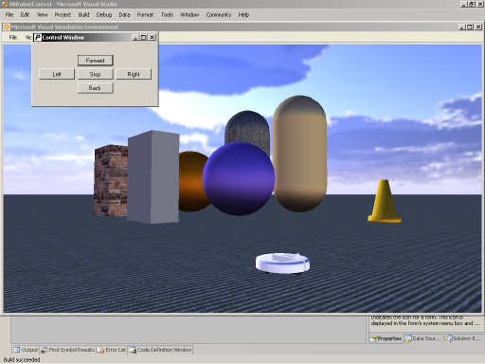
Figure 15: Running sample world in Robotics Simulator resulting from XML manifest files
Had success with this is VB and in IronPython. End of day and going home.
28 April 2007:
After tons of trouble with working Uhoo the past two days and making me miss another “On a Friday” session—the failure one way after another with the C# Uhoo Simulator—and a chance VB construction modified to the right code. Works flawlessly and I’ve been adding to it. Have to log the construction around the simulation(input), control, database, and display sometime soon. Will keep to the Visual Basic language for the duration of this place of beginning and for the eventual experiment. I really do not have the time to fuck around with semantics and attitude when I have important things to accomplish. A picture of the state of Uhoo:
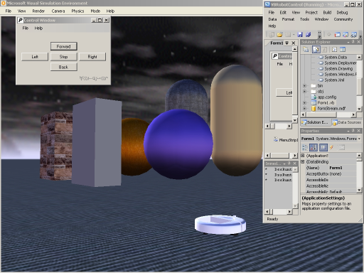
Figure 16: Current State of Uhoo (with working controller and non-connected dataset) April 2007

So have made it pretty far with the software and am starting to get a notion what kind of paper I should begin to write with the graphs that K talked about in IEEE style. Tried to stay in C# but nearly impossible to run the service inside the service without too much more time wasted, spent a day and a three-quarters with the C# and in the last moments made the switch. Okay, closing down for now. Later.
30 April 2007:
Close now to getting some semblance of a working project. Be very careful over these next few steps and be sure to try to classify what it is that is being done and the reasons why. Not only for the testing regimen, but for the good of the thesis as a whole. This programming portal is where it begins and where it seems to necessarily have to have been, for lack of better words. But I must find the words and stick to them closely.
A performance note, the #develop gives more information about the project and the dlls loaded but tachs the processor at 97% when a window such as “About…”, average without control operation around 86% while VB Express runs at 36% if paid attention to, but if left ignored, will tach the processor at the same 97%. The environment, then, will need to be run alone, from the VB.IDE for maximum performance on this single-core, 1.8Ghz Pentium Celeron-M, 128MB ATI 200M Express, with 2GB of system RAM.
Another note. The Mac—Magdelena—is reassembled with her hard-drive and running OSX 10.3.9 with the O2 on Ethernet. She is also running classic OS9.2.2 so when the time comes, the machine can run both the newer and older apps. No direct usage at present as there is no desk space to work on it. Nevertheless, the machine is ready when that day comes.
I have drawn a quick sketch in the Physics 3920 notebook of the simulation window I’m plotting. I have been debating putting it in digital form but I may yet. The reason for the delay is I’m not sure where the compiler comes into the system—in the use of the database table arrangement in formStream and the high-level symbolic code Sydrandria.
The formStream database was sampled as a dataset in VB, a little different in handling than C#, but I’ve attached the database in SQL Studio. It is also in EMS. The SQL is a little fragile in VB, so take it easy with it until it gets revised to XMS.
1 May 2007:
An interesting experiment. For bph_choice, grab an XML file with data to be parsed to a database (hosted on www.paradoxtechnologies.org/bph_choice.xml) then process through a MathML based on an equation in the database. This experiment will check to see if my idea of generative equation sparred by external stimuli is a valid assumption. This stems from Sydrandria v.2.0.1.0 June 2003. Not sure if this is reasonable at all for the compiler to attain a quantified “flavor” of expression, but is a good question to address now.
What is needed:
- parse datafile via the Assimilator routine (gets AssimilationID)—based on PaImportXML style,
- assign values for the two new fields coming up in the simulation—audio and visual.
Now return to the simulator and build the controls. The database operations will wait for now.
The first thing is to map the system as it exists programmatically. There is an error with simpledashboard.html service with an assembly mismatch. This is the next crucial fix.
Taking a break from the present work to author the structure of TDABids. Perhaps then I can have a better understanding of XML in structures.
26 May 2007:
Will continue the work on Uhoo but under a different consideration—FSX. Have begun the project this day and the cables are prepared for the next step. Work next should consider writing about the project, what should be glean from it, and what publications/school endeavors can be addressed by it.
28 June 2007:
The first step in understanding and creating a dissertation around FSX is to ignore the fact that there is an existing prototype that operates within certain specifications and to instead focus on creating a numerical model:
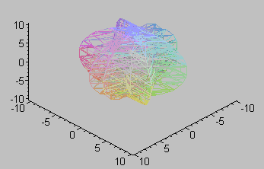
Figure 17: Manifold Theory of Transmission (FSX)
In grasping an analytical style of discerning the numerical system in terms of manifolds—computational geometry and topology—it makes for an interesting approach especially considering the task at present is to design a proof.
Figure 17 is the “optimal” wavefunction, within the ideal range 588 ≤ Ψ ≤ 1800—optimal in terms of wave stability:
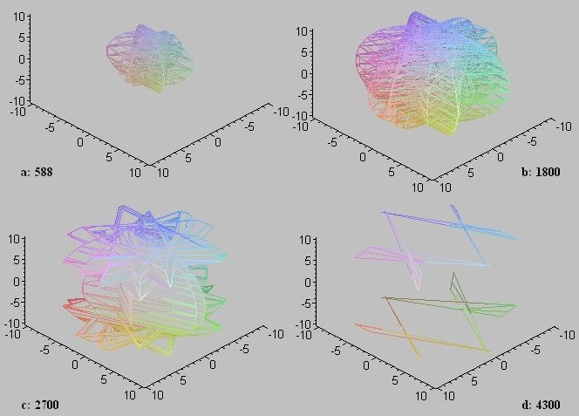
Figure 18: Wavefunction stability derived from the Characteristic Equation
derived from the characteristic equation:

solved: in the absolute limits
where ρ(v) = 6, ψ is the unit indication of cm² and t is signal on|off. Equation (2,3,4)
Beginning with a look at the flow field of the form at its appearance to its dissipation in spherical coordinates :
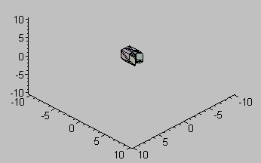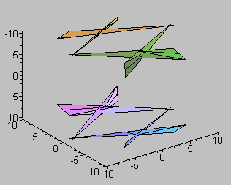
Figure 19a: r = 98 Figure 19b: r = 4300
there are involved several mathematical procedures that are being addressed simultaneously:
  - there is a synthesized system containing a characteristic equation, a solution pattern, a range, and a limit wherein the system is usable in engineering terms,
  - the behavior of the waveform is that it emerges from a central fixed point and disperses in two equilateral (Uhoo) triangles with a shared length intersecting the point forming a symmetric fold,
  - the shape is consistent when changing the limits and ranged when switching between cylindrical and spherical coordinates.
The form can be addressed as in terms of non-Euclidean geometry as…
30 June 2007:
Usually don’t write thoughts here but I need to “interface” my creativity to the problem at hand.
A note here to contain the theory in the “governing ODE” from hadenwerks; currently is contained within the paper: paper name here.
2 July 2007:
Have downloaded Comsol MultiPhysics v3.3. Install and check out to see how it functions.
1804: Comsol only now installed. Will burn DVD for home and head out. Try with the real work tomorrow ;-).
2105: On computer #2 with the sucky keyboard to install Comsol. Going to try to trim the installation size. Installing the Script interface this time against the advice of the install readme. Takes lots of resources on this computer 1.8GHz AMD, 768MB RAM, 64MBVRAM, 20GB HD.
2045: Software in and defragmenting. www.funda.nl.
2215: Can be used with Matlab, wonder about scilab?
2223: Started new file to begin experimenting with the program. On the traveler. One last note, the comsol script program is running without problem and everything seems to be in order.
3 July 2007:
1046: Reading the ac/dc users guide to get started this morning; 1140: Completed first tutorial and stored in folder #1 including readme organization; 1703: Completed second tutorial and stored in folder #2. 1832: Completed third tutorial, exported two figures and stored in folder #3. Resume on document page 54.
Here is an example of a figure made in Comsol:
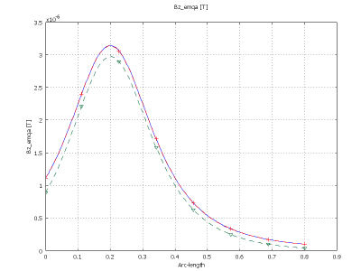
Figure 20: Solution Diffs
4 July 2007:
Having reviewed what is contained after these three tutorials, I have found it is a discussion of the details of Maxwell and electromagnetic theory in general. Although a helpful reference, it is of greater interest to apply the theory to real-model problems wherein I can learn the software and glean insights regarding Project FSX. To this end, I am now working out of the AC/DC Model Library document and following the second chapter, page 8.
Did two more tutorials and skipping through the motor sections to inductance with two wires, which is very similar to the first condition for FSX. Am breaking at 1500 to write the parameters for the experiment which will be run sometime during the next few days.
In order for the animation to be viewable in most of the open-source players, use progressive jpeg for the .avi movie.
Am getting toward the end of my learning and nearing my own launching-point. There are three more tutorials that will outline the basic parts of FSX and the fourth being a template but using a square coil instead of a circular one, although these are defined in several different types of dimensions (electric and magnetic) in the previous three. Will see if I can get to folder #9 before leaving today.
Having finished through #7, the complications of the models are getting harder; as such it seems some information is neglected or miswritten in the tutorial. I had trouble with some details of #6 and parts of #7. It may be of interest later to review these after gaining some more experience with the software.
Noted this morning to create a template for the experiments I want to conduct with the FSX pads. It might be a good idea to take a break, then come back and write the document.
1524: Taking lunch break.
Spent the remainder of the day assembling the data needs to begin testing the FSX pads.
5 July 2007:
Assembling the experimental conditional data for the FSX pads into a composite .xls file to try to document the continuum of quantities and properties of the materials in the physical FSX.
The first to consider is the loop antenna—the ‘pads’ for Tx and Rx. As they are circularly wound, carrying the integral of the loop around P and S of both transmitter and receiver pad.
6 July 2007:
In researching the data regarding spiral antenna systems, there are several hypotheses regarding behavior of these types. There is mention that an effective spiral must have equal striplines and slots according to a corollary of Babinet’s Principle. There are some variations however between this and a logarithmic spiral. Here is a typical description useful for the report on this antenna:
This project has cavity backed spirals with a variety of package and performance options. These Archimedean spirals employ very broadband balun feed networks and are available in right- and left-hand polarizations. Current spiral designs provide frequency coverage in discrete bands from 200 MHz to 40 GHz and diameters from greater than 30 inches to less than 1 inch. Typical antennas operate continuously over bands such as 2 to 18 GHz and 18 to 40 GHz, while maintaining excellent radiation pattern characteristics and low axial ratio.
8 July 2007:
Performing an operational test of the transmittance setup, here is what it looks like:
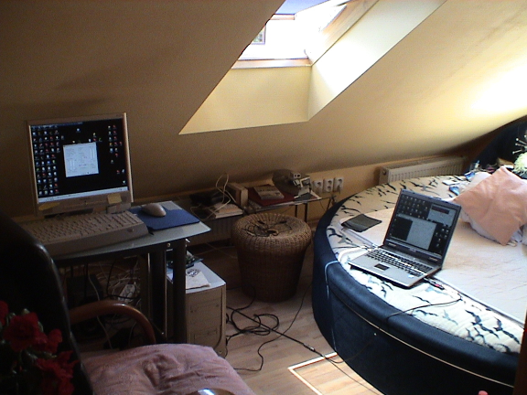
Figure 21: Experimental Setup

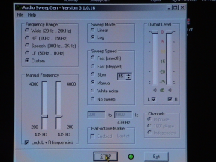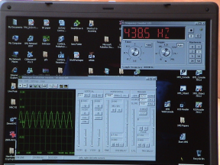
Figure 22: Computer 1 Generator (Left), Computer 2 Analyzer (Right)

This experiment will be an operational test of the FSX. The first step is to understand the performance and degree of robustness of the components used here. There are two computers involved, a 1.8GHz AMD, 768MB RAM, 64MB VRAM; ASUS 1.7GHz Celeron Single Core, 2GB RAM, 128MB VRAM. The AMD functions in this experiment as the generator, the ASUS the receiver/analyzer. A wire is leaving the AMD through the speaker jack to a series of connectors which change the configuration to BNC—the type of connector on the FSX array. The same is repeated on the other end of this length of cable.
The setup runs quite well; feedback noise is reduced 70% with the addition of a 50Ω feed-thru termination on the analyzer end. The wires, however, are very susceptible to noise and small movements in the connectors; this operation can only be used in the short term although I believe the results can be trusted. All the software is free or open-source and the oscilloscope is a 14-day trial.
Now to perform an operational test on FSX. This experiment will use one set of ‘banana’ cables—one red and one black 100cm in length—and two 50Ω BNC cables 103cm in length. The distance separating the pads is 198cm ≤ d₀ ≤ 232cm (2 x 100cm cables, 32cm length of the capacitor). The setup is shown in the figure:
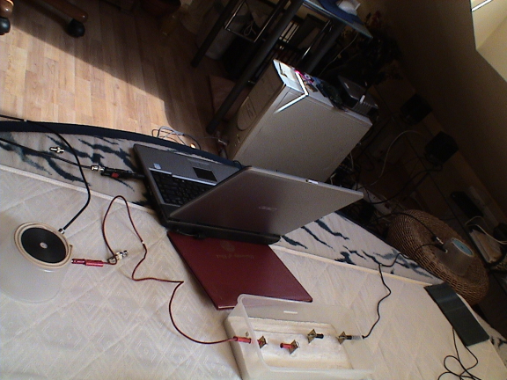
Figure 23: FSX Setup--Transmitter (Right, Blue) Receiver (Left, Black) RESU (Center)
The set functions but is leaking due to the poor equipment; however, a resonance frequency was obtained:
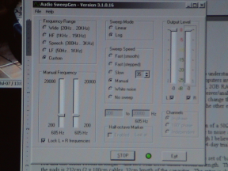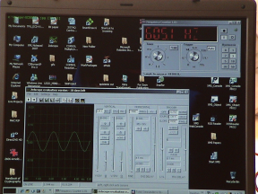
Figure 24: Resonance band ≈ 605Hz
It is confirmed that the device operates as expected; however, no further tests will be conducted until a full numerical analysis is performed and the proper equipment obtained. Many of the touch-points are dirty and the computer sound cards feedback into the units disturbing not only a stable resonance point but adding a substantial quotient of energy to the receiver pad. The feedback does increase in magnitude during the charging cycle of the RESU (capacitor) which could damage the equipment. This experiment was to verify the operational status of the now 3 year-old prototype.
There was a connection error on the transmitter; have continuity problems. (Remedy & retest). Remedied and retested, although signal present in the coils, not enough pressure in the sound card circuits to get the signal to leave the pads, instead it collects in the capacitor and upon leaving the coils usually stored there inside, they were warm upon taking them out. There is decent energy in this format but more power is required for it to make the jump.
9 July 2007:

Using LyX to process the analytical document; is a good solution to the looming and perspicacious report deadline since I am without a strategy and not have authored a single word.
10 July 2007:
Having accomplished how to generate the numerical computations (COMSOL), the antenna simulations of the spiral coils (NEC), and the composite document (LyX), it is now of interest to delegate the content. Having perused some PhD thesis sites and before I browse the categories, I have decided to try writing the report in the active, first-person.
In considering the theme Toward an Artificial Life Form it is non-trivial to include mentioning the three basic features:
  - Independence, autonomy (from human interference), and non-interrupted operation,
  - Choice (volition),
  - Internal governance (ultra-stability / homeostasis).
(1) is the conformal single-arm Archimedean spiral, the system of equations, accompanying antenna theory, a method of signaling power and communication simultaneously. (2) is Featured Power. (3) is the governing equation (ODE) first demarcated during the Hadenwerks.
For (1) DRAFT:
Keywords: Methods of Signaling, Self-Optimization and Homeostasis, Orchestration
Anticipated Result: Cooperative Robotic Colonies
Background: The field of Artificial Intelligence (AI) and its spawn, Artificial Life (AL), have never been effectual as a means of answering the most basic question: Can a machine be made to resemble in function and behavior the array of life-forms that appear so prevalently in the real world? A damning document The Lighthill Report details this problem and the recent confessions of failure in solving any problems in AI have poured into the press of late. This thesis will pronounce a final analysis of the failures in AI by arguing that machines should not be made to mimic life-forms, forced into an unsuitable models, but instead should be designed as life-forms in their own right and subject to the same rules. (Arguments from the book written in France) [Or as John McCarthy notes:] this thesis will be smarter and work harder at the problems it attempts to solve and not be buried in mathematical paradigms save the appropriate numerical analyses.
In this section, I will propose to analyze a closed transmission-reception system optimized to transmit quantities of power and communication using the power wave as a carrier. I will study a spiral of arms a with a fixed number of turns n related to the radians on a circle (n = 2π) 1, 2, 4,..2a.
Consider an Archimedean spiral r_{s} where the distance s between each of the arcs is constant, that is, dependent on (some relation of ∫n dn). The mean capacitance on the antenna increases with n as well as the mean impedance over a nearly constant transmission time t. The equation governing this system is . The inner radius is given by: .
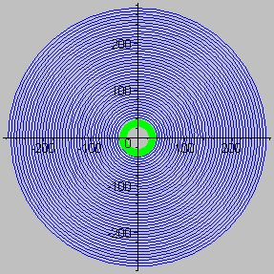Figure 25: The R_{x} Spiral
I am (want to be) the AI Master.
12 July 2007:
The Determinate Machine: A machine that behaves in the same way as does a closed single-valued transformation; a transformation is single-valued if it converts each operand to only one transform. The justification is simply that the definition works—that it gives us what we want, and nowhere runs grossly counter to what we feel intuitively to be reasonable, with a significant caveat: that we provide a range of possible behaviors while simultaneously understanding that our intuition could be erroneous given the situation at hand. A machine, therefore, is not understood as being intelligent by its observers unless the sequence of states defining a trajectory or line of behavior is able to compartmentalized and given symbolic value as such. The only control allowed here will be the assignment of a range of states from which the machine can make a choice subsequent to processing and entering a domain where the range lies. What is non-trivial is the contribution of the transformation to the next successive state based on the operator, which in natural systems in not always known or investigated, but in terms of the machine is less trivial.
In pursuit of the above, there must exist a system of classification of types of determinate machines based on their function and attributions given in their states and the flavors of their particular operands. As such an ambition could be wrought with confusion, a development platform containing a suitable IDE must be deployed that has the ability for unit testing.
To collect data of past successes, BPS was concerned primarily with how a transformation logic could be deployed based on a Kohonen map, how weights would be distributed and tasks spread evenly across the surface of the map relying explicitly on an external event to trigger the intervention of the operand which consisted of a prescribed set of behaviors mostly being retrieval of fresh information for the given coordinate else calling a directional vector with a “winning” neuron representing the convergence of the new state agreed to by the system because it is “the winner”.
14 July 2007:
The concept of workflow requires an understanding of a means of visualizing the problem to be solved.
Looking at the problem programmatically and implementing the proper paradigm and considering myself as the role of ‘zoologist’—merely a classifier of the plethora of possible combinative state machines of varying typologies—beginning firstly with a common-source IDE, State-Machine Workflow in C#. The first example is a Simple Order State Machine; that is, a three-state child machine based on the task of processing an order [item : quantity] which has a set of finite inputs—a range of items and a limited quantity—from a workflow parent single-state machine called the OrderProcessingWorkflow.
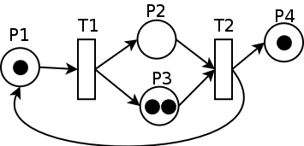Figure 26: Petri Net
While working the flow, support in WCF needs to be established, notably, the CCR runtime and DSS host to plug into the VB Robot assembly where the simulation of the environment is. Working on a complete simulation environment for the intelligence. Install CCR-DSS libraries and run basic service code to establish the footprint. Reason is to attach the BphSydController services I designed and demarcated earlier in this document (Figure 16) on http://dolores:50000 to the workflow state diagram.
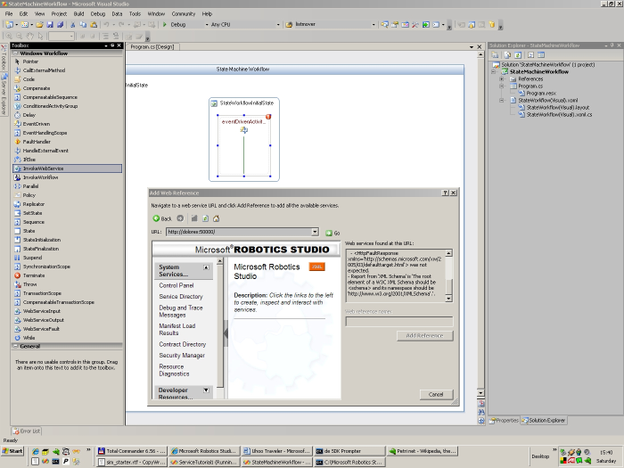Figure 27: You elusive motherfucker
The error seems to indicate the wrong type of child note representation for the service to the XAML—the WSDL description in XML. Going to be an interesting pursuit to be sure.
16J7: The Dream World of the Robot – How to write about this one will be a challenge…think of state flows and how to mock them up….what about the writing of the thesis report...?
18 July 2007:
..from a dream…you don’t realize the value of what you have in your possession.
Part I: Modeling of the Problem
Multiphysics: meaningful simulations of today’s complex systems require arbitrary couplings between different physics phenomena in one and the same model, such couplings in this thesis section denoted wireless power for robot colonies will attempt to analyze such a complex system and demonstrate tools for analysis. The coupled multiphysics models will be arbitrary couplings between:
- central transmitting complex (queen),
- mobile receiving swarm quad/bipeds (drones),
- control and orchestration of power distribution model.
Questions:
- what are the geometries of the system under study?
- How can the problem be broken down into manageable pieces (then assemble them) that I can obtain funding for?
Pieces Parts:
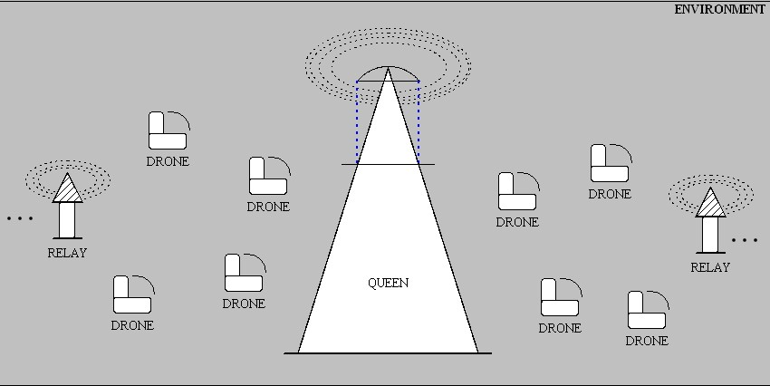Figure 28: Geometry Mockup
Geometry Description: A cavity-resonant conical transmitter/receiver with an extensible conic cap (QUEEN) coupled (whispering gallery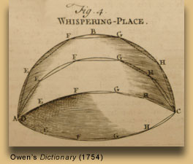ellipsoidal transmission pathways) to a collection of social autonomous robots who’s quadruped bodies form a conductive shape and surface area creating a means of an inductive potential (DRONES). They’re body shape can transform its length along the x-axis and the z-axis by mechanical means of standing upright bipedally in an equidistant fashion. The purpose of the morphology is to allow more directional receivership at a cost of mobility speed.
Features: High capacitance, high impedance system—to aid in powering devices in the far-field where the edges of the eddy currents will be boosted in range by the placement of signal relays—of two flavors, coupled and uncoupled fields. Coupled uses a series of concentric circles on the charge and uncoupled uses a contiguous spiral.
Model Requirements: An electrically charged conic section powered by a single n turn Archimedean spiral coil coupled to a linear coil (filament) running its length along the z-axis. The spiral’s outer radius , and inner radius are arranged such that the radius of the filament with length , is related to the spiral as: . At the apex of the filament lies a conic section acting as a transmission antenna T_{a}. The field is (smoothed / amplified / radiated) by an outer conic section T_{b}. In the figure:
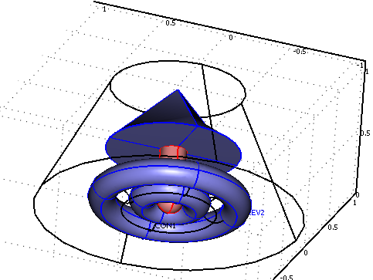Figure 29: Current Model State
19J7: Composite model mocked up with a proportional spiral wave count, capacitance hooks, and better scaled render:
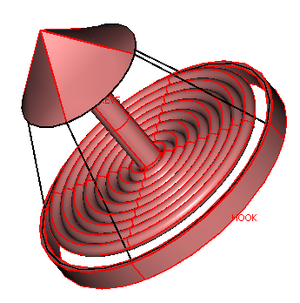Figure 30: Composite Model State
Now to add the environment that the system will operate in:
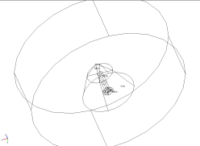Figure 31: Simplified Model in Environment
Figure 31 expresses the core as a function of its limit—at transponder minimum placement.
Now to add the material and electrical characteristics. Start with something easy, like copper.

Greek and Roman Siege Machinery 399BC to AD 363, pp.3- 2003.
James Reinders, Intel Software Development Products, 19 March 2007. http://www.go-parallel.com.
source

