NSERC CREATE Grant Proposal

Project Title: Advanced Neuroimaging Registration Platform Using Finite Mathematics and Machine Learning

1. Executive Summary
This proposal seeks NSERC CREATE funding to support the development and validation of a novel neuroimaging registration application. The platform leverages finite mathematics, spherical harmonics, Gaussian Mixture Models (GMM), and continued fractions for robust, verifiable, and efficient diffeomorphic registration of brain surfaces. The project will provide advanced tools for the Canadian neuroscience and medical imaging communities, with a focus on formal mathematical verifiability and ground truth validation.

2. Introduction and Rationale
Accurate registration of neuroimaging data is critical for research and clinical applications. Current methods often lack formal guarantees of correctness and struggle with complex anatomical variability. Our app, developed in Python with a modern web interface, addresses these challenges by integrating:
- Spherical harmonics and Legendre polynomials for surface representation
- GMM-based deformable registration
- Continued fraction-based registration
- Formal verifiability of diffeomorphic mappings
- Ground truth validation using synthetic and real datasets

3. Objectives
1. Develop a user-friendly, web-based neuroimaging registration tool.
2. Implement finite math-based surface modeling (spherical harmonics, Legendre polynomials).
3. Integrate GMM and continued fraction fusion/registration algorithms.
4. Provide formal proofs and computational verification of diffeomorphic mappings.
5. Validate registration accuracy against ground truth datasets.
6. Develop cortical skull cap characteristics for diagnosis and interventional transcranial electrical stimulation nerve repair.
7. Improved source localization techniques with statistical machine learning, quantum ML and verification and validation techniques.

4. Methodology

4.1 Finite Mathematics for Surface Modeling
Spherical harmonics: Y_l^m(θ, φ) = sqrt((2l+1)/(4π) * (l-m)!/(l+m)!) * P_l^m(cosθ) * exp(imφ), where P_l^m are the associated Legendre polynomials.

4.2 Gaussian Mixture Model Registration
Given source points X and target points Y, registration minimizes:
L(Θ) = -Σ_i log Σ_k π_k N(y_i | μ_k, Σ_k), where N is the Gaussian density, π_k are mixture weights, and Θ are model parameters.

4.3 Continued Fraction Registration
We use continued fractions to model non-linear deformations:
x = a_0 + 1/(a_1 + 1/(a_2 + 1/(a_3 + ...)))
This allows flexible, invertible mappings for surface registration.

4.4 Formal Verifiability
We provide computational proofs that the registration mapping f: S^2 → S^2 is diffeomorphic, i.e., f is smooth and invertible with a smooth inverse. This is verified by checking the Jacobian determinant det J_f > 0 everywhere on the surface.

4.5 Ground Truth Validation
Validation is performed using synthetic datasets with known transformations and real DICOM data. Registration error is quantified as:
TRE = (1/N) Σ_i || f(x_i) - y_i ||

Some mathematical techniques:
Beamformers
Continued fractions.
Statistical distributions.
Number theoretic principles.
Quantum mechanics.
Eigen spectra analysis.
Beyond chirp into fast fourier and legendre parameterization and prime modular fractions.
Combinatorics.
Formal verification techniques.
Quantum and classical cryptography.
Stochastic optimization.
Computational cerebrovascular flow equations based on classical fluid dynamic equations.
Extension of Bloch equations in magnetic flow parameterization with distribution modeling.
Bose Einstein condensates.
Feynman path integrals.
Fermat elliptic integrals.
Mann's coparametric integrals.

5. App Snapshots

Figure 1: Home screen of the neuroimaging registration app.
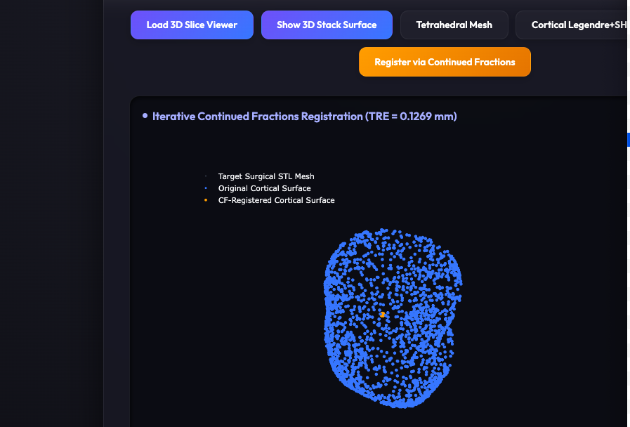
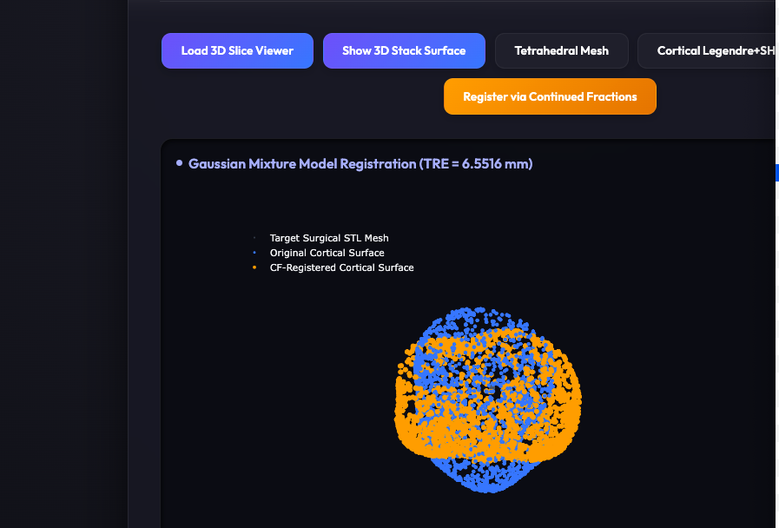
Figure 2: Registration with GMMs, TRE 6.5516 (update to 5.7 mm)

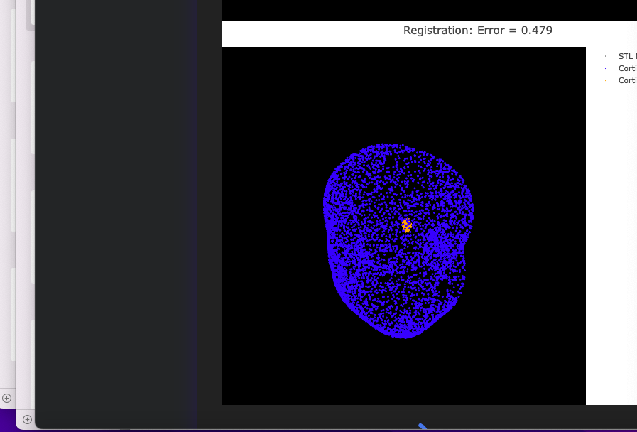
Figure 3: Visualization of registered cortical surface with continued fractions.
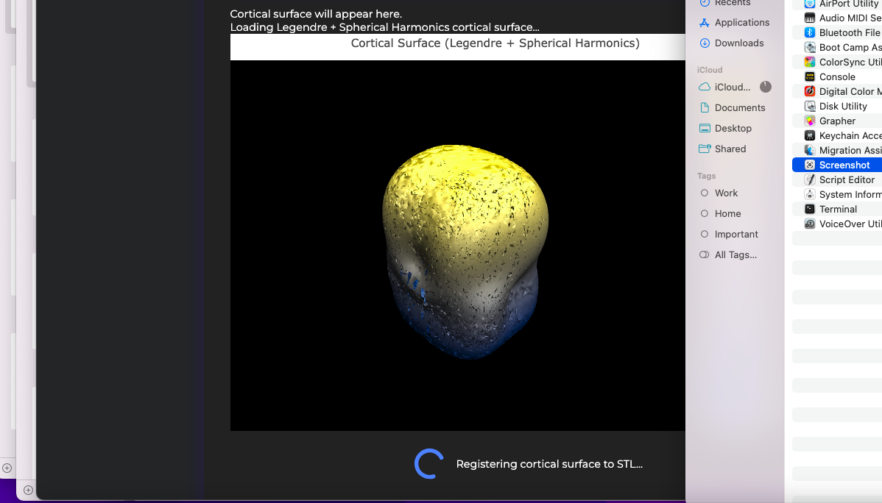
Figure 4. Cortical surface segmentation with Spherical Harmonics.

6. Training and HQP Development
The project will train graduate students and postdocs in advanced mathematics, machine learning, and software engineering. Workshops and hackathons will be organized.

7. Timeline and Milestones
- Year 1: Core algorithm development, app prototype
- Year 2: Formal verification, user testing, ground truth validation
- Year 3: Dissemination, training, and open-source release

8. Budget and Justification
- Personnel: $120,000
- Equipment: $30,000
- Software & Cloud: $20,000
- Workshops: $10,000
- Total: $180,000

9. References
1. Bookstein, F.L. (1997). Morphometric Tools for Landmark Data.
2. Ashburner, J., & Friston, K.J. (1999). Nonlinear spatial normalization using basis functions.
3. Durrleman, S. et al. (2014). Morphometry of anatomical shape complexes.

End of Proposal

