Comprehensive Finite Mathematical Framework
for Deep Brain Stimulation Systems
Technical Report: Equations, Models, and Dynamics
Deep Brain Stimulation Scientific Advisory Board
January 2026

Abstract
This technical report formalizes the mathematical underpinnings of the Deep Brain Stimulation (DBS) application. It covers the Finite Element Analysis (FEA) of electric fields, the coupled differential equations for OCD CSTC loops, the neurotransmitter dynamics in Depression, the quantum surface integrals and continued fraction metrics for ASD neural repair, and the neural field equations for Dementia pathology. Each module is grounded in stochastic physics and statistical mechanics.

1. Finite Element Analysis (FEA) of Electric Fields and Post Treatment Parameters
The fundamental physics of DBS involves the distribution of electric potential Phi in the brain tissue, governed by the quasi-static Poisson equation:
∇ · (σ(x) ∇Φ(x)) = -∇ · J_source
where sigma(x) represents the anisotropic conductivity tensor. The Volume of Tissue Activated (VTA) is the manifold where the second spatial derivative of the potential exceeds the axonal threshold:
VTA = { x ∈ Ω | Δ²Φ(x) > θ_activation }

2. OCD Module: CSTC Loop Dynamics
OCD pathology is modeled as a hyperactive gain cycle in the Cortico-Striato-Thalamo-Cortical loop. The state vectors for Orbitofrontal Cortex (OFC), Caudate (C), and Thalamus (T) evolve according to coupled nonlinear ODEs:
τ dC/dt = -C + S(w_OFC->C · OFC + I_DBS)
τ dT/dt = -T + S(w_C->T · C - w_GPi->T · GPi)
τ dOFC/dt = -OFC + S(w_T->OFC · T + I_ext)

3. Depression Module: Neurotransmitter Dynamics
The Depression model simulates the restoration of bioamines (Serotonin 5-HT, Dopamine DA) and the regulation of Glutamate (Glu). The dynamics under formulation are:
dS_5HT/dt = α · E_eff(f) · (1 - S_5HT) - γ(S_5HT - S_base)
The stimulation efficacy E_eff is strictly frequency-dependent, modeled as a Gaussian resonance around 130 Hz:
E_eff(f) = A · exp( - (f - 130)² / 2σ² )
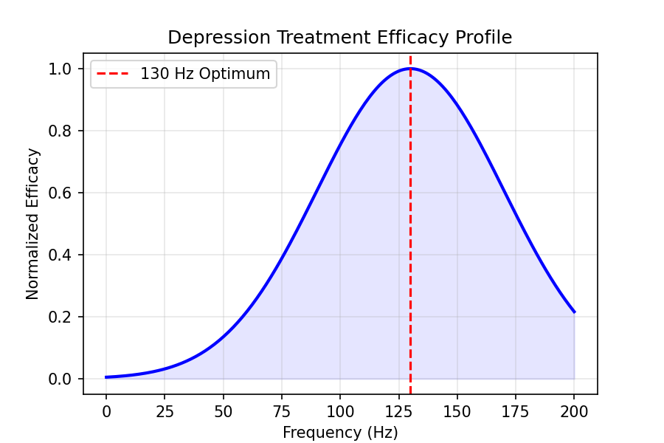

4. Seasonal Affective Disorder (SAD): Circadian Entrainment
SAD is modeled as a desynchronization of the Circadian pacemaker (Suprachiasmatic Nucleus, SCN). DBS aims to re-entrain the phase φ(t) of the oscillator using a Kuramoto-like forcing term:
dφ/dt = ω + K · sin(φ_dbs - φ) + Noise
Where K is the coupling strength proportional to stimulation amplitude. Melatonin secretion M(t) is inversely coupled to SCN activity A_scn(t):
dM/dt = -β · A_scn(t) · M + P_night(t)
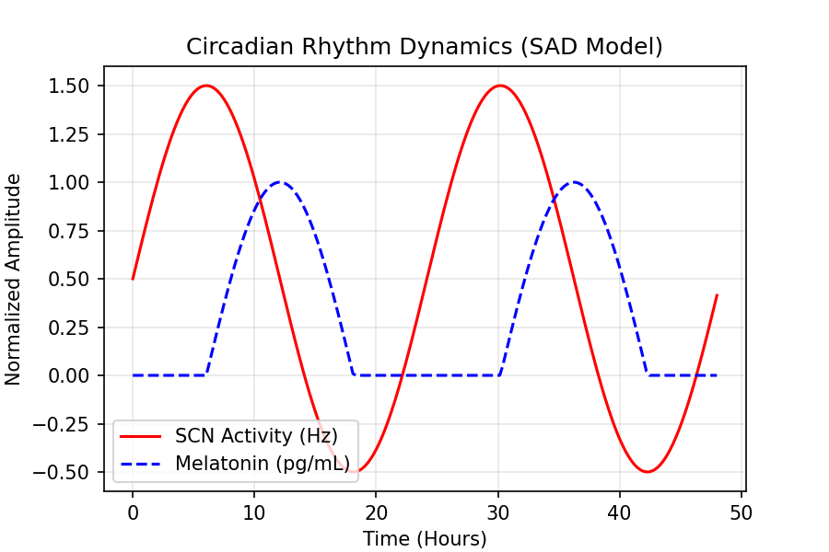

5. ASD Module: Quantum Neural Repair
ASD repair focuses on restoring connectivity. We utilize a Quantum Surface Integral formalism where the neural connectivity is treated as a wavefunction Psi:
Φ_repair = ∮_S Ψ* ∇Ψ · n dS
The repair trajectory is modeled using Continued Fraction sequences, representing the hierarchical restructuring of neural pathways:
C(t) = a0 + 1 / (a1 + 1 / (a2 + ...))

6. Dementia Module: Neural Decay & Memory
Dementia pathology involves time-dependent atrophy and amyloid burden (Beta). The activity A of a memory region is governed by:
τ dA/dt = -A + σ( Σ w_ij A_j + C_chol - P_beta )

