Software Requirements Specification

For

SupplyTwinAI: An Autonomous Multi-Agent Supply Chain Digital Twin for Intelligent Decision Support

Prepared by:
Pranitha Avula - 23BD1A0566
Sindhu Sri Thirunagari - 23BD1A0579
Kavya Tummalapally - 23BD1A057A
Divya Sree Vavilala - 23BD1A057H
Team: 12 — CSE-D
Faculty Supervisor: Mr. C. Sundeep Babu
Domain: Artificial Intelligence and Machine Learning

Table of Contents
1. Introduction 4
1.1 Purpose 4
1.2 Document Conventions 4
1.3 Intended Audience and Reading Suggestions 4
1.4 Product Scope 4
1.5 References 5
2. Overall Description 6
2.1 Product Perspective 6
2.2 Product Functions 6
2.3 User Classes and Characteristics 6
2.4 Operating Environment 7
2.5 Design and Implementation Constraints 7
2.6 User Documentation 7
2.7 Assumptions and Dependencies 7
3. External Interface Requirements 8
3.1 User Interfaces 8
3.2 Hardware Interfaces 8
3.3 Software Interfaces 8
3.4 Communications Interfaces 9
4. System Features 10
4.1 Data Ingestion and ETL 10
4.2 Knowledge Graph Construction and Querying 10
4.3 GraphRAG-Grounded Retrieval 11
4.4 Multi-Agent Disruption Monitoring and Risk Scoring 12
4.5 Persistent Disruption Memory 13
4.6 AI Assistant (Natural-Language Query) 14
4.7 Manager Dashboard and Digital Twin Visualization 15
4.8 Recommendation Center and Approval Workflow 15
4.9 Administration 16
5. Other Nonfunctional Requirements 17
5.1 Performance Requirements 17
5.2 Safety Requirements 17
5.3 Security Requirements 17
5.4 Software Quality Attributes 18
5.5 Business Rules 18
6. Other Requirements 19
Appendix A: Glossary 20
Appendix B: Analysis Models 22
B.1 Architecture Overview 22
B.2 Use Case Diagram 22
B.3 Sequence Diagram — Disruption Detection & Recommendation Flow 25
B.4 Class Diagram 26
Appendix C: To Be Determined (TBD) List 27

1. Introduction

1.1 Purpose
This Software Requirements Specification (SRS) defines the functional and non-functional requirements for SupplyTwinAI, an AI-driven, autonomous multi-agent supply chain digital twin system developed by Team 12 as a final-year capstone project. It specifies what the system shall do, not how it is internally implemented, and covers the complete system at Version 1.0 — the scope delivered across Review 1 and Review 2.

1.2 Document Conventions
This document follows IEEE 830-1998 structural conventions, adapted to the feature-based requirements format popularized by Wiegers' SRS template. The word "shall" indicates a mandatory requirement; "should" indicates a recommended but non-mandatory behavior. Bold text marks defined terms (first use) and named UI elements/screens (e.g., Recommendation Center). Functional requirements are numbered REQ-1, REQ-2, ... and reset within each system feature in Section 4; each requirement can therefore be uniquely identified by its feature and number (e.g., REQ-3 under Section 4.4). Non-functional requirements in Section 5 are numbered per subsection (e.g., NFR-P1 for the first performance requirement). No requirement priority marking scheme beyond the High/Medium/Low priority stated per feature in Section 4 is used, since this is a single-release capstone deliverable rather than a multi-release backlog.

1.3 Intended Audience and Reading Suggestions
This document is intended for four audiences: (1) the four-member development team, who should read Sections 2–5 in full before implementation and use Section 4 as the authoritative feature/requirement checklist during development; (2) the faculty supervisor and evaluation panel, who will use this document to verify delivered functionality against committed requirements during Review 1 and Review 2; (3) any future student extending this work, who should start with Section 2 (Overall Description) and Appendix B (Analysis Models) to understand system boundaries before reading individual requirements; and (4) testers, who should read Section 4's Stimulus/Response Sequences directly as the basis for test case design. Readers unfamiliar with the base literature this project extends should read Section 2.1 (Product Perspective) before Section 4.

1.4 Product Scope
SupplyTwinAI is a decision-support software system that extends the four-layer Digital Twin of Supply Chains (DTofSC) architecture proposed in Jesus et al., "Digital Twins of Supply Chains: A Systems Approach" [1] with an autonomous reasoning layer. Where [1]'s architecture addresses digital representation, addressability, and data convergence of supply chain entities but stops short of autonomous reasoning, SupplyTwinAI adds a Knowledge Graph, GraphRAG-grounded retrieval, LLM-based reasoning, persistent disruption memory, and a six-agent LangGraph orchestration layer that together monitor, analyze, and recommend responses to supply chain disruptions in near real time.
In scope for this release: ingestion and normalization of the DataCo dataset plus a live simulation module (Section 4.1); a Neo4j knowledge graph satisfying the addressability requirement of [1] (Section 4.2); GraphRAG retrieval grounding all LLM calls (Section 4.3); six LangGraph-orchestrated agents producing a composite risk score and mitigation recommendations (Section 4.4); persistent disruption memory (Section 4.5); a natural-language AI Assistant (Section 4.6); a Manager Dashboard and Digital Twin graph view (Section 4.7); a human-approval-gated Recommendation Center (Section 4.8); and an Admin area for data, agent, and reporting management (Section 4.9) — delivered as a single React/FastAPI web application on cloud infrastructure.
Explicitly out of scope: any write-back or actuation into real-world ERP, WMS, TMS, or carrier systems (the system is read-only with respect to external enterprise systems and always requires human approval before a recommendation is considered acted-on, per REQ-2 in Section 4.8); integration with live, paid, or partner-specific data feeds (the system uses the DataCo historical dataset plus a simulated live-event generator, not a production pipeline); multi-tenant support and organizational hierarchies spanning multiple companies; native mobile applications; and formal security certification (e.g., SOC 2, ISO 27001).

1.5 References
[1] V. Jesus, D. Kalaitzi, L. Batista, and N. Leal Lopez, "Digital Twins of Supply Chains: A Systems Approach," IEEE Trans. Eng. Manage., vol. 71, pp. 14915–14932, 2024. https://ieeexplore.ieee.org/document/10707169
[2] "Agentic Digital Twins: Bridging Model-Based and AI-Driven Decision-Making Support for a New Era of Supply Chain and Operations Management," Int. J. Production Research, 2026. https://www.tandfonline.com/doi/full/10.1080/00207543.2026.2630277
[3] "Agentic LLMs in the Supply Chain: Towards Autonomous Multi-Agent Consensus-Seeking," Int. J. Production Research, 2025. https://www.tandfonline.com/doi/full/10.1080/00207543.2025.2604311
[4] "Automating Supply Chain Disruption Monitoring via an Agentic AI Approach," arXiv:2601.09680, 2026. https://arxiv.org/html/2601.09680v1
[5] "LLM-Based Multi-Agent Orchestration: A Survey of Frameworks, Communication Protocols, and Emerging Patterns," Future Internet, 2026. https://doi.org/10.3390/fi18060326
[6] T. Zang et al., "Event-State Knowledge Graph-Enhanced GraphRAG for Order-Driven 3D Printing Supply Chain Configuration," Expert Systems with Applications, 2026. https://www.sciencedirect.com/science/article/abs/pii/S0957417426008511
[7] "Enhancing Supply Chain Visibility with Knowledge Graphs and Large Language Models," Int. J. Production Research, 2025. https://www.tandfonline.com/doi/full/10.1080/00207543.2025.2575841
[8] H. Wang, J. Jiang, L. J. Hong, and G. Jiang, "LLMs for Supply Chain Management," arXiv:2505.18597, 2025. https://arxiv.org/pdf/2505.18597
[9] "Forecasting Supply Chain Disruptions with Foresight Learning," arXiv:2604.01298, 2026. https://arxiv.org/pdf/2604.01298
[10] "Always-On Agents: A Survey of Persistent Memory, State, and Governance in LLM Agents," arXiv:2606.30306, 2026. https://arxiv.org/pdf/2606.30306

2. Overall Description

2.1 Product Perspective
SupplyTwinAI is a new, self-contained system rather than a replacement for or plug-in to any existing enterprise product. It is architecturally positioned as an extension of the four-layer DTofSC systems architecture defined in [1]:
1. Physical Twin layer — the supply-chain and product view, satisfying addressability. SupplyTwinAI realizes this as the ingested DataCo dataset plus simulated live events, each entity assigned a unique, queryable identifier.
2. Convergence layer — [1]'s blockchain-based discovery/trust point. SupplyTwinAI substitutes this with its ETL pipeline and PostgreSQL relational schema, which unifies heterogeneous source records into one addressable schema (blockchain-based trust convergence is not implemented — see Section 2.5).
3. Digital Twin layer — discovery, querying, simulation of the supply chain. SupplyTwinAI realizes this as the Neo4j knowledge graph and the live simulation module.
4. Higher-level applications layer — forecasting, decision support, visualization, track-and-trace. [1] leaves this layer largely conceptual; SupplyTwinAI's core contribution is populating it with a concrete reasoning stack: GraphRAG retrieval, Gemini-based LLM reasoning, persistent disruption memory, and six LangGraph-orchestrated autonomous agents, exposed through a Manager Dashboard, a Digital Twin graph view, an AI Assistant, and a Recommendation Center.
The system is standalone. It depends on three external, independently hosted services it does not control — the Gemini API (LLM inference), Open-Meteo (weather data), and NewsAPI (news data) — each accessed as a read-only data/inference source over HTTPS.

2.2 Product Functions
At a high level, SupplyTwinAI provides: data ingestion and unification (DataCo dataset plus simulated live events into a shared relational schema); knowledge graph construction and multi-hop querying; grounded retrieval (GraphRAG) that conditions LLM responses on graph context to reduce hallucination; autonomous multi-agent reasoning (six LangGraph agents producing a composite risk assessment and mitigation recommendation); persistent disruption memory so recommendations improve over time; natural-language querying against the knowledge graph and memory; and visualization/reporting through a KPI-oriented dashboard, an interactive graph view, and a Recommendation Center with confidence-scored mitigation options. Full detail for each function appears as a system feature in Section 4.

2.3 User Classes and Characteristics
SupplyTwinAI defines two user classes. The Supply Chain Manager is the primary end user who views the Manager Dashboard, inspects the Digital Twin graph, poses natural-language questions to the AI Assistant, and reviews and accepts/rejects recommendations in the Recommendation Center. This user is assumed to have domain knowledge of supply chain operations but no expectation of technical knowledge of knowledge graphs, LLMs, or the underlying agent architecture — the UI must present all AI-derived output in plain business language. The System Administrator is a secondary user class responsible for managing supply chain data (triggering/reviewing ETL imports), configuring agent parameters (thresholds and score weights), and generating summary reports, through a distinct, access-controlled Admin area. This user is assumed to have technical familiarity with the system's data model and agent configuration.

2.4 Operating Environment
SupplyTwinAI is a web-based application, accessed through a modern browser (Chrome, Firefox, Edge, or Safari) on desktop or tablet, requiring no client-side installation and no specific client operating system. The frontend (React/Vite) runs entirely in the browser; the backend (Python/FastAPI) runs on cloud-hosted infrastructure (Render), with PostgreSQL hosted via Supabase and the knowledge graph hosted via Neo4j Aura, and the static frontend bundle deployed via Vercel. Runtime operation additionally depends on outbound internet connectivity from the backend to the Gemini API, Open-Meteo, and NewsAPI.

2.5 Design and Implementation Constraints
The system must preserve the four-layer separation and the addressability principle from [1]; entities must retain globally unique, queryable identifiers end-to-end from ingestion through the knowledge graph. Unlike [1]'s proposed blockchain-based convergence mechanism, SupplyTwinAI uses a centralized ETL and relational schema for data unification — an accepted deviation given the capstone timeline, not an oversight. All reasoning involving natural-language generation or interpretation depends on the Gemini API being reachable; the system has no offline/local-inference fallback. The system is built and validated against the static, historical DataCo dataset augmented by a synthetic live-event generator, not a live enterprise data feed. It is developed by a four-member student team within a single academic capstone cycle, which bounds the scope defined in Section 1.4. Finally, the technology stack is a fixed design constraint for this release: frontend on React/Vite/Tailwind CSS/Shadcn UI/React Flow/Chart.js/Leaflet; backend on Python/FastAPI/SQLAlchemy/WebSockets; databases fixed to PostgreSQL (Supabase-hosted) and Neo4j (Aura-hosted).

2.6 User Documentation
The system will ship with: a project README covering local setup, environment variables, and how to run the ETL pipeline and simulation module; auto-generated interactive API documentation for all backend endpoints via FastAPI's built-in OpenAPI/Swagger UI; and light in-app guidance (tooltips on the Manager Dashboard and Recommendation Center) sufficient to meet the first-use usability target in Section 5.4. No separate printed user manual is planned, consistent with the capstone scope in Section 1.4.

2.7 Assumptions and Dependencies
It is assumed that the DataCo dataset is representative enough of real supplier/shipment/inventory relationships to produce meaningful knowledge graph structure and agent reasoning, even though it is historical rather than live. It is assumed that Open-Meteo and NewsAPI remain free-tier accessible and do not change their response schemas in ways that break ingestion during the project timeline. It is assumed that Gemini API quota/rate limits are sufficient for demo-scale concurrent usage (a handful of simultaneous users during evaluation), not production-scale traffic. The system depends on continuous internet connectivity for all three external services; no functional requirement assumes offline operation. It is assumed that cloud hosting tiers used (Vercel, Render, Supabase, Neo4j Aura) are free/student tiers adequate for demonstration purposes, not guaranteed production SLAs.

3. External Interface Requirements

3.1 User Interfaces
A Login screen shall accept an email and password and shall display a validation error for incorrect credentials without revealing whether the email or password was the incorrect field. The Manager Dashboard shall present KPI cards (total active shipments, at-risk count, risk distribution, pending recommendations) at the top of the viewport and a summary risk chart (Chart.js) below, both visible without scrolling on a 1366×768 viewport. The Digital Twin graph view shall render using React Flow with distinct node icons/colors per entity type (Supplier, Shipment, Warehouse) and distinct edge styles per relationship type; a location-aware variant shall use Leaflet to plot shipment routes on a map where geographic coordinates are available. The AI Assistant shall be presented as a persistent chat panel accessible from any screen, showing the running conversation history for the current session. The Recommendation Center shall present each recommendation as a card with visibly distinct Accept and Reject controls, visually distinguishing Pending, Accepted, and Rejected states. An Admin area, visible only to System Administrator accounts, shall provide screens for ETL run monitoring, agent configuration, and report generation, visually separated from Manager-facing screens; its agent configuration screen shall validate threshold and weight inputs (e.g., weights sum to 1.0, thresholds within 0–100) before allowing save. All screens shall use the Shadcn UI component library and Tailwind CSS for consistent styling and shall be usable at viewport widths from 768px (tablet) upward.

3.2 Hardware Interfaces
SupplyTwinAI does not interface directly with any physical device, sensor, or actuator. The development and demonstration environment requires a machine with a quad-core CPU (Intel i5/AMD Ryzen 5 or higher), minimum 16 GB RAM, and SSD storage. No GPU is required, since all LLM inference is performed remotely via the Gemini API rather than local/on-device inference. A stable internet connection is required at both development time and runtime for access to Gemini, Open-Meteo, NewsAPI, and the cloud-hosted databases; the system defines no offline hardware mode.

3.3 Software Interfaces
Interface | Provider | Purpose | Protocol/Format
Gemini API | Google | LLM reasoning, NL generation, recommendation justification | HTTPS / JSON (REST)
Open-Meteo API | Open-Meteo | Weather forecast data for the External Intelligence Agent | HTTPS / JSON (REST), no API key
NewsAPI | NewsAPI.org | News feed data for the External Intelligence Agent | HTTPS / JSON (REST), API-key authenticated
PostgreSQL (via Supabase) | Supabase | Relational storage for ingested/simulated records and user accounts | SQL over TCP (SQLAlchemy ORM)
Neo4j (Aura) | Neo4j | Knowledge graph storage and Cypher query execution | Bolt protocol / Cypher
Auth (JWT) | FastAPI backend | Issues and validates bearer tokens for login | HTTPS, JWT in Authorization header

The FastAPI backend shall expose a versioned REST API (e.g., `/api/v1/...`) consumed exclusively by the React frontend. The backend shall use SQLAlchemy as the ORM layer for all PostgreSQL access; no raw SQL string concatenation shall be used for user-influenced queries. GraphRAG retrieval shall query Neo4j via parameterized Cypher queries executed through an official Neo4j Python driver. LangChain/LangGraph shall mediate all calls to the Gemini API; no component shall call the Gemini API directly outside this orchestration layer, so prompts, context, and outputs remain traceable.

3.4 Communications Interfaces
The frontend shall maintain a WebSocket connection to the backend for real-time push of dashboard KPI updates and new/updated agent output. If the WebSocket connection drops, the frontend shall attempt automatic reconnection with exponential backoff and shall fall back to polling the REST API at a fixed interval until reconnected. All external API calls (Gemini, Open-Meteo, NewsAPI) shall set a request timeout (recommended 10 seconds) and shall trigger the graceful-degradation behavior of Section 5.2 on timeout or error response. All API requests and responses between frontend and backend shall use JSON as the payload format, with error responses following a consistent `{error: {code, message}}` structure.

4. System Features

4.1 Data Ingestion and ETL

4.1.1 Description and Priority
Ingests the DataCo dataset and a synthetic live-event stream into a normalized, addressable PostgreSQL schema that every other feature depends on. Priority: High — foundational; no other feature can function without it.

4.1.2 Stimulus/Response Sequences
- Administrator Action: Triggers an ETL import run from the Admin screen.
- System Response: Cleans and validates source records, rejecting or flagging rows with null primary identifiers, malformed dates, or negative quantities/prices, then loads valid records into PostgreSQL and returns a summary of loaded/rejected/flagged rows.
- System Action: The live simulation module reaches its next scheduled interval.
- System Response: Generates a synthetic event (new order, shipment status change, or inventory depletion) and writes it to the same PostgreSQL schema used for historical data.

4.1.3 Functional Requirements
- REQ-1: The system shall ingest the DataCo dataset (orders, shipments, suppliers, inventory records) and load it into a normalized PostgreSQL schema of at least nine tables.
- REQ-2: The ETL pipeline shall clean ingested records by rejecting or flagging rows with null primary identifiers, malformed dates, or negative quantities/prices.
- REQ-3: The ETL pipeline shall assign a unique, globally queryable identifier to every ingested entity (supplier, shipment, order line, inventory item), satisfying the addressability requirement defined in [1].
- REQ-4: The system shall provide a live simulation module that generates synthetic ongoing events at a configurable interval to emulate a live operating supply chain.
- REQ-5: The system shall write simulated events to the same PostgreSQL schema used for historical data, so downstream components treat both sources uniformly.

4.2 Knowledge Graph Construction and Querying

4.2.1 Description and Priority
Builds and maintains a Neo4j knowledge graph mirroring the PostgreSQL schema, satisfying the addressability requirement and enabling multi-hop reasoning queries. Priority: High.

4.2.2 Stimulus/Response Sequences
- System Action: A new or updated PostgreSQL record is committed (from ETL or simulation).
- System Response: The knowledge graph is synchronized to reflect the change within the refresh interval defined in Section 5.1.
- Component Action: A component (agent, GraphRAG, or AI Assistant) issues a multi-hop graph query (e.g., "which shipments are affected if Supplier X fails?").
- System Response: Returns the connected nodes and edges spanning up to three relationship hops.

4.2.3 Functional Requirements
- REQ-1: The system shall construct a Neo4j knowledge graph from the PostgreSQL schema, representing at minimum Supplier, Shipment, Product, Warehouse/Inventory, and DisruptionEvent as node types.
- REQ-2: The knowledge graph shall implement at least five relationship types (e.g., SUPPLIES, SHIPS_VIA, STOCKED_AT, DELAYED_BY, AFFECTS) connecting the node types in REQ-1.
- REQ-3: The system shall keep the knowledge graph synchronized with PostgreSQL such that new or updated records are reflected in the graph within the interval defined in Section 5.1.
- REQ-4: The system shall support multi-hop graph queries traversing at least three relationship hops.

4.3 GraphRAG-Grounded Retrieval

4.3.1 Description and Priority
Grounds every LLM call in retrieved knowledge-graph context rather than an ungrounded prompt, reducing hallucination and making agent/assistant output traceable. Priority: High.

4.3.2 Stimulus/Response Sequences
- Component Action: Any component is about to issue an LLM call for reasoning or natural-language generation.
- System Response: GraphRAG retrieves and ranks the top-N most relevant graph nodes/edges and attaches them as context before the LLM call executes.
- System Response: The retrieved context used to produce a given answer or recommendation is stored alongside that answer/recommendation for traceability.

4.3.3 Functional Requirements
- REQ-1: Before any LLM call that answers a user question or informs an agent decision, the system shall retrieve relevant subgraph context from the knowledge graph via GraphRAG rather than passing an ungrounded prompt.
- REQ-2: The system shall rank and limit retrieved graph context to the top-N most relevant nodes/edges (N configurable) to keep LLM prompt size within the model's context window.
- REQ-3: The system shall attach the retrieved graph context used for a given answer to that answer's stored record, so a recommendation or NL answer can be traced back to the graph facts that produced it.

4.4 Multi-Agent Disruption Monitoring and Risk Scoring

4.4.1 Description and Priority
Six LangGraph-orchestrated agents (Supplier, Shipment, Inventory, External Intelligence, Risk, Recommendation) independently monitor their domain and combine into a composite risk score and mitigation recommendation. Priority: High — this is the project's core research contribution.

4.4.2 Stimulus/Response Sequences
- System Action: A new or updated shipment, supplier, or inventory record, or a new external signal, becomes available.
- System Response: The Supplier, Shipment, Inventory, and External Intelligence agents independently evaluate the entity and produce structured signals (reliability score, delay flag, reorder alert, and classified weather/news items respectively).
- System Action: All four upstream agents have produced output for the same entity.
- System Response: The Risk Agent computes a weighted composite risk score and persists it with a timestamp.
- System Action: The composite risk score exceeds the configured alert threshold.
- System Response: The Recommendation Agent generates at least one mitigation recommendation with a confidence score and GraphRAG-grounded justification.

4.4.3 Functional Requirements
- REQ-1: The system shall implement six distinct LangGraph agent nodes — Supplier, Shipment, Inventory, External Intelligence, Risk, and Recommendation — each with a bounded responsibility.
- REQ-2: The Supplier Agent shall evaluate supplier reliability using historical on-time delivery rate and defect/return rate, and shall propose alternative suppliers when a monitored supplier's reliability score falls below a configurable threshold.
- REQ-3: The Shipment Agent shall track shipment status, current location, and ETA, and shall flag a shipment as at-risk when its predicted delay exceeds a configurable threshold (default 24 hours).
- REQ-4: The Inventory Agent shall monitor stock levels against a reorder point per item and shall raise a reorder alert when projected stock will fall below that reorder point before the next expected restock.
- REQ-5: The External Intelligence Agent shall poll Open-Meteo and NewsAPI on a configurable schedule and shall classify retrieved items as relevant/irrelevant to a monitored shipment route or supplier location using keyword and geolocation matching.
- REQ-6: The Risk Agent shall compute a composite risk score (0–100, or mapped to Low/Medium/High) for each monitored shipment or supplier as a weighted combination of supplier reliability (REQ-2), shipment delay probability (REQ-3), inventory buffer adequacy (REQ-4), and external intelligence severity (REQ-5).
- REQ-7: The weights used in the Risk Agent's composite score (REQ-6) shall be defined in a configuration file editable from the Admin area (Section 4.9), not hardcoded.
- REQ-8: The Recommendation Agent shall, for every risk score above a configurable alert threshold, generate at least one mitigation recommendation with an associated confidence score (0–100%) and a natural-language justification grounded in the GraphRAG context (Section 4.3).
- REQ-9: LangGraph shall orchestrate the six agents such that Supplier, Shipment, Inventory, and External Intelligence agents execute independently (in parallel where no data dependency exists), the Risk Agent executes only after all four have produced output for the same entity, and the Recommendation Agent executes only after the Risk Agent.
- REQ-10: Every agent output (score, flag, or recommendation) shall be persisted with a timestamp and the identifier of the entity it concerns, so the system can reconstruct the reasoning trail for any past decision.

4.5 Persistent Disruption Memory

4.5.1 Description and Priority
Retains past disruption events, their signals, and their outcomes, so future recommendations are grounded in what has happened before rather than reasoning from a blank state. Priority: Medium — enhances recommendation quality but is not required for the core monitor-analyze-recommend loop to function.

4.5.2 Stimulus/Response Sequences
- System Action: A recommendation cycle for a disruption event completes (Section 4.4) and the manager records an Accept/Reject decision (Section 4.8).
- System Response: The triggering signals, computed risk score, generated recommendation(s), and the manager's decision are persisted in a queryable store.
- System Action: The Recommendation Agent begins generating a new recommendation for an entity.
- System Response: Persistent memory is queried for prior disruptions involving the same or similar entities, and their past outcomes are included as additional grounding context.

4.5.3 Functional Requirements
- REQ-1: The system shall persist every completed disruption event — its triggering signals, computed risk score, generated recommendation(s), and the manager's accept/reject decision — in a queryable store.
- REQ-2: When the Recommendation Agent generates a new recommendation, it shall query persistent memory for prior disruptions involving the same or similar entities and shall include their past outcomes as additional grounding context.
- REQ-3: The system shall allow the AI Assistant (Section 4.6) to answer questions that reference historical disruptions using persistent memory.

4.6 AI Assistant (Natural-Language Query)

4.6.1 Description and Priority
A chat-style, GraphRAG-grounded natural-language interface letting a manager ask free-text questions about suppliers, shipments, inventory, or risk status. Priority: High — the primary way a non-technical manager accesses the system's reasoning.

4.6.2 Stimulus/Response Sequences
- User Action: Manager types a free-text question (e.g., "why is this shipment late?") into the AI Assistant panel.
- System Response: Retrieves GraphRAG context and, where relevant, persistent memory, and returns a grounded natural-language answer within the time bound in Section 5.1.
- User Action: Manager asks a question referencing an entity not present in the system.
- System Response: States explicitly that the question cannot be answered from available context, rather than generating an unsupported answer.

4.6.3 Functional Requirements
- REQ-1: The system shall provide a chat-style interface where the Supply Chain Manager can submit free-text questions about suppliers, shipments, inventory, or risk status.
- REQ-2: The AI Assistant shall answer using GraphRAG-retrieved graph context and, where relevant, persistent memory, and shall not answer purely from the LLM's unconditioned general knowledge.
- REQ-3: If a submitted question cannot be answered from available graph/memory context, the AI Assistant shall state that explicitly rather than generating an unsupported answer.
- REQ-4: The AI Assistant shall respond to a submitted question within the time bound defined in Section 5.1.

4.7 Manager Dashboard and Digital Twin Visualization

4.7.1 Description and Priority
A KPI-oriented dashboard and an interactive graph view giving the manager an at-a-glance and explorable view of the supply chain's current state. Priority: High.

4.7.2 Stimulus/Response Sequences
- User Action: Manager opens the Manager Dashboard.
- System Response: Displays current KPIs (active shipments, at-risk count, risk distribution, pending recommendations) without requiring a page reload for subsequent updates.
- User Action: Manager selects a node in the Digital Twin graph view.
- System Response: Displays that node's current agent-derived status (e.g., a shipment's delay flag and ETA).

4.7.3 Functional Requirements
- REQ-1: The Manager Dashboard shall display, at minimum, total active shipments, count of at-risk shipments, current composite risk distribution, and count of pending recommendations.
- REQ-2: The system shall provide an interactive Digital Twin graph view (React Flow) rendering suppliers, shipments, and inventory nodes from the knowledge graph, allowing the user to select a node and view its current agent-derived status.
- REQ-3: Dashboard KPIs and the Digital Twin view shall refresh automatically as new agent output is produced, without requiring a full page reload (Section 3.4).

4.8 Recommendation Center and Approval Workflow

4.8.1 Description and Priority
Presents system-generated mitigation recommendations to the manager and requires an explicit human decision before any recommendation is considered acted-on. Priority: High — this is the system's primary safety/accountability control (Section 5.2).

4.8.2 Stimulus/Response Sequences
- User Action: Manager opens the Recommendation Center.
- System Response: Lists all pending recommendations with affected entity, risk score, recommended action, confidence score, and justification.
- User Action: Manager clicks Accept or Reject on a recommendation.
- System Response: Updates the recommendation's status, timestamps the decision, and persists it to disruption memory (Section 4.5) so it informs future recommendations.

4.8.3 Functional Requirements
- REQ-1: The system shall list all pending recommendations (status = Pending) in a dedicated Recommendation Center view, each showing the affected entity, risk score, recommended action, confidence score, and justification.
- REQ-2: The Supply Chain Manager shall be able to explicitly Accept or Reject each pending recommendation; the system shall not change a recommendation's status automatically under any confidence threshold.
- REQ-3: Upon Accept or Reject, the system shall update the recommendation's status, timestamp the decision, and persist it to the disruption memory store so it can inform future recommendations.
- REQ-4: The system shall allow the manager to filter the Recommendation Center by status (Pending/Accepted/Rejected), affected entity type, or risk level.

4.9 Administration

4.9.1 Description and Priority
Gives the System Administrator control over data ingestion, agent configuration, and reporting through a dedicated, access-controlled Admin area. Priority: Medium — necessary for operating the system but not part of the manager-facing decision-support loop.

4.9.2 Stimulus/Response Sequences
- Administrator Action: Opens the agent configuration screen and edits a risk threshold or score weight.
- System Response: Validates the input (e.g., weights sum to 1.0, thresholds within 0–100) and, if valid, applies the change without requiring a code redeploy.
- Administrator Action: Requests a summary report for a selected date range.
- System Response: Generates a report of disruption events, recommendations issued, and their Accept/Reject outcomes, exportable as CSV or PDF.

4.9.3 Functional Requirements
- REQ-1: The System Administrator shall be able to trigger and monitor ETL import runs from an Admin screen, including viewing a summary of records loaded, rejected, and flagged per run.
- REQ-2: The System Administrator shall be able to view and edit agent configuration parameters — risk thresholds, the Risk Agent's composite score weights, and External Intelligence polling frequency — through an Admin screen, with changes taking effect without a code redeploy.
- REQ-3: The System Administrator shall be able to generate a summary report (covering a selected date range) of disruption events, recommendations issued, and their Accept/Reject outcomes, exportable in at least one common format (CSV or PDF).

5. Other Nonfunctional Requirements

5.1 Performance Requirements
- NFR-P1: A new or updated record written by ETL or the simulation module shall be reflected in the Neo4j knowledge graph within 30 seconds.
- NFR-P2: The AI Assistant shall return a natural-language answer to a submitted question within 8 seconds under normal load, inclusive of GraphRAG retrieval and Gemini API round-trip time.
- NFR-P3: The Manager Dashboard and Digital Twin graph view shall complete initial load within 3 seconds on a standard broadband connection (≥10 Mbps).
- NFR-P4: The system shall support at least 5 concurrent users performing dashboard viewing, AI Assistant queries, and recommendation actions without response times exceeding the bounds in NFR-P1–NFR-P3 by more than 50%.
- NFR-P5: The Risk Agent shall complete composite score computation for a given entity within 5 seconds of receiving output from the four upstream agents.

5.2 Safety Requirements
Because SupplyTwinAI's output can influence real operational decisions, the following rules bound the harm a system error can cause: NFR-S1: the system shall never automatically execute or apply a recommendation — every recommendation requires explicit human Accept/Reject (Section 4.8, REQ-2) — so an incorrect model output cannot itself trigger an unwanted supply chain action. NFR-S2: if the Gemini API, Open-Meteo, or NewsAPI is unreachable, the affected agent(s) shall degrade gracefully — continuing to serve last-known data with a visible "stale data" indicator — rather than causing the dashboard or AI Assistant to fail entirely or silently show incorrect current-state data. NFR-S3: all persisted disruption memory records and Accept/Reject decisions shall survive an application restart; no in-flight recommendation state shall be lost on redeploy.

5.3 Security Requirements
- NFR-SE1: All communication between the React frontend, FastAPI backend, and external APIs (Gemini, Open-Meteo, NewsAPI) shall use HTTPS/TLS; no credential or API key shall be transmitted in plaintext.
- NFR-SE2: API keys and database credentials shall be stored in environment variables or a secrets manager, never committed to source control or hardcoded in application code.
- NFR-SE3: The system shall authenticate users before granting access to the Manager Dashboard, AI Assistant, or Recommendation Center; no functional endpoint shall be reachable without a valid session.
- NFR-SE4: The system shall enforce role-based access control such that Admin screens are reachable only by users with the System Administrator role; a Supply Chain Manager account shall receive a 403/forbidden response if it attempts to reach an admin-only endpoint.
- NFR-SE5: User-submitted natural-language input to the AI Assistant shall be sanitized/validated before use in any database query (SQL or Cypher) to prevent injection attacks.
- NFR-SE6: The system shall log all Accept/Reject decisions with the acting user's identity and timestamp, providing an auditable decision trail.

5.4 Software Quality Attributes
Usability: a first-time Supply Chain Manager user shall be able to locate and interpret the current highest-risk shipment on the Manager Dashboard within 60 seconds without external instruction, verified via a task-based usability check with at least 3 test users; all AI-derived output shall be presented in plain business language with no raw graph query syntax, agent/system internals, or LLM prompt artifacts exposed in the standard UI; every recommendation shown shall include a human-readable justification, not only a numeric score.
Reliability: the system shall target 95% uptime during the evaluation/demo period (excluding scheduled maintenance), consistent with free-tier cloud hosting; no single agent's failure (e.g., an exception in the External Intelligence Agent) shall prevent the other five agents from completing and producing output for the same evaluation cycle.
Maintainability: the Risk Agent's score weights and all agent thresholds shall be externalized to configuration, editable from the Admin area (Section 4.9), rather than requiring a code change and redeploy to tune.
Portability: the system shall run on any modern desktop or tablet browser (Chrome, Firefox, Edge, Safari) without OS-specific dependencies, and its cloud components (Vercel, Render, Supabase, Neo4j Aura) are each independently replaceable with an equivalent provider without a frontend/backend code rewrite.

5.5 Business Rules
- A recommendation's status shall change from Pending only via an explicit Supply Chain Manager Accept or Reject action (Section 4.8, REQ-2); no confidence threshold shall cause an automatic status change.
- Only System Administrator accounts may trigger ETL imports or modify agent thresholds/weights (Section 5.3, NFR-SE4).
- Every AI Assistant answer and every recommendation's justification must be traceable to the GraphRAG context that produced it (Section 4.3, REQ-3).

6. Other Requirements
No additional legal, licensing, or regulatory-compliance requirements apply beyond the constraints already stated in Section 2.5. Internationalization/localization is out of scope for this release; all UI text is English-only. The system's browser/device compatibility requirement is stated in Section 2.4 (desktop and tablet, ≥768px viewport, on Chrome/Firefox/Edge/Safari); no native mobile support is required, consistent with Section 1.4.

Appendix A: Glossary
Term | Definition
DT | Digital Twin — a virtual, synchronized representation of a physical entity or process.
DTofSC | Digital Twin of Supply Chain — the generalization of DT to an entire supply chain network, as conceptualized in [1].
Addressability | The requirement, identified in [1], that every supply chain entity have a unique, global, queryable identity, analogous to an addressable server on a network.
KG | Knowledge Graph — a graph-structured data model (implemented in Neo4j) representing entities and their relationships.
GraphRAG | Graph-based Retrieval-Augmented Generation — a retrieval technique that grounds LLM responses in structured knowledge graph context rather than unstructured document chunks alone.
RAG | Retrieval-Augmented Generation — a technique where an LLM's output is conditioned on retrieved external context.
LLM | Large Language Model — here, the Gemini API models performing reasoning and natural-language generation.
LangGraph | A graph-based orchestration framework (built on LangChain) used to coordinate the six autonomous agents' control flow and state.
Agent | An autonomous LangGraph node with a bounded responsibility (e.g., Supplier Agent, Risk Agent) that reads system/external state and produces structured outputs.
ETL | Extract, Transform, Load — the pipeline that cleans and loads the DataCo dataset into PostgreSQL.
NL | Natural Language — as in the natural-language query interface (AI Assistant).
KPI | Key Performance Indicator — summary metrics shown on the Manager Dashboard.
API | Application Programming Interface.
SC / SCM | Supply Chain / Supply Chain Management.
DataCo Dataset | A public, historical e-commerce/logistics dataset used as the primary source of supplier, order, shipment, and inventory records.
Neo4j | The graph database management system used to store and query the knowledge graph.
Cypher | Neo4j's declarative graph query language.
Bolt | Neo4j's binary network protocol used by client drivers to execute Cypher queries.
Neo4j Aura | Neo4j's managed cloud database service, used as the deployment target for the knowledge graph.
FastAPI | The Python web framework used to implement the backend REST API.
SQLAlchemy | The Python ORM used for all PostgreSQL access from the backend.
WebSocket | A persistent, bidirectional network protocol used to push real-time dashboard and agent updates.
JWT | JSON Web Token — a signed token format used to represent an authenticated user session.
Supabase | A managed backend platform providing hosted PostgreSQL and authentication services used in this project.
Composite Risk Score | The 0–100 (or Low/Medium/High) score computed by the Risk Agent as a weighted combination of supplier, shipment, inventory, and external-intelligence signals.
Confidence Score | The 0–100% value attached to a Recommendation Agent output, indicating estimated confidence in that recommendation.
Disruption Event | A recorded occurrence (e.g., late shipment, supplier failure, adverse weather on a route) that triggers risk scoring and, where thresholds are exceeded, a recommendation.

Appendix B: Analysis Models

B.1 Architecture Overview
SupplyTwinAI's architecture, consistent with Section 2.1, flows as follows: the DataCo dataset and the live simulation module feed an ETL pipeline that cleans and unifies records into a 9-table PostgreSQL schema; a Neo4j knowledge graph (5 relation types) is built and kept synchronized from that schema; a GraphRAG retrieval layer grounds all LLM calls in this graph; six LangGraph-orchestrated agents (Supplier, Shipment, Inventory, External Intelligence, Risk, Recommendation) consume graph context plus external weather/news feeds to produce risk scores and recommendations; results are delivered to the Manager Dashboard, the Digital Twin graph view, the AI Assistant, and the Recommendation Center.

B.2 Use Case Diagram
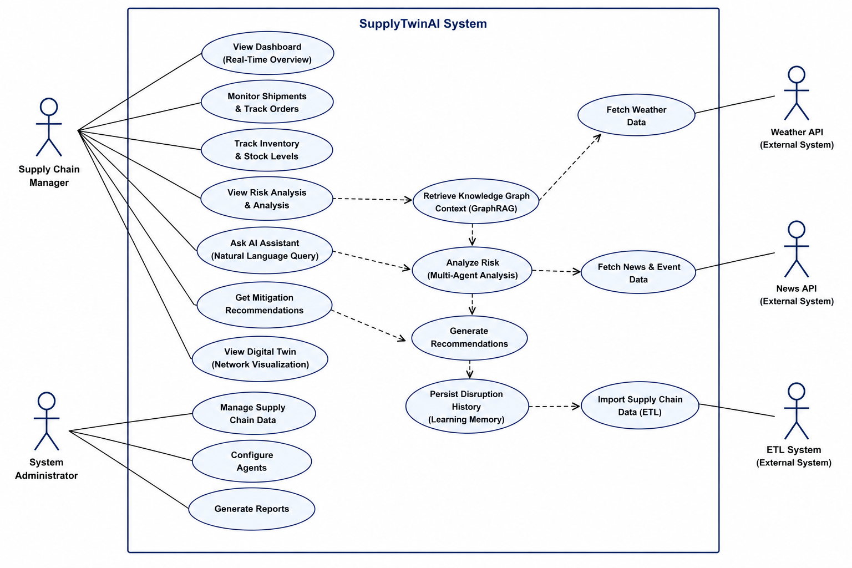
Figure: Use Case Diagram

Actors: Supply Chain Manager and System Administrator (primary human actors); Weather API, News API, and the ETL System (external/internal system actors).
UC-ID | Use Case | Primary Actor | Brief Description
UC-01 | View Dashboard (Real-Time Overview) | Supply Chain Manager | Views live KPIs — active shipments, at-risk count, risk distribution, pending recommendations (Section 4.7).
UC-02 | Monitor Shipments & Track Orders | Supply Chain Manager | Views shipment-level status, current location, and ETA for in-transit orders (Section 4.4).
UC-03 | Track Inventory & Stock Levels | Supply Chain Manager | Views current stock levels against reorder points and active reorder alerts (Section 4.4).
UC-04 | View Risk Analysis | Supply Chain Manager | Views the composite risk score and contributing factors for a selected supplier or shipment; includes UC-11.
UC-05 | Ask AI Assistant (Natural-Language Query) | Supply Chain Manager | Submits a free-text question and receives a grounded natural-language answer; includes UC-11 and UC-14.
UC-06 | Get Mitigation Recommendations | Supply Chain Manager | Views system-generated mitigation options for an at-risk entity; includes UC-12.
UC-07 | View Digital Twin (Network Visualization) | Supply Chain Manager | Explores the interactive graph view of suppliers, shipments, and inventory (Section 4.7).
UC-08 | Manage Supply Chain Data | System Administrator | Triggers and monitors ETL import runs; includes UC-15.
UC-09 | Configure Agents | System Administrator | Views and edits agent thresholds and Risk Agent score weights (Section 4.9).
UC-10 | Generate Reports | System Administrator | Generates a date-ranged summary report of disruptions, recommendations, and outcomes (Section 4.9).
UC-11 | Retrieve Knowledge Graph Context (GraphRAG) | System (internal) | Retrieves graph-grounded context from Neo4j to condition a downstream LLM call (Section 4.3).
UC-12 | Analyze Risk (Multi-Agent Analysis) | System (internal) | Combines Supplier, Shipment, Inventory, and External Intelligence signals into a composite risk score; includes UC-13.
UC-13 | Generate Recommendations | System (internal) | Produces a mitigation action, confidence score, and justification for a risk-flagged entity (Section 4.4).
UC-14 | Persist Disruption History (Learning Memory) | System (internal) | Stores the disruption event, risk score, recommendation, and eventual manager decision (Section 4.5).
UC-15 | Import Supply Chain Data (ETL) | External/Internal (ETL System) | Extracts, cleans, and loads DataCo dataset and simulated event records into PostgreSQL (Section 4.1).

B.3 Sequence Diagram — Disruption Detection & Recommendation Flow
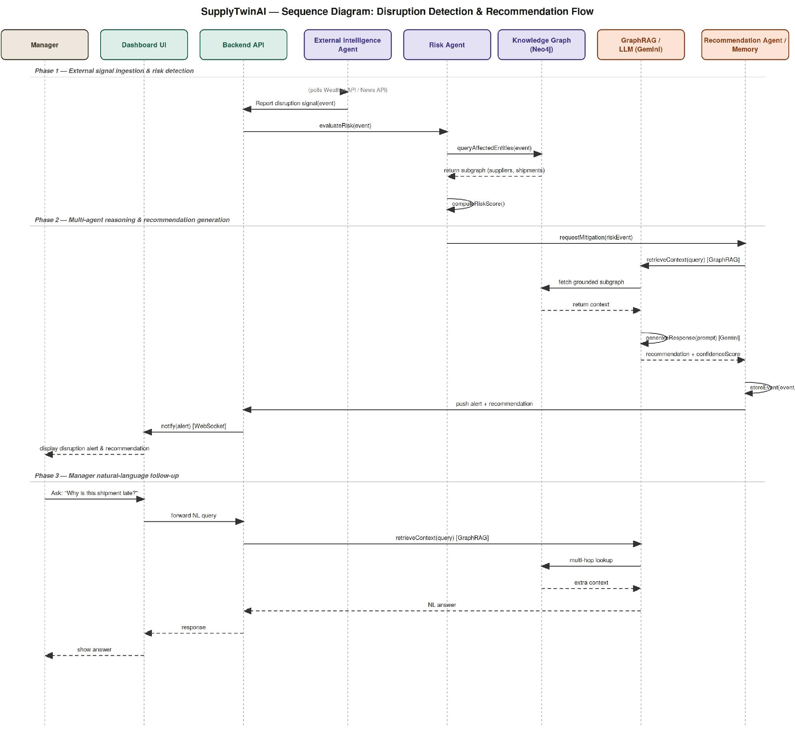
Figure: Sequence Diagram

This diagram traces the flow underlying UC-04, UC-05, and UC-06: an external signal (or a manager's natural-language question) triggers the External Intelligence Agent or Backend API, which invokes the Risk Agent; the Risk Agent queries the knowledge graph for affected entities, computes a risk score, and requests mitigation from the Recommendation Agent; GraphRAG retrieves grounded context from Neo4j before the Gemini call; the resulting recommendation and confidence score are stored (Section 4.5) and pushed to the Manager Dashboard over WebSocket (Section 3.4).

B.4 Class Diagram
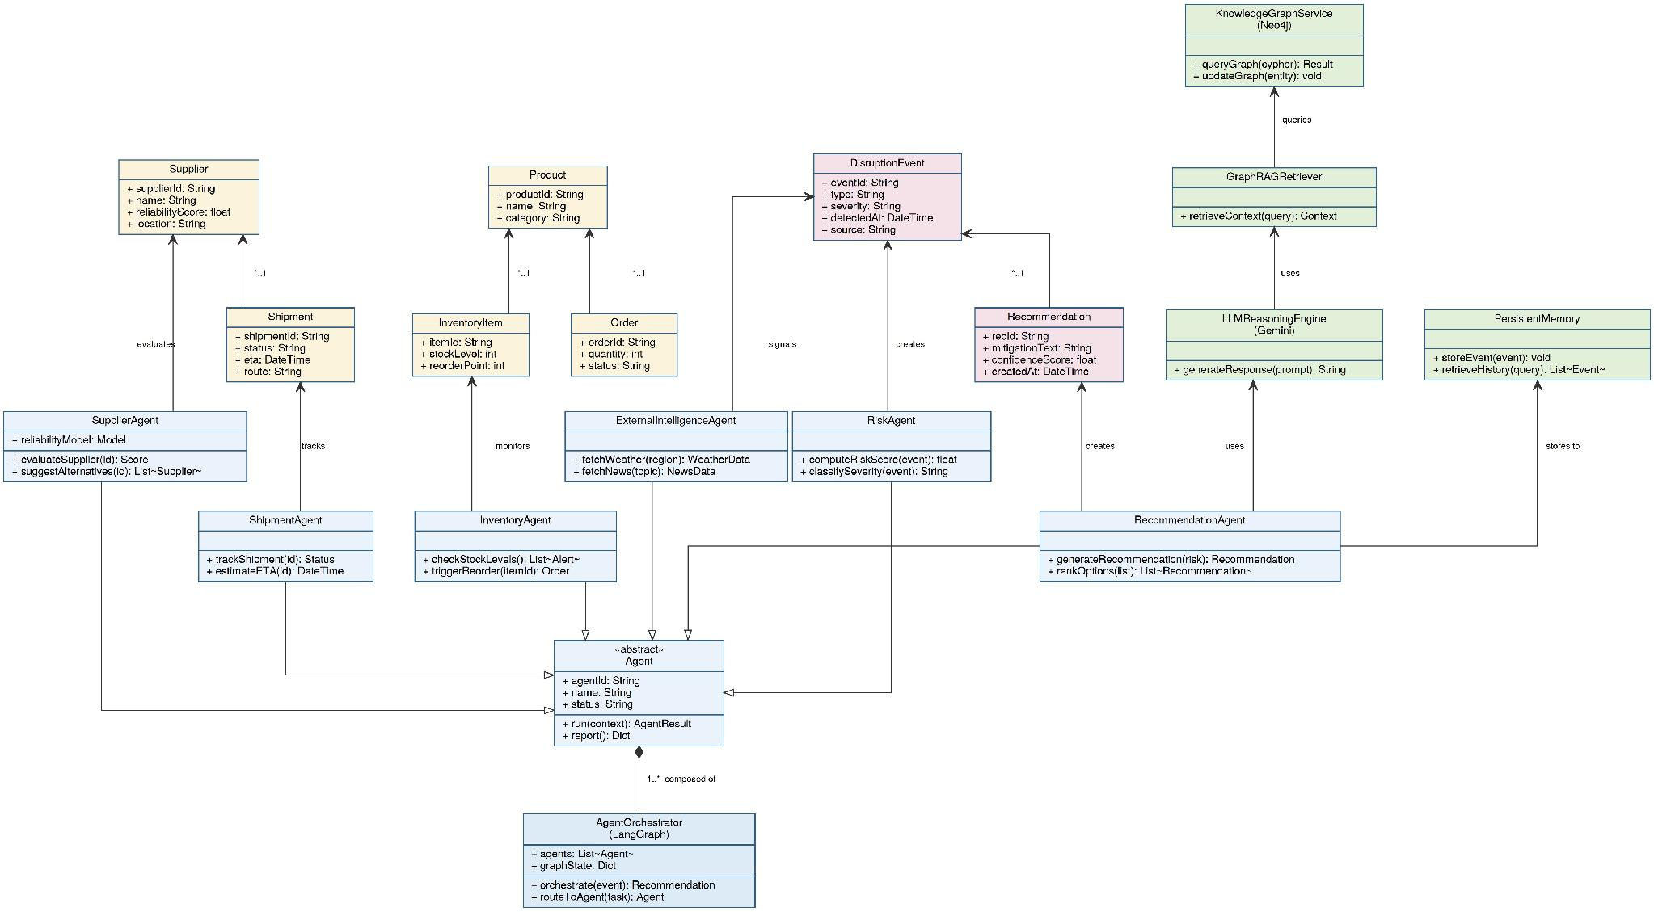
Figure: Class Diagram

This diagram models the core domain entities and their relationships. Domain classes (Supplier, Shipment, Product, Order, InventoryItem, DisruptionEvent, Recommendation) hold the persistent state tracked in PostgreSQL. Six concrete agents (SupplierAgent, ShipmentAgent, InventoryAgent, ExternalIntelligenceAgent, RiskAgent, RecommendationAgent) inherit from an abstract Agent base class defining agentId, name, status, run(context), and report(); each agent evaluates, tracks, monitors, signals, or creates the domain entity it is responsible for (e.g., SupplierAgent evaluates Supplier, RiskAgent signals DisruptionEvent, RecommendationAgent creates Recommendation). AgentOrchestrator (the LangGraph layer) is composed of one-to-many Agent instances and routes tasks between them via orchestrate(event) and routeToAgent(task). Supporting service classes — KnowledgeGraphService (Neo4j), GraphRAGRetriever, LLMReasoningEngine (Gemini), and PersistentMemory — are used by the RiskAgent and RecommendationAgent to query the knowledge graph, retrieve grounded context, generate LLM responses, and store disruption history (Section 4.5), respectively.

Appendix C: To Be Determined (TBD) List
1. Risk Score Weights – Final numeric values for the Risk Agent's composite score weights (supplier reliability, shipment delay, inventory buffer, external severity); to be tuned empirically once real agent output is available (Section 4.4, REQ-6/REQ-7).
2. Risk Thresholds – Exact composite risk score thresholds separating Low/Medium/High, and the alert threshold that triggers recommendation generation (Section 4.4, REQ-6/REQ-8).
3. Concurrent User Target – Whether the demo baseline of 5 concurrent users should be raised if the system is demonstrated to a larger evaluation panel (Section 5.1, NFR-P4).
4. Report Export Format – Whether Admin report export ships as CSV only, PDF only, or both (Section 4.9, REQ-3).
5. Hosting Quota Limits – Final free-tier quota limits for Supabase and Neo4j Aura, to be confirmed once actual data volume and query load are measured during development (Section 2.7).
6. Institution & Submission Date – Institution name and formal document submission date for the title page, pending confirmation.

