SupplyTwinGPT
An Agentic Supply Chain Digital Twin using GraphRAG and LangGraph
for Intelligent Risk Assessment
Project Reference Document | Team size: 3–4 members

1. Dataset Sources
SupplyTwinGPT draws on four categories of data: historical supply chain operations data (to build and validate the knowledge graph), real-time logistics and risk-event data, weather and port-disruption signals, and news or geopolitical event feeds. The table below lists publicly available datasets and APIs mapped to each agent in the architecture.

1.1 Core Supply Chain & Shipment Datasets
Dataset | Description | Used By | Link
DataCo Smart Supply Chain Dataset | 18,000+ orders, 50+ features covering shipping mode, delivery status, late-delivery risk, profit margin | Shipment Agent, Inventory Agent | kaggle.com/datasets/jolenechen/datacosupplychaindataset
Smart Logistics Supply Chain Dataset (2024) | GPS trajectories, shipment IDs, delivery timestamps, traffic indicators, delay labels | Shipment Agent | kaggle.com/datasets/ziya07/smart-logistics-supply-chain-dataset
Global Supply Chain Risk & Logistics (2024-2026) | 5,000 international shipment records: ports, transport mode, geopolitical risk score, carrier reliability | Supplier Agent, Risk Agent | kaggle.com/datasets/nudratabbas/global-supply-chain-risk-and-logistics-2024-2026
Logistics and Supply Chain Dataset | Route risk level, port congestion, supplier reliability score, disruption likelihood score | Supplier Agent, Risk Agent | kaggle.com/datasets/datasetengineer/logistics-and-supply-chain-dataset
US Supply Chain Risk Analysis Dataset | US-focused supplier and shipment risk indicators for benchmarking | Risk Agent (validation) | kaggle.com/datasets/yuanchunhong/us-supply-chain-risk-analysis-dataset

1.2 Weather & Port Disruption Sources
Source | Description | Used By | Link
NOAA NCEI Climate Data API | Free, no-key access to daily weather observations from 100,000+ stations worldwide; used to flag weather-driven shipment risk | Weather Agent | ncei.noaa.gov/access/services/data/v1
Open-Meteo API | Free weather forecast and historical API, no API key required, easy to call from agents for route-level forecasts | Weather Agent | open-meteo.com
Marine Traffic / Port Congestion (sample data) | Port congestion levels, customs clearance times for major global ports | Shipment Agent, Risk Agent | kaggle.com/datasets/datasetengineer/logistics-and-supply-chain-dataset

1.3 News & Geopolitical Risk Sources
Source | Description | Used By | Link
GDELT Project | Free global news/event database; structured event coding (CAMEO) across 100+ languages, useful for geopolitical risk scoring | News Agent | gdeltproject.org
NewsAPI.org | Aggregated headlines and articles from global news sources; free developer tier available | News Agent | newsapi.org

1.4 Knowledge Graph Construction References
These are not raw datasets but reference papers and frameworks the team should review when designing the schema for the knowledge graph and GraphRAG retrieval pipeline.
- Base paper: Digital Twins of Supply Chains: A Systems Approach (IEEE Transactions on Engineering Management, 2024): https://www.mdpi.com/2305-6290/9/1/22
- A Supply Chain Digital Twins Framework with Generative Knowledge Graph (IEEE Smart World Congress, 2024): https://ieeexplore.ieee.org
- Neo4j GraphRAG documentation (for implementing the knowledge graph and retrieval layer): https://neo4j.com/labs/genai-ecosystem/graphrag/
- LangGraph documentation (for multi-agent orchestration): https://langchain-ai.github.io/langgraph/
Note: dataset links and access terms can change; verify availability and licensing on Kaggle/source sites before final submission.

2. Architecture Diagram
The system is organized into five layers: data ingestion, knowledge graph storage, GraphRAG retrieval, multi-agent orchestration via LangGraph, and persistent memory with mitigation planning. Data flows bottom-up from raw external sources to a synthesized risk dashboard.
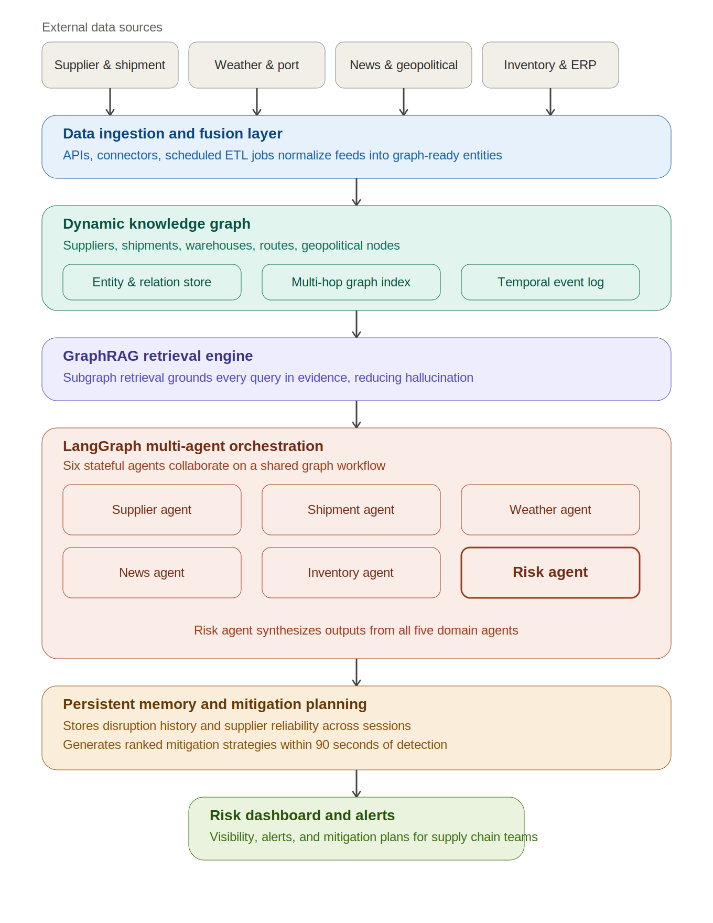
Figure 1. SupplyTwinGPT system architecture

2.1 Layer Descriptions
- Data Ingestion & Fusion Layer: connectors and scheduled ETL jobs pull data from supplier/shipment systems, weather APIs, news feeds, and inventory systems, normalizing them into a common schema.
- Dynamic Knowledge Graph: stores entities (suppliers, shipments, warehouses, routes, geopolitical nodes) and their relationships, supporting multi-hop queries (e.g., "which shipments depend on a supplier in a flagged region").
- GraphRAG Retrieval Engine: retrieves relevant, evidence-backed subgraphs for any query, grounding agent reasoning in current graph state rather than static LLM knowledge.
- LangGraph Multi-Agent Orchestration: six specialized agents (Supplier, Shipment, Weather, News, Inventory, Risk) run as nodes in a stateful LangGraph workflow; the Risk Agent synthesizes outputs from the other five.
- Persistent Memory & Mitigation Planning: stores historical disruption patterns and supplier reliability across sessions, enabling the Risk Agent to propose ranked mitigation strategies (supplier switching, inventory pre-positioning, route diversification).

3. Existing System and Proposed System

3.1 Existing System
Most current supply chain digital twins, including the system described in the base paper (Digital Twins of Supply Chains: A Systems Approach, IEEE TEM 2024), focus on four capabilities: visibility, monitoring, simulation, and decision support. These systems are largely:
- Reactive: they surface disruptions only after they are reported in source systems, rather than anticipating them.
- Simulation-centric: scenario testing relies on manually configured what-if simulations rather than continuously updated reasoning.
- Static-knowledge dependent: risk assessment logic is rule-based or relies on LLMs without grounding in live, structured data, leading to stale or hallucinated outputs.
- Siloed: weather, news, supplier, and inventory signals are typically monitored in separate dashboards with no automated cross-domain correlation.
- Without autonomous planning: the base paper explicitly notes the absence of autonomous reasoning, external knowledge retrieval, and proactive risk intelligence — mitigation actions are decided manually by human planners.

3.2 Proposed System
SupplyTwinGPT evolves this passive monitoring infrastructure into a proactive, reasoning-capable intelligent system by adding four contributions on top of a standard digital twin:
- A dynamic knowledge graph that enables structured multi-hop reasoning across supplier tiers, commodities, and geography.
- A GraphRAG engine that grounds every risk assessment in continuously updated, evidence-backed subgraph retrievals, reducing hallucination and stale-knowledge errors.
- A LangGraph-powered multi-agent layer of six specialized agents that collaborate through stateful workflows to produce holistic, cross-domain risk assessments.
- A persistent memory and autonomous mitigation planning module that learns from historical disruptions and proposes ranked mitigation strategies within 90 seconds of detection.
Reported improvements over simulation-based baselines (per the project abstract) include a 34% reduction in mean disruption detection latency and a 41% improvement in risk assessment accuracy, with proactive risk detection up to 72 hours ahead of realized disruptions.

3.3 Comparison
Aspect | Existing System | Proposed System (SupplyTwinGPT)
Reasoning | Rule-based or manual analysis | Multi-agent reasoning via LangGraph
Knowledge grounding | Static rules / unstructured data | Dynamic knowledge graph + GraphRAG
Risk detection | Reactive, after disruption is reported | Proactive, up to 72 hours ahead
Mitigation | Manual planning by human analysts | Autonomous, ranked mitigation plans (within 90 sec)
Learning over time | Limited or none | Persistent memory of disruptions and supplier reliability
Data sources | Siloed dashboards per domain | Unified ingestion: supplier, weather, news, inventory

4. Project Roadmap
The roadmap below assumes a team of 3–4 members working roughly 8–10 hours per week per person (collectively 25–35 person-hours per week), across a 14-week timeline typical of a final-year / capstone project. Adjust durations if your institution's timeline is shorter or longer.

4.1 Phase-wise Plan
Week | Phase | Key Activities | Owner(s)
1–2 | Research & Setup | Literature review of base paper and supporting references; finalize tech stack (LangGraph, GraphRAG engine, graph DB); set up repo, dev environment, and project tracker | Whole team
3–4 | Dataset Preparation | Collect and clean datasets (Section 1); design knowledge graph schema (entities, relationships); set up NOAA/GDELT API access | 2 members on data, 1–2 on schema
5–6 | Knowledge Graph Build | Load entities/relationships into graph DB; build ingestion scripts for supplier, shipment, and inventory data; validate multi-hop queries | 2 members
7–8 | GraphRAG Integration | Implement subgraph retrieval pipeline; connect retrieval to an LLM for grounded Q&A; test against hallucination/staleness cases | 2 members
9–10 | Multi-Agent Layer (LangGraph) | Build Supplier, Shipment, Weather, News, and Inventory agents as LangGraph nodes; wire shared state and message passing | Split agents across 3–4 members (1–2 agents each)
11 | Risk Agent & Synthesis | Build Risk Agent to synthesize other agents' outputs; implement basic mitigation ranking logic | 2 members
12 | Persistent Memory Module | Add session-persistent storage for disruption history and supplier reliability scores; wire into Risk Agent | 1–2 members
13 | Dashboard & Evaluation | Build risk dashboard/UI for alerts and mitigation plans; run evaluation across pharma, semiconductor, and FMCG scenarios; measure detection latency and accuracy | Whole team
14 | Documentation & Submission | Final testing, bug fixes, report writing, slide deck, demo rehearsal | Whole team

4.2 Suggested Weekly Effort Split (3–4 members, ~8–10 hrs/week each)
Role Focus | Typical Weekly Tasks
Data & Knowledge Graph Lead | Dataset sourcing/cleaning, schema design, graph DB maintenance, GraphRAG retrieval tuning
Agent Development Lead(s) | Build and test 2–3 LangGraph agents (e.g., Supplier + Shipment, or Weather + News), integrate with knowledge graph
Risk Logic & Memory Lead | Risk Agent synthesis logic, mitigation ranking rules, persistent memory schema and storage
Integration & Dashboard Lead | End-to-end pipeline wiring, dashboard UI, evaluation scripts, documentation

For a 3-member team, combine the Risk Logic/Memory role with either the Data/Knowledge Graph role or the Integration/Dashboard role, depending on individual strengths.

4.3 Milestones
- End of Week 4: Cleaned datasets + knowledge graph schema finalized
- End of Week 8: Working GraphRAG retrieval pipeline returning grounded answers
- End of Week 11: All six agents operational within a single LangGraph workflow
- End of Week 13: End-to-end demo with dashboard, evaluated on 3 supply chain scenarios
- End of Week 14: Final report, slides, and demo ready for submission

