# Navigation Reader

The parsing of the RINEX navigation file is done line by line and character by character. Each element in the RINEX file is given a certain amount of spacing to fill up. This information on the spacing in found GAGE GROUP’s gLab RINEX file [format description](http://gage14.upc.es/gLAB/HTML/GPS_Navigation_Rinex_v2.11.html) (GAGE, 2014).

The header file contains metadata information about the RINEX file such as the RINEX version. The line identifier in header has reserved space of 20 characters at the end of the line. Each RINEX file has 80 characters per line therefore the location of the header labels are always known. For each header label the location of the variables is defined by the index of character spacing. For each label a dictionary key is defined as the variable value corresponding to the label stored. Besides the RINEX version the header contains comments about the RINEX file, and 3 optional information such as the emphemeris coefficients of the Ionosphere $α and β$. Also optionally included in the header is the clock offset coefficients of UTC from GPS and the number of leap seconds current the GPS time is from UTC. The end of the header is defined by the label ‘END OF HEADER’ once this is passed then parsing of the navigation data begins.

The navigation data is sorted in the RINEX file by the GPS PRN number then epoch the ephemeris data is valid for. Again the spacing for each element of the broadcast is defined the parsing for every line. The label for the PRN key is defined for the first 2 space of the line after header. Once the PRN number is parsed then the lines are counted from that point on. Each element of the line has certain index and spacing then the data is parsed until the 8th line is reached and a new PRN number is parsed. The each broadcast contains 29 variables that the satellite broadcasts. These 29 variables are given in a block of 8 lines and 4 columns, one of the spaces is for the PRN number and the epoch while the other 2 spaces of the 32 spaces are left empty in the RINEX 2.11 version.

The data is collectively stored with a nested dictionary, where the top most key is the GPS PRN number, then the data blocks are divided by subkeys of the epoch the broadcast data is valid for.

|  |  |  |
| --- | --- | --- |
| Key | Value | Description |
| ‘PRN’ | Dictionary with sub keys  epoch | Contains the 29 keplerian elements and broadcasted navigation information by the satellite. |

|  |
| --- |
| Dictionary Structure |
| {'G01': {'10:1:1:16:0:0.0': {'Cic': 5.587935447693e-09,  'Cis': 7.636845111847e-08,  'Crc': 183.21875,  'Crs': -165.46875,  'Cuc': -8.651986718178e-06,  'Cus': 1.038610935211e-05,  'Deln': 5.447369761959e-09,  'Ecc': 0.003840734250844,  'Fit_int': 4.0,  'GPS_W': 1564.0,  'IDOT': -7.000291590243e-11,  'IODC': 51.0,  'IODE': 51.0,  'Io': 0.9635689853388,  'L2_CC': 1.0,  'L2_P': 0.0,  'Mo': 0.0841761497488,  'OMEGA': -0.1005044703918,  'OMEGA_DOT': -7.951402636407e-09,  'Omega': 0.9428572252394,  'SV_Acc': 2.0,  'SV_CLB': -7.538078352809e-05,  'SV_CLD': -3.069544618484e-12,  'SV_CLR': 0.0,  'SV_Health': 63.0,  'SqrtA': 5153.668302536,  'TGD': -1.909211277962e-08,  'TOE': 489600.0,  'Trans_time': 487788.0}, |

# Satellite Position

To compute the receiver coordinates the coordinates of the satellite must be determined first. It is a fairly straightforward process of determining the satellite coordinates, the Keplerian elements of the satellite is broadcasted in the Navigation file. Each satellite in the GPS constellation does this broadcast of all the GPS satellites in the constellation and broadcasts its prediction of position in orbit for each two hours. Once all of the 29 parameters in the RINEX navigation file are read and stored the process of determining the satellite position occurs in the module satpos.py.

The process of determining the Satellite positions were outlined in very detail in ICD document. The algorithm is defined in section 20.3.3.4.3 User Algorithm for Emphemeris Determination Pages 97-100. The equations are defined in Table 20-IV of the ICD document.

The SatPos function strictly follows the defined guidelines, except a few tweaks the time variable used in the process of determining the satellite position is GPS seconds of the week, which is the number of seconds that have passed since the start of a GPS week which is on Saturday midnight.

The eccentric anomaly defined in the algorithm is solved for used an iterative process, the Eccentric anomaly is calculated until the difference of the current value and the previous value are smaller than a defined threshold $ϵ$ which in the software was defined to be $ϵ=0.000000000001$. Once this condition is satisfied the current Eccentric Anomaly is saved and used for further calculations.

Once all of the Orbital parameters are determined and the position of the satellite in the orbit determined the final output of the function is the ECEF coordinates of the satellite in interest.

# Tropospheric Correction

When the GPS signal travels through the atmosphere it is refracted by the medium, which in turn delays the signal, this refraction is mostly caused by the moisture content in the Troposhere. This delay can be modeled and determined so it can be used to correct the pseudorange observations. The model used in the software was the Saastamoinen Closed Form model. The model is defined as:

$dtrop=\frac{0.002277}{\cos\left(z\right)}\left[P_{0}+\left(\frac{1255}{T}+0.05\right)e_{0}-\left({\tan\left(z\right)}^{2}\right)\right]$

$dtrop$: correction in meters

$z:$ zenith angle from the receiver to the satellite of interest

$P_{0}:$ atmospheric pressure in mbar

$T:$ temperature in C

$e_{0}:$ water vapor pressure in mbar

This element of the software did not function properly, it was causing significant deviations in the order of thousands of meters in some cases in the solution therefore the tropospheric delay was omitted in the final solution.

# Terms for Analysis

## Standard deviation

The standard deviation is a statistical measure of accuracy of a given variable. It defines a confidence interval of where the true value of the variable can lie within. One standard deviation defines 68% confidence interval where the true value of the variable lies within. For the position solution each of the coordinates are defined with the value and its standard deviation. The standard deviation is a product from the Least Squares process of the position solution. It is the square root of the diagonal elements of the Covariance matrix of the unknowns, which in this case are the X,Y,Z, and the clock offset.

## Dilution of Precision

The Dilution of Precision is a measure of precision of the solution. It is defined simply as the trace of the covariance matrix of the solution. The two types of DOPs used in this report are Geometric DOP (GDOP) and Position DOP (PDOP). The DOPs are defined as: $GDOP=\sqrt{σ_{x}^{2}+σ_{y}^{2}+σ_{z}^{2}+σ_{t}^{2}c^{2}}$

$PDOP=\sqrt{σ_{x}^{2}+σ_{y}^{2}+σ_{z}^{2}}$

# Analysis

This section describes the analysis of the solution for the data used for a test site.

## Test Site ALBH

The RINEX datasets were provided by the Teaching Assistant, the station used for the positioning solution was designated ALBH. The station is located near Victoria, British Columbia. ALBH is a continuously tracking GNSS site, it is part of the Western Canada Deformation Array (WCDA) it is also part of the Canadian Active Control System (CACS) (NRCAN, 2014). The published coordinates of the site is given in the Natural Resources Canada’s CACS website.

The ECEF coordinates are published as:

X: -2341333.003 ± 0.0007

Y: -3539049.514 ± 0.0008

Z: 4745791.300 ± 0.0009

## Satellite Positions

As described before the satellite positions for every epoch of the recorded observation have to be calculated. The RINEX observations are recorded for every 30 seconds, therefore there are quite a number of satellite positions to be determined about 2600 epochs of measurements. A good way of ensuring the satellite positions are being calculated correctly is visualize the satellite positions. The expectation of these plots is to follow a similar path of the sun a rise and fall motion.

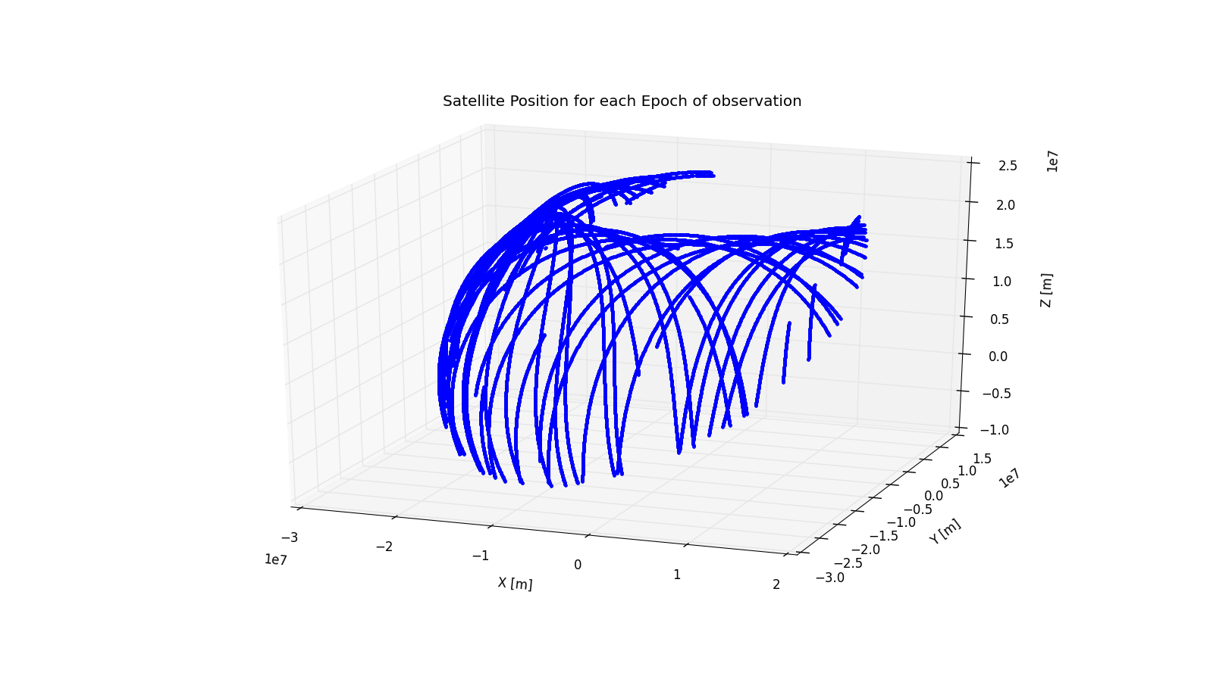

Figure 1: Satellite positions for each epoch of observations

Figure 1 is the plot of all the satellites position visible in timeline of the observations. As one can see it is as expected the satellite positions follow the expected motion of rise and fall.

## Positions

The final solution of the receiver coordinates can be plotted to visualize the quality of the solution. The pyplot library was used for all graphical plotting and image generation. Below is a scatter 2D plot of the receiver X and Y coordinates.

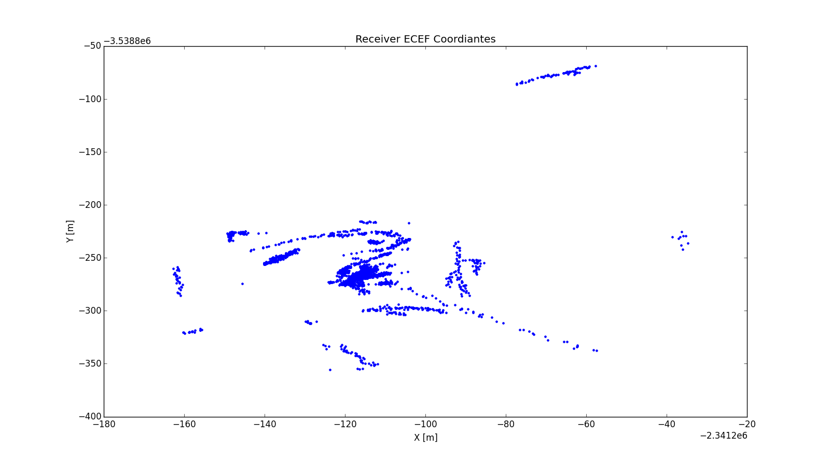

Figure 2: Receiver ECEF 2D plot

Looking at Figure 2 there seems to be a irregularity with the position solutions. The expectation of the final solutions would be a general agreement of the position therefore the scatter plot should show a cluster of positions centered around a region. Looking at Figure 2 that is not the case, there are several position solutions several hundreds of meters away from the centered cluster of points around the published coordinates. The expected accuracy of the Stand Position Solution are meter level the final solutions outputted do not seem to satisfy the quality. Further investigation has to be made to understand this anomaly, there could be various factors resulting this deviation. It should be kept in mind that the tropospheric delay was not corrected for these solutions because of divergence in the final solution with the tropospheric delay turned on the position solutions were different in the range of kilometers. One interesting characteristic from the plot that can be noticed is there are streaks in the positions. This hints towards a correlation between time, therefore there has to be a blunder in the programming where it is obtaining an incorrect satellite position or an incorrect time. Due to time constraints the debugging of the code was not successful.

Another piece of evidence that can be used to visualize the discrepancy in the solutions is the coordinate difference from the published coordinates of the solution.

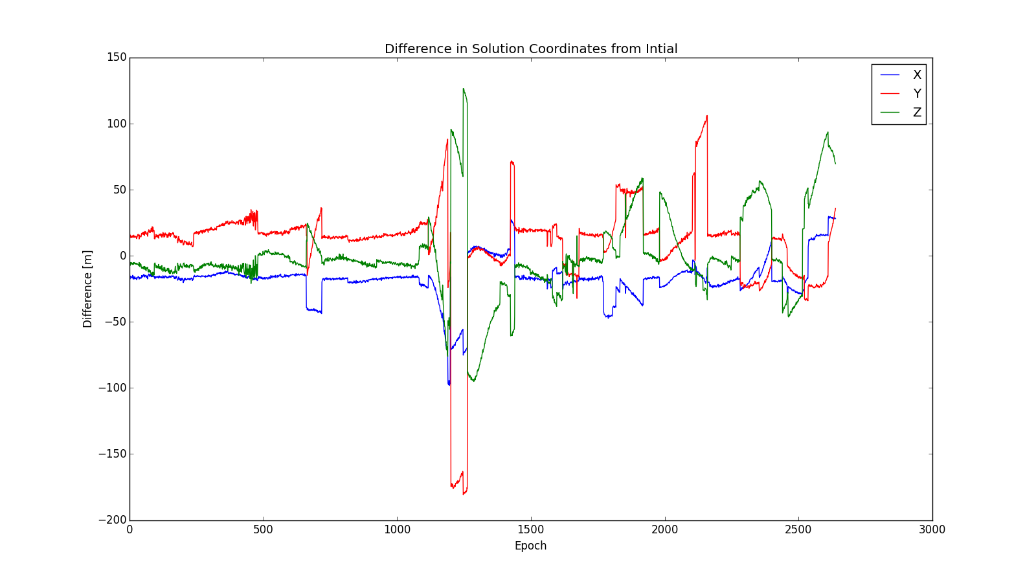

Figure 3: Coordinate differences from published coordinates

As one can notice from Figure 3 the initial solutions seem to have a stable deviation of about meter level for X and Z, 10s of meters for the Y component for about the first 1000 epochs then coordinates deviate to 100 of meters past the 1100th epoch. This anomaly hints to the general time to which is causing the discrepancy in the position solutions.

The solutions were averaged to obtain a general estimate of the position of ALBH, below are the tabulated results.

|  |  |  |
| --- | --- | --- |
| Component | Value | Standard Deviation |
| X [m] | -2341315.307 | 15.103 |
| Y [m] | -3539059.522 | 34.744 |
| Z [m] | 4745791.669 | 31.694 |
| t [s] | -3.39126190338e-08 | 3.06918042012e-07 |

Table 1: Final averaged solutions for ALBH

To get a general sense how different the solutions are from the published ones the difference between the solutions were determined and tabulated below.

|  |  |
| --- | --- |
| Component | Coordinate difference [m] |
| X | 17.695 |
| Y | -10.008 |
| Z | 0.369 |

Table 2: Coordinate difference between the solutions and the published coordinates

Looking at the coordinate differences it can be seen that X component is varied the most by about 17.695 meters followed by the Y component then by the Z.

## DOPs

The DOP of the final solution can be visualized to see if there is any correlation between the epoch when the discrepancy begins. The figure below illustrates the GDOP values for each epoch of solution.

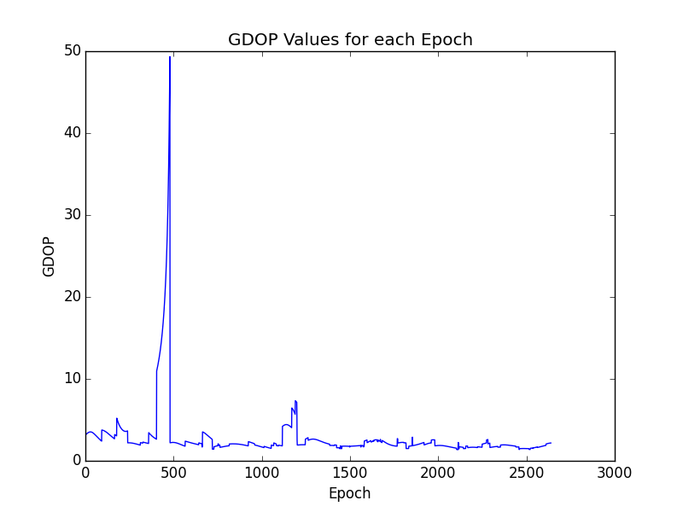

Figure 4: GDOP values for each epoch of observation

Looking at Figure 4 this is a quite a noticeable discrepancy in the GDOP of the solution for a period of time around the 500th epoch. This spike in the GDOP value although does not correlate with the discrepancy illustrated in Figure 3 with the coordinate discrepancy. For the rest of the solution the GDOP seems to have a reasonably low and workable value. The average GDOP for the timeline of the observation file was 2.76. Which is quite good but looking at the GDOP plots it still doesn’t provide insight on the deviation of the final coordinates.

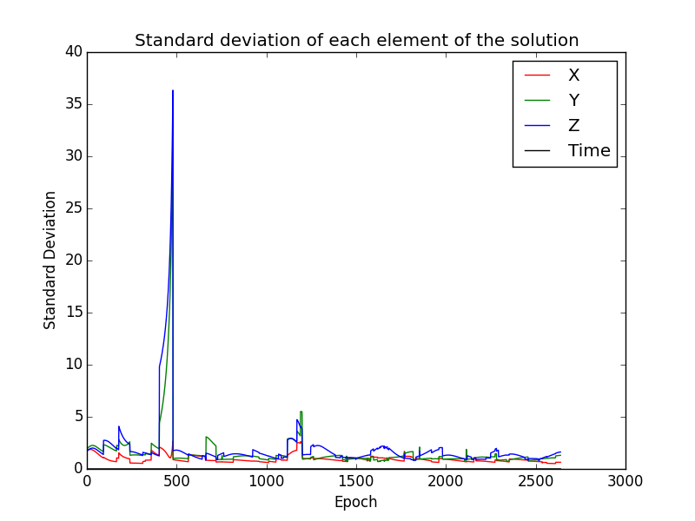

Figure 5: Standard Deviation of each element of the solution

Figure 5 illustrates the standard deviation of each of the elements in the final solution. It can be clearly seen the huge spike seen in the GDOP plots are mostly contributed by the Y and Z component of the solution. This narrows down the component to which is causing the deviation of the position of the receiver with the published one. As mentioned before due to time constraints the problem could not be pinpointed and solved.

# Conclusion

This report involves all the software components needed to compute a Standard Positioning Service GPS navigation solution. The software was tested for a test case of observation data, although a position was outputted, the quality of the solution was not acceptable. The software bugs that caused the deviation could not be determined over the timeline of this project due to time constraints. If there was more time the tropospheric delay of the GPS signal could be implemented as well and tested as well as the Klobuchar model for determining the ionospheric delay for a single frequency receiver.