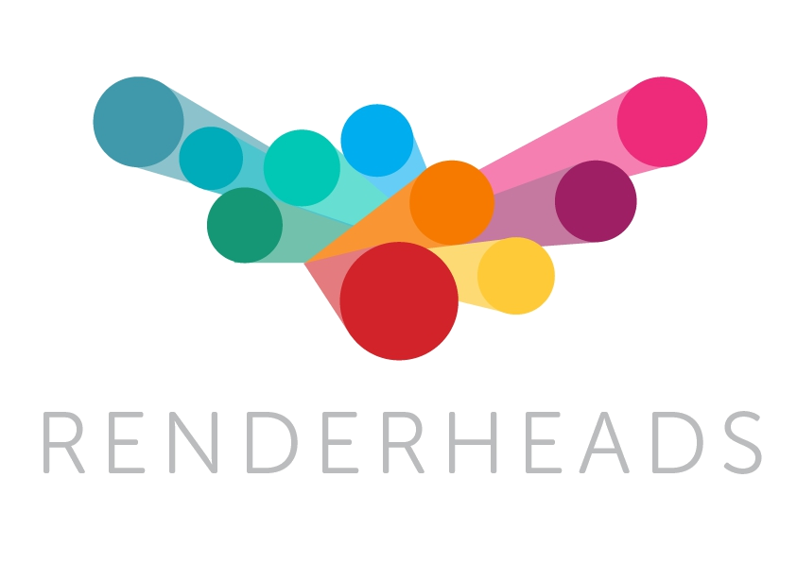

AVPro Windows Media

Unity plugin for fast flexible video playback

Version 2.90

Released 24 February 2016

Contents

- Introduction

  - Features

  - Trial Version

  - Media Credits

- System Requirements

  - Platforms not supported

- Installation

  - Trial Version Upgrade Notes

  - Video File Locations

- Unity Components

- Use Case Notes

  - Transparent Video

  - Video Clips

  - Video Scrubbing

  - Super High Resolution 4K / 8K Playback

  - Low CPU Usage

  - Multiple Audio Speakers

  - Oculus Rift Virtual Reality

- Playback Performance

  - Hardware

  - Video Format

  - Codec Tuning

  - Video Resolution

  - Machine Setup

  - MultiThreading

  - Display FrameRate Sync

  - Garbage Collection

  - Latest Version

- Codec Guide

  - Formats

  - Format Support

  - Container Format Support

  - Codec Format Support

  - Keyframes

  - Fixed vs Variable FrameRate

  - Specific Codecs

- Video Tools & Software

- Support

- About RenderHeads Ltd

- Appendix A FAQ

- Appendix B Version History

2 / 34

AVPro Windows Media Unity Plugin © 20112016 RenderHeads Ltd

1. Introduction
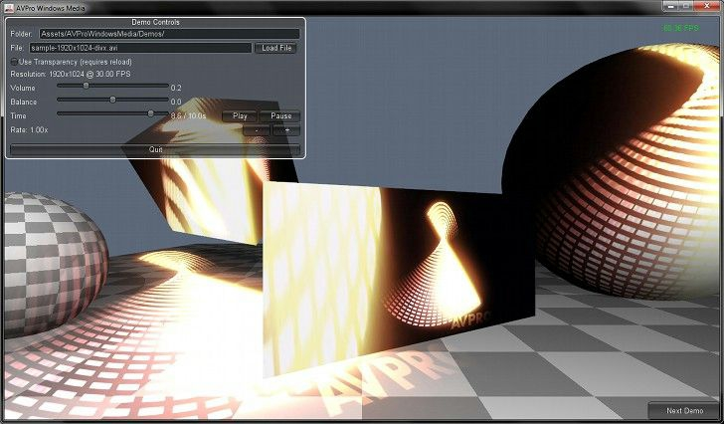

“AVPro Windows Media” is a plugin for Unity that allows fast and easy playback of supported Microsoft DirectShow media.

The plugin is aimed at the highend user group that require video playback features beyond Unity’s builtin video support.

DirectShow is a trademark of Microsoft Inc., registered in the U.S. and other countries.

- Features

  - Unity 4.6 5.4 supported

  - Both 32 and 64bit friendly

  - Free watermarked trial version available

  - Years of professional use in the field

  - Fast native Direct3D9, Direct3D11 and OpenGL texture updates

  - Frame accurate seeking and scrubbing

  - Supports video transparency

  - Native Hap codec support (no plugin needed)

  - Play videos from disk or from memory

  - Supports internal clips

  - 7.1 audio channel mixer

  - AV sync offset control

3 / 34

AVPro Windows Media Unity Plugin © 20112016 RenderHeads Ltd
- Unity 4.6 uGUI support.

- NGUI support.

*Not ideal for 4K playback unless using the Hap or H.263 codec (see 4K notes below)

1.2 Trial Version

We offer an unlimited trial version of AVPro Windows Media for download from our website. The trial version has no missing features or time restrictions but it does apply a watermark to the rendered output. The watermarking shouldn’t affect performance.

1.3 Media Credits

samplesphere1024x512divx (c) copyright Daniel Arnett, ​https://vimeo.com/97887646

Audio in sample video created by Citizen Nyx (​http://ccmixter.org/people/nyx​)

4 / 34

AVPro Windows Media Unity Plugin © 20112016 RenderHeads Ltd
2. System Requirements

  - Unity Pro 4.6 5.4

  - Desktop Microsoft Windows platform (32bit and 64bit)

  - Codecs for any video/audio you want to play

- Platforms not Supported

  - WebGL

  - WebPlayer

  - Mobile, Android, iOS, Windows Phone

  - Mac

  - Linux

  - Windows Metro / Store Apps (Note: Windows Metro apps don’t support DirectShow which this plugin is built upon. This plugin only supports Windows desktop apps)

** Oculus Rift: Not officially supported (yet), but feel free to test it for yourself with the trial version. We have heard from people that have successfully used it.

5 / 34

AVPro Windows Media Unity Plugin © 20112016 RenderHeads Ltd

