***Documentation***

***Assignment_1***

**Student Name: Caruntu Denisa Ioana**

**Group: 30423**

**CONTENTS**

**1. Assignment Objective ................................................................................................................................. 3**

**2. Problem Analysis, Modeling, Scenarios, Use Cases................................................................................. 3**

**3. Design .........................................................................................................................................................3-4**

**4. Implementation ........................................................................................................................................4-6**

**5. Results .......................................................................................................................................................6-8**

**6. Conclusions ................................................................................................................................................. 8**

**7. Bibliography................................................................................................................................................. 8**

**1. Assignment Objective**

The main objective of the assignment is to create a polynomial calculator that can perform the operations of addition, subtraction, integration, and differentiation. The design implementation of it should be simple and clear for the user, not making it complicated to view the answer and the fields that require information.

That being said, two polynomials will be inserted, and based on the button that is pushed, an answer to the performed operation selected will be generated.

**2. Problem Analysis, Modeling, Scenarios, Use Cases**

We will have to take into consideration the algorithms of Addition, Subtraction, Differentiation, and Integration. The polynomials will have to be separated into monomials and each monomial will have a key(the power of x) and a coefficient (the value that is being multiplied by the previous).  
Each entry will have to be converted from String to Polynomial and, after the operations are being performed, it will have to converted the other way around (in order for it to be presented to the user).

**3. Design**

The design is simple and clear to the user, the implementation being based on different kinds of elements.   
We will use JLabels which will give us indications about where the two polynomials will be inserted.  
In addition, two TextFields will serve as a way of introducing our two polynomials. The JButtons will be pressed based on the operation that the user is willing to perform and the Result will be shown in a JLabel.

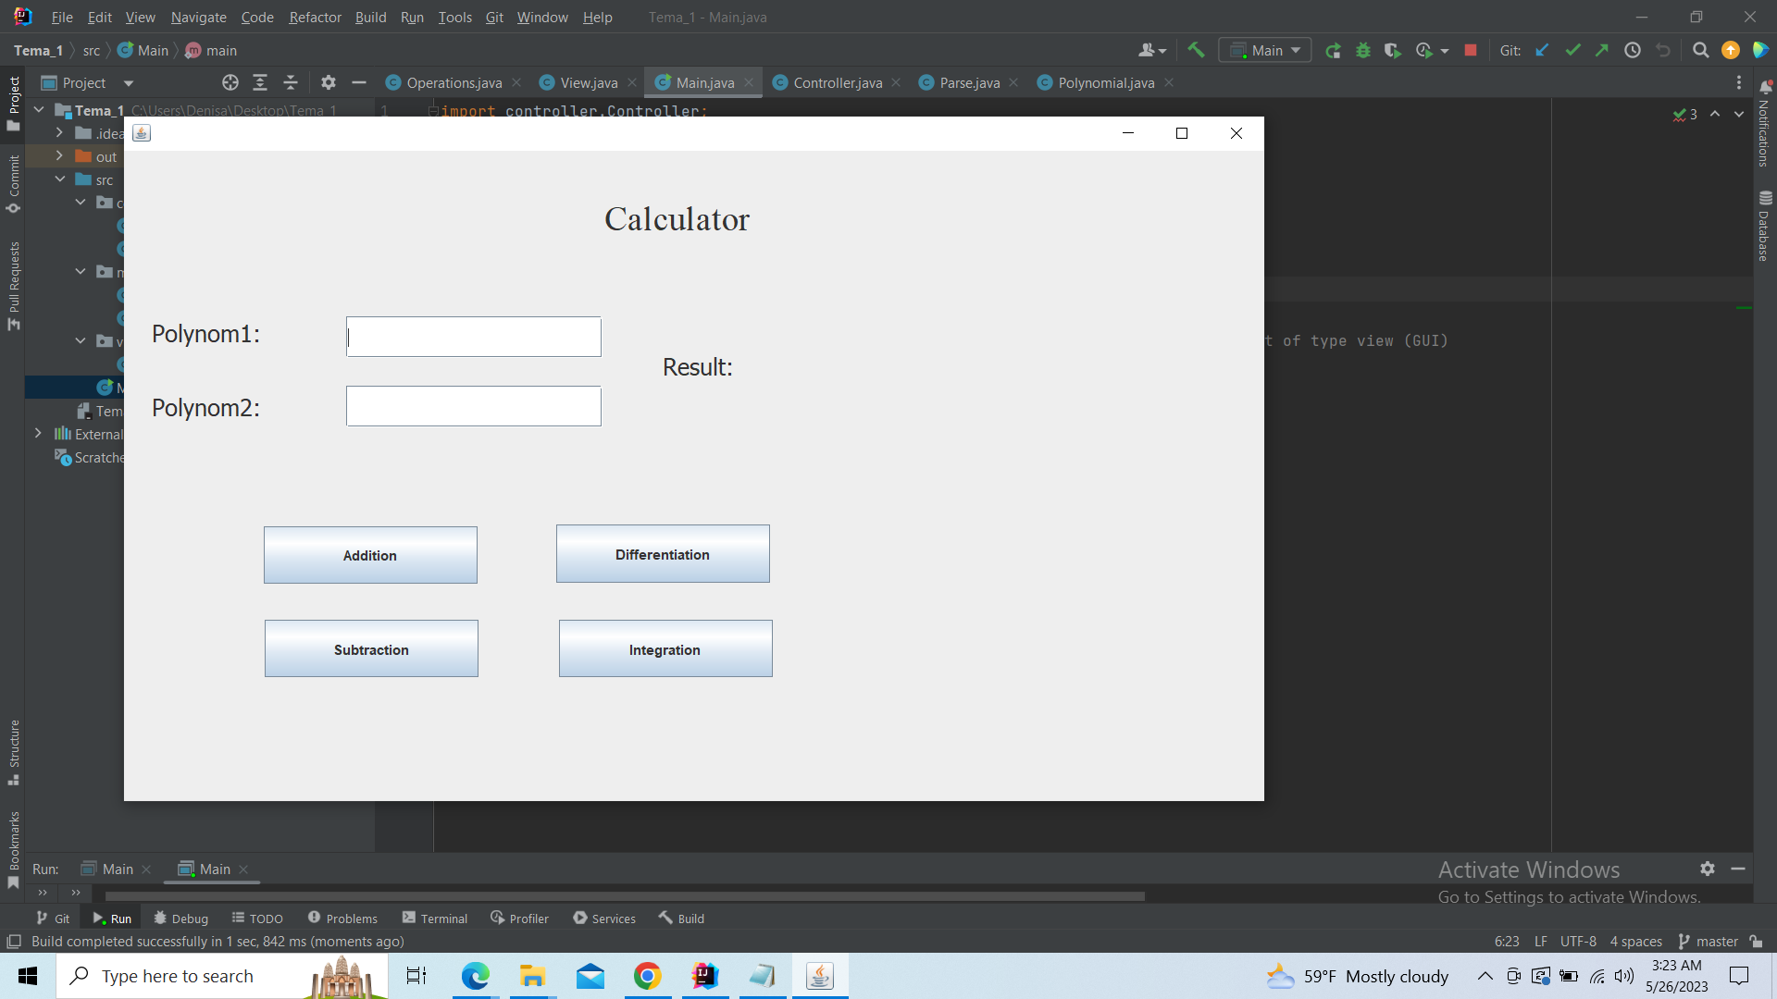

**4. Implementation**

We will have 3 different packages in our code: view, model, and controller. 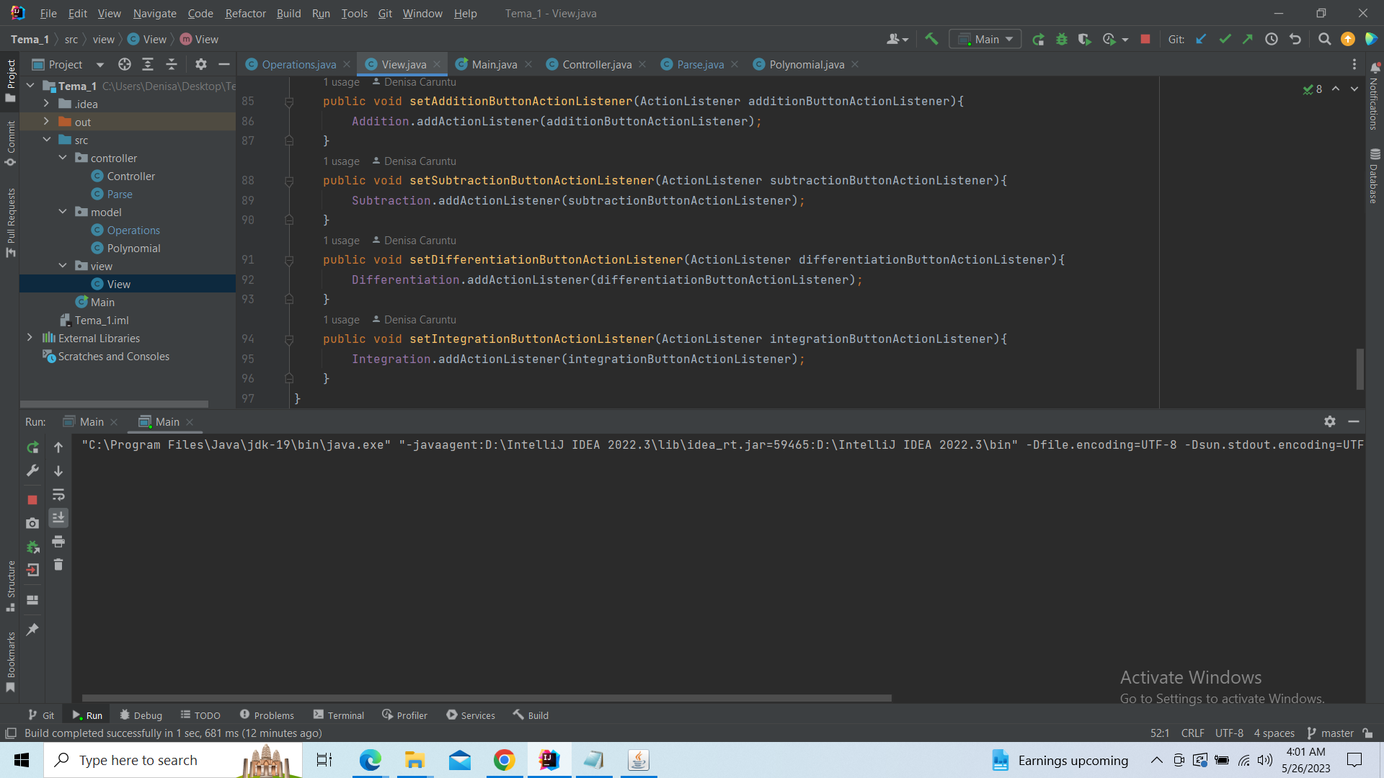

*View:* it will contain one single class where the design will be described using different parameters, based on the type of element used (JLabel, Jbutton, TextField). We will also create different listeners for the buttons and they will react as if they “listen” when we push them, performing the operations. Each one of them will be connected to operations implemented in the Operations class.

*Model:* 2 different Classes will be implemented here: Operations and Polynomial. The last one will create an attribute of HashMap type, here introducing our keys (the power of the monomial=integer type) and values (the coefficient of the polynomial=double type).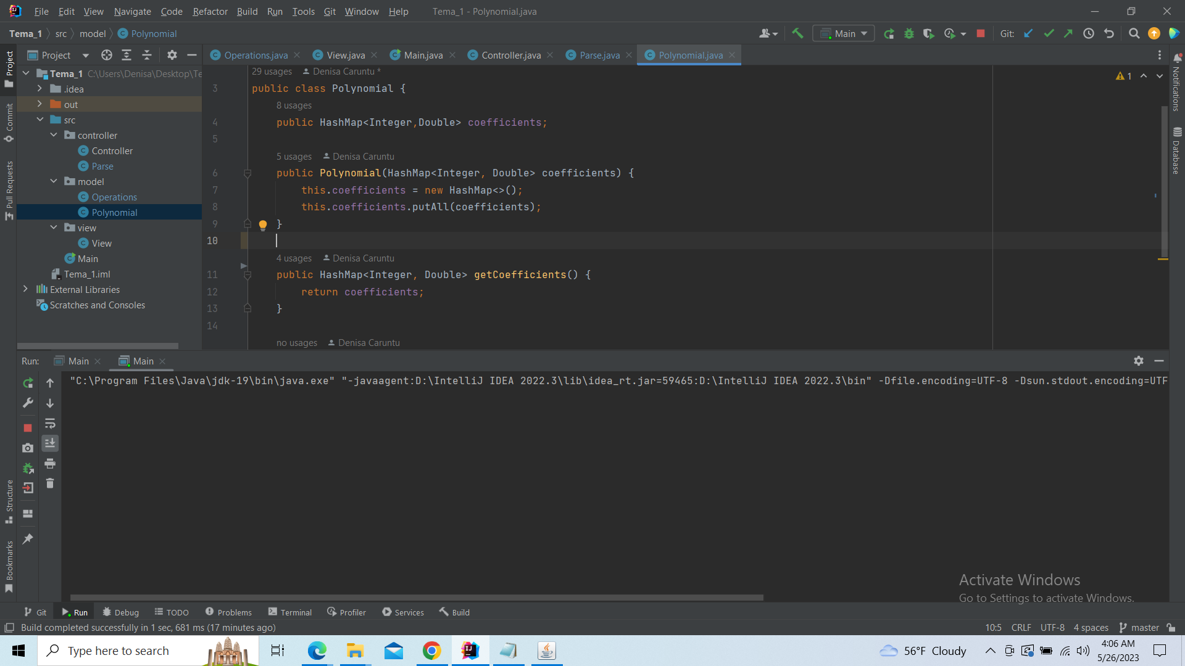

The Operations Class will take care of the operations we are trying to implement.   
For the Addition and Subtraction, we will create a new HashMap that will take our coefficients and keys. If the key(power) of the monomial is the same, an operation between variables will be performed. In case of a result with a coefficient 0, we eliminate it from our output.

The Differentiation and Integration are based on mathematical algorithms.

*Controller:* Here, the class Controller will take care of how we connect the Operations to the buttons created in View. We will use ActionListeners that will take the values that we introduce as a string and transform them into polynomials on which we can operate, perform the calculations and return a value back into a string to be presented.

The last task will be taken care of by the Parse class. We will add elements to the string builder using the append function.

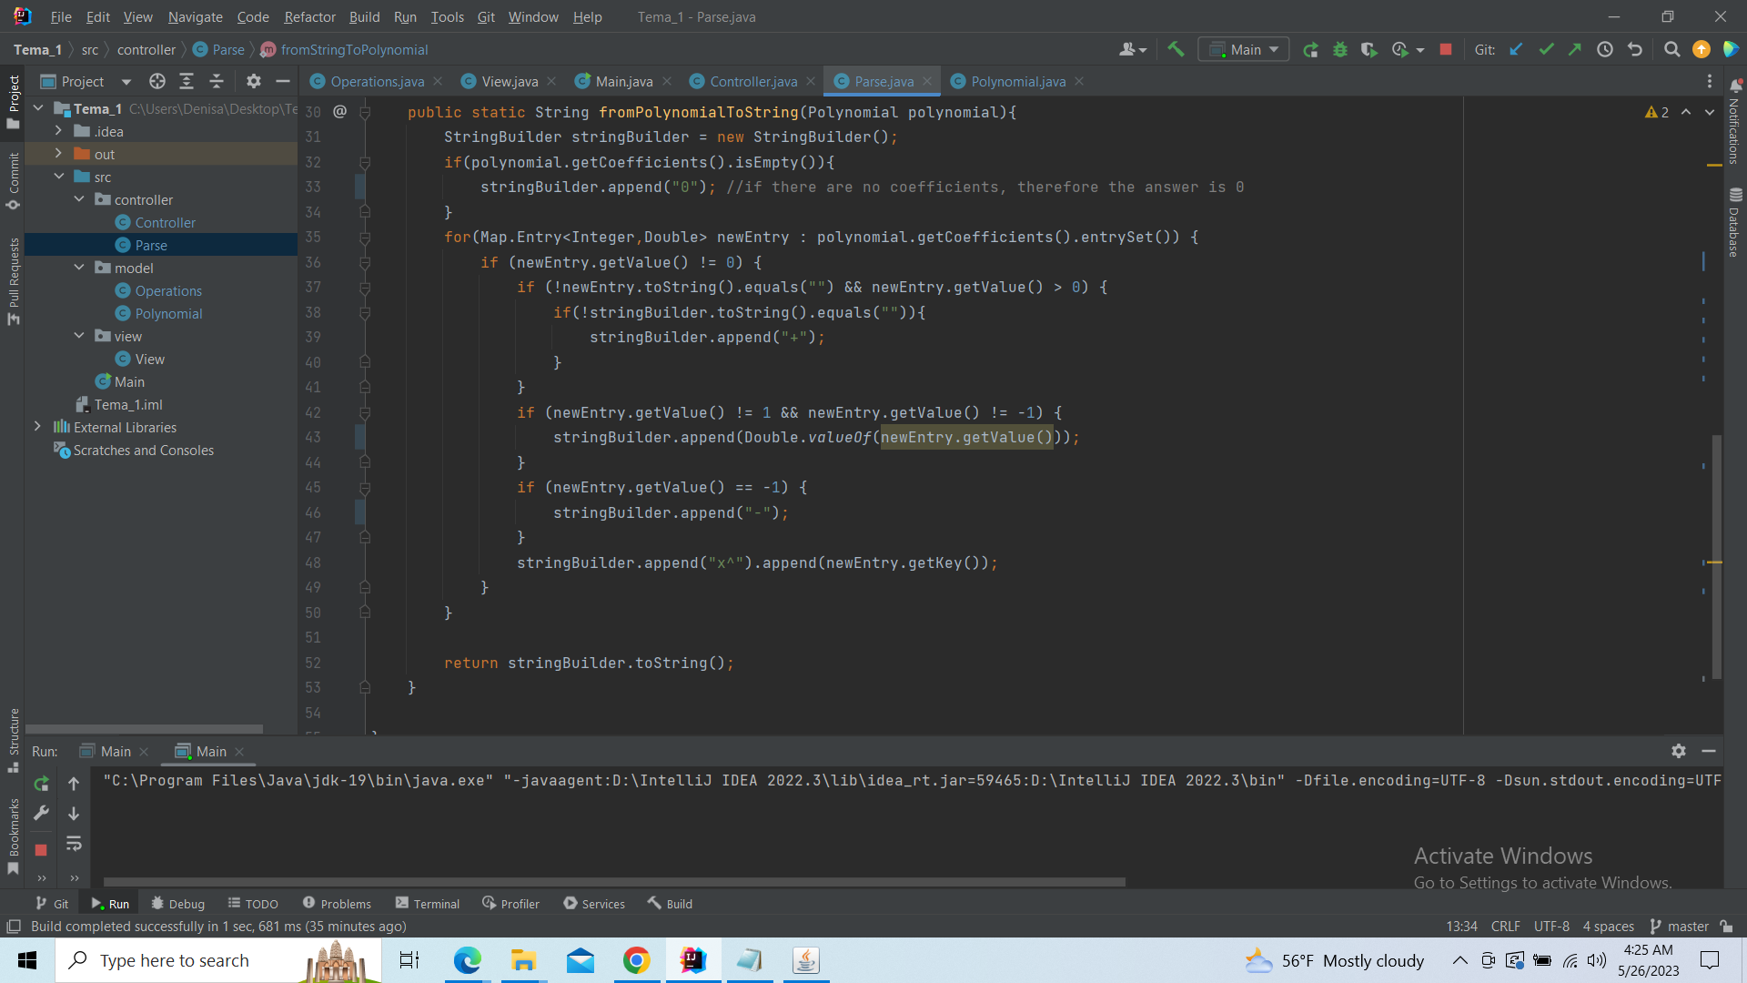

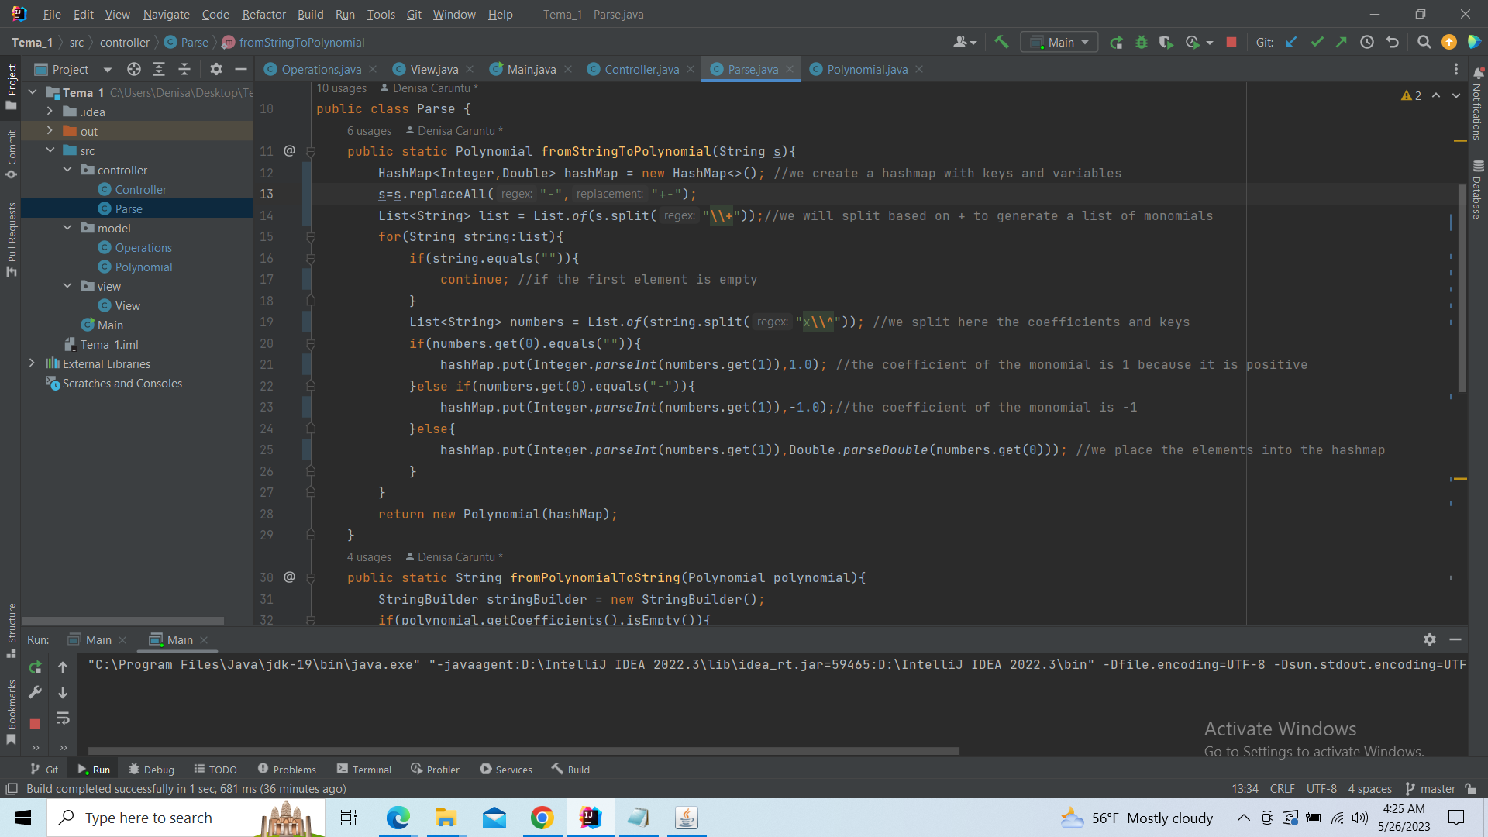

**5. Results**

I tested different cases for different scenarios that might appear, polynomials with different keys, and values, then checked if the answer was right.

**Addition**

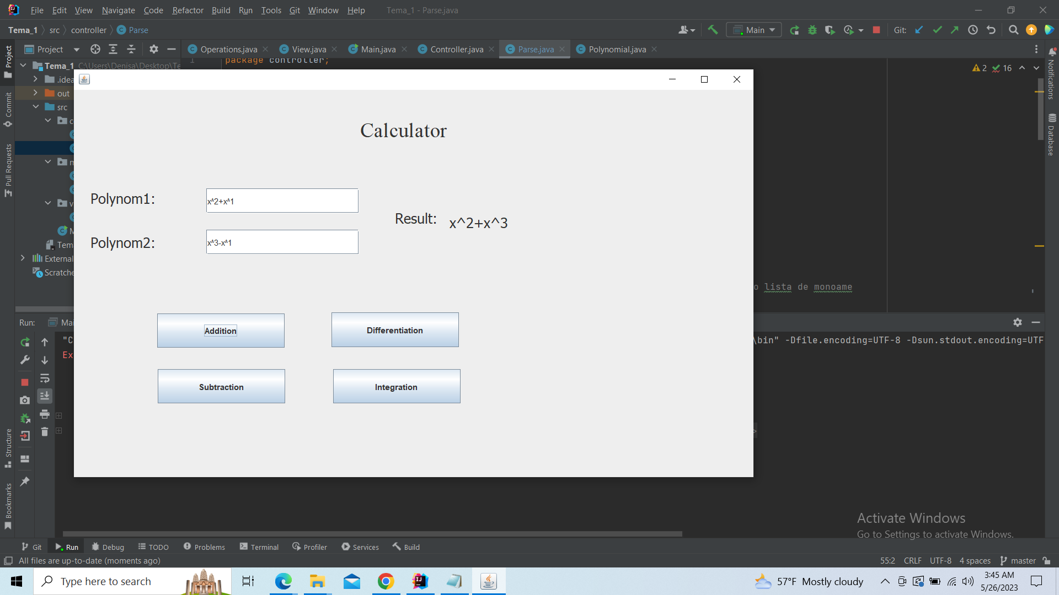

**Subtraction**

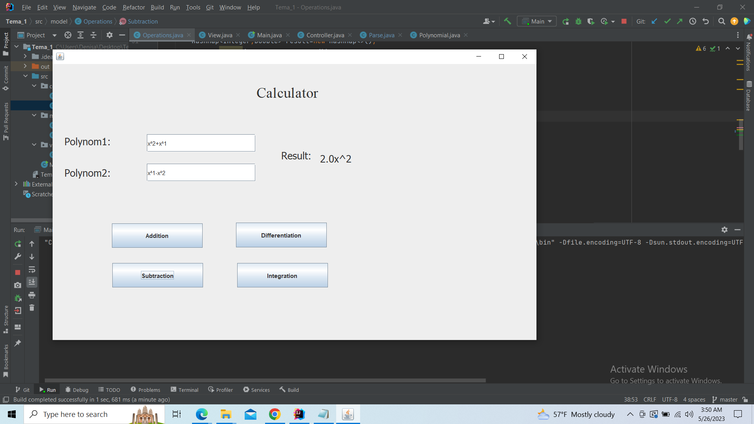

**Differentiation:**

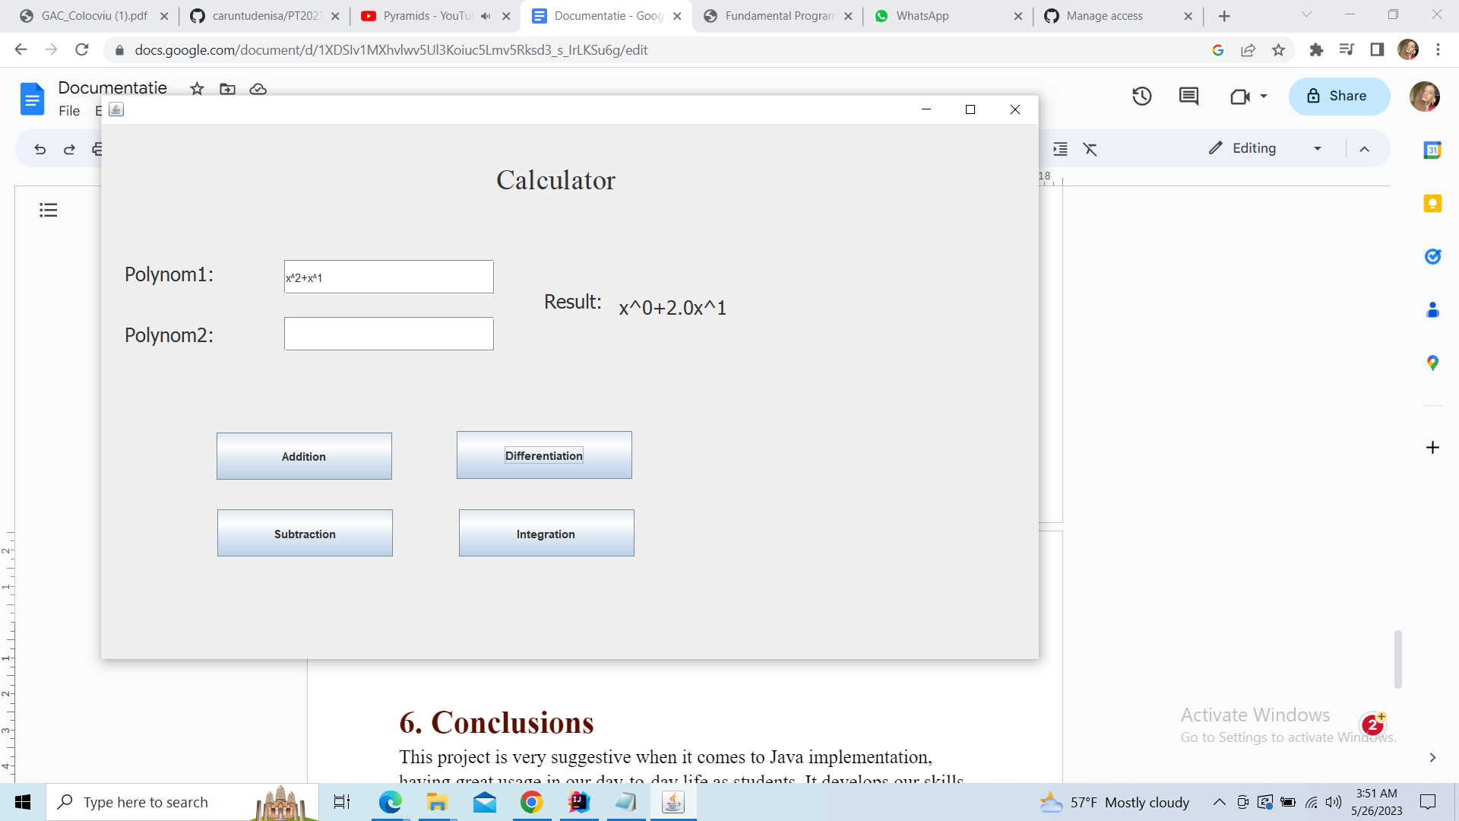

**Integration:**

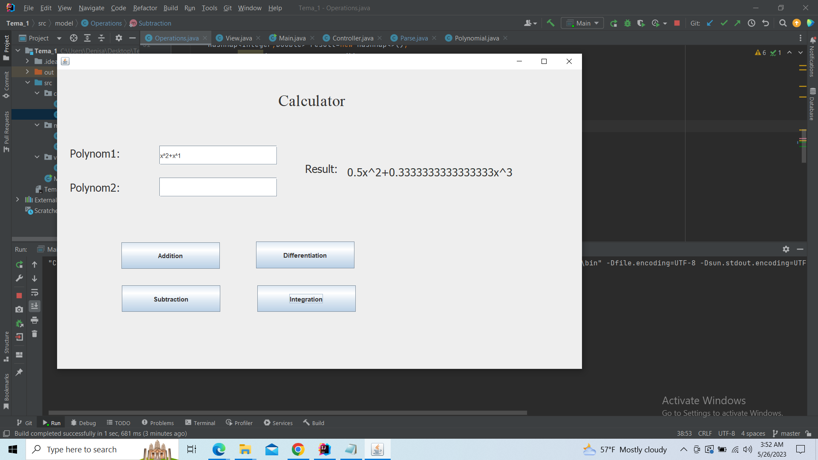

**6. Conclusions**This project is very suggestive when it comes to Java implementation, having great usage in our day-to-day life as students. It sharpens our skills in creating connections between different Classes, developing them and analyzing different problems that might occur during the process of coding.

**7. Bibliography**