Sumário

AJAX 1

Server side 1

Single Records 1

Many Records - Loop 2

Client side 2

Single Records 2

Many Records - Loop 3

# AJAX

## Server side

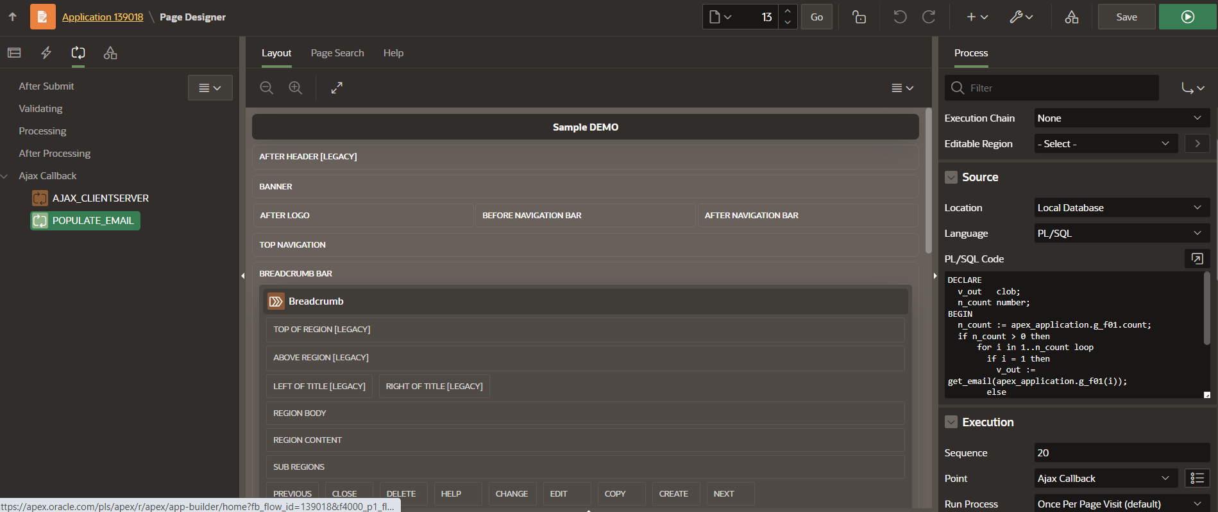

### Single Records

#### Exemplo 1

DECLARE

v_out clob;

n_count number;

BEGIN

n_count := apex_application.g_f01.count;

if n_count > 0 then

for i in 1..n_count loop

if i = 1 then

v_out := get_email(apex_application.g_f01(i));

else

v_out := v_out || ', ' || get_email(apex_application.g_f01(i));

end if;

end loop;

htp.p(v_out);

end if;

END;

### Many Records - Loop

#### Exemplo 1

DECLARE

v_out clob;

n_count number;

BEGIN

n_count := apex_application.g_f01.count;

if n_count > 0 then

for i in 1..n_count loop

if i = 1 then

v_out := get_email(apex_application.g_f01(i));

else

v_out := v_out || ', ' || get_email(apex_application.g_f01(i));

end if;

end loop;

htp.p(v_out);

end if;

END;

## Client side

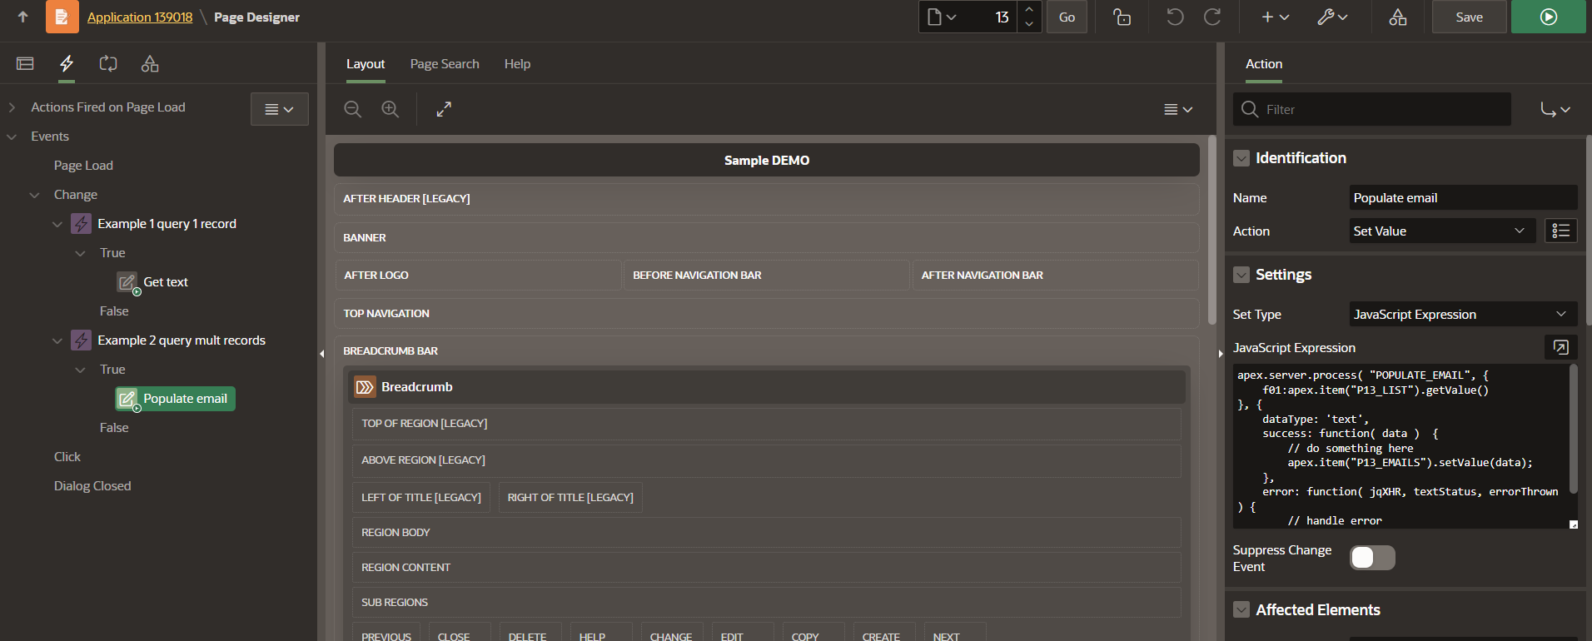

### Single Records

#### Exemplo 1

apex.server.process( "AJAX_CLIENTSERVER", {

x01:apex.item("P13_ID").getValue()

}, {

dataType:'text',

success: function( data ) {

// do something here

//apex.item("P13_TEXT").setValue(data);

apex.item("P13_TEXT").setValue(JSON.parse(data))

}

} );

### Many Records - Loop

#### Exemplo 1

apex.server.process( "POPULATE_EMAIL", {

f01:apex.item("P13_LIST").getValue()

}, {

dataType: 'text',

success: function( data ) {

// do something here

apex.item("P13_EMAILS").setValue(data);

},

error: function( jqXHR, textStatus, errorThrown ) {

// handle error

}

} );