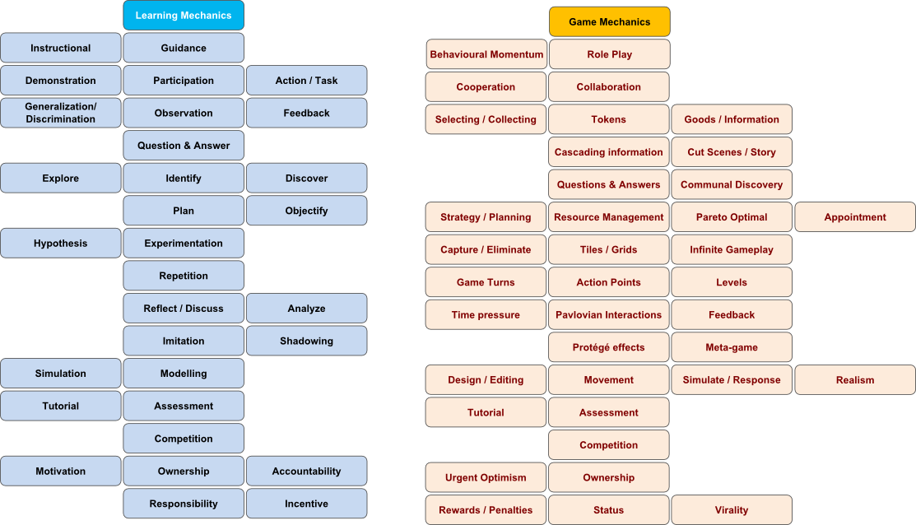
Game: Senior PM Game

Game Map
New turn
Game Description
Hire or fire employees

Start
Simulation
Manage human resources
Start
Read Context and Tutorial
Bid on projects
Feedback

Learning Mechanics

Action / Task

Competition
Instructional
Plan

Feedback

Game Mechanics

Information
Resource
Management

Tutorial
Competition
Strategy / Planning
Feedback

Table: Description of Serious Game Mechanics

Game mechanic | Learning mechanic | Implementation | Usage
Information /  Tutorial | Instructional | At the beginning the Player can get a short tutorial and during the game he always gets information which help him choosing the correct decisions. | When the player gets information in additional mirrors about bids or the employees, he explores how his decisions infuence the project.
Competition | Competition | The player can see competiton in the bidding system. | The GM is shown in a system in which you can bid for different projects against other players during a given time. He can bid on one or two projects. This GM tries to show the competition in the real world.
Plan | Strategy / Planning | The player needs to plan which employee works at which part of the project shown in the time schedule graphic. | During time goes on in the project time schedule, the player can see if choosing the employee for the different parts of the project was succesful. This way he can improve his planning skills the next project.
Action/Task | Resource Management | Connected to the point mentioned above the player has to hire or fire employees to have the best team for the projects. | The player has to finish different tasks of projects and can see how succesful the choice of employees for the different parts of the project was. (Nearly the same Usage like in “Strategy/Planning”)
Feedback | Feedback | The player gets Feedback after every project about the time he needed and the cashflow. This shows the success of the project.  He also gets a full feedback when he clicks on “my page” with his all-time success with the parts:  Attempted  Completed  OT & UB  On-time (OT)  Under-budget (UB)  Project value  Fees earned  Bonus earned | The Player can see how succesful he already was in one game or in all games together, so he gets an overview of what he can improve and compare himself to others (colleagues or friends).

