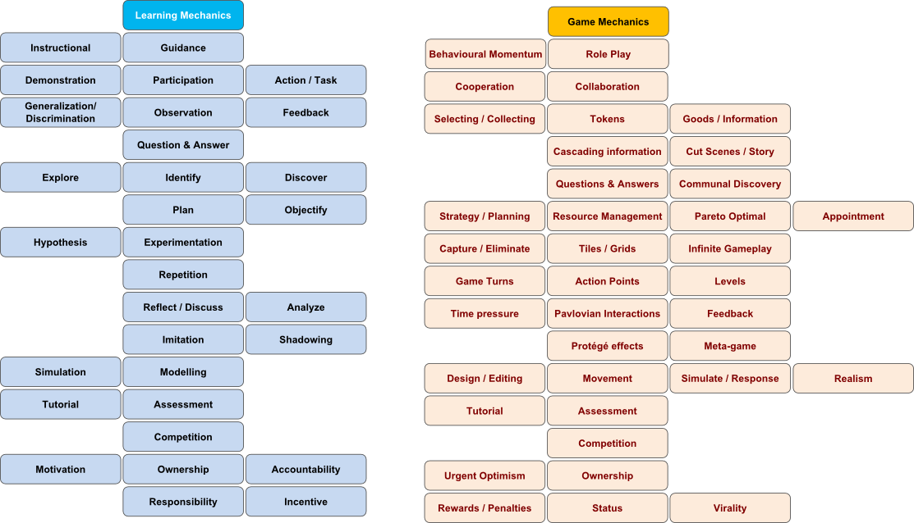
Game: Senior PM Game

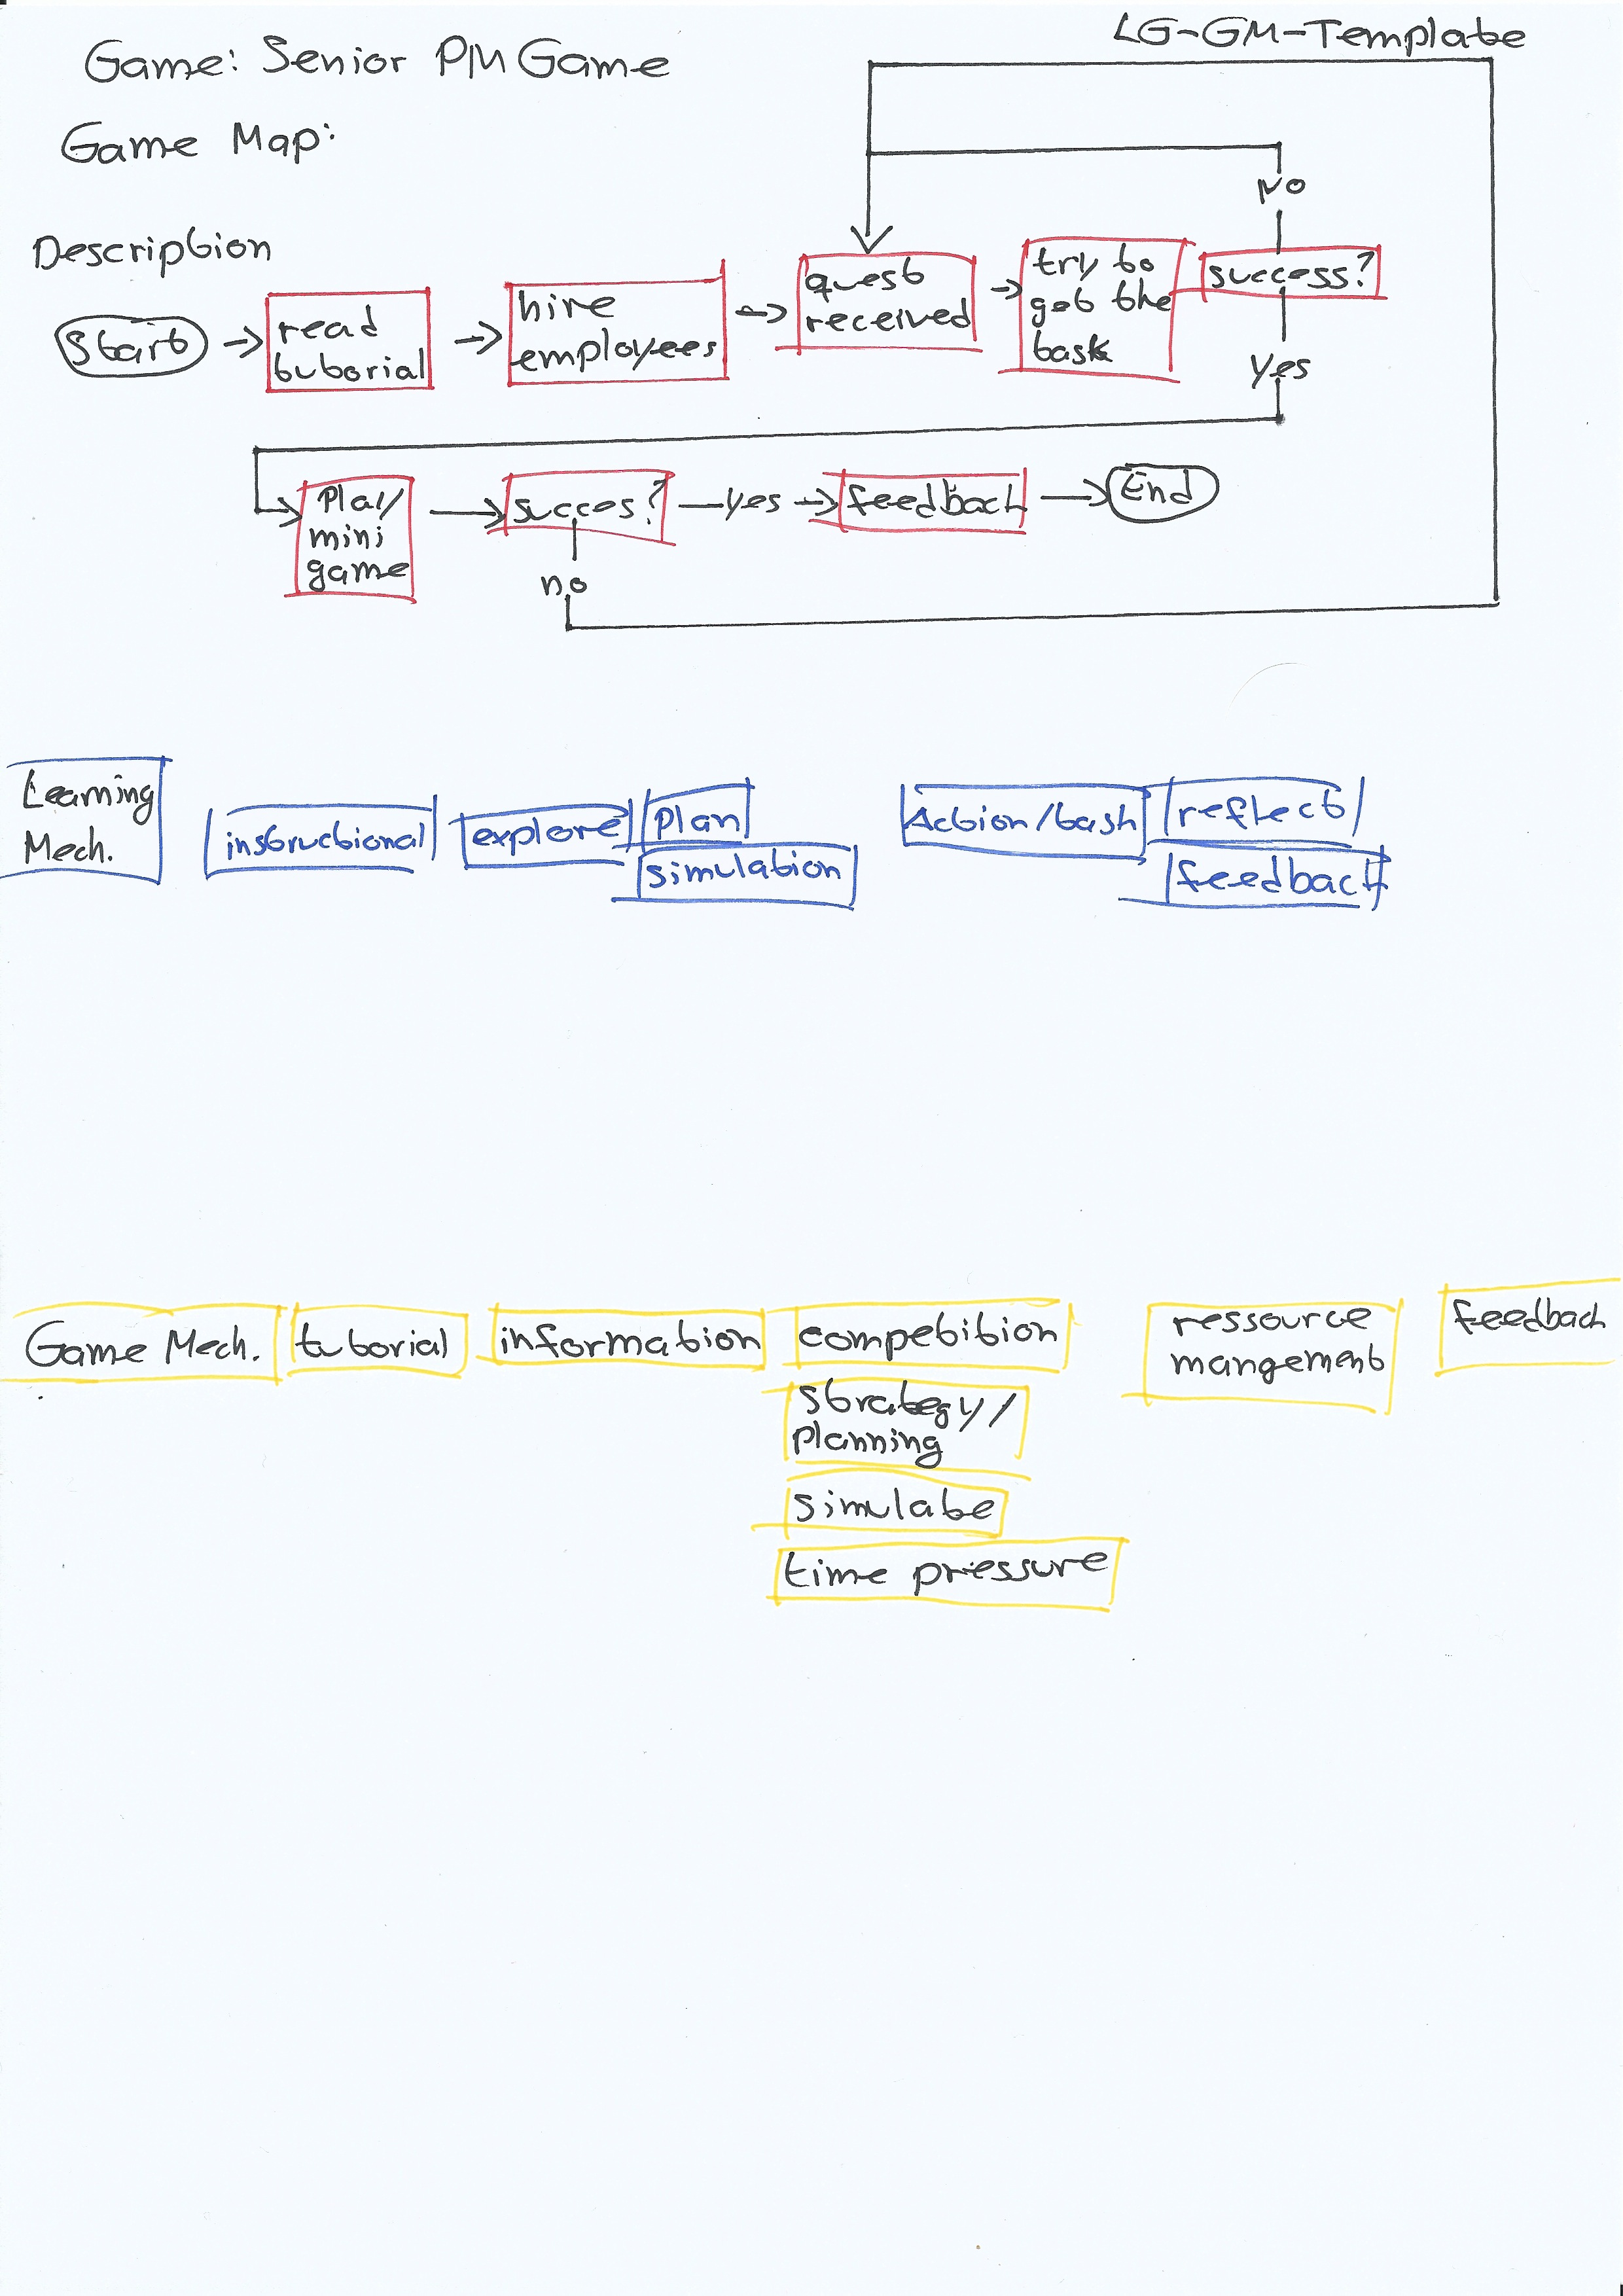

Game mechanic | Learning mechanic | Implementation | Usage
tutorial | Instructional | As text in the beginning oft he game | It’s used to show the user how to play the game
information | explore | In the cards oft he employees | In the cards oft he employees the user can explore the different abilities of them.
competition | Action/task | When you place the bid | You have to place a bid to get the project, so it’s a competition between the different players to get the project
Strategy/planning | plan | In the minigame | When you got the project you have to play a mini-game in which you have to manage the ressources of your employees clever, so that you can solve the task.
simulate | simulation | The mini-game is a simulation | If you start the simulation the mini-game-starts
Time pressure | assessment | In the mini-game | You’ve get in time pressure, if your employees aren’t well trained or motivated
Ressource management | reflection | After the mini-game | You get a reflection, whether you completed the projet under or over budget, so you learn what to do better in future
feedback | feedback | Info box after the project | It’s like the point „reflection“ above

