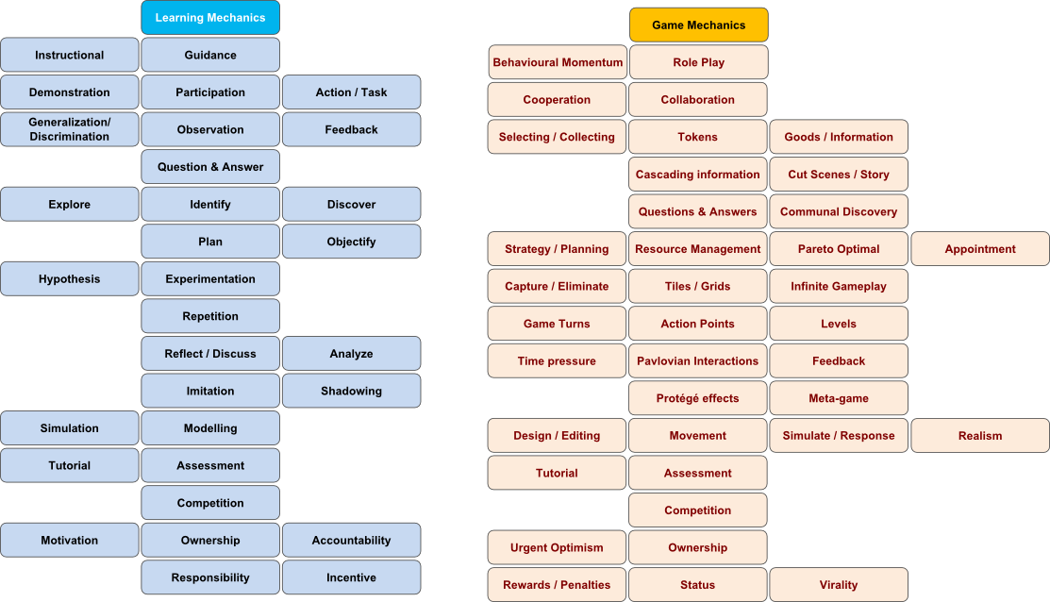
Game: ______Senior PM Game_____________________________

Game Map
get project?
Description of Game

Start read context/ tutorial hire staff bid for project start project edit project repeat? End

Improve your workplace?

Learning Mechanics

Instructional Analyze Plan Simulation / Analyze / Reflect Repetition
Tutorial Plan / Experimentation

Game Mechanics

Tutorial Selecting Resource Level / Simulate / Stratedy Infinite Gameplay
Management Resource Management / Tokens
Selecting Feedback / Time pressure

Narrative Mechanics ???

Table: Description of Serious Game Mechanics

Game mechanic | Learning mechanic | Implementation | Usage
Selecting | Analyze | You analyze the employee | You learn to analyze the employee for your projects
Time pressure | Analyze | You need to analyze the projects before doing them to be able to do them in time | You learn to analyze a problem before you try to work it out
Simulate | Simulation | Simulation of realistic topics of projectmanagement and employee behaviour | You can understand how the topics works in real life better
Infinite Gameplay | Repetition | You have infinite chances, so you can experiment how you deal with projects better | The more you experiment and practise, the better you learn how to successfully manage the project
Resource management | Plan | You plan your capacity of your work power(resources) and coordinate it | You are able to coordinate different kinds of resources
Strategy Planning | Plan | You plan your workplace and tasks | You learn to plan an efficient way to coordinate your employee in a project
Feedback | Reflect / Analyze | You see and analyze the results of your decisions to make it better next time | You learn to accept your faults, look more for feedback of your decisions and analyze them for better results

