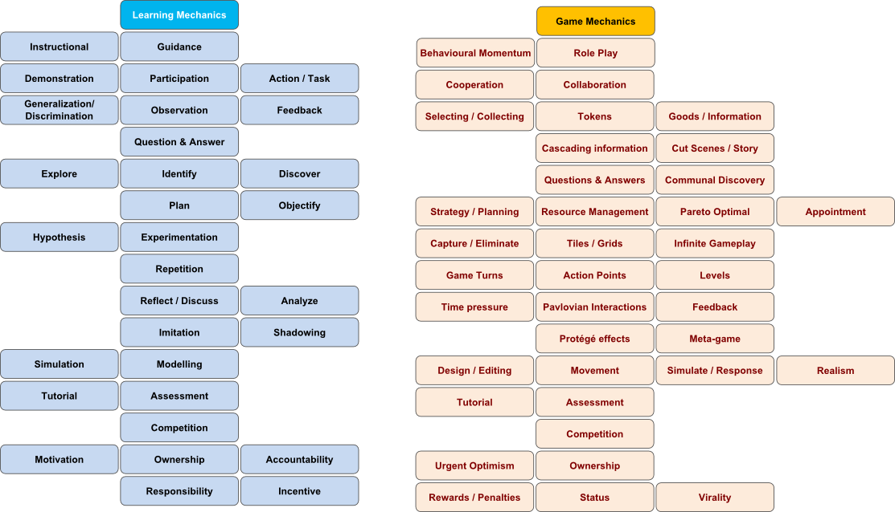
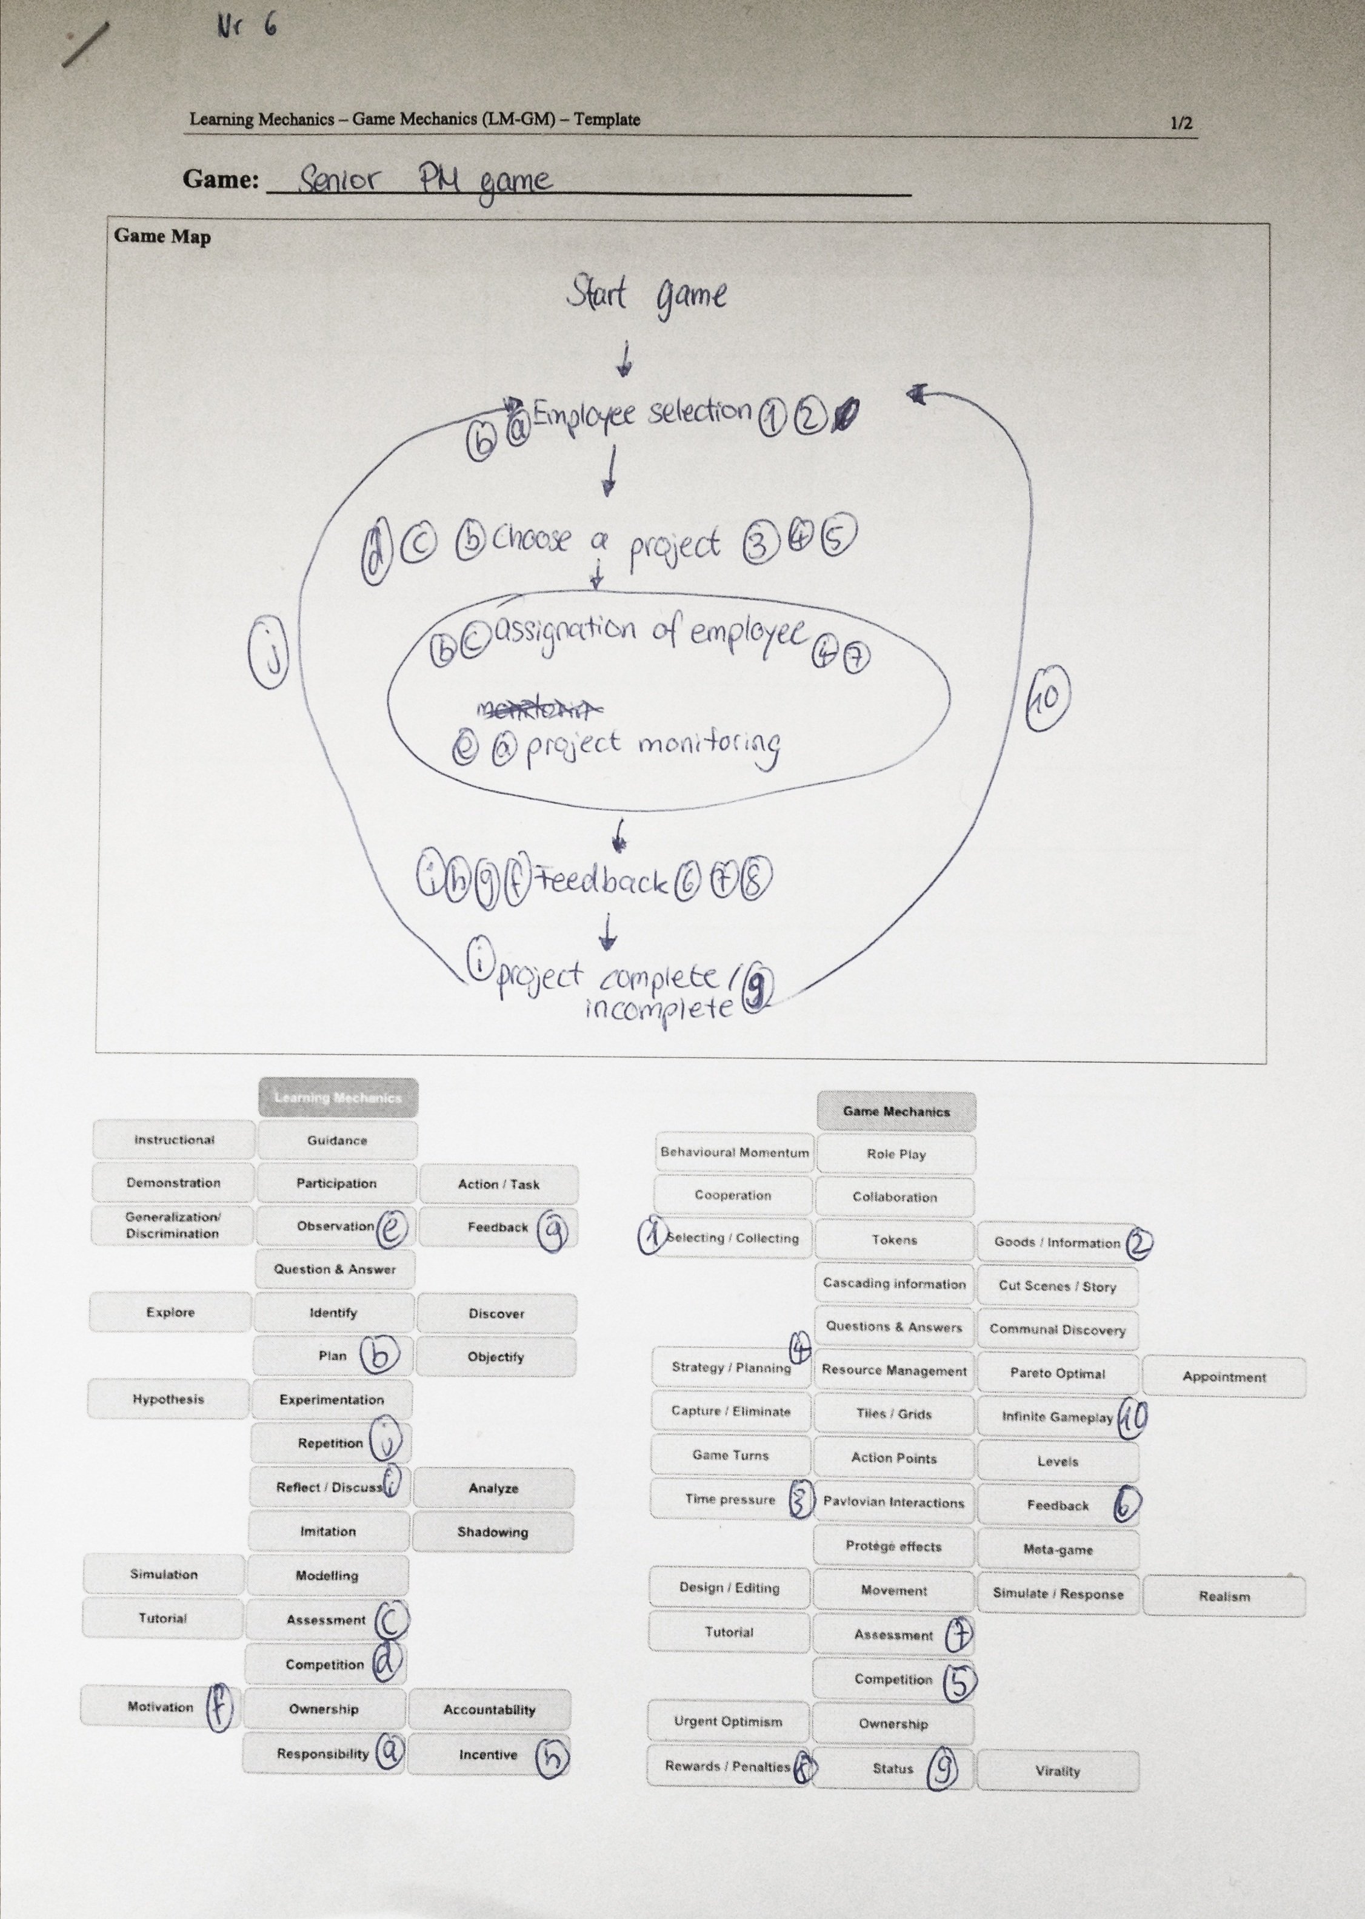Game: ________________________________________________

Game Map

Table: Description of Serious Game Mechanics

Game mechanic | Learning mechanic | Implementation | Usage
Infinite Gameplay | Planning,  Repetition | You can choose your projects infinitely | To get routine.
“Ownership” | Responsibility | The employee | To get an impression from dealing with the employee.
Status, Strategy/  Planning | Planning | Projects | Train your planning/management skills.
Feedback, Assessment,  Rewards / Penalties | Feedback,  Motivation, Assessment, Incentive,  Reflect / Discuss | Score  -Budget  -Time  - Management fees  Feeling from the employee | Motivates you to do it better next time.  The feeling from the employee shows you that you also have to think your employees wishes/needs.
Competition | Competition | Project bids | Shows you that not all projects are like you want it. Also you can´t get all projects you want.
Selecting / Collecting,  Goods / Informations | Responsibility,  Planning | Selection of employee | Teach you to consider your decisions.
Time pressure,  Strategy/  Planning | Assessment | Project selection | Teach you to decide quickly (under time pressure)
Appointment | Planning,  Responsibility | Project | Teach your management/planning skills.

