SGADM Game Analysis | Part I – Activities map 13

Game: Senior PM Game

 | Gaming activity | Learning activity | Internal teaching activity | External teaching activity (optional)
Activity | PLay the game | Learn how to plan the process of different projects done by different staffs.  Learn how employees improve their skills with the running time. | Use the game to explain how projectmanagement works and how important a good assignment of tasks is for the succsess of a project. | -
Subject | Player | Player/learner | Game designer | -
Motives | Competition  Learning about Projectmanagement | Learn how to increase your score with planning the right occupancy of staffs for the projects. | Give people a chance to improve their management skills. | -
Tool | Game | Game | Game | -

SGADM Game Analysis | Part II – Game diagram and actions/ tools/ goals table

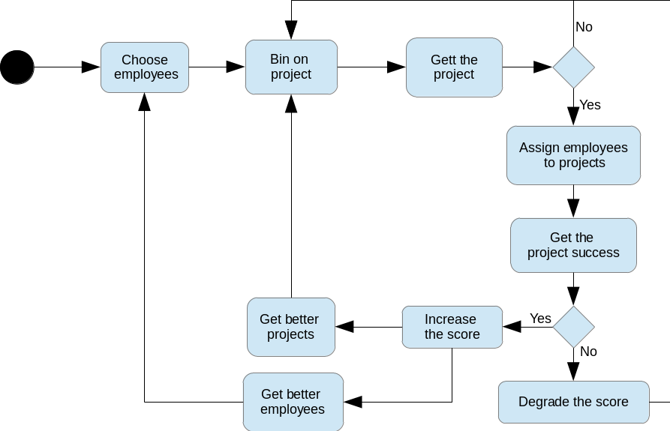

Game actions | The player is able to choose 4 employees with different kinds of skills. With these staffs the player is able to practice a project where the different skills of the staffs are require.
Game tools | projects ; employees ; score ; bid points ; penalties
Game goals | The goal is to increase your score with successful practicing at projects.
Learning Actions | Distribution of the different employees on the projects.
Learning Tools | employees with different skills ; different projects
Learning Goals | Learn how to plan the process of different projects done by different staffs.
Internal Teaching actions | Inform the player of the results of his decisions and reward good choises with a good score and punish him for bad decisions with penalties.
Internal Teaching tools | score ; bonus ; penalties
Internal Teaching goals | The player have to understand that his decisions have consequence on his projects and on his score.
External Teaching actions | -
External Teaching tools | -
External Teaching goals | -

SGADM Game Analysis | Part III – Abstractions table

Game actions | planning ; manage resources
Game tools | Tokens ; rewards ; penalties ; performance meters
Game goals | maximize score
Learning Actions | planning ; selecting ; experimentating
Learning Tools | simulator
Learning Goals | reflective observation ; organization
Internal Teaching actions | sanctioning bad performance ; rewarding good performance
Internal Teaching tools | simulators ; rewards ; penalties
Internal Teaching goals | assessing performance ; providing feedback
External Teaching actions | -
External Teaching tools | -
External Teaching goals | -

Gaming actions
Entity manipulations |  |  | Movement |  | Time-related | Information
Capturing | Eliminating | Owning | Avoiding | Shooting | Manipulating time | Asking  questions
Collecting | Exchanging | Planning / Strategy | Colliding | Targeting | Starting/ Stopping time | Answering questions / trivia
Creating | Generating | Removing | Moving | Teleporting | Advance game period | Obtain help
Customizing | Managing  resources | Selecting | Evading | Traversing |  | See performance evaluation
Designing | Manipulating gravity | Tactical maneuvering | Rotating | Visiting |  | Watch / Listen to / Read information
Destroying | Matching | Trading virtual items |  |  |  | Watch / Listen to / Read story
Editing

Gaming goals
Collect resources | Get acquainted with story
Be the first to reach the end | Learn to use interface
Be the last player standing | Maximize performance
Collect information | Maximize score
Complete quest | Perform task within allotted time
Complete side quests | Reach narrative end
Form/discover goal | Reach resources end

Gaming tools
Objects |  | Attributes | Time | Feedback | Help | Chance/ Randomness | Narrative (aesthetics) | Rules | Segmentation of gameplay | Goal metrics
2D/3D space | Modifiers | Lives | Chronometer | Achievements | Advice and assistance | Dice | Cut scenes | (In)complete information | Alternating turns | Achievement
Cards | Non-playing characters (NPC) | Position in space | Time pressure | Leaderboards | Guide character | Lottery | Role play | Competition | Challenges | Performance record
Gifts | Tiles | Roles |  | Penalties | Checklists/ Task lists | Random appearances | Story (text) | Game modes | Checkpoints | Score
Goods | Tokens | Secrets |  | Performance meters | Tips | Randomizers |  | Gamemaster / referee | Game Period | Success level
Grids | Virtual money | Virtual skills |  | Performance record | Tutorial |  |  | Multiplayer | Infinite gameplay | Time
Information |  |  |  | Points | Warning messages |  |  | Zero-sum / non-zero-sum | Levels
 |  |  |  | Progress bar |  |  |  |  | Metagame
 |  |  |  | Rewards |  |  |  |  | Puzzles
 |  |  |  | Status levels |  |  |  |  | Quest / Problem
 |  |  |  |  |  |  |  |  | Time

Learning tools
Animation
Challenge
Graphics
Information
Report
Simulator
Story
Student diary
Task list/ Checklist
Tasks
Tests
Text
Video

Learning actions
Completing goal | Memorizing
Discovering | Model building
Discriminating | Objectifying
Discussion | Observing
Experimentating | Participating
Exploring | Participating in conversation
Forming hypothesis | Performing action/ task
Forming goal | Planning
Generalizing | Puzzlement
Identifying | Reading
Imitating | Repetition
Listening | Selecting/ Choosing
Locating | Verifying/ Reviewing

Learning goals
Bloom's Taxonomy – Cognitive domain | Bloom's Taxonomy – Affective domain | Bloom's Taxonomy – Psychomotor domain | Kolb's experiential learning cycle | Fink's Taxonomy
Remembering | Receiving phenomena | Perception (awareness) | Concrete experience | Foundational Knowledge
Understanding | Responding to phenomena | Set | Active experimentation | Application
Analyzing | Valuing | Guided response | Reflective observation | Integration
Applying | Organization | Mechanism  (basic proficiency) | Abstract conceptualization | Human dimension
Evaluating | Internalizing values | Complex Overt Response |  | Caring
Creating |  | Adaptation |  | Learning  how to learn
 |  | Origination

Teaching goals
Gagné's Nine Events of Instruction | ARCS Model of Motivational Design
Gaining attention | Attention
Informing learner of objective | Relevance
Stimulating recall of prior learning | Confidence
Presenting the stimulus | Satisfaction
Providing learning guidance
Eliciting performance
Providing feedback
Assessing performance
Enhancing retention and transfer

Teaching tools
Checklists
Deadlines
Discussion
Help text
Limited set of choices
Penalties
Performance measures
Practice tests
Questions & Answers
Rewards
Simulators
Story
Tips / Assistance
Warning messages

Teaching actions
Demonstrating
Presenting material
Presenting problem
Presenting quiz
Qualitatively assessing performance
Quantitatively assessing performance
Reviewing lesson
Rewarding good performance
Sanctioning bad performance
Scaffolding
Showing similar problems
Stressing importance
Suggesting improvements
Telling story

Shapes of an activity diagram


Initial state


End state


Action state


Decision with
alternate paths

Beginning or end of parallel activities
(or when the order does not matter)


Connecting arrows

