SGADM Game Analysis | Part I – Activities map

Game: Senior PM Game

 | Gaming activity | Learning activity | Internal teaching activity | External teaching activity (optional)
Activity | Play the game | Learn how your staff is able to develop their skills.  Learn which employees are important for which tasks based on their personal Skills.  Learn that organization and teamwork is most important to end a project with success. | The game teaches that good organization is the key to success.  You can use the game to explain the importance of project management and teamwork.Play
Subject | Player | Player | Teacher/ Game producer
Motives | Learn how to manage a project.  Competition and concurrent | The player is learning efficient project management and rise up the scoreboard. | The game gives people a opportunity to improve their skills concerning management.
Tool | Game | Game | Game

SGADM Game Analysis | Part II – Game diagram and actions/ tools/ goals table

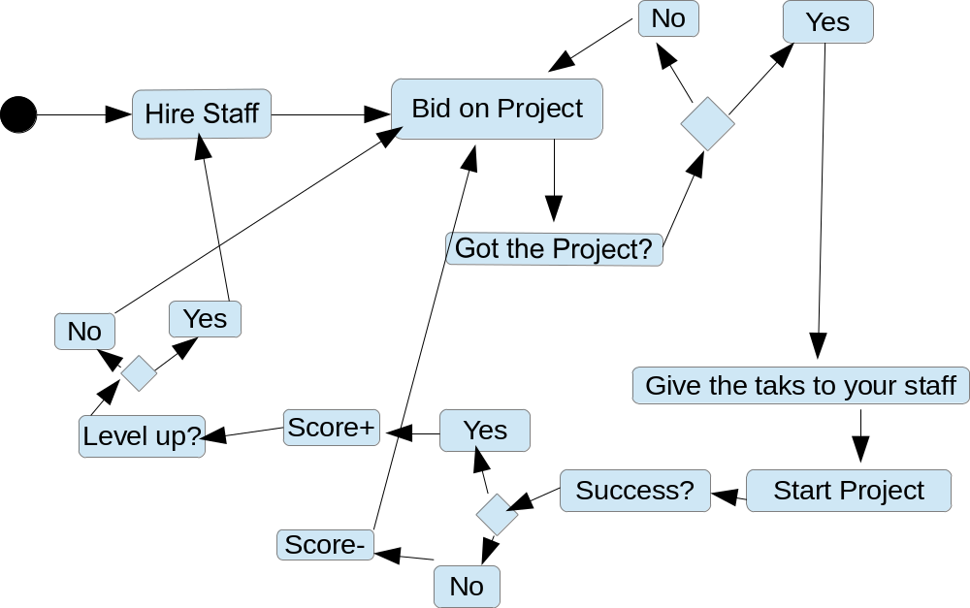

Game actions | The User choose 4 employees. All of them have different skills. The player have "bid points" to bid on projects. If you win the bid you give the tasks of the project to your staff.  When your management was good, the Project is a success and your score rises. If you Level up you can hire 4 more employees.
Game tools | Employees(staff), Score, Project, Bonus, Bid points, Statistics
Game goals | Get a good score.
Learning Actions | Coordinate the employees/ assignment of tasks for the individual employees.
Learning Tools | Projects/different Tasks, Employees
Learning Goals | Make the right decsions based on the skills of individuals.
Internal Teaching actions | Reward good decisions of the Player to teach him what is right
Internal Teaching tools | Score, Statistics
Internal Teaching goals | Feedback based on the players decisions
External Teaching actions
External Teaching tools
External Teaching goals

SGADM Game Analysis | Part III – Abstractions table

Game actions | Organize, Manage given Resources
Game tools | Rewards, Score
Game goals | Get the best possibile score
Learning Actions | Selecting, Experimentating, Organisation
Learning Tools | Simulator
Learning Goals | Organization
Internal Teaching actions | Rewards for right decisions, Penalties for bad ones
Internal Teaching tools | Simulators, Rewards, Statistics, Penalties
Internal Teaching goals
External Teaching actions
External Teaching tools
External Teaching goals

Gaming actions
Entity manipulations |  |  | Movement |  | Time-related | Information
Capturing | Eliminating | Owning | Avoiding | Shooting | Manipulating time | Asking  questions
Collecting | Exchanging | Planning / Strategy | Colliding | Targeting | Starting/ Stopping time | Answering questions / trivia
Creating | Generating | Removing | Moving | Teleporting | Advance game period | Obtain help
Customizing | Managing  resources | Selecting | Evading | Traversing |  | See performance evaluation
Designing | Manipulating gravity | Tactical maneuvering | Rotating | Visiting |  | Watch / Listen to / Read information
Destroying | Matching | Trading virtual items |  |  |  | Watch / Listen to / Read story
Editing

Gaming goals
Collect resources | Get acquainted with story
Be the first to reach the end | Learn to use interface
Be the last player standing | Maximize performance
Collect information | Maximize score
Complete quest | Perform task within allotted time
Complete side quests | Reach narrative end
Form/discover goal | Reach resources end

Gaming tools
Objects |  | Attributes | Time | Feedback | Help | Chance/ Randomness | Narrative (aesthetics) | Rules | Segmentation of gameplay | Goal metrics
2D/3D space | Modifiers | Lives | Chronometer | Achievements | Advice and assistance | Dice | Cut scenes | (In)complete information | Alternating turns | Achievement
Cards | Non-playing characters (NPC) | Position in space | Time pressure | Leaderboards | Guide character | Lottery | Role play | Competition | Challenges | Performance record
Gifts | Tiles | Roles |  | Penalties | Checklists/ Task lists | Random appearances | Story (text) | Game modes | Checkpoints | Score
Goods | Tokens | Secrets |  | Performance meters | Tips | Randomizers |  | Gamemaster / referee | Game Period | Success level
Grids | Virtual money | Virtual skills |  | Performance record | Tutorial |  |  | Multiplayer | Infinite gameplay | Time
Information |  |  |  | Points | Warning messages |  |  | Zero-sum / non-zero-sum | Levels
 |  |  |  | Progress bar |  |  |  |  | Metagame
 |  |  |  | Rewards |  |  |  |  | Puzzles
 |  |  |  | Status levels |  |  |  |  | Quest / Problem
 |  |  |  |  |  |  |  |  | Time

Learning tools
Animation
Challenge
Graphics
Information
Report
Simulator
Story
Student diary
Task list/ Checklist
Tasks
Tests
Text
Video

Learning actions
Completing goal | Memorizing
Discovering | Model building
Discriminating | Objectifying
Discussion | Observing
Experimentating | Participating
Exploring | Participating in conversation
Forming hypothesis | Performing action/ task
Forming goal | Planning
Generalizing | Puzzlement
Identifying | Reading
Imitating | Repetition
Listening | Selecting/ Choosing
Locating | Verifying/ Reviewing

Learning goals
Bloom's Taxonomy – Cognitive domain | Bloom's Taxonomy – Affective domain | Bloom's Taxonomy – Psychomotor domain | Kolb's experiential learning cycle | Fink's Taxonomy
Remembering | Receiving phenomena | Perception (awareness) | Concrete experience | Foundational Knowledge
Understanding | Responding to phenomena | Set | Active experimentation | Application
Analyzing | Valuing | Guided response | Reflective observation | Integration
Applying | Organization | Mechanism  (basic proficiency) | Abstract conceptualization | Human dimension
Evaluating | Internalizing values | Complex Overt Response |  | Caring
Creating |  | Adaptation |  | Learning  how to learn
 |  | Origination

Teaching goals
Gagné's Nine Events of Instruction | ARCS Model of Motivational Design
Gaining attention | Attention
Informing learner of objective | Relevance
Stimulating recall of prior learning | Confidence
Presenting the stimulus | Satisfaction
Providing learning guidance
Eliciting performance
Providing feedback
Assessing performance
Enhancing retention and transfer

Teaching tools
Checklists
Deadlines
Discussion
Help text
Limited set of choices
Penalties
Performance measures
Practice tests
Questions & Answers
Rewards
Simulators
Story
Tips / Assistance
Warning messages

Teaching actions
Demonstrating
Presenting material
Presenting problem
Presenting quiz
Qualitatively assessing performance
Quantitatively assessing performance
Reviewing lesson
Rewarding good performance
Sanctioning bad performance
Scaffolding
Showing similar problems
Stressing importance
Suggesting improvements
Telling story

Shapes of an activity diagram


Initial state


End state


Action state


Decision with
alternate paths

Beginning or end of parallel activities
(or when the order does not matter)


Connecting arrows

