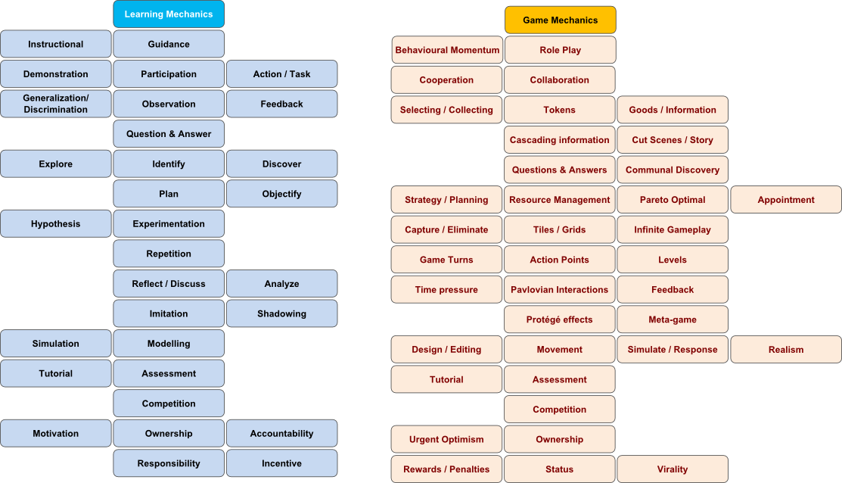
Game: Senior PM Game

Game Map Yes Need Workforce?
Description of Game:
No No Yes
Yes succes /no success No
Start Read instructions Acquire workforce Bid for project Get project Do project Receive income, bonus/penalty Repeat End

Learn Mechanics:

Instruction Objectify Analyse Competition Plan, Responsibility, Repitition
Objectify, Experiment,
Analyse, Simulation

Game Mechanics:

Selecting Selecting Competition Strategy/Planning Infinite gameplay
Reward/Penalty
Resource management
Level, Gameturns
Time Pressure
Simulation
Realism

Table: Description of Serious Game Mechanics

Game mechanic | Learning mechanic | Implementation | Usage
Strategy/  Planning | Plan | You plan the usage of the workforce | You learn to plan an efficient way to coordinate your workforce in a project
Rewards/  penalties | Responsibility | You receive rewards/penalties for being under/over time limit | You learn that not being able to do the task correctly has consequenses, so you choose projects responsibly
Resource management | Plan, Objectify | You objectify your workforce which is your resource in this game to coordinate it | You objectify the non-object resource a bit to be able to make an successful plan
Infinite Gameplay | Experimentation | Since you have an infinite amount of chances, you can experiment and variate how you deal with projects | The more you experiment and practise, the better you learn how to successfully manage the project
Game turns, Levels | Repitition | The projects are more or less similar in each difficulty so you can basically repeat the projects until you are able to do harder ones | More practise through repitition of the tasks and using the acquired skills to handly more difficult ones
Time pressure | Analyse | You need to analyse the projects before doing them to be able to do them in time | You learn to analyse a problem before you try to work it out, so you can do it properly under given circumstances
Simulate/  Response,  Realism | Simulation | Simulation of realistic aspects of projectmanagement and workforce behaviour | You can understand how the topic works in real life better
Competition | Competition | Since it's a multiplayer game, other players can try to get the same projects that you want. | You learn that there is competition, which means you have to improve to be able to sustain the competition

