CIP HS26 · Group 105 · Project documentation
Premiums vs. Paychecks: Health Insurance Affordability Across Swiss Cantons, 2012–2022
Alisa Bitschnau, Chaitanya Arya, Jobin Joseph · Repository: github.com/carya0001/CIP-project

1 Introduction
Mandatory health insurance premiums in Switzerland are charged per person and do not depend on income. The same premium therefore weighs very differently on households in different cantons, which differ both in premium levels and in incomes. Public debate usually looks at premium growth alone. In this project we combine premium data with cantonal tax statistics to measure how heavy the premium is relative to income, how this has developed between 2012 and 2022, and how much individual insurance choices can change the picture. The period ends in 2022 because the cantonal tax statistics are currently published up to tax year 2022.
We answer the three research questions of our feasibility study:
- RQ1 – Change over time: How has the affordability of mandatory health insurance changed between 2012 and 2022? Did premiums increase faster than income (RQ1.1)?
- RQ2 – Regional differences: How does affordability differ between the cantons, and have these differences grown or narrowed?
- RQ3 – Insurance choices: How much do premiums differ by deductible and insurance model across the cantons?

2 Methods

2.1 Data sources and acquisition
All data come from public federal sources and were collected with Python (Table 1). Before scraping we checked robots.txt: ESTV allows access, and priminfo.admin.ch has no robots.txt. The two static scrapers check robots.txt in code, pause between downloads and record the URL and retrieval time of every file. Raw files are stored unchanged in data/raw/.
Table 1: Data sources, acquisition methods and responsibilities.
Source | Method | Data | Collected by
ESTV, direct federal tax statistics | Static scraping (requests, BeautifulSoup): XLSX links read from the overview page | Taxable income and taxpayers per canton and household type, 2012–2022 (11 files) | Chaitanya Arya
BFS STAT-TAB (PxWeb) | REST API, JSON POST queries | Median, P25, P75 monthly gross wage per large region, even years 2012–2022 | Chaitanya Arya
FOPH priminfo archive | Static scraping of the archive page, PDF download, parsing with pdfplumber | Official premium tables of all insurers, regions, age groups, models and deductibles, 2012–2022 (11 PDFs) | Alisa Bitschnau
FOPH priminfo premium calculator | Dynamic scraping with Selenium | Current premium of every insurer in the capital of each canton (628 offers) | Jobin Joseph
The premium PDFs contain more than 1,000 pages each and change their layout over the years (model titles, dashes, a missing colon from 2019 on, Italian headers in Ticino). The parser therefore reads the PDFs line by line instead of relying on table detection. It takes model, canton, age group and premium region from the page headers and assigns each premium to its deductible by its horizontal position under the column header. This produced 2,922,813 premium values; only 16 lines (2016–2018) could not be matched safely, and these are reported, not silently dropped.
The premium calculator is a JavaScript form, so it can only be read by interacting with it: Selenium types the postal code and picks it from the typeahead list, enters the birth year, selects the deductible from a dropdown, ticks accident cover and the insurance model, clicks “calculate” and reads the results table. It was run for one adult profile (born 1988, CHF 300, with accident cover, standard model) in the 26 cantonal capitals in October 2026. Because it covers one premium region per canton and a different year, we use it as a current snapshot and do not merge it into the 2012–2022 time series.

2.2 Cleaning and transformation
Table 2 summarises how the mandatory cleaning steps were applied. The scripts print the result of every check, so the cleaning is reproducible.
Table 2: Cleaning and transformation steps.
Step | Income (ESTV, BFS) | Premiums (priminfo PDFs)
Gaps / missing data | All 286 canton-years present, no missing values | No missing values; all 26 cantons in every year; HMO missing in GL and VS before 2016 (not offered)
Data types | Columns cast explicitly; bilingual headers and changing sheet and column names mapped to one schema | Year, region, deductible as integers, premiums as floats, model and canton as categories
Value ranges | Positive values, Gini between 0 and 1, P25 ≤ median ≤ P75 ≤ mean | Premiums > 0, valid deductibles, premium falls with higher deductible, lower without accident cover. Only exception: one product (BeneFit) at CHF 1,500, printed so in the PDF and kept
Outliers | 3·IQR rule on year-on-year change: only Valais 2020 (+6.6 %) flagged and kept | 3·IQR within year and deductible: 1,788 high values (mostly GE, BS) are real tariffs and kept
Format / merge | Yearly files stacked; household types in long format | Reduced to one value per canton and year; merged 1:1 with income on canton + year (286 rows)
Enrichment | Canton code, large region, growth index (2012 = 100), regional BFS wage (odd years interpolated) | Annual premium, premium burden, discount vs. reference case, yearly saving

2.3 Analysis methods
To compare like with like we define a reference case: an adult in the standard model with the lowest deductible (CHF 300) and accident cover. For each canton and year we take the mean premium over all insurers within a premium region and then the mean over the regions of the canton. We weight insurers and regions equally because market shares and population per premium region are not available.
Our main measure is the premium burden = annual premium ÷ median taxable income × 100. We use the median because income is right-skewed. The burden compares one adult's premium with one tax unit's income (a married couple counts as one unit), so it is an indicator for comparing cantons and years, not the real share of a household budget. Growth is shown as an index (2012 = 100) for the median canton, with the 10th–90th percentile of cantons as a band. Regional differences are measured by the range and standard deviation of the burden and by the Pearson correlation between income and premium. For RQ3 we apply the same averaging to all four insurance models and six deductibles and compute the discount against the reference case. The analysis uses pandas and NumPy; the figures are made with matplotlib and the interactive dashboard with Plotly.

3 Results and discussion

3.1 RQ1: Premiums grew almost three times faster than income
Between 2012 and 2022 the premium of the reference case rose by +33.8 % in the median canton (from CHF 4,151 to CHF 5,459 a year), while median taxable income rose by only +12.3 % (Figure 1). Premiums grew faster than income in all 26 cantons, from +22 % in Bern to +44 % in Appenzell Ausserrhoden. From 2013 on, the two bands no longer overlap: premium growth in the slower cantons (10th percentile) is higher than income growth in the faster cantons (90th percentile). As a result, the typical burden rose from 9.3 % to 11.3 % of median taxable income, an increase of two percentage points or more than a fifth. The rise was steepest between 2015 and 2019. In 2021 and 2022 the burden eased slightly (11.5 % → 11.3 %) because premiums hardly changed while incomes kept growing. The answer to RQ1.1 is therefore a clear yes.
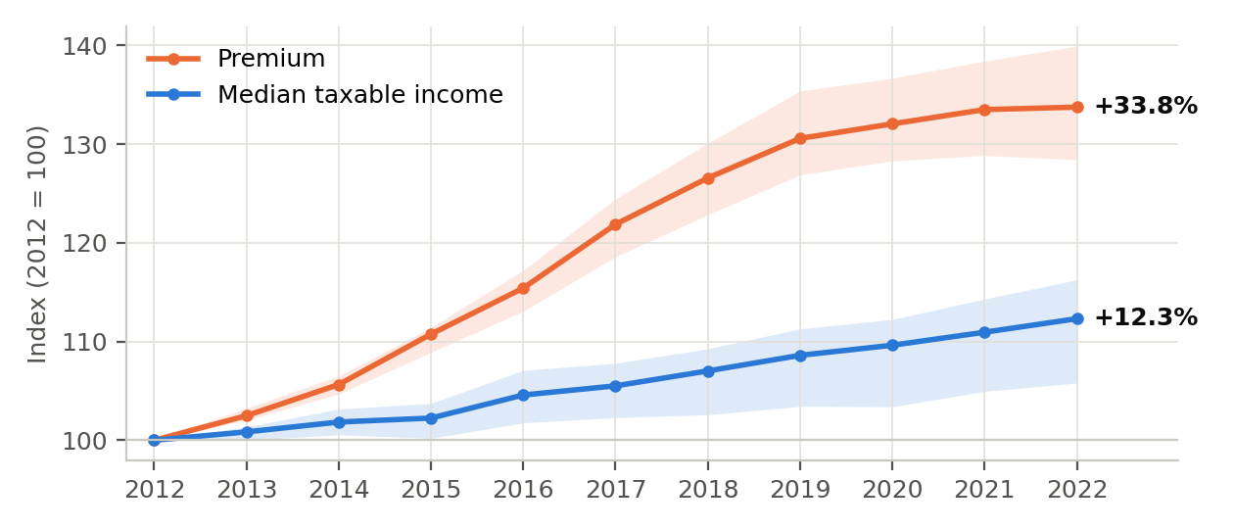
Figure 1: Premium and median taxable income as an index (2012 = 100). Lines: median canton; bands: 10th–90th percentile of the 26 cantons.

3.2 RQ2: The gap between cantons has widened
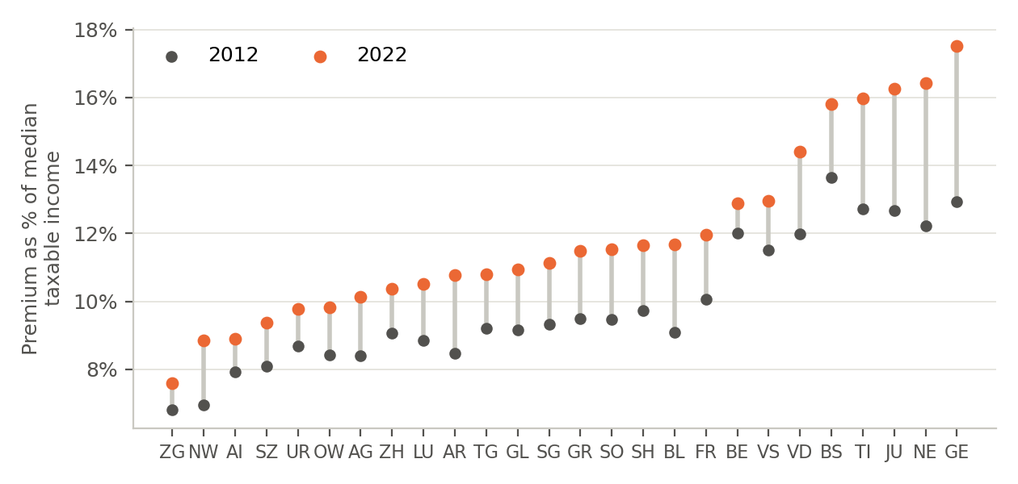
Figure 2: Premium burden per canton in 2012 and 2022, sorted by the burden in 2022.
The burden differs strongly between cantons (Figure 2). In 2022 it ranges from 7.6 % in Zug to 17.5 % in Geneva. It is highest in western Switzerland (Geneva, Neuchâtel, Jura, Vaud), Ticino and Basel-Stadt, and lowest in central Switzerland. Every canton has a higher burden in 2022 than in 2012, but the increase is uneven: Geneva (+4.6 percentage points) and Neuchâtel (+4.2 pp) lost the most, Zug (+0.8 pp) and Bern (+0.9 pp) the least. In Geneva the median taxable income was even 1.3 % lower in 2022 than in 2012. The differences between cantons have therefore widened: the range grew from 6.8 to 9.9 percentage points and the standard deviation from 1.9 to 2.7 pp.
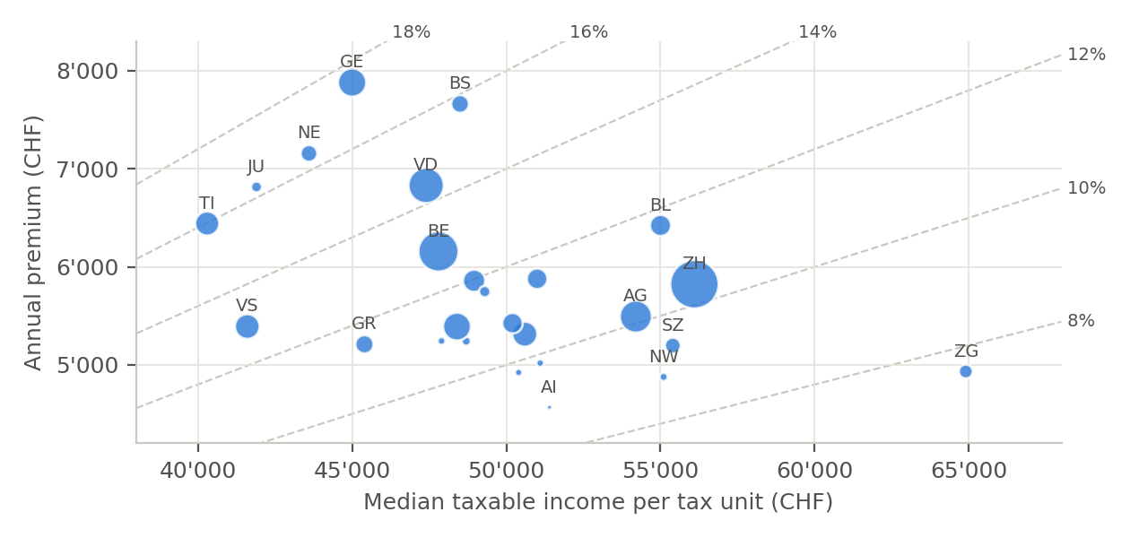
Figure 3: Median taxable income and annual premium per canton in 2022. Bubble size: number of taxpayers. Dashed lines: equal burden.
Figure 3 shows why. Cantons with lower incomes tend to have higher premiums, so the two effects add up instead of cancelling out. This relationship has become stronger: the correlation between median income and premium was close to zero in 2012 (r = −0.10) and clearly negative in 2022 (r = −0.46). Geneva, Neuchâtel and Jura combine low median incomes with high premiums, while Zug combines the highest income with low premiums.

3.3 RQ3: Insurance choices help, but not where it matters most
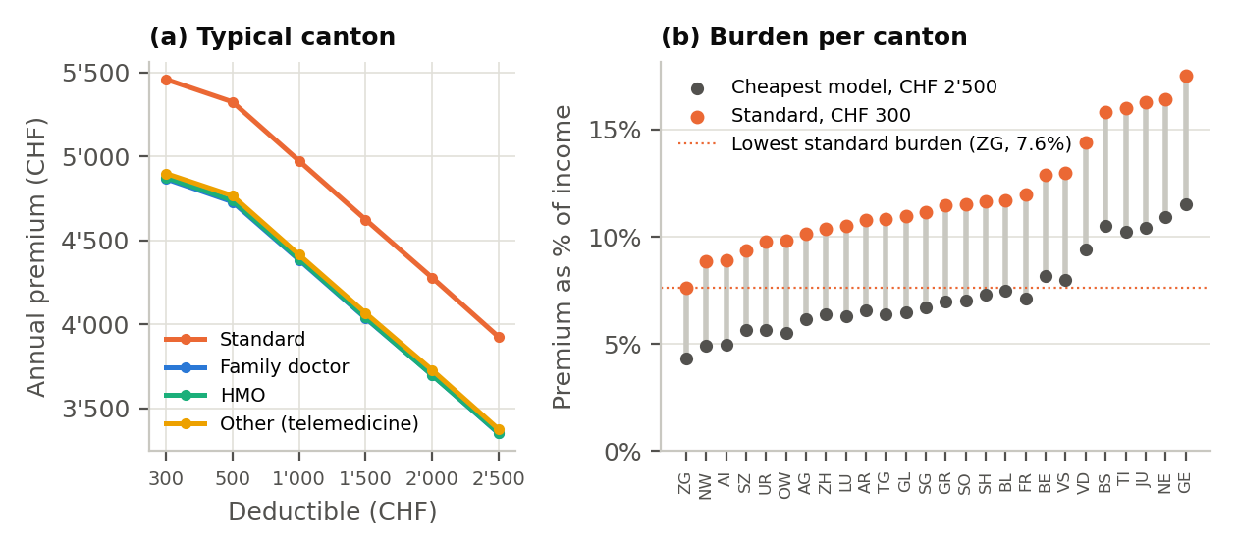
Figure 4: (a) Annual premium by insurance model and deductible, median canton 2022. (b) Burden with the reference case and with the cheapest model at CHF 2,500 deductible, per canton 2022.
Alternative models are cheaper than the standard model by a similar amount (Figure 4a): in 2022 the family doctor model, HMO and telemedicine models cost about 11–12 % less at the same deductible. In 2012 the HMO discount was still 17 %. A higher deductible saves more: the CHF 2,500 deductible lowers the standard premium by CHF 1,535 a year in the median canton. Remarkably, this saving in francs is almost the same in every canton and year (CHF 1,434–1,560), which is consistent with the federal rule that limits deductible discounts to 70 % of the additional risk (70 % of CHF 2,200 = CHF 1,540). Because premiums rose while the franc amount stayed the same, the discount fell from 37 % in 2012 to 28 % in 2022.
The higher deductible only pays off if the year's health costs stay low. Between CHF 300 and 2,500 of costs, the insured pays 90 % of the extra costs themself (the other 10 % are co-payment under both options). The CHF 2,500 deductible is therefore cheaper only if costs stay below about CHF 300 + 1,535 ÷ 0.9 ≈ CHF 2,000 a year. Combining the cheapest model with the highest deductible lowers the typical burden from 11.3 % to 6.8 % (Figure 4b). However, even with this cheapest choice, the burden in 8 of 26 cantons (Geneva, Neuchâtel, Basel-Stadt, Jura, Ticino, Vaud, Bern, Valais) remains higher than the standard burden in Zug. Where someone lives matters more for the burden than how they insure, and the cheapest options are mainly useful for people who rarely need care.
Robustness. Dropping accident cover lowers premiums by about 6 % but leaves the ranking of the cantons by burden practically unchanged (Spearman rank correlation at least 0.998 in every year), so our conclusions do not depend on this choice.

4 Conclusion
Between 2012 and 2022, health insurance premiums grew almost three times as fast as median taxable income in Switzerland, and the typical burden rose from 9.3 % to 11.3 %. The burden grew in every canton, but most in western Switzerland and Ticino, where incomes are lower and premiums higher, so the gap between cantons widened. Alternative insurance models and high deductibles can lower the premium by about 39 % in the typical canton, but the deductible discount is fixed in francs and loses weight as premiums rise, and it shifts costs to people who get sick.
Learnings. Most of the work went into data acquisition and cleaning rather than analysis. Official PDFs are not machine-friendly: layouts change from year to year, and a robust parser had to read text positions instead of tables and report every line it could not read. The tax files changed column names, sheet names and household categories over time and had to be mapped to one schema. Selenium needs explicit waits for every element of a JavaScript form. Systematic range and outlier checks paid off: they found a real tariff quirk (BeneFit) and a likely break in the Valais tax data instead of hiding them.
Limitations. Taxable income is income after deductions and per tax unit, not disposable household income. Premium subsidies, which reduce the burden for low incomes, are not included. Insurers and premium regions are weighted equally because market shares and population per region are not available. The 2020 value of Valais is flagged as a likely break in the source data. The calculator snapshot covers only the capital of each canton.
Outlook. The analysis could be extended with premium subsidies per canton (priminfo publishes them as PDFs), with population-weighted premium regions, with the ESTV data for 2023 and later once published, and by running the Selenium scraper for all premium regions and household types. A regression could then explain the burden with income, urbanisation and healthcare supply per canton.

References
Federal Office of Public Health (FOPH). Priminfo – premium archive and premium calculator. https://www.priminfo.admin.ch (retrieved October 2026).
Federal Tax Administration (FTA/ESTV). Statistics on direct federal tax, natural persons, 2012–2022. https://www.estv.admin.ch (retrieved October 2026).
Federal Statistical Office (BFS). STAT-TAB, table px-x-0304010000_201, Swiss Earnings Structure Survey. https://www.pxweb.bfs.admin.ch/api/v1/de/ (retrieved October 2026).
Swiss Federal Council. Ordinance on Health Insurance (KVV), SR 832.102, Art. 93–95.

