

REQUEST FOR PROPOSAL
Design & Fabrication of a Custom Mobile Ministry Stage Trailer
"Jesus On Wheels — Outside The Four Walls"
Issued by
FAMILY LIFE CHURCH OF LIVINGSTON
4362 US-59 S, Livingston, TX 77351 • www.flcworship.com
RFP Number | FLC-2026-MT01
Issue Date | [November 2, 2026]
Questions Due | [November 16, 2026 — 5:00 PM local time]
Proposals Due | [December 4, 2026 — 5:00 PM local time]
RFP Contact | Pastor Cary Baskin, Senior Pastor · cmbllc@yahoo.com · (936) 365-3113

Contents
1. Introduction & Purpose
2. About Family Life Church
3. Project Overview & Ministry Goals
4. RFP Schedule
5. Technical Specifications & Scope of Work
6. Reference & Concept Images
7. Proposal Submission Requirements
8. Pricing Form
9. Evaluation Criteria
10. Terms & Conditions
11. Vendor Questions & Contact Information
Appendix A — Estimated Electrical Load Worksheet
Appendix B — Vendor Submission Checklist
Appendix C — Vendor Acknowledgment & Signature

1. Introduction & Purpose
Family Life Church ("FLC," "the Church") invites qualified trailer manufacturers, custom fabricators, and mobile-stage builders ("Vendors") to submit proposals to design, engineer, fabricate, outfit, and deliver one (1) custom mobile ministry stage trailer.
The trailer will serve as the centerpiece of the Church's "Jesus On Wheels — Outside The Four Walls" outreach ministry, bringing live worship, preaching, prayer, and community events to parks, neighborhoods, schools, festivals, and other locations beyond the church building.
The Church is seeking a turnkey solution: the finished trailer should arrive road-legal, fully wired, climate-controlled, powered, and ready to receive the Church-supplied sound system and worship instruments so the ministry team can arrive, deploy the stage, and begin ministering with minimal setup.
This RFP describes the Church's requirements, the information Vendors must provide, and how proposals will be evaluated. Vendors are encouraged to propose improvements, alternates, or cost-saving ideas that meet the intent of this RFP.

2. About Family Life Church
Family Life Church of Livingston is a Spirit-filled Apostolic church located in Livingston, Texas, led by Senior Pastor Cary Baskin and his wife, Mary. The Church describes itself as "a warm and loving church where you are important to God" — a welcoming community where everyone belongs.
The Church serves its community through ministries for families, children, youth, young adults, men, women, and single adults; a Spanish-language ministry; multiple Bible studies; and the FLCA Christian school. The "Jesus On Wheels" mobile ministry trailer will extend this work beyond the church building into Livingston, Polk County, and the surrounding region. More information is available at www.flcworship.com.
Organization | Family Life Church of Livingston
Website | www.flcworship.com
Address | 4362 US-59 S, Livingston, TX 77351
Primary Contact | Pastor Cary Baskin, Senior Pastor
Email / Phone | cmbllc@yahoo.com / (936) 365-3113 (Church Office)
Service Times | Sunday School 10:00 AM · Sunday Morning 11:00 AM · Sunday Evening 6:30 PM · Wednesday Bible Study 7:00 PM
Tax Status | 501(c)(3) non-profit religious organization — tax-exempt certificate available upon request [confirm]

3. Project Overview & Ministry Goals

3.1 Concept Summary
The desired trailer is an enclosed, tandem-axle cargo-style trailer with a heavy steel tube frame (similar to the frame shown in Section 6), a gloss-black exterior, and a full-length side wall that folds down to become a stage deck. When deployed, the folded-down side and the interior floor must form one continuous, flush, single-level stage surface. The upper portion of the same side lifts to form a canopy/awning over the stage. The trailer roof is a walkable deck with perimeter guardrails and an access ladder, and carries two (2) rooftop air-conditioning units.

3.2 Ministry Goals
- Provide a professional, safe, weather-resilient mobile stage for outdoor worship services, concerts, revivals, and community outreach.
- Be completely self-sufficient on power — able to run both A/C units, the Church-supplied sound system and instruments, lighting, and auxiliary equipment from an onboard generator, with the option of shore power.
- Provide secure, organized storage and dedicated power for the Church-supplied sound system and musical instruments.
- Be quick to deploy and pack up (target: 30 minutes or less with a team of 2–3 volunteers).
- Present a polished, inviting, branded appearance that reflects the excellence of the ministry.
- Be durable, low-maintenance, and safe to tow with a standard 3/4-ton or 1-ton pickup truck.

3.3 Intended Use Profile
Typical event size | 100 – 500 attendees outdoors
Event frequency | [Estimated 2–6 events per month]; year-round use
Typical event length | 2 – 6 hours of continuous operation
Travel radius | [Primarily local/regional, occasional long-distance trips]
Tow vehicle | [Church to specify — e.g., 3/4-ton or 1-ton pickup, 2-5/16" ball]
Operators | Church staff and trained volunteers (non-professionals)

4. RFP Schedule
The Church reserves the right to modify this schedule. Any changes will be communicated to all registered Vendors in writing.
Milestone | Date (Tentative)
RFP issued | [November 2, 2026]
Notice of intent to bid (email the RFP Contact) | [November 9, 2026]
Deadline for written questions | [November 16, 2026]
Church responses to questions (sent to all Vendors) | [November 20, 2026]
Proposals due | [December 4, 2026, 5:00 PM]
Shortlist interviews / shop visits | [December 7 – 15, 2026]
Vendor selection & notice of award | [December 18, 2026]
Contract execution & design kickoff | [January 2027]
Design approval (drawings signed off by Church) | Vendor to propose
Target delivery date | [Vendor to propose — Church preference: Spring 2027]

5. Technical Specifications & Scope of Work
The following specifications describe the Church's minimum requirements and preferences. For each line item, Vendors must indicate in the "Vendor Response" column whether they Comply, propose an Exception/Alternate (with explanation), or need Clarification. Items marked "Preferred" or "Option" should be priced separately on the Pricing Form (Section 8). Brand names are listed for reference only; equal or better products may be proposed.

5.1 General Dimensions & Chassis
Ref | Requirement | Vendor Response (Comply / Exception / Notes)
CH-01 | Enclosed tandem-axle trailer, bumper-pull configuration. Preferred size: approximately 8.5 ft wide × 24 ft box length (Vendor may recommend 20–28 ft based on design). Interior height approximately 7.5–8 ft.
CH-02 | Overall travel height, including rooftop A/C units and guardrails in travel position, not to exceed 13 ft 6 in. If needed, guardrails must fold down or be removable for travel.
CH-03 | Tandem axles rated for the full loaded weight with margin (e.g., two 7,000 lb axles, 14,000 lb GVWR, or as engineered). Vendor to provide estimated empty weight, payload, and tongue weight.
CH-04 | Electric brakes on all axles, breakaway kit with battery, safety chains, adjustable coupler (2-5/16" ball or as specified), and heavy-duty tongue jack (electric preferred).
CH-05 | Torsion or leaf-spring suspension suitable for a sensitive audio/instrument payload; Vendor to recommend.
CH-06 | Radial trailer tires (load range E or higher), aluminum or black alloy wheels, and a matching mounted spare tire.
CH-07 | Four (4) heavy-duty adjustable stabilizer/leveling jacks at the corners of the main frame with wide foot pads (see concept images), plus additional support legs for the deployed stage wing (see 5.2). Option: electric or hydraulic auto-leveling.
CH-08 | DOT-compliant LED lighting (FMVSS 108), conspicuity tape, 17-digit VIN, and Manufacturer's Statement/Certificate of Origin (MSO/MCO) for titling and registration in the State of Texas. NATM membership/compliance preferred.

5.2 Frame & Flush Fold-Down Stage Floor (Critical Requirement)
This is the most important structural feature of the trailer. The Church requires a two-layer (double-stacked) frame: a lower steel chassis frame (main rails, crossmembers, axle mounts) and an upper steel floor frame built on top of it. The purpose of the two layers is to raise the interior floor and hinge line so that when the side wall is lowered, the inside face of the wall lands exactly level with the interior floor, creating one continuous, flat stage with no step, ramp, or gap.
Ref | Requirement | Vendor Response (Comply / Exception / Notes)
FR-01 | Fully welded steel tube frame (similar to reference photo, Section 6) — Vendor to specify tube sizes, wall thickness, and crossmember spacing (16 in on-center or closer preferred). Frame to be primed and painted or powder-coated for corrosion protection.
FR-02 | Two-layer frame construction: lower chassis frame plus upper floor frame, engineered so the fold-down wall hinge line is at the top of the finished interior floor.
FR-03 | When deployed, the fold-down stage wall surface must be flush with the interior floor within ±1/8 inch, with no lip, step, or trip hazard at the hinge line. A continuous hinge with a flush transition plate or threshold is acceptable.
FR-04 | Fold-down stage wall to run the usable length of the curbside (or roadside — Church to confirm) wall. Target deployed stage: approximately 20 ft wide × 16 ft deep (interior floor + folded-down wall).
FR-05 | Deployed stage wing supported by integrated outrigger arms/supports from the lower frame and adjustable stabilizer legs at the outer edge (minimum 3 legs along the outer edge, see concept images).
FR-06 | Entire stage surface (interior floor + deployed wing) engineered for a minimum uniform live load of 100 psf plus concentrated loads for a drum riser and equipment. Vendor to provide engineering calculations or a stamped letter from a licensed engineer.
FR-07 | Stage wing raise/lower system: electric winch, hydraulic, or spring/gas-strut assist so that two adults can safely operate it. Include safety cables, positive mechanical locks in both open and closed positions, and pinch-point protection.
FR-08 | Upper section of the same side wall lifts to form a canopy/awning over the stage with gas struts or actuators, locking rods, and integrated LED lighting (see 5.9).
FR-09 | Removable stage-edge safety rail sections and a set of portable stage steps with handrails (minimum one set, two preferred) for audience-side and side access.
FR-10 | Fold-down wall to be fully weather-sealed when closed (automotive-grade bulb seals, positive-pressure latches, and locking cam bars).
FR-11 | Stage floor finish: durable, slip-resistant, water-resistant surface (e.g., black/charcoal textured stage deck, coin rubber, or commercial aluminum tread with non-slip coating). Vendor to recommend.

5.3 Body & Exterior
Ref | Requirement | Vendor Response (Comply / Exception / Notes)
EX-01 | Exterior skin: gloss-black aluminum or composite panels (screwless/bonded preferred) with polished aluminum or stainless trim, corner caps, and rub rails as shown in concept images.
EX-02 | Walls and roof insulated (spray foam or rigid foam, minimum R-7 walls / R-10 roof preferred) to support efficient air conditioning.
EX-03 | Rear access: Vendor to price both (a) double rear barn doors with stainless cam-bar latches, and (b) a rear ramp door with spring assist and non-slip surface for loading equipment. Church will select one.
EX-04 | Side entry door (36 in minimum, RV-style with keyed deadbolt) for access to the backstage/storage area.
EX-05 | Front: flat or V-nose per Vendor recommendation. Front storage compartment and/or tongue-mounted lockable generator enclosure (see 5.6).
EX-06 | All exterior doors, compartments, and the stage wall must be lockable and keyed alike.
EX-07 | Exterior LED marker and clearance lights, LED porch/scene lights on all four sides for nighttime setup.
EX-08 | Full vinyl wrap with the Church's "Jesus On Wheels — Outside The Four Walls" branding (logo in Section 6). Church will provide artwork or Vendor may quote design services. Option: leave gloss black with decal logos only.

5.4 Rooftop Deck, Guardrails & Ladder
Ref | Requirement | Vendor Response (Comply / Exception / Notes)
RF-01 | Walkable, structurally reinforced roof deck engineered for a minimum 75 psf live load (Vendor to state rating) with a non-slip surface.
RF-02 | Perimeter guardrails (approximately 42 in high with mid-rail and toe board) in brushed or powder-coated aluminum/steel, as shown in concept images. Rails must fold down or remove for travel if needed to stay under 13 ft 6 in.
RF-03 | Rear- or side-mounted fixed aluminum ladder with grab handles and a lockable ladder guard to prevent unauthorized climbing.
RF-04 | Roof layout to integrate the two A/C units (5.5) with protective guards around them so they are not stepped on, while preserving usable deck space for cameras, lighting, or speakers.
RF-05 | Two (2) weatherproof GFCI outlets on the roof deck (see 5.7).
RF-06 | Option: speaker-pole mounts or a light-truss mounting point on the roof deck.

5.5 Air Conditioning (Two Rooftop Units)
Ref | Requirement | Vendor Response (Comply / Exception / Notes)
AC-01 | Two (2) high-quality, low-profile rooftop RV-style A/C units, minimum 15,000 BTU each (e.g., Dometic Penguin II, Coleman-Mach 15, Furrion Chill, or equal). Heat-pump or heat-strip models preferred for cool-weather use.
AC-02 | Ducted or ceiling-assembly distribution designed to cool both the stage area and backstage/storage area.
AC-03 | Soft-start devices (e.g., Micro-Air EasyStart or equal) installed on both units to reduce startup surge on the generator.
AC-04 | Each A/C on its own dedicated circuit breaker; digital wall thermostat(s) with zone control.
AC-05 | Units to be quiet-rated as much as practical given proximity to the stage and microphones. Vendor to state dBA ratings.
AC-06 | Manufacturer warranties registered to Family Life Church.

5.6 Generator
The generator must be large enough to run both A/C units simultaneously, plus the Church-supplied sound system and instruments, lighting, and auxiliary outlets with headroom. Based on the preliminary load estimate in Appendix A (approximately 7,500 W running), the Church is requesting a generator of at least 10,000 W continuous (running) output. Vendors must provide their own load calculation and may recommend a larger unit.
Ref | Requirement | Vendor Response (Comply / Exception / Notes)
GN-01 | Generator rated minimum 10,000 W continuous / 12,000 W peak, 120/240 V. Acceptable approaches: (a) one enclosed quiet commercial generator (gasoline, propane, dual-fuel, or diesel), or (b) two parallel-capable inverter generators (e.g., two Honda EU7000is) with parallel kit. Vendor to recommend and justify.
GN-02 | Low noise is essential because the trailer is used for live worship. Target ≤ 65 dBA at 23 ft under typical load. Vendor to state rated noise level.
GN-03 | Clean, inverter-quality power (THD < 5%) suitable for sensitive audio and digital equipment.
GN-04 | Electric start with remote start/stop switch inside the trailer; hour meter and fuel gauge visible.
GN-05 | Mounted in a lockable, ventilated, theft-resistant enclosure on the tongue or in a dedicated sealed compartment isolated from the interior, with exhaust directed away from the stage and audience.
GN-06 | Fuel capacity for at least 6 hours of continuous operation at typical load (onboard tank or auxiliary tank).
GN-07 | Vibration isolation mounts to minimize noise transmission to the stage.
GN-08 | Carbon-monoxide detector inside the trailer (see 5.11).

5.7 Electrical System & Outlets
Ref | Requirement | Vendor Response (Comply / Exception / Notes)
EL-01 | Electrical system designed and installed to NEC / NFPA 1192 (or applicable RVIA) standards by a qualified electrician. Vendor to provide a one-line wiring diagram and panel schedule at delivery.
EL-02 | 50 A, 120/240 V shore-power inlet with a 25 ft (min.) shore cord, and an automatic transfer switch between shore and generator power.
EL-03 | Main distribution panel with labeled breakers; dedicated circuits for each A/C, audio, lighting, and general outlets. Audio circuits isolated from A/C and lighting circuits to prevent hum/noise.
EL-04 | Whole-trailer surge protection and a rack-mounted power conditioner for the audio system.
EL-05 | Interior stage outlets: duplex 20 A outlets approximately every 4 ft along the back stage wall, plus a minimum of six (6) flush floor-pocket outlets in the stage floor (drums, keys, guitar amps, monitors, pedalboards).
EL-06 | Outlets on the fold-down stage wing edge (minimum 2 weatherproof, flush/recessed) for front-of-stage equipment.
EL-07 | Exterior weatherproof GFCI outlets: minimum two per side, two at the rear, and one at the tongue, with in-use covers.
EL-08 | Roof deck: minimum two (2) weatherproof GFCI outlets.
EL-09 | Backstage/storage area: minimum four (4) outlets plus USB-A/USB-C charging stations.
EL-10 | Power distribution outputs for external equipment (e.g., two 30 A twist-lock outputs and one 50 A output) for vendors, inflatables, food service, or additional lighting.
EL-11 | 12 V DC system with deep-cycle or lithium battery bank for interior lights, breakaway, and stage-wing winch; charged by converter/charger. Option: inverter to run lights and small loads without the generator; option: roof solar if space allows.
EL-12 | Cable pass-through ports with weatherproof covers so cords can exit the trailer without propping doors open.

5.8 Provisions for Church-Supplied Sound System & Instruments
Family Life Church will furnish its own P/A (sound) system and musical instruments. These items are NOT part of this scope and should not be priced. However, the trailer must be designed to power, mount, protect, and transport this equipment. The Vendor shall provide the following infrastructure and coordinate the final layout with the Church's worship and sound team during design. The Church will provide an equipment list with dimensions and power requirements after award.
Ref | Requirement | Vendor Response (Comply / Exception / Notes)
PV-01 | Dedicated, isolated audio power circuits and stage outlets as described in Section 5.7, located to suit the Church's stage layout (drums, keys, guitar/bass amps, monitors, front-of-house).
PV-02 | Structural blocking and mounting brackets for two Church-supplied speakers on the stage back wall (as shown in concept images), plus mounting points for main-speaker poles or roof/canopy speaker mounts.
PV-03 | Pre-installed conduit/raceway with pull strings between the stage, the backstage equipment area, and a front-of-house/sound-operator position, plus weatherproof cable pass-through ports.
PV-04 | Designated, climate-protected space in the backstage area for Church-supplied equipment rack(s) and road cases, with shock-resistant mounting provisions.
PV-05 | Secure travel storage for instruments and audio gear: lockable built-in cabinets and/or open bays sized to the Church's equipment list, with E-track/L-track and tie-down points throughout.
PV-06 | Option: removable, carpeted drum riser that stores securely for travel.
PV-07 | Option: fold-down sound-operator desk/counter with power and cable access.

5.9 Lighting
Ref | Requirement | Vendor Response (Comply / Exception / Notes)
LT-01 | Interior: recessed dimmable LED ceiling lights (as shown in concept images) throughout the stage and backstage areas.
LT-02 | Stage lighting: minimum six (6) to eight (8) LED RGBW wash fixtures mounted on the canopy/awning or a light bar, with a simple DMX controller or app control.
LT-03 | LED accent/uplighting on the stage back wall (option).
LT-04 | Exterior LED scene/work lights on all sides and under the stage wing for safe nighttime setup and teardown.
LT-05 | Option: two (2) follow/spot fixtures or a front-of-house truss package.

5.10 Interior Finish (As Shown in Concept Images)
Ref | Requirement | Vendor Response (Comply / Exception / Notes)
IN-01 | Stage back wall and side walls finished in warm wood-look plank paneling (laminate, LVT wall plank, or real wood veneer) as shown in concept images — durable, moisture-resistant, and easy to clean.
IN-02 | Clean white or light-colored finished ceiling with recessed LED lighting and integrated A/C vents.
IN-03 | Backstage / green-room / storage area separated from the stage by a finished partition wall with one or two black doors (as shown in concept images) — used for equipment storage, a changing/prayer room, and staging.
IN-04 | Built-in cabinetry and shelving in the backstage area with latches suitable for travel; E-track or L-track along walls for securing equipment.
IN-05 | Stage back wall mounting provisions (blocking/backing) for a future LED screen or banner, and speaker mounts.
IN-06 | Option: small sink, water tank, or portable restroom provisions (Vendor to advise feasibility and weight impact).

5.11 Safety & Compliance
Ref | Requirement | Vendor Response (Comply / Exception / Notes)
SF-01 | Two (2) fire extinguishers (ABC rated), one smoke detector, one carbon-monoxide detector, and a first-aid kit mounted inside.
SF-02 | Emergency exit capability from the backstage area if the stage wall is closed.
SF-03 | Non-slip surfaces on stage, ramp, steps, ladder, and roof deck.
SF-04 | Safety labeling for stage wing operation, load ratings (stage and roof), electrical panels, and generator.
SF-05 | Wheel chocks (2 pairs) and a coupler/hitch lock and wheel lock for theft deterrence.
SF-06 | Option: GPS tracker, exterior security cameras, and an alarm system.
SF-07 | Option: backup camera system and side-view cameras for the tow vehicle.

5.12 Documentation, Training, Delivery & Warranty
Ref | Requirement | Vendor Response (Comply / Exception / Notes)
DL-01 | Owner's manual including deployment/stow procedure, maintenance schedule, wiring diagrams, as-built drawings, and all component manuals and warranty cards.
DL-02 | Hands-on training session (minimum 4 hours) for Church staff and volunteers covering towing, leveling, stage deployment, generator, electrical, A/C, and lighting operation.
DL-03 | Delivery to Family Life Church, 4362 US-59 S, Livingston, TX 77351, or pickup at Vendor facility (Vendor to price delivery separately).
DL-04 | Weekly progress photos emailed to the Church throughout fabrication, and at least one in-person or video walkthrough at frame and rough-in stages.
DL-05 | Final inspection and acceptance walkthrough with the Church before final payment.
DL-06 | Warranty: Vendor to state warranty terms — the Church requests a minimum 5-year structural/frame warranty, 2-year workmanship warranty, and manufacturer warranties on all components.
DL-07 | Availability of service and parts support after delivery; identify nearest service location.

6. Reference & Concept Images
The following images illustrate the look, layout, and features the Church desires. Several are concept renderings and are provided for design intent only; Vendors are expected to engineer and propose their own detailed design. Brand names visible in renderings (e.g., generator) are illustrative and not a requirement.
Figure 1 — Ministry branding: "Jesus On Wheels — Outside The Four Walls" (for exterior wrap)
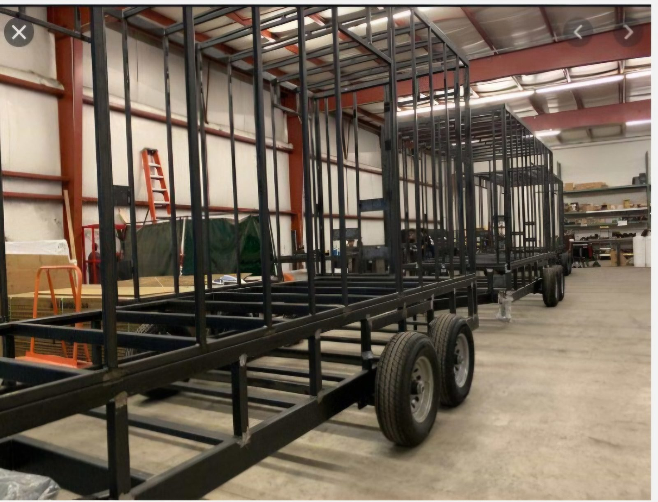
Figure 2 — Reference frame construction: welded steel tube chassis and wall framing (Church requests a two-layer floor frame so the fold-down stage is flush with the interior floor)
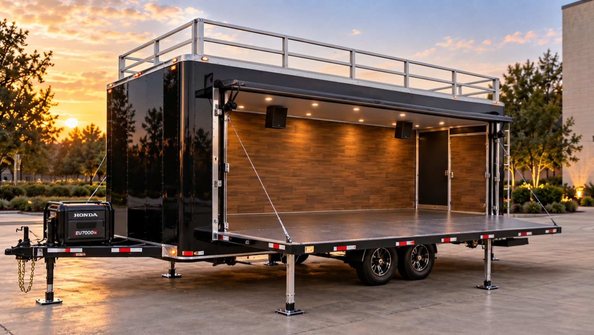
Figure 3 — Stage deployed (3/4 view): flush stage floor, lifted canopy, wood-look interior, recessed lighting, speakers, roof deck guardrails, stabilizer legs
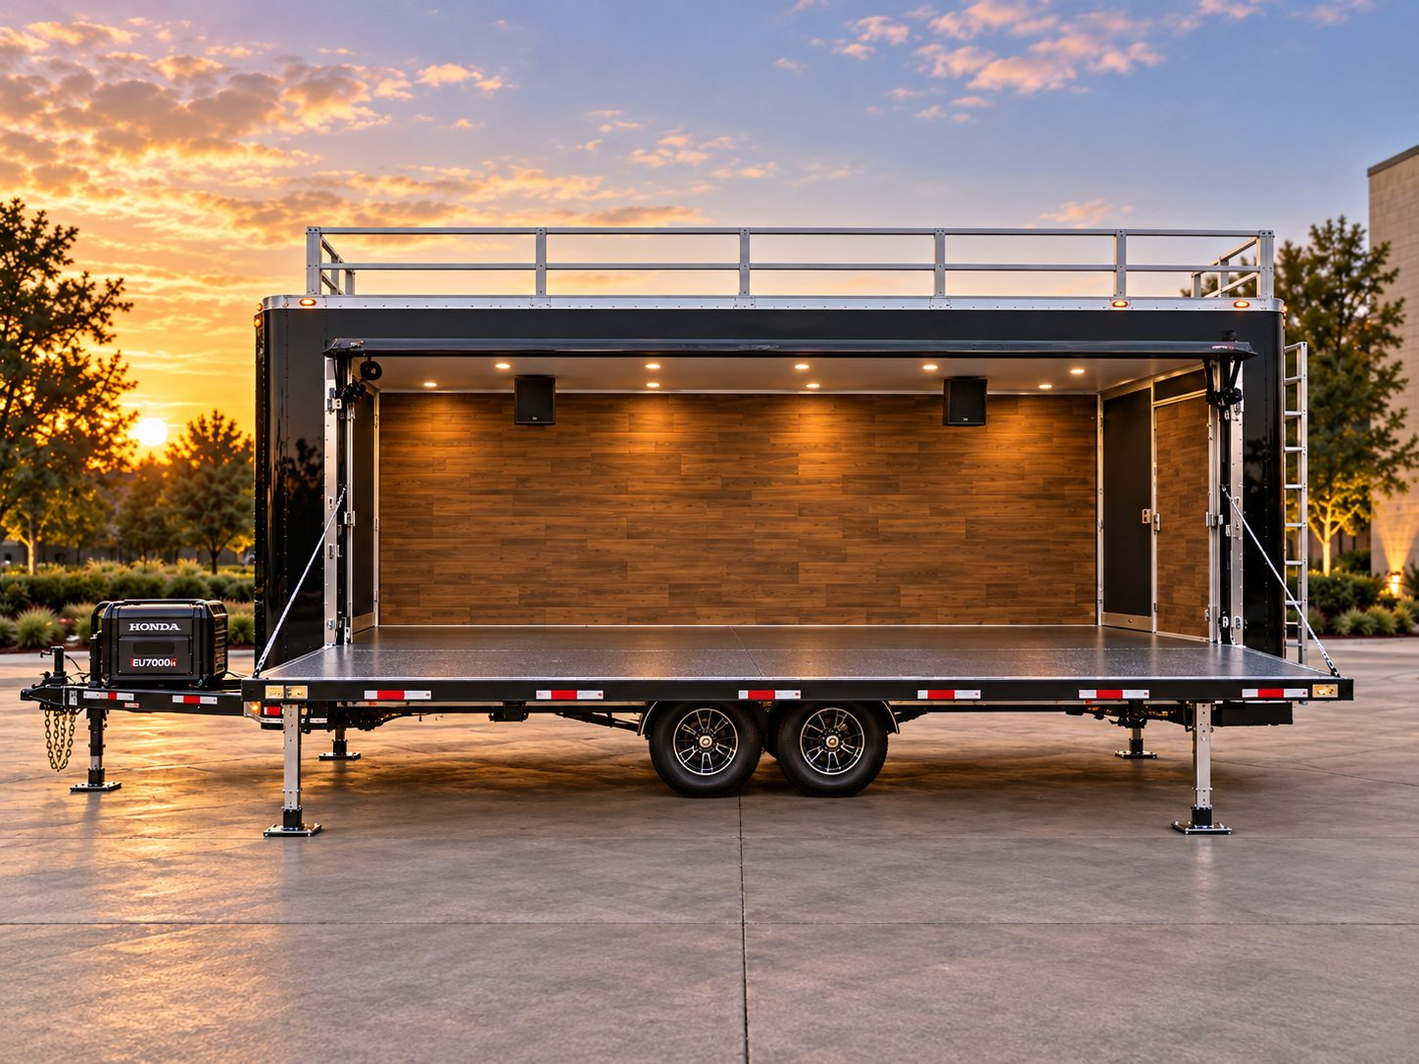
Figure 4 — Stage deployed (side view): continuous single-level stage, backstage doors, ladder, tongue-mounted generator
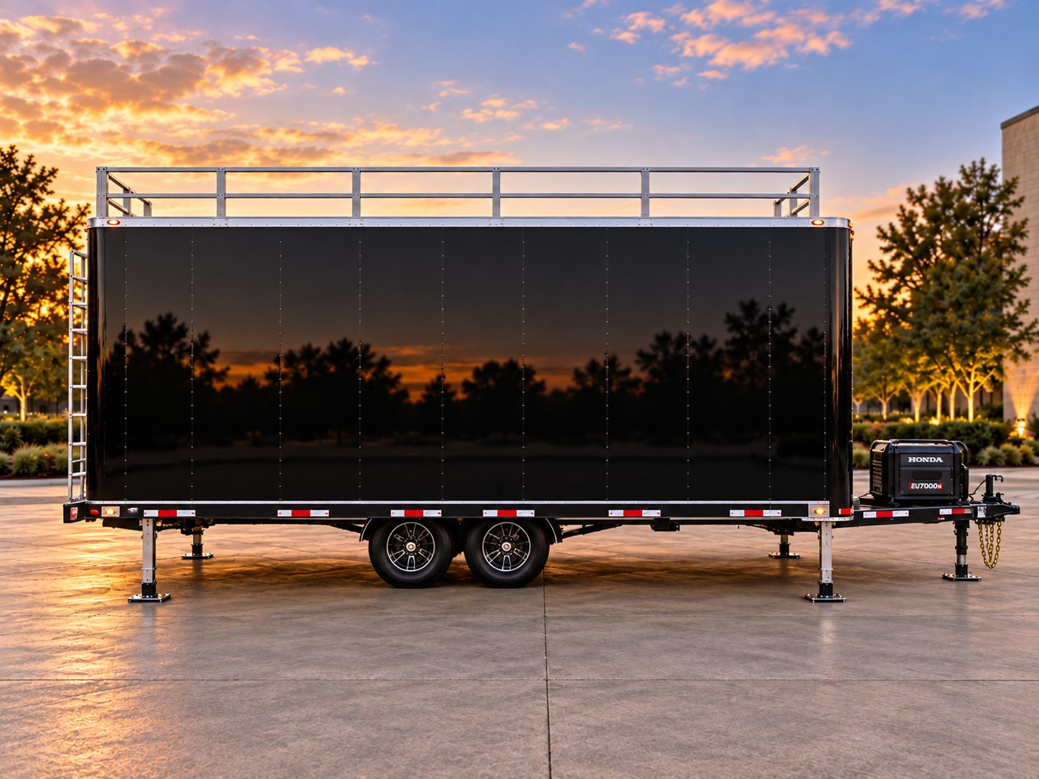
Figure 5 — Travel configuration (side view): gloss-black exterior, roof guardrails, stabilizer jacks
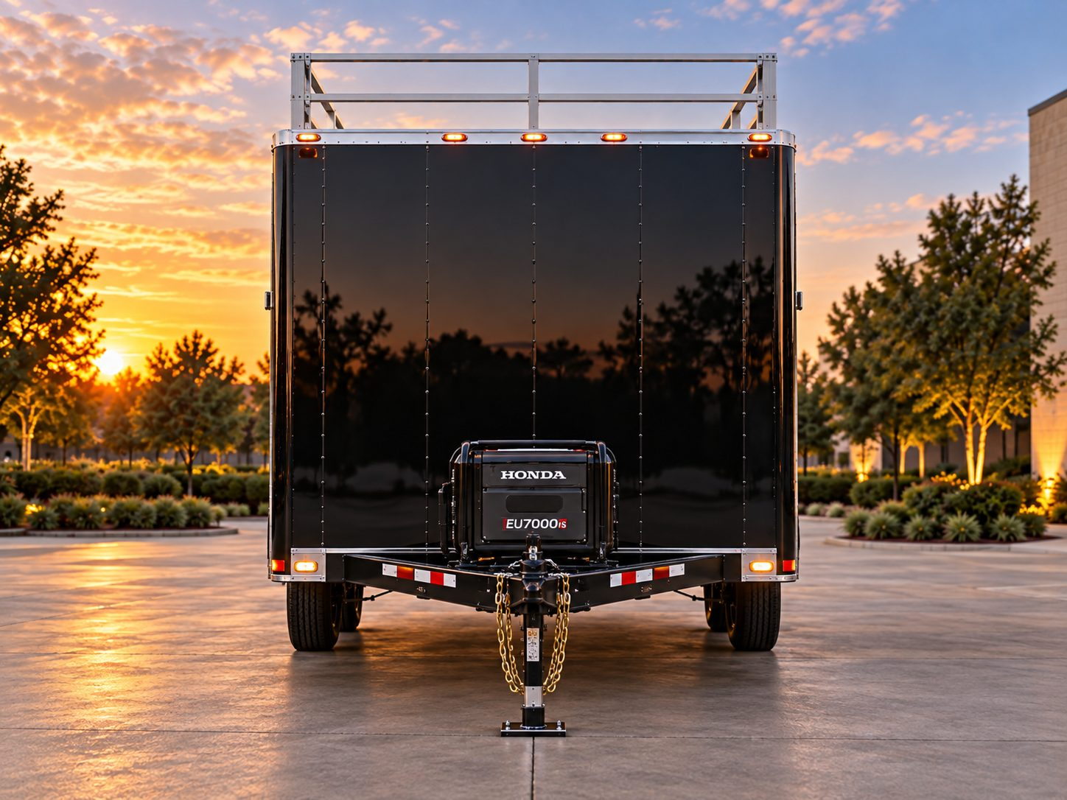
Figure 6 — Front view: tongue-mounted generator, stabilizer jack, safety chains
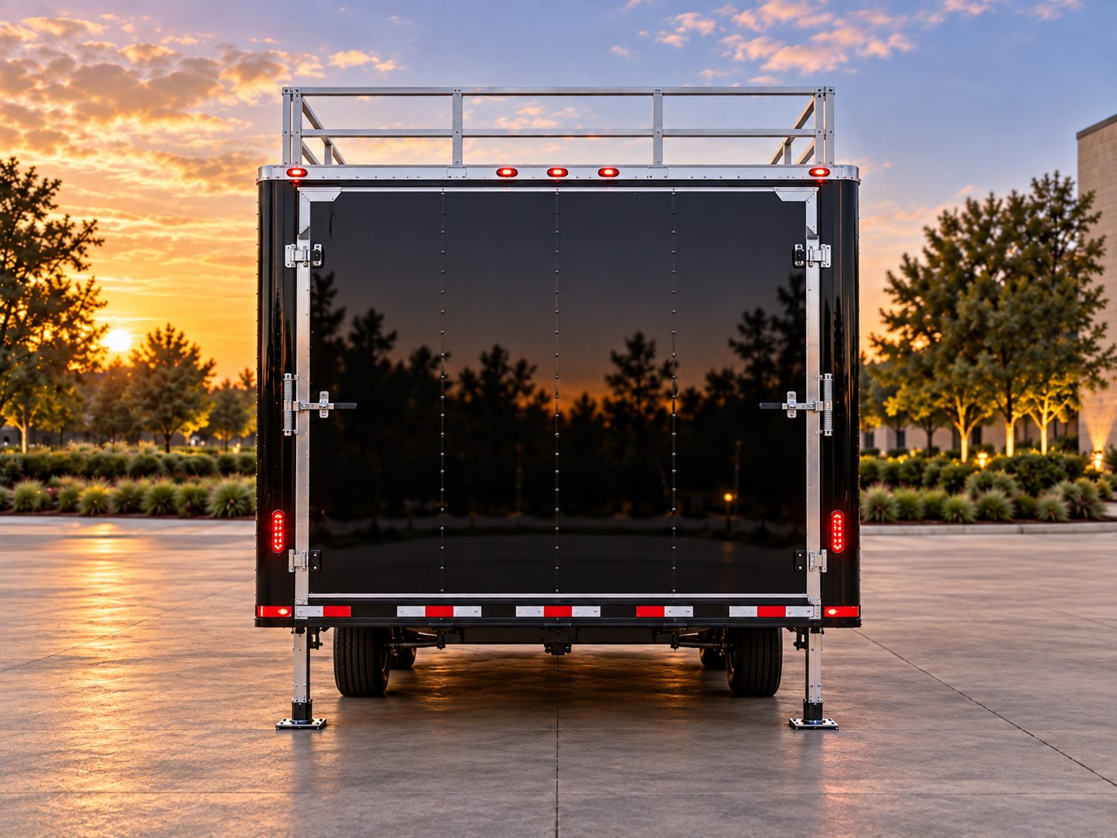
Figure 7 — Rear view option A: double rear barn doors with cam-bar latches
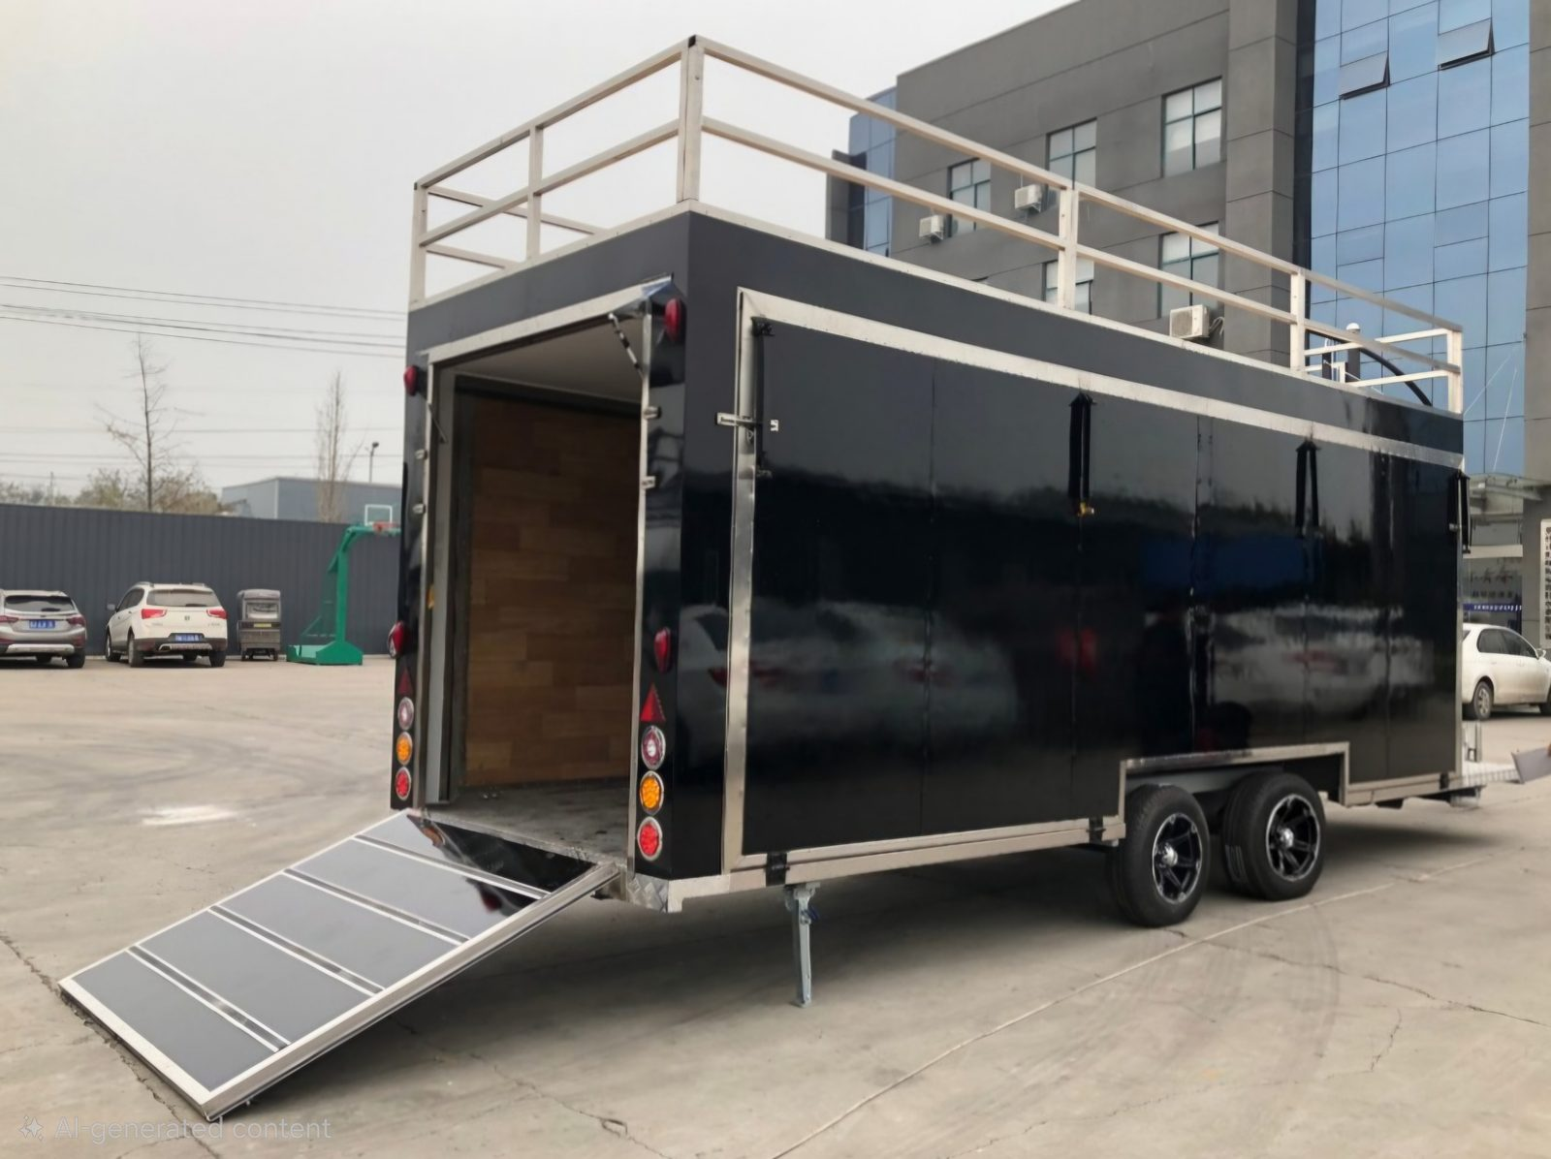
Figure 8 — Rear view option B: rear ramp door for equipment loading

7. Proposal Submission Requirements
Proposals should be organized using the sections below, in the order listed. Incomplete proposals may be deemed non-responsive.

7.1 Cover Letter
A one- to two-page letter signed by an authorized representative summarizing the Vendor's understanding of the project, the proposed solution, total price, and proposed delivery date. Include a statement that the proposal is valid for at least 90 days.

7.2 Company Profile & Qualifications
- Legal company name, address, website, and primary contact.
- Years in business and years building custom trailers / mobile stages.
- Description of facility, equipment, and in-house capabilities (welding, fabrication, electrical, HVAC, finishing, wraps).
- Number of employees and the project team that will be assigned (project manager, lead fabricator, electrician).
- List of any subcontractors and the work they will perform.
- Business licenses, certifications (e.g., NATM membership, AWS-certified welders, licensed electricians), and dealer/manufacturer registrations.

7.3 Portfolio — Pictures of Previous Custom Work (Required)
The Church requests photographs of at least 5–10 previously completed custom trailers, with emphasis on projects similar to this one. For each project, please include:
- Multiple photos (exterior, interior, and — where applicable — stage deployed and during construction/frame stage).
- A brief description: trailer size, key features, customer type (church, nonprofit, event company, business), and year completed.
- Particular interest in: mobile stage trailers, fold-down/hydraulic stage walls, rooftop decks, ministry/outreach trailers, concession or command trailers, and trailers with integrated generators, HVAC, and A/V systems.
- Links to videos, website galleries, or social-media pages showing completed work (encouraged).

7.4 References
Provide at least three (3) client references for similar custom builds completed within the last five years (churches or nonprofits preferred), including contact name, organization, phone, email, project description, and completion date.

7.5 Technical Proposal & Drawings
- Completed Vendor Response column for every line item in Section 5 (Comply / Exception / Notes).
- Preliminary drawings: floor plan, all four exterior elevations, a section showing the two-layer frame and flush stage hinge detail, and a deployed-stage view.
- Detailed equipment list with make/model for A/C units, generator, electrical components, and lighting.
- Electrical load calculation demonstrating generator sizing (see Appendix A for the Church's preliminary estimate).
- Estimated empty weight, GVWR, payload capacity, tongue weight, and recommended tow vehicle.
- Description of the stage deployment process and estimated setup/teardown time.
- Any recommended improvements, value-engineering ideas, or alternates.

7.6 Pricing
Complete the Pricing Form in Section 8. Pricing must be itemized; a single lump-sum price without breakdown will not be accepted. Identify sales tax treatment (the Church may be tax-exempt), delivery charges, and any items excluded.

7.7 Schedule
Provide a project schedule from contract signing to delivery showing design, engineering, material procurement, fabrication, electrical/HVAC, finishing, wrap, testing, and delivery milestones. Disclose current shop backlog.

7.8 Payment Terms, Warranty & Insurance
- Proposed payment schedule tied to milestones (the Church prefers progress payments, e.g., deposit at contract, payment at frame completion, payment at rough-in, and final payment upon acceptance).
- Full warranty terms and service/support process.
- Certificate of insurance showing general liability, product liability, and coverage of the trailer while in the Vendor's possession.
- Financing or leasing options, if available (optional).

7.9 How to Submit
Submit one (1) electronic copy (PDF) by email to Pastor Cary Baskin at cmbllc@yahoo.com with the subject line "FLC Ministry Trailer RFP — [Vendor Name]" no later than the due date in Section 4. Photos may be included in the PDF or provided via a shared link. Optional: one printed copy mailed to Family Life Church, Attn: Pastor Cary Baskin, 4362 US-59 S, Livingston, TX 77351. Late proposals may not be considered.

8. Pricing Form
Vendors must complete this form. Add rows as needed. All prices in U.S. dollars.
Item | Price | Lead Time / Notes
A. Base Trailer
Base trailer: chassis, two-layer steel frame, axles, brakes, tires, body, insulation, exterior skin
Flush fold-down stage wall with lift system, outriggers, stage legs, canopy/awning section
Rooftop walkable deck, guardrails, and ladder
Interior finish (wood-look walls, ceiling, stage flooring, partition, backstage doors, cabinetry)
Rear doors — Option A: double barn doors
Rear doors — Option B: ramp door
B. Power & Climate
Two (2) rooftop A/C units with soft starts, ducting, thermostats — installed
Generator (min. 10,000 W continuous) with enclosure, remote start, fuel system — installed
Electrical system: shore inlet, transfer switch, panel, surge protection, all outlets, 12 V system
Option: inverter/battery upgrade or roof solar
C. Lighting & Equipment Provisions
Lighting package (interior, stage LED washes, controller, exterior scene lights)
Provisions for Church-supplied sound system & instruments (Section 5.8: speaker mounts, conduit, rack space, storage, tie-downs)
Option: drum riser and sound-operator desk
D. Graphics, Options & Services
Full vinyl wrap with "Jesus On Wheels" branding (Church-supplied artwork)
Graphic design services (if needed)
Auto-leveling system (option)
Security package: GPS tracker, cameras, alarm (option)
Engineering / stamped structural letter
Training, documentation, and manuals
Delivery to Family Life Church (Livingston, TX)
Other Vendor-recommended options (list)
E. Totals
Total — Base Proposal (Sections A–D, excluding options/alternates)
Sales tax (if applicable)
Grand Total

Proposed delivery: ______ weeks after contract signing. Proposal valid for: ______ days.

9. Evaluation Criteria
Proposals will be evaluated by a Church committee using the criteria below. The Church is not obligated to select the lowest-priced proposal and will award to the Vendor offering the best overall value.
Criterion | Weight
Experience & portfolio of comparable custom builds (including photos of previous work) | 25%
Technical compliance with specifications, quality of design, and engineering of the flush stage floor | 25%
Price and overall value | 20%
Proposed schedule and ability to meet delivery date | 10%
Warranty, service, training, and post-delivery support | 10%
References and reputation | 10%
Total | 100%
Shortlisted Vendors may be invited to present their proposal, host a shop visit, or provide additional information.

10. Terms & Conditions
- This RFP does not commit Family Life Church to award a contract, to pay any costs incurred in preparing a proposal, or to procure or contract for services or equipment.
- The Church reserves the right to accept or reject any or all proposals, in whole or in part, to waive minor irregularities, to negotiate with any Vendor, and to cancel this RFP at any time.
- All costs of preparing and submitting a proposal are the sole responsibility of the Vendor.
- Proposals become the property of the Church. The Church will treat pricing and proprietary information as confidential to the extent practical.
- The selected Vendor will be required to execute a written contract including final specifications, approved drawings, price, payment schedule, delivery date, warranty, and change-order procedure. No work shall begin until the contract is signed and drawings are approved in writing.
- Any changes in scope after contract signing must be documented through a written change order signed by both parties before work proceeds.
- The Vendor shall maintain appropriate insurance and assume risk of loss for the trailer and all equipment until delivery and acceptance by the Church.
- The trailer must comply with all applicable federal, state, and local laws and regulations for road use and electrical safety. Vendor shall furnish the MSO/MCO and all documentation needed for titling.
- The Church will furnish its own sound system and musical instruments. The Vendor shall coordinate with the Church on mounting, power, and storage provisions, and the Church may elect to have the Vendor install certain Church-supplied items under a separate written agreement.
- Artwork, logos, and branding provided by the Church remain the property of Family Life Church and may be used only for this project. Vendor may photograph the finished trailer for its portfolio with the Church's written permission.

11. Vendor Questions & Contact Information
All questions regarding this RFP must be submitted in writing by email to the RFP Contact by the question deadline. Answers will be shared with all Vendors who have submitted a notice of intent to bid. Vendors should not contact other Church staff or members regarding this RFP.
RFP Contact | Pastor Cary Baskin, Senior Pastor
Organization | Family Life Church of Livingston
Email | cmbllc@yahoo.com
Phone | (936) 365-3113 (Church Office)
Mailing Address | 4362 US-59 S, Livingston, TX 77351
Website | www.flcworship.com

Appendix A — Estimated Electrical Load Worksheet
The table below is the Church's preliminary estimate to guide generator sizing. Vendors must verify and submit their own calculation based on the specific equipment proposed.
Load | Qty | Running Watts (each) | Running Watts (total) | Startup Surge (est.)
Rooftop A/C, 15,000 BTU (with soft start) | 2 | ~1,700 | ~3,400 | ~2,000 each with soft start (~3,000+ without)
P/A system (Church-supplied) — powered mains, subs, monitors (average program) | 1 | ~1,500 | ~1,500 | —
Mixer, wireless mics, rack (Church-supplied) | 1 | ~300 | ~300 | —
Instruments (Church-supplied): keyboards, amps, electronic drums | 1 set | ~600 | ~600 | —
Stage LED lighting (6–8 fixtures) | 1 | ~600 | ~600 | —
Interior & exterior LED lighting | 1 | ~200 | ~200 | —
Auxiliary outlets (laptops, projector/screen, chargers, misc.) | 1 | ~1,000 | ~1,000 | —
Estimated total running load |  |  | ~7,600 W
Recommended minimum generator (≈30% headroom) |  |  | 10,000 W continuous

Note: Using external 30 A/50 A outputs for third-party equipment (inflatables, food vendors) will require additional capacity or a separate generator. Vendors should advise.

Appendix B — Vendor Submission Checklist
Required Item | Included (✓)
Signed cover letter (proposal valid 90 days)
Company profile, licenses, certifications, project team, subcontractors
Photos of 5–10 previous custom builds with descriptions
Three (3) or more client references
Completed Section 5 specification response tables
Preliminary drawings including two-layer frame / flush stage hinge detail
Equipment list with makes/models
Electrical load calculation and generator recommendation
Weight estimate (empty weight, GVWR, tongue weight) and tow-vehicle recommendation
Completed, itemized Pricing Form (Section 8)
Project schedule and current backlog
Payment terms, warranty terms, and service plan
Certificate of insurance
Signed Vendor Acknowledgment (Appendix C)

Appendix C — Vendor Acknowledgment & Signature
By signing below, the Vendor acknowledges that it has read and understands this Request for Proposal, including all specifications and terms, and that the information submitted in its proposal is true and accurate. The Vendor agrees that its proposal will remain valid for ninety (90) days from the proposal due date.
Addenda received (list numbers): ______________________

Company Name
Authorized Representative
Title
Signature
Date
Address
Phone / Email
Website / Social Media (portfolio)

Thank you for your interest in partnering with Family Life Church to take the Gospel "Outside The Four Walls."

