本期内容:
- 对StreamingContext功能及源码解析
- 对Dstream功能及源码剖析
- 对Receiver功能及其源码剖析
- 最后一部分将StreamingContext,Dstream,Receiver结合起来分析其流程
- StreamingContext功能及其源码剖析:
- 通过StreamingContext对象jssc,创建应用程序主入口，并连上Driver上的接收数据服务端口9999写入源数据
数据来源：inputDstream----receiver
处理数据:Dstrream transformation->Dstream graph就是DAG的模板，这个模板是框架托管的，当我们指定时间间隔的时候例如5秒钟，Driver端就会根据时间间隔触发job,它触发job的方式就是根据outputDStream指定的function操作。例如print会传给foreachRDD，最后转换为RDD.action最后，RDD产生。
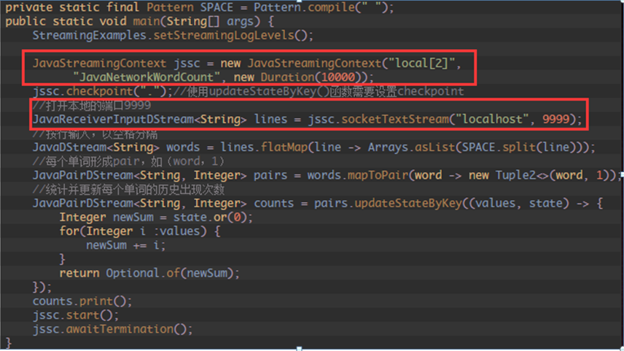
- StreamingContext的主要功能:
主程序的入口:
提供了各种创建DStream的方法接收流入的数据（例如:Kafka,Flume,Twitter,ZeroMQ和简单的TCP套接字等)

通过构造函数实例化StreamingContext对象时，可以指定Master URL,appName,或者传入SparkConf配置对象，或者已经创建的SparkContext对象；

将接收的数据传入Dstreams对象中
通过StreamingContext对象实例的Start方法启动当前应用程序的流计算框架或通过Stop方法结束应用程序的流计算框架
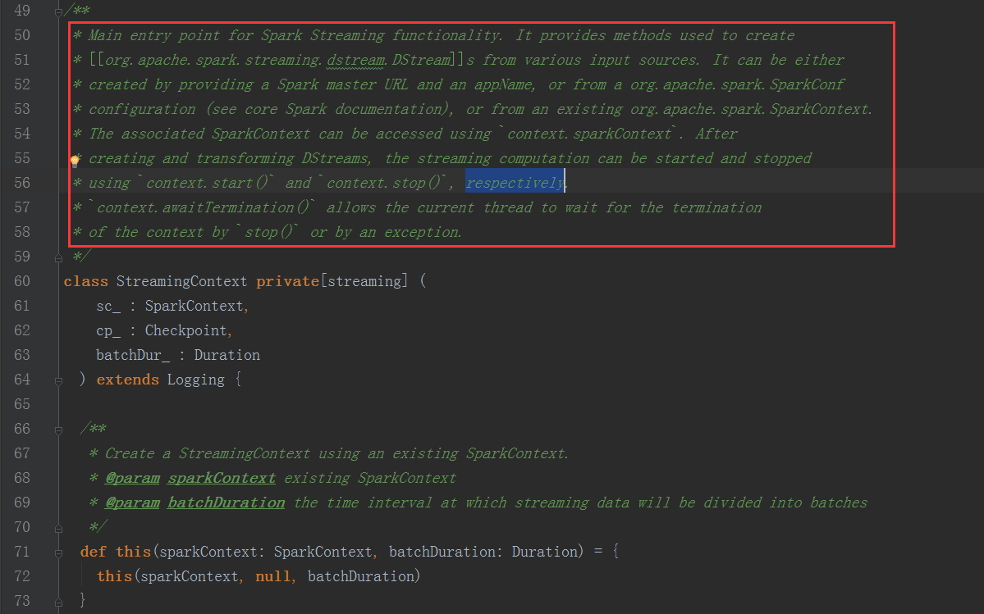
- DStream功能及其源码剖析
1.Dstream是RDD的模板，Dstream是抽象的，RDD也是抽象的
2.Dstream的具体实现子类如下图所示
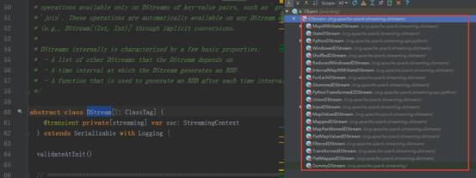
- 以StreamingContext实例的socketTextStream方法为例，其执行完的结果返回Dstream对象实例，其源码调用过程如下图:
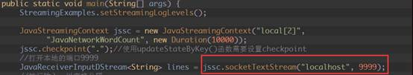
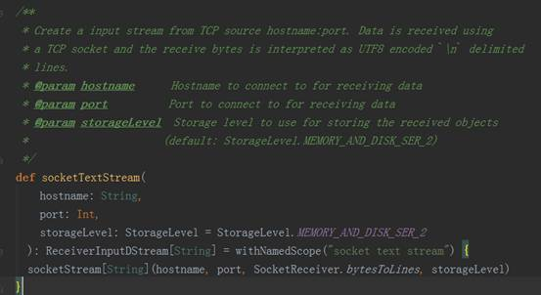
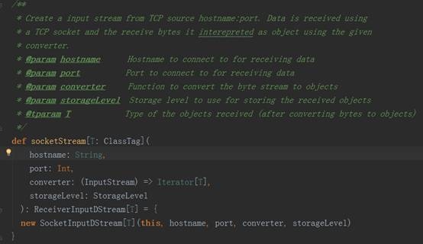
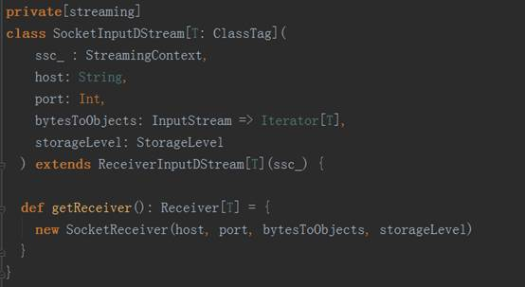
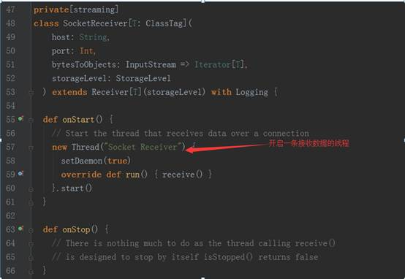
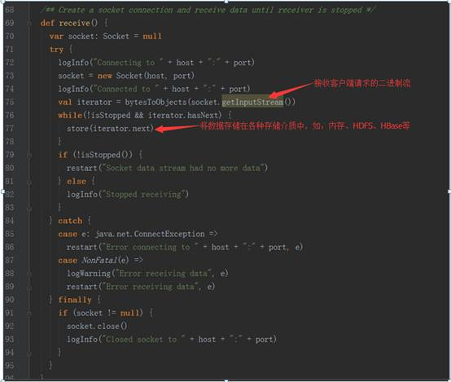
socket.getInputStream获取数据，while循环来存储储蓄数据（内存，磁盘)
- Receiver功能及源码剖析:
- Receiver代表数据的输入，接收外部输入的数据，如从Kafka上抓取数据;
- Receiver运行在Worker节点上；
- Receiver在Worker节点上抓取Kafka分布式消息框架上的数据时，具体实现类是KafkaReceiver
- Receiver是抽象类，其抓取数据的实现子类如下图所示:
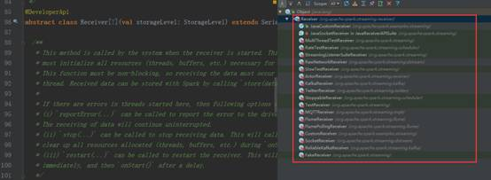
- 如果上述实现类都满足不了您的要求，您自己可以定义Receiver类，只需要继承Receiver抽象类来实现自己子类的业务需求。
- StreamingContext,Dstream,Receiver结合流程分析:
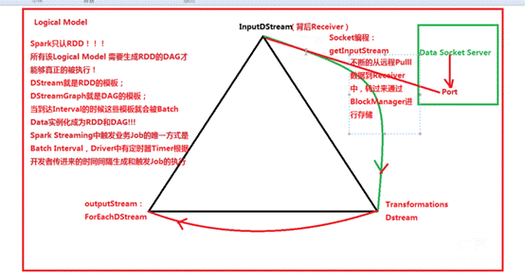
- inputStream代表了数据输入流(如:Socket,Kafka,Flume等
- Transformation代表了对数据的一系列操作，如flatMap,map等
- outputStream代表了数据的输出，例如wordCount中的print方法
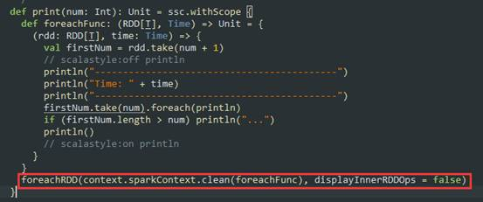
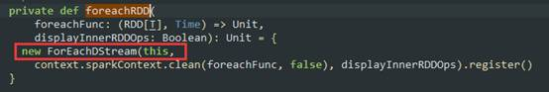

数据在流进来之后最终会生产Job,最终还是基于Spark Core的RDD进行执行；在处理流进来的数据时是Dstream进行Transforamtion由于StreamingContext所以根本不会去运行，StreamingContext会根据Transforamtion生成”Dstream”的链条即DstreamGraph,而DstreamGraph就是DAG的模板，这个模板是被框架托管的。当我们指定时间间隔的时候，Driver端回根据这个时间间隔来触发Job而触发Job的方法就是根据outputDstream中指定的具体的function,例如wordcount中print，这个函数一定会传给foreachDstream,它会把函数交给最后一个Dstream产生的RDD,也就是RDD的print操作，而这个操作就是RDD触发Action
总结:
使用Spark Streaming可以处理各种数据来源类型，如：数据库，HDFS,服务器log日志，网络流，其强大超越了你想象不到的场景，只是很多时候大家不会用，其真正的原因是对Spark,spark streaming本身不了解

/**
* Main entry point for Spark Streaming functionality. It provides methods used to create
* [[org.apache.spark.streaming.dstream.DStream]]s from various input sources. It can be either
* created by providing a Spark master URL and an appName, or from a org.apache.spark.SparkConf
* configuration (see core Spark documentation), or from an existing org.apache.spark.SparkContext.
* The associated SparkContext can be accessed using `context.sparkContext`. After
* creating and transforming DStreams, the streaming computation can be started and stopped
* using `context.start()` and `context.stop()`, respectively.
* `context.awaitTermination()` allows the current thread to wait for the termination
* of the context by `stop()` or by an exception.
*/

/**
* A Discretized Stream (DStream), the basic abstraction in Spark Streaming, is a continuous
* sequence of RDDs (of the same type) representing a continuous stream of data (see
* org.apache.spark.rdd.RDD in the Spark core documentation for more details on RDDs).
* DStreams can either be created from live data (such as, data from TCP sockets, Kafka, Flume,
* etc.) using a [[org.apache.spark.streaming.StreamingContext]] or it can be generated by
* transforming existing DStreams using operations such as `map`,
* `window` and `reduceByKeyAndWindow`. While a Spark Streaming program is running, each DStream
* periodically generates a RDD, either from live data or by transforming the RDD generated by a
* parent DStream.
*
* This class contains the basic operations available on all DStreams, such as `map`, `filter` and
* `window`. In addition, [[org.apache.spark.streaming.dstream.PairDStreamFunctions]] contains
* operations available only on DStreams of key-value pairs, such as `groupByKeyAndWindow` and
* `join`. These operations are automatically available on any DStream of pairs
* (e.g., DStream[(Int, Int)] through implicit conversions.
*
* DStreams internally is characterized by a few basic properties:
* - A list of other DStreams that the DStream depends on
* - A time interval at which the DStream generates an RDD
* - A function that is used to generate an RDD after each time interval
*/
abstract class DStream[T: ClassTag] (
@transient private[streaming] var ssc: StreamingContext
) extends Serializable with Logging {
validateAtInit()

