|  |  |  |  |  |  |  |  |
| --- | --- | --- | --- | --- | --- | --- | --- |
| **Technical Report:** | **(9014)XXX-XXXX** | | | | Page 1 of 3 | | |
| **Date Received:** | JUN. 09, 2014 | | | |  | | |
| **Date Modified:** | / | | | |  | | |
| **Date Out:** | JUN. 13, 2014 | |  | **OVERALL RATING** | | **PASS** |  | |
|  | |  |  |  | |
|  | |  |  |  | |

|  |  |  |  |
| --- | --- | --- | --- |
| **Vendor:** | vendor | **Factory/Manufacturer:** | weishi |
| **Sample Description:** | watch | **Retest:** | YES |
| **Style No.:** | 1111111 | **P.O. No.:** | 434321231 |
| **Country of Origin:** | USA | **Country of Destination:** | ENGLANDdCHINA |
| **Color:** | green | **Brand Name:** | WEI |
| **Previous Report No.:** | / | | |

|  |  |  |  |  |
| --- | --- | --- | --- | --- |
| **TEST PROPERTY** | **PASS** | **FAIL** | **DATA** | **COMMENTS** |
| TOTAL LEAD AND CADMIUM CONTENT | X |  |  |  |

|  |
| --- |
| **TEST RESULT** |

**Total Lead And Cadmium Content**

|  |  |  |  |  |  |  |  |
| --- | --- | --- | --- | --- | --- | --- | --- |
| **Test Point** | **Component** | **Result(ppm)** | | **Limit(ppm)** | | **Material Type** | **Conclusion** |
| **Lead** | **Cadmium** | **Lead** | **Cadmium** |
| 1 | Transparent coating on metal(refer to (9014)122-0059 T1) | 19.3 | 15.6 | 90 | 40.0 | I | PASS |
| 2 | Transparent coating on metal(refer to (9014)122-0059 T1) | 15 | 16 | 17 | 18 | 19 | 20 |

|  |  |  |  |  |  |  |  |
| --- | --- | --- | --- | --- | --- | --- | --- |
| **Type I:** | | | |  | **For Material Classified As Surface Coating** | | |
| Test Method  (For Lead) | | | | **:** | CPSC-CH-E1003-09.1,Standard Operating Procedure for Determining Lead (Pb) in Paint and Similar Surface Coatings,Feb 25,2011 | | |
| Test Method  (For Cadmium) | | | | **:** | AOAC 974.02:2005 (Modified). Analysis by Inductively Coupled Argon Plasma Spectrometer (ICP). | | |
| **Type II:** | | | |  | **For Material Classified As Metal** | | |
| Test Method  (For Lead) | | | | **:** | CPSC-CH-E1001-8.3.Standard Operating Procedure for Determining Total Lead (Pb) in Children’s Metal Products (Including Children’s Metal Jewelry), Revision,Nov 15,2012 | | |
| Test Method  (For Cadmium) | | | | **:** | EPA 3050B:1996 (Modified) .Analysis by Inductively Coupled Argon Plasma Spectrometer (ICP) or Atomic Absorption Spectrophotometer(AAS) | | |
| **Type III:** | | | |  | **For Material Classified As Plastic and Other Substrate Material** | | |
| Test Method  (For Lead) | | | | **:** | CPSC-CH-E1002.08.3 Standard Operating Procedure for Determining Total Lead in Non-Metal Children’s Products,Revision, Nov 15,2012 | | |
| Test Method  (For Cadmium) | | | | **:** | EPA 3051A:2007 (Modified) or EPA 3052:1996 (Modified). Analysis by Inductively Coupled Argon Plasma Spectrometer (ICP) or Atomic Absorption Spectrophotometer(AAS) | | |
| Note: |
|  | | “<” = Less than | | | mg/kg = milligram per kilogram = ppm = part per million |
|  | | g = gram | | |  |

**Original Sample**

**BVCPS (SHANGHAI)-QINGDAO BRANCH CONTACT INFORMATION FOR THIS REPORT**

**Technical enquiry:**

Stephen Han 86-532-58827919 stephen.han@cn.bureauveritas.com

**General enquiry and invoicing:**

Carol Zhu 86-532-58827917 cpshlop1.qd@cn.bureauveritas.com

Jenny Huang 86-532-58827917 cpshlop1.qd@cn.bureauveritas.com

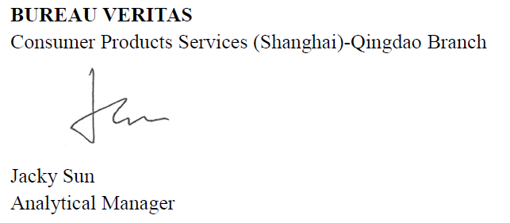

2

Transparent coating on metal(refer to (9014)122-0059 T1)