**Translator Application Documentation**

**Overview**

This Translator Application is a simple GUI-based translation tool built using Python's Tkinter for the GUI and Hugging Face's MarianMTModel for the translation functionality. It allows users to translate text between different languages by leveraging pre-trained machine translation models.

**Table of Contents**

1. Installation Requirements
2. How to Run the Application
3. Features
4. OOP Implementation
5. File Structure

**Installation Requirements**

To run the Translator Application, you need to have Python installed (preferably version 3.6+). Additionally, the following libraries need to be installed in your environment.

**Packages to Install**

1. **Tkinter** (for the GUI)
   * On Linux:

sudo apt-get install python3-tk

* + On Windows/macOS, Tkinter usually comes pre-installed with Python.

1. **Transformers** (for Hugging Face translation models)

pip install transformers

1. **PyTorch** (for loading the MarianMT translation model)
   * For most systems (CPU-based):

pip install torch torchvision torchaudio

* + For specific setups (CUDA/GPU), visit [PyTorch installation](https://pytorch.org/get-started/locally/) for detailed instructions.

1. **SentencePiece** (required for tokenization)

pip install sentencepiece

1. **Sacremoses** (optional for tokenization post-processing)

pip install sacremoses

1. **Huggingface-hub** (for managing model files and configurations)

pip install huggingface-hub

**Complete Installation Command**

pip install transformers torch torchvision torchaudio sentencepiece sacremoses huggingface-hub

**How to Run the Application**

Once all the required packages are installed, you can run the Translator Application by following these steps:

**Step 1: Download/Clone the Repository**

* If you have the repository on your local machine, navigate to the folder where the app.py file is located.

**Step 2: Run the Application**

* Open a terminal or command prompt in the project directory.
* Run the following command:

python app.py

This will launch the Translator Application's GUI.

**Step 3: Using the Application**

1. Input the text you want to translate.
2. Click on the "Translate" button.
3. 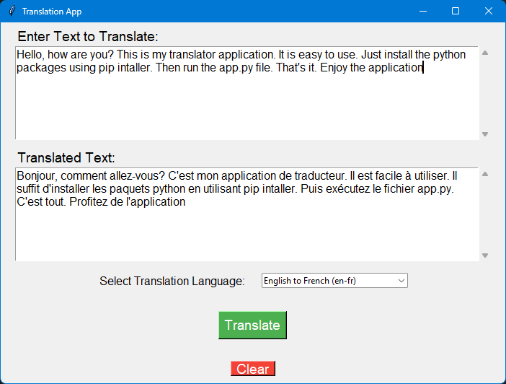The translated text will be displayed in the designated area.

Figure : Screenshot of translator app while translating an English paragraph into French Language

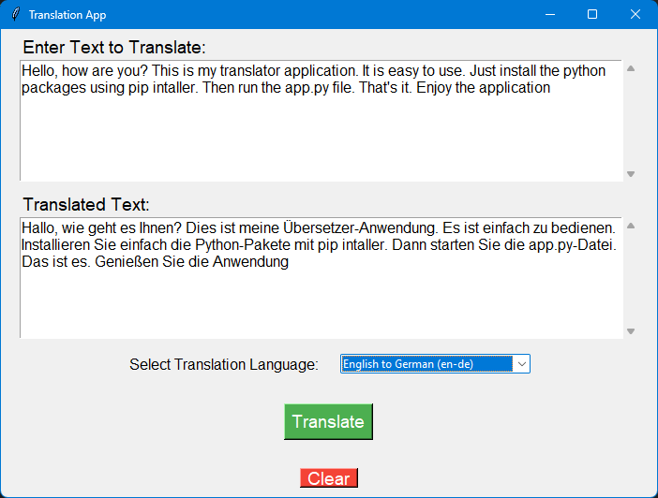

Figure : Screenshot of Translator APP while translating English to German

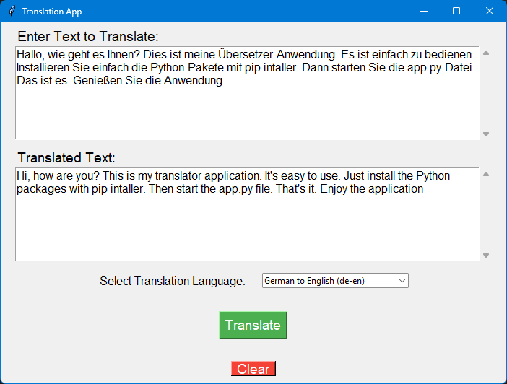**Features**

Figure :Screenshot of Translator APP while translating German to English

1. **Simple GUI**: The application uses a Tkinter GUI, allowing users to input text and receive translations.
2. **Multiple Language Translation**: The app uses Hugging Face’s MarianMTModel to translate between various languages.
3. **Error Handling & Logging**: The app includes decorators for logging translation activity and handling errors, ensuring a smooth user experience.

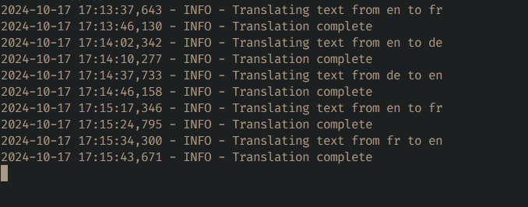**OOP Implementation**

Figure :Screenshot of Loggin

This Translator Application implements several key Object-Oriented Programming (OOP) concepts. Here's how OOP is applied:

**1. Encapsulation**

* **Class-Based Design**: The app separates functionality into different classes for modularity and clarity.
  + HuggingFaceTranslateService: Encapsulates the logic for translation services.
  + TranslationGUI: Encapsulates the logic for creating and managing the GUI components.
  + LabeledEntry: Encapsulates GUI elements for user input fields (from gui_components.py).
* These classes contain methods that hide their internal implementation details, providing a clean interface for other parts of the code.

**2. Abstraction**

* The TranslationService class (in translator.py) is an **abstract base class** (ABC) that defines the structure of any translation service with the translate method.
* **HuggingFaceTranslateService** implements this abstract class and provides the concrete implementation using the MarianMT model.

**3. Inheritance**

* **TranslationService** is the parent class, and HuggingFaceTranslateService inherits from it.
* This allows the code to define a common structure (the translate method) in the base class and implement specific behavior (MarianMT translation) in the child class.

**4. Polymorphism**

* The translate method in TranslationService is overridden in the subclass HuggingFaceTranslateService. This allows different types of translation services to be created by simply changing the class, enabling flexibility in the app’s design.
* This allows the app to use a general interface for translation services while relying on the specific implementation for Hugging Face models.

**5. Decorators (Enhancing OOP)**

* **log_translation** and **handle_errors** decorators are used to enhance class methods with additional functionality such as logging and error handling. This ensures that object methods are extended without modifying their core functionality.

**File Structure**

├── app.py # Main entry point of the application

├── translator.py # Contains translation logic (OOP implementation with Hugging Face)

├── decorators.py # Custom decorators for logging and error handling

├── gui_components.py # GUI components encapsulated in classes

├── translation_gui.py # GUI management and logic for displaying translations

* **app.py**: Contains the main() function that initializes the GUI and translation service.
* **translator.py**: Implements the HuggingFaceTranslateService class, inheriting from TranslationService.
* **decorators.py**: Defines decorators for logging and error handling to enhance OOP functionality.
* **gui_components.py**: Contains reusable GUI components like LabeledEntry.
* **translation_gui.py**: Manages the GUI layout and connects it with the translation service.

**Conclusion**

This Translator Application demonstrates a clean, OOP-based design while utilizing modern NLP models from Hugging Face. By adhering to OOP principles, the code is modular, maintainable, and easy to extend. By simply changing the translation service class or adding new features, the app can scale to more complex use cases.