Questions

1@ What are the differnece between I2C and SPI protocol ?

2@ What is the frame format of SPI ?

3@ what are the Speed modes of SPI ?

4@ Explain The process of data propagation in SPI with the signification of clock Phase and clock polarity.

[1.]  Some of the features that allows SPI widely used are.

    1. Full duplex communication.

    2. Higher throughput than TWI.

    3. Not limited to 8 bit words in the case of bit transferring.

    4. Simple hardware interfacing

    5. Arbitrary choice of message sizes, contents and purpose.

    6. Typically low power requirements

    7. Slave uses master’s clock and does not require precision oscillators.

    8. Lower power requirements than TWI due to less circuitry.

9. There is not any standard speed for SPI.

[2.]

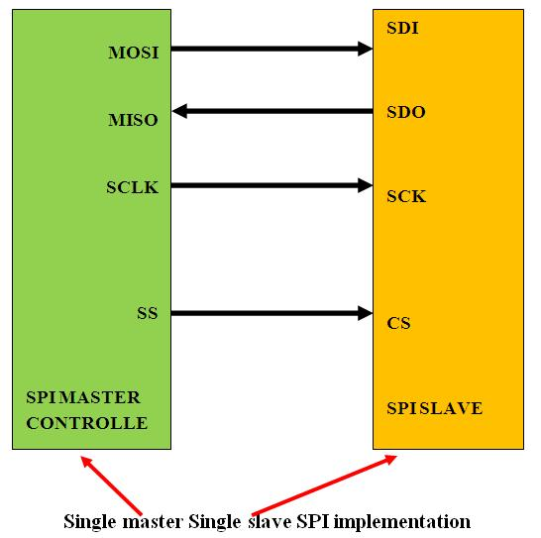

[3. ] **Clock polarity and phase in SPI :**

|  |  |  |
| --- | --- | --- |
| **Mode** | **Clock Polarity (CPOL)** | **Clock Phase (CPHA)** |
| **SPI_MODE0** | 0 | 0 |
| **SPI_MODE1** | 0 | 1 |
| **SPI_MODE2** | 1 | 0 |
| **SPI_MODE3** | 1 | 1 |

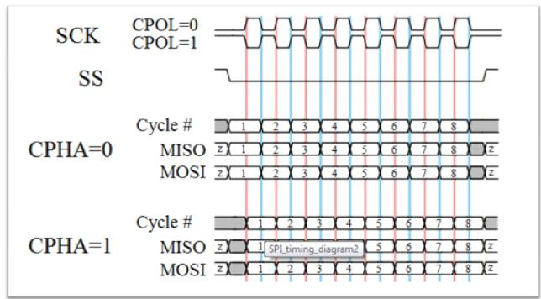

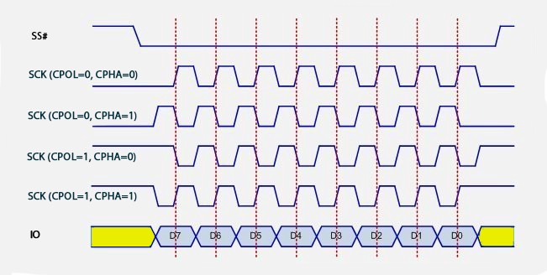

1. If the phase of the clock is zero (i.e. CPHA = 0) data is latched at the rising edge of the clock with CPOL = 0, and at the falling edge of the clock with CPOL = 1.
2. If CPHA = 1, the polarities are reversed. Data is latched at the falling edge of the clock with CPOL = 0, and at the rising edge with CPOL = 1.