###### **Excerpts from Interview #1:** **Technical Interview:**

* What is internal size of RAM, ROM in 8051?
* Tell us a File operation in C language with an illustrated example.
* What is the difference between i=10 & i==10?
* What is silicon BJT circuit?
* Compare DTL and TTL families of digital ICs
* What is job of loader in compiler?

1. The standard 8051 comes with **4K ROM, 128 bytes RAM**, 4 8bit ports and 2 timer

counters. Other members of the family are the ROMless 8031, 8052 with 256 bytes of RAM and 3 counter/timers etc.

3). a=10' is used to assign the value of 10 in 'a' variable whereas 'a==10' compare the value of 'a' variable with 10.

4).

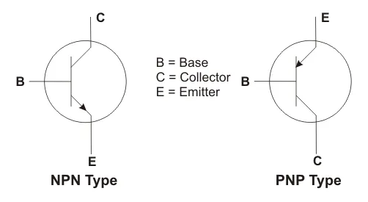 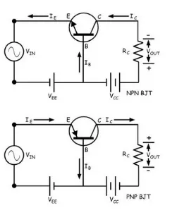

5).

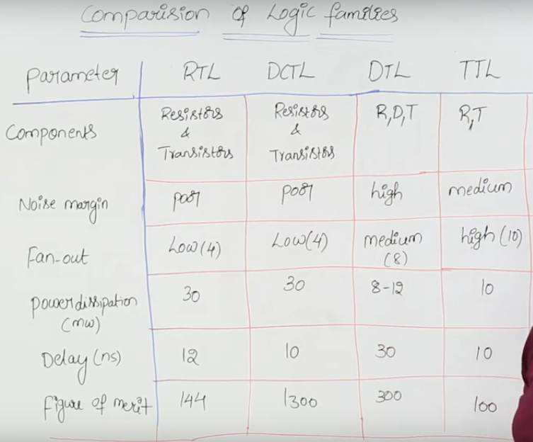

6). Loader

Loader is a part of operating system and is responsible for loading executable files into memory and execute them. It calculates the size of a program (instructions and data) and creates memory space for it. It initializes various registers to initiate execution.

### Cross-compiler

A compiler that runs on platform (A) and is capable of generating executable code for platform (B) is called a cross-compiler.

### Source-to-source Compiler

A compiler that takes the source code of one programming language and translates it into the source code of another programming language is called a source-to-source compiler.

###### **Excerpts from Interview #2:**

**Technical interview:**

* Draw and explain Architecture of microcontroller 8051?
* What is the SPI Protocol?
* Define Zener diode.
* Can you execute bit Array in C language. ANS. YES
* Differentiate S-R and J-K flip flops.
* Explain the working of a prime no. series generator in C.

-----------------------------------------------------------------------------------------------------------------------------------

ZENER DIODE-🡪A Zener diode is a heavily doped semiconductor device that is designed to operate in the reverse direction.

A Zener diode not only allows current to flow from anode to cathode but also, in the reverse direction on reaching the Zener voltage.

BIT ARRAY🡪 This is a C Program to implement Bit Array. A bit array is an array data structure that compactly stores bits. It can be used to implement a simple set data structure. A bit array is effective at exploiting bit-level parallelism in hardware to perform operations quickly.

Difference between S-R & J-K Flipflop🡪 The JK Flipflop is a variation or an improvement of the SR Flipflop.

The only difference between JK flip flop and SR flip flop is that **when both inputs of SR flip flop is set to 1**, the circuit produces the invalid states as outputs, but in case of JK flip flop, there are no invalid states even if both 'J' and 'K' flip flops are set to 1.

###### **Excerpts from Interview #3:**

**Technical interview:**

* Is the following statement valid: int *char = 25?
* Explain to us the internal structure of UART.
* Define the terms inductance, resistance and capacitance? Give the units of measurement of each.
* What is an ideal differential amplifier?
* Discuss any Quist plot.
* How does a half wave rectifier circuit work?

--------------------------------------------------------------------------------------------------------------------------------------

1). No, becaue both int & char are keywords , we cant use together like that.

**UART Block Diagram (internal structure)**

The UART block diagram consists of two components namely the transmitter & receiver that is shown below.  The transmitter section includes three blocks namely transmit hold register, shift register and also control logic. Likewise, the receiver section includes a receive hold register, shift register, and control logic. These two sections are commonly provided by a baud-rate-generator. This generator is used for generating the speed when the transmitter section & receiver section has to transmit or receive the data.

The hold register in the transmitter comprises the data-byte to be transmitted. The shift registers in transmitter and receiver move the bits to the right or left till a byte of data is transmitted or received. A read (or) write control logic is used for telling when to read or write.

The baud-rate-generator among the transmitter and the receiver generates the speed that ranges from 110 bps to 230400 bps. Typically, the baud rates of microcontrollers are 9600 to 115200.

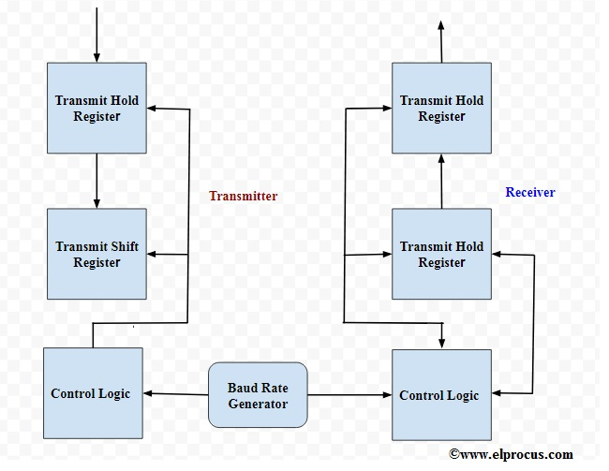

3).

## Capacitance

Capacitance is the ability of a device to store [electric charge](https://www.livescience.com/53144-electric-charge.html), and as such, the electronic component that stores electric charge is called a capacitor.

## Resistance

As its name implies, a resistor is an electronic component that resists the flow of [electric current](https://www.livescience.com/53889-electric-current.html) in a circuit.

## Inductance

An inductor is an electronic component consisting of a coil of wire with an electric current running through it, creating a magnetic field. The unit for inductance is the henry (H).

An **inductor** is an energy storage device which stores energy in form of [magnetic field](https://www.electrical4u.com/magnetic-field/).

6). Rectifier 🡪 A rectifier is a device that converts [alternating current](https://www.electrical4u.com/alternating-current/) (AC) to [direct current](https://www.electrical4u.com/dc-current/) (DC). It is done by using a diode or a group of diodes. Half wave rectifiers use one diode, while a [full wave rectifier](https://www.electrical4u.com/full-wave-rectifiers/) uses multiple diodes.

A **half wave rectifier** is defined as a [type of rectifier](https://www.electrical4u.com/rectifier-type-instrument-construction-principle-of-operation/) that only allows one half-cycle of an AC [voltage](https://www.electrical4u.com/voltage-or-electric-potential-difference/) waveform to pass, blocking the other half-cycle. Half-wave rectifiers are used to convert AC voltage to DC voltage, and only require a single [diode](https://www.electrical4u.com/diode-working-principle-and-types-of-diode/) to construct.

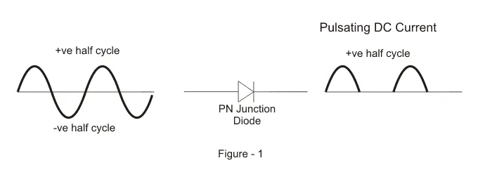

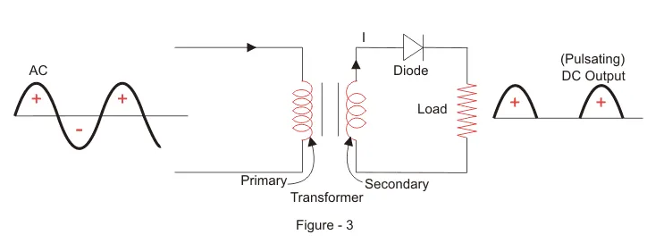

A full wave rectifier is defined as a [type of rectifier](https://www.electrical4u.com/rectifier-type-instrument-construction-principle-of-operation/) that converts both halves of each cycle of an alternating wave (AC signal) into a pulsating DC signal. Full-wave rectifiers are used to convert AC voltage to DC voltage, requiring multiple diodes to construct. Full wave rectification is the process of converting an AC signal to a DC signal.

* Centre-tapped Full Wave Rectifier
* Full Wave Bridge Rectifier

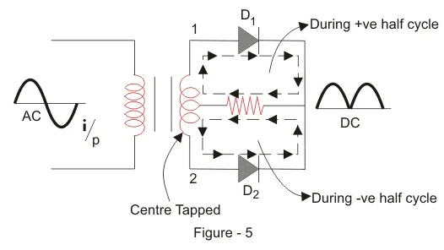

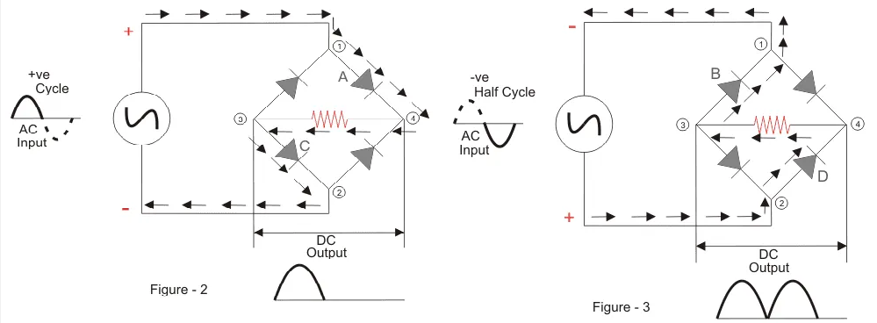

# 4). Differential amplifier

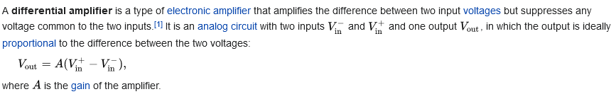

V out = A ( V in + − V in − ) , {\displaystyle V_{\text{out}}=A(V_{\text{in}}^{+}-V_{\text{in}}^{-}),}

## What is an Ideal OP Amp?

An [operational amplifier](https://www.electrical4u.com/op-amp-working-principle-of-op-amp/) (OP Amp) is a [direct current](https://www.electrical4u.com/dc-current/) coupled voltage amplifier. That is, it increases the input voltage that passes through it. The input [resistance](https://www.electrical4u.com/what-is-electrical-resistance/) of an OP amp should be high whereas the output resistance should be low. An OP amp should also have very high open loop gain. In an ideal OP amp, the input resistance and open loop gain is infinity whereas the output resistance is zero.

An ideal OP amp has have following characteristics—

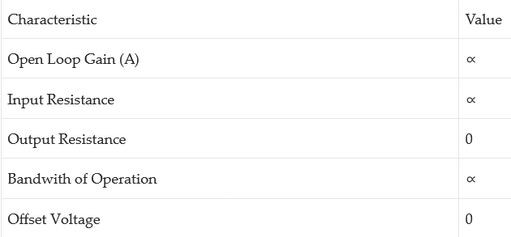

So, an **ideal op amp** is defined as, a differential amplifier with infinite open loop gain, infinite input [resistance](https://www.electrical4u.com/what-is-electrical-resistance/) and zero output resistance.

The **ideal op amp** has zero input [current](https://www.electrical4u.com/electric-current-and-theory-of-electricity/). This is because of infinite input resistance. As the input resistance of **ideal op amp** is infinite, an open circuit exists at input, hence current at both input terminals is zero.

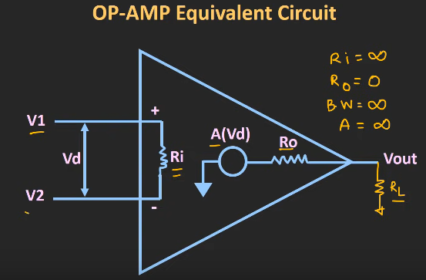

###### **Excerpts from Interview #4:**

**Technical interview:**

1. Can you draw the architecture for the 8086 microprocessor.
2. What are the various interrupts in 8086? Explain.
3. Explain KVL & KCL with physical significance.
4. Explain the advantages of CMOS compared to TTL.
5. Write a program to reverse a string.
6. Are you willing to travel? How much?
7. Tell me about a time when you were tolerant of an opinion that was different from yours.
8. Tell me about a time when you delegated a project effectively.
9. What is your greatest strength?
10. Tell me about a time when you were unable to complete a project on time.
11. Correct the following equation: 5+5+5=550

---------------------------------------------------------------------------------------------------------------------------

1).

## ***Features of 8086***

The most prominent features of a 8086 microprocessor are as follows −

* It has an instruction queue, which is capable of storing six instruction bytes from the memory resulting in faster processing.
* It was the first 16-bit processor having 16-bit ALU, 16-bit registers, internal data bus, and 16-bit external data bus resulting in faster processing.
* It is available in 3 versions based on the frequency of operation −
  + 8086 → 5MHz
  + 8086-2 → 8MHz
  + (c)8086-1 → 10 MHz
* It uses two stages of pipelining, i.e. Fetch Stage and Execute Stage, which improves performance.
* Fetch stage can prefetch up to 6 bytes of instructions and stores them in the queue.
* Execute stage executes these instructions.
* It has 256 vectored interrupts.
* It consists of 29,000 transistors.

## Comparison between 8085 & 8086 Microprocessor

* **Size** − 8085 is 8-bit microprocessor, whereas 8086 is 16-bit microprocessor.
* **Address Bus** − 8085 has 16-bit address bus while 8086 has 20-bit address bus.
* **Memory** − 8085 can access up to 64Kb, whereas 8086 can access up to 1 Mb of memory.
* **Instruction** − 8085 doesn’t have an instruction queue, whereas 8086 has an instruction queue.
* **Pipelining** − 8085 doesn’t support a pipelined architecture while 8086 supports a pipelined architecture.
* **I/O** − 8085 can address 2^8 = 256 I/O's, whereas 8086 can access 2^16 = 65,536 I/O's.
* **Cost** − The cost of 8085 is low whereas that of 8086 is high.

## Architecture of 8086

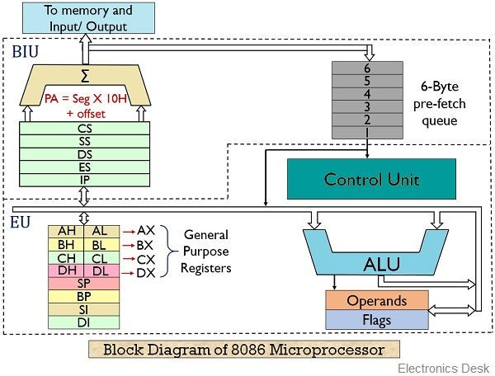

References🡪 <https://www.geeksforgeeks.org/architecture-of-8086/>

2).

## **Hardware Interrupts**

Hardware interrupt is caused by any peripheral device by sending a signal through a specified pin to the microprocessor.

The 8086 has two hardware interrupt pins, i.e. NMI and INTR. NMI is a non-maskable interrupt and INTR is a maskable interrupt having lower priority. One more interrupt pin associated is INTA called interrupt acknowledge.

### NMI

It is a single non-maskable interrupt pin (NMI) having higher priority than the maskable interrupt request pin (INTR)and it is of type 2 interrupt.

When this interrupt is activated, these actions take place −

* Completes the current instruction that is in progress.
* Pushes the Flag register values on to the stack.
* Pushes the CS (code segment) value and IP (instruction pointer) value of the return address on to the stack.
* IP is loaded from the contents of the word location 00008H.
* CS is loaded from the contents of the next word location 0000AH.
* Interrupt flag and trap flag are reset to 0.

### INTR

The INTR is a maskable interrupt because the microprocessor will be interrupted only if interrupts are enabled using set interrupt flag instruction. It should not be enabled using clear interrupt Flag instruction.

The INTR interrupt is activated by an I/O port. If the interrupt is enabled and NMI is disabled, then the microprocessor first completes the current execution and sends ‘0’ on INTA pin twice. The first ‘0’ means INTA informs the external device to get ready and during the second ‘0’ the microprocessor receives the 8 bit, say X, from the programmable interrupt controller.

<https://www.tutorialspoint.com/microprocessor/microprocessor_8086_interrupts.htm>

3).

## ***Kirchhoff’s laws***

Kirchhoff’s laws mainly deal with voltage and current in the electrical circuits. These laws can be understood as results of the Maxwell equations in the low frequency limit. They are perfect for DC and AC circuits at frequencies where the electromagnetic radiation wavelengths are very large when we compare with other circuits.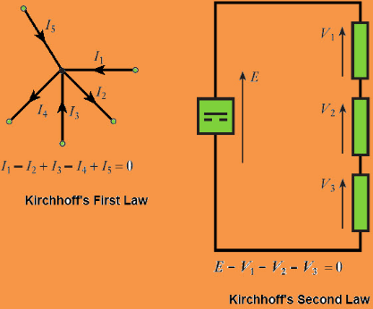

There are various relationships among voltages and currents of an electrical circuit. These relationships are determined by Kirchhoffs laws such as KVL and KCL. These laws are used to determine the impedance of the complex network or equivalent electrical resistance and the currents flowing in the several branches of the n/w.

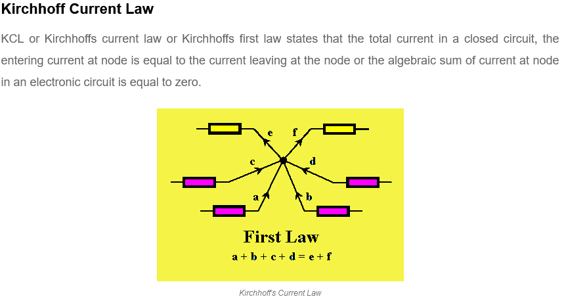

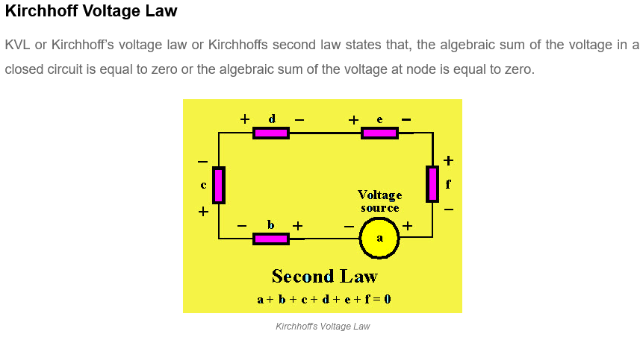

4).

### ****What Is The Difference Between CMOS and TTL? Which one is Better?****

The **advantage of the CMOS over the TTL chips** is that the CMOS has a higher **density of logic gates** within the same material. TTL chips **consume more power** as compared to the power consumed by the CMOS chips even at rest. The power consumption of the CMOS depends on various factors and is variable. The **clock rate** is one of the major factors for power consumption. Higher clock values will result in higher power consumption. When making the comparisons, a single gate in CMOS chip would consume the 10nW of power whereas an equivalent gate on the TTL chip will consume approximately 10mW power. The difference is substantially high and this is why the **CMOS chips are always preferred over the TTL chips.**

### ****Difference between CMOS and TTL - Conclusion****

To **compare TTL and CMOS**, one must think about the points mentioned above. As the CMOS consists of the FET’s and the TTL circuits are made up of BJT, CMOS chips are much faster and efficient. There is a much higher density of the logic functions in a single chip in CMOS as compared to the TTL. Also, the power consumption of the TTL circuits is higher when compared to the power consumption of CMOS. Though the CMOS has lesser power consumption, CMOS chips are more susceptible to the static electric discharge and thus can be damaged easily. CMOS chips could have the TTL logics and could be used for the replacement of the TTL IC.

<https://components101.com/articles/ttl-vs-cmos-ics-and-how-to-choose-between-them>

11). Make a four from the plus sign and you get 545+5=550

###### **Excerpts from Interview #5:**

**Technical interview:**

1. What voltage will an AC voltmeter display?
2. Referring to instruction words, what is a mnemonic?
3. Explain pull-up and pull-down (Micro-controllers).
4. Write an algorithm for finding the minimum element in an unsorted array.

-----------------------------------------------------------------------------------------------------------------------------

1).

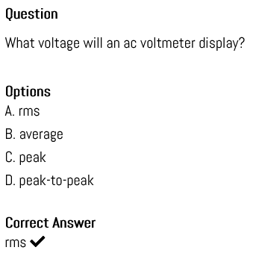

2).

A mnemonic in the microprocessor is either a symbol, **a name or a term that defines a computer function or operation**. A mnemonic is always used to give users quick access to computer functions, processes or services. Through mnemonics, a user will bypass the actual and longways or path to perform a task.

3).

A pull-up resistor **connects unused input pins** (AND and NAND gates) to the dc supply voltage, (Vcc) to keep the given input HIGH. A pull-down resistor connects unused input pins (OR and NOR gates) to ground, (0V) to keep the given input LOW.

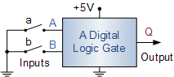

As the input is now effectively unconnected from either a defined HIGH or LOW condition, it has the potential to “float” about between 0V and +5V (Vcc) allowing the input to self–bias at any voltage level whether that represents a HIGH or a LOW condition.

This uncertain situation may cause the digital input at “A” to stay at a logic level “0” (LOW) when the switch is open, when we actually need a logic “1”, (HIGH) causing the logic gate to falsely switch the output at “Q”. Also once there, this floating and weak input signal could easily change value at the slightest of interference or noise from its neighbouring inputs or could even cause it to go into oscillation, rendering the gate practically unusable. The same situation is also true with regards to the switching of input “B”.

Then to prevent accidental switching of digital circuits, any unconnected inputs called “floating inputs” should be tied to a logic “1” or logic “0” as appropriate for the circuit. We can easily do this by using what are commonly called **Pull-up Resistors** and **Pull-down Resistors** to give the input pin a defined default state, even if the switch is open, closed or there is nothing is connected to it.

###### **Excerpts from Interview #6:**

**Technical interview:**

1. Explain the term OSI layer?
2. What do you understand by the term platform independence?
3. What is 8085 assembly language program?
4. State main differences between JDK and JVM.
5. What do you understand by networking?
6. What do you mean by indirection?
7. What is Data Independence?

--------------------------------------------------------------------------------------------------------------------------------------

2).

Software that can run on a variety of hardware platforms or software architectures. Platform-independent software can be used in many different environments, requiring less planning and translation across an enterprise.

5).

## What Does Network Mean?

A network, in computing, is a group of two or more devices or nodes that can communicate. The devices or nodes in question can be connected by physical or wireless connections.

Q.What is “THIS” pointer in C++ ?

To understand ‘this’ pointer, it is important to know how objects look at functions and data members of a class.

1. Each object gets its own copy of the data member.
2. All-access the same function definition as present in the code segment.

Meaning each object gets its own copy of data members and all objects share a single copy of member functions.  
Then now question is that if only one copy of each member function exists and is used by multiple objects, how are the proper data members are accessed and updated?  
The compiler supplies an implicit pointer along with the names of the functions as ‘this’.  
The ‘this’ pointer is passed as a hidden argument to all nonstatic member function calls and is available as a local variable within the body of all nonstatic functions. ‘this’ pointer is not available in static member functions as static member functions can be called without any object (with class name).  
For a class X, the type of this pointer is ‘X* ‘. Also, if a member function of X is declared as const, then the type of this pointer is ‘const X *.

## Q. What are the applications of BJT and draw the diagram of how it works internally?

## What is a BJT

A Bipolar Junction Transistor (also known as a BJT or BJT Transistor) is a three-terminal semiconductor device consisting of two p-n junctions which are able to amplify or magnify a signal. It is a [current](https://www.electrical4u.com/electric-current-and-theory-of-electricity/) controlled device. The three terminals of the BJT are the base, the collector and the emitter. A BJT is a type of [transistor](https://www.electrical4u.com/working-principle-of-transistor/) that uses both electrons and holes as charge carriers.

A signal of small amplitude if applied to the base is available in the amplified form at the collector of the transistor. This is the amplification provided by the BJT. Note that it does require an external source of [DC](https://www.electrical4u.com/dc-current/) power supply to carry out the amplification process.

There are two types of bipolar junction transistors – [NPN transistors](https://www.electrical4u.com/npn-transistor/) and [PNP transistors](https://www.electrical4u.com/pnp-transistor/). A diagram of these two types of bipolar junction transistors is given below.

The bipolar junction transistor (BJT) is used in logic circuits. The BJT is used **as an oscillator**. It is used as an amplifier. It is used as a multivibrator.

Q. Name of the circuit which shifts the input signal by 180 degree phase, how, and draw the diagram.

🡪 In an **RC Oscillator** circuit the input is shifted 180o

