Title

Author

Month Year

Abstract

Lorem ipsum dolor sit amet, consectetur adipiscing elit, sed do eiusmod tempor incididunt ut labore et dolore magna aliqua. Ultricies mi quis hendrerit dolor magna eget est lorem. Quam elementum pulvinar etiam non quam lacus suspendisse. Sagittis purus sit amet volutpat consequat mauris nunc congue. Quis enim lobortis scelerisque fermentum. Tristique risus nec feugiat in.

Keywords

keywords, are , lower case

# Section

Sections are left-justified. Paragraphs have a 6pt separation after.

Bullet point lists use the BulletList style and look like this:

* Item 1
* Item 2
* Etc.

# Another Section

We evaluate our modeling framework by qualitatively inspecting samples paths generated for an individual claim and also comparing the aggregate estimate of unpaid claims with a chain ladder estimate. We note that, to the best of our knowledge, prior to the current paper, there is not a benchmark for individual claims forecasts. We also discuss the extensibility of our approach to accommodate company specific data elements and expert knowledge.

## Subsection

Figure 3 shows various posterior densities, obtained by sampling the model weights 1,000 times, of parameters for the output distributions of a single claim. Our model assigns a higher probability of payment in the next year along with more variability around that probability. It can be seen that the expected probability of a payment decreases as we forecast further into the future. Given that a loss payment occurs, we see from the middle and bottom plots that both the expected value and the variability for both the mean and variance of the log-normal distributions increase with time. In other words, for this particular claim, loss payments become less likely as time goes on, but if they occur, they tend to be more severe and the model is less certain about the severity distribution.

### Sub-subsection

Lorem ipsum

# Figures and Tables

## Figures

Figure captions should be blah.

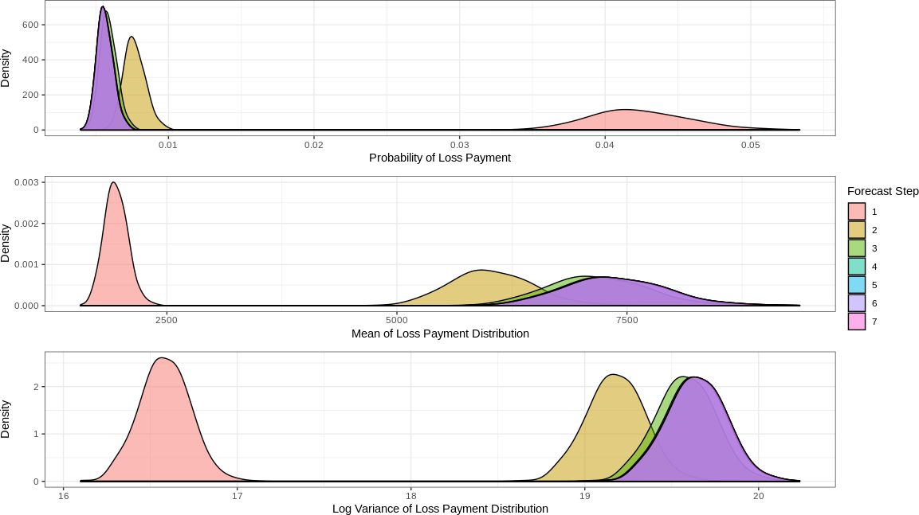

Figure

## Tables

Tables should be blah

|  |  |  |
| --- | --- | --- |
|  |  |  |
|  |  |  |
|  |  |  |
|  |  |  |

Mojo

# Acknowledgments

Be sure to acknowledge whoever helped you out.

# Appendix

# References

[1] K. Antonio and R. Plat. Micro-level stochastic loss reserving for general insurance. *Scandinavian Actuarial Journal*, 2014(7):649–669, 2014.

[3] M. Baudry and C. Y. Robert. A machine learning approach for individual claims reserving in insurance. *Applied Stochastic Models in Business and Industry*.