6th IAHR Europe Congress, June 30th – July 2nd, 2020, Warsaw, Poland

Sequential calibration using remotely sensed data to improve the identifiability of hydrological model parameters

Jesús CASADO-RODRÍGUEZ1, Manuel DEL JESUS2

1, 2 Environmental Hydraulics Institute, University of Cantabria, Spain

email: casadoj@unican.es

email: manuel.deljesus@unican.es

Abstract

Parameter identifiability is a known issue in conceptual hydrological models. The number of model parameters and the lack of variety in the target variables used to calibrate cause uncertainty about the representativeness of the calibrated model. In this context, remote sensing emerges as a key source of information that allows us to calibrate spatial processes in the water cycle. In this study, we combine the use of remotely sensed data in the calibration of spatial surface processes, such as snow and evapotranspiration, with a novel procedure that calibrates discharge by applying flow disaggregation techniques. The objective is to improve the identifiability of the calibrated model parameters.

1. Introduction

State of the art hydrological models often require a vast number of parameters to reproduce the processes in the water cycle. This is a result of modelling an increasing number of processes, which requires a larger model flexibility. Calibrating such models becomes a complicated task, both in terms of computational effort and parameter identifiability. The concept of parameter identifiability (or equifinality) states that multiple parameterizations of a model, representing diverse behaviors of the catchment, are indistinguishable in terms of model performance (Beven, 2001). This fact limits the applicability of the model to posterior studies such as erosion, nutrient transport, dynamic vegetation or climate change impacts.

A way of reducing equifinality is to calibrate several target variables (Beven, 1992), instead of simply discharge. Following this thread, remote sensing becomes an invaluable source of information for calibrating processes in the water cycle for which traditional information sources are scarce, such as snow or vegetation. Examples of the use of remotely sensed data for calibrating hydrological models are abundant in the literature (Koch, 2018; Pasquato, 2015; Ruiz Pérez, 2016; Wambura, 2018).

Since remotely sensed data can only supply information about surface processes, there remains equifinality in the identification of subsurface processes, namely the distribution of discharge in surface runoff, interflow and groundwater flow. To tackle this uncertainty without the need for further information, we developed a sequential calibration method based on hydrograph separation techniques (Casado-Rodríguez, 2019).

The objective of this study is to combine the information of remotely sensed data and that obtained from hydrograph disaggregation in a sequential calibration process in order to improve the identifiability of a hydrological model.

1. Methodology
   1. Study area and data

The study area are two mesoscale basins in the Picos de Europa National Park (Northern Spain): the upper Sella and the Cares river basins. Both are middle-high mountain catchments with a large elevation range (above 2500 m) and limited anthropogenic intervention.

Input data are climatological records from meteorological stations, topography, and maps of soil properties and land cover. To calibrate the model, apart from the common use of discharge observations in gauging stations, we generate series of maps of snow cover and evapotranspiration derived from MODIS satellite images.

* 1. Hydrological model

The hydrological model we use in this study is TETIS (GIMHA, 2018), a conceptual distributed model. TETIS conceptualizes the water cycle as a series of seven tanks representing each of the storages in the water cycle: interception, snowpack, four soil layers (static, surface, gravitational, aquifer) and streams.

* 1. Calibration method

We perform calibration in a sequence from the surface to soil surface to the deepest underground processes. We start by calibrating spatial surface processes: first snow accumulation and ablation, and then evapotranspiration. The target variables are the respective maps derived from MODIS, and the objective criteria is the SPAEF (Koch, 2018), a spatial efficiency metric that resembles the logic behind the KGE (Kling-Gupta efficiency) commonly used for time series. As a result of these two phases, we fit the parameters for the interception, snowpack and static tanks, and indirectly minimize the model bias.

The calibration of the remaining four tanks, those related to discharge production, targets the disaggregated discharge series. We assume that quick flow is the sum of surface runoff and interflow, so that we calibrate both the surface and gravitational tanks against it; whereas slow flow corresponds to groundwater flow, so we use it to calibrate the aquifer. Eventually, we use total discharge to calibrate the flow routing along streams. The objective criteria used to calibrate discharge is the NSE (Nash-Sutcliffe efficiency).

As a benchmark method, we calibrate the same catchments using only total discharge. First, we fit snow and evapotranspiration to minimize bias, and second, we fit the discharge-producing tanks to maximize NSE.

1. Results

Preliminary results (shown in Fig.1) prove that a sequential calibration process improves model representativeness, as it discards parameterizations of high performance but incorrect behavior. In addition, it improves model performance both in terms of disaggregated and total discharge. However, the problem of parameter identifiability, though constrained, does not subside, since we obtain rather different parameter values for two basins with similar climate and topography.

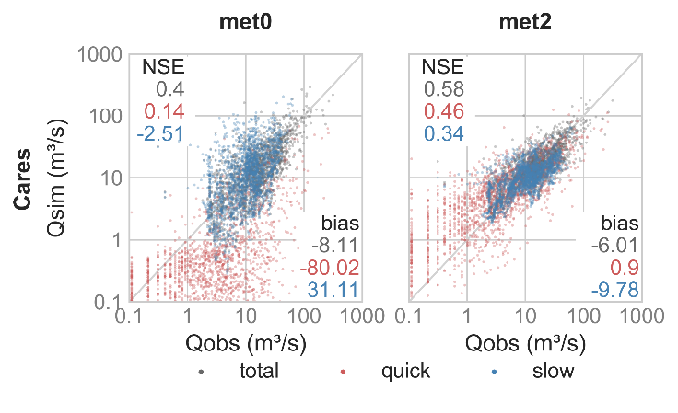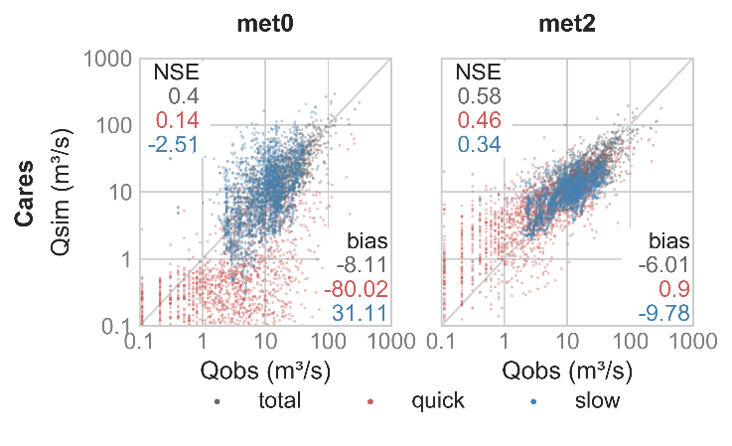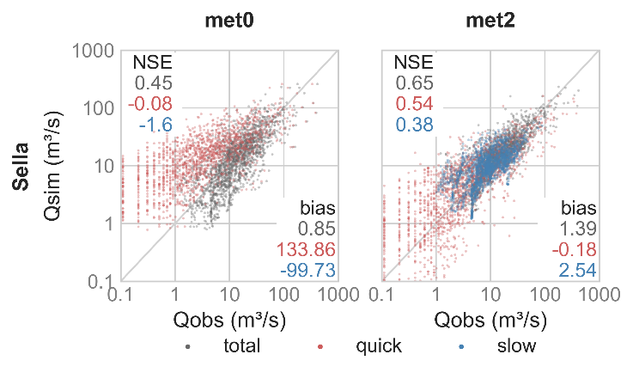

**Fig. 1.** Scatter plots of daily total, quick and slow discharge for both study catchments. *Met0* stands for the benchmark calibration method and *met2* for the method presented in this study.

Acknowledgements

The authors would like to acknowledge the National Research Agencyfrom the Spanish Ministry of Economy, Industry and Competitiveness, and the European Regional Development Fund (ERDF) for the funding provided through the grant BIA2016-78397-P (AEI/FEDER, UE). The first author also holds a scholarship FPU 17/05352 granted by the Spanish Ministry of Education and Vocational Training.

References

Beven K, Binley A (1992) The Future of Distributed model: Calibration and Uncertainty Prediction, Hydrological Processes, 6, 279–298.

Beven K., Freer J (2001) Equifinality, data assimilation, and uncertainty estimation in mechanistic modelling of complex environmental systems using the GLUE methodology, Journal of Hydrology, 249(1–4), 11–29

Casado-Rodríguez J, Del Jesu-Peñil M (2019) Reducción de la equifinalidad de un modelo hidrológico conceptual, Jornadas de Ingeniería Del Agua

GIMHA (2018) Description of the Distributed Conceptual Hydrological Model Tetis V.9.0.1

Koch J, Demirel MC, Stisen S (2018) The SPAtial EFficiency metric (SPAEF): Multiple-component evaluation of spatial patterns for optimization of hydrological models, Geoscientific Model Development, 11(5), 1873–1886

Pasquato M, Medici C, Friend AD, Francés F (2015). Comparing two approaches for parsimonious vegetation modelling in semiarid regions using satellite data, Ecohydrology, 8(6), 1024–1036

Ruiz Pérez G (2016). On the use of satellite data to calibrate a parsimonious ecohydrological model in ungauged basins. Universidad Politécnica de Valencia.

Wambura FJ, Dietrich O, Lischeid G (2018). Improving a distributed hydrological model using evapotranspiration-related boundary conditions as additional constraints in a data-scarce river basin, Hydrological Processes, 32(6), 759–775